# Differentiation – Product Rule:

This tutorial is on differentiation, specifically the use of the product rule in differentiation. The product rule will be explained as to why it is needed in differentiation. The rule itself will be presented and two examples will be used to demonstrate the application of the product in differentiation

Product Rule is used in differentiating two or more functions that are being multiplied together. It is used to determine the derivative of the product of two functions, the product rule is written as follows.

**Product Rule**

If $y = uv$ where *u* and *v* are functions of *x*, then

$$\frac{dy}{dx}=u\frac{dv}{dx}+v\frac{du}{dx}$$

Here, we will differentiate the following expression, two functions.

## Example 1

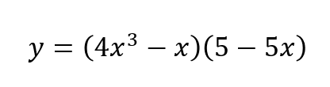

First we will put each part of the rule together.



This is differentiated as ${4x}^{3}$ becoming ${12x}^{2}$ and $-x$, becoming -1.

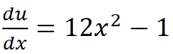



This is differentiated as minus five.

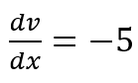

Now, each part of the rule will be assembled.

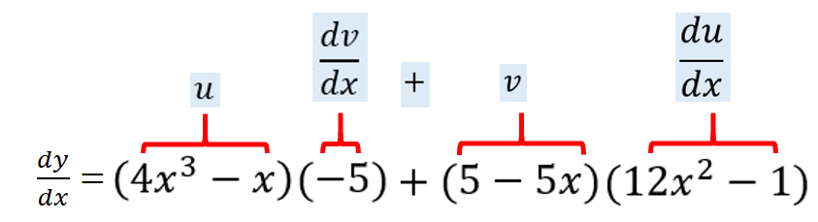

Now each piece will be multiplied.

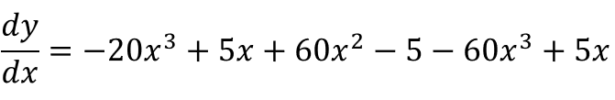

Here, where we have numbers to the same x power. We will combine those to simplify the equation.

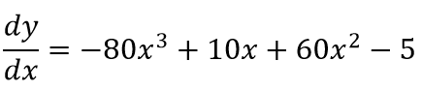

This can be rewritten in a number of different ways.

First, with the power of x in descending order, which is often the most common way of writing.

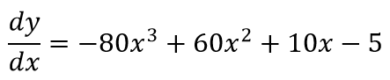

It can also be factorized. If you wish to reduce it further.

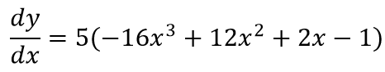

Each of these representations are correct. And its just preference as to how they're written.

## Example 2

In this example, we will be substituting the value of one.

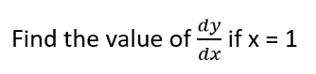

Again, we're rewriting expression.

$$\frac{dy}{dx}=-80x^{3}+60x^{2}+10x-5$$

And here we're substitution, one in each place of x.

$$\frac{dy}{dx}=-80\left(1^{3}\right)+60\left(1^{2}\right)+10(1)-5$$

Once that has been done, we multiply out each section.

$$\frac{dy}{dx}=-80+60+10-5$$

And then complete the sum.

$$\frac{dy}{dx}=-15$$