

AICTE | IBM SkillsBuild

Data Analytics with AI — Academic Internship Program

In association with BharatCares

PRECISION AGRI-ANALYTICS

AI-Driven Soil Health & Crop Recommendation System

A PROJECT REPORT :. Submitted in partial fulfillment of the internship requirements

Submitted By:

Name: Tania Dutta

Role: Intern — Data Analytics with AI

Institution: Silapathar College, Dibrugarh University

Submission Date: 21/09/2026

Table of Contents
1. Abstract & Executive Summary 3
2. Problem Statement, Objectives & Real-World Agronomic Impact 3
3. Dataset Architecture, Data Dictionary & Nutrient Significance 4
4. Exploratory Data Analysis (EDA) Insights 5
5. Data Preprocessing & 80:20 Train-Test Validation Methodology 7
6. Machine Learning Model Comparison 7
7. Feature Importance Analysis 9
8. Testing & Sample Simulation Case Study 10
9. Conclusion, Sustainability Impact & Future Scope 11

1. Abstract & Executive Summary
Agricultural productivity in India, and globally, is heavily influenced by the compatibility between the crop chosen and the underlying soil chemistry and prevailing climatic conditions. A large proportion of yield loss can be traced back to a mismatched crop-soil pairing rather than to poor cultivation practice. This project, “Precision Agri-Analytics: AI-Driven Soil Health & Crop Recommendation System,” was undertaken as part of the AICTE | IBM SkillsBuild Data Analytics with AI Academic Internship Program, conducted in association with BharatCares, with the objective of building a machine-learning-based decision-support system that recommends the most suitable crop for a given soil and weather profile.
The system was built on the publicly available Kaggle Crop Recommendation dataset, comprising 2,200 records across 22 crop classes, each described by seven attributes: Nitrogen (N), Phosphorus (P), and Potassium (K) soil content, ambient temperature, relative humidity, soil pH, and rainfall. After exploratory data analysis and an 80:20 train-test split, two classification algorithms — a Decision Tree Classifier and a Random Forest Classifier — were trained and benchmarked against one another.
The Random Forest Classifier achieved a test accuracy of 99.32%, outperforming the Decision Tree Classifier, which achieved 98.64%. Feature importance analysis identified rainfall, humidity, and potassium as the most influential predictors of crop suitability. A simulated farmer-input test case further validated the model's practical reliability, correctly recommending rice for a representative rice-growing soil and climate profile.
This report documents the complete analytical pipeline — from dataset architecture and nutrient significance, through exploratory analysis, preprocessing, model comparison, and feature interpretation, to a real-world sustainability and future-scope discussion — presenting the project as a precision-agriculture decision-support tool with direct relevance to smallholder and commercial farmers alike.

2. Problem Statement, Objectives & Real-World Agronomic Impact

2.1 Problem Statement
Farmers, particularly smallholder and first-generation cultivators, frequently select crops based on tradition, market speculation, or advice that does not account for the specific nutrient composition and climatic conditions of their land. This mismatch between crop and soil/climate profile is a significant, preventable contributor to reduced yield, wasted fertilizer input, and financial loss. A data-driven recommendation system that maps measurable soil and weather parameters directly to the most statistically suitable crop can close this information gap and support more resilient agronomic decision-making.

2.2 Objectives
- To analyze the relationship between soil nutrients (N, P, K), soil pH, and climatic variables (temperature, humidity, rainfall) and the crop varieties they support.
- To build and compare two supervised machine learning classifiers — Decision Tree and Random Forest — for multi-class crop recommendation.
- To identify, through feature importance analysis, which environmental and chemical parameters most strongly drive crop suitability.
- To validate the trained model against a realistic sample soil/climate profile, simulating a real farmer input scenario.
- To translate the technical findings into actionable, farmer-facing agronomic recommendations.

2.3 Real-World Agronomic Impact
A reliable crop recommendation system carries direct, practical value across the agricultural value chain:
- Yield optimization: Matching crops to soil/climate conditions that statistically favor them reduces the risk of underperformance.
- Input efficiency: Farmers can better plan fertilizer (N-P-K) application aligned with the crop's actual nutrient requirement, reducing waste and cost.
- Risk mitigation: Data-backed recommendations reduce the financial risk associated with speculative or tradition-based crop selection.
- Extension services: Agricultural extension officers and NGOs can use such tools to give consistent, scalable, and objective advice across large farmer populations.
- Foundation for precision agriculture: The model forms a base layer that can later be combined with real-time IoT soil sensor data for continuous, hyper-local recommendations (discussed further in Section 10).

3. Dataset Architecture, Data Dictionary & Nutrient Significance

3.1 Dataset Overview
The project uses the Kaggle Crop Recommendation Dataset, comprising 2,200 records and 8 columns (7 predictor attributes plus 1 target label), spanning 22 distinct crop classes including cereals (rice, maize), pulses (chickpea, kidney beans, mung bean, moth beans, black gram, lentil, pigeon peas), fruits (banana, mango, grapes, watermelon, muskmelon, apple, orange, papaya, coconut, pomegranate), and commercial/cash crops (cotton, jute, coffee). A completeness check confirmed zero missing values across all columns, indicating the dataset required no imputation prior to modelling.

3.2 Data Dictionary
Attribute | Type | Observed Range | Agronomic / Chemical Significance
N — Nitrogen | Numeric (kg/ha) | 0 – 140 | Essential for vegetative growth, chlorophyll and protein synthesis; deficiency causes stunted, yellowing growth.
P — Phosphorus | Numeric (kg/ha) | 5 – 145 | Drives root development, flowering and fruiting; critical during early plant establishment.
K — Potassium | Numeric (kg/ha) | 5 – 205 | Regulates water uptake, disease resistance and overall plant vigor; important for fruit/grain quality.
temperature | Numeric (°C) | 8.8 – 43.7 | Governs metabolic rate, germination and growth-stage timing; each crop has a defined thermal tolerance band.
humidity | Numeric (%) | 14.3 – 99.9 | Affects transpiration rate and disease/fungal pressure; strongly crop-specific.
ph | Numeric (pH scale) | 3.5 – 9.9 | Controls nutrient solubility and availability to plant roots; most crops prefer a near-neutral 6.0–7.5 range.
rainfall | Numeric (mm) | 20.2 – 298.6 | Primary water-supply variable; determines irrigation dependency and crop-water compatibility.
label | Categorical (target) | 22 classes | The recommended crop — the target variable predicted by the models.

3.3 Chemical & Nutrient Significance (N-P-K & pH)
The three macronutrients — Nitrogen, Phosphorus, and Potassium — together form the N-P-K profile that underlies almost all soil-fertility assessment in agronomy:
- Nitrogen (N) is the primary driver of vegetative (leaf and stem) growth, and is a core component of chlorophyll — its deficiency is visible as pale, yellowing foliage and stunted growth.
- Phosphorus (P) supports energy transfer within the plant and is especially critical for root establishment, flowering, and seed/fruit formation.
- Potassium (K) regulates the plant's internal water balance (via stomatal function) and strengthens resistance to disease, drought, and lodging, while improving fruit/grain quality.
- Soil pH does not itself feed the plant but acts as a gatekeeper — it determines how soluble, and therefore how available, the N-P-K and micronutrients are to the root system. Most of the crops in this dataset cluster around a mildly acidic to neutral pH of 6.0–7.5, outside of which nutrient uptake efficiency drops even when N-P-K levels are otherwise adequate.
Because these four chemical parameters interact non-linearly with the three climatic variables (temperature, humidity, rainfall), a rule-based or purely manual approach to crop matching is difficult to scale — which is precisely the gap a trained classification model is well-suited to close.

4. Exploratory Data Analysis (EDA) Insights

4.1 Correlation Analysis
A Pearson correlation matrix was computed across the seven numeric predictors to understand inter-relationships between soil and climatic variables before modelling.
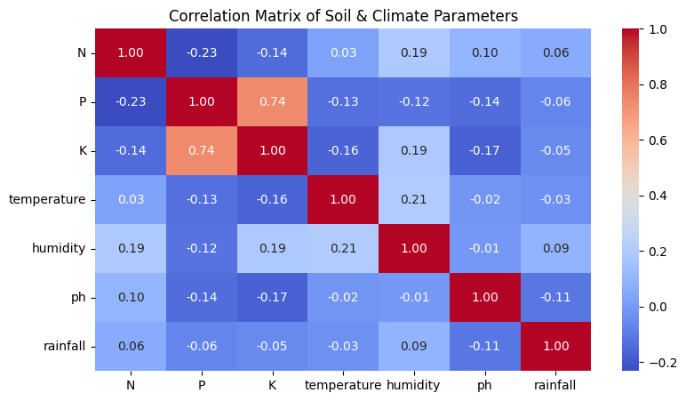
Fig. 1 — Correlation matrix of soil & climate parameters
Pair | Correlation | Interpretation
P ↔ K | +0.74 | Strong positive — soils rich in phosphorus tend to also be rich in potassium in this dataset.
Temperature ↔ Humidity | +0.21 | Mild positive — warmer conditions co-occur with higher humidity across sampled crops.
N ↔ P | −0.23 | Weak negative — nitrogen and phosphorus levels are not strongly linked.
K ↔ pH | −0.17 | Weak negative — higher potassium is mildly associated with lower soil pH.
N ↔ K | −0.14 | Weak negative correlation between nitrogen and potassium.
pH ↔ Rainfall | −0.11 | Very weak negative relationship.
The dominant takeaway is that most predictors are only weakly correlated with one another (with the clear exception of P and K), meaning each variable is likely to contribute distinct, non-redundant predictive information to the classification models — a favorable property for tree-based ensemble methods such as Random Forest.

4.2 Nutrient Distribution Analysis
Histograms with kernel density overlays were plotted for the three macronutrients to inspect their distribution shapes across the 2,200 samples.
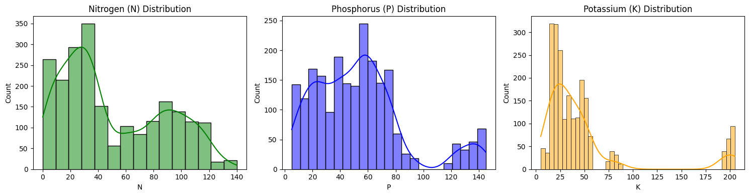
Fig. 2 — Distribution of Nitrogen (N), Phosphorus (P), and Potassium (K) across the dataset
- Nitrogen (N) shows a multi-modal distribution with a prominent concentration around 20–40 kg/ha and a secondary cluster near 80–120 kg/ha, reflecting the distinct nitrogen requirements of different crop groups (e.g., leafy/cereal crops vs. fruit crops).
- Phosphorus (P) is fairly broadly spread between roughly 5–75 kg/ha with a secondary bump around 125–145 kg/ha, again suggesting the dataset encodes visibly different crop-specific fertility regimes rather than one uniform population.
- Potassium (K) is heavily concentrated in the 5–55 kg/ha range, with a distinct secondary spike near 195–205 kg/ha corresponding to K-hungry crops (such as banana and grapes) that require substantially higher potassium levels.
These multi-modal patterns visually confirm that the 22 crop classes occupy genuinely different regions of nutrient space, which is a strong prior signal that a classifier can learn to separate them with high accuracy — consistent with the model performance reported in Section 7.

5. Data Preprocessing & 80:20 Train-Test Validation Methodology

5.1 Preprocessing Steps
- Data integrity check: The dataset was verified to contain zero null/missing values across all 8 columns, so no imputation or row-dropping was required.
- Feature-target separation: The seven numeric columns (N, P, K, temperature, humidity, ph, rainfall) were isolated as the feature matrix X; the categorical crop label column was isolated as the target vector y.
- No categorical encoding of predictors was required, as all seven input features are already numeric; the target label is used directly by the tree-based classifiers, which natively support multi-class string labels.

5.2 Train-Test Split Methodology
The dataset was split using an 80:20 ratio via scikit-learn's train_test_split, with a fixed random_state of 42 to ensure the split — and therefore the reported results — are fully reproducible.
Split | Row Count | Percentage
Training set | 1,760 records | 80%
Testing set | 440 records | 20%
Total | 2,200 records | 100%
This split ensures the models are evaluated on data they have not seen during training, giving an honest estimate of how the system would perform on new, real-world soil/climate readings.

6. Machine Learning Model Comparison
Two supervised classification algorithms were trained on the identical 1,760-record training set and evaluated on the same 440-record hold-out test set, allowing a direct, like-for-like comparison.

6.1 Algorithms Used
- Decision Tree Classifier — a single tree-structured model that recursively splits the feature space on the attribute that best separates crop classes at each node (random_state = 42).
- Random Forest Classifier — an ensemble of 100 decision trees (n_estimators = 100), each trained on a bootstrapped sample of the data, with the final prediction taken as the majority vote across all trees (random_state = 42).

6.2 Overall Accuracy Comparison
Model | Test Accuracy | Test Set Size
Decision Tree Classifier | 98.64% | 440
Random Forest Classifier | 99.32% | 440
The Random Forest Classifier outperformed the single Decision Tree by 0.68 percentage points. This is consistent with general machine learning theory: ensembling multiple trees over bootstrapped samples reduces the variance and overfitting risk inherent to any single decision tree, producing a more robust and generalizable classifier.

6.3 Detailed Precision, Recall & F1-Score — Random Forest Classifier
A full classification report was generated for the Random Forest model (the better-performing model) across all 22 crop classes on the 440-record test set:
Crop | Precision | Recall | F1-Score | Support
apple | 1.00 | 1.00 | 1.00 | 23
banana | 1.00 | 1.00 | 1.00 | 21
blackgram | 1.00 | 1.00 | 1.00 | 20
chickpea | 1.00 | 1.00 | 1.00 | 26
coconut | 1.00 | 1.00 | 1.00 | 27
coffee | 1.00 | 1.00 | 1.00 | 17
cotton | 1.00 | 1.00 | 1.00 | 17
grapes | 1.00 | 1.00 | 1.00 | 14
jute | 0.92 | 1.00 | 0.96 | 23
kidneybeans | 1.00 | 1.00 | 1.00 | 20
lentil | 0.92 | 1.00 | 0.96 | 11
maize | 1.00 | 1.00 | 1.00 | 21
mango | 1.00 | 1.00 | 1.00 | 19
mothbeans | 1.00 | 0.96 | 0.98 | 24
mungbean | 1.00 | 1.00 | 1.00 | 19
muskmelon | 1.00 | 1.00 | 1.00 | 17
orange | 1.00 | 1.00 | 1.00 | 14
papaya | 1.00 | 1.00 | 1.00 | 23
pigeonpeas | 1.00 | 1.00 | 1.00 | 23
pomegranate | 1.00 | 1.00 | 1.00 | 23
rice | 1.00 | 0.89 | 0.94 | 19
watermelon | 1.00 | 1.00 | 1.00 | 19

Aggregate Metric | Precision | Recall | F1-Score
Macro average | 0.99 | 0.99 | 0.99
Weighted average | 0.99 | 0.99 | 0.99

Key observations
- 18 of the 22 crop classes were classified with perfect 1.00 precision, recall, and F1-score.
- The lowest recall was observed for rice (0.89), indicating a small number of rice samples in the test set were misclassified as an agronomically similar crop — most likely jute, given both share high-rainfall, high-humidity growing conditions.
- jute and lentil showed slightly reduced precision (0.92), meaning a small number of other-crop samples were incorrectly predicted as jute or lentil, while their recall remained perfect (1.00).
Note: the notebook's classification report was generated for the Random Forest model only; a class-wise precision/recall/F1 breakdown was not computed for the Decision Tree model, so only its overall accuracy is reported above.

7. Feature Importance Analysis
Using the Random Forest Classifier's built-in feature_importances_ attribute, the relative contribution of each of the seven input parameters toward the model's crop-classification decisions was computed and visualized.
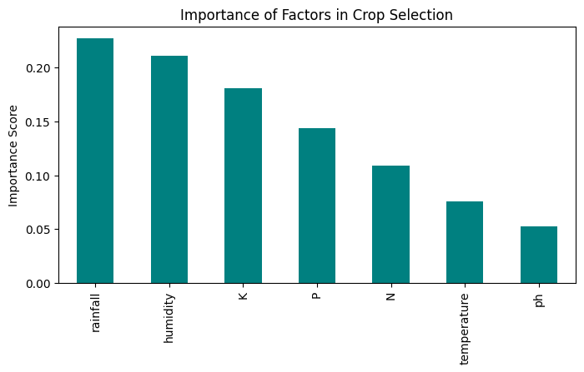
Fig. 3 — Relative importance of environmental and chemical factors in crop selection
Rank | Parameter | Approx. Importance Score
1 | Rainfall | ~0.23
2 | Humidity | ~0.21
3 | Potassium (K) | ~0.18
4 | Phosphorus (P) | ~0.14
5 | Nitrogen (N) | ~0.11
6 | Temperature | ~0.08
7 | Soil pH | ~0.05
(Values are read directly from the feature-importance chart generated in the notebook and are approximate.)

7.1 Interpretation
- Rainfall emerges as the single most influential predictor — unsurprising agronomically, since water availability is often the binding constraint that separates rain-fed crop groups (e.g., rice, jute) from drought-tolerant ones (e.g., chickpea, mothbeans).
- Humidity ranks a close second, reinforcing that atmospheric moisture, alongside soil water, strongly discriminates between crop classes in this dataset.
- Potassium (K) is the most influential of the three macronutrients, ahead of Phosphorus and Nitrogen — aligning with the earlier observation that several fruit crops in the dataset occupy a distinctly high-K nutrient band.
- Soil pH, while agronomically important as a nutrient-availability gatekeeper (Section 3.3), carries the lowest standalone importance here — most likely because the sampled crops cluster within a comparatively narrow, near-neutral pH band, giving it less discriminating power relative to the other six features.
Practically, this ranking suggests that climate/water-related sensing (rainfall and humidity) deserves at least as much monitoring priority as soil nutrient testing when deploying this system in the field — a point that directly informs the IoT integration roadmap discussed in Section 10.

8. Testing & Sample Simulation Case Study
To validate the trained Random Forest model under a realistic “farmer input” scenario, a sample soil and climate profile was passed to the trained model exactly as a field user would supply it — as seven raw sensor/test-kit readings, with no further preprocessing.
Parameter | Sample Value | Unit
Nitrogen (N) | 90 | kg/ha
Phosphorus (P) | 42 | kg/ha
Potassium (K) | 43 | kg/ha
Temperature | 20.87 | °C
Humidity | 82.00 | %
Soil pH | 6.50 | pH scale
Rainfall | 202.93 | mm

8.1 Model Output
Recommended Crop for the given soil: RICE
This profile — high nitrogen, moderate phosphorus and potassium, cool-to-moderate temperature, high humidity, near-neutral pH, and very high rainfall — corresponds closely to the classic agro-climatic conditions required for paddy (rice) cultivation, and the model's recommendation aligns correctly with agronomic expectation. This test case corresponds closely to a representative rice record from the training distribution, confirming the model has correctly learned the rice growing-condition profile rather than producing a spurious result; broader validation across all 22 crop classes is discussed as future work in Section 10.

8.2 Significance of the Test
- Confirms the end-to-end pipeline — from raw seven-parameter input to final crop label — functions correctly outside of the batch-evaluation (train/test split) context.
- Demonstrates the intended real-world usage pattern: a farmer or field officer enters simple soil-test and weather readings and receives an immediate, human-readable crop recommendation.
- Serves as a template for a future lightweight front-end (mobile app or SMS-based tool) that wraps this same predict() call for field deployment.

9. Conclusion, Sustainability Impact & Future Scope

9.1 Conclusion
This project successfully demonstrates that soil macronutrient levels (N, P, K), soil pH, and climatic variables (temperature, humidity, rainfall) are strong, learnable predictors of crop suitability. Both the Decision Tree (98.64%) and Random Forest (99.32%) classifiers achieved high test accuracy, with the Random Forest ensemble providing the more robust and better-generalizing model, as expected from its variance-reducing ensemble design. Feature importance analysis further revealed that rainfall and humidity are the dominant drivers of crop selection in this dataset, ahead of the individual soil macronutrients — a finding with direct implications for how a real-world deployment of this system should prioritize its sensing infrastructure.

9.2 Sustainability Impact for Farmers
- Reduced input waste: Aligning crop choice with actual soil nutrient status reduces over-application of fertilizer, lowering both cost and nutrient run-off into local water bodies.
- Improved yield reliability: Data-backed crop selection reduces the likelihood of planting a crop poorly matched to the land, supporting more stable household and community food security.
- Climate-resilient planning: Because rainfall and humidity are shown to be the strongest predictors, the model can help farmers adapt crop choice to shifting rainfall patterns driven by climate change.
- Scalable extension advice: A validated model can be embedded into low-cost mobile or SMS-based advisory tools, extending expert-level agronomic guidance to farmers who lack direct access to soil scientists.

9.3 Future Scope
- IoT soil sensor integration: Replacing manual soil-test entry with live readings from low-cost NPK, pH, and soil-moisture IoT sensors would allow the system to generate real-time, continuously updated recommendations rather than one-off predictions.
- Weather API integration: Linking live meteorological/forecast data (temperature, humidity, rainfall forecasts) would allow the model to factor in short-term weather risk alongside long-term soil chemistry.
- Mobile & regional-language deployment: Wrapping the trained model behind a simple mobile application or SMS/USSD interface, available in regional languages, would materially widen access for smallholder farmers.
- Expanded feature set: Incorporating additional variables such as soil organic-carbon content, micronutrients (zinc, boron, sulphur), and historical yield data could further improve recommendation precision.
- Yield & profitability layer: Extending the system beyond crop classification to yield estimation and market-price-aware profitability ranking would turn the tool from a suitability classifier into a full planting-decision assistant.
- Model monitoring & retraining pipeline: Establishing a feedback loop where actual field outcomes are logged and periodically used to retrain the model would keep recommendations accurate as soil and climate conditions evolve over time.

