**George Young  
Founder and CEO  
Kalypso**

Recognized Expert in Product Lifecycle Management, product development strategy, process and technology. He is a member of Ohio State University Technology Review Board. Kalypso has its technology center based in Monterrey.

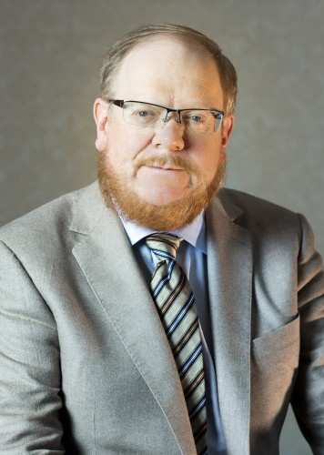

**Abraham Tijerina-Priego  
Coordinator Strategy Nuevo Leon 4.0  
Metalsa S.A. de C.V.**

Abraham Tijerina is coordinator of the State of Nuevo Leon’s Industry 4.0 Strategy, an Industry led, Government and Academia supported initiative, launched to foster the leadership of Nuevo Leon on the Fourth Industrial Revolution under the direction of Metalsa.

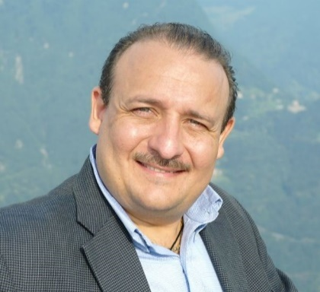

**Camila Lecaros  
Managing Director  
MassChallenge**

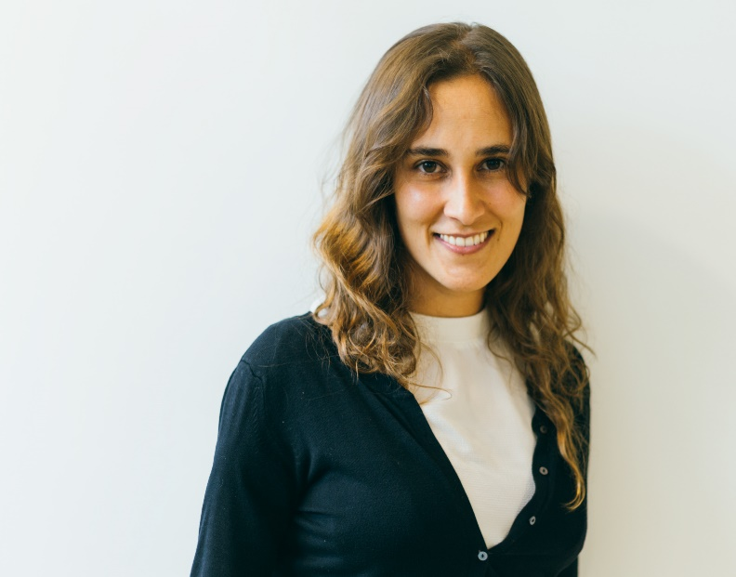Camila is the Managing Director for MassChallenge's program in Mexico City. MassChallenge is one of the most important startup accelerators.

**Enrique Valladares   
Director de Ventas, ERP/EPM   
Oracle de México**

More than 15 years of experience in the development of commercial strategy and technological applications. Recently became responsible of ERP/EPM solutions in Mexico.

