A new global gender divide is emerging
Financial Times, January 26th 2024
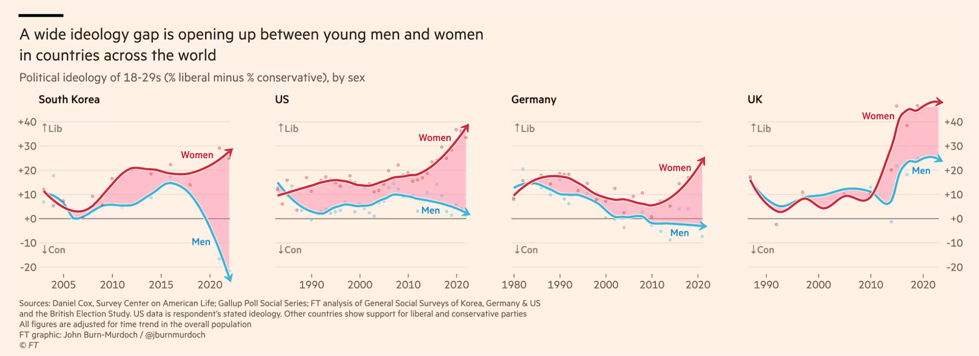
John Burn-Murdoch
One of the most well-established patterns in measuring public opinion is that every generation tends to move as one in terms of its politics and general ideology. Its members share the same formative experiences, reach life’s big milestones at the same time and intermingle in the same spaces. So how should we make sense of reports that Gen Z is hyper-progressive on certain issues, but surprisingly conservative on others? The answer, in the words of Alice Evans, a visiting fellow at Stanford University and one of the leading researchers on the topic, is that today’s under-thirties are undergoing a great gender divergence, with young women in the former camp and young men the latter. Gen Z is two generations, not one. In countries on every continent, an ideological gap has opened up between young men and women.
Tens of millions of people who occupy the same cities, workplaces, classrooms and even homes no longer see eye-to-eye. In the US, Gallup data shows that after decades where the sexes were each spread roughly equally across liberal and conservative world views, women aged 18 to 30 are now 30 percentage points more liberal than their male contemporaries. That gap took just six years to open up. Germany also now shows a 30-point gap between increasingly conservative young men and progressive female contemporaries, and in the UK the gap is 25 points. In Poland last year, almost half of men aged 18-21 backed the hard-right Confederation party, compared to just a sixth of young women of the same age. Outside the west, there are even more stark divisions. In South Korea there is now a yawning chasm between young men and women, and it’s a similar situation in China. In Africa, Tunisia shows the same pattern. Notably, in every country this dramatic split is either exclusive to the younger generation or far more pronounced there than among men and women in their thirties and upwards. The #MeToo movement was the key trigger, giving rise to fiercely feminist values among young women who felt empowered to speak out against long-running injustices. That spark found especially dry tinder in South Korea, where gender inequality remains stark, and outright misogyny is common. In the country’s 2022 presidential election, while older men and women voted in lockstep, young men swung heavily behind the right-wing People Power party, and young women backed the liberal Democratic party in almost equal and opposite numbers. Korea’s is an extreme situation, but it serves as a warning to other countries of what can happen when young men and women part ways. Its society is riven in two. Its marriage rate has plummeted, and birth rate has fallen precipitously, dropping to 0.78 births per woman in 2022, the lowest of any country in the world. Seven years on from the initial #MeToo explosion, the gender divergence in attitudes has become self-sustaining. Survey data show that in many countries the ideological differences now extend beyond this issue. The clear progressive-vs-conservative divide on sexual harassment appears to have caused — or at least is part of — a broader realignment of young men and women into conservative and liberal camps respectively on other issues. In the US, UK and Germany, young women now take far more liberal positions on immigration and racial justice than young men, while older age groups remain evenly matched. The trend in most countries has been one of women shifting left while men stand still, but there are signs that young men are actively moving to the right in Germany, where today’s under-30s are more opposed to immigration than their elders, and have shifted towards the far-right AfD in recent years. It would be easy to say this is all a phase that will pass, but the ideology gaps are only growing, and data shows that people’s formative political experiences are hard to shake off. All of this is exacerbated by the fact that the proliferation of smartphones and social media mean that young men and women now increasingly inhabit separate spaces and experience separate cultures. Too often young people’s views are overlooked owing to their low rates of political participation, but this shift could leave ripples for generations to come, impacting far more than vote counts.

