**What is activity recognition?**

* **Activity recognition aims to recognize the actions and goals of one or more agents from a series of observations on the agents' actions and the environmental conditions.**
* **In simple terms by activity recognition, our goal is to understand the human activity, recognize it and monitor it, also in some cases predict the outcome or just the next step of the activity.**

Corresponding to each human activity one may record a spectrum of respective acceleration and can plot a graph. These graphs can be used as the raw data in activity recognition.(These observations are recorded using accelerometer. )

A close up of text on a black background

Description generated with very high confidence

**But how?**

In order to achieve this, one must have the understanding of deep learning.

**DEEP LEARNING:**

* **Deep learning is a subset of machine learning and AI.**
* **A machine learning system is trained rather than explicitly programmed.**
* **Hence, deep learning is a new take on learning representations from data that puts emphasis on learning successive layers of increasingly meaningful representations.**
* **The deep in deep learning stands for the idea of successive layers of representations of data.**
* **In deep learning these layered representations are learned via models called neural networks (layered structure stacked op top of the other.).**

**Deep neural networks**

Each circle represents a neuron.

Each neuron in a layer is connected to each neuron in the next layer.

A neuron contains nothing but a number. This number (weight) is it’s activation number. (Already set but can be modified).

A neuron is set to ON when the signal value is greater than it’s activation value.

Activation in one layer determines the activation in the other layer.

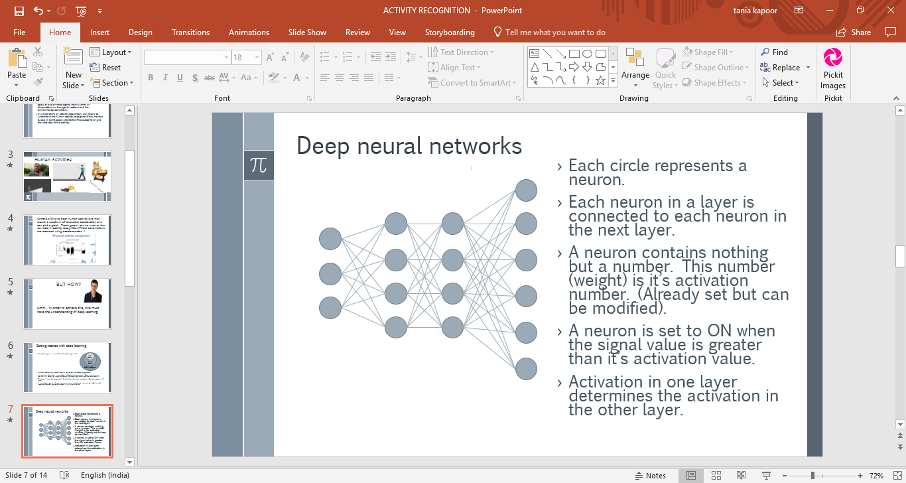

Nueral networks used in the project are CNN, RNN, LSTM (improved RNN)

**Prototype:**

This is the fusion model

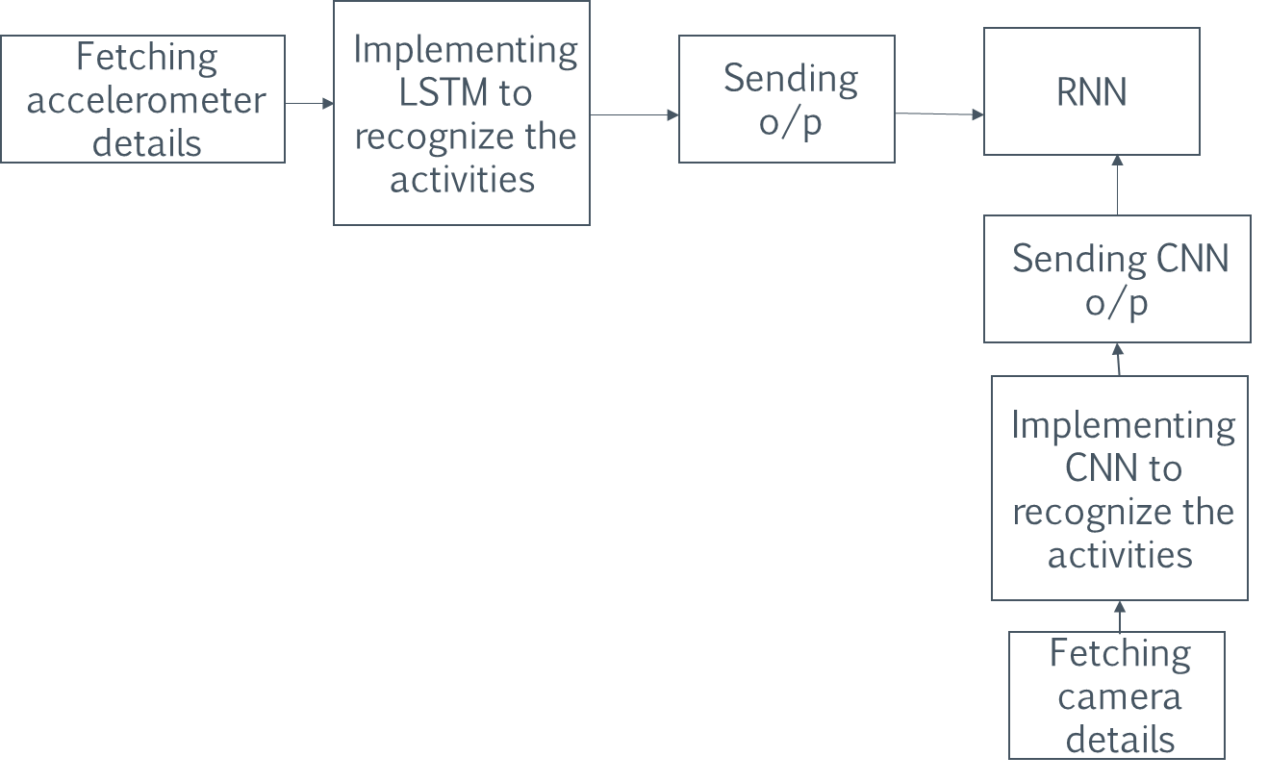

Here are two applications which helps us integrate input data in one device:

* For fetching camera details the application to be used is IP WEBCAM
* For fetching accelerometer details from a device the application to be used is Accelor Log

