Mini Project
Foundation of Programming-CSE10010
Restaurant Bill Generator using C

Team Members:
1)Sanjana Pandharkar – 1262251827
2)Pragnya Pal – 1262252574
3)Tania Roy – 1262251952
4)Aarna Kushwaha – 1262251781

Project Guide: Dr. Anushri Kulkarni. Designation:

Institution Name: MIT WORLD PEACE UNIVERSITY

Submission Date:

2.Acknowledgment
We take this opportunity to express our sincere gratitude to all those who have supported and guided us throughout the successful completion of our project titled “Restaurant Bill Generator using C Programming.” This project has been a valuable learning experience, and it would not have been possible without the encouragement and assistance of many individuals.
First and foremost, we would like to express our heartfelt thanks to our respected project guide, Dr. Anushri Kulkarni, for their continuous guidance, patience, and constructive suggestions. Their expert knowledge in programming concepts and structured development helped us understand the practical implementation of theoretical topics. Their constant motivation encouraged us to improve our logical thinking and problem-solving skills while developing this project. We are truly grateful for the time and effort they invested in reviewing our work and providing meaningful feedback at every stage.
We also extend our sincere appreciation to all the faculty members of the Department of Computer Science for providing us with strong foundational knowledge in C programming. The concepts of loops, conditional statements, switch-case structures, variables, arithmetic operations, and structured programming taught in our lectures played a crucial role in the successful development of this system. Their dedication to teaching and commitment to academic excellence inspired us to apply classroom learning to real-world applications.
We would like to thank our institution for providing a supportive academic environment and the necessary infrastructure to complete this project efficiently. The resources, laboratory facilities, and learning materials made it possible for us to experiment, test, and refine our program successfully.
We are equally thankful to our classmates and friends for their cooperation, idea sharing, and encouragement during the project development process. Discussions with peers helped us gain new perspectives and solve technical challenges effectively. Their moral support kept us motivated throughout the completion of this project.
Lastly, we express our heartfelt gratitude to our families for their continuous encouragement, understanding, and emotional support. Their belief in our abilities gave us the confidence to complete this project with dedication and sincerity.
We sincerely acknowledge everyone who directly or indirectly contributed to the successful completion of this project.

3. Abstract
Introduction / Project Description
The Restaurant Billing System is a console-based application developed using the C programming language. The primary purpose of this project is to simplify and automate the restaurant billing process. In many small restaurants and food stalls, billing is done manually, which can lead to calculation errors and time delays. This system eliminates such issues by performing automatic and accurate calculations.
The program is menu-driven and allows users to:
- Select food items from a predefined menu.
- Enter quantity for each selected item.
- Place multiple orders in a single session.
- Apply discount coupons.
- Automatically calculate service charge and GST.
- Generate a structured and detailed final bill.
Core Concepts Used:
- Do–While Loop – Used to repeat the ordering process until the user decides to stop.
- Switch–Case Statement – Handles multiple menu options efficiently.
- Conditional Statements (if) – Used to print only ordered items and validate coupon choices.
- Arithmetic Operations – Used for calculating total price, discount, GST, and service charge.
- Variables and State Tracking – Integer and float variables are used to store bill amount, item quantities, discounts, and final amount.
Working Process:
- Program starts and displays menu.
- User selects item and enters quantity.
- System calculates price using multiplication.
- User can continue ordering.
- Total bill is displayed.
- Coupon selection is provided.
- Discount is applied.
- Service charge (10%) and GST (5%) are added.
- Final detailed receipt is generated.

Applications:
- Restaurant and café billing systems
- College canteen management
- Retail shop billing
- POS (Point of Sale) systems
- Backend logic for online food ordering systems
Conclusion:
This program demonstrates a simple restaurant billing system developed using core C programming concepts such as loops, conditional statements, switch–case structures, and arithmetic operations. It allows users to place multiple orders, apply discounts through coupons, and generates a clear, itemized bill including service charges and GST. The program shows how structured programming can be used to create practical, real-world applications like automated billing systems.

4. Table of Contents
Section | Pg No.
Introduction
Literature Review
System Design/ Methodology
Implementation
Results and Discussion
Conclusion
Future Scope
Research Paper/ Patent Details
Plagiarism Check
References
Appendix

5. Introduction
Problem Statement:
To create a simple computer-based restaurant billing system using C language to calculate the total bill, apply discounts, add service charges, and generate the final payable amount.

Background/Context:
With the increasing use of computers in daily life, small applications can be developed to automate routine tasks such as billing, record keeping, and calculations.

This project simulates a restaurant ordering system where a user can select food items, enter quantity, apply coupons, and get a detailed bill with GST and service charges.

Objectives:
The main objectives of this project are:
* To design a simple menu-driven billing system using C language.
* To allow the user to select multiple food items and quantities.

* To calculate the total bill automatically.
* To apply discount coupons based on user choice.
* To add service charge and GST to the bill.
* To display item-wise bill details clearly.
* To understand the use of loops, switch-case, variables, and arithmetic operations in C.

6. System Design/Methodology
Overview of the Approach:
The project is designed as a menu-driven restaurant billing system using C programming language.

The program displays a list of food items with prices. The user selects the item number and quantity. The program calculates the total bill using a loop so that multiple items can be ordered.

After ordering, the program allows the user to select a coupon for discount. Then service charge and GST are added, and the final bill is displayed along with item-wise details.

The approach used includes:
- Menu driven input
- Loop for multiple orders
- Switch-case for item selection
- Arithmetic calculation for billing
- Conditional logic for coupon system

Components/Modules Used:

Software Components
- stdio.h
  - Used for input/output operations (printf, scanf)

Variables Used
- bill → stores total cost before discount
- choice, quantity → user input
- continueOrder → loop control
- couponChoice → coupon selection
- discountAmount → calculated discount
- afterDiscount, serviceCharge, gst, finalAmount → billing calculations

Item Counters
- i1 to i10 → track quantity of each food item
Helps in printing item-wise bill

Control Structures
- do-while loop → ensures menu runs at least once
- switch-case → handles item selection and coupon logic
- if statements → print only ordered items

Algorithms or Techniques:
The program employs a combination of fundamental programming techniques to implement its functionality in a clear and systematic manner. At its core, the logic revolves around iterative input handling, conditional decision-making, and step-by-step financial computation.
The ordering process is governed by a looping mechanism, specifically a do-while loop, which ensures that the menu is displayed at least once and continues to reappear as long as the user wishes to add more items.
Within each iteration of the loop, the program uses a switch-case control structure to handle the user’s choice of menu item. Each case corresponds to a specific food item and contains the logic required to calculate its cost.
After the ordering loop terminates, the program implements a coupon-based discount algorithm. Here again, a switch-case structure is used to evaluate the user’s coupon choice and determine the corresponding discount.
Following the application of discounts, the program proceeds with a multi-stage billing calculation. Instead of directly computing the final amount, it breaks the process into logical steps: first determining the discounted total, then adding a service charge as a percentage of that amount, and finally calculating GST on the updated value. This layered approach mirrors real-world billing systems and improves both readability and maintainability of the code.

A. Menu Selection Algorithm
- Display menu
- Take user choice
- Take quantity
- Use switch-case:
  - Multiply price × quantity
  - Add to total bill
  - Update item counter

B. Looping Technique (Ordering System)
- Uses do-while loop
- Ensures:
  - User can order multiple times
  - Loop runs at least once
Condition: Repeat while continueOrder == 1

C. Coupon Discount Algorithm
- Display coupon options
- Take user input
- Apply logic using switch-case:
  - 10% discount → bill * 0.10
  - 20% discount → bill * 0.20
  - Flat discount → 50
  - No coupon → 0

D. Billing Calculation Algorithm
Step-by-step computation:
- After Discount
afterDiscount = bill - discountAmount
- Service Charge (10%)
serviceCharge = afterDiscount * 0.10

- GST (5%)
gst = (afterDiscount + serviceCharge) * 0.05
- Final Amount
finalAmount = afterDiscount + serviceCharge + gst

E. Bill Generation Technique
- Uses multiple if conditions:
  - Only prints items with quantity > 0
- Displays:
  - Item name
  - Quantity
  - Total price per item
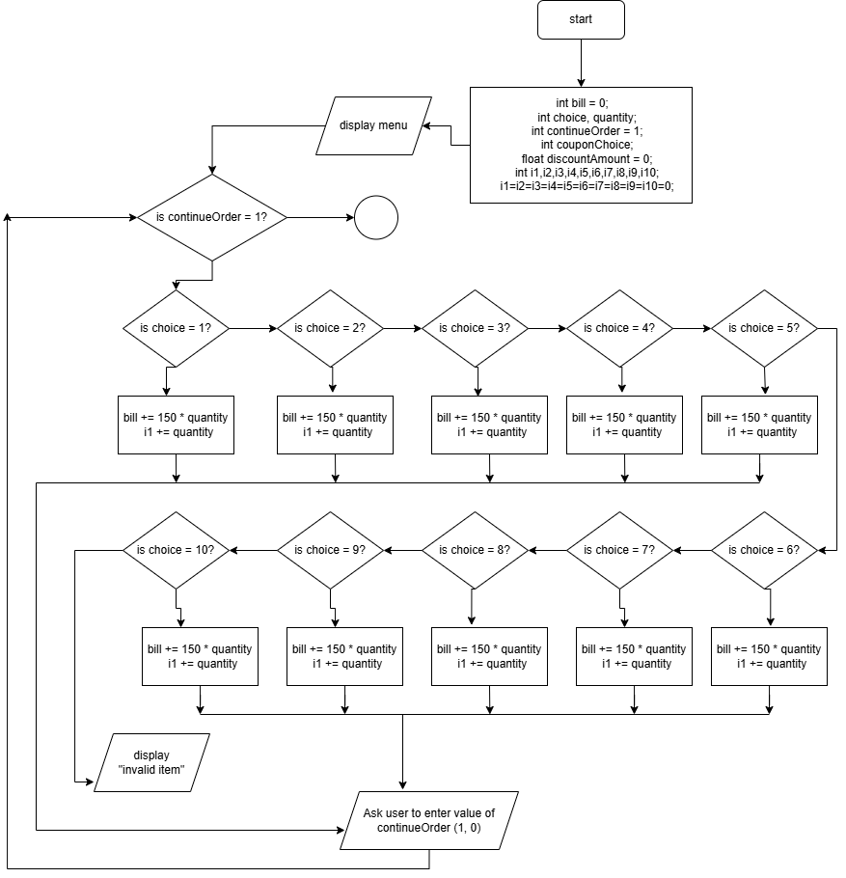
Flowchart

