SPY
Seb-motivated, enthusiastic, resuE-oriented young'pe on is:wilIing to discuss the p.așrôon of a Video/Åudio.editor. The opportońity pręsented is vęry ąppeahng as'Ît afÏows me.to broaden my careęr horizops and reveal my creątİye spirit. My.unčanny interest and..expęrIen«e Ìń;audïõ.and vidęo editing, sÏ'rong desipe'tq connect m'y Murę prôfesșrón with creative'fiéid and:en’tirę pasșion to.bush iu'p my' k'noŃÌedge motrvałe me tq..apply. I believe thg(' my abiłity to taçkłe hard
,tasks, ftéxiõilty and dëõi«ä'Ïion to tłi'e'wóik I do make rńe'a suitąblë čandidatë four tŁiis,poşiŁion'.

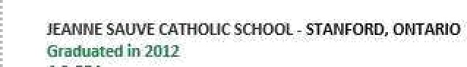

- Strang interpe'Fsg'naî Skills
- ..Excellent:comrnunÏcëtion s1‹ïłîș

- Deta‹ł örİemed
- Great probIęm-siting ability
  - M5 OfFæe Suite
  - Adobë.Premiere 9ro Œ
  - Adobe Auüition CC
  - Adobë.Premiere Clip.'
- Cœatìve anõ inno atșe'ŁhtnŸtng
- Perfea decision-making skills
- Ability.to Kprk.in a.țeam
- FîexiõÌłity
a Seri-motivared

- Cared \/ideoSttiôio.
- FL 5tudio-12:1:2
- Apple iMõvie
- Audio Mixer


