1. To find Largest of Three Numbers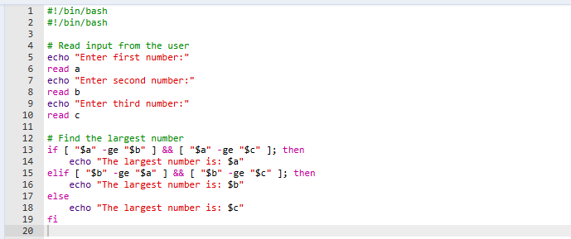

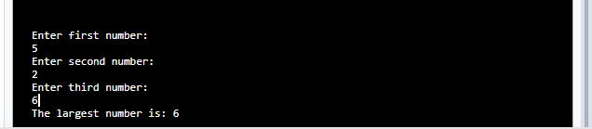

1. To find a year is leap year or not

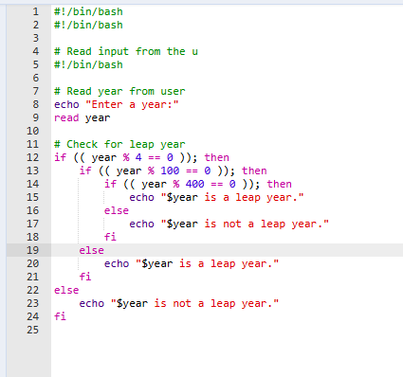

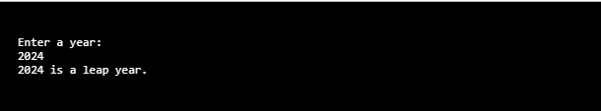

1. To input angles of a triangle and find out whether it is valid triangle or not

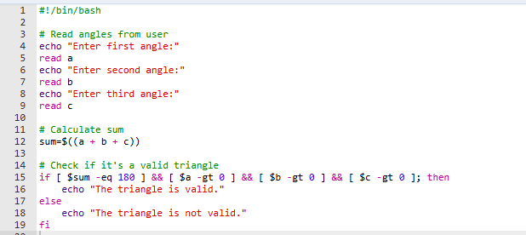

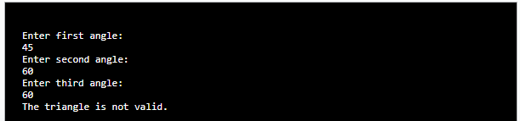

4. To check whether a character is alphabet, digit or special character.

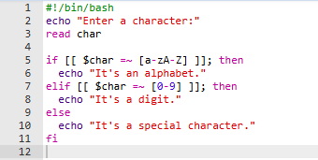

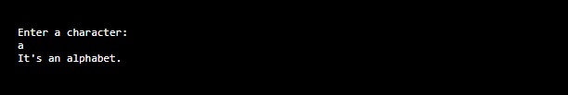

5.To calculate profit or loss

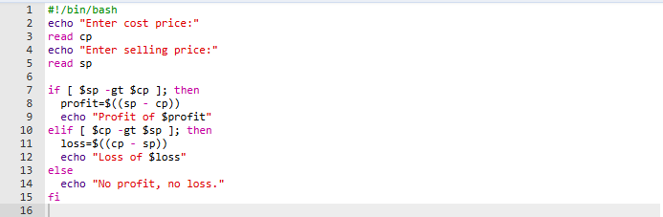

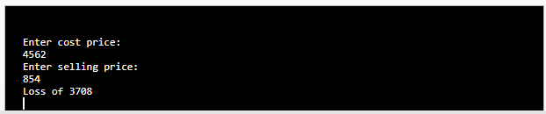

1. To print all even and odd number from 1 to 10

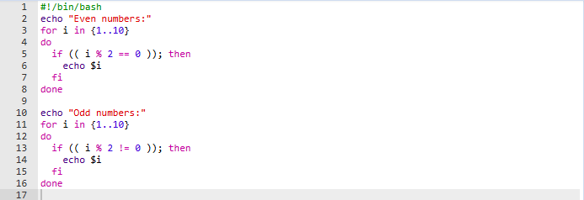

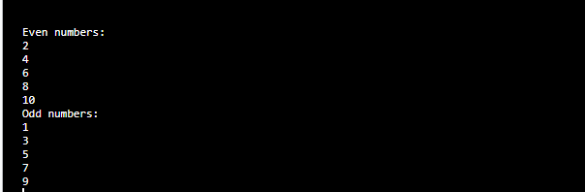

1. To print table of a given number

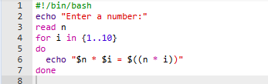

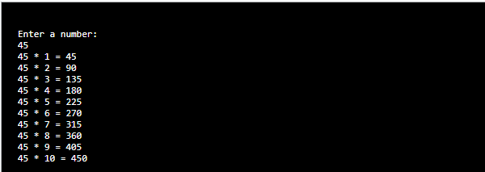

1. To find factorial of a given integer

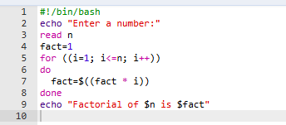

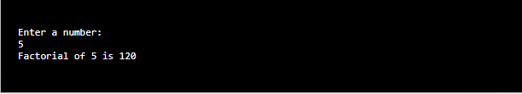

1. To print sum of all even numbers from 1 to 10.

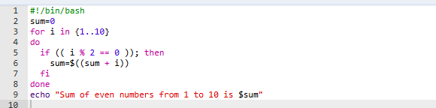

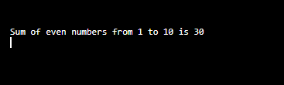

1. To print sum of digit of any number.

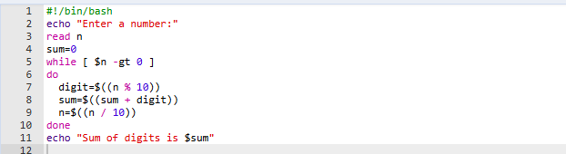

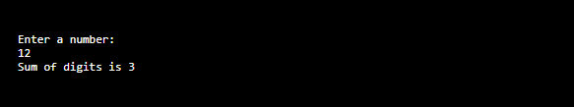

1. To make a basic calculator which performs addition, subtraction, Multiplication, division

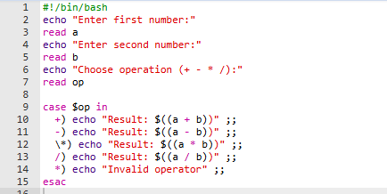

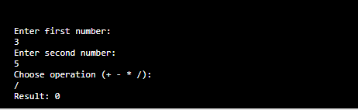

1. To print days of a week

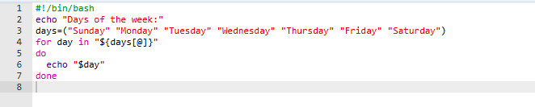

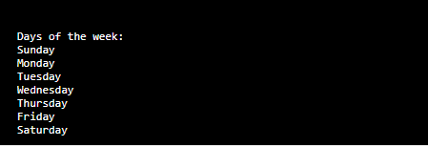

1. To print starting 4 months having 31 days.

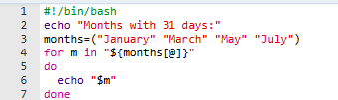

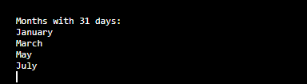

14. Using functions,

a. To find given number is Amstrong number or not

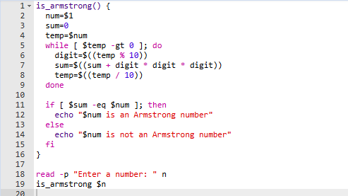

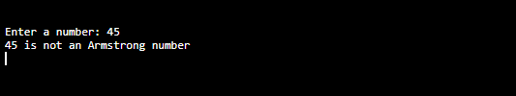

b. To find whether a number is palindrome or not

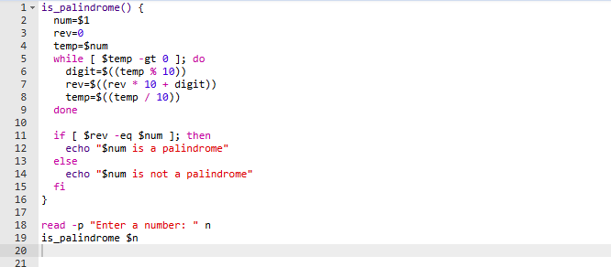

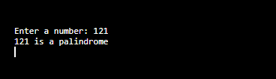

c. To print Fibonacci series upto n terms

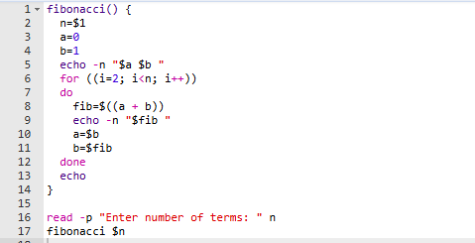

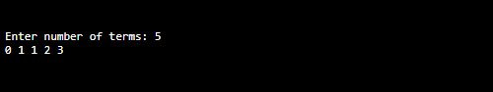

d. To find given number is prime or composite

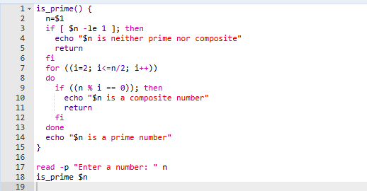

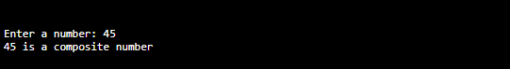

e. To convert a given decimal number to binary equivalent

