**Lab Sheet – 2**

**1. Write a C program to prompt the user to input three integer values and print these values in forward and reversed order.**

**2. Write a program to calculate compound interest.**

**3. Write a program to swap two variables values with and without using third variables**

**4. Write a program to print the size of char, float, double and long double data types in C**

**5. Write a program to check odd or even number (a) using modulus operator (b) using bitwise operator (c) without using bitwise and modulus operator (d) using conditional operator.**

**6. Write a program to calculate year, month and days of given days.**

**7. Write a program to take input your date of birth and calculate age.**

***Problem 1*: Write a C program to prompt the user to input three integer values and print these values in forward and reversed order.**

**Code:**

#include <stdio.h>

int main()

{

int a, b, c;

printf("Enter three integer number: ");

scanf("%d %d %d", &a, &b, &c);

printf("Forward order: %d %d %d\n", a, b, c);

printf("Revarsed order: %d %d %d\n", c, b, a);

return 0;

}

**Output:**

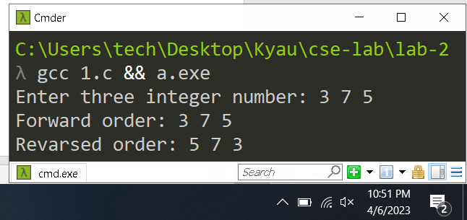

***Problem 2*: Write a program to calculate compound interest.**

**Code:**

#include <stdio.h>

#include <math.h>

int main()

{

float principle, rate, time, compount_interest;

printf("Enter the principle: ");

scanf("%f", &principle);

printf("Enter the rate of interest: ");

scanf("%f", &rate);

printf("Enter the time :");

scanf("%f", &time);

compount_interest = principle * pow((1 + rate / 100), time) - principle;

printf("\nThe compound interest is %0.3f", compount_interest);

return 0;

}

**Output:**

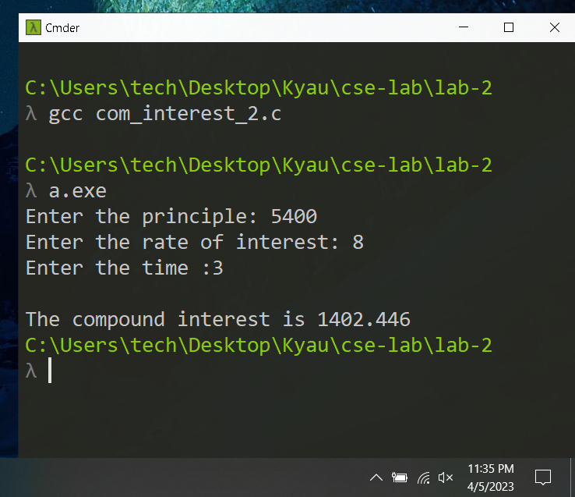

**Problem 3: Write a program to swap two variables values with and without using third variables**

**Code:**

#include <stdio.h>

int main()

{

int a = 10, b = 20;

printf("Before swap a=%d b=%d", a, b);

a = a + b;

b = a - b;

a = a - b;

printf("\nAfter swap a=%d b=%d", a, b);

return 0;

}

**Output:**

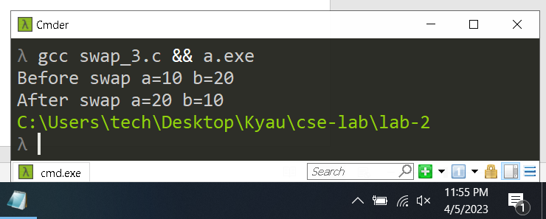

***Problem 4*: Write a program to print the size of char, float, double and long double data types in C**

**Code:**

#include <stdio.h>

int main()

{

printf("The size of char is = %d\n", sizeof(char));

printf("The size of float is = %d\n", sizeof(float));

printf("The size of double is = %d\n", sizeof(double));

printf("The size of long double is = %d\n", sizeof(long double));

return 0;

}

**Output:**

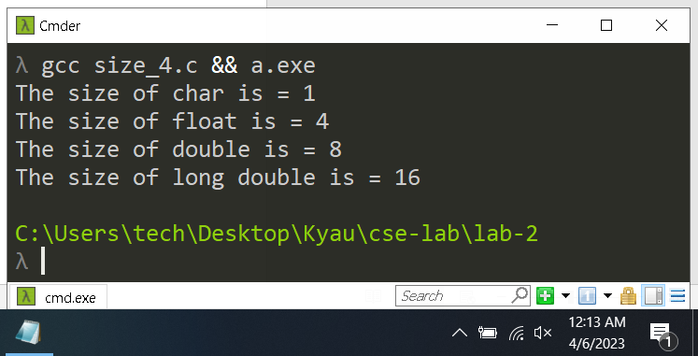

***Problem 5*: Write a program to check odd or even number (a) using modulus operator (b) using bitwise operator (c) without using bitwise and modulus operator (d) using conditional operator.**

**Answer (a ) ( using modulus operator )**

**Code:**

#include <stdio.h>

int main(){

int number;

printf("Enter a number to check even or odd: ");

scanf("%d", &number);

printf("\tUsing modulus operator\n");

if (number % 2 == 0)

printf("%d is a even number\n", number);

else

printf("%d is a odd number\n", number);

return 0;

}

**Output:**

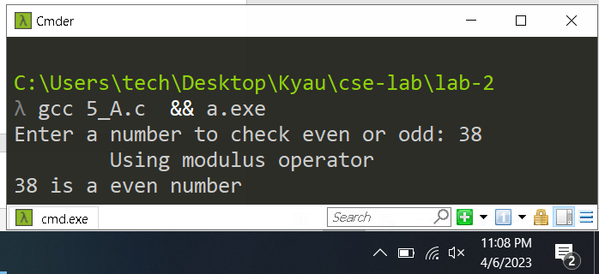

**Answer (b) ( using bitwise operator )**

**Code:**

#include <stdio.h>

int main(){

int number;

printf("Enter a number to check even or odd: ");

scanf("%d", &number);

printf("\tUsing Bitwise operator\n");

if ((number & 1) == 0)

printf("%d is a even number\n", number);

else

printf("%d is a odd number\n", number);

return 0;

}

**Output:**

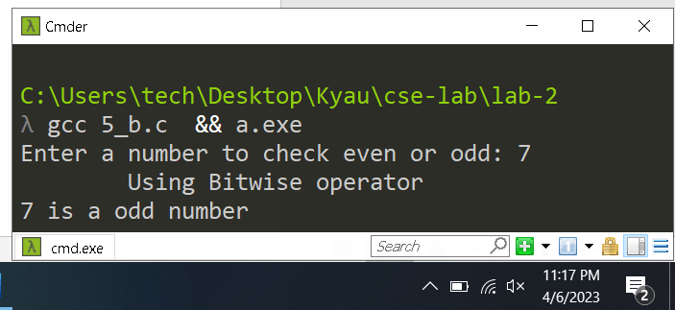

**Answer (b) (without using bitwise and modulus operator)**

**Code:**

#include <stdio.h>

int main(){

int number;

printf("Enter a number to check even or odd: ");

scanf("%d", &number);

printf("\twithout using bitwise and modulus operator\n");

if ((number / 2) * 2 == number)

printf("%d is a even number\n", number);

else

printf("%d is a odd number\n", number);

return 0;

}

**Output:**

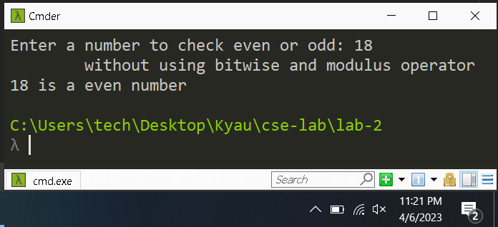

**Answer (d) (using conditional operator.)**

**Code:**

#include <stdio.h>

int main(){

int number;

printf("Enter a number to check even or odd: ");

scanf("%d", &number);

printf("\tusing conditional operator.\n");

number % 2 == 0 ? printf("%d is a even number\n", number) : printf("%d is a odd number\n", number);

return 0;

}

**Output:**

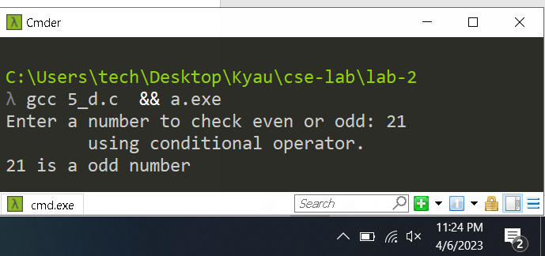

***Problem 6*: Write a program to calculate year, month and days of given days.**

**Code**:

#include <stdio.h>

int main()

{

int userInput, year, month, day;

printf("Enter a number: ");

scanf("%d", &userInput);

year = userInput / 365;

month = (userInput - year * 365) / 30;

day = (userInput - year * 365) - (month * 30);

printf(" Years: %d\n Month: %d\n Days: %d\n", year, month, day);

return 0;

}

**Output:**

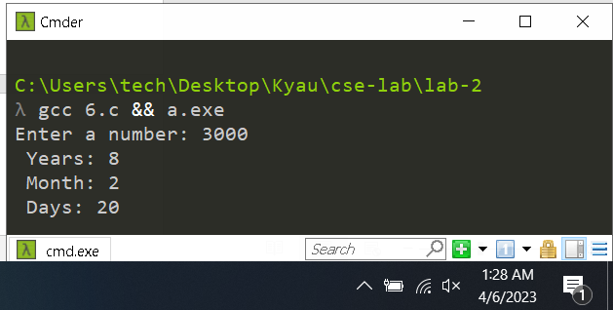

**7. Write a program to take input your date of birth and calculate age.**

**Code:**

#include <stdio.h>

// function to calculate current age

void age(int present_date, int present_month, int present_year, int birth_date, int birth_month, int birth_year) {

int month[] = { 31, 28, 31, 30, 31, 30, 31, 31, 30, 31, 30, 31 };

if (birth_date > present_date) {

present_date = present_date + month[birth_month - 1];

present_month = present_month - 1;

}

if (birth_month > present_month) {

present_year = present_year - 1;

present_month = present_month + 12;

}

int final_date = present_date - birth_date;

int final_month = present_month - birth_month;

int final_year = present_year - birth_year;

printf("\nPresent Age Years: %d Months: %d Days: %d", final_year, final_month, final_date);

}

// main function

int main() {

int present_date , present_month ,present_year;

int birth_date ,birth_month ,birth_year;

printf("Enter current Day/Month/Year: ");

scanf("%d %d %d" ,&present_date, &present_month, &present_year);

printf("Enter Birth Day/Month/Year: ");

scanf("%d %d %d" ,&birth_date, &birth_month, &birth_year);

age(present_date, present_month, present_year, birth_date, birth_month, birth_year);

return 0;

}

**Output:**

