**Lab Sheet – 3**

**1.** **Write a program to find the largest and smallest among three entered numbers and display whether the identified largest/smallest number is even or odd.**

**2. Write a program to check whether the entered year is leap year or not (a year is leap if it is divisible by 4 and divisible by 100 or 400.)**

**3. Write a program that asks a number and test the number whether it is multiple of 5 or not, divisible by 7 but not by eleven.**

**4. Write a program to read the values of coefficients a, b and c of a quadratic equation ax2+bx+c=0 and find roots of the equation.**

**Problem 1.** Write a program to find the largest and smallest among three entered numbers and display whether the identified largest/smallest number is even or odd.

**Code:**

#include <stdio.h>

int main(){

int x, y, z, max, min;

printf("Enter three number: ");

scanf("%d %d %d", &x, &y, &z);

**// Find Maximum Value**

if (x > y){

if (x > z){

max = x;

}else{

max = z;

}

}else{

if (y > z){

max = y;

}else{

max = z;

}

}

**// Find Minimum value**

if (x < y){

if (x < z){

min = x;

}else{

min = z;

}

}else{

if (y < z){

min = y;

}else{

min = z;

}

}

printf("\nMaximum value is: %d\nMinimum value is %d\n\n", max, min);

**// Check even or odd between max and min number**

max % 2 == 0 ? printf("Maximum value %d is even\n", max) : printf("Maximum value %d is odd\n", max);

min % 2 == 0 ? printf("Minimum value %d is even\n", min) : printf("Minimum value %d is odd\n", min);

return 0;

}

***Output:***

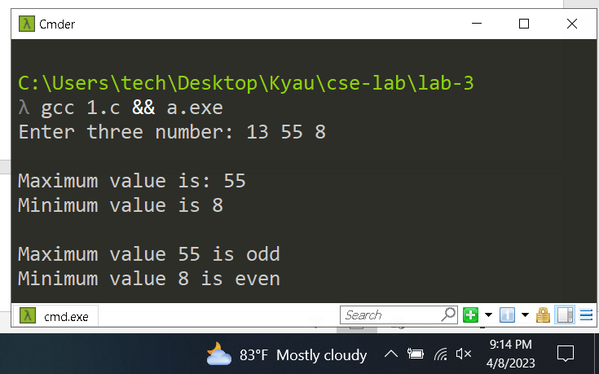

***Problem 2:*  Write a program to check whether the entered year is leap year or not (a year is leap if it is divisible by 4 and divisible by 100 or 400.)**

**Code:**

#include <stdio.h>

int main() {

int year;

printf("Enter a year: ");

scanf("%d", &year);

if(year % 400 == 0){

printf("%d is a leap year\n" , year);

}else{

if(year % 4 == 0 && year % 100 != 0){

printf("%d is a leap year\n" , year);

}else{

printf("%d is a not a leap year\n" , year);

}

}

return 0;

}

**Output:**

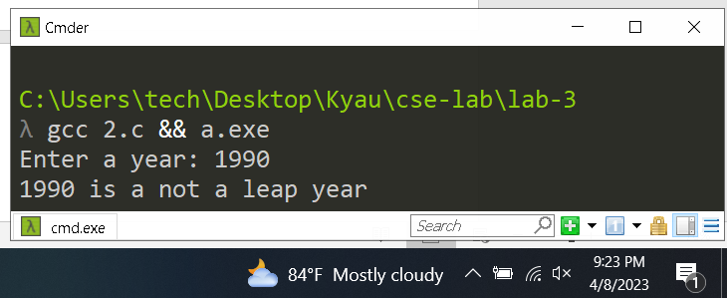

***Problem 3:* Write a program that asks a number and test the number whether it is multiple of 5 or not,** divisible **by 7 but not by eleven.**

**Code:**

**Output:**

***Problem 4:* Write a program to read the values of coefficients a, b and c of a quadratic equation ax2+bx+c=0 and find roots of the equation.**

**Code:**

#include<stdio.h>

#include<math.h>

int main(){

double a, b, c, discriminant, root1, root2, realPart, imaginePart;

printf("Enter coefficients a, b and c: ");

scanf("%lf %lf %lf", &a, &b, &c);

discriminant = (b * b) -( 4 * a * c);

if(discriminant > 0){

root1 = (-b + sqrt(discriminant)) / (2 * a);

root2 = (-b - sqrt(discriminant)) / (2 * a);

printf("root1 = %.2lf and root2 = %.2lf", root1, root2);

}else if(discriminant == 0) {

root1 = root2 = -b / (2 * a);

printf("root1 = root2 = %.2lf;", root1);

}else{

realPart = -b / (2 * a);

imaginePart = sqrt(-discriminant) / (2 * a);

printf("root1 = %.2lf+%.2lfi and root2 = %.2f-%.2fi", realPart, imaginePart, realPart, imaginePart);

}

return 0; }

**Output:**

