**Lab Sheet – 4**

**1**. **5+10+15+- - - - - - - - - +100**

**2. 1 + 2 + 4 + - - - - - - - - - + 1024**

**3. 1 + 4 + 9 + 16- - - - - - - - - + n^2**

**4. 1 ^3 + 2^3 + 3^ 3 + 4^3 + - - - - - - - - - + n^3**

**5. 1^ 3 + 3 ^3 + 5^ 3 + 7^3 + - - - - - - - - - + n^3**

**6. 1 + 2 ^2 + 3^ 3 + 4^4 + - - - - - - - - - + n^n**

**Problem 1**: **5+10+15+- - - - - - - - - +100**

**Code:**

#include <stdio.h>

int main(){

int n = 100, sum = 0;

for (int i = 5; i <= n; i += 5){

sum += i;

}

printf("Sum = %d\n", sum);

return 0;

}

**Output:**

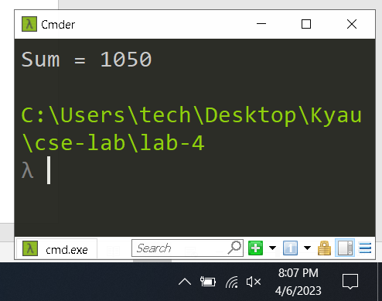

**Problem 2:** 1 + 2 + 4 + - - - - - - - - - + 1024

**Code:**

#include <stdio.h>

int main(){

int n = 1024, sum = 0;

for (int i = 1; i <= n; i *= 2){

sum += i;

} printf("Sum = %d\n", sum);

return 0;

}

**Output:**

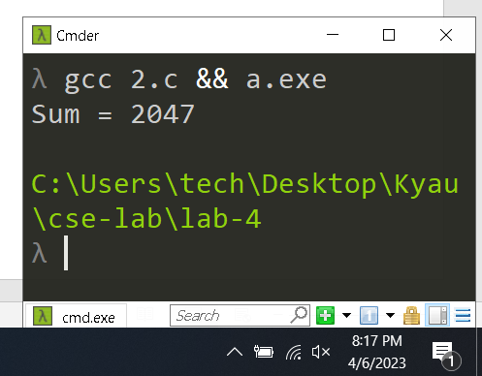

**Problem 3: 1 + 4 + 9 + 16- - - - - - - - - + n^2**

**Code:**

#include <stdio.h>

#include <math.h>

int main(){

int n, sum = 0;

printf("Enter a number: ");

scanf("%d", &n);

for (int i = 1; i <= n; i++){

sum += pow(i, 2);

}

printf("Sum = %d\n", sum);

return 0;

}

**Output:**

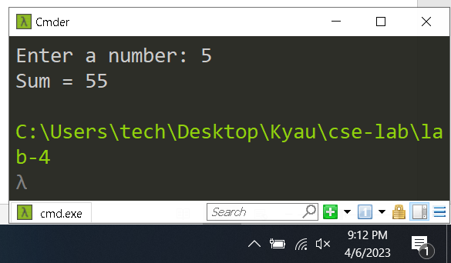

**Problem 4:** 1 ^3 + 2^3 + 3^ 3 + 4^3 + - - - - - - - - - + n^3

**Code:**

#include <stdio.h>

int main(){

int n, sum = 0;

printf("Enter a number: ");

scanf("%d", &n);

for (int i = 1; i <= n; i++){

sum += i * i * i;

}

printf("Sum = %d\n", sum);

return 0;

}

**Output:**

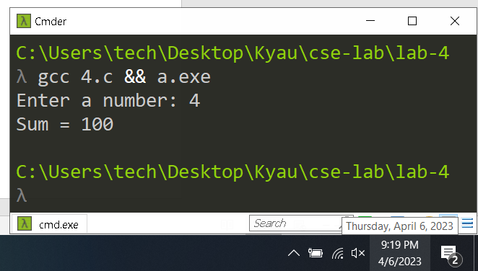

**Problem 5:** 1^ 3 + 3 ^3 + 5^ 3 + 7^3 + - - - - - - - - - + n^3

**Code:**

#include <stdio.h>

int main(){

int n, sum = 0;

printf("Enter a number: ");

scanf("%d", &n);

for (int i = 1; i <= n; i++){

if (i % 2 != 0)

sum += i * i * i;

}

printf("Sum = %d\n", sum);

return 0;

}

**Output:**

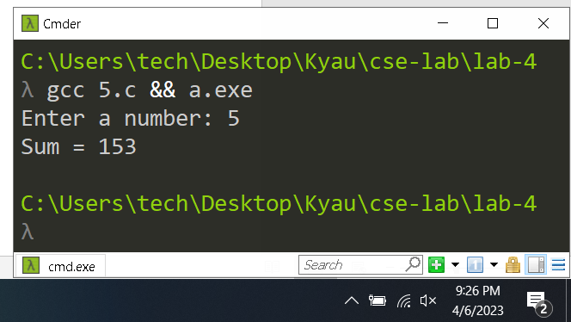

**Problem 6:** 1 + 2 ^2 + 3^ 3 + 4^4 + - - - - - - - - - + n^n

**Code:**

#include <stdio.h>

#include <math.h>

int main(){

int n;

long long int sum = 0;

printf("Enter a number: ");

scanf("%d", &n);

for (int i = 1; i <= n; i++){

sum += pow(i, i);

}

printf("Sum = %lld\n", sum);

return 0;

}

**Output:**

