

Excel Analytics Toolbar

Journal Entry Testing Guide

Think before you print me

This user guide has 125 pages. If you really want to print a copy for your reference, consider printing double-sided, 2 to a page, or using your printer’s ‘booklet printing’ setting. This guide has been paginated to be easy to read as an A5 document.



Contents

Introduction 3

What is the objective of journal entry testing? 3

How can the toolbar assist in the performance of journal entry testing? 3

What are some known limitations of the toolbar? 3

What journal entry information is needed from the client? 4

What is a cleansed data set? 5

STEP #1: Trial balance reconciliation and other integrity checks on journal entry data 7

Trial balance reconciliation 7

Other integrity checks 9

Entries with invalid dates 9

Entries with blank account numbers, descriptions, or user IDs 11

Entries that do not net to zero 12

STEP #2: Identifiying journal entries with fraud characteristics 13

Characteristic #1: Unrelated Accounts 14

Characteristic #2: Users Who Seldom Post Entries 17

Characteristic #3: Entries Containing Keywords of Audit Interest 20

Characteristic #4: Post Closing Journal Entries with Short Descriptions 22

Characteristic #5: Back Dated and Pre Dated Entries 24

Characteristic #6: Income Statement Entries Posted Before Period End 25

Characteristic #7: Large Revenue Entries Reversed After Period End 29

Characteristic #8: Entries with Round Numbers or Recurring Ending Digits 32

Characteristic #9: Potential Duplicate Entries 33

Characteristic #10: Entries Posted on Holidays / Weekends 37

Characteristic #11: Seldom Used Accounts 38

STEP #3: Selecting journal entries to test 41

Appendix A 45

Keywords of Audit Interest for Journal Entry Characteristic #3 45

Appendix B 46

Pre-populate a list of keywords and holidays (Characteristics #3 and #10) 46

Appendix C 49

Analyzing Journal Entries by Quarter 49

Appendix D 51

Adding Trial Balance Grouping information to a Journal Entry Data Set 51

**Document History**

Version Additions/Modifications

May 2015 Updated Test #2, #9 and #11 for revised testing approach

November 2015 Updated for workarounds due to EA tools not operating as anticipated as a result of Microsoft Patch in September

February 2016 Workarounds no longer necessary

March 2017 Updated step #5 of characteristic #9 for removal of threshold criteria (i.e. criteria #2 and #3)

Modified *Step #3 Selecting Journal Entries to Test* to remove the suggestion that we only test journal entries exhibiting 3 or more characteristics of interest.

Introduction

## What is the objective of journal entry testing?

Canadian Auditing Standard 240 (“CAS 240”) requires us to perform journal entry testing as a response to the risk of management override of controls. It also describes some of the characteristics of fraudulent journal entries that may be relevant when identifying and selecting journal entries for testing. According to CAS 240 paragraph A43 *Inappropriate journal entries or other adjustments often have unique identifying characteristics. Such characteristics may include entries (a) made to unrelated, unusual, or seldom-used accounts, (b) made by individuals who typically do not make journal entries, (c) recorded at the end of the period or as post-closing entries that have little or no explanation or description, (d) made either before or during the preparation of the financial statements that do not have account numbers, or (e) containing round numbers or consistent ending numbers.*

**NOTE:** For audits performed in accordance with PCAOB standards (AU Section 316.61, *Consideration of Fraud in a Financial Statement Audit*), the characteristics of fraudulent entries or adjustments are same as CAS 240.A43, which are listed in the paragraph above.

These journal entry characteristics are examples of the characteristics of fraudulent journal entries, but it is up to the engagement team to determine whether all are relevant in their circumstances, and whether additional characteristics may also be relevant. Journal entry testing involves the exercise of substantial professional judgment that requires experience and knowledge of the entity; accordingly, it is important for the engagement partner and manager to be appropriately involved in the planning and execution of journal entry testing, especially the determination of the characteristics of interest and the judgmental selection of journal entries for further testing.

Once the engagement team has identified the characteristics that are relevant, Excel Analytics (“EA”) tools can analyze journal entry data to identify and extract the entries that have these characteristics for further testing.

## How can the toolbar assist in the performance of journal entry testing?

This guide describes how EA tools can be used to identify journal entries which have the common characteristics of fraudulent journal entries, and provides some instructions on how to use each EA tool. If you need further guidance on how to use a particular EA tool, please refer to the *User Guide* accessible through the *Analytics Help* icon in the EA toolbar.

## What are some known limitations of the toolbar?

Due to programming limitations, there is currently no undo button available for the EA toolbar. Therefore, it is recommended that practitioners save all data prior to running any EA tools in order to avoid loss of unsaved data.

Due to data size limitations, using the EA toolbar for journal entry testing is recommended for data sets with approximately 150,000 lines and less. If a journal entry report is larger than 150,000 lines, using the EA toolbar may not successfully run each of the tests. Consider your computer and its capacity – newer computers will be able to handle larger data sets, and run the journal entry tests faster. Consider the planned testing approach, including whether testing the data by quarter is more effective to reduce data size to a manageable size. The use of the EA toolbar is not recommended for data sets greater than 300,000 lines.

**NOTE:** As the data size increases, it may take longer to run the EA tools and general Excel functions. It is recommended to close other programs and other Excel workbooks when using the EA toolbar to perform journal entry testing.

## `What journal entry information is needed from the client?

Prior to asking for the journal entry data set from your client, here are some considerations:

* The journal entry data set should include at a minimum the following information needed to run the various journal entry tests (in addition to journal entry number and amount):

|  |  |  |  |  |  |  |  |
| --- | --- | --- | --- | --- | --- | --- | --- |
| **Characteristic** | **Required Data** | | | | | | |
| **Entry Description** | **Effective Date** | **Posted Date** | **User ID** | **GL Account #** | **Financial Statement Line** | **JE Data for month after period-end** |
| #1 – Unrelated Accounts |  |  |  |  | X | X |  |
| #2 – Users Who Seldom Post Entries |  |  |  | X |  |  |  |
| #3 – Entries Containing Keywords of Audit Interest | X |  |  |  |  |  |  |
| #4 – Post Closing Journal Entries with Short Descriptions | X |  | X |  |  |  |  |
| #5 – Back Dated and Pre-Dated Entries |  | X | X |  |  |  |  |
| #6 – Income Statement Entries Posted Before Period End |  |  | X |  | X | X |  |
| #7 – Large Revenue Entries Reversed After Period End |  |  | X |  | X | X | X |
| #8 – Entries with Round Numbers or Recurring Digits | Not applicable. | | | | | | |
| #9 – Potential Duplicate Entries |  | X |  |  | X |  |  |
| #10 – Entries Posted on Holidays / Weekends |  |  | X |  |  |  |  |
| #11 – Seldom Used Accounts |  | X |  |  | X |  |  |

* Consider whether you would like the journal entry data set to distinguish between standard and non-standard entries. You may want to consider only non-standard entries for certain characteristics (e.g. often there is a fraud risk with non-standard entries posted on weekends but not standard entries).
* If your client does business in more than one currency, determine whether any conversion is needed to have consistency in the data prior to running the journal entry tests.
* Obtain your client’s holiday calendar so that you can accurately set the parameters when testing for entries posted on holidays.

## What is a cleansed data set?

Before performing any type of data analysis, it is important that you have cleansed data. Throughout the guide there are references to cleansed data, which is defined by the following factors:

* A single rectangular block of data on the worksheet (do not leave a blank row between the header and the data);
* A single header row (in row 1);
* No missing headers (blank cells in row 1);
* No blank rows or columns;
* No total rows or columns;
* No empty cells;
* Dates formatted as dates and numbers formatted as numbers;
* Numerical or date columns only containing one type of data (i.e. no text values).

For a walkthrough on cleaning a data set, refer to the [G240e Introduction to Excel Analytics](https://dlpdelc.deloitteresources.com/content.aspx?src=delus&vdr=saba&crscode=01057778) e-learning course.

C:\Users\aabrosimova\AppData\Local\Microsoft\Windows\Temporary Internet Files\Content.Outlook\2AY34UU1\tips (2).pngTo check that the data set is cleansed before performing data analysis, you can use the Sheet Checker  
() tool. Selecting any tool will also run the Sheet Checker by default before loading the selected tool.

C:\Users\aabrosimova\AppData\Local\Microsoft\Windows\Temporary Internet Files\Content.Outlook\2AY34UU1\tips (2).png

Some of the journal entry tests below analyze debits or credits specifically; therefore, it is recommended that practitioners format their amount column to show debits as positive numbers and credits as negative numbers. Practitioners should consider using the Negative to Positive () tool, which converts negative numbers to positive numbers and vice versa. For example, if the data set is similar to that shown below, perform the following steps:

* 1.  Use the Filter tool to filter the ‘DR/CR’ column in the journal entry data set. Select the Filter tool and then “Sort A to Z”. Ensure that the dropdown box appears on all columns, so that the data will keep the row information intact as it is filtered.

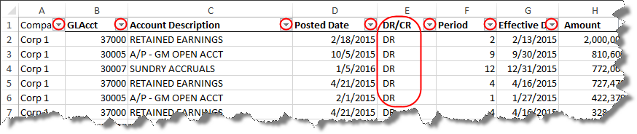

* 1. The credits will be visible at the top of your data set. Highlight the cells in the Amount column for all the related ‘CR’ and run the Negative to Positive () tool.
  2. Sum the column to check that the report nets to 0. Investigate any differences.

C:\Users\aabrosimova\AppData\Local\Microsoft\Windows\Temporary Internet Files\Content.Outlook\2AY34UU1\tips (2).png

Consider reviewingthe data set for nil entries (entries where both the credits and the debits are nil) and removing them from the journal entry data set prior to running tests. These entries could impact the accuracy of your analysis. For example, consider when we look for entries posted by individuals who seldom post entries. A data set with numerous nil entries will overstate the number of entries posted by a certain individual, as Characteristic #2 below does not consider the journal entry amount.

STEP #1: Trial balance reconciliation and other integrity checks on journal entry data

Prior to running any journal entry tests, engagement teams should run integrity checks on their data set. The material below walks through how the Excel Analytics toolbar can be used to perform a trial balance reconciliation and other integrity tests.

## Trial balance reconciliation

Performing integrity checks on the journal entry data is critical to ensure that the journal entry report is complete and that it reconciles the opening trial balance to the closing trial balance. The completeness of the journal entry data should be confirmed before proceeding with the other integrity checks and journal entry tests. In order to check that the entries in the journal entry report reconcile the opening trial balance to the closing trial balance, perform the following steps:

1.  Summarize > Advanced Summary
   1. For the “Column to Summarize”, select the journal entry amount column.
   2. For “Group items”, *Group by* the G/L account number. Select whether results should be ascending or descending order.
   3. Select “Summary output”.

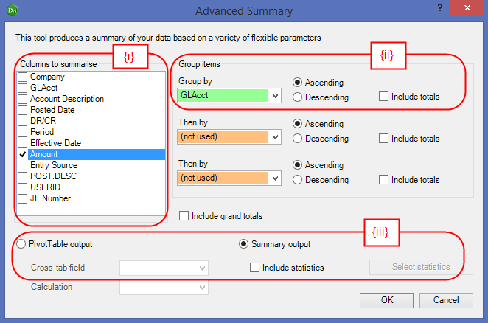

* 1. A summary table will be produced in a new tab with G/L account numbers and the total dollar amount of journal entries that hit each G/L account. The worksheet is automatically named “Advanced Summary”.

1.  Manage Sheets > Join 2 Sheets
   1. Select the *Workbook* and *Worksheet* of the respective data. *Matching Column* = G/L Account Number column. To set-up the trial balance reconciliation appropriately, ensure sheet “**1**” is the opening trial balance data.

**NOTE:** In order to see the columns in (ii) below, ensure the opening trial balance data has been cleansed. Refer to *What is a Cleansed Data Set?* in the Introduction.

* 1. Select the columns to be imported. It is recommended to include only the “Amount Total” for sheet **“2”** (from the “Advanced Summary” worksheet).
  2. Select all boxes.Do not select ‘Use Levenshtein fuzzy matching’.

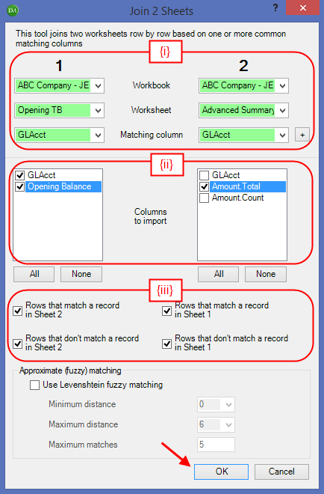

* 1. Click “OK”. A new worksheet is created, which is called “Joined”.
  2. Reperform steps (i) – (iv) using *Sheet* ***“1”*** = “Joined” and *Sheet* ***“2”*** = closing trial balance data.
  3. Rename the output sheet to “TB Reconciliation”
  4. Insert a column between “Amount.Total” and “Closing Balance”. Label the column “Calculated Closing Balance”. In the first cell, D5, add the following formula: = B5 + C5, where B5 represents the column containing the opening balance, and C5 is the cell containing the “Amount.Total” (total dollar amount of journal entries). Copy the formula to all cells in the column.
  5. Insert a column at the end. Label the column “Difference”. In the first cell, F5, add the following formula: = D5 - E5, where D5 represents the column containing the “Calculated Closing Balance” (created in step (vii) above), and E5 is the cell containing the closing balance. Copy the formula to all cells in the column.

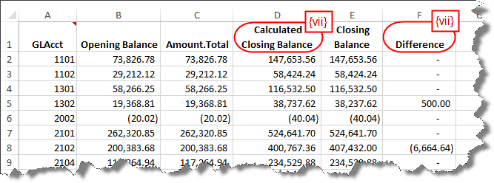

**NOTE:** Engagement teams should investigate any differences that are greater than a clearly trivial amount prior to running any journal entry tests in the next section, *Identifying journal entries with fraud characteristics.*

## Other integrity checks

In addition, there are several integrity characteristics of journal entries that should be considered:

### Entries with invalid dates

* 1.  Select the column that represents the effective date of the journal entry. Use the Filter tool to display only those entries occurring in a year / month outside of the fiscal year. Ensure that the dropdown box appears on all columns, so that the data will keep the row information intact as it is filtered.

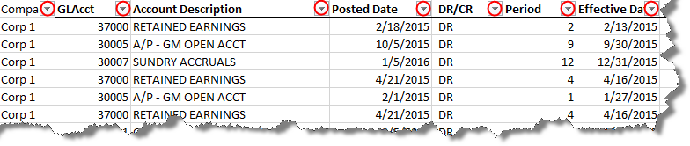

For example, if the client’s year-end is December 31 2015. Select the dropdown arrow for effective date and select the month of December 2015.

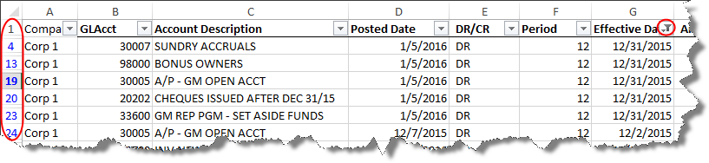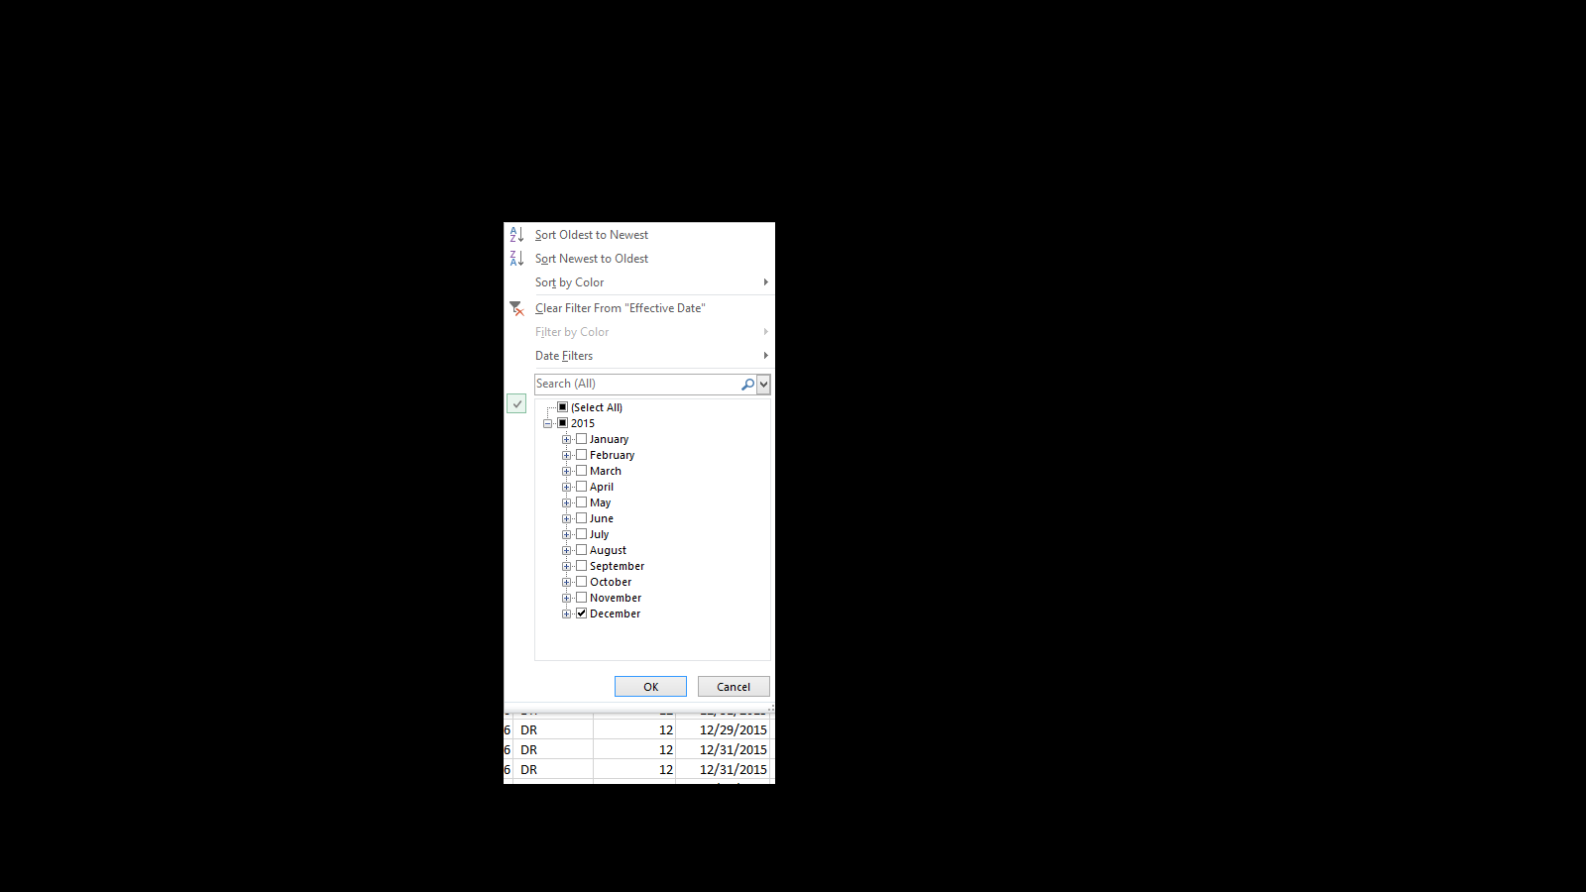

**NOTE:** When data is filtered, the row numbers will appear in blue, which are the original row numbers of the data set prior to applying the filter. In addition, this filter symbol  will appear on the column that has been filtered.

* 1. Use the Extract Visible Cells tool to copy the filtered journal entries to a new worksheet. This worksheet may be used to facilitate discussions with management to resolve any integrity issues prior to running the journal entry tests in the next section of this Guide.

### Entries with blank account numbers, descriptions, or user IDs

* 1.  Extract Data > Exception Report
  + Use the following criteria when running this tool:
    - Criteria 1 – *Column* = column containing account numbers; *Action* = “Is blank”; **OR**
    - Criteria 2 – *Column* = column containing journal entry description; *Action* = “Is blank”; **OR**
    - Criteria 3 – *Column* = column containing user IDs; *Action* = “Is blank”.

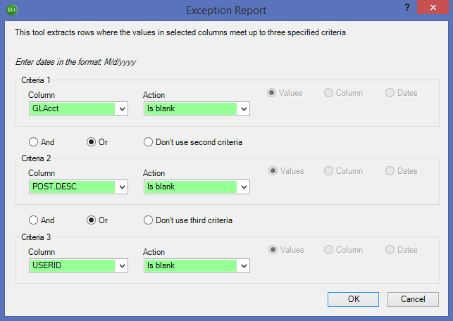

**NOTE:** This tool has a capacity for three criteria only. If an engagement team determines that there are additional parameters to test integrity, simply re-run this tool again with the new parameters.

* + An Extraction Report and Extraction WK will be created on two new worksheets.
    - The Extraction Report is a listing all of the journal entries meeting the criteria selected (four columns are added to the end sheet). This report will only be generated if the criteria are met, so in this case: Criteria 1 OR Criteria 2 OR Criteria 3. This worksheet may be used to facilitate discussions with management to resolve any integrity issues prior to running further journal entry tests in the next section of this Guide.
    - The Extraction WK is the entire journal entry list with the four columns added to the end, showing what entries matched what criteria individually. This sheet is not needed for the resolution of any journal entry integrity issues and may be deleted.

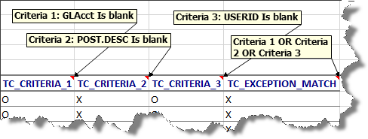

### Entries that do not net to zero

1.  Use the Summarize > Quick Summary to summarize the journal entry amount column for each journal entry number. This will create a pivot table on a new worksheet.

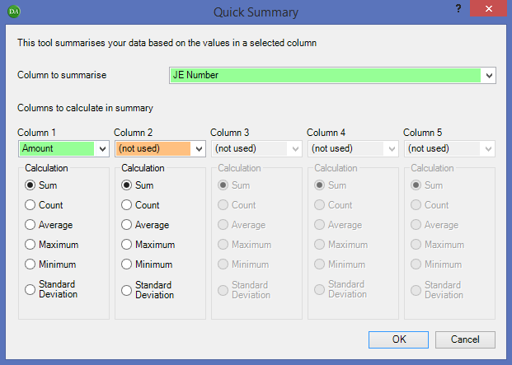

1. Filter the pivot table for amounts in the total column that are not equal to zero.
2. Double click on the totals in the filtered pivot table to view the unbalanced journal entries. This list may be used to facilitate discussions with management to resolve any integrity issues prior to running further journal entry tests in the next section of this Guide.

STEP #2: Identifiying journal entries with fraud characteristics

The EA toolbar can help you to identify journal entries that have certain characteristics that may be indicative of fraudulent journal entries. Engagement teams will need to analyze the journal entry listing for each characteristic individually. The output of the analysis will be a workbook with multiple worksheets each listing the journal entries that exhibit a certain characteristic.

Engagement teams will then need to create a consolidated list of the journal entries and the characteristics that they exhibit, refer to the Selecting journal entries to test section below for further details. It will be up to the engagement team to determine the journal entries that will be selected for further testing out of this profiled population. The number of journal entries selected for testing is a matter of professional judgment and may be influenced by several factors including the number of entries demonstrating characteristics of interest and the number of characteristics exhibited by each journal entry.

For additional journal entry testing guidance, refer to the [Technical Library – Alerts, Guides, and Tools](https://techlib.deloitte.com/default.aspx?view=content&id=0901ff818166a6dd):

* [Journal Entry Testing to Address the Risk of Management Override of Controls Guide [PUB]](https://techlib.deloitte.com/default.aspx?view=content&id=0901ff81816798ca)
* [Journal Entry Testing to Address the Risk of Management Override of Controls [PUB] – Q&A’s (08_2015)](https://techlib.deloitte.com/default.aspx?view=content&id=0901ff81816798cb)
* [Journal Entry Testing to Address the Risk of Management Override of Controls Guide [PRIV]](https://techlib.deloitte.com/default.aspx?view=content&id=0901ff818167a03b)
* [Audit Alert 2012-08: Journal Entry Testing to Address the Risk of Management Override of Controls (July 2015)](https://techlib.deloitte.com/default.aspx?view=content&id=0901ff818158ae5d" \o "Audit Alert 2012-08)

**When performing the tests, the engagement team will be selecting and entering the parameters for each test.** All tests below are based on journal entry lines, unless otherwise specified.

**Engagement Teams need to ensure that there is appropriate audit documentation of the tools used and the parameters selected for each test.** Engagement teams are encouraged to use the following documentation template, which can be found in the Technical Library:

* [21330 Test of Journal Entries and Other Adjustments [PRIV] (05_2015)](https://techlib.deloitte.com/default.aspx?view=content&id=0901ff81807c5a25)
* [21340 Journal Entry Testing – Excel Analytics Documentation Template [PUB] (05_2015)](https://techlib.deloitte.com/default.aspx?view=content&id=0901ff8180f842fb)

**NOTE:** If the engagement team has planned an approach to analyze journal entries on a quarterly basis, refer to Appendix C for guidance on separating the journal entry population by quarter.

## Characteristic #1: Unrelated Accounts

Entries exhibiting this characteristic are booked to unrelated accounts. Below are some standard account combinations that are not normally expected within a single journal entry. Engagement teams should assess whether any modifications are needed for their circumstances.

* Any credits to revenue and debits to anything on the balance sheet other than cash, accounts receivable, deferred revenue (or accrued expenses, if deferred revenues are included in accrued expenses), or customer (security) deposit.; and
* Any credits to cost of sales, with corresponding debits to any long-term assets, liabilities or equity.

**NOTE:** Before proceeding, practitioners will need to understand how the general ledger accounts are grouped for financial statement purposes. If the journal entry data set does not include a column indicating the financial statement line, consider using the process outlined in Appendix D to add this information to the data set based on the trial balance groupings in our audit file.

Suggested method to identify journal entries exhibiting this characteristic:

1. First we will need to isolate the credits to revenue.
   1. Use the Filter Tool to filter the “DRCR column” to show only CR.

**NOTE:** If the data set does not have a DRCR column, engagement teams can run  Extract Data > Exception Report using the following criteria:

Criteria 1 – *Column* = “Amount”; *Action* = “is less than” 0.

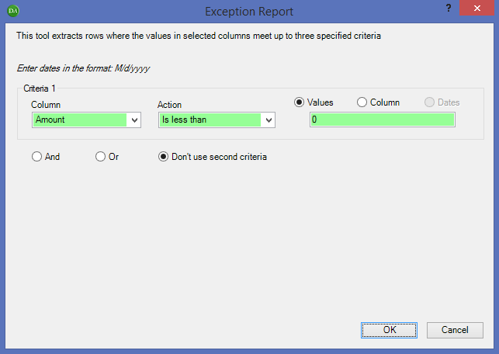

An Extraction Report and an Extraction WK will be created on two new worksheets. The Extraction Report is a listing of all of the journal entries meeting the criteria specified. Use this Extraction report and proceed to the next step.

* 1. Use the Filter Tool to filter the “financial statement line” or “trial balance grouping” column to show only revenue. You will now only see journal entry lines with CR booked to revenue accounts.

1. Extract Visible Cells on the filtered worksheet.

**NOTE:** If the data contains formulas, the following pop-up box will appear (below). Select “Paste raw data”. “Paste raw data” will return the data as is; formulas will be kept intact. Whereas, “Paste values” will return the data as hardcoded numbers/text.

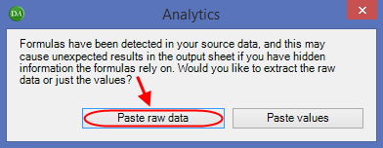

1. Rename the new tab “Step #1”.
2. Next, we will need to isolate the debits to the balance sheet accounts other than cash, accounts receivable, deferred revenue (or account expense, if deferred revenues are buried in accrued expenses), or customer (security) deposit.
   1. Use the Filter Tool to filter the “DRCR column” to show only DR. If the data set does not have DRCR column, engagement teams can run  Extract Data > Exception Report as noted in Step (1)i. above, and extract rows where the amount is greater than 0.
   2. Use the Filter Tool to filter the “financial statement line” or “trial balance grouping” column to show only the following: investments, inventories, prepaids, fixed assets, intangibles and other long term assets, accounts payable, other current liabilities, notes payable or long term debt.
3. Extract Visible Cells on the filtered worksheet.

**NOTE:** If the data contains formulas, the following pop-up box will appear (below). Select “Paste raw data”. “Paste raw data” will return the data as is; formulas will be kept intact. Whereas, “Paste values” will return the data as hardcoded numbers/text.



1. Rename the new tab “Step #2”.
2.  Use the Manage Sheets > Join 2 Sheets tool to join the credits to revenue (“Step #1” worksheet) and debits to the balance sheet for certain accounts (“Step #2” worksheet). Select the journal entry number as the “matching column” and select the “columns to import”, ensuring that JENumber column is selected.
3. Uncheck the box for “Rows that don’t match a record”, see the red circle below.
4. Do not select ‘Use Levenshtein fuzzy matching’.

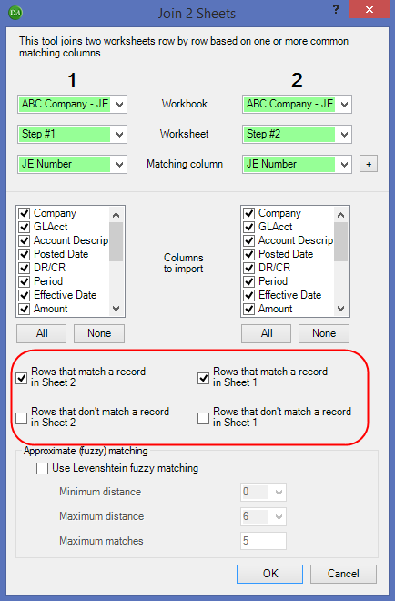

1. A new worksheet titled “Joined” will be created listing the unique journal entries booked in the period meeting the criteria laid out above. Rename the worksheet “Test #1a”, which will be the worksheet used in the Selecting journal entries to test section below.
2. Repeat steps (1) – (3) for any credits to cost of sales, with corresponding debits to any long-term assets or liabilities or equity. When filtering in step (2)(ii) filter for the following: fixed assets, intangibles and other long-term assets, notes payable or long-term debt, other long-term liabilities, and equity. Rename the “Joined” worksheet, in step (3)(iii), “Test #1b”, which will be the worksheet used in the Selecting journal entries to test section below.
3. Remove any filters to the original journal entry listing before moving on to the next Fraud Characteristic Test.

## Characteristic #2: Users Who Seldom Post Entries

Entries exhibiting this characteristic are booked by users with less than X total entries booked in a selected period.

**NOTE**: If the journal entry data set has more than one User ID associated with an individual journal entry number (i.e. different User ID’s for different journal entry line items within one journal entry), you may need to revise the process outlined below. Step (1)(ii) matches each unique journal entry number with the first corresponding User ID. All other User ID’s attached to that journal entry number will be ignored.

Suggested method to identify journal entries exhibiting this characteristic:

* First, create a list of unique journal entry numbers along with the corresponding User ID representing the employee who posted the journal entry.
  1. Select the journal entry number column and copy it into the first column of a new worksheet. Rename the worksheet “Unique JE #”. Sort this column and eliminate any duplicates.
     + To eliminate duplicates, highlight the column and use the Remove Duplicates on the Excel Data Ribbon.



* 1.  Use the Manage Sheets > Join 2 Sheets tool to join the “Unique JE #” worksheet with the User ID information from the original journal entry data. Select the journal entry number as the “matching column” and the User ID as the “column to import”.
     + Select all boxes, except “Rows that don’t match a record in sheet 1” under sheet **“2”.** Also, do not select ‘Use Levenshtein fuzzy matching’.

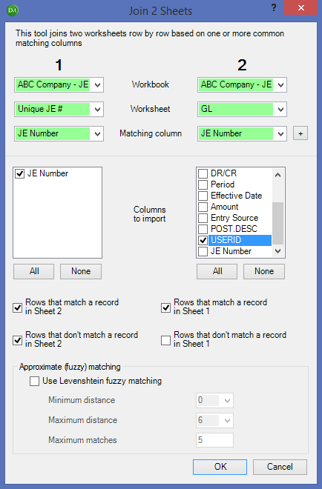

A new worksheet titled “Joined” will be created listing the unique journal entries booked in the period, as well as the user ID of the individual who posted the entry. Rename the worksheet “Joined JE# & User ID”.

1.  Use the Summarize > Advanced Summary tool to count the number of times a user posts a journal entry each period.
2. For the “Column to Summarize”, select the User ID column.
3. For “Group items”, Group by the User ID. Select whether results should be ascending or descending order.
4. Select “Summary output” and check “Include statistics”. Click the “Select Statistics” button and ensure that “Count” is checked.

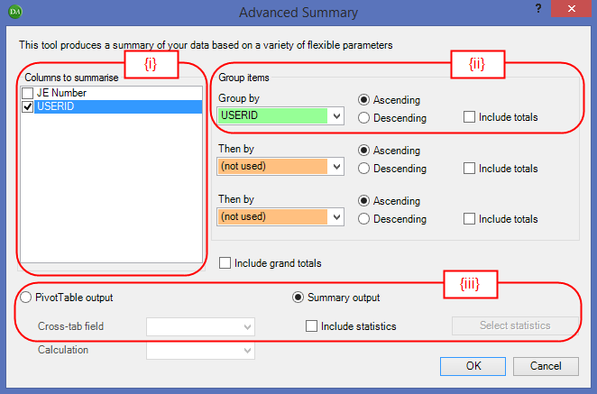

A summary table will be produced in a new tab with User IDs and the total count of User IDs. The worksheet is automatically named “Advanced Summary”.

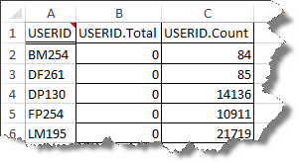

1.  Use the Manage Sheets > Join 2 Sheets tool to join the “Joined JE# & User ID” worksheet (created in (1) above) with the User ID information in the “Advanced Summary” tab (created in (2) above).
2. Select the User ID as the “matching column” and the User ID.Count column as the “column to import” under sheet **“2”.**
3. Select all boxes, except “Rows that don’t match a record in sheet 1” under sheet “2”. Also, do not select ‘Use Levenshtein fuzzy matching’.
4. Click “OK”. A new worksheet titled “Joined” will be created listing each JE Number, User ID, as well as the number of times the User ID was used to post a journal entry.
5. Use the Filter Tool to filter the “Count” column to show only User ID’s that occur a certain amount of times in the journal entry listing (<10 times in the example below).

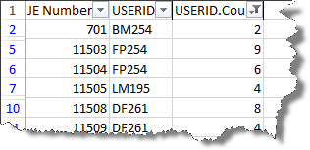

The result is a filtered journal entry listing showing all entries booked by individuals who post less than X journal entries in the period (<10 journal entries in this example).

1. Extract Visible Cells on the filtered worksheet, step (4) above.

**NOTE:** If the data contains formulas, the following pop-up box will appear (below). Select “Paste raw data”. “Paste raw data” will return the data as is; formulas will be kept intact. Whereas, “Paste values” will return the data as hardcoded numbers/text.



Rename the worksheet “Test #2”, which will be the worksheet used in the Selecting journal entries to test section below.

## Characteristic #3: Entries Containing Keywords of Audit Interest

Entries exhibiting this characteristic have keywords of potential audit interest in the journal entry description.

A list of standard keywords has been included in Appendix A. To pre-populate a list of key words of audit interest prior to running this tool, refer to Appendix B.

Suggested method to identify journal entries exhibiting this characteristic:

1.  Extract Data > Words and Phrases
   1. Select the journal entry description and/ journal entry line description columns as the *Range* in the “Source” section. Engagement teams may use the “…” button to select the range from the Excel worksheet or can highlight the column prior to running the tool (the range will be prepopulated once the radio button for “Range” is selected).
   2. Add words of interest. You can manually enter words and click ‘Add Word’ button. OR use a stored list (refer to Appendix B for guidance on creating a stored list). Click ‘Add a stored list’ button and another window will pop up; select the relevant list for the engagement.

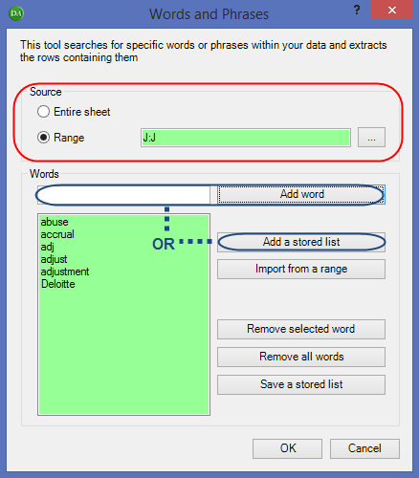

* 1. A new sheet will be created listing all the journal entries containing specific comments. The cells will be highlighted in red and two new columns created at the end of the document. The first column identifies the keywords that were found and the second column contains the original row in the data set.

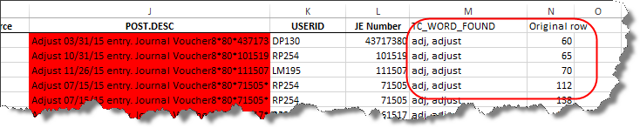

* 1. Rename the worksheet “Test #3”, which will be the worksheet used in the Selecting journal entries to test section below.

**NOTE:** Depending on the results, engagement teams may choose to modify the key words used and re-run the test. For example, in retail a client may have an upload for Debit Card Sales in the description, which would be flagged if ‘Debit’ was a keyword. Remember to document the rationale or judgment used in planning the journal entry testing.

## Characteristic #4: Post Closing Journal Entries with Short Descriptions

Entries exhibiting this characteristic have been posted more than X days after period end with a blank description or description less than Y characters**.** Note that in order to flag entries posted X days after the period end, client provided journal entry listing would be required to contain a column indicating the posting date and effective date for each entry.

Suggested method to identify journal entries exhibiting this characteristic:

1. Add two columns to the journal entry report, with a heading name of “# of Characters in Description” and “Difference from Period End”.
   1. **# of Characters in Description** Column - Use the following formula to populate the column: =LEN(M2) where M2 represents the journal entry description column. This formula returns the number of characters in a text string. To copy the formula for the entire column, select the cell and place your pointer at the bottom right corner. Your pointer will change to this symbol “**+**”, then double-click. This will copy the formula to the end of the data. Double check that your formula has been copied to the bottom. 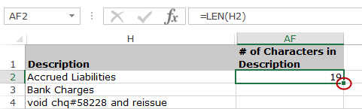

**NOTE:** If you end up with all rows with the same number of characters, you may be counting spaces. To correct this, you can use one of the toolbar’s formatting tools. Select the journal entry description column and use:

 Manipulate Text >  Remove leading and trailing spaces

* 1. **Difference from Period End** Column - Use the following formula to populate the column: = Cell containing the posting date – period end date.

1.  Extract Data > Exception Report
2. Use the following criteria when running the exception report:
   * + Criteria 1 – *Column* = # of Characters in Description (created in (1)(i) above); *Action* = “Is less than or equal to” a specific value (add the number of characters the engagement team has determined to be considered a short description), **AND**
     + Criteria 2 – *Column* = Difference from Period End (created in (1)(ii) above); *Action* = “Is greater than” X days (with X being the number of days after year end that the engagement team has determined to be of interest).

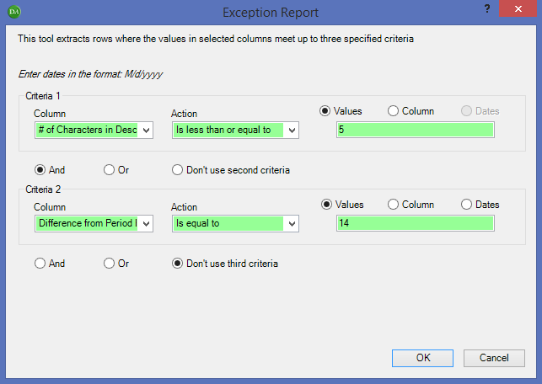

1. An Extraction Report and Extraction WK will be created on two new worksheets.
   * + The Extraction Report is a listing all of the journal entries meeting the criteria selected (three columns are added to the end sheet). This report will only be generated if the criteria are met, so in this case: Criteria 1 AND Criteria 2.
     + The Extraction WK is the entire journal entry list with the three columns added to the end, showing what entries matched what criteria individually. This sheet is not needed for the aggregation of journal entries and may be deleted.

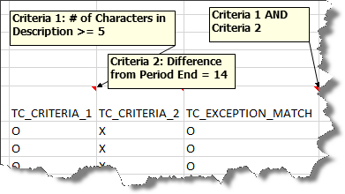

1. Rename the Extraction Report worksheet “Test #4”, which will be the worksheet used in the Selecting journal entries to test section below.
2. Remove any filters to the original journal entry listing before moving on to the next Fraud Characteristic Test.

**NOTE:** Depending on the client and data, engagement teams may wish to run additional tests on length of characters. In this example, the journal entry description column was checked. Other considerations may be line description or header description. Teams may add an additional criteria or re-run the test.

## Characteristic #5: Back Dated and Pre Dated Entries

Entries exhibiting this characteristic have been posted more than X number of days before or after the effective date of the journal entry.

Suggested method to identify journal entries exhibiting this characteristic:

1. Enter an Excel formula to calculate the difference between effective date and posting date for each journal entry:
   1. Create a new column, titled “Difference b/n Effective & Posting Date”. Type in Excel formula “= Cell reference containing effective date – Cell reference containing posting date”.

If the result is a positive number, it indicates that the entry was pre-dated. For example, posted date 1/1/2014, effective 3/31/2014.

If the result is a negative number, it indicates that the entry was back-dated. For example, posted date 10/15/2014, effective 9/30/2014.

1.  Extract Data > Exception Report
   1. Use the following criteria when running this tool:
      * Criteria 1 (to test for pre-dated entries)– *Column* = “Difference b/n Effective & Posting Date”; *Action* = “Is greater than” X days; **OR**
      * Criteria 2 (to test for back-dated entries) – Column = “Difference b/n Effective & Posting Date”; Action = “Is less than -X days. Make sure the value is entered as a negative number.

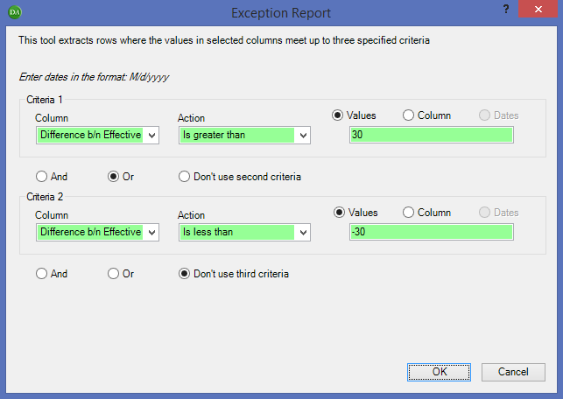

* 1. An Extraction Report and Extraction WK will be created on two new worksheets.
     + The Extraction Report is a listing all of the journal entries meeting the criteria selected (three columns are added to the end sheet). This report will only be generated if the criteria are met, so in this case: Criteria 1 OR Criteria 2.
     + The Extraction WK is the entire journal entry list with the three columns added to the end, showing what entries matched what criteria individually. This sheet is not needed for the aggregation of journal entries and may be deleted.

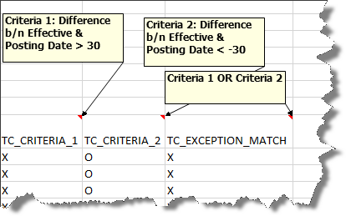

* 1. Rename the Extraction Report worksheet “Test #5”, which will be the worksheet used in the Selecting journal entries to test section below.

## Characteristic #6: Income Statement Entries Posted Before Period End

Entries exhibiting this characteristic are income statement entries with large credits (over X amount) posted within Y days of period end.

Suggested method to identify journal entries exhibiting this characteristic:

1. Filter the journal entry report for income statement accounts only. If the journal entry data set includes a column indicating the financial statement line, or you followed the process outlined in Appendix D to add a trial balance grouping column to the data set, either of these columns can be used.
2. Extract Visible Cells
   1. Use this tool to extract all entries posted to income statement accounts to another worksheet.

**NOTE:** If the data contains formulas, the following pop-up box will appear (below). Select “Paste raw data”. “Paste raw data” will return the data as is; formulas will be kept intact. Whereas, “Paste values” will return the data as hardcoded numbers/text.



This worksheet is not needed for the aggregation of journal entries and may be deleted once the remaining steps for Characteristic #6 have been completed.

**NOTE:** As an alternative to steps (1) and (2), engagement teams can isolate amounts booked to income statement accounts using an extraction report. In the example below the income statement account numbers are between 40000 and 69999.

* Run Extract Data > Exception Report using the following criteria: *Column* = Account Number; *Action* = “Is between” 40000 and 69999.

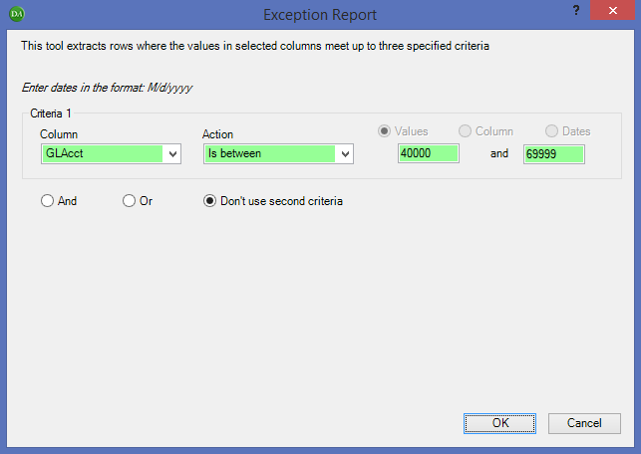

* If the account numbers are not being recognized appropriately when running the EA Tool (i.e. the following message pops up “No records matched your criteria, cannot create report” when you know there should be results), the data may need to be formatted. To correct for this, you can use one of the toolbar’s formatting tools. Select the journal entry account number column and use: Manipulate Text > Convert textnumbers to numbers**.**

1. Extract Data > Exception Report

**NOTE:** To perform this test, credits should appear as negative numbers in the journal entry data. If the data contains a column of positive numbers and a column to identify whether the amount is a DR or CR, refer to the Introduction for guidance on formatting the data.

* 1. Use the following criteria when using the Tool:
* Criteria 1 – *Column* = Journal entry amount column; *Action* = “Is less than” X value. Where X represents large negative numbers (credits to the income statement) based on the engagement team’s determined parameter. Make sure the value is entered as a negative number.; AND
* Criteria 2 – *Column* = Posting date; *Action* = “Is between” a date range. Enter a period that is prior to year end.

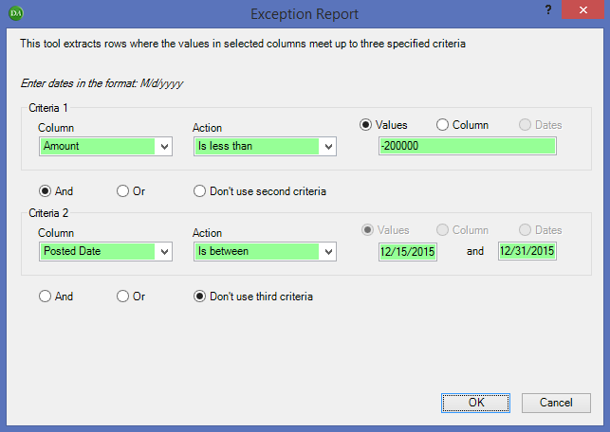

* 1. An Extraction Report and Extraction WK will be created on two new worksheets.
     + The Extraction Report is a listing all of the journal entries meeting the criteria selected (three columns are added to the end sheet). This report will only be generated if the criteria are met, so in this case: Criteria 1 AND Criteria 2.
     + The Extraction WK is the entire journal entry list with the three columns added to the end, showing what entries matched what criteria individually. This sheet is not needed for the aggregation of journal entries and may be deleted.

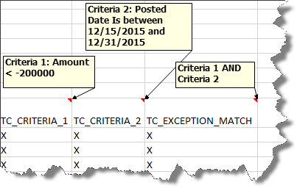

* 1. Rename the Extraction Report worksheet “Test #6”, which will be the worksheet used in the Selecting journal entries to test section below.

**NOTE:** If you need more than one range, for Criteria 2 (e.g. to identify entries posted within Y days of each period end) select *Action* = “Is equal to” a defined date range. When you select “Define Dates”, the pop-up box below will open. You can enter a single date, or a range of dates. Enter a period that is just prior to period end. Click the “Add date” button.

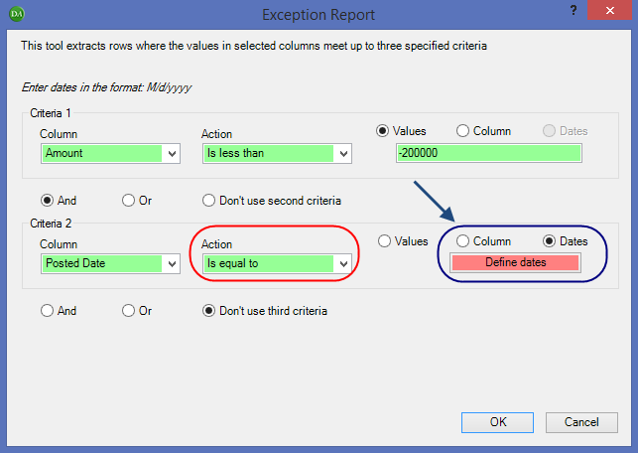

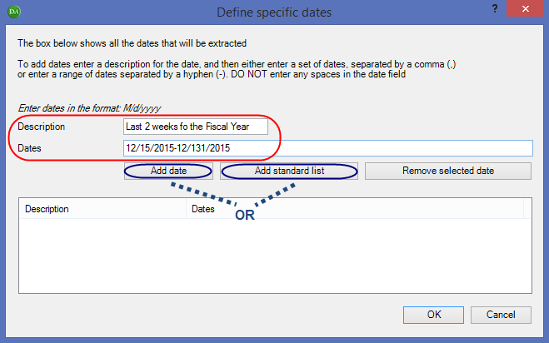

Or you can use a stored list (refer to Appendix B for guidance on creating a stored list). Click ‘Add standard list’ button and another window will pop up; select the relevant list for the engagement and click ‘Ok’.

1. Remove any filters to the original journal entry listing before moving on to the next Fraud Characteristic Test.

## Characteristic #7: Large Revenue Entries Reversed After Period End

Entries exhibiting this characteristic are entries with large debits to revenue (over $X) posted within Y days after period end and effective either before or after period end.

**NOTE:** Using the original journal entry listing, this test will flag entries posted after period end and effective during the fiscal year. Identifying entries both posted and effective after year end may be of audit interest, indicating a potential overstatement of revenue during the period under audit. Therefore, engagement teams may request the journal entry data for a period after year end and run this test on that data set separately. Remember to assess and document the accuracy and completeness of the journal entry data for a period after year end obtained.

**Note**: Engagement teams should avoid splitting their data set into quarters for this characteristic. Splitting the data into quarters creates a risk that not all entries of interest will be identified – particularly those entries posted and effective in the period directly after quarter end. Consider for example a large debit to revenue posted and effective on April 10th (10 days after the end of Q1). If you split your data set into quarters and run an exception report on entries effective in Q1, looking for entries posted in the two week period after Q1, you would not identify this entry because it would not be in the Q1 data set. However if you ran the exception report on all entries for the year, you would identify this entry.

Suggested method to identify journal entries exhibiting this characteristic:

The example below will identify entries in the one week period after a given period end.

1. Filter the journal entry report for revenue accounts only. If the journal entry data set includes a column indicating the financial statement line, or you followed the process outlined in Appendix D to add a trial balance grouping column to the data set, either of these columns can be used.
2. Extract Visible Cells
   1. Use this tool to extract all entries posted to revenue accounts to another worksheet.

**NOTE:** If the data contains formulas, the following pop-up box will appear (below). Select “Paste raw data”. “Paste raw data” will return the data as is; formulas will be kept intact. Whereas, “Paste values” will return the data as hardcoded numbers/text.



This worksheet is not needed for the aggregation of journal entries and may be deleted once the remaining steps for Characteristic #7 have been completed.

**NOTE:** As an alternative to steps (1) and (2), engagement teams can isolate amounts booked to income statement accounts using an extraction report. In the example below the revenue account numbers are between 40000 and 49999.

* Run Extract Data > Exception Report using the following criteria: *Column* = Account Number; *Action* = “Is between” 40000 and 49999.

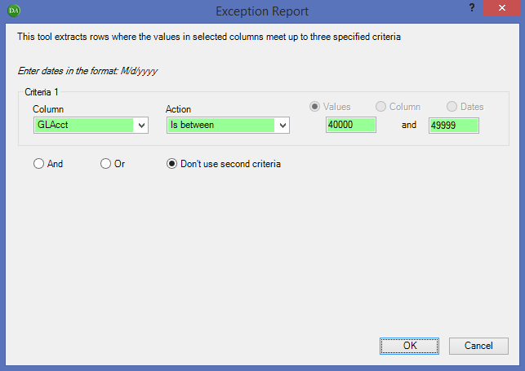

* If the account numbers are not being recognized appropriately when running the EA Tool (i.e. the following message pops up “No records matched your criteria, cannot create report” when you know there should be results), the data may need to be formatted. To correct for this, you can use one of the toolbar’s formatting tools. Select the journal entry account number column and use: Manipulate Text > Convert textnumbers to numbers**.**

1. Extract Data > Exception Report
   1. Enter the following criteria when running the Exception Report:
      * Criteria 1 – *Column* = Journal entry amount column; *Action* = “Is greater than” X value. Where X represents large debits to the revenue account based on the engagement team’s determined parameter; AND
      * Criteria 2 – *Column* = Posting date; *Action* = “Is between” a date range. Enter a period that is post period end.

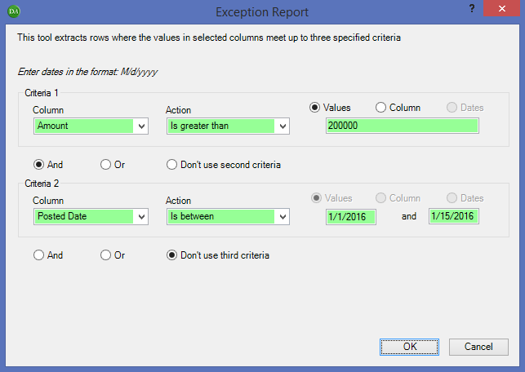

* 1. An Extraction Report and Extraction WK will be created on two new worksheets.
     + The Extraction Report is a listing all of the journal entries meeting the criteria selected (three columns are added to the end sheet). This report will only be generated if the criteria are met, so in this case: Criteria 1 AND Criteria 2.
     + The Extraction WK is the entire journal entry list with the three columns added to the end, showing what entries matched what criteria individually. This sheet is not needed for the aggregation of journal entries and may be deleted.

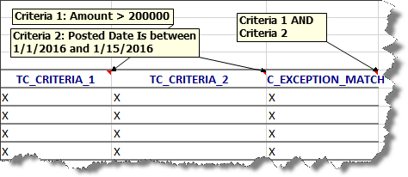

* 1. Rename the Extraction Report worksheet “Test #7”, which will be the worksheet used in the Selecting journal entries to test section below.

**NOTE:** If you need more than one date range, for Criteria 2, refer to Characteristic #6 (3) for further details. An example of this would be if you would like to run one exception report for all large debits to revenue posted in the first 30 days following each quarter end.

1. Remove any filters to the original journal entry listing before moving on to the next Fraud Characteristic Test.

## Characteristic #8: Entries with Round Numbers or Recurring Ending Digits

Entries exhibiting this characteristic have amounts that are round numbers or have recurring ending digits (commonly ending in ‘999’).

Suggested method to identify journal entries exhibiting this characteristic:

1.  Numeric Inquiry > Number Analysis
   1. Select Amount column
   2. Select ‘Identify round numbers’ and select the applicable ‘Rounding base’.

**NOTE:** Engagement teams may choose to run this tool multiple times depending on the base that you want to use (e.g. 100,000 & 1,000,000)

* 1. Select ‘Identify "999" transactions’

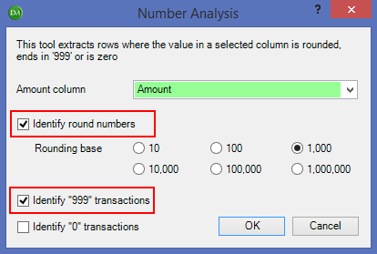

Two new worksheets will be created. One worksheet will be labelled “Round Number”, and the other will be labelled “Identify 999”.

* 1. Rename the “Round Number” and “Identify 999” worksheets “Test #8a” and “Test #8b”, respectively, which will be the worksheets used in the Selecting Journal Entries to Test section below.

**NOTE:** The number analysis tool will only identify consecutive digits at the end of the number, not separated by decimals. For example:

* + $999.99 will not be extracted because there are only 2 consecutive 9’s after the decimal.
  + $100,999 will be extracted because there are 3 consecutive 9’s not separated by decimals and the end of the number.
  + $10,000.45 will not be extracted because the digits at the end of the number are 45 (decimals count).

## Characteristic #9: Potential Duplicate Entries

Entries exhibiting this characteristic may have the same amounts, booked to the same accounts on different days.

NOTE: Engagement teams can focus on client specific fraud risks by filtering for entries affecting certain account numbers or financial statement lines.

Suggested method to identify journal entries exhibiting this characteristic:

1.  Duplicates
   1. Utilize the “Same different test” tool to identify entries where the GL account number and amount are the same, but the journal entry number is different.

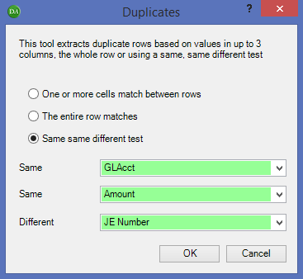

* 1. A SSD (Same, Same, Difference) Report and Duplicates WK will be created on two new worksheets.
     + 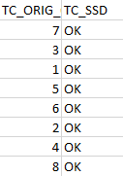The SSD is a listing all of the journal entries meeting the same same different criteria selected (two columns are added to the end sheet). TC_ORIG_ORDER represents the location of the journal entry in the original data set; for example with headings, the number represents excel row number minus one. TC_SSD will show SSD in this worksheet, indicating that it matches the criteria.
     + The Duplicates WK is the entire journal entry list with two columns added to the end, showing what entries matched what criteria individually. The TC_SSD column will show “SSD” or “OK”. The OK means there are no duplicates. This sheet is not needed for the aggregation of journal entries and may be deleted.
  2. Rename the “SSD” worksheet “Step #1 - Duplicates”.

1. To determine how often each duplicate occurs, use the “CONCATENATE” excel function to combine the GL Account # column and the Amount column into one column.
   1. In the “Step #1 – Duplicates” worksheet, add a column to combine the GL Account # and the Amount to one column, named “G/L Acct # + Amount”. This can be done with the CONCATENATE function.

The formula should look like this = CONCATENATE(A2,”-“, N2) where:

* “A2” represents the column containing the G/L account number;
* “-“ adds a separator between the G/L account number and the amount; and
* “N2” represents the column containing the journal entry amount.
  1. To copy the formula for the entire column, select the cell and place your pointer at the bottom right corner. Your pointer will change to this symbol “**+**”, then double-click. This will copy the formula to the end of the data. Double check that your formula has been copied to the bottom.

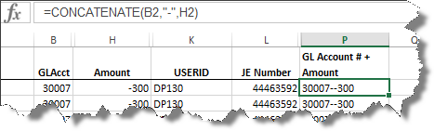

1.  Use the Summarize > Advanced Summary tool to count the number of duplicates in the data set, and to calculate the value of those duplicates.
2. For the “Column to Summarize”, select the Amount column.
3. For “Group items”, *Group by* the “G/L Acct # + Amount” column (created in step (2) above); *Then by* the Amount column. Select whether results should be ascending or descending order.
4. Select “Summary output” and check “Include statistics”. Click the “Select Statistics” button and ensure that “Count” is checked.

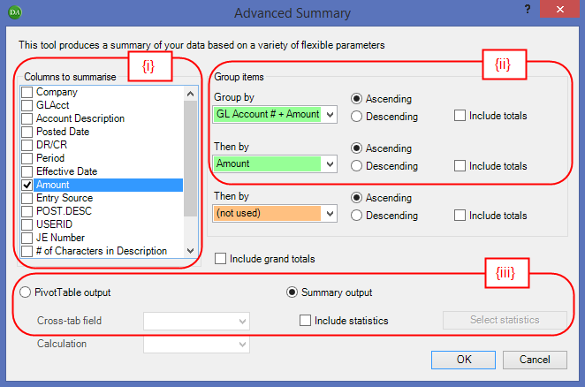

1. A summary table will be produced in a new tab with the Amount column summarized and counted based on the “G/L Acct # + Amount” column. The worksheet is automatically named “Advanced Summary”. The Amount.Count column shows a count of the number of duplicates in the data set. The Amount.Total column is equal to the Amount.Count * the Amount and represents the total value of the duplicated entries.

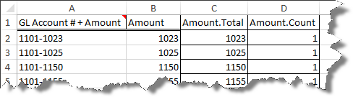

1. Rename the “Advanced Summary” worksheet “Step #2 – Advanced Summary”.
2.  Use the Manage Sheets > Join 2 Sheets tool to join the “Step #1” worksheet with the “Step #2” worksheet.
   1. Select the “G/L Acct # + Amount” as the “matching column”
   2. Select the Amount Total and Amount Count as the “columns to import”.
   3. Select “Rows that match a record in Sheet 2” and “Rows that match a record in Sheet 1”. Do not select “Use Levenshtein fuzzy matching”.

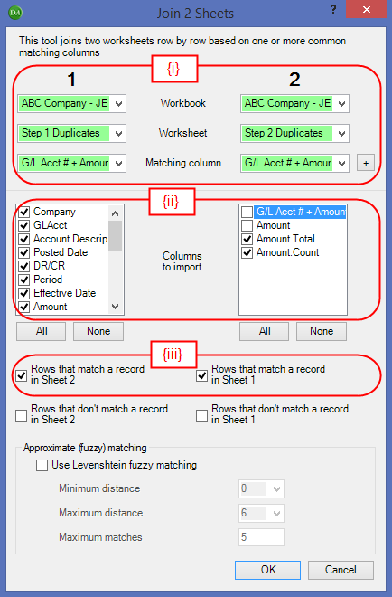

1. Click “OK”. A new worksheet is created, which is called “Joined”.
2. Rename the “Joined” worksheet “Step #3 – Joined”.
3.  Use the Extract Data > Exception Report tool to extract duplicates that occurred more than X times.
4. Use the following criteria when running this tool on worksheet “Step #3 – Joined”:
   * + Criteria 1 – *Column* = “Amount.Count”; *Action* = “Is greater than” X times

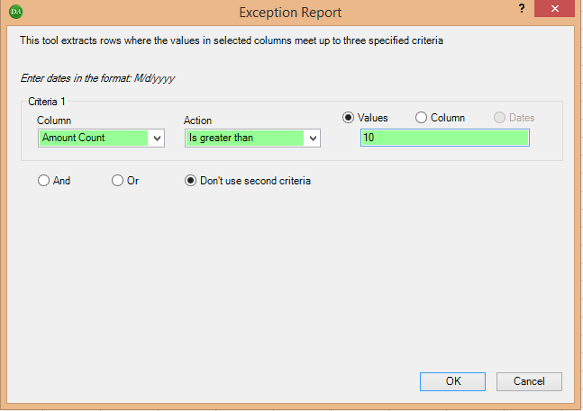

1. An Extraction Report and Extraction WK will be created on two new worksheets.
   * + The Extraction Report is a listing all of the journal entries meeting the criteria selected (four columns are added to the end sheet). This report will only be generated if the criteria are met, so in this case: Criteria 1.
     + The Extraction WK is the entire journal entry list with the three columns added to the end, showing what entries matched what criteria individually. This sheet is not needed for the aggregation of journal entries and may be deleted.
2. Rename the “Extraction Report” worksheet “Test #9”, which will be the worksheet used in the Selecting journal entries to test section below.

## Characteristic #10: Entries Posted on Holidays / Weekends

Entries exhibiting this characteristic are those where the posting date is on a weekend or holiday where it would be unusual for individuals to be at work posting journal entries. The engagement team can determine whether the test will search for entries made on weekends, holidays or both. Entity-specific holidays can be entered in this section and the week-end days can also be defined.To pre-populate a list of holidays, refer to Appendix B.

Often it is normal for standard journal entries to be posted on weekends or holidays, but this would not be the case for non-standard journal entries. If this is the case, consider filtering the journal entry report for non-standard journal entries before completing the steps below. Remember to document the rationale or judgment used in planning the journal entry testing.

Suggested method to identify journal entries exhibiting this characteristic:

1.  Add Date
   1. Select the column that contains the journal entry posting date. Select format "DDDD" in order for the new date column to show in weekday format. Also select the correct “first month”.
2.  Extract Data > Exception Report
   1. Use the following criteria:
      * Criteria 1 – *Column* = Posting date; *Action* = “Is equal to” a defined date range. In order to define the Specific Dates, choose “Add standard list” and select “Default” to use the prepopulated list for holidays. (Refer to Appendix B for guidance on pre-populating a list of holidays); **OR**
      * Criteria 2 – *Column* = The date column added in step (1); *Action* = “Contains” Saturday; **OR**
      * Criteria 3 – *Column* = The date column added in step (1); *Action* = “Contains” Sunday

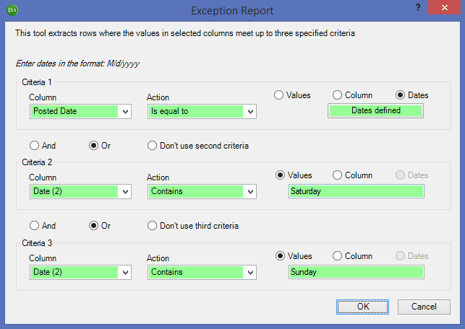

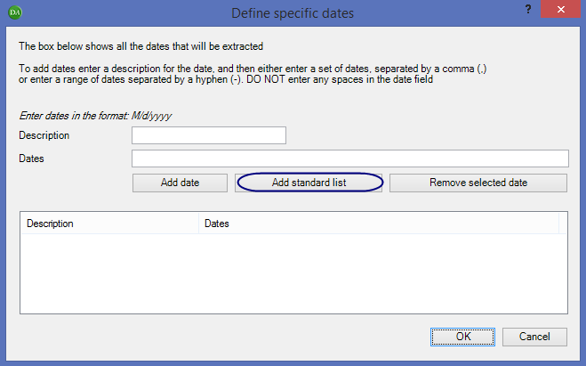

* 1. An Extraction Report and Extraction WK will be created on two new worksheets.
     + The Extraction Report is a listing all of the journal entries meeting the criteria selected (four columns are added to the end sheet). This report will only be generated if the criteria are met, so in this case: Criteria 1 OR Criteria 2 OR Criteria 3.
     + The Extraction WK is the entire journal entry list with the three columns added to the end, showing what entries matched what criteria individually. This sheet is not needed for the aggregation of journal entries and may be deleted.

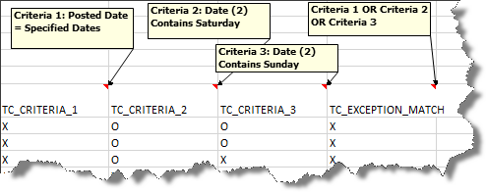

* 1. Rename the Extraction Report worksheet “Test #10”, which will be the worksheet used in the Selecting journal entries to test section below.

## Characteristic #11: Seldom Used Accounts

Entries exhibiting this characteristic have been booked to GL accounts that appear less than X number (parameter value) times in the journal entry listing in a given period.

Suggested method to identify journal entries exhibiting this characteristic:

1.  Use the Summarize > Advanced Summary tool to count the number of times that a GL account appears in the journal entry data set.
   1. For the “Column to Summarize”, select the G/L account number column.
   2. For “Group items”, *Group by* the G/L account column. Select whether results should be ascending or descending order.
   3. Select “Summary output” and check “Include statistics”. Click the “Select Statistics” button and ensure that “Count” is checked.

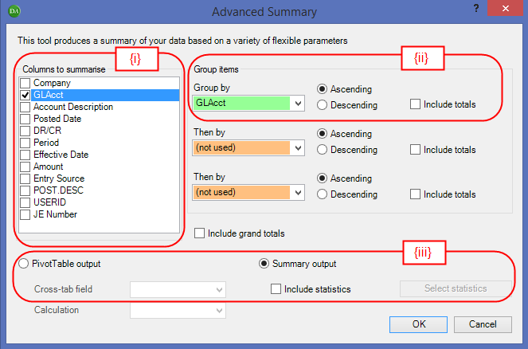

* 1. A summary table will be produced in a new tab with a summary of how many times an account has been used. The worksheet is automatically named “Advanced Summary”.

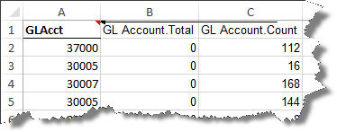

1. Use the Filter Tool to filter the “G/L Account #.Count” column to show only G/L accounts that occur a certain number of times in the journal entry listing.
2. Extract Visible Cells on the filtered worksheet, step (2). above. Rename this worksheet “Seldom Used Accounts”.

**NOTE:** If the data contains formulas, the following pop-up box will appear (below). Select “Paste raw data”. “Paste raw data” will return the data as is; formulas will be kept intact. Whereas, “Paste values” will return the data as hardcoded numbers/text.



1.  Use the Manage Sheets > Join 2 Sheets tool to join the “Seldom Used Accounts” worksheet (generated in step 3 above) with the original journal entry data set.
2. Select the “G/L Account #” as the “matching column”
3. Select the “G/L Account #.Count” as the “column to import”.
4. Select “Rows that match a record in Sheet 2” and “Rows that match a record in Sheet 1”. Do not select “Use Levenshtein fuzzy matching”.

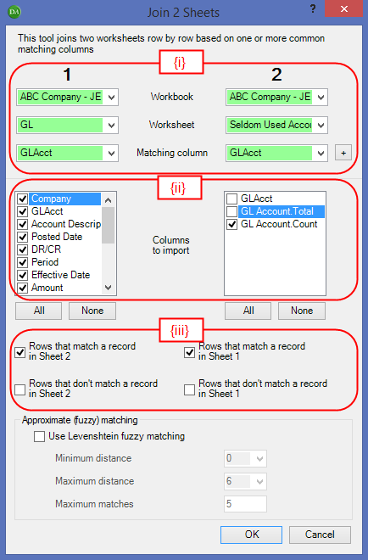

1. Click “OK”. A new worksheet is created, which is called “Joined”. Rename the worksheet “Test #11”, which will be the worksheet used in the [Selecting journal entries to test](#Selecting_Journal_Entries_To_Test) section below.

STEP #3: Selecting journal entries to test

The proceeding section of this guide has focused on the identification of journal entries that exhibit characteristics of fraud. Now that these journal entries have been identified, it is up to the engagement team to determine which of these journal entries to test. Refer to the introduction to Step #2, Identifying journal entries with fraud characteristics for additional journal entry testing guidance.

This guide will not tell you how to determine which of the identified entries to test. However this guide will explain how to create a consolidated list of all journal entries exhibiting a fraud characteristic.

At this stage you have a worksheet identifying journal entries of interest for each characteristic of fraud that was identified by the engagement team. The results for each characteristic is within the excel worksheets labelled “Test #1”, “Test #2”, “Test #3”, etc. Copy each of those worksheets into a new excel workbook.

In some cases the results for a given characteristic will be in an extraction report. In other cases the results will be a filtered journal entry listing. If you have not already done so, review the journal entries that appear on the extraction reports or filtered journal entry listings to ensure that they are all entries of interest. In most cases the worksheets will list all *journal entry lines* that have been flagged for a certain characteristic. To determine how many different *journal entries* have been flagged, copy the journal entry number column to a new worksheet, and use the remove duplicates function in the Excel Data Ribbon. If necessary re-run the tools with different parameters. Alternatively document why certain entries are not entries of interest, and do not bring them into the final analysis in the next steps.

Suggested method to create a worksheet with the full journal entry detail of all entries exhibiting 1 or more characteristics of fraud:

In order to create a consolidated worksheet with all of the journal entry detail needed to complete the testing of the journal entries of interest, start with the original journal entry data tab, and then use a V-lookup function to determine if that journal entry appears on the respective “Test #1”, “Test #2”, etc. worksheets.

1. On the original journal entry data tab (received from client), add a column for each of the characteristics where we have identified potentially fraudulent entries (Note that you may have more characteristics than what is shown in the sample screen shot below).

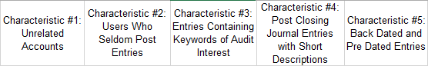

1. In the first cell under the “Characteristic 1” column, enter a V-lookup function:

=VLOOKUP(B2, “Test #1”!$B:$B, 1, FALSE)

In the V-Lookup function the following parameters are entered:

* ***Lookup_value*** = “B2” represents the cell with the journal entry number.
* ***Table_array*** = “Test #1”!$B:$B directs us to the results worksheet and the column containing the journal entry numbers that were booked to seldom used accounts.
* ***Col_index_nuber*** = 1. If the journal entry number in cell B2 is found on the selected column of the Test #1 worksheet, the formula will return the journal entry number. If not, it will return “#N/A”.
* ***Range_lookup*** = False.

The remaining cells in the “Characteristic” columns need to be entered in the same way. The result will be something similar to this: 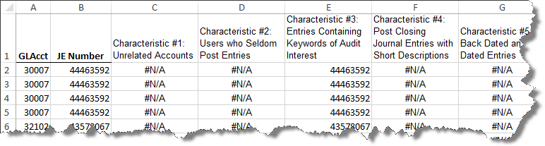

1. Now add a column to count the number of times a certain journal entry has been flagged. This can be done with a =COUNTIF function (for the screen shot shown above):

=COUNTIF (C2:G2, B2)

In the COUNTIF function the following parameters are entered:

* “C2:G2” represents range in a row where entries are flagged as exhibiting fraud characteristics or not
* B2 represents the journal entry number

The result of entering the COUNTIF function can be seen in column Q below:

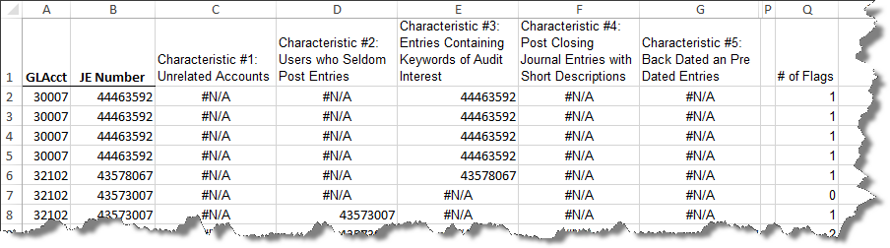

1. It is now possible to add a filter to the column identifying all entries that have 1 or more flags
2.  After the filter has been applied, you can use the Extract Visible Cells tool to copy the selected journal entries to a new worksheet for testing purposes.

**NOTE:** If the data contains formulas, the following pop-up box will appear (below). Select “Paste raw data”. “Paste raw data” will return the data as is; formulas will be kept intact. Ensure that all columns are visible, which will keep the VLOOKUP formula pulling from the intended cell. Whereas, “Paste values” will return the data as hardcoded numbers/text.



Suggested method to format the testing worksheet created in Step (5) above:

The extracted data is based on journal entry lines, therefore to summarize by journal entry, perform the following:

1. Select Subtotal from the Excel Data Ribbon



1. In order to summarize by journal entry, make the following selections in the Subtotal pop-up box:

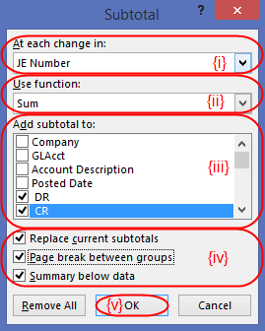

1. *At each change in* = column heading containing journal entry numbers;
2. *Use function* = “Sum”;
3. *Add subtotal to* = column containing debit amount and credit amount. In this example, the debits and credits are in separate columns. By adding a subtotal, it will show that the entry nets to zero.;
4. Check the following boxes:
   * *Replace current subtotals*;
   * *Page break between groups* – this will add a formatted line below each journal entry, which will be helpful to easily see what lines are included in each journal entry.; and
   * *Summary below data*; and
5. Select “OK”
6. Engagement team’s may choose to collapse to the “2” level, which will show a summary of the journal entry numbers selected for testing. To see the journal entry details by line and the Fraud Characteristics flagged, open to the “3” level.

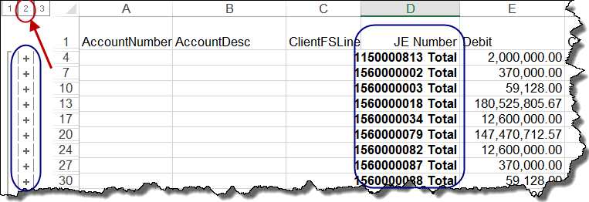

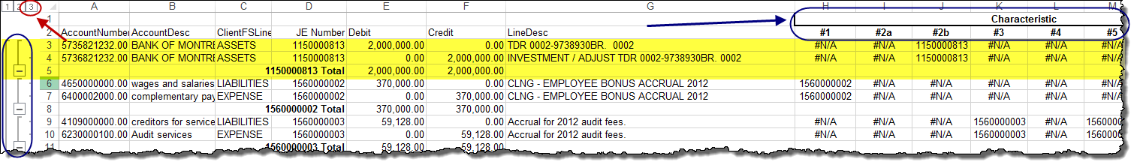

1. Engagement teams may add the documentation of the testing on the right hand side of the testing worksheet.

Appendix A

## Keywords of Audit Interest for Journal Entry Characteristic #3

The following default keywords can be used as well as any additional keywords identified by the audit team. To import the list below, refer to further details in Appendix B.

|  |  |  |  |  |  |  |  |
| --- | --- | --- | --- | --- | --- | --- | --- |
| Abuse | Contingencies | | Early | Kitty | | Restate | |
| Accrual | Controller | | Ebit | | Manage earnings | | Rev | |
| Adj | Cookie jar | | EBITDA | | Manip | | Reversal | |
| Adjust | Correct | | Embezzle | | Mis | | Reverse | |
| Adjustment | Correction | | Error | | Misstate | | Risks | |
| Alter | Corrupt | | Estimate | | Not deductible | | Screen | |
| As directed | Cover | | Estimated | | Opportunity | | Secret | |
| As requested | Coverup | | Estd | | Per | | Smooth | |
| Audit | Cover-up | | Fictitious | | Plug | | Spread | |
| Bribe | D&T | | Fraud | | Problem | | Suspend | |
| Bury | Delete | | Fudge | | Quota | | Suspense | |
| Cancel | Deloitte | | Gift | | Recl | | Temp | |
| Capital | Demand | | Hide | | Reclass | | Test | |
| CEO | Deterioration | | Hidden | | Recls | | Transf | |
| CFO | Director | | Holdback | | Reconcile | | Tsfr | |
| Classif | Don't use | | Immaterial | | Reduce | | Txfr | |
| Conceal | Dont use | | Improper | | Reduce | | Unsupported | |
| Confident | | Dt | Inappropriate | Remove | | | | |
| Confidential | | Dummy | Increase | Reserve | | | | |

Appendix B

## Pre-populate a list of keywords and holidays (Characteristics #3 and #10)

1. Pre-populate a list of keywords:

*  Select Options > Comments from the EA Toolbar
* There are three ways to add keywords:

1. Add Word:

* Type in the desired keywords and click on “Add word”

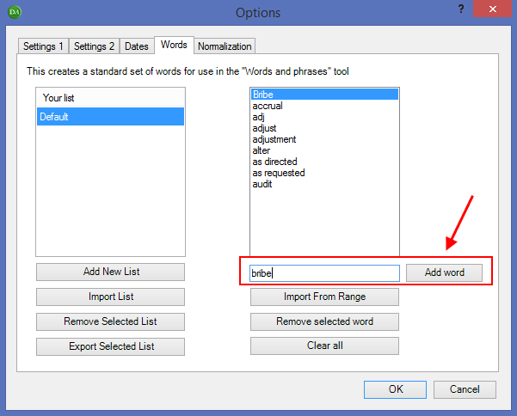

1. Import List:

* Save the following file to your Desktop. If you want to maintain a list by engagement, adjust the name of the file prior to importing to the EA Toolbar.
* Select “Import List”, select the file that you have saved to your desktop, and press OK
* The list can be modified by adding a word (as described in Step (i) above) or using “Remove selected word” button.

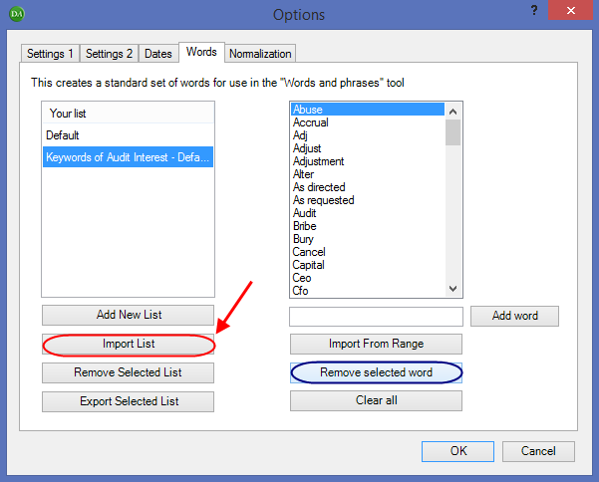

1. Import From Range:

* In an excel worksheet, type the desired words in one column. The following file contains the keywords of audit interest listed in Appendix A. Open the file and continue with the steps below.



* Select “Add New List”, type the name of the list (“Sample Company” in the example below), and select OK
* Select “Import from Range”, specify the range in the pop-up box, and select OK

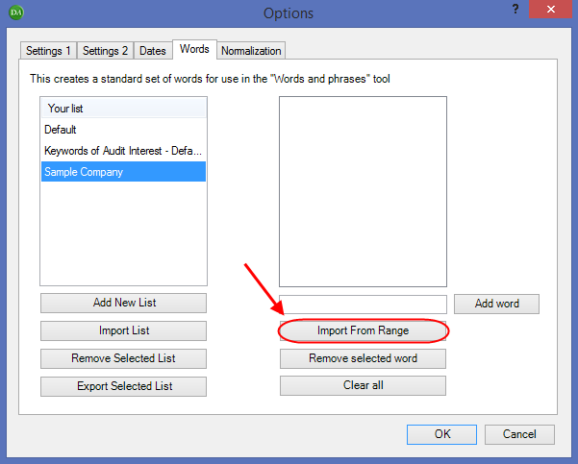

**NOTE:** Practitioners are encouraged to maintain separate lists of keywords of audit interest depending on the JE testing strategy on each engagement.

1. Pre-populate a list of holidays:

*  Select Options > Dates from the EA Toolbar
* There are two ways to add keywords:

1. Add Standard List:

* There is a standard list of holidays stored within the Excel Analytics Options tool. Practitioners can select “Add Standard List” to efficiently populate a list of holidays.

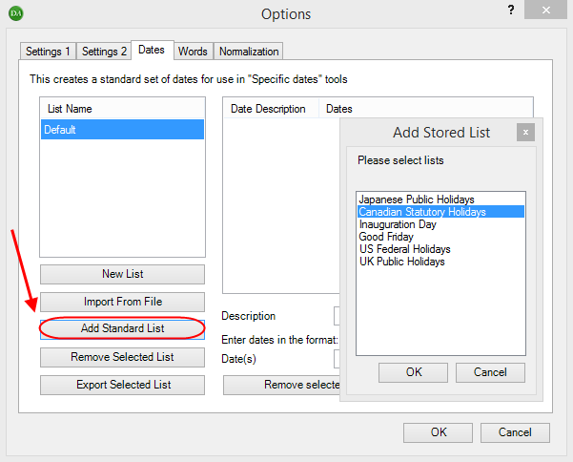

1. Add date:

* Teams may be required to consider other provincial holidays. To add custom holidays: enter Description and related date(s), and click “Add date”.

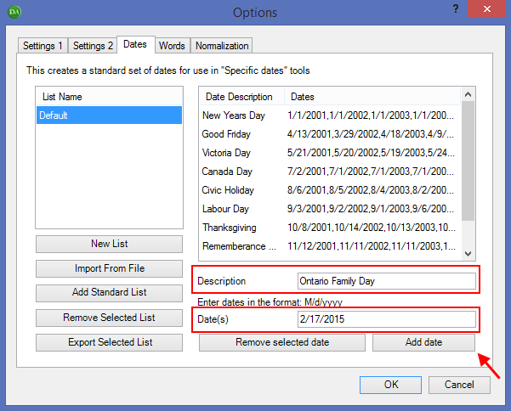

Appendix C

## Analyzing Journal Entries by Quarter

If the engagement team has planned to analyze the journal entry data by quarter, the following steps may be performed to prepare the journal entry data by quarter:

1.  Add Date Column
   1. Enter the “New date format” that corresponds to the period relevant to your analysis. For example: if you would like to see how many journal entry line items contain a certain account in a quarter, select “Q” for quarter. Ensure that your “source date column” represents the effective date of the journal entry (not the posting date).

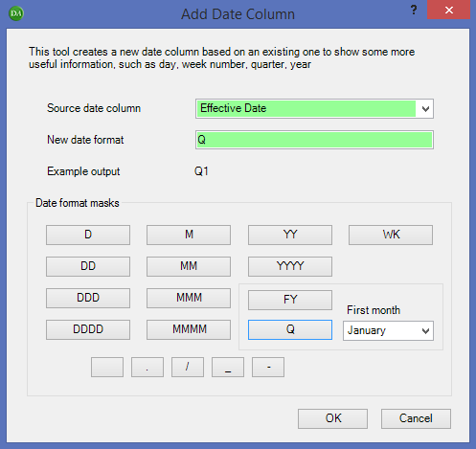

1. Perform the following steps to separate the journal entry data into quarters (or respective parameter set by the engagement team):
   1. Use the Filter Tool to filter the “Date” column (created in step (1) above) for “Q1” only.
   2. Use the Extract Visible Cells tool to copy the Q1 entries to a new worksheet for testing purposes.

**NOTE:** If the data contains formulas, the following pop-up box will appear (below). Select “Paste raw data”. “Paste raw data” will return the data as is; formulas will be kept intact. Whereas, “Paste values” will return the data as hardcoded numbers/text.



* 1. Rename the worksheet “Q1 Extract”.
  2. Perform steps (i) – (iii) for Q2, Q3, and Q4 respectively.
  3. Perform the respective Fraud Characteristic Test in the Identifying journal entries with fraud characteristics section for each quarter.

Appendix D

## Adding Trial Balance Grouping information to a Journal Entry Data Set

If the journal entry data set does not include a column indicating the financial statement line associated with the general ledger account to which the line is posted, this information can be added based on the Trial Balance groupings in our audit file.

Perform the following steps to add this information to the journal entry data set:

1. Extract the trial balance groupings from the audit file
   1. Open the trial balance at the “Detail” level.
   2. Under the “View” tab, select “Groupings View”.
   3. Click on the scale icon in the top left corner of the screen and choose Save as Working Paper > Selected View
   4. Copy the worksheet that is created into the workbook with your journal entry data set
2.  Use the Manage Sheets > Join 2 Sheets tool to add the trial balance groupings to the journal entry data set.
   1. Select the GL Account Number as the “matching column” and select the “columns to import”, ensuring that all columns from the journal entry data set are selected and the Target Grouping column is selected from the Trial Balance Grouping worksheet.
      * Select all boxes, except “Rows that don’t match a record in sheet 1” under sheet **“2”.** Also, do not select ‘Use Levenshtein fuzzy matching’.

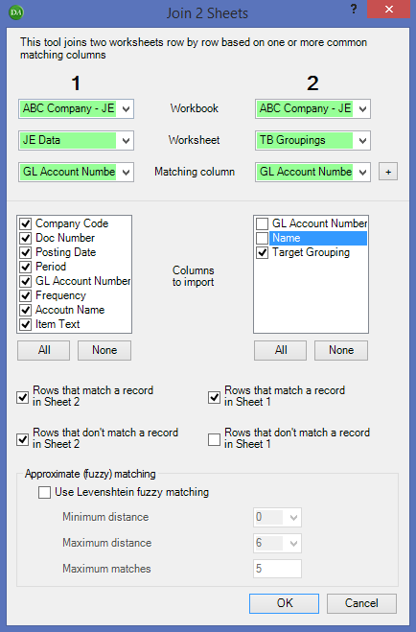

* 1. A new worksheet titled “Joined” will be created including all the data from the original journal entry data set, with an additional column for the trial balance groupings.
  2. Filter the “Target Grouping” column for blanks to identify any rows where the GL account number in the journal entry data was not matched with a trial balance grouping. These will need to be filled in manually.