h

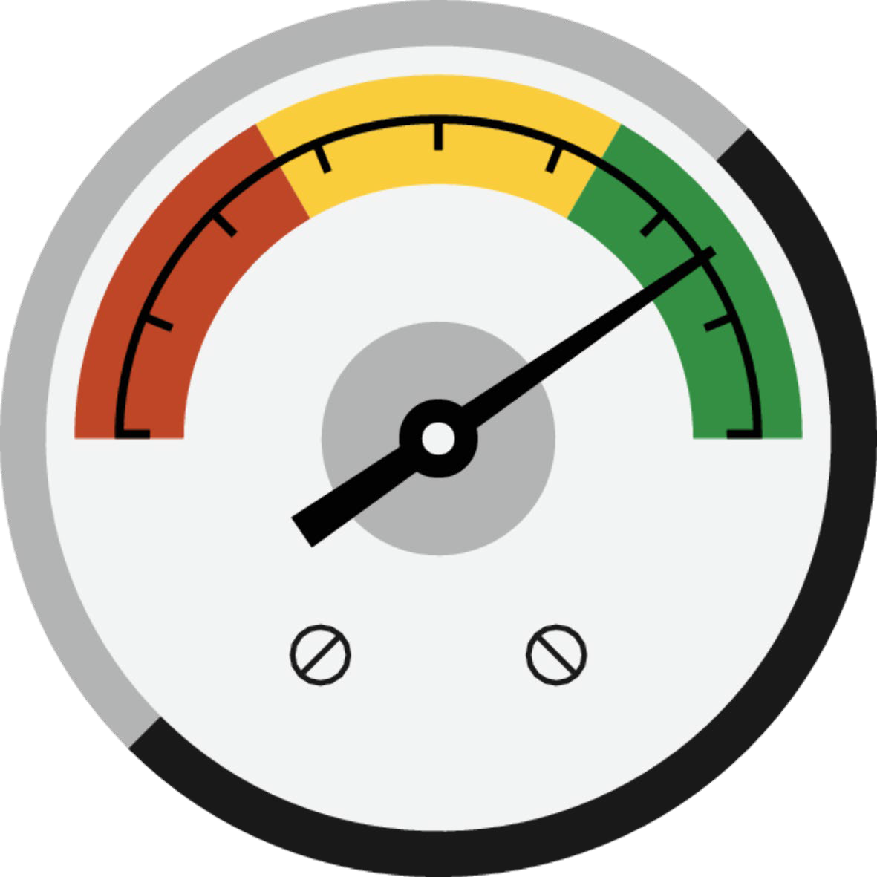

**Audit Sampling and Substantive Analytical Procedures: Quick Reference Guide**

*Sample Sizes for Audit Sampling (Tests of Controls, Tests of Details, and Attribute Sampling) and Thresholds for Substantive Analytical Procedures*

August 2019

**Contents**

Sample size tables for tests of controls 3

Figure 23001.1 — Suggested sample sizes for inspection of documentation to support our inquiries for the purpose of testing the operating effectiveness of controls — Lower and higher risks of material misstatement 3

Figure 23001.2 — Suggested sample sizes for inspection of documentation to support our inquiries for the purpose of testing the operating effectiveness of controls — Significant risks of material misstatement 4

Figure 23001.3—Suggested sample sizes for inspection of documentation to support our inquiries for the purpose of testing the operating effectiveness of controls when planning for one deviation in a control that occurs many times per day 5

Sample size tables for tests of details 6

Figure 23002-4.1 Audit Sampling Sample Size Table — Lower and Higher Risks 6

Figure 23002-4.2 Audit Sampling Sample Size Table — Significant Risks 7

Thresholds for substantive analytical procedures 8

Figure 23002-2.1: Determination of Threshold Levels 8

Attribute sampling tables 8

Figure 23005A.1 Attribute Sampling Sample Size Table — Attribute Sampling Used as the Only Substantive Procedure 8

Figure 23005A.2 Attribute Sampling Sample Size Table — Attribute Sampling Used in Combination with Other Substantive Procedures 8

# Sample size tables for tests of controls

## Figure 23001.1 — Suggested sample sizes for inspection of documentation to support our inquiries for the purpose of testing the operating effectiveness of controls — Lower and higher risks of material misstatement

|  |  |  |  |  |  |
| --- | --- | --- | --- | --- | --- |
|  | | **Lower Risk of Material Misstatement** | | **Higher Risk of Material Misstatement** | |
|  | | **Risk Associated with the Control** | | **Risk Associated with the Control** | |
|  | | | | | |
| **Nature of**  **Control** | **Frequency of Performance**  **of the Control** | **Not Higher** | **Higher** | **Not Higher** | **Higher** |

|  |  |  |  |  |  |
| --- | --- | --- | --- | --- | --- |
| Manual | Many times per day | 10 | 15 | 25 | 35 |
| Manual | Daily | 7 | 10 | 15 | 20 |
| Manual | Weekly | 5 | 5 | 5 | 8 |
| Manual | Monthly | 2 | 2 | 2 | 3 |
| Manual | Quarterly | 2 | 2 | 2 | 2 |
| Manual | Annually | 1 | 1 | 1 | 1 |

Automated Controls If we have tested the related general IT controls and such controls are operating effectively, a sample size of one of each relevant variant of an automated control typically provides us with sufficient appropriate

audit evidence that the automated control is operating effectively. A variant of an automated control is a version of the automated control that varies in function or calculation from other forms of the same automated control. We determine which variants are relevant in the context of how the variants address the identified risk of material misstatement. If there are a large number of relevant variants, we may use a sample size determined in accordance with Figure 23001.1 or Figure 23001.2, taking into consideration the risk of material misstatement, the risk associated with the control, and the number of relevant variants and how this translates to a frequency.

Indirect Controls (e.g., indirect entity-level controls, general IT controls)

For those indirect entity-level controls that do not themselves directly address risks of material misstatement, the higher risk of material misstatement column, along with the appropriate column for the assessed risk associated with the control (i.e., higher or not higher) is the suggested minimum sample size for the test of operating effectiveness.

For general IT controls, assess the risk arising from IT as lower, higher, or significant and use the corresponding sample size from the appropriate risk of material misstatement column in Figure 23001.1 (i.e., lower or higher) or Figure 23001.2 (i.e., significant), along with the appropriate column for the assessed risk associated with the control (i.e., higher or not higher) as the suggested minimum sample size for the test of operating effectiveness.

In the event that the indirect control is directly responsive to a significant risk (e.g., management override of controls), the significant risk of material misstatement column, along with the appropriate column for the assessed risk associated with the control, in Figure 23001.2 is the suggested minimum sample size for the test of operating effectiveness.

The table assumes zero deviations.

## Figure 23001.2 — Suggested sample sizes for inspection of documentation to support our inquiries for the purpose of testing the operating effectiveness of controls — Significant risks of material misstatement

|  |  |  |  |
| --- | --- | --- | --- |
| **Nature of Control** | **Frequency of Performance of the Control** | **Significant Risk of Material Misstatement** | |
| **Risk Associated with the Control** | |
| **Not Higher** | **Higher** |

|  |  |  |  |
| --- | --- | --- | --- |
| Manual | Many times per day | 45 | 60* |
| Manual | Daily | 25 | 40* |
| Manual | Weekly | 8 | 10 |
| Manual | Monthly | 3 | 4 |
| Manual | Quarterly | 2 | 2 |
| Manual | Annually | 1 | 1 |

Automated Controls If we have tested the related general IT controls and such controls are operating effectively, a sample size of one of each relevant variant of an automated control typically provides us with sufficient appropriate

audit evidence that the automated control is operating effectively. A variant of an automated control is a version of the automated control that varies in function or calculation from other forms of the same automated control. We determine which variants are relevant in the context of how the variants address the identified risk of material misstatement. If there are a large number of relevant variants, we may use a sample size determined in accordance with Figure 23001.1 or Figure 23001.2, taking into consideration the risk of material misstatement, the risk associated with the control, and the number of relevant variants and how this translates to a frequency.

Indirect Controls (e.g., indirect entity-level controls, general IT controls)

For those indirect entity-level controls that do not themselves directly address risks of material misstatement, the higher risk of material misstatement column, along with the appropriate column for the assessed risk associated with the control (i.e., higher or not higher) in Figure 23001.1 is the suggested minimum sample size for the test of operating effectiveness.

For general IT controls, assess the risk arising from IT as lower, higher, or significant and use the corresponding sample size from the appropriate risk of material misstatement column in Figure 23001.1 (i.e., lower or higher) or Figure 23001.2 (i.e., significant), along with the appropriate column for the assessed risk associated with the control (i.e., higher or not higher) as the suggested minimum sample size for the test of operating effectiveness.

In the event that the indirect control is directly responsive to a significant risk (e.g., management override of controls), the significant risk of material misstatement column, along with the appropriate column for the assessed risk associated with the control, is the suggested minimum sample size for the test of operating effectiveness.

The table assumes zero deviations.

*In the event that we identify a control that operates many times a day or daily that addresses a significant risk for which the risk associated with the control is assessed as higher, consider whether this is the most appropriate control to address the risk.

## Figure 23001.3 — Suggested sample sizes for inspection of documentation to support our inquiries for the purpose of testing the operating effectiveness of controls when planning for one deviation in a control that occurs many times per day

|  |  |  |  |  |  |  |  |
| --- | --- | --- | --- | --- | --- | --- | --- |
|  | | **Lower Risk of Material Misstatement** | | **Higher Risk of Material Misstatement** | | **Significant Risk of Material Misstatement** | |
|  | | | | | | | |
|  | | **Risk Associated with the Control** | | **Risk Associated with the Control** | | **Risk Associated with the Control** | |
| **Frequency of** | | | | | | | |
| **Nature of Control** | **Performance of the Control** | **Not Higher** | **Higher** | **Not Higher** | **Higher** | **Not Higher** | **Higher** |

Manual Many times per day 25 35 40 60 70 95

The table assumes one deviation in a control that occurs many times per day has been planned for. When the control is performed less than many times per day it is likely not appropriate to plan for deviations.

If the engagement team plans for more than one deviation for a control that occurs “Many times per day”, we are required to consult with the NPPD or their designee.

# Sample size tables for tests of details

## Figure 23002-4.1 — Audit Sampling Sample Size Table — Lower and Higher Risks

|  |  |  |  |  |
| --- | --- | --- | --- | --- |
| **Population Size — Multiples of Performance** | **Not Relying on Controls** | | **Relying on Controls** | |
| **Materiality** | **Lower Risk** | **Higher Risk** | **Lower Risk** | **Higher Risk** |

|  |  |  |  |  |
| --- | --- | --- | --- | --- |
| 1x | 1 | 2 | 1 | 1 |
| 2x | 2 | 3 | 1 | 1 |
| 3x | 2 | 5 | 1 | 2 |
| 4x | 3 | 6 | 1 | 2 |
| 5x | 3 | 8 | 1 | 3 |
| 6x | 4 | 9 | 2 | 3 |
| 7x | 5 | 11 | 2 | 4 |
| 8x | 5 | 12 | 2 | 4 |
| 9x | 6 | 14 | 2 | 5 |
| 10x | 6 | 15 | 2 | 5 |
| 15x | 9 | 23 | 3 | 8 |
| 20x | 12 | 30 | 4 | 10 |
| 25x | 15 | 38 | 5 | 13 |
| 30x | 18 | 45 | 6 | 15 |
| 40x | 24 | 60 | 8 | 20 |
| 50x | 30 | 75 | 10 | 25 |
| 100x | 60 | 150 | 20 | 50 |
| Greater than 100x | (*) | (*) | (*) | (*) |

The sample sizes above represent suggested minimum samples sizes. Engagement management may determine that, in some circumstances, it is appropriate to increase the sample sizes above those in this table.

For populations in between the listed levels of performance materiality, we may interpolate to determine the appropriate sample size.

(*) See DTTL AAM 23002-4.32A or DTTL PCAOB AAM 23002-4.28F for considerations that are applicable when determining the minimum suggested sample size. Consultation in such circumstance is encouraged.

## Figure 23002-4.2 — Audit Sampling Sample Size Table — Significant Risks

|  |  |  |
| --- | --- | --- |
|  | **Significant Risk (!)** |  |
|  |  |  |
| **Population Size — Multiples of Performance Materiality** | **Not Relying on Controls** | **Relying on Controls** |
| 1x | 4 | 2 |
| 2x | 6 | 2 |
| 3x | 10 | 4 |
| 4x | 12 | 4 |
| 5x | 16 | 6 |
| 6x | 18 | 6 |
| 7x | 22 | 8 |
| 8x | 24 | 8 |
| 9x | 28 | 10 |
| 10x | 30 | 10 |
| 15x | 46 | 16 |
| 20x | 60 | 20 |
| 25x | 76 | 26 |
| 30x | 90 | 30 |
| 40x | 120 | 40 |
| 50x | 150 | 50 |
| 100x | 300 | 100 |
| Greater than 100x | (*) | (*) |
| The sample sizes above represent suggested minimum samples sizes. Engagement management may determine that, in some circumstances, it is appropriate to increase the sample sizes above those in this table.  For populations in between the listed levels of performance materiality, we may interpolate to determine the appropriate sample size.  (!) For populations that contain a significant risk, we are required to perform substantive procedures that are specifically responsive to that risk. For audits performed in accordance with the standards of the PCAOB, such procedures are required to include tests of details. These specifically responsive substantive procedures frequently involve nonrepresentative selection.  (*) See paragraph DTTL AAM 23002-4.32A or DTTL PCAOB AAM 23002-4.28F for considerations that are applicable when determining the minimum suggested sample size. Consultation in such circumstance is encouraged. | | |

# Thresholds for substantive analytical procedures

## Figure 23002-2.1 — Determination of Threshold Levels

|  |  |  |  |  |  |
| --- | --- | --- | --- | --- | --- |
| **Threshold, not to exceed the LOWER of** | **Not Relying on Controls** | | **Relying on Controls** | |  |
| **the following** | **Lower Risk** | **Higher Risk** | **Lower Risk** | **Higher Risk** | **Significant Risk (!)** |

Percentage of disaggregated recorded amount, or

22% 15% 35% 25% 20%

Percentage of performance materiality 65% 45% 95% 90% 50%

(!) For populations that contain a significant risk, we are required to perform substantive procedures that are specifically responsive to that risk. For audits performed in accordance with the standards of the PCAOB, such procedures are required to include tests of details.

# Attribute sampling tables

### The sample sizes in Figures 23005A.1 and 23005A.2 represent suggested minimum samples sizes.

## Figure 23005A.1 — Attribute Sampling Sample Size Table — Attribute Sampling Used as the Only Substantive Procedure

|  |  |  |  |  |  |  |
| --- | --- | --- | --- | --- | --- | --- |
| **Number of Expected Deviations** | **Lower Risk and Relying on Controls** | **Lower Risk and Not Relying on Controls** | **Higher Risk and Relying on Controls** | **Higher Risk and Not Relying on Controls** | **Significant Risk and Relying on Controls** | **Significant Risk and Not Relying on Controls** |
| 0 | 4 | 14 | 10 | 30 | 20 | 60 |
| 1 | 16 | 34 | 28 | 57 | 43 | 95 |
| 2 | 30 | 54 | 46 | 83 | 66 | 127 |

## Figure 23005A.2 — Attribute Sampling Sample Size Table — Attribute Sampling Used in Combination with Other Substantive Procedures

|  |  |  |  |  |  |  |
| --- | --- | --- | --- | --- | --- | --- |
| **Number of Expected Deviations** | **Lower Risk and Relying on Controls** | **Lower Risk and Not Relying on Controls** | **Higher Risk and Relying on Controls** | **Higher Risk and Not Relying on Controls** | **Significant Risk and Relying on Controls** | **Significant Risk and Not Relying on Controls** |
| 0 | 2 | 7 | 5 | 15 | 10 | 30 |
| 1 | 11 | 22 | 18 | 36 | 28 | 57 |
| 2 | 22 | 38 | 33 | 56 | 46 | 83 |



#### About Deloitte

Deloitte refers to one or more of Deloitte Touche Tohmatsu Limited ("DTTL"), its global network of member firms and their related entities. DTTL (also referred to as "Deloitte Global") and each of its member firms are legally separate and independent entities.

DTTL does not provide services to clients. Please see [www.deloitte.com/about](https://www2.deloitte.com/global/en/pages/about-deloitte/articles/network-structure.html) to learn more.

This document is for internal distribution and use only among personnel of Deloitte Touche Tohmatsu Limited, its member firms and their related entities (collectively, the “Deloitte network”). None of the Deloitte network shall be responsible for any loss whatsoever sustained by any person who relies on this communication.

© 2019. For information, contact Deloitte Touche Tohmatsu Limited.