nprstuff
Tanim Islam
I like NPR, so I made some scripts to download my favorite programs from NPR. For now, I have something that downloads Fresh Air, Wait Wait..Don’t Tell Me, and This American Life. This package can probably, straightforwardly be extended to other NPR and PRI programs.
Although this project started off as a way to download these three programs, I have expanded it to include a grab bag of altogether different types of functionalities. What remains the same? This distribution consists mainly of executable python scripts.
I organize this document into the following sections: , , (in folders gui and gui2), and a small section called .
This document was converted from a LaTeXsource using Pandoc, via
pandoc -s README.tex -o README.md

Core Functionality
This consists of functionality to grab episodes from Fresh Air, Wait Wait..Don’t Tell Me, and This American Life. These consist of the following pieces of python code:
- npr_utils.py contains common utilities to get the proper metadata for NPR programs, to name these media files in the proper date format, and to get the full paths to the LibAV/FFMPEG and HandBrakeCLI tools to create the NPR programs in m4a and mp3 formats (among other functionalities).
- These four files handle NPR Fresh Air downloads: freshair.py, freshair_crontab.py, freshair_fix_crontab.py, and freshair_by_year.py.
  - freshair.py is the main executable that downloads NPR Fresh Air episodes, converts them to m4a format, and then applies correct metadata. The help screen for this command line tool is here,
Usage: freshair.py [options]

Options:
-h, --help show this help message and exit
--dirname=DIRNAME Name of the directory to store the file. Default is
/mnt/media/freshair.
--date=DATE The date, in the form of "January 1, 2014." The default
is today's date, November 14, 2015.
--debug If chosen, run freshair.py in debug mode. Useful for
debugging :)
  - freshair_crontab.py downloads an NPR Fresh Air episode on a given weekday. It should be called by a cron job that should be run every weekday.
  - freshair_fix_crontab.py tries to re-download NPR Fresh Air episodes that may be incomplete – defined as shorter than 30 minutes – and which are 90 days or older. This executable searches through the library of all NPR Fresh Air episodes, and tries to re-download older, possibly incomplete episodes.
  - freshair_by_year.py downloads all the NPR Fresh Air episodes in a given year.
- These four files handle NPR Wait Wait downloads: waitwait.py, waitwait_realmedia.py, waitwait_crontab.py, and waitwait_by_year.py.
  - freshair.py is the main executable that downloads NPR Wait Wait episodes, converts them to m4a format, and then applies correct metadata. waitwait_realmedia.py is a python module that allows one to download NPR Wait Wait episodes older than 2004, which are in RealMedia format. The help screen for this command line tool is here,
Usage: waitwait.py [options]

Options:
-h, --help show this help message and exit
--dirname=DIRNAME Name of the directory to store the file. Default is
/mnt/media/waitwait.
--date=DATE The date, in the form of "January 1, 2014." The default
is last Saturday, November 14, 2015.
--debugonly If chosen, download the NPR XML data sheet for this Wait
Wait episode.
  - waitwait_crontab.py downloads an NPR Wait Wait episode on a given Saturday. It should be called by a cron job that should be run every Saturday.
  - waitwait_by_year.py downloads all the NPR Wait Wait episodes in a given year.
- thisamericanlife.py manually downloads a given episode number of This American Life. This executable uses a custom online archive for older This American Life episodes that are described here. The help screen for this command line tool is here,
Usage: thisamericanlife.py [options]

Options:
-h, --help show this help message and exit
--episode=EPISODE Episode number of This American Life to download.
Default is 150.
--directory=DIRECTORY
Directory into which to download This American Life
episodes. Default is /mnt/media/thisamericanlife.
--extra=EXTRASTUFF If defined, some extra stuff in the URL to get a This
American Life episode.

New Functionality
This consists of newer functionality that does not download NPR episodes, nor can one straightforwardly modify them to download NPR episodes. These consist of the following pieces of python code.
- autoCropImage.py automatically crops image (png, jpeg, tiff, etc.) files to remove whitespace. The default whitespace color is white. The help screen for this command line tool is here,
Usage: autoCropImage.py [options]

Options:
-h, --help show this help message and exit
--input=INPUT Name of the input file.
--output=OUTPUT Name of the output file. Optional.
--color=COLOR Name of the color over which to autocrop. Default is white.
- convertImage.py uses the CloudConvert REST API to smoothly and without pain points convert and resize SVG images to PNG images of the same base name. The help screen for this command line tool is here,
Usage: convertImage.py [options]

Options:
-h, --help show this help message and exit
--filename=FILENAME Name of the input SVG file.
--width=WIDTH If defined, new width of the file. Optional
- changedates.py changes the creation date of JPG and MOV files, that my Canon digital camera creates, by up and down one year. I created this tool because my Canon digital camera does not set the right year on the creation date for image files it creates. This caused problems when I uploaded those images to Google Picasa or Google+. The help screen for this command line tool is here,
Usage: changedates.py [options]

Options:
-h, --help show this help message and exit
--dirname=DIRNAME Name of the directory to look for jpeg files.
--movs If chosen, process MOV files instead.
--minus If chosen, subtract a year from the files.
- music_to_m4a.py can convert a single file from mp3/ogg/flac format to m4a format while preserving music file metadata, and can optionally set the total number of album tracks and the album cover if the music files is in an album. It can also rename an m4a music file into the format “artist name - song name.m4a.” The help screen for this command line tool is here,
Usage: music_to_m4a.py [options]

Options:
-h, --help show this help message and exit
--inputfile=INPUTFILE
Name of the input audio file to convert.
--outfile=OUTFILE Optional name of the output file.
--tottracks=TOTTRACKS
Optional total number of tracks in album of which song
is a part.
--albumloc=ALBUMLOC Optional path to location of the album cover image
file. Must be in JPEG or PNG.
--quiet If chosen, then verbosely print output of processing.
--rename If chosen, simply rename the m4a file to the form
<artist>.<song title>.m4a
- download_surahs.py downloads recorded surahs (Abdur-Rashid Sufi) to a directory of your choice. The help screen for this command line tool is here,
Usage: download_surahs.py [options]

Options:
-h, --help show this help message and exit
--outdir=OUTDIR Directory to put this data into. Default is
/mnt/software/sources/pythonics/nprstuff.

Graphics Functionality
This section describes the two graphical tools I have developed: gui matches a small subset of functionality that the Readability tool handles excellently; gui2 is a PyQt4 GUI front-end to the Readability API.

GUI: Media Website Text Formatter
This GUI can read from the following media websites: Lightspeed Magazine, Medium, The New Yorker, The New York Times, and the Virginia Quarterly Review. Here is a screenshot!
[!ht]0.65 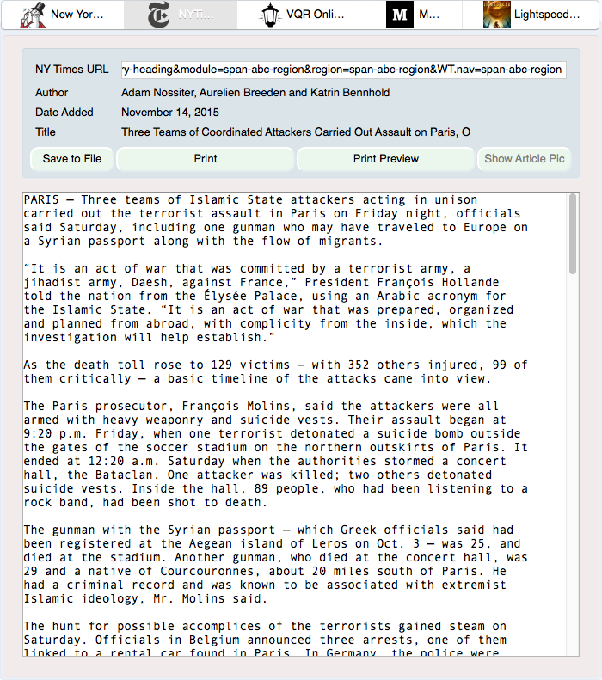
The screenshots of the save file dialog and the print preview dialog are shown Fig. [fig:gui_screenshot_save] and Fig. [fig:gui_screenshot_printpreview], respectively.
[!ht]0.4 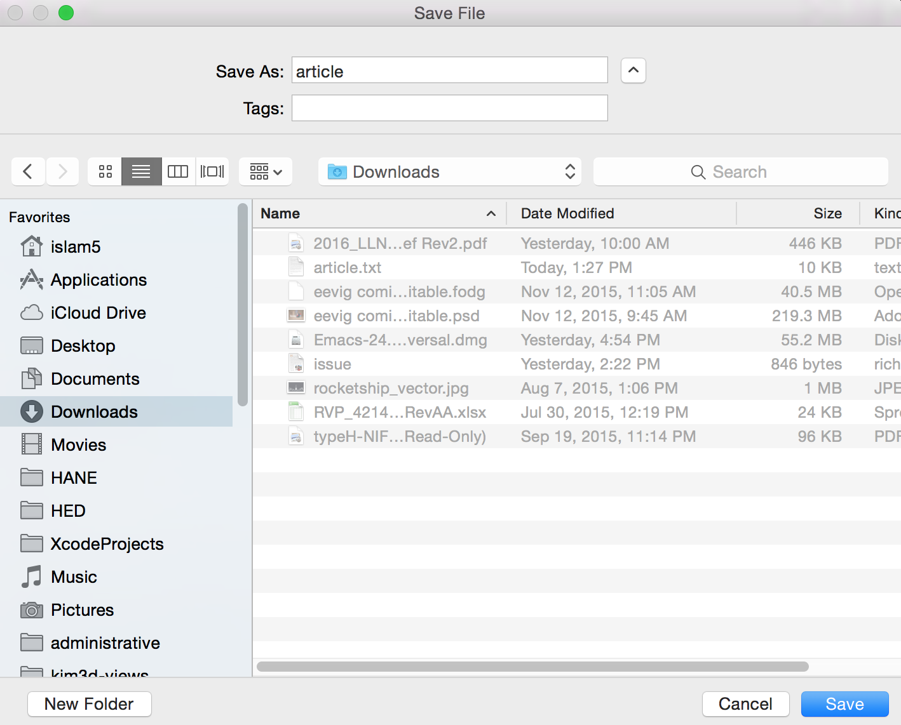
[!ht]0.5 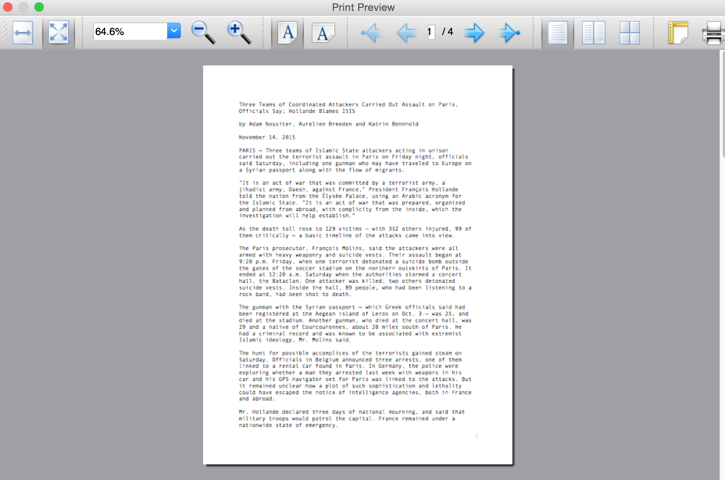
Note, here I do not support or maintain this tool after I found out about Readability.

GUI2: Readability GUI Front-End
This is the PyQt4 GUI front-end to Readability. A screenshot of the list of articles widget is shown in Fig. ([fig:gui2_screenshot_articlelist]), and a screenshot of the article text widget is shown in Fig. ([fig:gui2_screenshot_articletext]).
[!ht]0.52 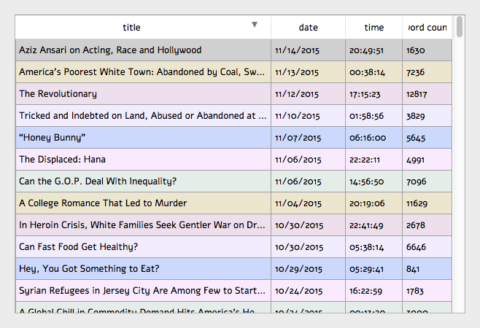
[!ht]0.45 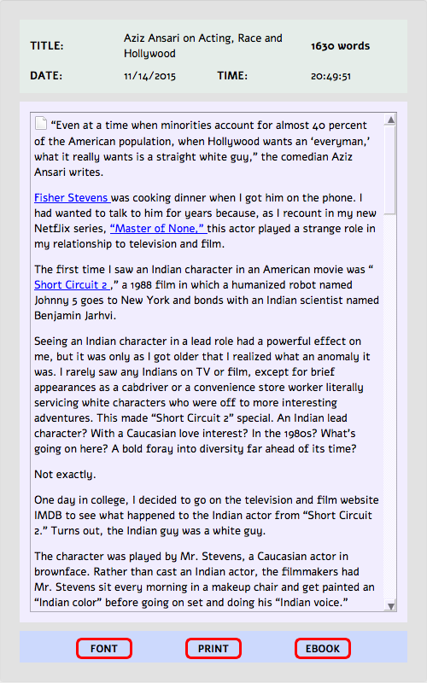
A screenshot of the font changing dialog, the Font button, is shown in Fig. ([fig:gui2_screenshot_fontdialog]). A screenshot of the print preview dialog, the Print button, is shown in Fig. ([fig:gui2_screenshot_printpreviewdialog]).
[!ht]0.53 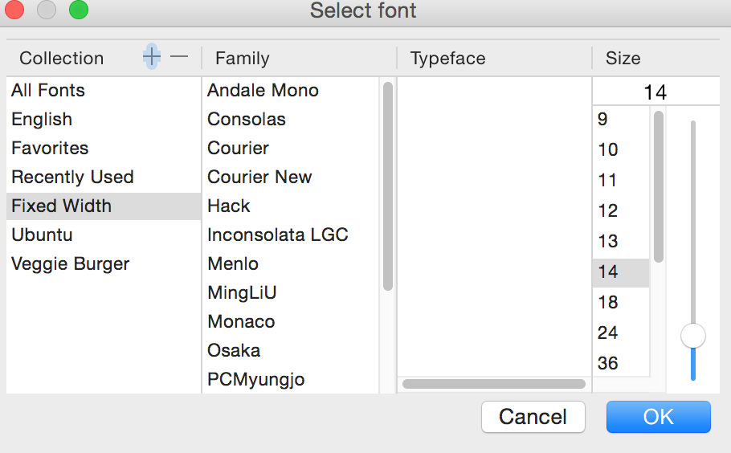
[!ht]0.45 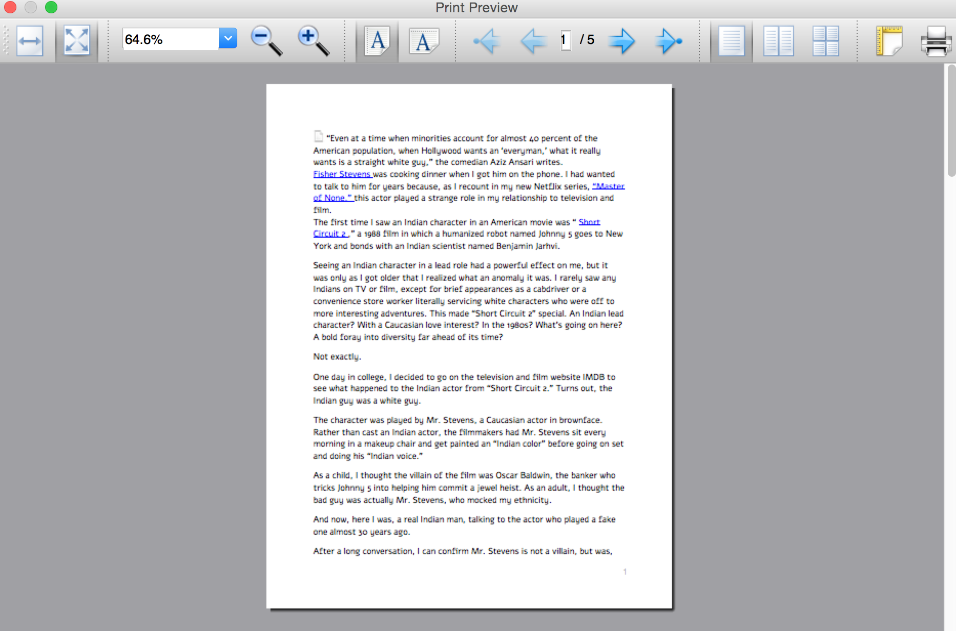
In the immediate future, I plan on at least implementing the following, all using the Readability API.
- EPUB button, to create the article in EPUB format.
- Adding and deleting articles through the article list widget.

Oldstuff
These are tools that I do not maintain, located in the oldstuff folder, but which others may find useful. These are pieces of code that I have started, but which are unmaintained. These are the following pieces of code: freshair.sh, waitwait.sh, and google_pull_contacts.py.

