Appendix: Video Transcript

**_____________________________________________________________________________________________________________________________________**

This is a Stats Manager that was created for my client Flip Scott who is a coach at Grand Ridge University. This is a program that was made in NetBeans which will run in there.

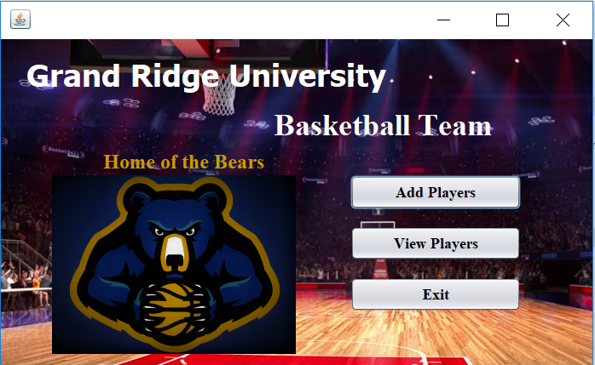Once you run the program in the NetBeans IDE, the startFrame Panel will pop up which is the GUI components of this program. This shows how the first success criteria has been met as the program is using Graphical User Interface which is known as GUI.

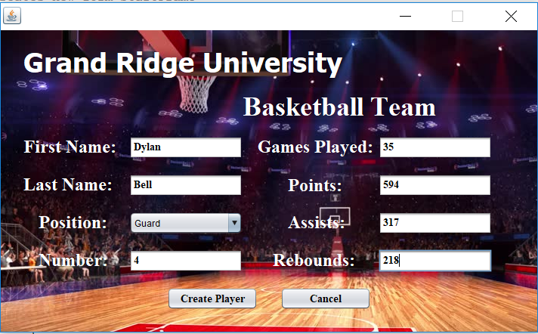Now Im going to click add player in the startFrame menu which then will open an Add Player panel that will allow the user to input information that is given to him to input.

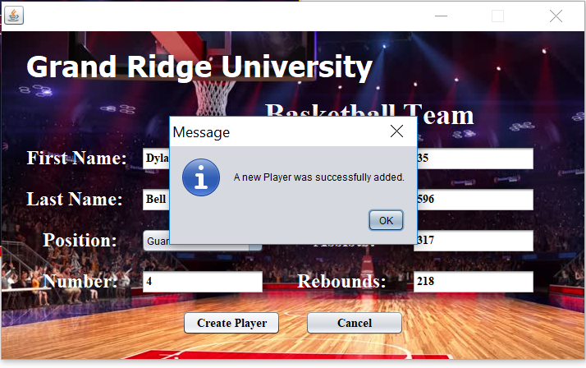I will now enter the player’s first name which is Dylan and the player’s last name which is Bell. I will then input all of information based on this season, so the dropdown for the position, I will click the Guard button, for jersey number I will enter “4”, for the number of game played I will enter “35”, for the total points I will enter “594”, for the total assists I will enter “317”, for the total rebounds I will enter “218”. Once inputting all the information, I will click “create player” and a message will pop up that a player was successfully created. This shows how the second success criteria has been met as the user can input information and successfully add a player.

I will now click the view player’s panel where we can view the player that we created. I will now go ahead and add 3 more players to show the different methods to sort it.

*Add 3 new Players*

As you can see 3 new players have been added and in the view all players sort will show you 4 players. I will now click the dropdown menu and click Last name which will than sort the players alphabetically. If I click the Guards option and then click sort, the only players that should show up is Dylan Bell and Anthony Wall. If I click the forward options and then click the sort button, the only players that should show up is Charles Graham and Bruce Savors. If I click jersey number, than this will sort it numerically by their jersey number. This shows how the third success criteria has been met as the user can sort it different ways such as alphabetically, position, or by their jersey number.

I will now click on a player’s name, for instance Dylan Bell, and once I click the “Show Stats button” all of his information will come up and it will calculate his seasonal average. The number of points per game that he averaged show be 17, the number of assists per game should be 9.1 and the number of rebounds per game should be 6.2. I will now click the show stats button and the statistics of the player will appear. The fourth success criteria has been met as it shows that the program can successfully calculate the player’s seasonal averages.

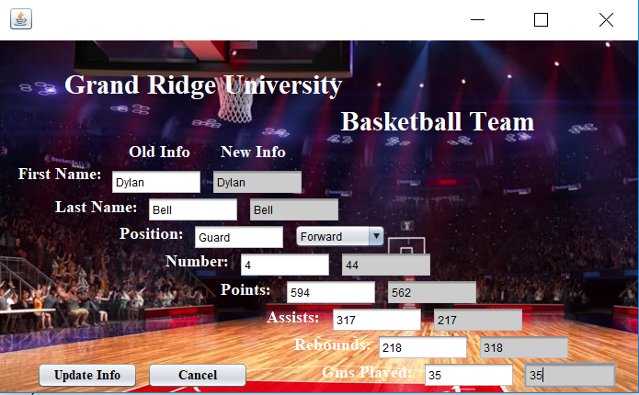I will now click on Dylan Bell and then click the edit player button. Once I click the edit player button a new panel will show up which is the updateInfo panel. In this panel, I will input new values of this player as I change his position to “forward”, change his jersey number to “44”, change the total points scored to 562, change the number of assists to 217, and also change the number of rebounds to “318”. This shows how the sixth success criteria is met as the user is able to enter and edit the information of their players choice.

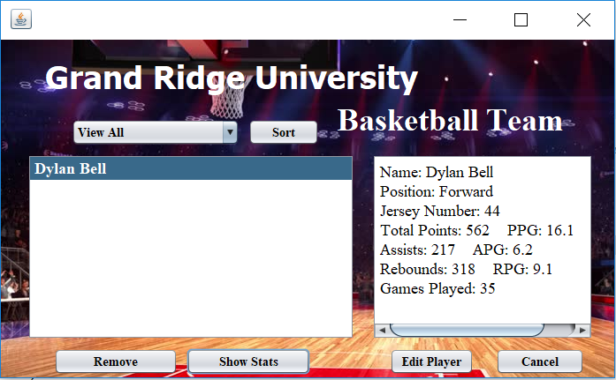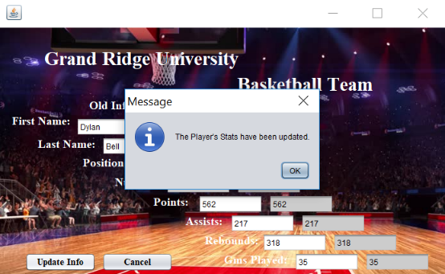I will then click the update info button which then update the player’s statistics and the user is notified that the player has successfully been updated as a message will appear. This will take me back to the viewPlayers panel and then I will click Dylan Bell and show stats and the new calculated averages will show up. This shows how the seventh success criteria is met as the program successfully updates the players’ new information.

I am now going to click Anthony Wall and then click the remove button and once I click the remove button, his name and information will be deleted from the player’s panel. This shows how the eighth success criteria was met as the program can successfully remove a player.

Clicking the exit button will successfully close the window. Now I will exit the program and then run the program again and then click the “view players” button and all information should be saved. This shows that the fifth and ninth success criteria have been met as the user can successfully exit the program and then once reopening the program all the previous information should be saved and should be able to be view.

Although the program met all the success criteria, the program can still be extended in ways to have further improvements. This program can be extended by having more input methods such as fouls, blocks, the percentage of the players shots, how many turnovers committed, etc. Another future improvement is where the program can calculate averages after every single game. Lastly another extension to the program is that is can be used as a mobile app on any phones or tablets.

And this is the statistics manager program.