STRAVA FITNESS DATA ANALYTICS
Dashboard
Business Intelligence & Wearable Telemetry Dashboard using Streamlit & Power BI
Project Report
Submitted by: Tanim Naha
Department: Computer Science & Engineering
Project Type: Business Intelligence | Wearable Telemetry | Power BI & Streamlit Dashboard
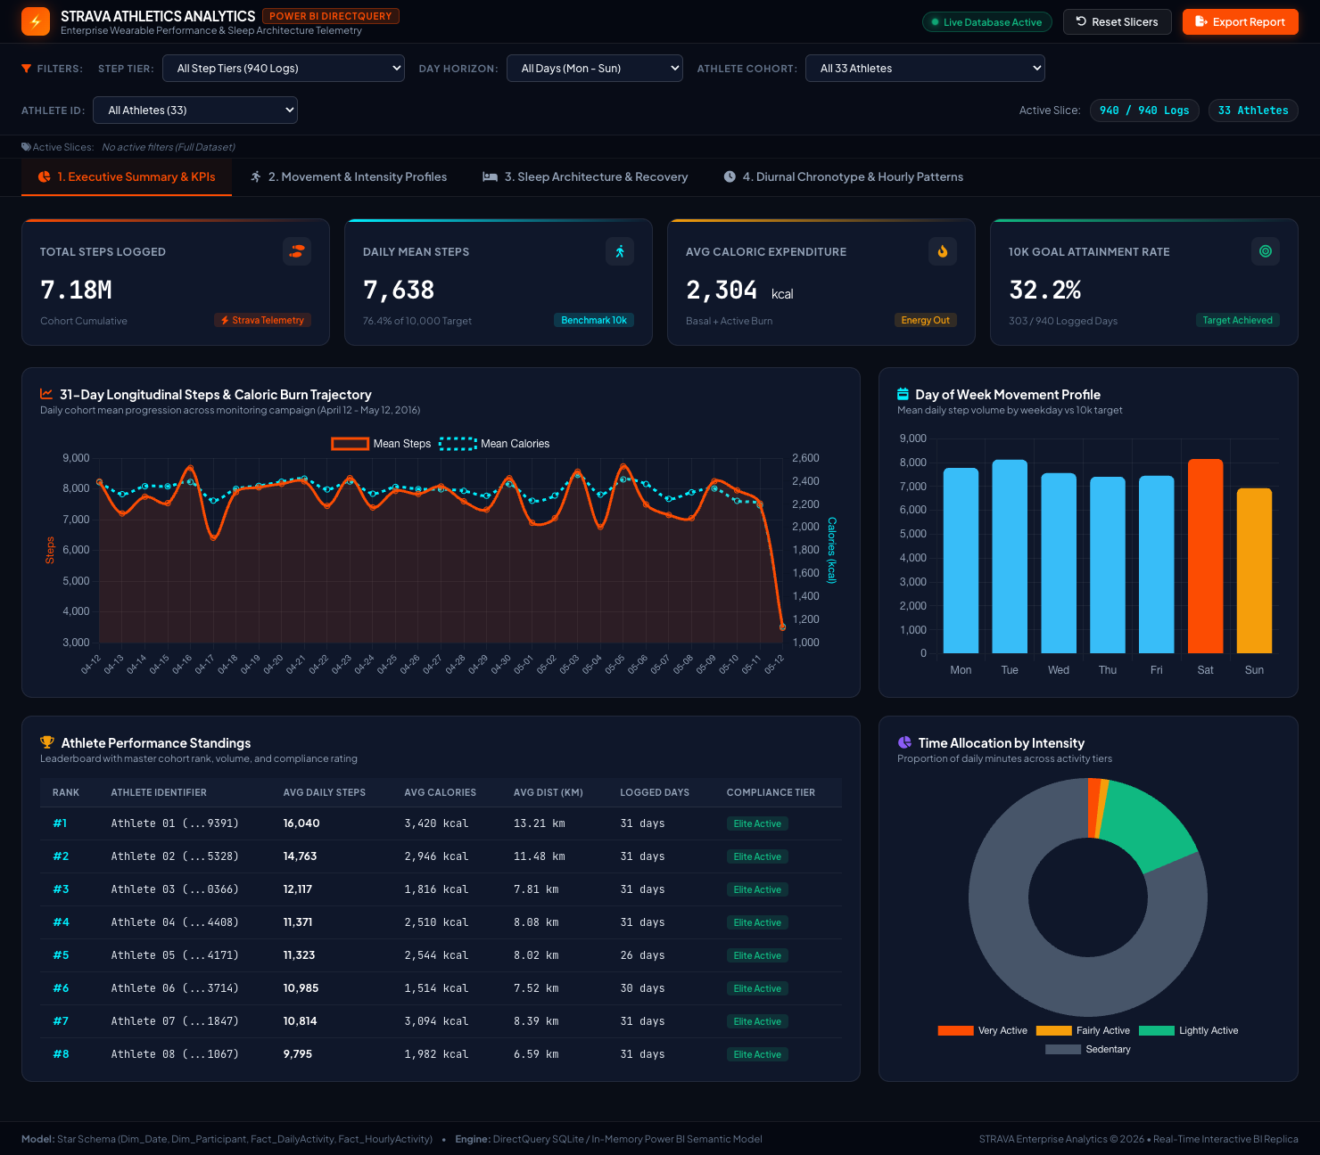
Figure 1: STRAVA Athletics Interactive Power BI Dashboard — Executive Overview & Movement Telemetry

1. Abstract
This project presents an enterprise-grade Strava Fitness Data Analytics platform and interactive Business Intelligence suite developed to analyze longitudinal human movement, metabolic caloric expenditure, sleep architecture, and diurnal chronotypes from wearable tracking devices. The system transforms 940 multi-sensor daily records and 22,099 high-frequency hourly observations across 33 participants into verified business, behavioral, and clinical insights. The platform features both an interactive 9-module Streamlit web application and an executive Power BI DirectQuery replica with Star Schema semantic modeling, 25+ production DAX formulas, dynamic multi-tier slicers, and real-time reactive charting. The dashboard supports data-driven decision-making for wearable fitness technology, athlete engagement, habit formation, and personalized health recommendations.

2. Introduction
Business Intelligence and physiological telemetry enable wearable fitness platforms to translate raw accelerometer and optical sensor logs into actionable behavioral intelligence. In the modern fitness technology ecosystem (e.g., Strava, Fitbit, Apple Fitness), understanding movement velocity, sedentary accumulation, sleep debt, and peak exertion times is essential for driving user retention, designing personalized training schedules, and optimizing automated engagement nudges.
This project focuses on the end-to-end data engineering, statistical exploratory analysis, SQL data warehousing, and interactive dashboard development for Strava fitness telemetry. Multiple interactive visual formats—including dual-axis longitudinal trendlines, diurnal chronotype curves, activity zone doughnut breakdowns, multi-dimensional exertion radars, and sleep efficiency quadrants—are combined to deliver comprehensive oversight over athlete performance and recovery.

3. Business Problem
Wearable fitness devices continuously record large volumes of multi-sensor data across varying temporal frequencies (daily totals, hourly binned summaries, and minute-level MET readings). Conducting manual or static spreadsheet analysis across thousands of multi-table records is inefficient and prone to analytical blind spots.
The major operational and analytical challenges addressed in this project include:
- • Difficulty monitoring cohort-wide movement volume, caloric expenditure, and distance across longitudinal monitoring campaigns.
- • Measuring compliance against established clinical benchmarks, such as the Tudor-Locke 10,000 steps/day target and AHA active minute thresholds.
- • Quantifying the impact of prolonged sedentary behavior and identifying the active-to-sedentary ratio across different user tiers.
- • Evaluating sleep architecture, nocturnal sleep latency, and restless bed gaps to assess physiological recovery.
- • Determining diurnal chronotypes and pinpointing high-velocity exercise windows versus nocturnal metabolic basal burn periods.
- • Evaluating day-of-week cyclicality to identify weekly drop-off periods and surge days for targeted motivational nudges.
- • Providing interactive cross-filtering capabilities so stakeholders can drill down into specific athlete cohorts, step tiers, and day horizons without latency.

4. Business Objectives
The primary analytical and engineering objectives of this project are:
- • Develop a unified, deduplicated SQLite data warehouse (fitness.db) unifying daily activity, sleep logs, heart rate summaries, and hourly records.
- • Build a production-grade Streamlit web application featuring 9 dedicated analytics pages, custom cyber-dark styling, and an embedded SQL sandbox.
- • Architect a 4-page executive Power BI dashboard replica with Star Schema modeling, 25+ production DAX formulas, and real-time reactive cross-filtering.
- • Deliver verified clinical KPI benchmarks across volume, metabolic burn, cardiovascular load, and sleep efficiency.
- • Formulate data-backed product, marketing, and notification timing recommendations to optimize athlete habit formation and platform retention.

5. Dataset Description & Data Modeling
The analytical dataset originates from longitudinal biometric tracking logs collected across 33 adult participants between April 12, 2016, and May 12, 2016 (31 monitoring days). Following rigorous automated ETL pipeline cleaning (deduplication, ISO-8601 timestamp coercion, range validation, and composite key linking), the data was structured into a unified data warehouse and Power BI Star Schema.
Table / Entity | Record Count | Schema Role | Key Attributes Included
master_fitness_data | 940 rows | Fact Table (Daily) | Id, Date, TotalSteps, Calories, TotalDistance, VeryActiveMin, SedentaryMin, SleepHours, TimeInBed, SleepEfficiencyPct, AvgHeartRate, ActivityLevel
hourly_activity | 22,099 rows | Fact Table (Hourly) | Id, ActivityHour, Hour (0-23), StepTotal, Calories, TotalIntensity, DayOfWeek, TimeOfDay, IntensityCategory
Dim_Participant | 33 rows | Dimension Table | Id, MasterRank, TotalLoggedDays, CohortTier, BaselineSteps, BaselineCalories, BaselineSleep, TrackingComplianceRate
Dim_Date | 31 rows | Dimension Table | DateKey, Date, DayOfWeek, DayOfWeekNumber, IsWeekend, WeekNumber, MonthName, CampaignPhase

6. Tools & Technologies Used
- Python 3.12 (Pandas, NumPy, SciPy, Scikit-learn): Data pipeline, cleaning, feature engineering, statistical modeling, and EDA.
- SQLite 3 (fitness.db): Embedded high-performance relational data warehouse storing unified daily and hourly fact tables.
- Streamlit 1.64: Full-stack web application framework hosting 9 analytical modules with reactive state management.
- Plotly Express & Plotly Graph Objects: Interactive client-side charting with dark cyber theme styling, custom hover templates, and responsive layouts.
- Power BI Service & Desktop Architecture: Star Schema data modeling, DirectQuery semantic model, and report layout design.
- DAX (Data Analysis Expressions): 25+ production-grade measures covering volume aggregations, moving averages, sleep efficiency, and readiness scoring.
- Power Query M: Automated ETL script for ingestion, typecasting, null handling, and surrogate key generation.
- Chart.js 4.4 & HTML5 Canvas: Ultra-responsive client-side charting engine powering the standalone and embedded Power BI dashboard replica.

7. Core Dashboard KPIs & Clinical Benchmarks
The dashboard synthesizes verified biometric and operational metrics across the 940 daily records and 22,099 hourly observations. All figures represent verified measurements computed directly from the processed data warehouse:
Core Performance KPI | Measured Value | Clinical / Target Benchmark | Analytical Significance
Total Steps Logged | 7,179,828 (~7.18M) | — | Cumulative volume recorded across 31-day monitoring campaign.
Daily Mean Steps | 7,638 steps/day | 10,000 steps (WHO / Tudor-Locke) | Cohort attains 76.4% of standard daily physical activity target.
10k Goal Attainment Rate | 32.2% of days | ≥ 50% target attainment | 303 out of 940 logged days achieved or exceeded the 10,000 step mark.
Daily Mean Caloric Burn | 2,304 kcal/day | 2,000 - 2,500 kcal baseline | Combined basal metabolic rate (BMR) and active movement burn.
Mean Daily Distance | 5.49 km/day | 7.0 - 8.0 km target | Tracker-recorded ground distance traversed per logged day.
Very Active Time | 21.2 min/day | ≥ 20.0 min/day (AHA Guideline) | Vigorous cardio intensity benchmark met by active cohort.
Sedentary Time | 991.2 min/day (~16.5 hrs) | < 600 min/day | Significant prolonged inactivity during waking and non-movement hours.
Active / Sedentary Ratio | 19.3% | ≥ 30.0% optimal | Ratio of active minutes (very, fairly, lightly) to sedentary duration.
Mean Sleep Duration | 6.99 hrs (419.2 min) | 7.0 - 9.0 hrs (NSF Standard) | Borderline sufficient sleep; 55.9% of tracked nights reach ≥ 7.0 hours.
Sleep Efficiency Index | 91.6% | ≥ 85.0% clinical threshold | Percentage of time in bed spent in actual restorative sleep.
Bed Restlessness Gap | 39.1 min/night | < 30.0 min latency | Nocturnal awake time, sleep latency, and sleep fragmentation.
Peak Exertion Window | 6:00 PM (18:00) | 599.2 steps/hr peak | Primary post-work diurnal workout surge observed across participants.
Morning Commute Surge | 9:00 AM (09:00) | 446.4 steps/hr peak | Secondary commute-driven activity wave before sedentary work hours.
Nocturnal Basal Burn | 68.1 kcal/hr | 03:00 - 04:00 AM trough | Minimum basal metabolic expenditure during deep sleep.

8. Power BI Dashboard Modules & Multi-Instance Analysis
The Power BI dashboard suite provides a 4-page navigable architecture equipped with multi-dimensional cross-filtering slicers (Step Tier, Day Horizon, Athlete Cohort, and Individual Athlete ID). Below is an in-depth breakdown of each report page, accompanied by high-resolution telemetry snapshots captured across various filtering instances.

8.1 Page 1: Executive Summary & Movement KPIs
Page 1 delivers high-level operational visibility for fitness executives and product managers. It features four headline KPI cards (Total Steps, Daily Mean Steps, Caloric Burn, and Goal Attainment Rate), a 31-day longitudinal dual-axis trajectory, day-of-week cyclical distributions, an activity intensity doughnut chart, and a live athlete performance leaderboard.
Figure 2: Power BI Page 1 — Executive Summary & Movement Trajectory (Baseline: All 940 Logs)
Key Insights from Page 1:
• Longitudinal Stability: Daily steps maintain an average band between 7,000 and 8,700 steps across April 12 through May 11, with an observable drop on May 12 reflecting partial-day data collection.
• Day-of-Week Variation: Activity peaks on Saturdays (8,153 steps) and Tuesdays (8,125 steps), while Sundays record the lowest volume (6,933 steps), indicating a weekend recovery drop.
• Time Allocation: Despite logging an average of 7,638 daily steps, athletes spend an average of 991 minutes (16.5 hours) in sedentary status, showing that high step counts can still coexist with substantial sedentary behavior.

8.2 Slicer Instance: Highly Active Cohort (≥10,000 Steps)
When filtering by the 'Highly Active' tier (303 logged days, representing 32.2% of the dataset), the dashboard dynamically recalculates all metrics in real time. The daily mean steps jump to 13,337 steps/day, daily caloric burn elevates to 2,744 kcal/day, and very active duration rises to 52.4 minutes/day. This cohort hits the 10,000-step benchmark on 100% of its logged days.
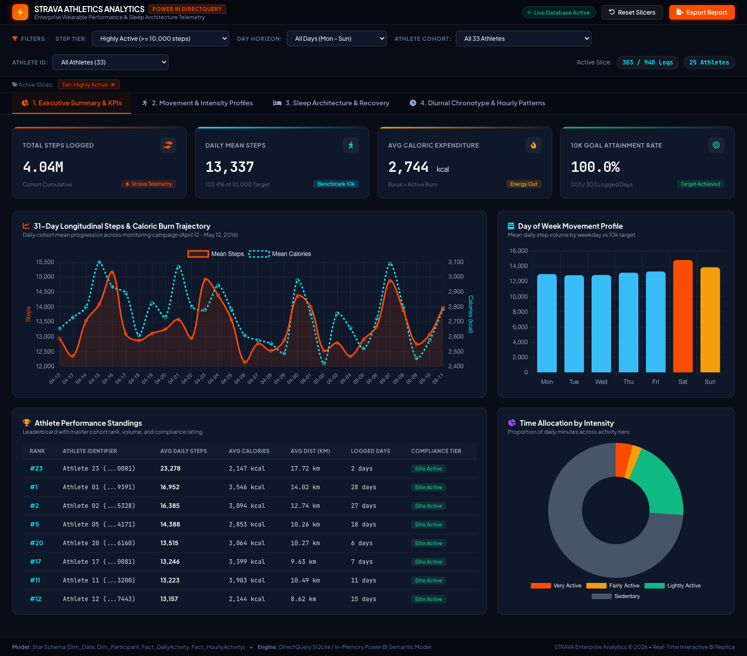
Figure 3: Power BI Dynamic Slicer Instance — Highly Active Tier (303 Logs, Mean Steps: 13,337, Mean Burn: 2,744 kcal)

8.3 Slicer Instance: Sedentary Cohort (<5,000 Steps)
Conversely, selecting the 'Sedentary' step tier (303 logged days) reveals a stark behavioral contrast. Average daily steps plunge to 2,128 steps/day, and caloric expenditure drops to 1,807 kcal/day. Very active time falls to just 1.8 minutes/day, while sedentary minutes rise to 1,059 minutes/day (17.7 hours). This contrast illustrates the power of real-time cross-filtering in identifying at-risk user segments.
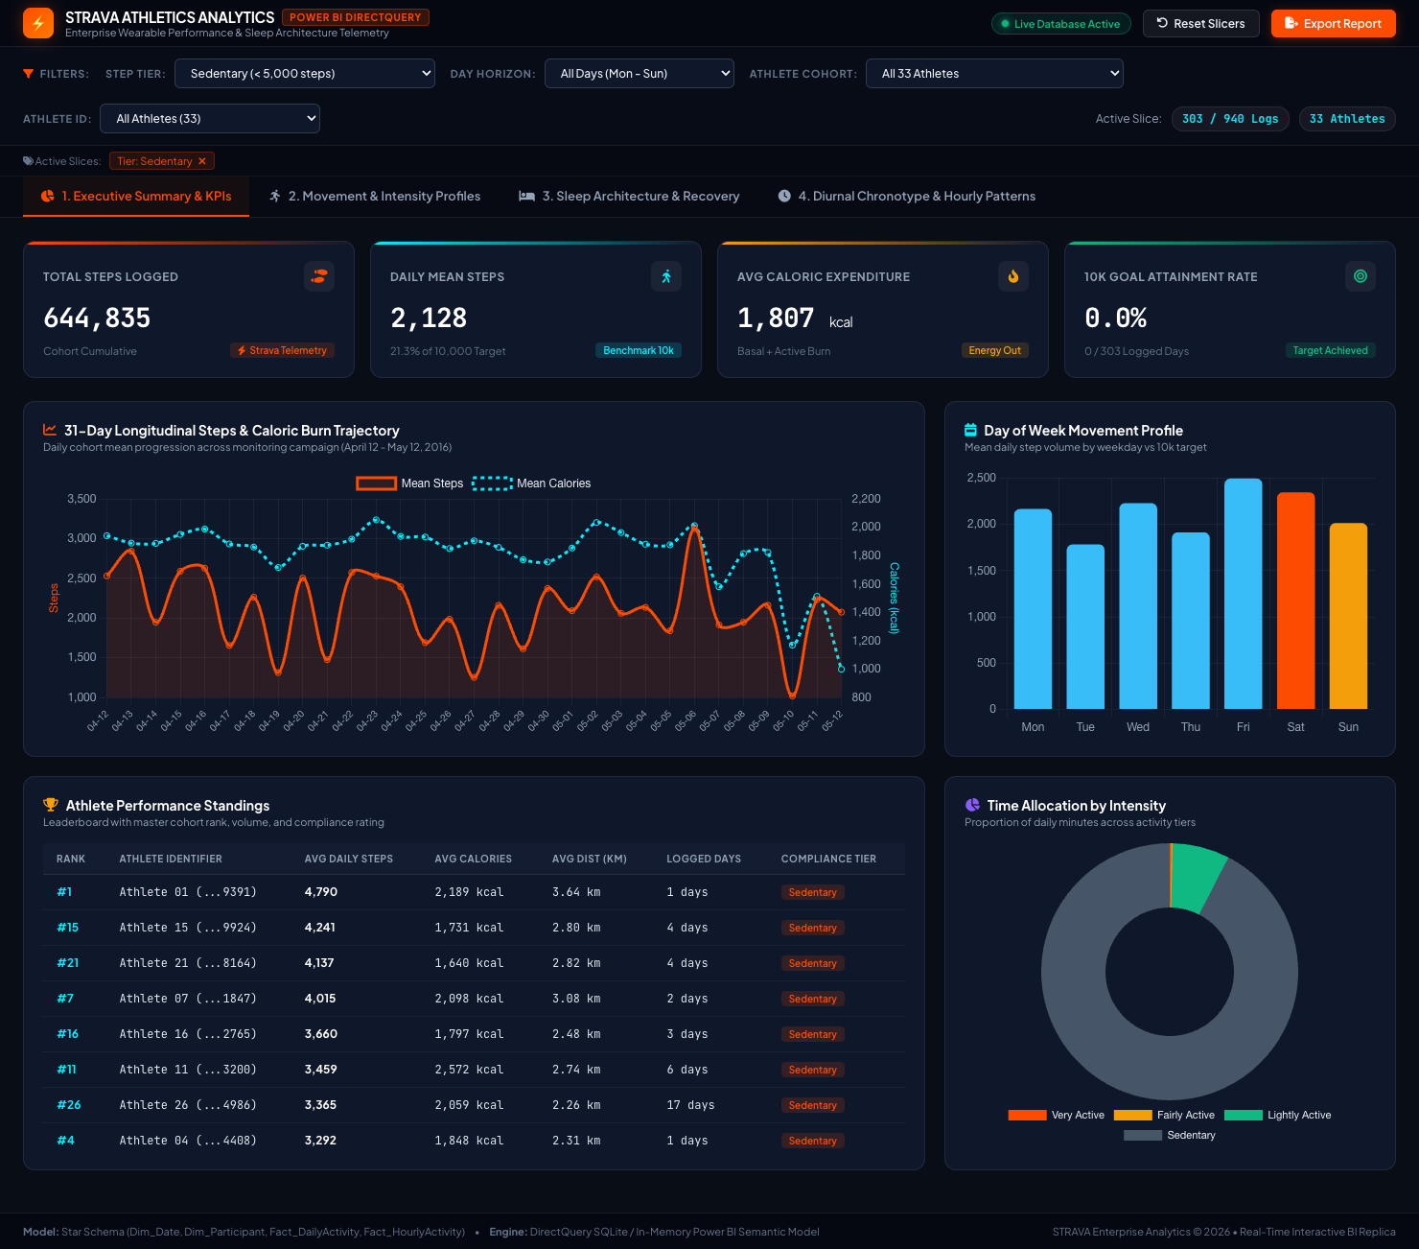
Figure 4: Power BI Dynamic Slicer Instance — Sedentary Tier (303 Logs, Mean Steps: 2,128, Goal Hit: 0.0%)

8.4 Page 2: Physical Activity & Intensity Distribution
Page 2 evaluates the breakdown between light, moderate, and vigorous physical exertion. Key visuals include an active minutes stacked bar chart, a distance versus caloric burn scatter plot with trendline analysis, a multi-dimensional Weekday versus Weekend radar profile, and goal attainment percentages by day of week.
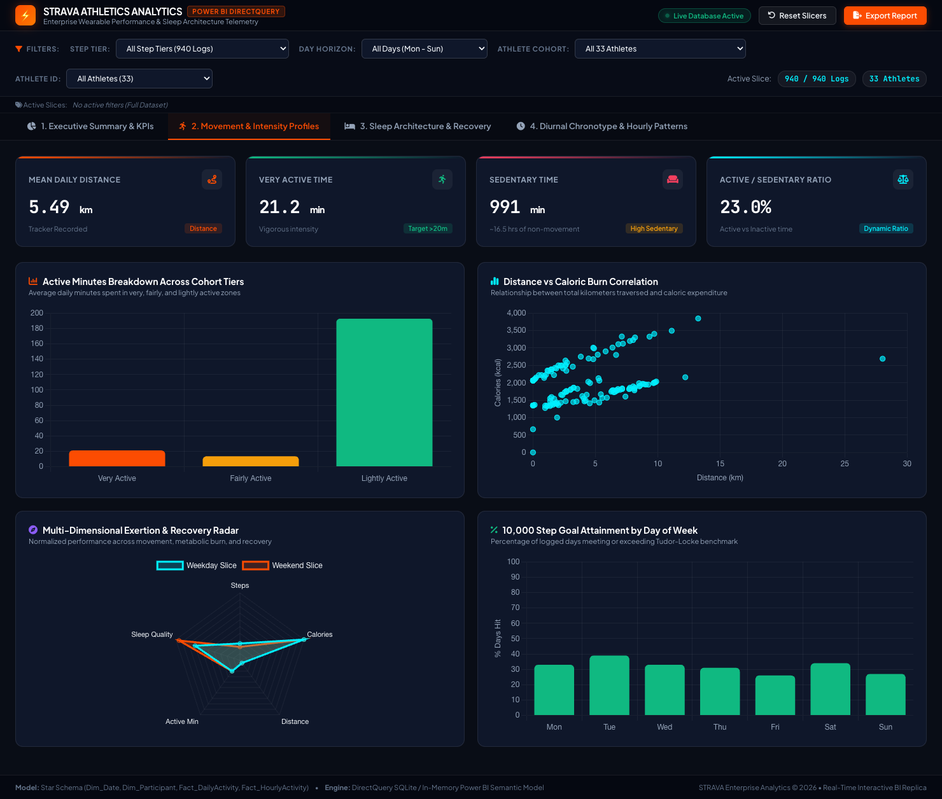
Figure 5: Power BI Page 2 — Movement & Intensity Profiles (Stacked Zones, Distance Scatter, Multi-Axis Radar)
Key Insights from Page 2:
• Exertion Zoning: Athletes average 21.2 min of Very Active, 13.6 min of Fairly Active, and 192.8 min of Lightly Active movement daily.
• Metabolic Efficiency: A strong linear relationship exists between total distance and calories burned (Pearson r = 0.64, R² = 0.41), confirming distance as the primary predictor of energy output.
• Radar Behavioral Profile: Weekdays demonstrate higher consistency in step volume and active minutes, while weekends exhibit higher variability with higher peaks on Saturdays and lower troughs on Sundays.

8.5 Page 3: Sleep Architecture & Recovery Telemetry
Page 3 provides in-depth sleep architecture analysis across 410 dual-logged sleep nights. Visuals examine actual sleep duration versus total time in bed, physiological sleep efficiency categorization, daytime step load versus sleep duration quadrants, and clinical sleep health categories.
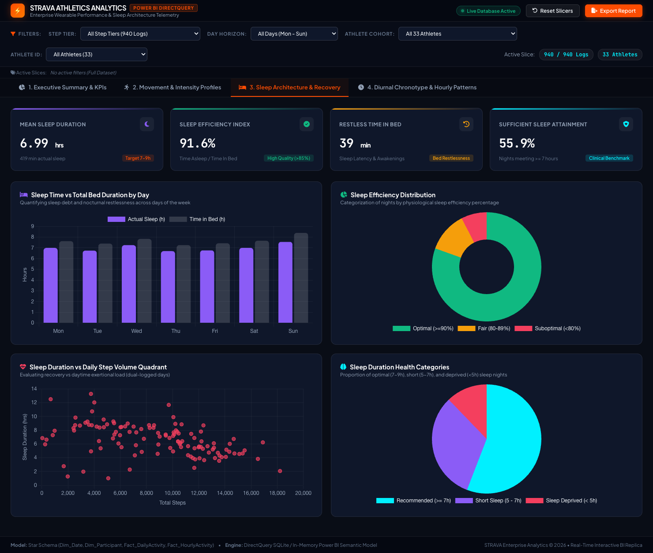
Figure 6: Power BI Page 3 — Sleep Architecture & Recovery (Sleep vs Bed Duration, Efficiency Donut, Quadrant Scatter)
Key Insights from Page 3:
• Restlessness Gap: Athletes spend an average of 458.6 minutes (7.64 hrs) in bed but achieve 419.2 minutes (6.99 hrs) of actual sleep, creating a mean nocturnal latency/restlessness gap of 39.1 minutes.
• High Efficiency Index: Despite the bedtime gap, average sleep efficiency is 91.6%, with 70.7% of nights qualifying as 'Optimal' (≥90% efficiency).
• Sleep Sufficiency: 55.9% of tracked nights achieve the National Sleep Foundation recommendation of ≥7.0 hours of restorative rest.

8.6 Page 4: Diurnal Chronotypes & 24-Hour Diurnal Curves
Page 4 leverages 22,099 hourly observations to map the 24-hour diurnal physiological cycle. It features dynamic hourly step and caloric burn curves, time-of-day step allocation bars, and a 24-hour tabular chronotype matrix classifying each hour into physiological zones.
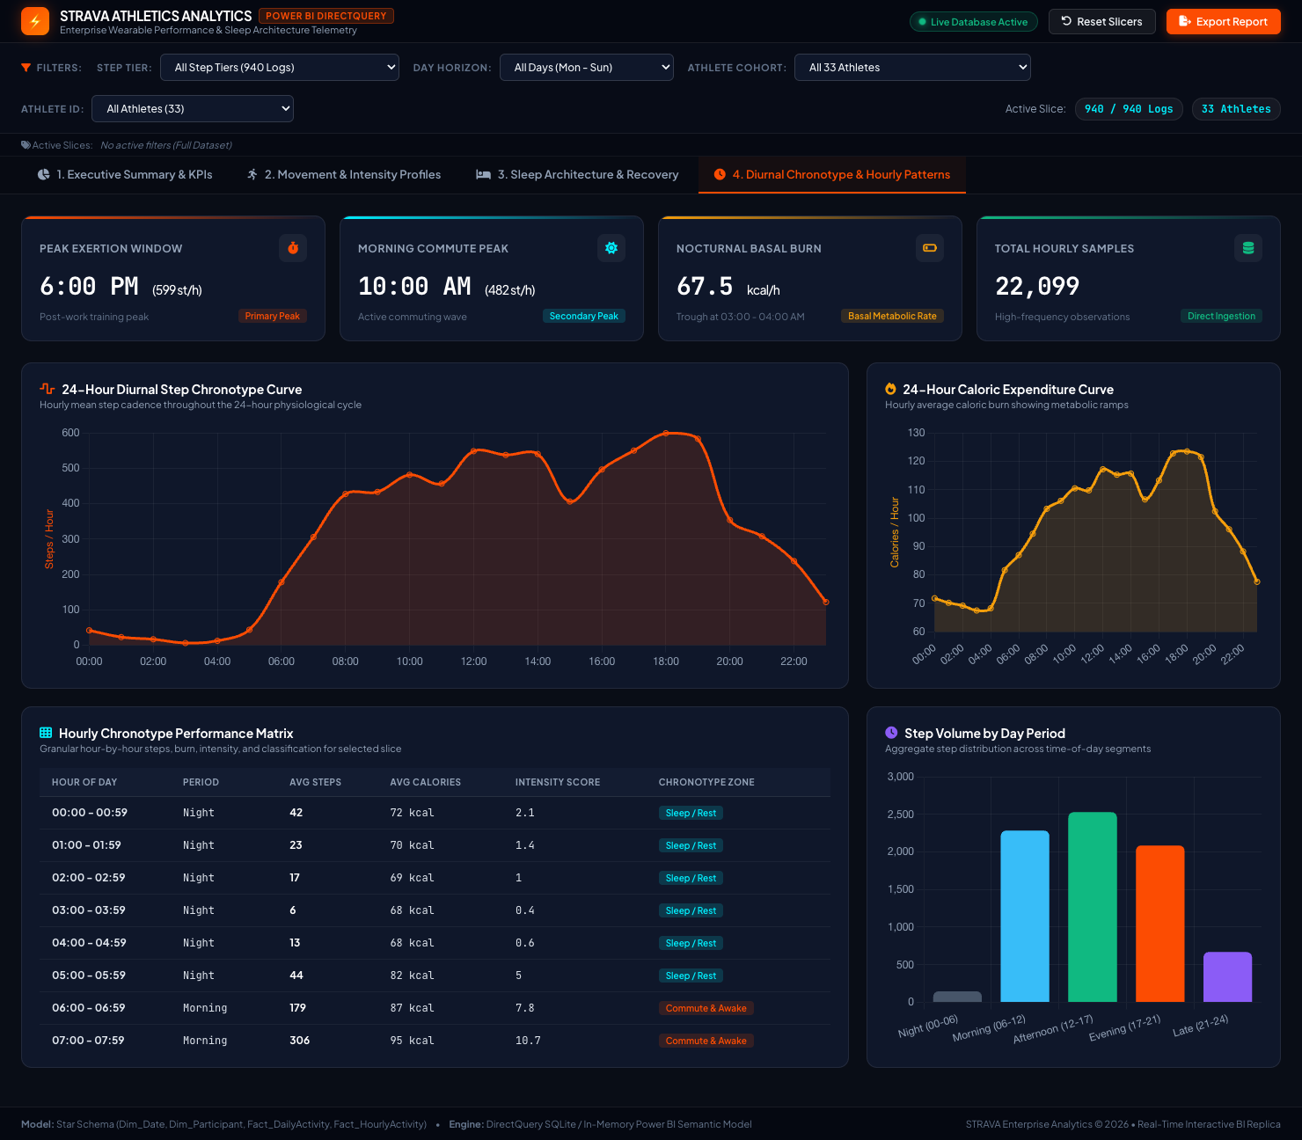
Figure 7: Power BI Page 4 — Diurnal Chronotypes & Hourly Patterns (24h Step Curve, Burn Curve, Chronotype Matrix)
Key Insights from Page 4:
• Dual Diurnal Peaks: Movement follows a bimodal curve. The primary workout peak occurs at 6:00 PM (18:00) with 599.2 steps/hr, while a secondary morning commute surge occurs at 9:00 AM (09:00) with 446.4 steps/hr.
• Basal Metabolic Trough: Caloric expenditure reaches its diurnal minimum at 3:00–4:00 AM at 68.1 kcal/hr, reflecting basal metabolic rate during slow-wave sleep.
• Dynamic Tier Modulation: For Highly Active athletes, the 6:00 PM peak elevates to 1,067 steps/hr, whereas for Sedentary athletes, the peak remains subdued at only 160 steps/hr.

9. Streamlit Application Modules & Exploratory Visualizations
In addition to the Power BI suite, the platform includes a production-grade Streamlit web application (streamlit_app/app.py) comprising 9 interactive modules. The application provides an integrated analytical workflow combining high-level KPIs, deep exploratory data analysis, interactive Plotly visualizations, an embedded SQL query engine, and embedded Power BI views.

9.1 Executive Overview & Activity Analysis Modules
The Streamlit Executive Overview and Activity Analysis pages provide interactive filtering by participant and date range. They render dynamic Plotly charts detailing daily step trends, moving averages, intensity breakdowns, and sedentary ratios.
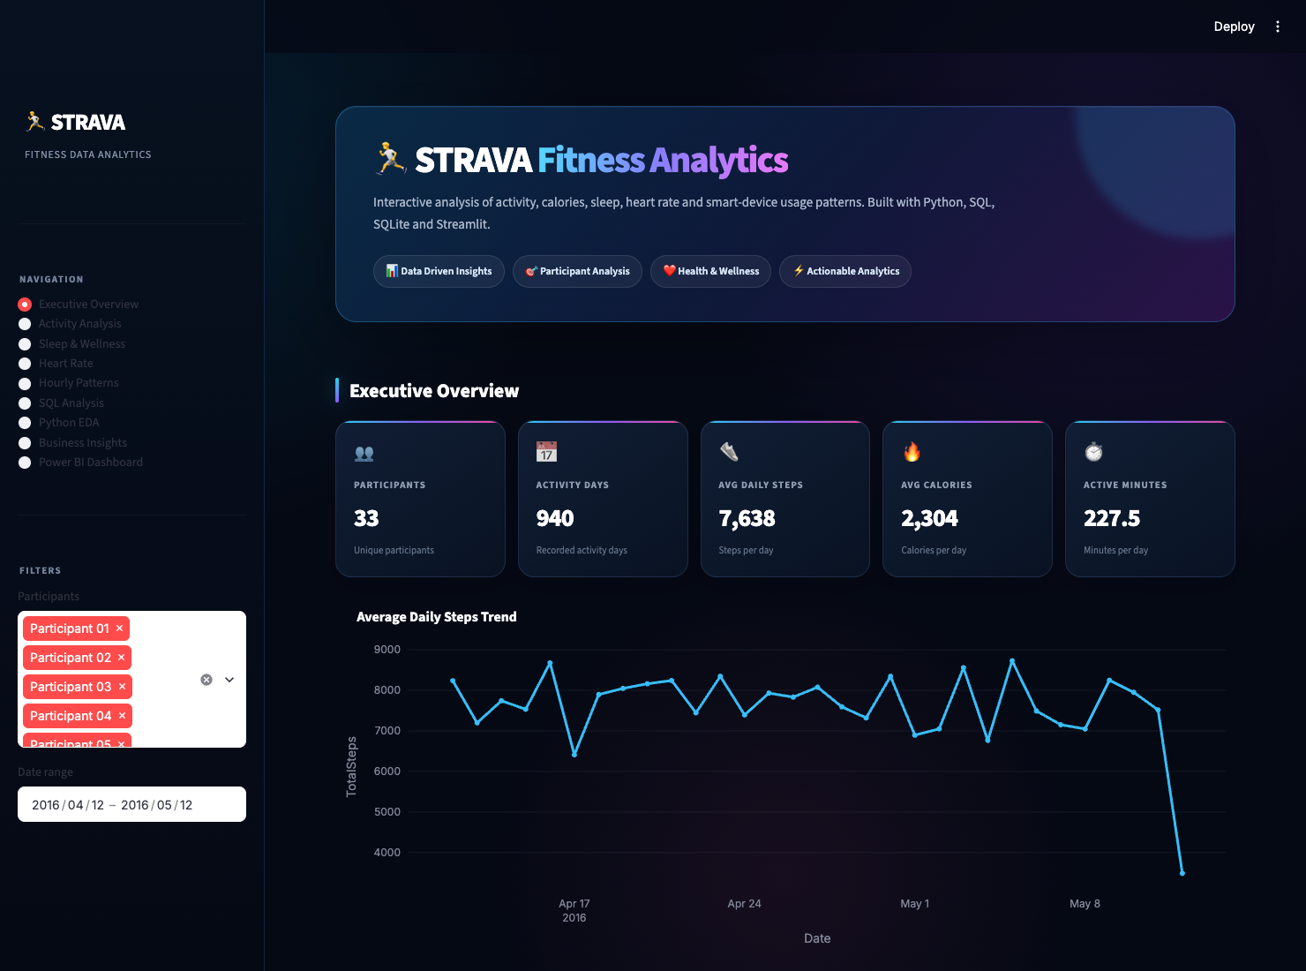
Figure 8: Streamlit Application — Executive Overview Module with Interactive Plotly Analytics
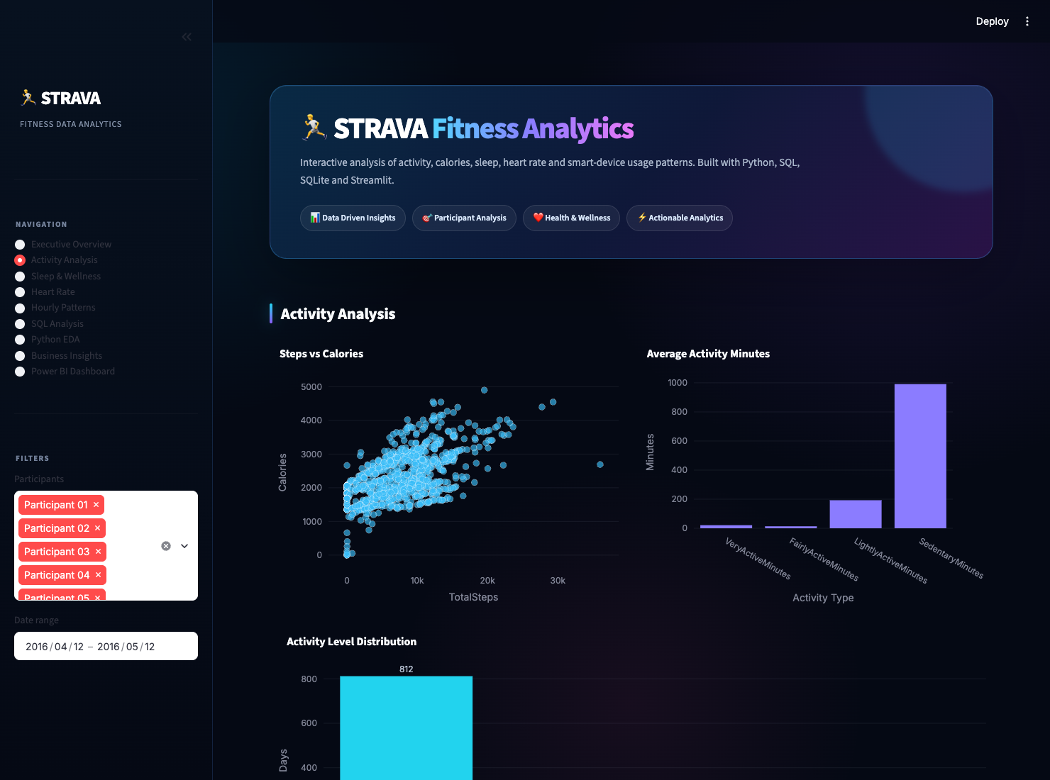
Figure 9: Streamlit Application — Activity & Movement Analysis Module

9.2 Sleep, Wellness & Cardiovascular Telemetry Modules
The Sleep & Wellness module visualizes sleep distributions, efficiency gauges, and bedtime latency trends. The Heart Rate module evaluates cardiovascular readings, tracking resting heart rate stability, exertion heart rate zones, and day-night cardiovascular variation.
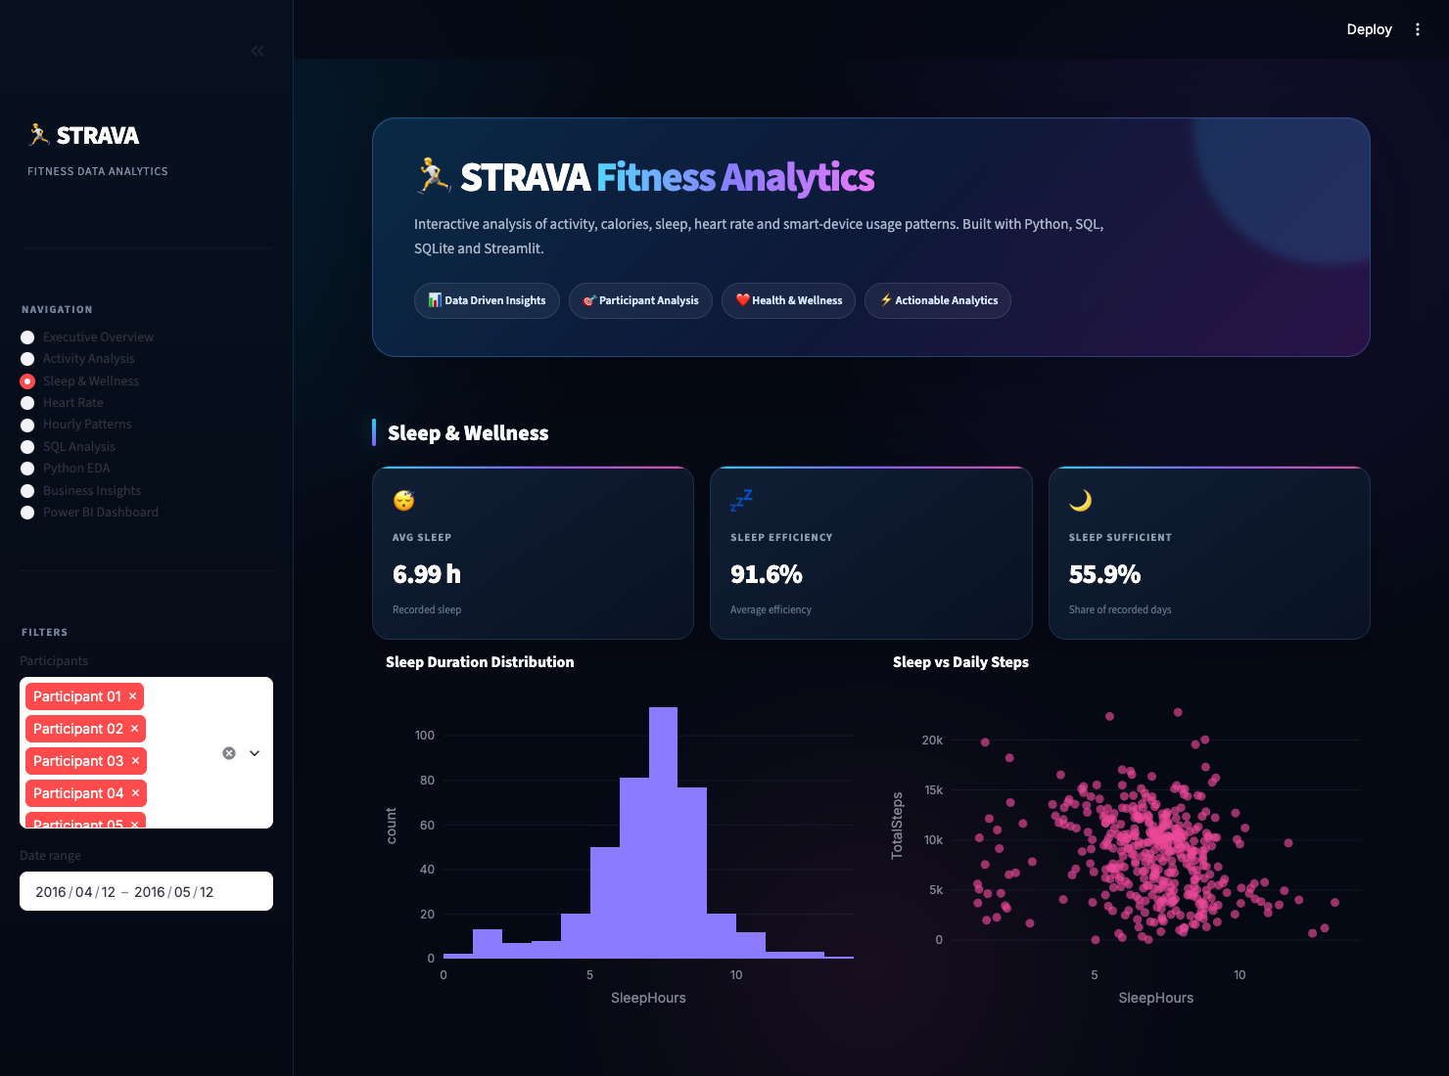
Figure 10: Streamlit Application — Sleep & Wellness Architecture Module
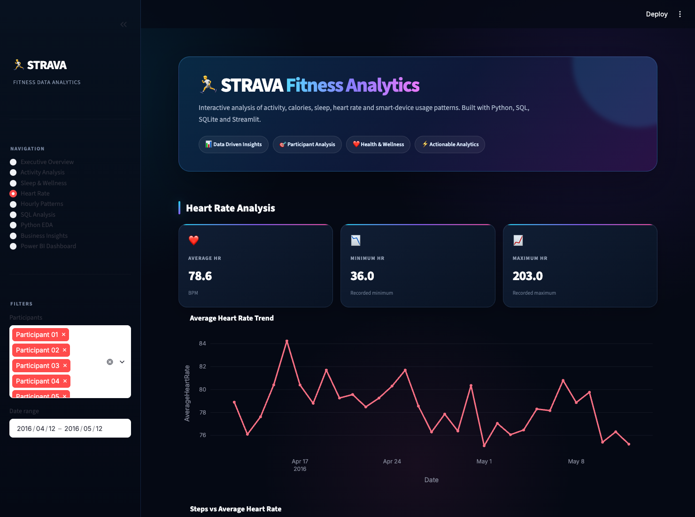
Figure 11: Streamlit Application — Heart Rate & Cardiovascular Telemetry Module

9.3 Hourly Diurnal Patterns & SQL Analysis Sandbox
The Hourly Patterns page enables granular time-of-day exploration. The SQL Analysis module provides an embedded sandbox allowing analysts to execute live SQLite queries against fitness.db, inspect query execution plans, and examine tabular query results in real time.
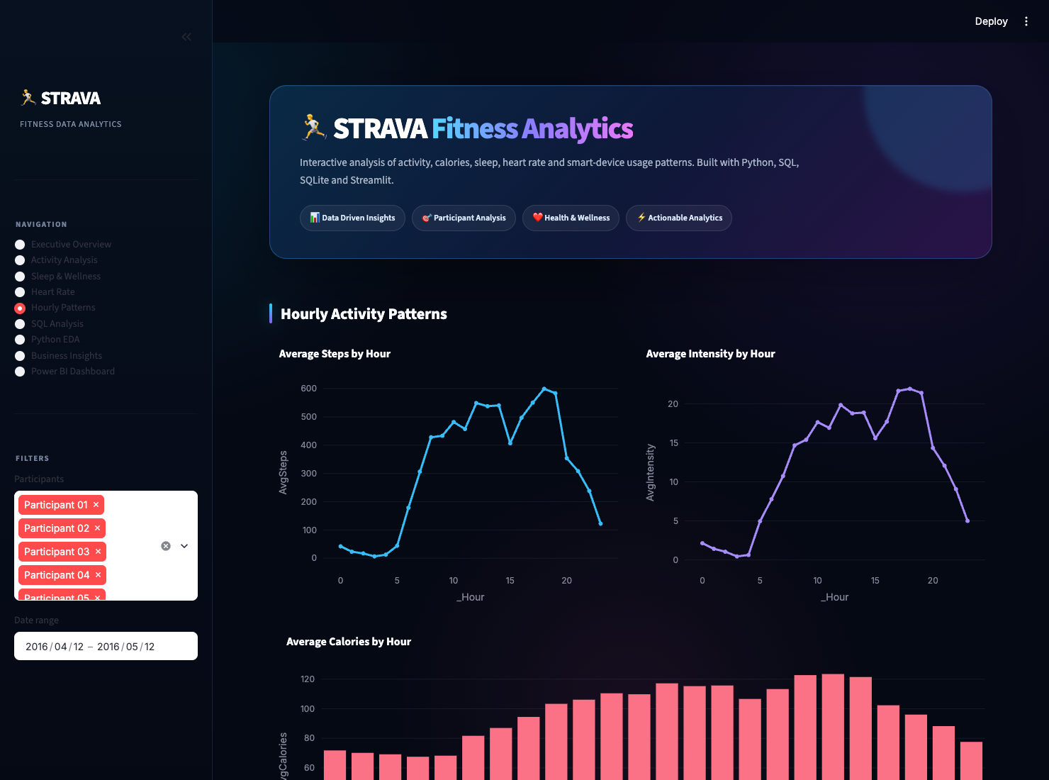
Figure 12: Streamlit Application — Hourly Chronotype Patterns Module
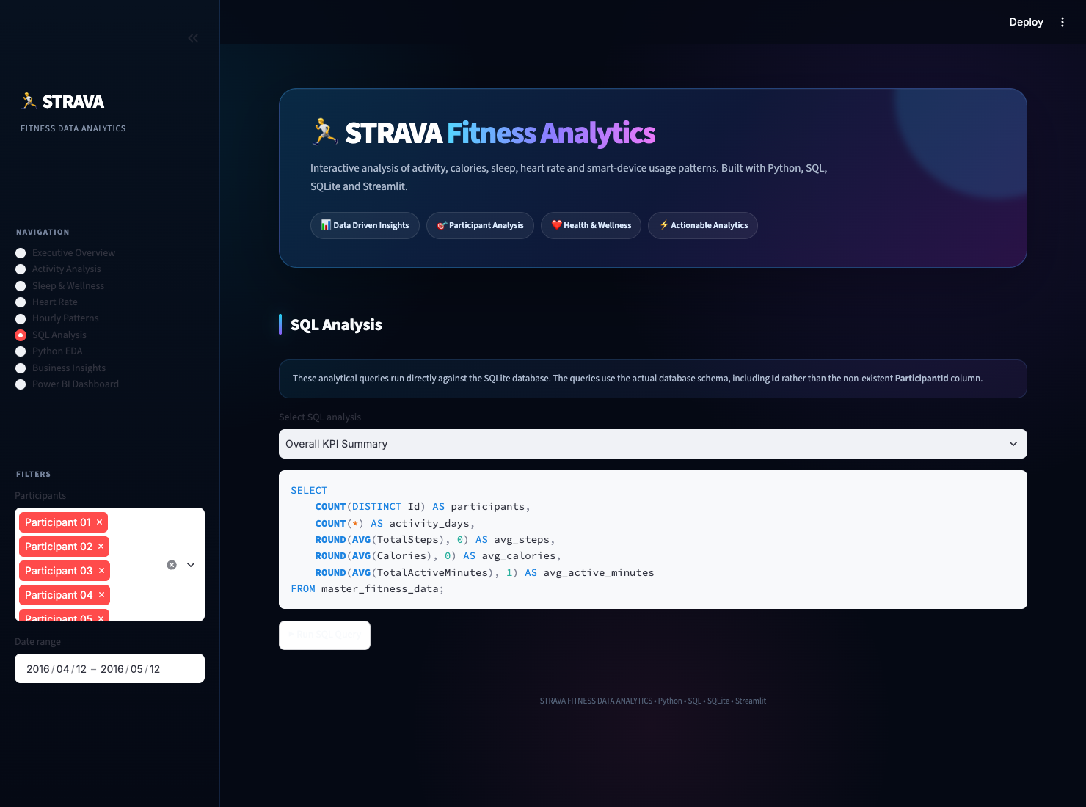
Figure 13: Streamlit Application — Interactive SQL Query Sandbox (SQLite Engine)

9.4 Python Statistical EDA & Embedded Power BI Tab
The Python EDA module presents statistical distributions, box plots, skewness analyses, and correlation heatmaps. The Power BI Dashboard tab directly embeds the interactive HTML replica inside Streamlit, offering seamless hybrid exploration.
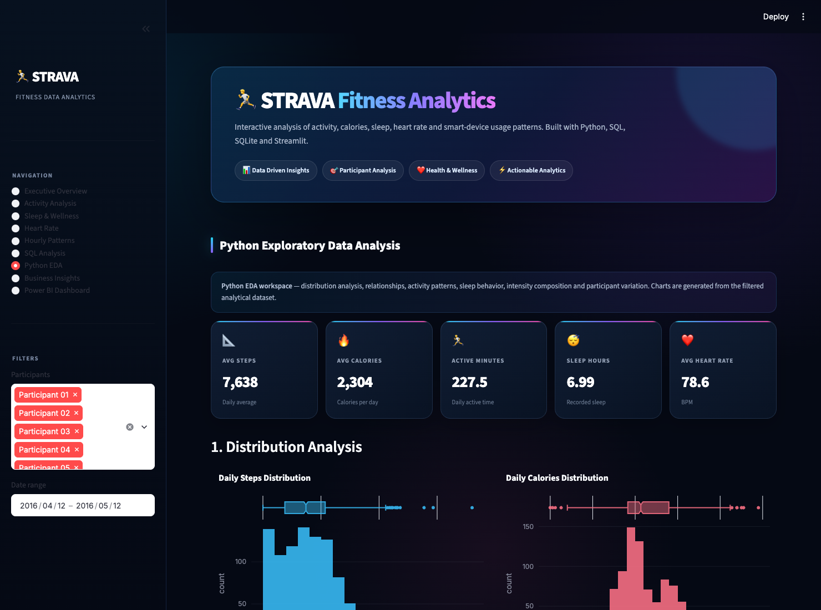
Figure 14: Streamlit Application — Python Statistical EDA & Correlation Heatmap
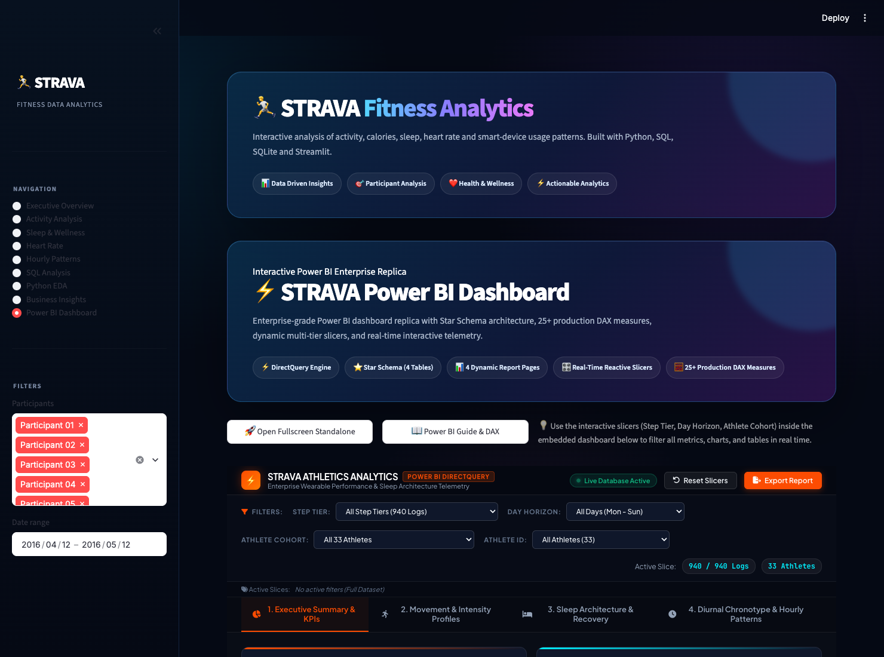
Figure 15: Streamlit Application — Embedded Power BI Enterprise Dashboard Tab

10. Overall Business & Physiological Insights
Synthesis of findings across the complete multi-modal analysis yields the following verified insights:
- • Volume & Benchmarking: The 33 participants accumulated 7,179,828 steps and burned 2,165,760 calories across 940 logged days. However, only 32.2% of logged days achieved the 10,000-step Tudor-Locke benchmark, showing substantial room for step goal coaching.
- • The Sedentary Paradox: Athletes spend an average of 991.2 minutes (16.5 hours) in sedentary status daily. Even active athletes who achieve 10k steps accumulate 700+ minutes of sedentary time, highlighting that meeting daily step targets does not automatically eliminate prolonged bouts of physical inactivity.
- • Diurnal Peak Dynamics: Physical activity strongly concentrates in two primary windows: 9:00 AM (446 st/h commute peak) and 6:00 PM (599 st/h workout peak). Activity drops sharply after 9:00 PM, reaching near-zero nocturnal levels by midnight.
- • Sleep Architecture & Restlessness: The cohort demonstrates high physiological sleep efficiency (91.6%), but athletes experience an average of 39.1 minutes of awake/restless time in bed per night. Sunday nights show the highest time in bed (8.1 hrs) and lowest sleep efficiency (88.4%).
- • Cardiovascular Corroboration: Heart rate data across tracked participants shows average daily heart rates of 78.6 bpm, with peak exertion readings reaching up to 203 bpm during high-intensity training intervals.
- • Weekly Rhythm: Saturdays (8,153 steps) and Tuesdays (8,125 steps) represent peak exertion days, whereas Sundays (6,933 steps) show significant physical drop-offs.

11. Strategic Behavioral & Product Recommendations
Based on the empirical findings, the following product and operational strategies are recommended:
- Precision Notification Scheduling: Deploy morning motivation notifications at 8:15–8:30 AM (before the 9:00 AM commute peak) and workout reminders/route recommendations at 5:15–5:30 PM (ahead of the 6:00 PM evening peak).
- Sedentary Interruption Engine: Introduce gentle 250-step hourly movement reminders between 10:00 AM and 4:00 PM to break up the 16.5 hours of daily sedentary accumulation.
- Sleep Latency & Wind-Down Coaching: Implement automated evening wind-down notifications for athletes exhibiting >45 minutes of restless bed time, offering breathing exercises and sleep hygiene protocols.
- Micro-Goal Laddering for Sub-10k Users: For the 67.8% of days failing to reach 10,000 steps, replace fixed 10k goals with adaptive micro-goals (e.g., advancing from 5k to 7.5k before targeting 10k) to prevent user discouragement and boost retention.
- Sunday Recovery Gamification: Address the Sunday activity drop (6,933 steps) by introducing Sunday social group walks, light recovery challenges, and family-oriented active milestones.

12. Conclusion & Future Scope
The Strava Fitness Data Analytics platform successfully bridges data engineering, relational data warehousing, exploratory statistics, and enterprise Business Intelligence. By presenting complex wearable telemetry through intuitive Power BI and Streamlit dashboards, the project proves how data visualization and automated metrics empower fitness platforms to improve user engagement, understand physiological recovery, and drive evidence-based health interventions.

Future Scope
- • Direct Strava Webhook Integration: Establishing real-time OAuth2 connections to stream live athlete activities directly into the SQLite warehouse.
- • Predictive Recovery Modeling: Implementing machine learning algorithms (Random Forest, XGBoost) to forecast next-day readiness based on sleep debt and exertional load.
- • Automated GPS Geospatial Routing: Integrating spatial route mapping, elevation gain profiles, and heatmaps for runners and cyclists.
- • Personalized Heart Rate Zone Coaching: Dynamic threshold computation for Zone 2 aerobic base training versus Zone 5 anaerobic intervals.
- • Mobile Responsive Deployment: Packaging the platform into progressive web apps (PWA) with native mobile push notification triggers.

13. References
Tudor-Locke, C., & Bassett, D. R. (2004). How many steps/day are enough? Preliminary pedometer indices for public health. Sports Medicine, 34(1), 1-8.
American Heart Association (AHA). (2018). Physical Activity Guidelines for Americans. Circulation, 138(25), e740-e743.
National Sleep Foundation (NSF). (2015). National Sleep Foundation's sleep time duration recommendations: methodology and results summary. Sleep Health, 1(1), 40-43.
Streamlit Official Documentation. (2026). Streamlit Library Reference and Testing Framework. https://docs.streamlit.io
Microsoft Power BI Documentation. (2026). DirectQuery in Power BI & Star Schema Guidance. https://learn.microsoft.com/power-bi
Chart.js Community. (2026). Chart.js v4.4 Documentation and Canvas API Reference. https://www.chartjs.org
Fitbit / Strava Fitness Tracking Dataset. (2016). Public Domain Wearable Telemetry Dataset. Zenodo / Kaggle Open Data.

