目录
1.系统需求描述 3
1.1背景 3
1.2可行性分析 3
1.3业务需求 3
1.4技术需求 3
2. 数据库设计 4
2.1 E-R图 4
2.2数据流程图 4
2.3数据字典 4
3.系统分析与设计 5
3.1系统结构分析 5
3.2系统详细设计 5
3.2.1后端详细设计（src目录） 5
3.2.2 前端详细设计（web目录） 5
4.系统实现与测试 5
4.1系统实现环境 5
4.2系统实现 6
4.3系统测试 26
5.结束语 32
5.1课程设计心得 32

1.系统需求描述

1.1背景
随着企业信息化的发展趋势和计算机技术的不断提高和飞速发展，其强大的
功能已为人们深刻认识,它已经进入人类社会的各个领域并发挥着越来越重要的
作用。无论是个人还是企业都对计算机应用提出了更高的要求。以数据库和计算
机技术为核心的各种企业权限管理系统的应用极大的推动了各种企业的发展，提
高了企业的管理水平。
客户权限管理，是近年来企业采用的一套先进管理方法。其主要含义就是对企业客户的详细资料做出必要的分析，挖掘出客户潜在销售能力，从而提高企业盈利能力。企业客户关系管理系统可以科学、高效地管理企业的客户资源，保存企业与客户进行商业活动相关资料，是当前新技术革命中一个十分活跃和具有很强生命力的技术应用领域，是信息化社会的产物，办公自动化的原动力是人类文明进步和发展的同时人类求的自身解放的需要。因此，快捷、准确、方便、高效的客户关系管理系统可以更好地为客户提供优质的服务，为企业的带来更大的经济利益。

1.2可行性分析
- 从政策的角度上来看，
科技的领先，大大提高了人们的生活质量，给人们带来了很大的便利。国家也在实行对科技领域的政策扶持，让科技领域良好，健康发展。
- 从经济的角度上来看:
学院的计算机室提供各种管理信息系统开发的软件，学校的图书馆也有丰富的图书资料可供借阅。并且学院给每个管理信息系统课程设计的学生都赠送 40个小时的上机操作时间。
- 从技术的角度上来看:
本系统要求能熟练掌握计算机编程语言。我们在大二已经学过了 struts 语言。并且需要有计算机。学院的计算机房有充足的计算机设备，并且装有非常多的程序可供使用。

1.3业务需求
根据业务模型的需求的需要，该系统的功能需求分析设计如下：
（1）登录模块
实现登录和注册功能
（2）管理员管理模块
管理员管理模块分为三部分：增加用户、删除用户，修改用户，查找用户和私人信息。
（3）产品和订单管理模块
产品信息的添加，删除，修改和查找，按关键字查找
产品订单的删除，修改，和关键字查找。

1.4技术需求
本系统使用MVC框架：
M: Model, 模型； （通过 JavaBean 实现）
★ 完成具体的业务操作,如:查询数据库,封装对象，
V:View, 视图。（通过 JSP 页面实现）
★ 展示数据 ，把数据展示在客户端，即前端的开发
C : Controller,控制器。（通过 Servlet 实现）
★ 获取用户的输入
★ 调用模型
★ 将数据交给视图进行展示

数据库设计

2.1 E-R图

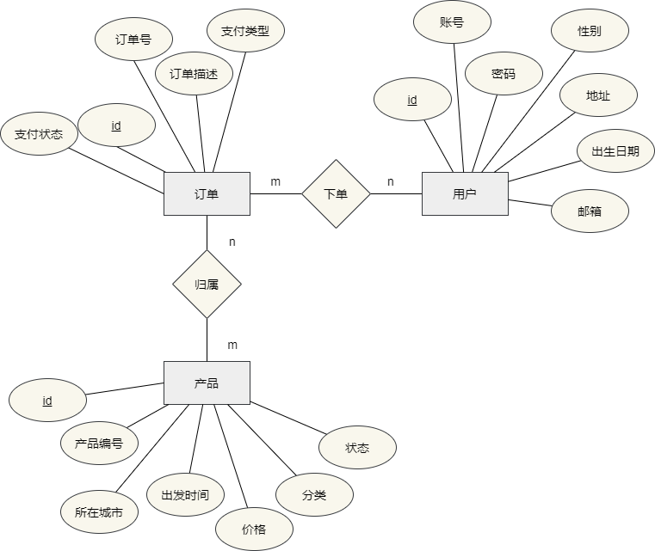

2.2数据流程图

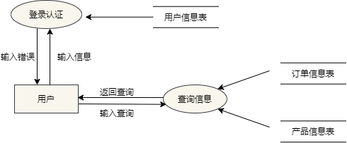

2.3数据字典
2.3.1产品表中：
字段“productStatus”（状态） 为int型，0关闭，1开启。
2.3.2订单表：
字段“payType”(支付方式)为int型，0支付宝，1微信，2其他。
字段“orderStatus”(订单状态)为int型，0未支付，1已支付

3.系统分析与设计

3.1系统结构分析
Project
| - src
| - controller
| - dao
| - domain
| - service
| - utils
| - JDBCUtils.java
| - druid.properties
| - web
| - bootstrap-3.4.1-dist
| - css
| - fonts
| - img
| - js
| - pages
| - WEB-INF
| - index.jsp

3.2系统详细设计

3.2.1后端详细设计（src目录）
controller层控制前端的请求与处理。dao层全称（data access object）用于对数据库进行增删改查。service层给controller层提供接口间接的访问dao层从而操作数据库。utils层是一个工具层，程序中只使用了一个JDBCUtils.java工具，用于给程序构建与数据库的连接池，提高程序访问数据库的开发效率。

3.2.2 前端详细设计（web目录）
Bootstrap-3.4.1-dist层是Bootstrap组件库，给前端提供更高效率的UI视图开发。css层则是编写的一些自定义的css样式，包括网页标签重置。fonts层存放的是字体文件，包括前端页面中的字体图标。img层存放的是前端的图片资源。js层用于操作前端的标签。pages层是前端的jsp页面文件。WEB-INF层存放的是程序不同场景的依赖包。

4.系统实现与测试

4.1系统实现环境
操作系统：win10
服务器：Tomcat v8.0.52
javaJDK：v16.0.2
数据库：mysql v5.7
编辑器：intelliJ IDEA 2020.2.3

4.2系统实现
数据库连接池的实现
public class JDBCUtils {
private static DataSource dataSource;
//静态代码块
static {
//1.创建读取配置文件的对象
Properties properties=new Properties();
try {
//2.导入数据库连接池配置信息文件
properties.load(JDBCUtils.class.getClassLoader().getResourceAsStream("druid.properties"));
//3.通过工厂创建数据库连接池
dataSource=DruidDataSourceFactory.createDataSource(properties);

} catch (IOException e) {
e.printStackTrace();
} catch (Exception e) {
e.printStackTrace();
}
}

public static Connection getConnection() throws SQLException{
return dataSource.getConnection();
}

//归还链接，释放资源
public static void close(Connection connection, PreparedStatement psmt) throws SQLException {
/*if (connection!=null){
connection.close();
}

if (psmt!=null){
psmt.close();
}*/

JDBCUtils.close(null,psmt,connection);
}

public static void close(ResultSet rlt,PreparedStatement pstmt,Connection connection) throws SQLException {
if (rlt!=null){
rlt.close();
}

if (connection!=null){
connection.close();
}

if (pstmt!=null){
pstmt.close();
}
}

}

登录的实现
@WebServlet("/loginServlet")
public class LoginServlet extends HttpServlet {

@Override
protected void doPost(HttpServletRequest req, HttpServletResponse resp) throws ServletException, IOException {
// super.doPost(req, resp);
IUserService iUserService = new UserService();
HttpSession session = req.getSession();

req.setCharacterEncoding("utf-8");
resp.setContentType("text/html;charset=UTF-8");
String account = req.getParameter("account");
String password = req.getParameter("password");

String serverCode = (String) session.getAttribute("code");
String client = req.getParameter("authcode");

Boolean retu = verify(serverCode,client);

if(!retu){
//验证码错误
resp.sendRedirect("/pages/error.jsp");
return;
}

boolean re = iUserService.login(account, password);

if (re) {
//登录成功
session.setAttribute("username", account);

// req.getRequestDispatcher("/find-user").forward(req, resp);
resp.sendRedirect("/pages/home.jsp");
}
}

/**
* 验证码大小写均可通过验证
*/
private boolean verify(String serCode, String ClientCode) {
if (serCode.length() == ClientCode.length()) {
char[] serCodeLen = serCode.toCharArray();
char[] ClientCodeLen = ClientCode.toCharArray();
for (int i = 0; i < serCodeLen.length; i++) {
int c = serCodeLen[i];
int C = ClientCodeLen[i];
if (c > C) {
if ((c - 32) != C) {
return false;
}
} else if (c < C) {
if ((c + 32) != C) {
return false;
}
}
}
return true;
}
return false;
}
}
@Override
public boolean login(String account, String password) {
String sql = "SELECT account,password FROM users WHERE account=? AND password=?;";
try {
connection = JDBCUtils.getConnection();
statement = connection.prepareStatement(sql);
statement.setString(1, account);
statement.setString(2, password);
resultSet = statement.executeQuery();
boolean result = resultSet.next();
JDBCUtils.close(resultSet, statement, connection);
return result;
} catch (SQLException throwables) {
throwables.printStackTrace();
}
return false;
}

注册与添加的实现
@WebServlet("/register")
public class addUser extends HttpServlet {

private IUserService userService = new UserService();

@Override
protected void doPost(HttpServletRequest req, HttpServletResponse resp) throws ServletException, IOException {
req.setCharacterEncoding("utf-8");
resp.setContentType("text/html;charset=UTF-8");

String account = req.getParameter("account");
String password = req.getParameter("password");
String sex = req.getParameter("sex");
String address = req.getParameter("address");
String birthday = req.getParameter("birthday");
String email = req.getParameter("email");

User user = new User();
user.setAccount(account);
user.setPassword(password);
user.setSex(sex);
user.setAddress(address);
user.setBirthday(birthday);
user.setEmail(email);

Boolean re = userService.add(user);
if(re){
resp.sendRedirect("/find-user");
}
}

}
//dao层
@Override
public boolean add(User user) {
String sql = "insert into users values(null,?,?,?,?,?,?)";
try {
connection = JDBCUtils.getConnection();
statement = connection.prepareStatement(sql);
statement.setString(1, user.getAccount());
statement.setString(2, user.getPassword());
statement.setString(3, user.getSex());
statement.setString(4, user.getAddress());
statement.setString(5, user.getBirthday());
statement.setString(6, user.getEmail());

return statement.executeUpdate() > 0;

} catch (SQLException e) {
System.out.println("add user fail");
System.out.println(e);
}

return false;
}

用户查询的实现
@WebServlet("/findUserByPage")
public class FindUserByPage extends HttpServlet {
@Override
protected void doGet(HttpServletRequest req, HttpServletResponse resp) throws ServletException, IOException {
HttpSession session = req.getSession();
IUserService userService = new UserService();
List<User> userList;
String currentStr = req.getParameter("current");
String flag = req.getParameter("flag");
String keywork = req.getParameter("q");
int current = 1;
int limit = 5;
int total = 0;
if (currentStr != null) {
//有提供当前页
current = Integer.parseInt(currentStr);
}
if (flag != null || (keywork != null && keywork.length() > 0)) {
//关键字分页查找
userList = userService.findByKeyWork(keywork, current, limit);
total = (userService.findAllByKey(keywork)).size();
session.setAttribute("keyword", keywork);
} else {
total = (userService.findAll()).size();
userList = userService.findUserByPage(current, limit);
}
int maxPage = total / limit + (total % limit > 0 ? 1 : 0);
session.setAttribute("limit", limit);
session.setAttribute("current", current);
session.setAttribute("total", total);
session.setAttribute("maxPage", maxPage);
session.setAttribute("userList", userList);
resp.sendRedirect("/pages/user-manage.jsp");
}
}
//dao层
// @Override
public List<User> findAllByPage(int current, int limit) {
int offset = (current - 1) * limit;

List<User> userList = new ArrayList<>();

String sql = "select * from users limit ?,?";
try {
connection = JDBCUtils.getConnection();
statement = connection.prepareStatement(sql);
statement.setInt(1, offset);
statement.setInt(2, limit);
//执行sql语句
resultSet = statement.executeQuery();
//处理sql语句
userList = getUsers(resultSet);

JDBCUtils.close(resultSet, statement, connection);

} catch (SQLException e) {
System.out.println("user delete fail");
}

return userList;
}

用户删除的实现
@WebServlet("/delUser")
public class DelUser extends HttpServlet {
@Override

protected void doGet(HttpServletRequest req, HttpServletResponse resp) throws ServletException, IOException {

req.setCharacterEncoding("utf-8");
resp.setContentType("text/html;charset=UTF-8");
int id = Integer.parseInt(req.getParameter("id"));
//
IUserService userService = new UserService();
boolean re = userService.delUser(id);
// if (re) {
// req.getRequestDispatcher("/pages/success.jsp").forward(req, resp);
resp.sendRedirect("/find-user");
// }

}
}
//dao层
@Override
public boolean delUser(int id) {

String sql = "delete from users where id=?";

try {
connection = JDBCUtils.getConnection();
statement = connection.prepareStatement(sql);

statement.setInt(1, id);
return statement.executeUpdate() > 0;
} catch (SQLException e) {
System.out.println("删除失败");
}

return false;
}

编辑用户的实现
@WebServlet("/to-edit-user")
public class toEditUSer extends HttpServlet {
IUserService userService = new UserService();
@Override
protected void doGet(HttpServletRequest req, HttpServletResponse resp) throws ServletException, IOException {
// /to-edit-user?id=30
int id = Integer.parseInt(req.getParameter("id"));
User user = userService.findUserById(id);
HttpSession session = req.getSession();
session.setAttribute("user",user);
resp.sendRedirect("/pages/edit-user.jsp");
}
}

@WebServlet("/edit-user")
public class EditUser extends HttpServlet {
IUserService userService = new UserService();
@Override
protected void doPost(HttpServletRequest req, HttpServletResponse resp) throws ServletException, IOException {
req.setCharacterEncoding("utf-8");
resp.setContentType("text/html;charset=UTF-8");
User user = new User();
String account = req.getParameter("account");
String sex = req.getParameter("sex");
String address = req.getParameter("address");
String birthday = req.getParameter("birthday");
String email = req.getParameter("email");
int id = Integer.parseInt(req.getParameter("id"));
user.setAccount(account);
user.setSex(sex);
user.setAddress(address);
user.setBirthday(birthday);
user.setEmail(email);
user.setId(id);
boolean re = userService.editUserById(user);
if(re){
resp.sendRedirect("/find-user");
}
}
}
//dao层
@Override
public Boolean editUserById(User user) {
String sql = "update `users` set `account`=?,`sex`=?,`address`=?,`birthday`=?,`email`=? where id=?";
try {
connection = JDBCUtils.getConnection();
statement = connection.prepareStatement(sql);
statement.setString(1, user.getAccount());
statement.setString(2, user.getSex());
statement.setString(3, user.getAddress());
statement.setString(4, user.getBirthday());
statement.setString(5, user.getEmail());
statement.setInt(6, user.getId());
int re = statement.executeUpdate();
if (re != 0) {
return true;
}
} catch (SQLException e) {
System.out.println("edit user by id fail");
System.out.println(e);
}
return false;
}

关键字查询用户的实现
@Override
public List<User> findByKeyWord(String key, int current, int limit) {
List<User> list = new ArrayList<>();
int offset = (current - 1) * limit;
String sql = "SELECT * FROM users WHERE `account`=? OR `passWord`=? OR `email`=? or `sex`=? or `address`=? limit ?,? ";
try {
connection = JDBCUtils.getConnection();
statement = connection.prepareStatement(sql);
statement.setString(1, key);
statement.setString(2, key);
statement.setString(3, key);
statement.setString(4, key);
statement.setString(5, key);
statement.setInt(6, offset);
statement.setInt(7, limit);
resultSet = statement.executeQuery();
while (resultSet.next()) {
int id = resultSet.getInt(1);
String account = resultSet.getString(2);
String passWord = resultSet.getString(3);
String sex = resultSet.getString(4);
String address = resultSet.getString(5);
String birthday = resultSet.getString(6);
String email = resultSet.getString(7);
list.add(new User(id, account, passWord, sex, address, birthday, email));
}
JDBCUtils.close(resultSet, statement, connection);
} catch (SQLException throwables) {
throwables.printStackTrace();
}
return list;
}

产品查询的实现
@WebServlet("/find-product-by-page")
public class FindProductByPage extends HttpServlet {
@Override
protected void doGet(HttpServletRequest req, HttpServletResponse resp) throws ServletException, IOException {
req.setCharacterEncoding("utf-8");
resp.setContentType("text/html;charset=UTF-8");
HttpSession session = req.getSession();
IProductService productService = new ProductService();
List<Product> productList;
String currentStr = req.getParameter("current");
String flag = req.getParameter("flag");
String keywork = req.getParameter("q");
int current = 1;
int limit = 5;
int total = 0;
if (currentStr != null) {
//有提供当前页
current = Integer.parseInt(currentStr);
}
if (flag != null || (keywork != null && keywork.length() > 0)) {
//关键字分页查找
productList = productService.findByKeyWord(keywork, current, limit);
total = (productService.findAllByKey(keywork)).size();
session.setAttribute("keyword", keywork);
} else {
total = (productService.findAll()).size();
productList = productService.findAllByPage(current, limit);
}
int maxPage = total / limit + (total % limit > 0 ? 1 : 0);
session.setAttribute("limit", limit);
session.setAttribute("current", current);
session.setAttribute("total", total);
session.setAttribute("maxPage", maxPage);
session.setAttribute("products", productList);
resp.sendRedirect("/pages/product-manage.jsp");
}
}
//dao层
public List<Product> findAllByPage(int current, int limit) {
int offset = (current - 1) * limit;
List<Product> products = new ArrayList<>();

String sql = "select * from products limit ?,?";

try {
connection = JDBCUtils.getConnection();
statement = connection.prepareStatement(sql);
statement.setInt(1, offset);
statement.setInt(2, limit);
resultSet = statement.executeQuery();
//处理sql语句
products = getProducts(resultSet);

} catch (SQLException e) {
System.out.println(e);
System.out.println("editProductById fail");
}

return products;
}

产品删除的实现
@WebServlet("/delProduct")
public class DelProduct extends HttpServlet {
protected void doPost(HttpServletRequest req, HttpServletResponse resp) throws ServletException, IOException {
req.setCharacterEncoding("utf-8");
resp.setContentType("text/html;charset=UTF-8");
int id = Integer.parseInt(req.getParameter("id"));
IProductService productService = new ProductService();
boolean re = productService.delProduct(id);
resp.sendRedirect("/product-manage");
}
}
//dao层
@Override
public boolean delUser(int id) {
String sql = "delete from products where id=?";
try {
connection = JDBCUtils.getConnection();
statement = connection.prepareStatement(sql);

statement.setInt(1, id);
return statement.executeUpdate() > 0;
} catch (SQLException e) {
System.out.println("删除失败");
}
return false;
}

产品添加的实现
@WebServlet("/add-product")
public class addProduct extends HttpServlet {
private IProductService productService = new ProductService();
@Override
protected void doPost(HttpServletRequest req, HttpServletResponse resp) throws ServletException, IOException {
req.setCharacterEncoding("utf-8");
resp.setContentType("text/html;charset=UTF-8");
String num = req.getParameter("num");
String name = req.getParameter("name");
String city = req.getParameter("city");
String departureTime = req.getParameter("departureTime");
Float price = Float.parseFloat(req.getParameter("price"));
String sort = req.getParameter("sort");
int status = Integer.parseInt(req.getParameter("status"));
Product product = new Product();
product.setProductNum(num);
product.setProductName(name);
product.setCityName(city);
product.setDepartureTime(departureTime);
product.setProductPrice(price);
product.setProductDesc(sort);
product.setProductStatus(status);
Boolean re = productService.add(product);
if (re) {
resp.sendRedirect("/product-manage");
}
}
}
//dao层
@Override
public boolean add(Product product) {
String sql = "insert into products values(null,?,?,?,?,?,?,?)";
try {
connection = JDBCUtils.getConnection();
statement = connection.prepareStatement(sql);
statement.setString(1, product.getProductNum());
statement.setString(2, product.getProductName());
statement.setString(3, product.getCityName());
statement.setString(4, product.getDepartureTime());
statement.setFloat(5, product.getProductPrice());
statement.setString(6, product.getProductDesc());
statement.setInt(7, product.getProductStatus());
return statement.executeUpdate() > 0;
} catch (SQLException e) {
System.out.println("add user fail");
System.out.println(e);
}
return false;
}

产品编辑的实现
@WebServlet("/edit-product")
public class EditProduct extends HttpServlet {
private IProductService productService = new ProductService();
@Override
protected void doPost(HttpServletRequest req, HttpServletResponse resp) throws ServletException, IOException {
req.setCharacterEncoding("utf-8");
resp.setContentType("text/html;charset=UTF-8");
int id = Integer.parseInt(req.getParameter("id"));
String num = req.getParameter("num");
String name = req.getParameter("name");
String city = req.getParameter("city");
String departureTime = req.getParameter("departureTime");
Float price = Float.parseFloat(req.getParameter("price"));
String sort = req.getParameter("sort");
int status = Integer.parseInt(req.getParameter("status"));
Product product = new Product();
product.setId(id);
product.setProductNum(num);
product.setProductName(name);
product.setCityName(city);
product.setDepartureTime(departureTime);
product.setProductPrice(price);
product.setProductDesc(sort);
product.setProductStatus(status);
boolean re = productService.editProductById(product);
if (re) {
resp.sendRedirect("/product-manage");
}
}
}
//dao层
@Override
public Boolean editProductById(Product product) {
String sql = "update `products` set `productNum`=?,`productName`=?,`cityName`=?,`departureTime`=?,`productPrice`=?,`productDesc`=?,`productStatus`=? where `id`=?";
try {
connection = JDBCUtils.getConnection();
statement = connection.prepareStatement(sql);
statement.setString(1, product.getProductNum());
statement.setString(2, product.getProductName());
statement.setString(3, product.getCityName());
statement.setString(4, product.getDepartureTime());
statement.setFloat(5, product.getProductPrice());
statement.setString(6, product.getProductDesc());
statement.setInt(7, product.getProductStatus());
statement.setInt(8, product.getId());
int re = statement.executeUpdate();
if (re != 0) {
return true;
}
} catch (SQLException e) {
System.out.println(e);
System.out.println("editProductById fail");
}
return false;
}

按关键字查询产品的实现
@Override
public List<Product> findByKeyWord(String key, int current, int limit) {
int offset = (current - 1) * limit;
List<Product> products = new ArrayList<>();

String sql = "select * from products where productNum=? or productName=? or departureTime=? or productDesc=? or cityName=? limit ?,?";
try {
connection = JDBCUtils.getConnection();
statement = connection.prepareStatement(sql);
statement.setString(1, key);
statement.setString(2, key);
statement.setString(3, key);
statement.setString(4, key);
statement.setString(5, key);
statement.setInt(6, offset);
statement.setInt(7, limit);

resultSet = statement.executeQuery();
//处理sql语句
products = getProducts(resultSet);

} catch (SQLException e) {
System.out.println(e);
System.out.println("editProductById fail");
}
return products;
}

查询订单的实现
@WebServlet("/find-order-by-page")
public class FindOrderByPage extends HttpServlet {
private IOrderService orderService = new OrderService();
@Override
protected void doGet(HttpServletRequest req, HttpServletResponse resp) throws ServletException, IOException {
req.setCharacterEncoding("utf-8");
resp.setContentType("text/html;charset=UTF-8");
HttpSession session = req.getSession();
List<Order> orderList;
String currentStr = req.getParameter("current");
String flag = req.getParameter("flag");
String keywork = req.getParameter("q");
int current = 1;
int limit = 5;
int total = 0;
if (currentStr != null) {
//有提供当前页
current = Integer.parseInt(currentStr);
}
if (flag != null || (keywork != null && keywork.length() > 0)) {
//关键字分页查找
orderList = orderService.findAllByKeywork(keywork, current, limit);
total = (orderService.findAllByKey(keywork)).size();
session.setAttribute("keyword", keywork);
} else {
total = (orderService.findAll()).size();
orderList = orderService.findAllByPage(current, limit);
}
int maxPage = total / limit + (total % limit > 0 ? 1 : 0);
session.setAttribute("limit", limit);
session.setAttribute("current", current);
session.setAttribute("total", total);
session.setAttribute("maxPage", maxPage);
session.setAttribute("orderList", orderList);
resp.sendRedirect("/pages/order-manage.jsp");
}
}
//dao层
@Override
public List<Order> findAllByPage(int current, int limit) {
int offset = (current - 1) * limit;
List<Order> orderList = new ArrayList<>();
String sql = "SELECT a.id,a.orderNum,a.orderTime,a.orderDesc,a.payType,a.orderStatus,c.productName,b.account FROM `orders` a INNER JOIN users b on a.userid=b.id INNER JOIN products c on a.productid = c.id limit ?,?";
try {
//创建连接对象
connection = JDBCUtils.getConnection();
//定义sql语句
statement = connection.prepareStatement(sql);
statement.setInt(1, offset);
statement.setInt(2, limit);
resultSet = statement.executeQuery();
//处理sql语句
orderList = getOrders(resultSet);
JDBCUtils.close(resultSet, statement, connection);
} catch (SQLException e) {
System.out.println(e);
System.out.println("findAllByPage fail");
}
return orderList;
}

删除订单的实现
@WebServlet("/del-order")
public class DelOrder extends HttpServlet {
@Override
protected void doPost(HttpServletRequest req, HttpServletResponse resp) throws ServletException, IOException {
req.setCharacterEncoding("utf-8");
resp.setContentType("text/html;charset=UTF-8");
int id = Integer.parseInt(req.getParameter("id"));
IOrderService orderService = new OrderService();
Boolean re = orderService.delOrder(id);
if (re) {
resp.sendRedirect("/find-order-by-page");
}
}
}
//dao层
@Override
public Boolean delOrder(int id) {
String sql = "delete from orders where id=?";
try {
//创建连接对象
connection = JDBCUtils.getConnection();
//定义sql语句
statement = connection.prepareStatement(sql);
statement.setInt(1, id);

int re = statement.executeUpdate();
//处理sql语句

JDBCUtils.close(resultSet, statement, connection);

return re > 0;

} catch (SQLException e) {
System.out.println(e);
System.out.println("order findall fail");
}
return false;
}

编辑订单的实现
@WebServlet("/edit-order")
public class EditOrder extends HttpServlet {

private IOrderService orderService = new OrderService();

@Override
protected void doPost(HttpServletRequest req, HttpServletResponse resp) throws ServletException, IOException {
req.setCharacterEncoding("utf-8");
resp.setContentType("text/html;charset=UTF-8");
Order order = new Order();
int status = Integer.parseInt(req.getParameter("status"));
String desc = req.getParameter("desc");
int payType = Integer.parseInt(req.getParameter("payType"));
int id = Integer.parseInt(req.getParameter("id"));
order.setStatus(status);
order.setDesc(desc);
order.setPayType(payType);
order.setId(id);
boolean re = orderService.editOrderById(order);
if (re) {
resp.sendRedirect("/find-order-by-page");
}
}
}
//dao层
public Boolean editOrderById(Order order) {
String sql = "update `orders` set `orderStatus`=?, `orderDesc`=?, payType=? where id=?";
try {
connection = JDBCUtils.getConnection();
statement = connection.prepareStatement(sql);
statement.setInt(1, order.getStatus());
statement.setString(2, order.getDesc());
statement.setInt(3, order.getPayType());
statement.setInt(4, order.getId());

return statement.executeUpdate() > 0;

} catch (SQLException e) {
System.out.println(e);
System.out.println("batch del fail");
}

return false;
}
关键字查询的实现
@Override
public List<Order> findAllByKeywork(String key, int current, int limit) {
int offset = (current - 1) * limit;
List<Order> orderList = new ArrayList<>();

String sql = "SELECT a.id,a.orderNum,a.orderTime,a.orderDesc,a.payType,a.orderStatus,c.productName,b.account FROM `orders` a INNER JOIN users b on a.userid=b.id INNER JOIN products c on a.productid = c.id where a.orderNum=? or a.orderTime=? or b.account=? or c.productName=? limit ?,?";

try {
//创建连接对象
connection = JDBCUtils.getConnection();
//定义sql语句
statement = connection.prepareStatement(sql);
statement.setString(1, key);
statement.setString(2, key);
statement.setString(3, key);
statement.setString(4, key);
statement.setInt(5, offset);
statement.setInt(6, limit);

resultSet = statement.executeQuery();
//处理sql语句
orderList = getOrders(resultSet);
JDBCUtils.close(resultSet, statement, connection);
} catch (SQLException e) {
System.out.println(e);
}
return orderList;
}

验证码图片的实现
@WebServlet("/servlet/ImageServlet")
public class ImageServlet extends HttpServlet {
//步骤
//1.定义BufferedImage对象
//2.获得Graphics
//3.通过Random长生随机验证码信息
//4.使用Graphics绘制图片
//5.记录验证码信息到session中
//6.使用ImageIO输出图片
protected void doGet(HttpServletRequest req, HttpServletResponse resp) throws ServletException, IOException {
//图片的宽度和高度
int width=90;
int height=33;
//验证码个数和干扰线个数
int len=4;
int count=15;
//设置图片宽高和图片类型
BufferedImage image=new BufferedImage(width,height, BufferedImage.TYPE_INT_RGB);
//1.获取图片画笔和设置字体
Graphics graphics = image.getGraphics();
graphics.setFont(new Font(null,Font.BOLD,height-4));
//取随机验证码
Random random=new Random();
//2.设置画笔颜色绘画图片背景颜色
graphics.setColor(new Color(random.nextInt(255),random.nextInt(255),random.nextInt(255)));
//3.绘制一个与设置图片大小一致
graphics.fillRect(0, 0, width, height);
//验证码字符
String code="";
char[] codeArray="ABCDEFGHIJKLMNOPQRSTUVWXYZabcdefghijklmnopqrstuvwxyz0123456789".toCharArray();
//获取随机验证码
for (int i = 0; i < len; i++) {
char c=codeArray[random.nextInt(codeArray.length)];
code=code+c;
//设置验证码字体随机
graphics.setColor(new Color(random.nextInt(255),random.nextInt(255),random.nextInt(255)));
//绘画验证码
graphics.drawString(c+"", (i+1)*18, height-4);
}
//保存在session中
HttpSession session=req.getSession();
session.setAttribute("code",code);
//绘制干扰线
for (int i = 0; i < count; i++) {
//设置随机干扰线颜色
graphics.setColor(new Color(random.nextInt(255),random.nextInt(255), random.nextInt(255),random.nextInt(255)));
//绘制干扰线
graphics.drawLine(random.nextInt(width), random.nextInt(height), random.nextInt(width), random.nextInt(height));
}
//输出图片
ImageIO.write(image,"png",resp.getOutputStream());
resp.getOutputStream().flush();
resp.getOutputStream().close();
}
}

4.3系统测试
登录页面（login.jsp）
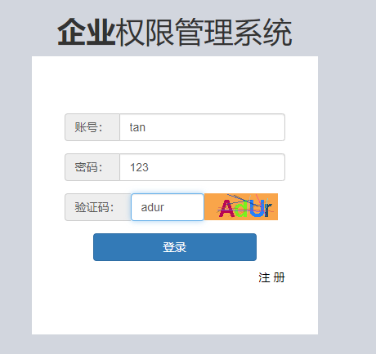
注册界面（register.jsp）
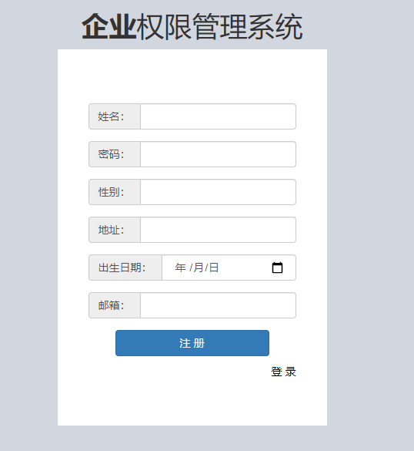

首页（home.jsp）
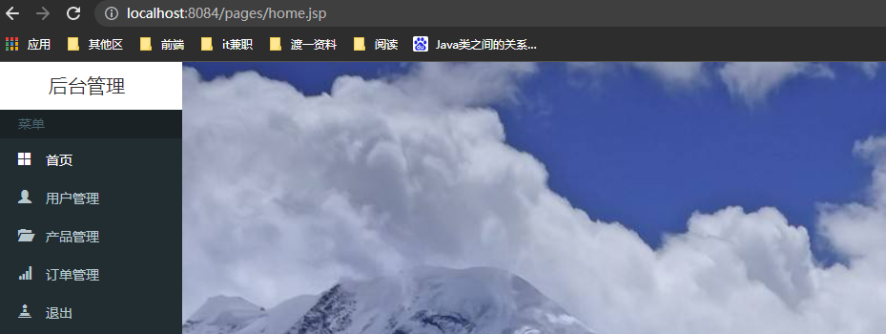

用户管理界面（user-manage.jsp）
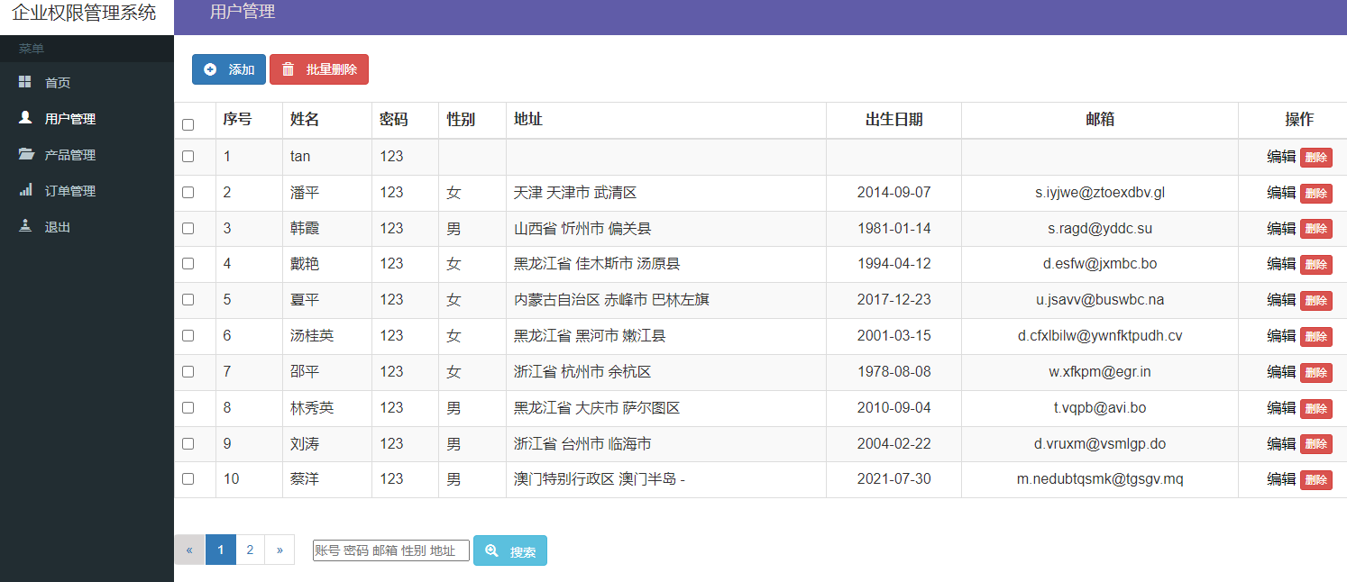
用户的添加
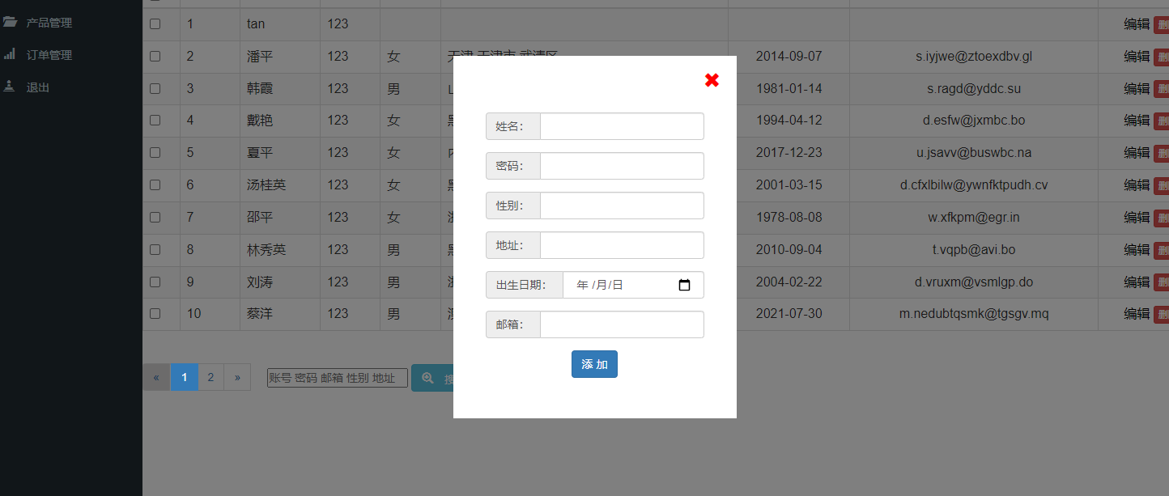

用户的编辑
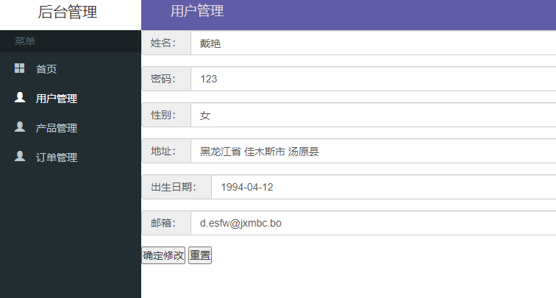

用户管理的分页
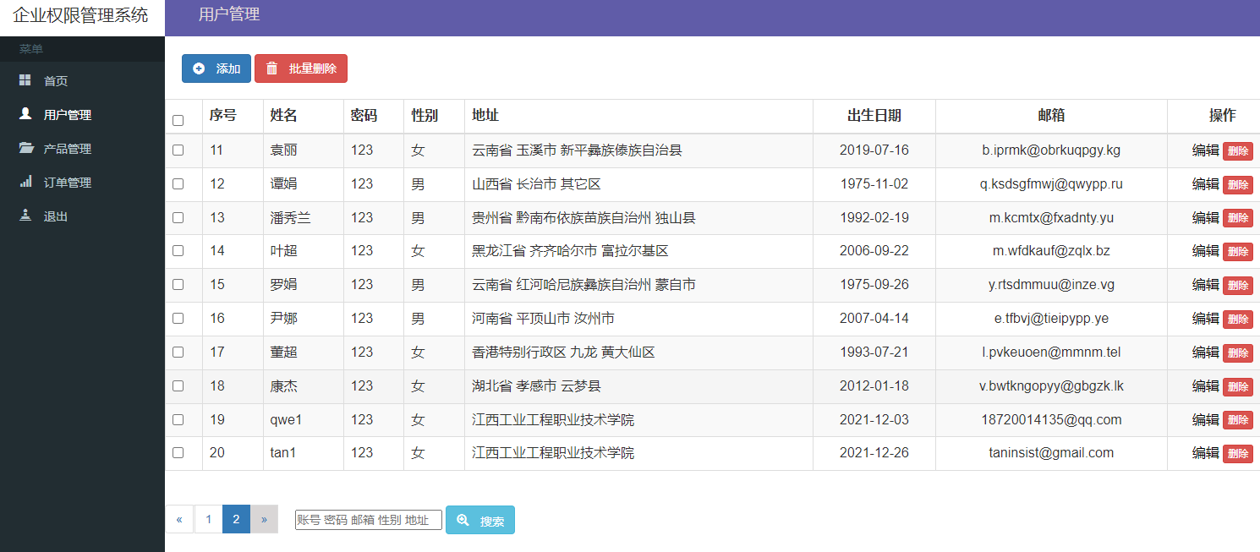
产品管理
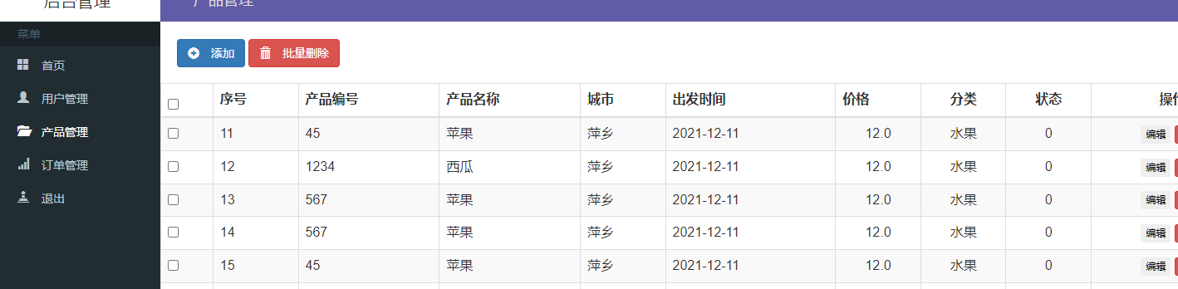

添加产品
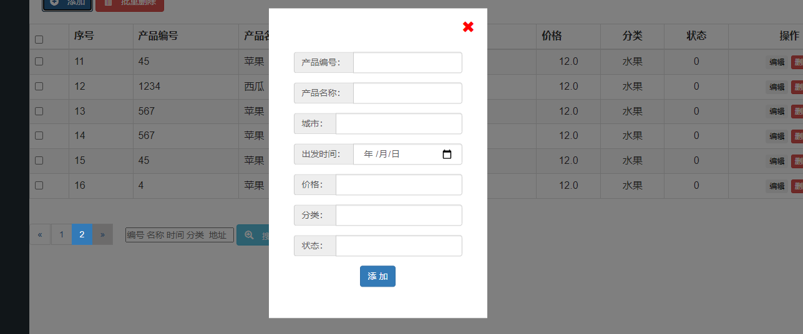

产品的编辑
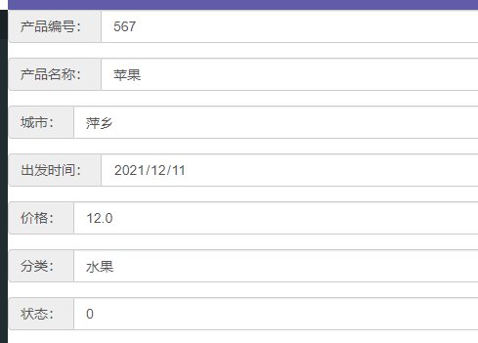

产品管理的分页
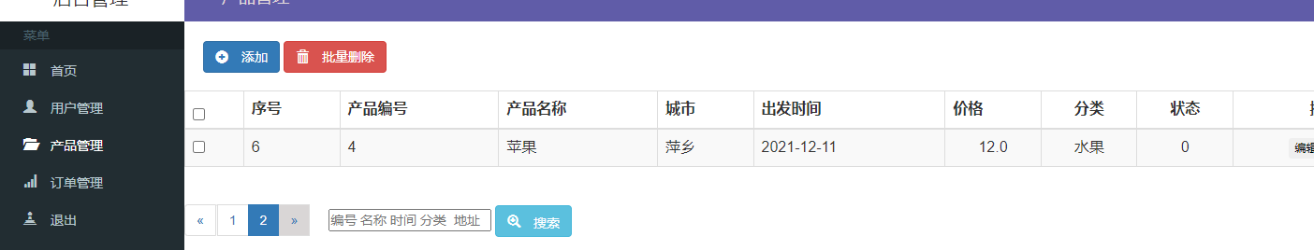

产品管理的批量删除
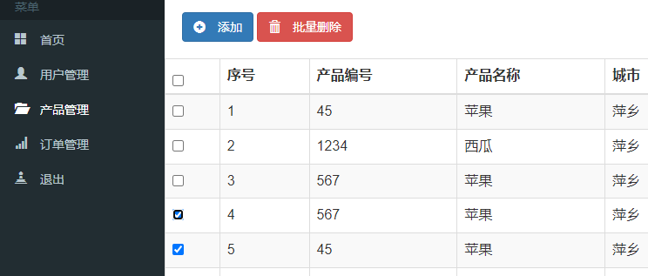
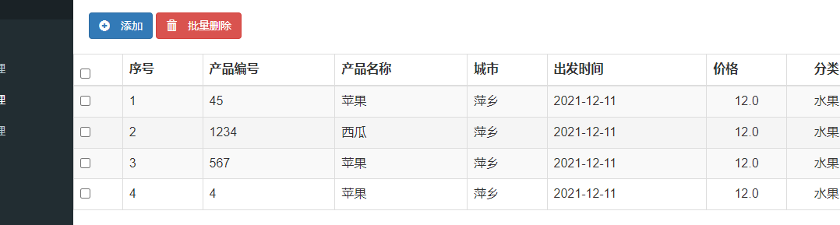

订单的查询
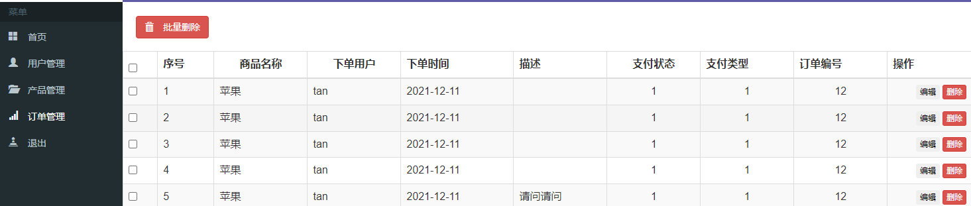

订单的添加
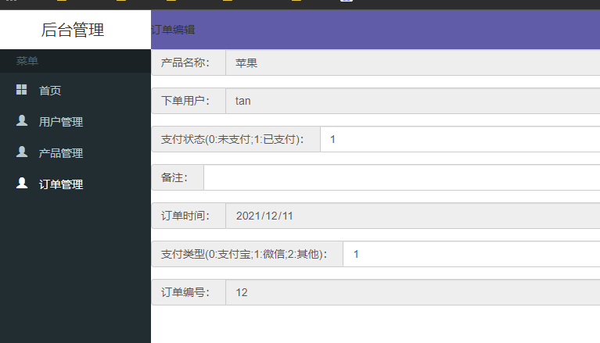

订单的分页查询
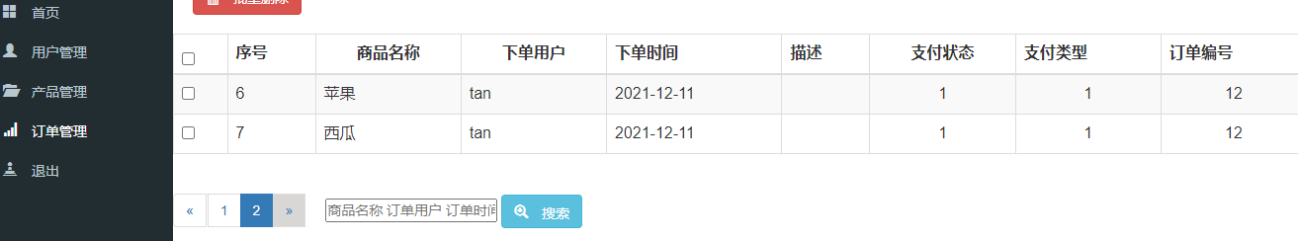

订单的批量删除
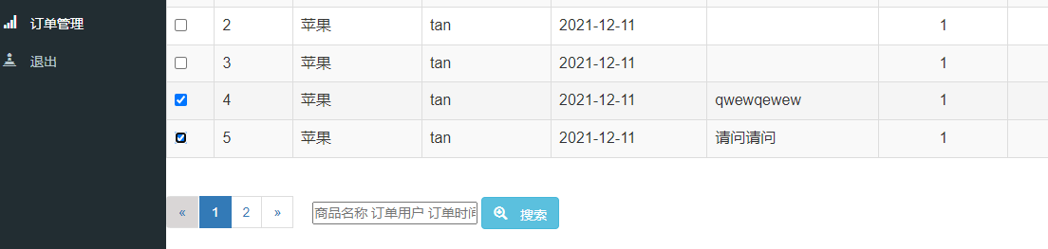
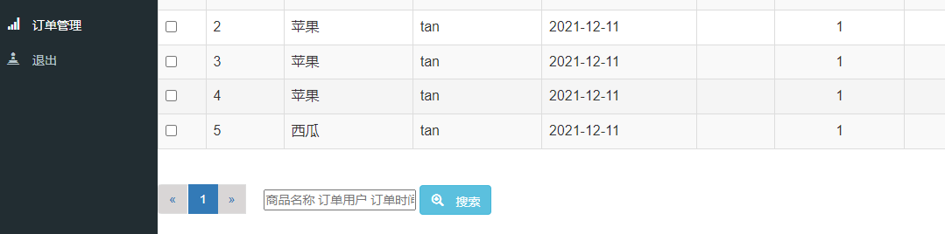

5.结束语

5.1课程设计心得
第一天：完成qygldb数据库的表的设计。
第二天：给各表添加初始数据。
第三天：完成登录的功能，途中遇到了不知道dao层和service层的接口和实现类都是干嘛的，后来通过实践，发现没有实现接口的类不能直接使用类中的方法。后来把类作为实现类在控制层就能正常使用了。
第四天：完成用户的注册功能。
第五天：完成用户的删除功能，途中遇到不知道如何把数据传递到后端，后来发现可以使用a标签的href属性请求地址进行传递参数，然后后端就可以拿到。拿到后就能进行处理了。
第六天：完成用户的编辑和添加。
第七天：完成用户的批量删除。完成用户的按关键字查询。
第八天：完成产品的增加，删除，修改和查询和分页查询
第九天：完成订单的增加，删除，修改和查询所有和分页查询
第十天：完成产品的批量删除和订单的批量删除。
第十一天和十二天，完成实训报告的编写。
经过两周的实训，我务实了Java Web开发方面的相关知识，主要的有JSP、Servlet、HTML，另外还有JDBC，Mysql数据库等等。
首先是JSP,它是Java Web开发的基础，需要的页面都是用JSP来建立的，它是一种动态的网页技术，其中，可以显示动态画面以及动画效果，在其中也可以编写Java代码，也可以加入html编写语言，通过form表单中的action属性可以实现页面间的跳转，点击不同的按钮，可以跳转到相应的页面，它是Java Web编程中必不可少的部分，Java语言开发的任何项目都要用到它；
其次是Servlet，它也是Java Web开发中必不可少的部分，Servlet是位于Web 服务器内部的服务器端的Java应用程序，与传统的从命令行启动的Java应用程序不同，Servlet由Web服务器进行加载，该Web服务器必须包含支持Servlet的Java虚拟机。Servlet生成响应内容并将其传给Server，响应内容动态生成，通常取决于客户端的请求。service()方法可能激活其它方法以处理请求，如doGet()或doPost()或程序员自己开发的新的方法，用的比较普遍的是doPost()方法。
再次，是HTML语言，它也是必不可少的，经常是嵌入在JSP中运用，它是一种静态页面开发技术，其中用的最多的是运用HTML语言建立form表单，其中有行（tr）和列（td），另外它的标签<div>也用的比较多，主要是利用它可以在页面上任意移动，而且它的大小不会改变，还可以隐藏、变透明等等，再有就是其中的JavaScript用的也比较多。

