**About Us:**

We understand the frustrations of searching for parking spaces in crowded urban areas or at busy events, which is why we've crafted a solution that empowers users to effortlessly find, reserve, and manage parking spots with just a few clicks.

Driven by innovation, we provide real-time availability updates, ensuring that users can always locate parking options tailored to their specific needs. Whether it's a short-term spot or a long-term reservation for an extended stay, our system accommodates various requirements to streamline the parking process for everyone involved.

For establishments lacking their own parking facilities, this app will provide a convenient solution by allowing them to reserve parking slots in advance. By pre-booking parking spaces, malls and restaurants can effectively reduce chaos during peak hours, ensuring a seamless experience for their customers.

For establishments equipped with their parking infrastructure, online parking system apps offer an opportunity to optimize space utilization and streamline operations. By leasing out their parking spaces through the app, these establishments can efficiently manage their resources while reducing manual labour costs associated with traditional parking management systems. This arrangement benefits both the businesses and the users, as it maximizes the value of available parking spaces while providing customers with convenient access to parking.

This approach not only enhances customer satisfaction but also reflects positively on the reputation of the businesses, fostering loyalty and trust among visitors.

By promoting efficient use of parking spaces and reducing unnecessary traffic congestion, our platform contributes to a greener, more sustainable future for urban environments.

In essence, our online parking system is more than just a service – it's a commitment to empowering individuals, optimizing resources, and simplifying the urban experience.

**PROBLEMS WE FACE REGULARLY FOR PARKING :**

**UNNECESSARY FINES:**

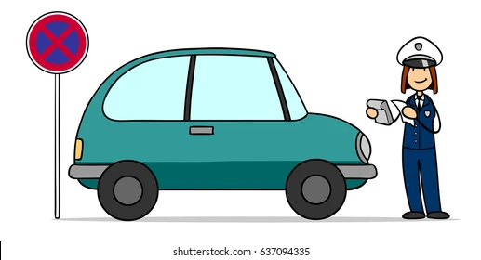

**SHORTAGE OF FREE PARKING SPACES NEAR MALLS,RESTAURANTS,HOSPITALS,RELIGIOUS PLACES :**

**NO PERKING FOR COMMON MAN:**

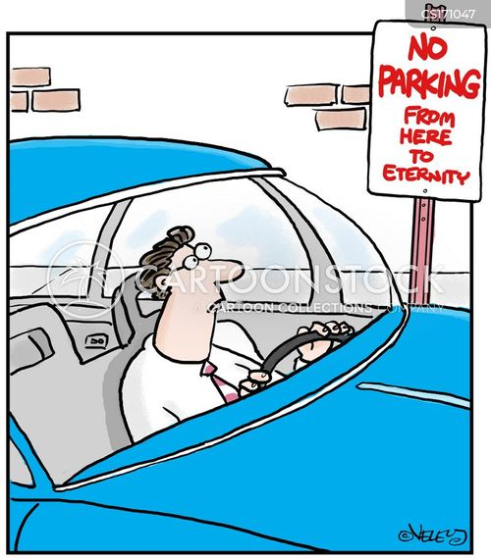

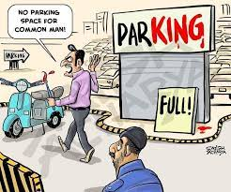

**PARKING SPAE BEFORE USING OUR APPLICATIOBN:**

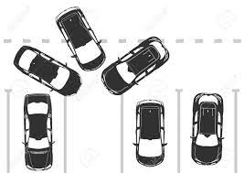

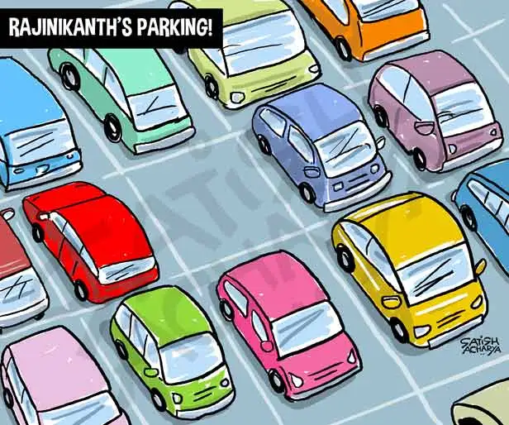

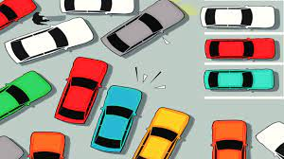

**AFTER USING OUR APPLICATION:**

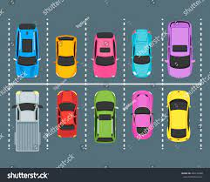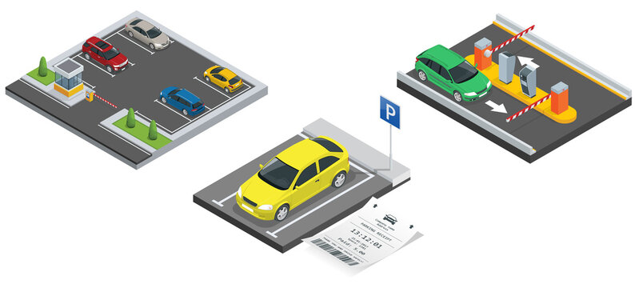

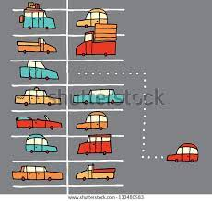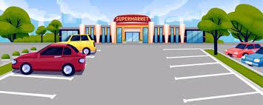

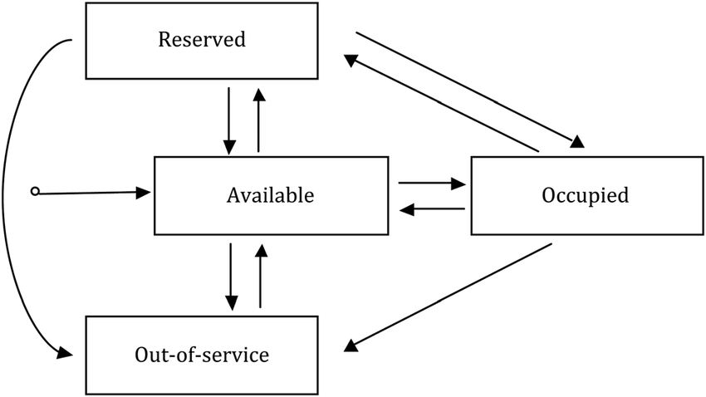**USER FRIENDLY SIMPLE ENVIRONMENT:**