CASE STUDY REPORT
Artificial Intelligence for Investments

Analysis of Nifty / Sensex Historical Data Using R
Student Name: Tanish Jagtap
Roll No.: 58
PRN: 23610060
Class/Division: B.Tech. — Artificial Intelligence & Data Science
Case No.: 01
Case Study Title: Analysis of Nifty / Sensex Historical Data Using R
Subject: Artificial Intelligence for Investments
Faculty: Prof. Bhagyashree Gore
Date: 31 August 2026
Data used: Sensex from 3 January 2000 and Nifty 50 from 17 September 2007, both up to 27 August 2026. All numbers given in this report were calculated from this data using R.
1. Case Background & Problem Statement
The Nifty 50 and the Sensex are the two main share market indexes in India. Mutual funds, index funds and many other investment products are based on them. Most of the risk calculations used with these indexes assume two things. First, that daily returns follow a normal curve. Second, that risk stays at one fixed level. The past data does not agree with either idea. The Nifty 50 gained 76 per cent in 2009 and lost 52 per cent in 2008. Its yearly risk level moved between 9 and 45 per cent in different years. This case study checks three simple questions using real data: do returns follow a normal curve, can the direction of the market be predicted, and does the risk stay the same?
2. Understanding of Case & Technology Selection
Relevant Concept/Technology:
This case study uses time series statistics. Four ideas are needed. Stationary data means the average and the spread do not change with time, and most tests are valid only on such data. Market efficiency means past prices cannot tell us the future direction. Volatility clustering means big moves are followed by more big moves. Changing variance means the risk level itself moves up and down over time, and the ARCH and GARCH models are made to handle this.
Tools/Technologies Required:
R is used for the whole analysis. The packages used are listed below. A second version of the code is also given that uses no packages at all.
Package | Use in this case study
quantmod | Downloads the Nifty 50 and Sensex price data
xts / zoo | Stores the data by date and handles market holidays
tseries | ADF test for stationary data, Jarque-Bera test for normal curve
FinTS | ARCH test, to check if the risk level changes
rugarch | Fits the GARCH(1,1) model
PerformanceAnalytics | Risk numbers such as loss limits and fall from peak
Base R | Ljung-Box test, correlation, graphs. No package needed
Table 1 R packages used and the work each one does.
Justification:
R is chosen because all of these tests are already available in it as ready functions, so they do not have to be written again. R also handles market holidays and missing days correctly, which is where normal spreadsheet work usually goes wrong. R is free and open source, so the same work can be repeated by anyone at no cost.
3. Proposed Analysis Approach
Architecture/Flow:
Data → Read data → Clean data → Find returns → Run tests → Result
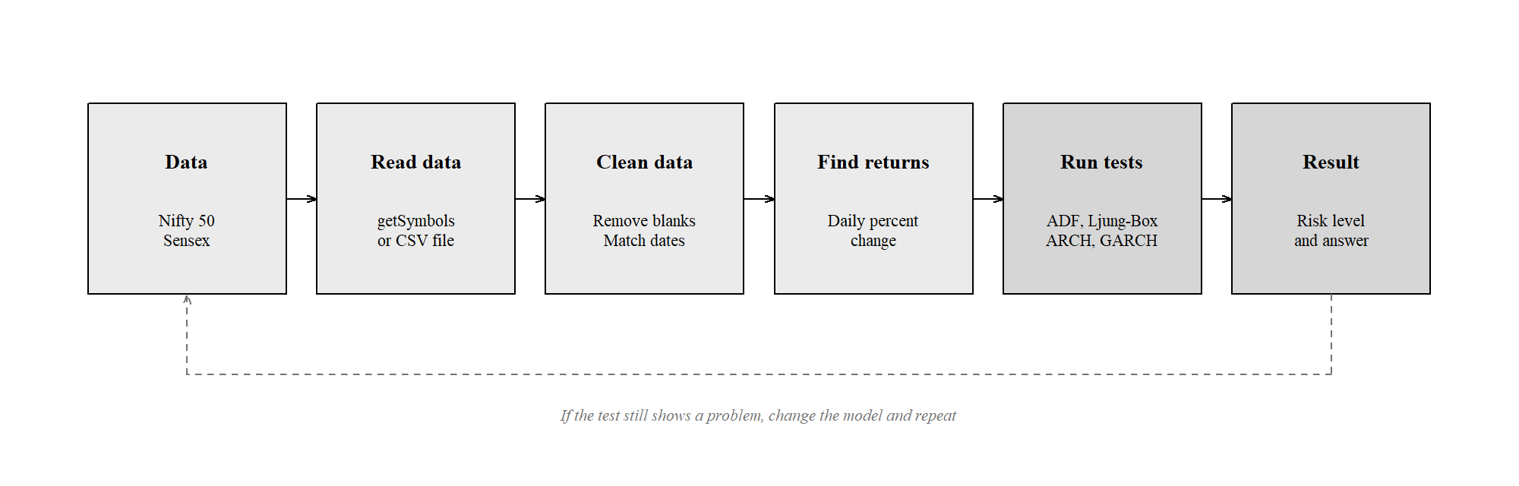
Fig. 1 Block diagram of the work. The dotted line shows that the model is checked again if the test still shows a problem.
The daily closing prices of both indexes are read into R. The data is cleaned by removing blank rows and matching the dates of the two indexes. Prices are then changed into daily returns using the formula r = 100 × ln(P today / P yesterday). This log form is used because such returns can be added over days, which is needed for one of the later tests. The tests are then run in a fixed order, because each test decides whether the next one is useful. First the shape of the data is checked with the Jarque-Bera test. Then the ADF test checks if the data is stationary. Then the variance ratio test checks if the direction can be predicted. Then the Ljung-Box and ARCH tests check if big moves come together. Only if the ARCH test shows a problem is the GARCH(1,1) model fitted. After fitting, the model is checked once more, and if the problem is still there the model has to be changed.
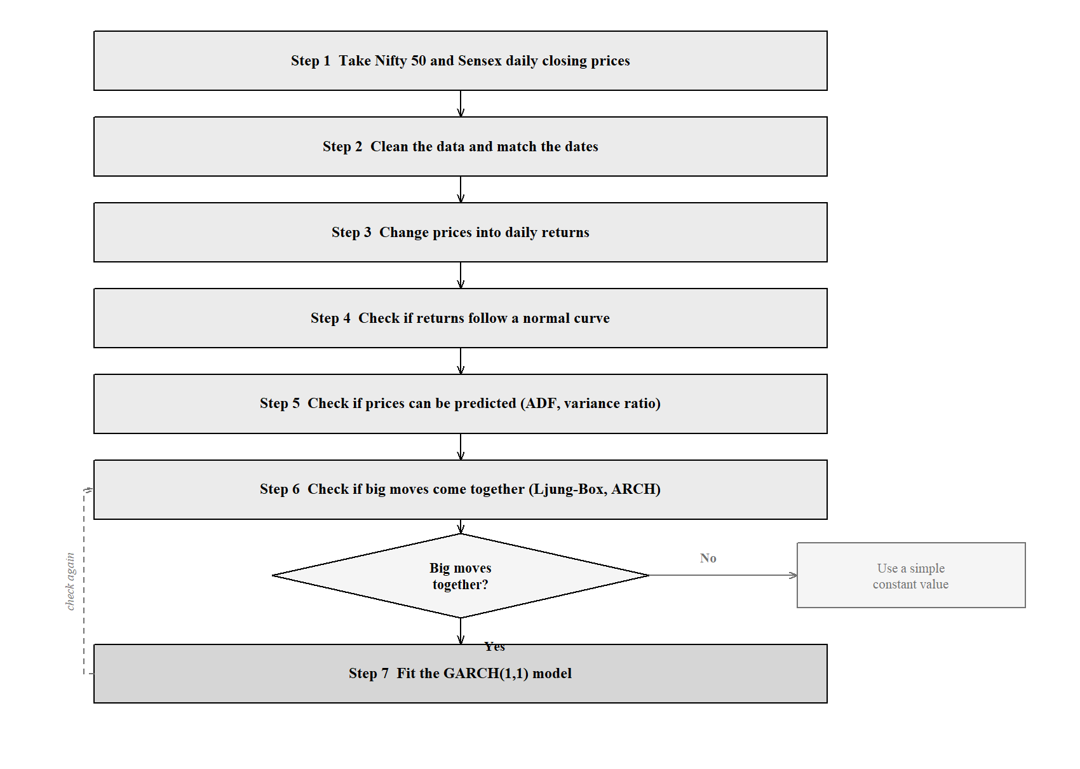
Fig. 2 Steps followed in the study.
Analysis:
The aim is not to predict the price of the index. The aim is to find out what the data is really like, so that any model built later is based on tested facts and not on guesses. Every test result is given in Appendix A with its value.
4. Expected Findings & Significance
Expected Findings:
Daily returns are expected to not follow a normal curve, with more very large moves than a normal curve allows. Prices are expected to be non stationary while returns are expected to be stationary. The direction of the market is expected to be almost impossible to predict from past prices. Risk, on the other hand, is expected to come in groups, so it should be possible to model it. All of these were found to be true, and the values are given in Appendix A.
Significance/Benefits:
The result is useful because the two things are opposite to what most people expect. The direction of the market, which everyone tries to guess, is almost impossible to guess. The risk level, which most methods treat as one fixed number, is the part that can actually be predicted. A method based on the normal curve puts the worst one per cent daily loss of the Nifty 50 at only 2.98 per cent, while the real data shows 3.62 per cent. So the amount invested and the stop loss should be decided from the current risk level, not from one average value.
5. Challenges / Limitations
• Dividends are not included. These are price indexes only, so the actual return is about 1 to 1.5 per cent per year higher. The risk results are not affected.
• Only big companies are included. Both indexes drop weak companies and add strong ones from time to time, so the return shown is better than the market as a whole.
• The model treats rises and falls as the same. In real markets a fall increases risk more than a rise of the same size. The GARCH(1,1) model used here cannot show this difference.
• Normal curve is assumed while fitting. The GARCH model is fitted assuming a normal curve, but the real data has more large moves. A Student-t curve would fit better.
• One set of values for the whole period. The same model values are used for 2008, for 2020 and for the calm years. Breaks in the data were not tested.
• Daily data only. Movements inside the trading day and gaps at the opening are not seen in daily closing prices.
6. References / Literature Survey
The papers below are grouped into three types: papers that created the methods, papers on whether markets can be predicted, and papers on the Indian market.
6.1 Summary of past work
[1] ARCH model
R. F. Engle, Econometrica, vol. 50, no. 4, pp. 987-1007, 1982.
• What it did: Made a model in which the risk level is allowed to change with time, and gave a test to check for it.
• What it found: Risk is not fixed. It changes, and this change can be measured.
• Used here: The ARCH test decides whether a GARCH model is needed at all.
[2] GARCH model
T. Bollerslev, Journal of Econometrics, vol. 31, no. 3, pp. 307-327, 1986.
• What it did: Improved the ARCH model by adding the previous risk level, so fewer values are needed.
• What it found: GARCH(1,1) with only three values works as well as a long ARCH model.
• Used here: This is the model fitted in this case study.
[3] EGARCH model
D. B. Nelson, Econometrica, vol. 59, no. 2, pp. 347-370, 1991.
• What it did: Allowed a fall in price to affect risk differently from a rise.
• What it found: A fall increases risk more than a rise of the same size.
• Used here: Mentioned as a limitation of this study, because the model used here treats both the same.
[4] Unit root test
D. A. Dickey and W. A. Fuller, Journal of the American Statistical Association, vol. 74, no. 366, pp. 427-431, 1979.
• What it did: Gave the correct table of values for testing whether data is stationary.
• What it found: Normal t table values cannot be used for this test.
• Used here: The ADF test in this study uses these values.
[5] Efficient market idea
E. F. Fama, Journal of Finance, vol. 25, no. 2, pp. 383-417, 1970.
• What it did: Collected the work on whether prices already contain all known information.
• What it found: If the market is efficient, past prices cannot help predict the future direction.
• Used here: This is the idea that the variance ratio test checks in this study.
[6] Variance ratio test
A. W. Lo and A. C. MacKinlay, Review of Financial Studies, vol. 1, no. 1, pp. 41-66, 1988.
• What it did: Gave a test based on how the spread of returns grows over longer periods.
• What it found: The test must be corrected for changing risk, otherwise it gives wrong results.
• Used here: This test is used in the code, with the correction included.
[7] Sensex volatility study
P. Srinivasan and P. Ibrahim, Asia-Pacific Business Review, vol. 6, no. 3, 2010.
• What it did: Compared GARCH, EGARCH and TGARCH models on daily Sensex returns.
• What it found: The simple GARCH(1,1) model worked well for the Sensex.
• Used here: Closest earlier study on the same index. This study uses a longer period.
[8] Nifty 50 volatility study
V. Mahajan, S. Thakan and A. Malik, Economies, vol. 10, no. 5, art. 102, 2022.
• What it did: Compared GARCH family models with a neural network for the Nifty 50.
• What it found: GARCH models were still as good as the neural network.
• Used here: Shows that GARCH(1,1) is a fair choice for this index.
[9] Random walk test on Indian market
A. Satapathy, Global Business Review, 2025.
• What it did: Tested the Nifty and 50 large shares with variance ratio and Hurst tests.
• What it found: The test could not prove that prices are predictable.
• Used here: Most recent study of this type, and it agrees with the result found here.
6.2 Comparison of the past work
Ref. | Study | Data used | Method | Main result
[1] | Engle (1982) | UK inflation | ARCH | Risk changes with time
[2] | Bollerslev (1986) | General | GARCH | Short model is enough
[3] | Nelson (1991) | US shares | EGARCH | Falls raise risk more
[5] | Fama (1970) | Review | Theory | Efficient market idea
[6] | Lo and MacKinlay (1988) | US weekly | Variance ratio | Test needs correction
[7] | Srinivasan and Ibrahim (2010) | Sensex | GARCH family | Simple GARCH is enough
[8] | Mahajan et al. (2022) | Nifty 50 | GARCH vs neural network | GARCH still works well
[9] | Satapathy (2025) | Nifty and 50 shares | Variance ratio, Hurst | Direction not predictable
Table 2 Short comparison of the papers studied.
6.3 Gap found
The papers on market efficiency stop after checking whether the direction can be predicted. The papers on volatility fit a model but do not check efficiency on the same data. Most Indian studies also end before 2020, so they leave out the Covid period, which is the largest risk event in this data. This case study does all these checks together, on both indexes, on data that includes 2020 and after.
6.4 References
[1] R. F. Engle, "Autoregressive conditional heteroscedasticity with estimates of the variance of United Kingdom inflation," Econometrica, vol. 50, no. 4, pp. 987-1007, 1982.
[2] T. Bollerslev, "Generalized autoregressive conditional heteroskedasticity," Journal of Econometrics, vol. 31, no. 3, pp. 307-327, 1986.
[3] D. B. Nelson, "Conditional heteroskedasticity in asset returns: a new approach," Econometrica, vol. 59, no. 2, pp. 347-370, 1991.
[4] D. A. Dickey and W. A. Fuller, "Distribution of the estimators for autoregressive time series with a unit root," Journal of the American Statistical Association, vol. 74, no. 366, pp. 427-431, 1979.
[5] E. F. Fama, "Efficient capital markets: a review of theory and empirical work," Journal of Finance, vol. 25, no. 2, pp. 383-417, 1970.
[6] A. W. Lo and A. C. MacKinlay, "Stock market prices do not follow random walks: evidence from a simple specification test," Review of Financial Studies, vol. 1, no. 1, pp. 41-66, 1988.
[7] G. M. Ljung and G. E. P. Box, "On a measure of lack of fit in time series models," Biometrika, vol. 65, no. 2, pp. 297-303, 1978.
[8] C. M. Jarque and A. K. Bera, "A test for normality of observations and regression residuals," International Statistical Review, vol. 55, no. 2, pp. 163-172, 1987.
[9] P. Srinivasan and P. Ibrahim, "Forecasting stock market volatility of BSE-30 index using GARCH models," Asia-Pacific Business Review, vol. 6, no. 3, 2010.
[10] A. Banerjee and S. Sarkar, "Modeling daily volatility of the Indian stock market using intra-day data," Working Paper No. 588, IIM Calcutta, 2006.
[11] V. Mahajan, S. Thakan and A. Malik, "Modeling and forecasting the volatility of NIFTY 50 using GARCH and RNN models," Economies, vol. 10, no. 5, art. 102, 2022.
[12] A. Tewari, "Forecasting NIFTY 50 benchmark index using seasonal ARIMA time series models," arXiv:2001.08979, 2020.
[13] A. Satapathy, "Test of random walk hypothesis in Indian stock market," Global Business Review, 2025.
[14] A. Ghalanos, "rugarch: univariate GARCH models," CRAN R package; J. A. Ryan and J. M. Ulrich, "quantmod," CRAN R package; R Core Team, R Foundation for Statistical Computing, Vienna. Index data: www.nseindia.com and www.bseindia.com.
Appendix A — Results
All values below were produced by the R code. Returns are daily and in per cent. Yearly values use 252 trading days.
A.1 Basic figures
Item | Nifty 50 | Sensex
First date | 2007-09-17 | 2000-01-03
Last date | 2026-08-27 | 2026-08-27
Number of days | 4,647 | 6,570
Average daily return (%) | 0.0361 | 0.0405
Yearly return (%) | 9.10 | 10.21
Yearly risk level (%) | 20.56 | 21.77
Best day (%) | 16.33 | 15.99
Worst day (%) | -13.90 | -14.10
Days the market went up (%) | 52.96 | 53.39
Table A.1 Basic figures for both indexes.
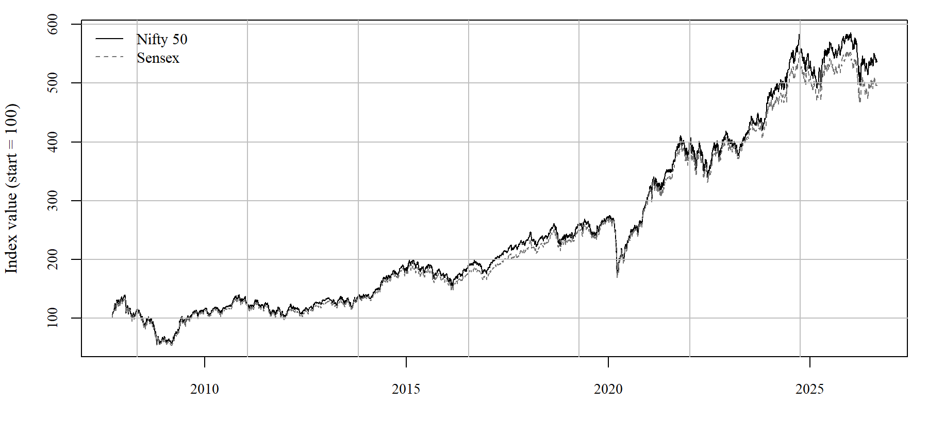
Fig. A.1 Both indexes with the starting value set to 100.
A.2 Do returns follow a normal curve?
Item | Nifty 50 | Sensex | If it were a normal curve
Skewness | -0.280 | -0.392 | 0
Extra peakedness | 15.14 | 10.07 | 0
Jarque-Bera value | 44,429 | 27,911 | near 0
p value | less than 0.001 | less than 0.001 | above 0.05
Days with a very large move | 70 | 107 | 13 and 18
Table A.2 Test for the normal curve.
The answer is no. The clearest proof is the last row. If returns followed a normal curve, about 13 days with a very large move were expected in the Nifty 50, but 70 days actually happened. That is more than five times as many. Very large moves are normal in this data, not rare.
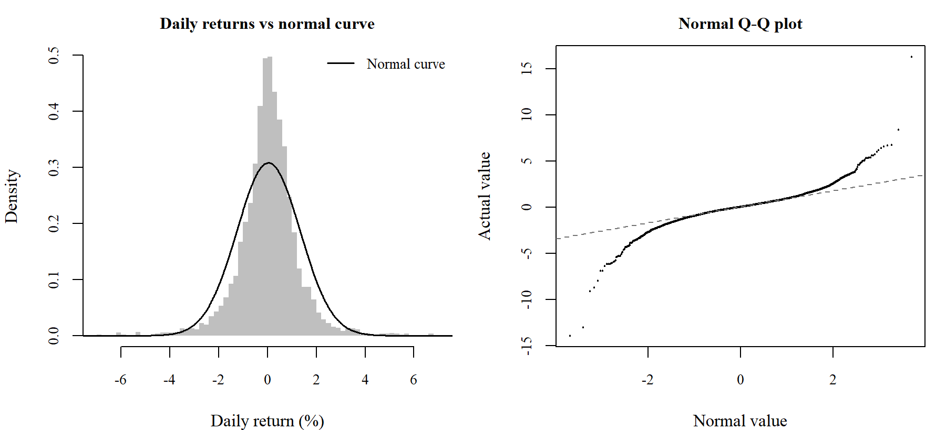
Fig. A.2 On the left, the real data has a taller centre and longer tails than the normal curve. On the right, the points bend away from the line at both ends, which shows the same thing.
A.3 Can the direction be predicted?
Test | Series | Nifty 50 | Sensex | Result
ADF | Price | -0.18 | -0.39 | Not stationary
ADF | Returns | -12.19 | -13.91 | Stationary
Variance ratio, q = 2 | Returns | 1.037 | 1.051 | Close to 1
Variance ratio, q = 4 | Returns | 1.036 | 1.043 | Close to 1
Variance ratio, q = 8 | Returns | 0.994 | 1.027 | Close to 1
Variance ratio, q = 16 | Returns | 1.034 | 1.071 | Close to 1
Table A.3 Tests for stationary data and for prediction. The 5 per cent table value for the ADF test is -2.86.
Prices are not stationary but returns are, so all the later work is done on returns. The variance ratio stays close to 1, which means the direction of the market cannot be predicted from past prices in any useful way.
A.4 Do big moves come together?
Test | Nifty 50 | p value | Sensex | p value
Ljung-Box on returns | 39.4 | less than 0.001 | 48.3 | less than 0.001
Ljung-Box on squared returns | 1,625 | less than 0.001 | 2,585 | less than 0.001
ARCH test (5 lags) | 485 | less than 0.001 | 790 | less than 0.001
Table A.4 Tests for grouping of big moves.
This is the main result of the study. The test on plain returns gives a small value (39.4), so the direction has almost no pattern. The same test on squared returns gives 1,625, which is about forty times larger. So the size of the move can be predicted even though the direction cannot.
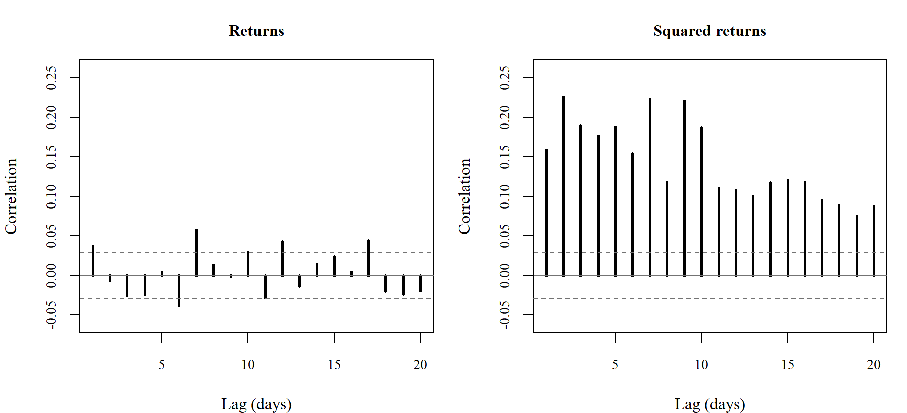
Fig. A.3 Returns stay inside the dotted lines, which means no pattern. Squared returns stay far outside them at every lag.
A.5 The GARCH(1,1) model
Value | Nifty 50 | Sensex | Meaning
omega | 0.0147 | 0.0204 | Base level of risk
alpha | 0.0952 | 0.1063 | Effect of yesterday's move
beta | 0.8975 | 0.8850 | Effect of yesterday's risk level
alpha + beta | 0.9927 | 0.9913 | Below 1, so risk comes back to normal
Half life (days) | 95 | 80 | Time taken for a shock to reduce by half
Long run risk level (%) | 22.53 | 24.38 | Level the risk returns to
Highest risk level (%) | 92 | 97 | Reached in 2020-03
ARCH test after fitting (p) | 0.48 | 0.20 | Above 0.05, so the model is acceptable
Table A.5 Values of the fitted GARCH(1,1) model.
The important number is the half life of about 95 trading days, which is close to four and a half months. This means a shock in the market does not go away in a day or two. It keeps the risk level high for months. After fitting the model, the ARCH test no longer shows a problem, so the model has taken care of the grouping of big moves.
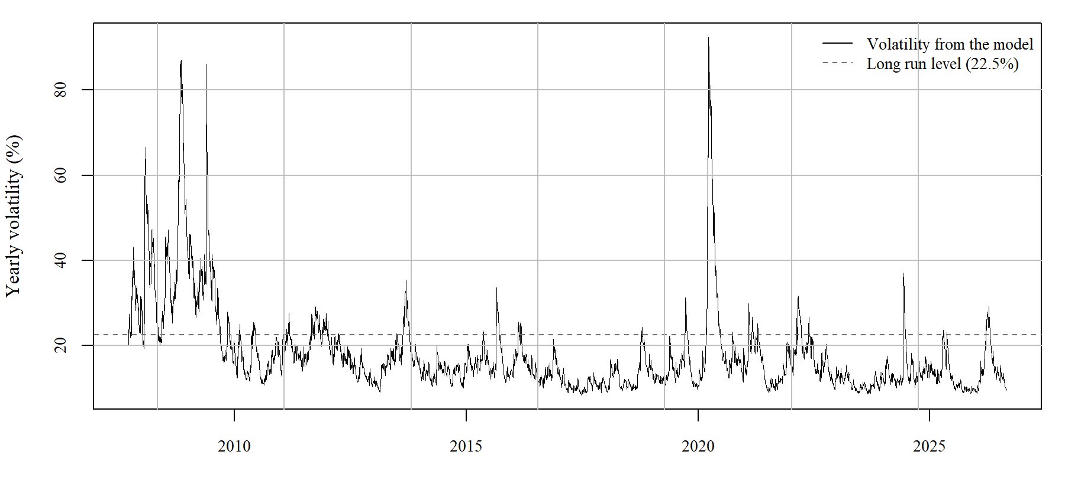
Fig. A.4 Risk level from the model. The highest point in March 2020 is about 92 per cent, which is more than four times the long run level of 22.5 per cent.
A.6 Risk numbers
Item | Nifty 50 | Sensex
Worst 1% daily loss, from real data (%) | -3.62 | -4.05
Worst 1% daily loss, using normal curve (%) | -2.98 | -3.15
Average loss on such bad days (%) | -5.46 | -5.69
Times this limit was crossed | 82 | 134
Times it should have been crossed | 46 | 66
Biggest fall from a peak (%) | -59.86 | -60.91
Days taken to recover from it | 1,036 | 1,031
Table A.6 Risk numbers for both indexes.
The loss limit based on the normal curve was crossed 82 times when it should have been crossed only about 46 times. On the days it was crossed, the average loss was 5.46 per cent, which is much worse than the limit itself. The largest fall was 59.9 per cent and it took about 2.8 years to come back to the old level.
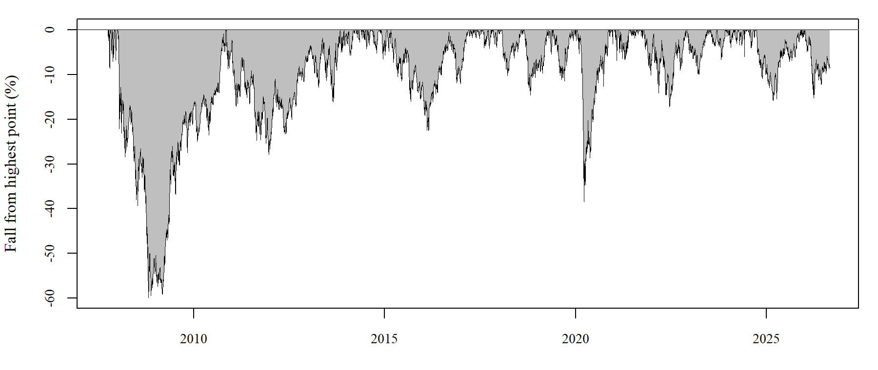
Fig. A.5 Fall of the Nifty 50 from its highest point up to that date.
A.7 Summary of answers
Question | Answer | Proof
Do returns follow a normal curve? | No | Jarque-Bera = 44,429, p below 0.001
Are prices stationary? | No | ADF = -0.18, table value -2.86
Are returns stationary? | Yes | ADF = -12.19, table value -2.86
Can the direction be predicted? | No | Variance ratio = 1.037, close to 1
Do big moves come together? | Yes | ARCH test = 485, p below 0.001
Can this be modelled? | Yes | GARCH(1,1); test after fitting p = 0.48
Does risk come back to normal? | Yes, slowly | alpha + beta = 0.9927, half life 95 days
Is risk higher than the normal curve says? | Yes | Limit crossed 1.8 times too often
Table A.7 All questions and the answers found.
Appendix B — R Code
Three R files are given with this report. All of them use the same data and give the same results.
File | Packages needed | What it does
01_nifty_sensex_analysis.R | quantmod, tseries, rugarch, PerformanceAnalytics, FinTS, moments | Main file. Downloads the data itself and runs all the tests.
02_nifty_sensex_baseR.R | None | Same tests written from the formula, so no package is needed. Use this on an online R compiler.
03_make_figures.R | None | Draws all the figures used in this report and in the slides.
Table B.1 The three R files.
Main part of the code
# change prices into daily returns
r_nifty <- na.omit(diff(log(Cl(nifty))) * 100)
r_sensex <- na.omit(diff(log(Cl(sensex))) * 100)

# check the shape of the data and whether it is stationary
jarque.bera.test(r_nifty) # does it follow a normal curve?
adf.test(log(Cl(nifty))) # is the price stationary?
adf.test(r_nifty) # are the returns stationary?

# check whether big moves come together
Box.test(r_nifty, lag = 10, type = "Ljung-Box")
Box.test(r_nifty^2, lag = 10, type = "Ljung-Box")
ArchTest(r_nifty - mean(r_nifty), lags = 5)

# fit the GARCH(1,1) model
spec <- ugarchspec(
variance.model = list(model = "sGARCH", garchOrder = c(1, 1)),
mean.model = list(armaOrder = c(0, 0), include.mean = TRUE))
fit <- ugarchfit(spec, data = r_nifty)

# check the model after fitting
z <- residuals(fit, standardize = TRUE)
ArchTest(z, lags = 5)
Listing B.1 The main part of the code, in the order it runs.
How to run it
• On a computer with R. Keep the two CSV files in the same folder as the code, open a terminal in that folder and type: Rscript 01_nifty_sensex_analysis.R
• On Posit Cloud. Open posit.cloud, make a free account, upload the files and run the first file. Internet is available there, so the packages install and the data downloads.
• On any online R compiler. Use the second file. It needs no packages. Upload the two CSV files along with it.
Data files
File | Rows | Period | Columns
NIFTY50.csv | 4,648 | 2007-09-17 to 2026-08-27 | Date, Open, High, Low, Close, Volume
SENSEX.csv | 6,571 | 2000-01-03 to 2026-08-27 | Date, Open, High, Low, Close, Volume
Table B.2 Data files given with this report.
Note: the first file can download fresh data, so running it on a later date will add new days and change the numbers a little. To get exactly the numbers printed in this report, use the CSV files given here.

