**SOFTWARE DESIGN AND ARCHITECTURE**

**TUTORIAL EXERCISE – 3**

**GROUP 15**

**Tanish Singla 100782583**

**Akshat Gupta 100813132**

**Harsh Tamakuwala 100824220**

1. Leveraging these components create a UML diagram of an architecture that adopts the MVC design pattern and the layered pattern.

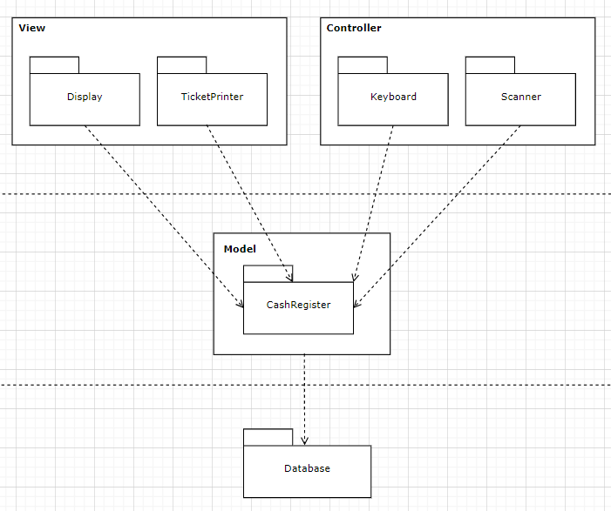

1. Create a sequence diagram that captures the use case of an item’s UPC code being scanned through the Scanner, resulting in the operation of looking up the price of the item from a product Database and displaying that price on the Display. Note: this scenario depicts what is referred to as “Business Logic”. In the MVC pattern keep in mind where this logic resides.

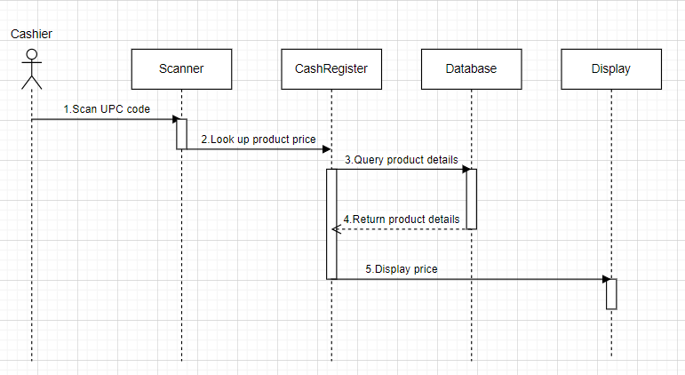

1. Code this design using Java. For the code you can simply create a Keyboard, CashRegister, and Display Class and show that when a product ID is entered into the keyboard as a number that the product name and price are displayed. Note: You will need to create a file with the products and prices. Submit the code and test case example demonstrating that the code works.

OUTPUT:

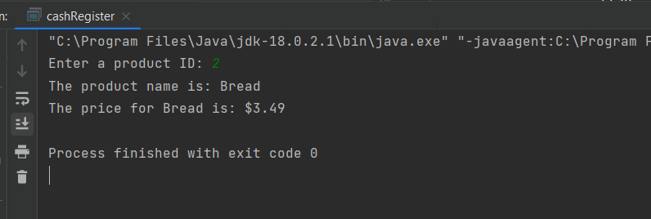

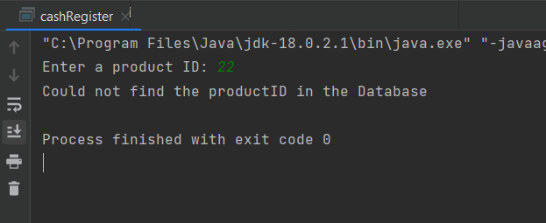

Data.txt

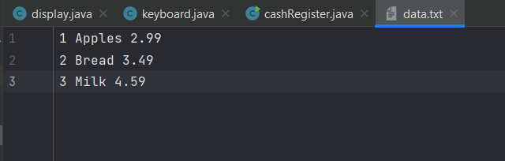

Keyboard.java

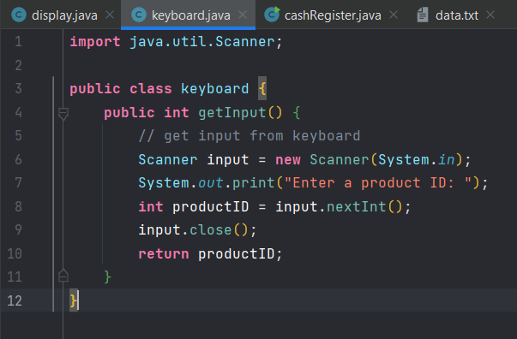

Display.java

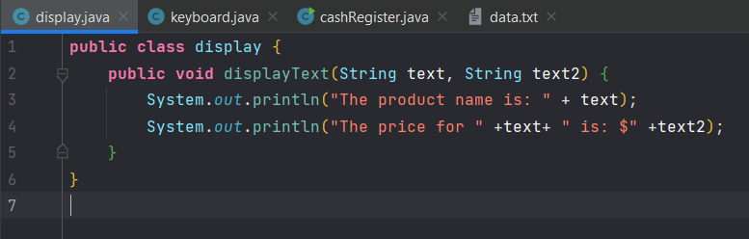

cashRegister.java

