ELEE 3490U



***LAB-1***

***Using Git and GitHub Group 5***

**Group Member 1 Name:** Tanish Singla

**Student ID:** 100782583

**Group Member 2 Name:** Akshat Gupta

**Student ID:** 100813132

**Date:**

* Create a Git repository using the cheat sheet commands

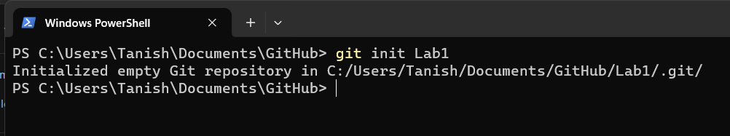

* Edit the “Student” file to include your Student Name & Student ID

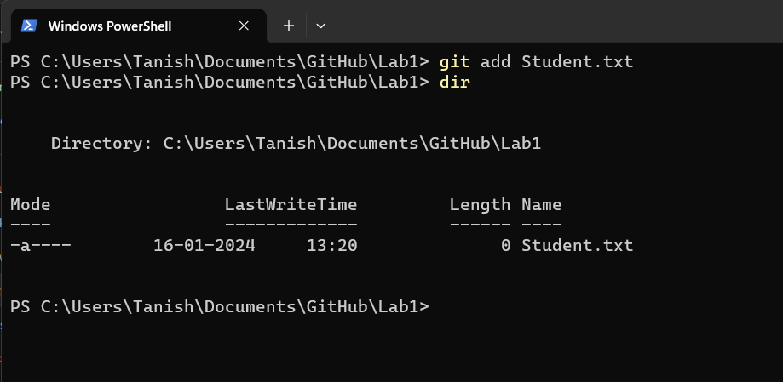

* Commit changes

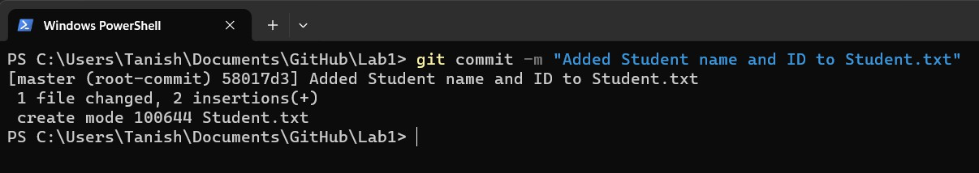

* Create IgnoreExample.txt

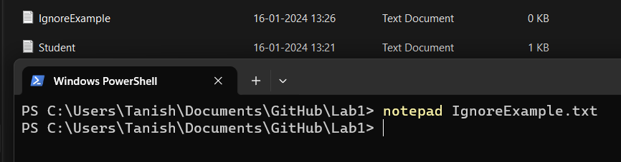

* Edit content of IgnoreExample.txt

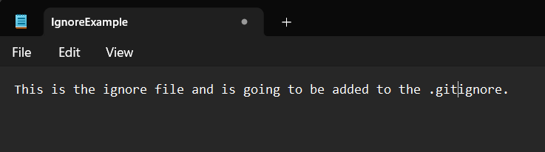

* Use git status and screenshot the outcome

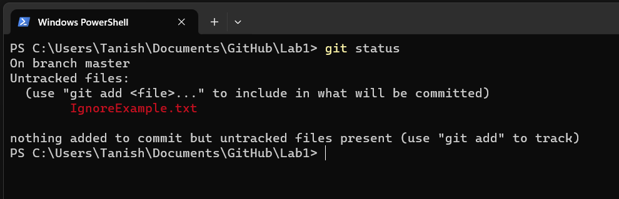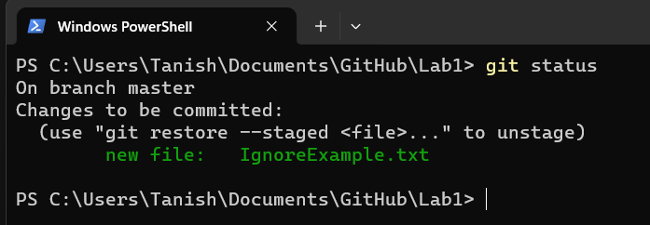

* Commit changes

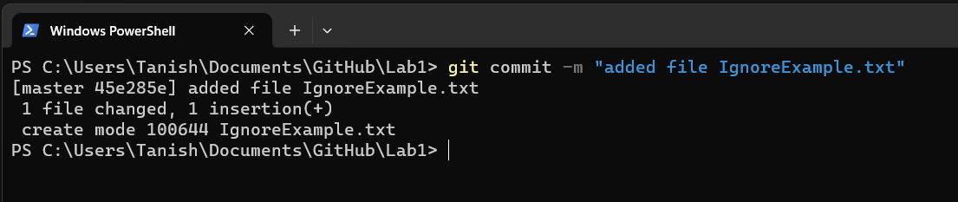

* Add IgnoreExample.txt to .gitignore file

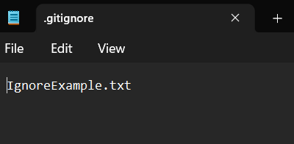

* Edit content of IgnoreExample.txt

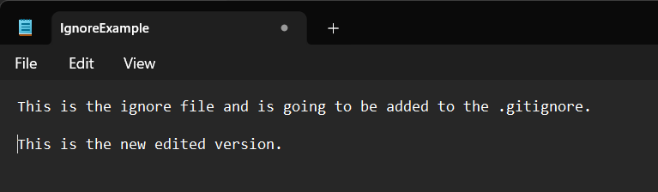

* Use git status and screenshot the outcome

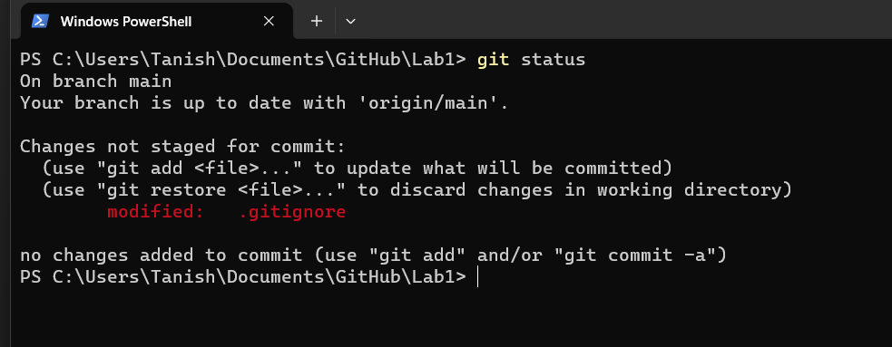

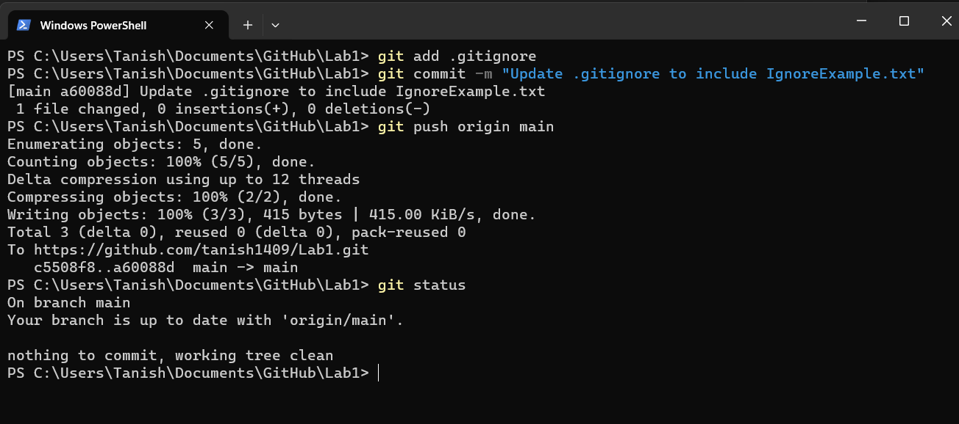

* Create a new branch using the git branch

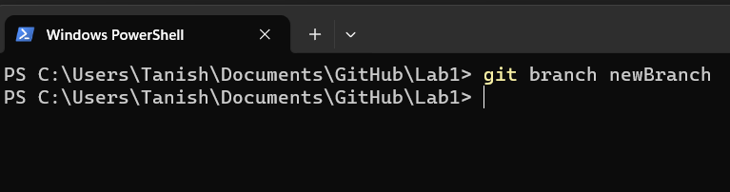

* Switch to the new branch

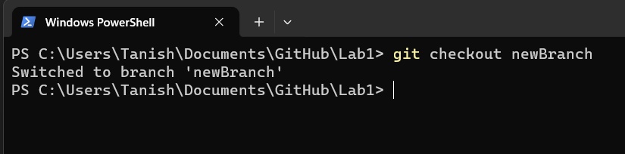

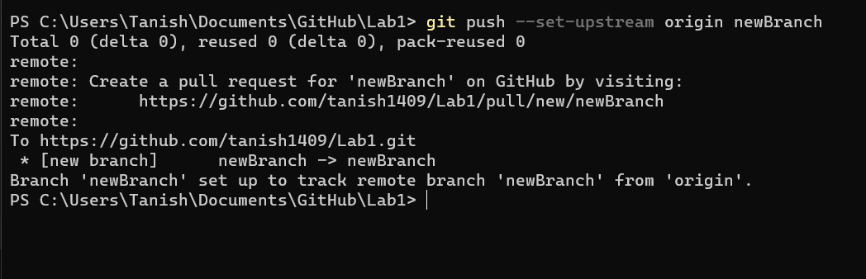

* 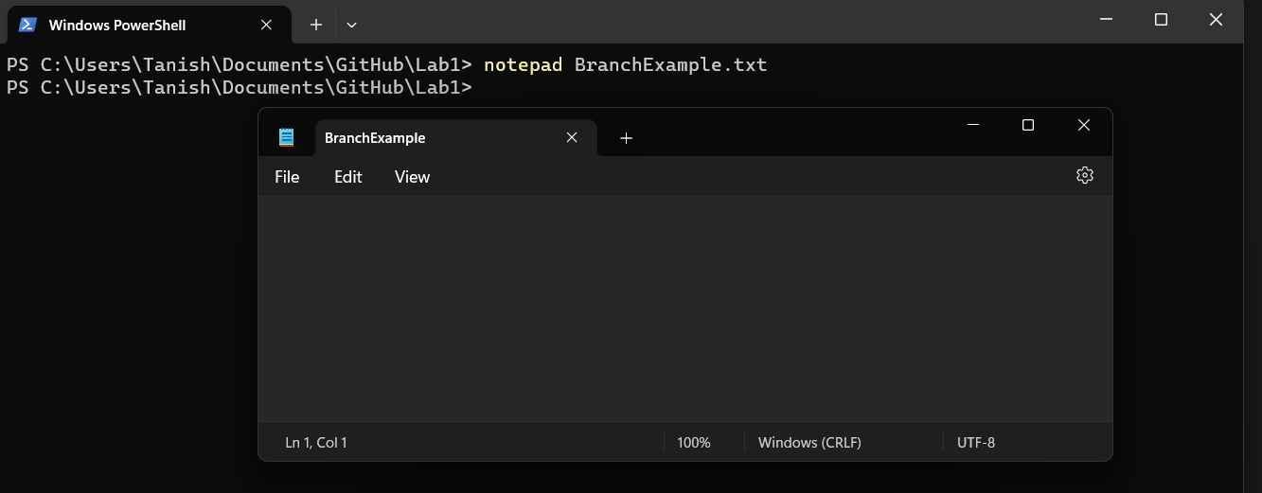Edit BranchExample.txt (create this if not present) via the notepad command notepad BranchExample.txt
* Use git add to update branch example, commit and use the notepad command again

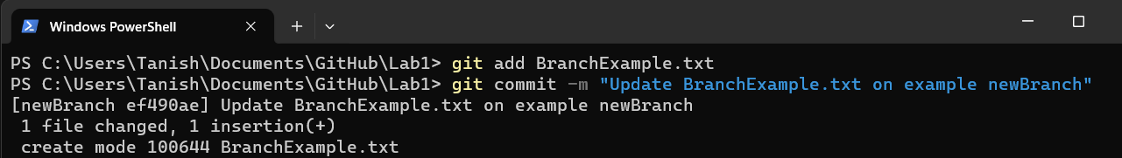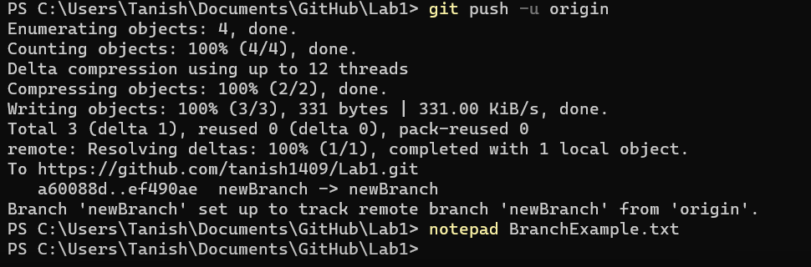

* Screenshot content

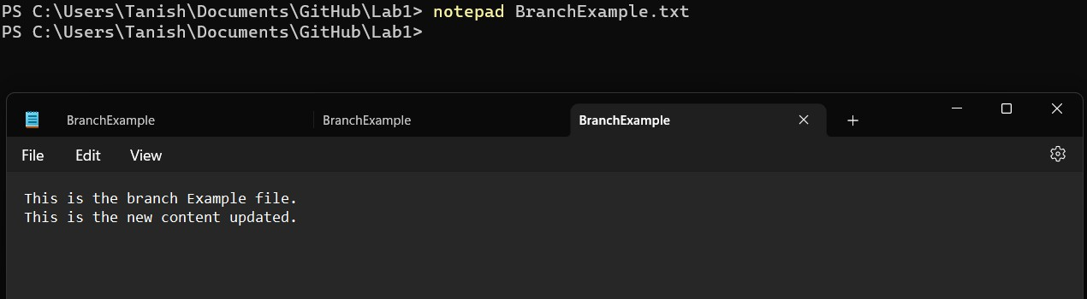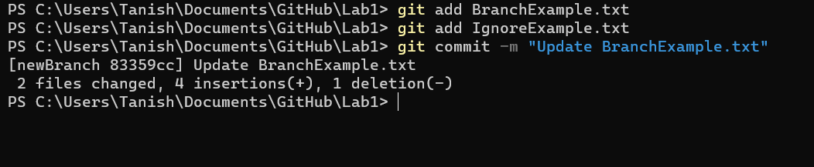

* Switch back to the master branch

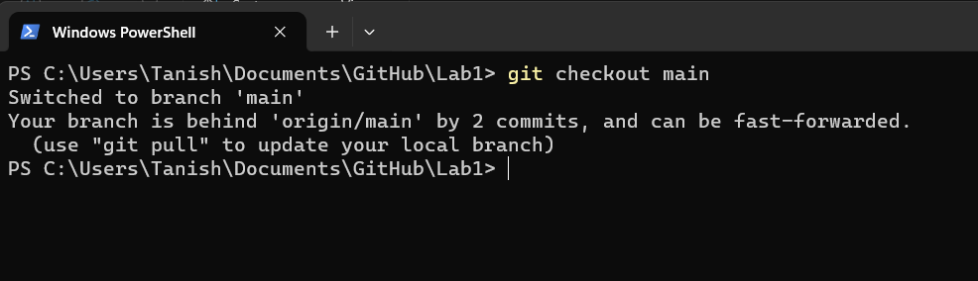

* Use the same notepad command

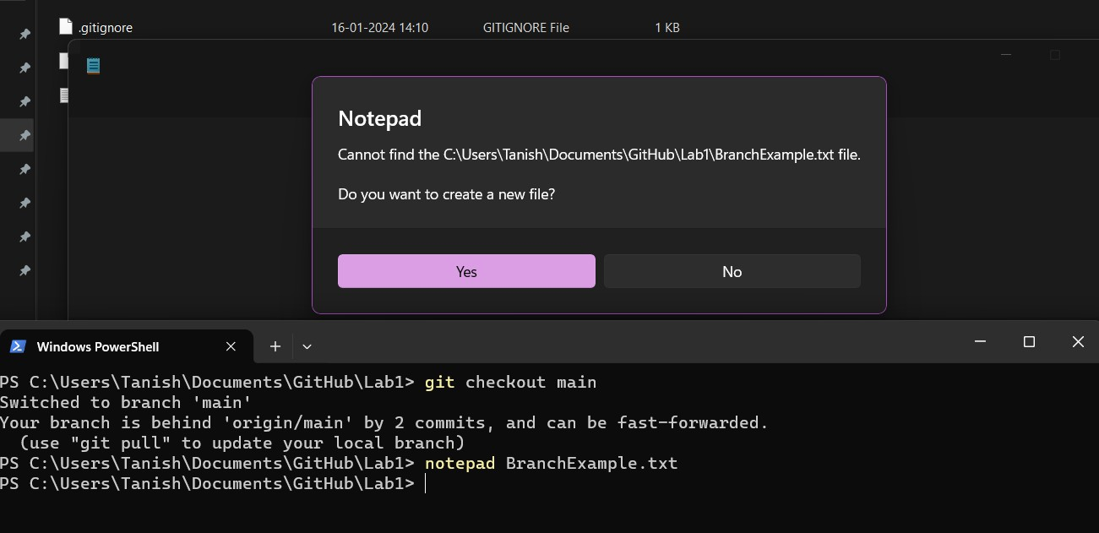

* Screenshot the outcome

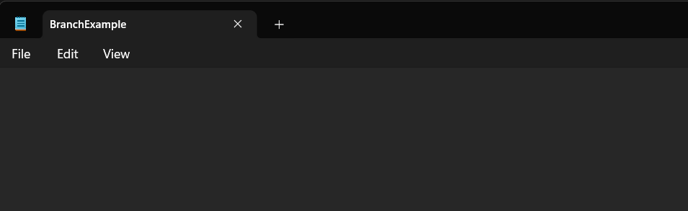

* Remove RemoveExample.txt (create one first if not present)

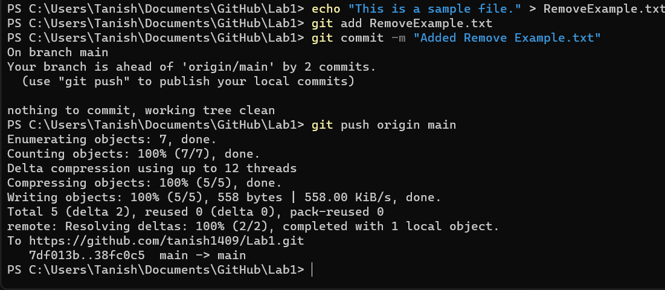

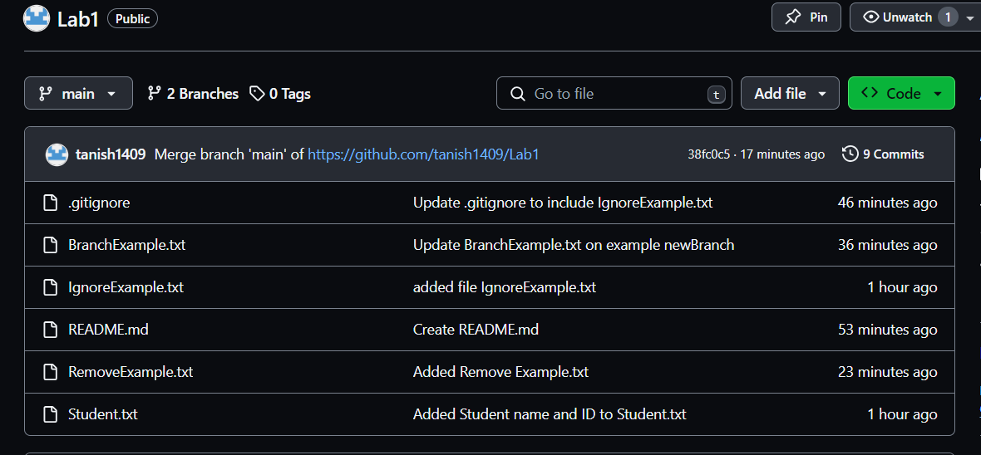

* Commit

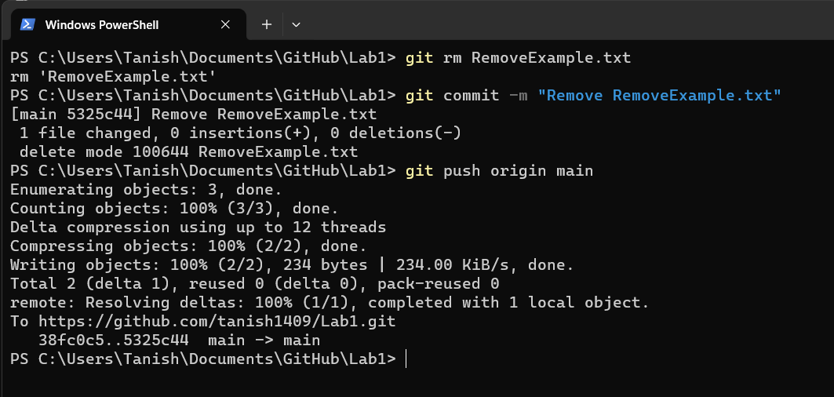

* Use git status and screenshot outcome

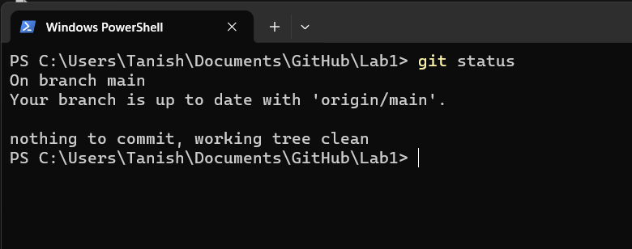

* Use the clean command to remove the file completely

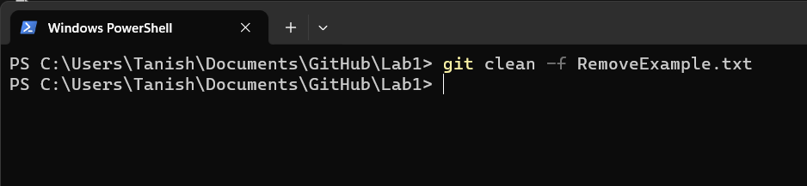

* Use git status and screenshot outcome

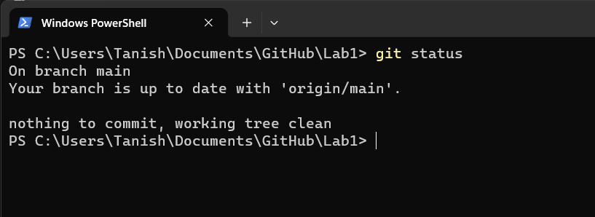

* Use git add to add your word document with the screenshots to the repository; it should look something like this:
  + git add Screenshots.docx
* Commit