**ELEE 3980U**



***Lab-2 (Maven and Web App)***

**Name:** Tanish Singla

**Student ID:** 100782583

**Date:** 29/01/2024

**SUCCESSFUL RUNNING OF WEB LOCALHOST**

**HELLO WORLD**

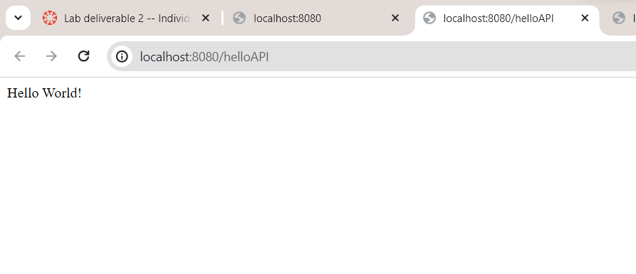

**HELLO JACK**

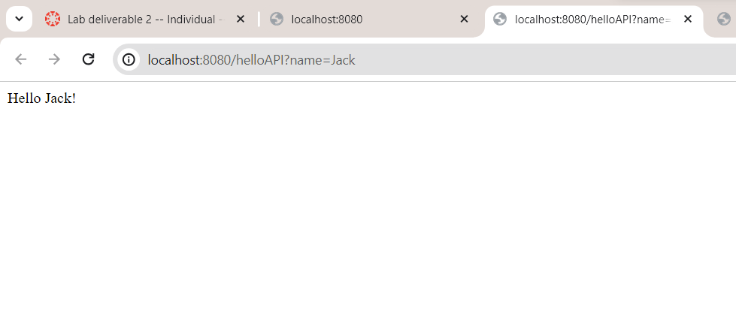

**API EMAIL**

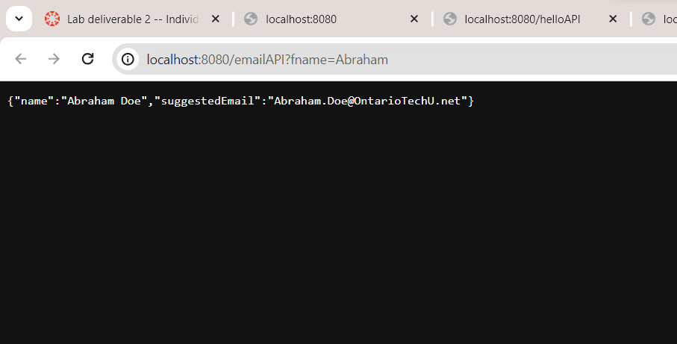

**CALCULATOR**

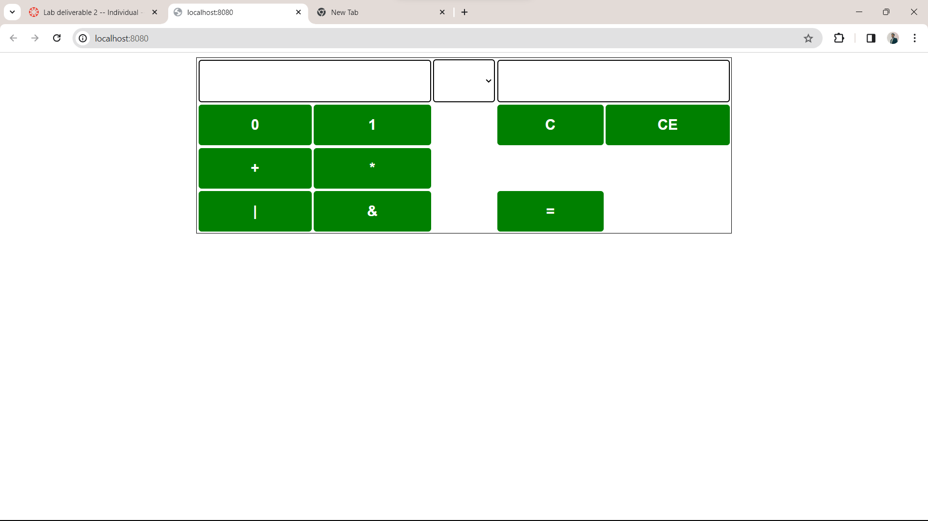

**THREE TEST CASES OF WEB APPLICATION**

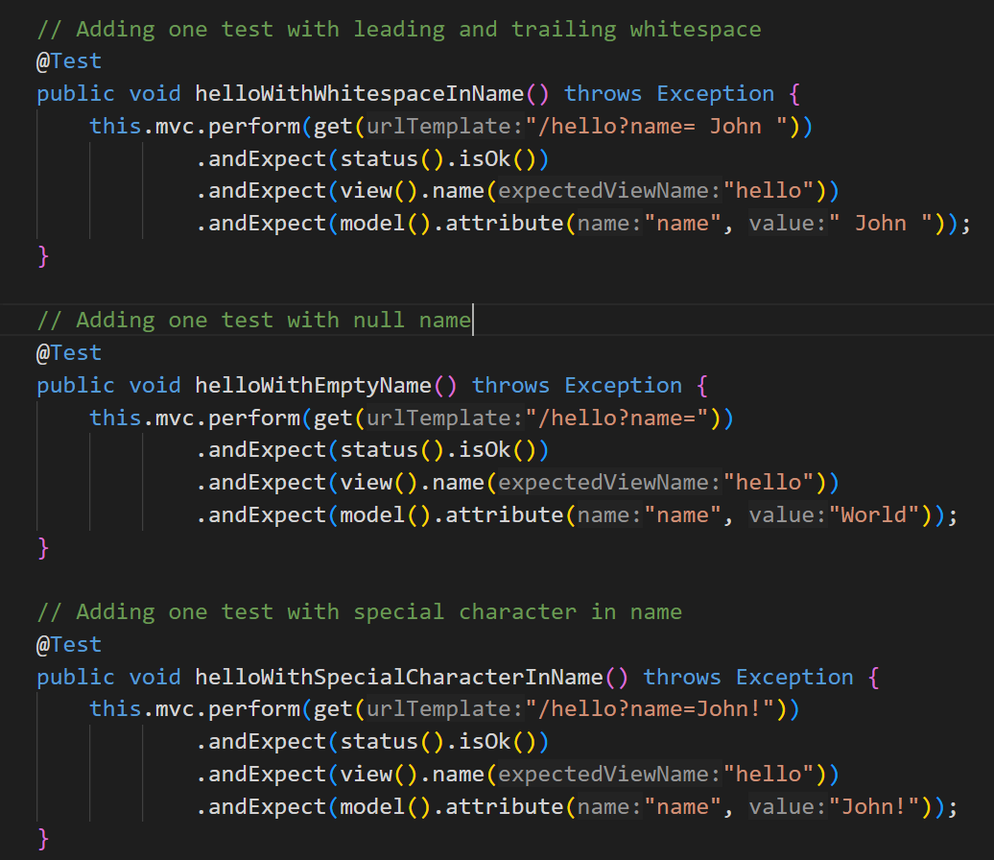

**SUNFIRE REPORTS FOR SUCCESS FROM 2 TO 5**

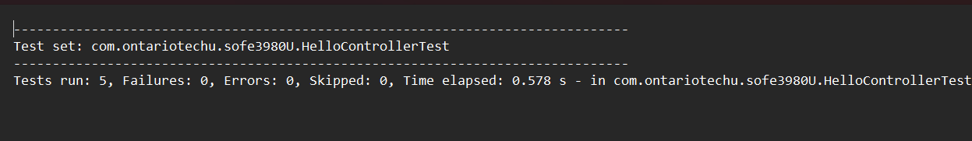

**OUTPUT WENT FROM 8 TO 10 TO BE 3 MORE SUCCESSFUL TESTS**

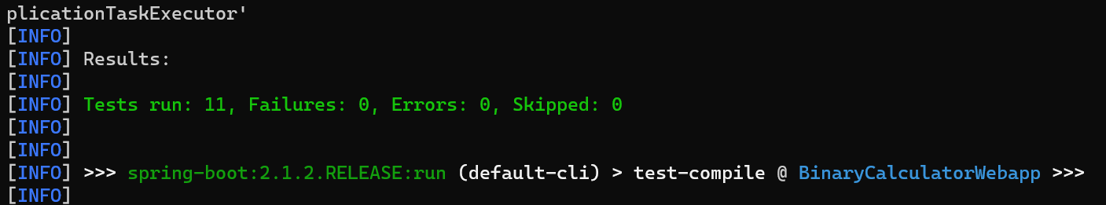

**THREE TEST CASES OF API APPLICATION**

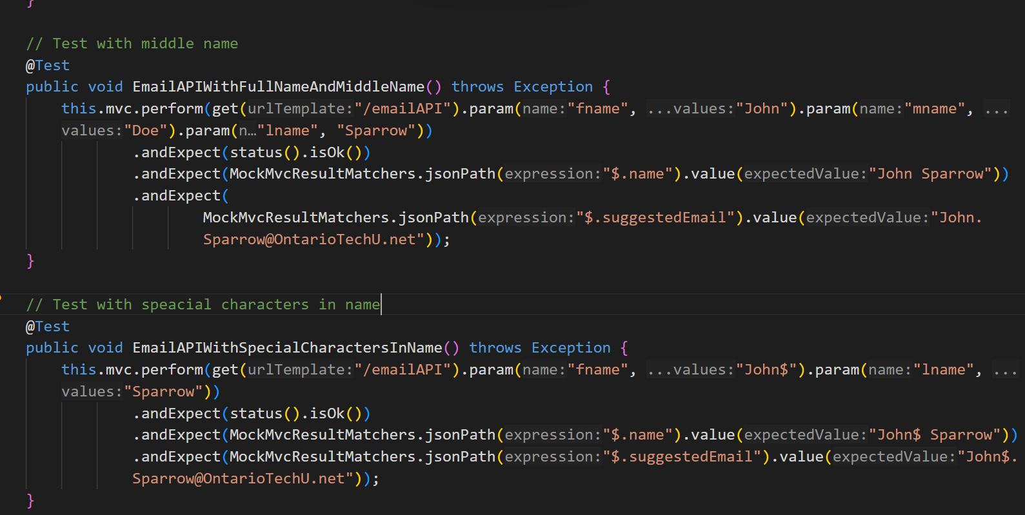 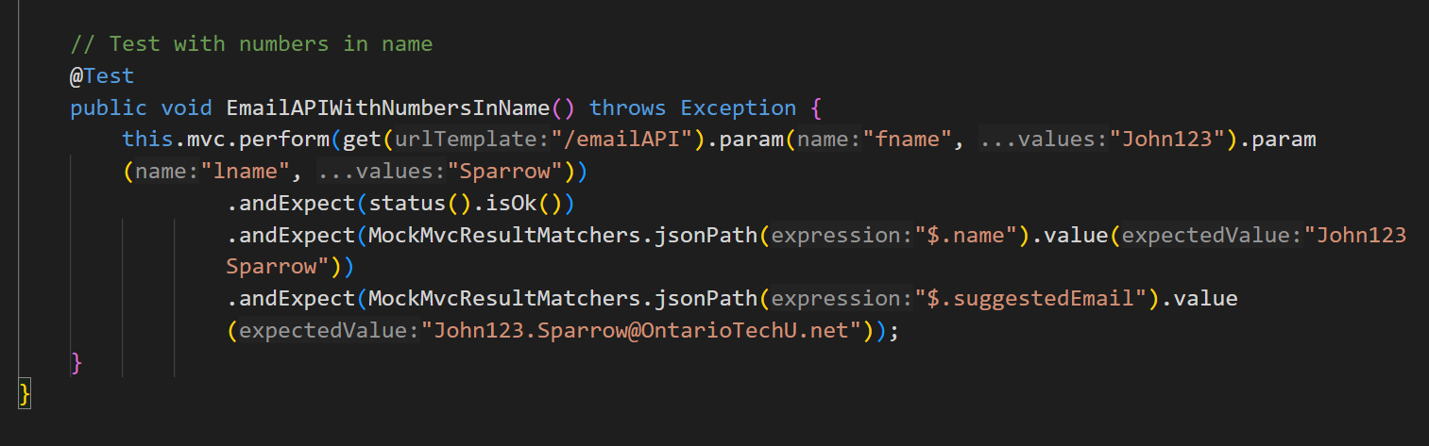

**SUNFIRE REPORTS FOR SUCCESS FROM 6 TO 9**

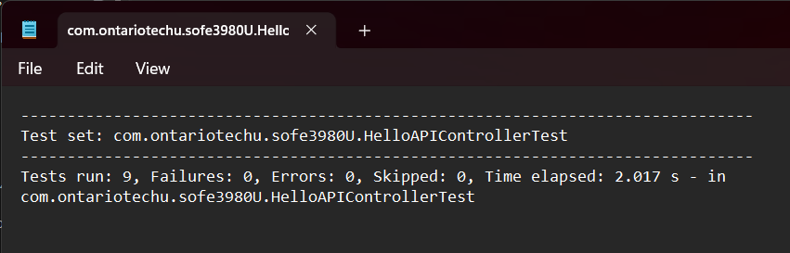

**OUTPUT WENT FROM 11 TO 14 TO BE 3 MORE SUCCESSFUL TESTS**

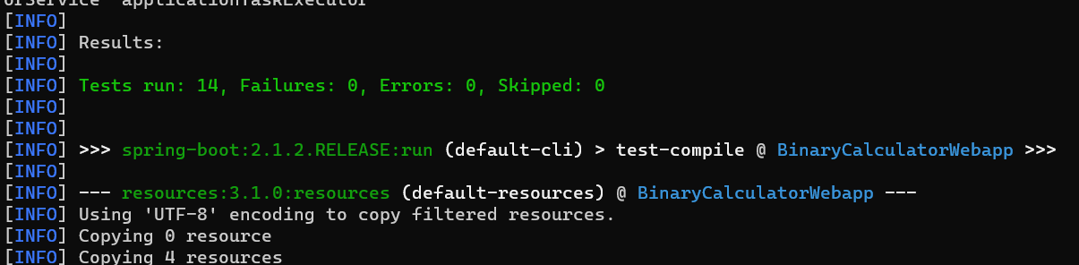

**RUN THE TESTS WITH BINARY CONTROLLER (19 SUCCESSFULL)**

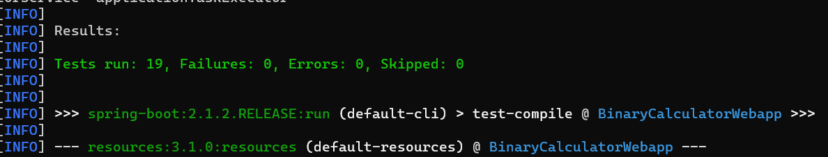

**ADD OUTPUT**

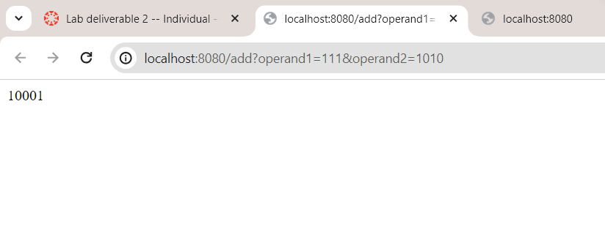

**JSON ADD**

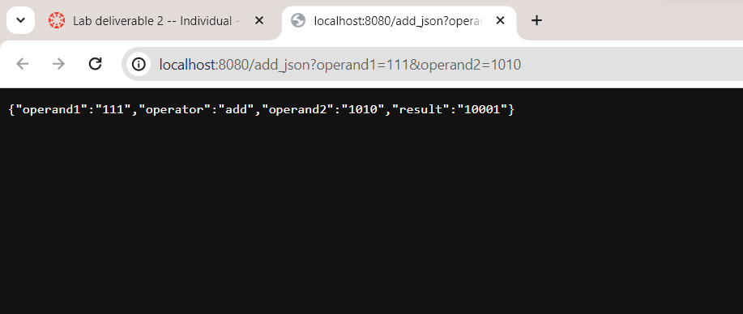

**TESTS WITH API**

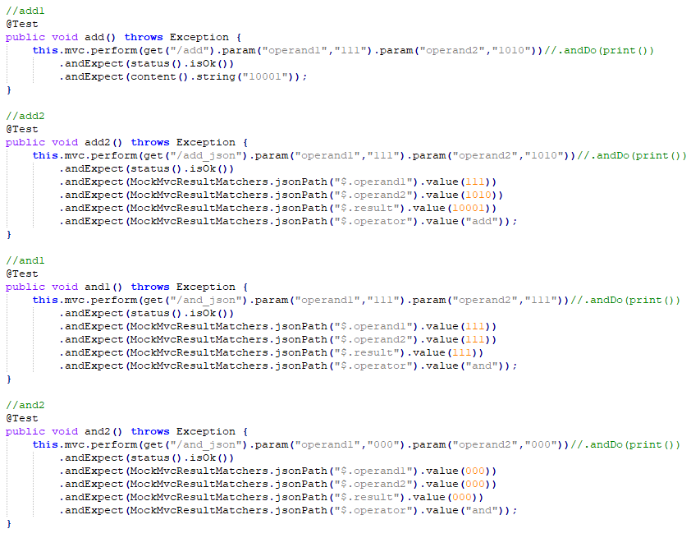

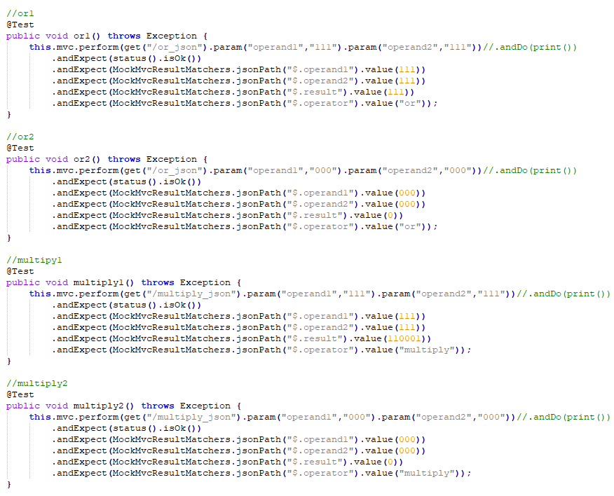

**TEST WITHOUT API**

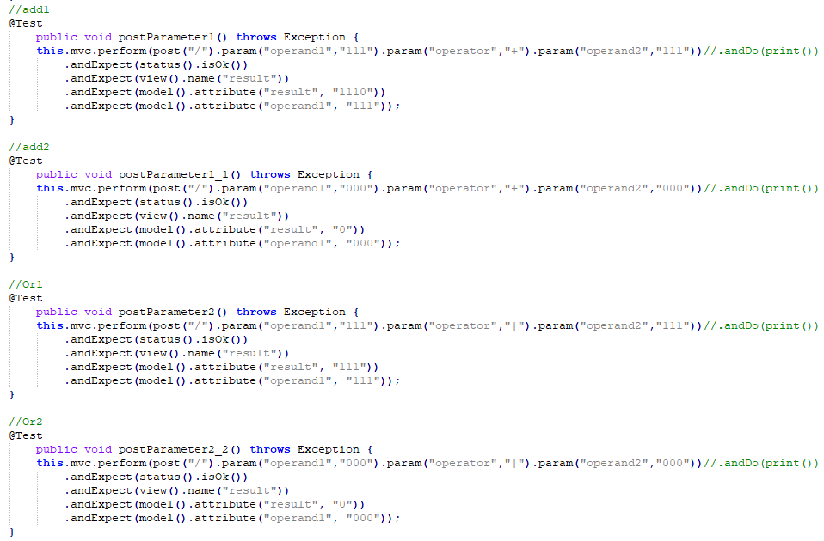

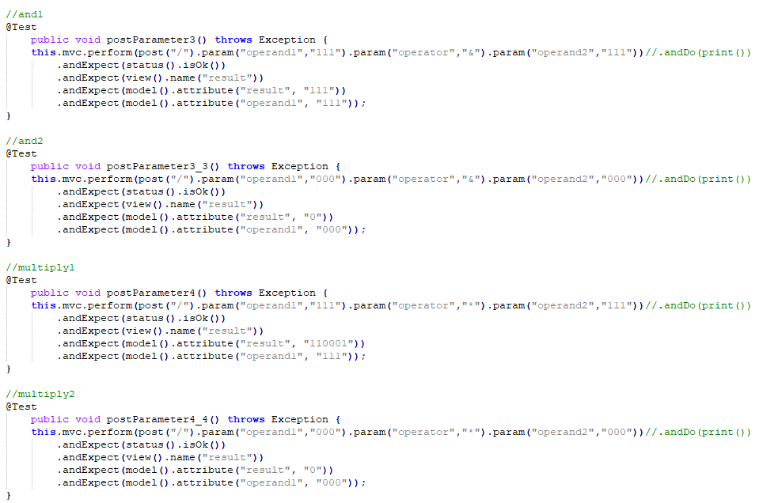

**UPDATED WITH ALL TESTS RUNNING FOR EACH OPERTATION WITH AND W/O API**

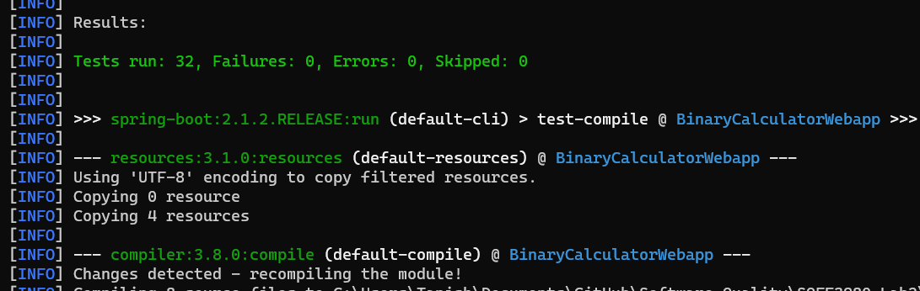

**BINARY API SUNFIRE REPORTS**

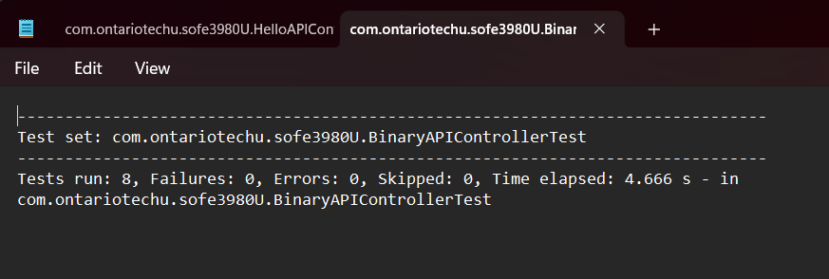

**BINARY SUNFIRE REPORT**

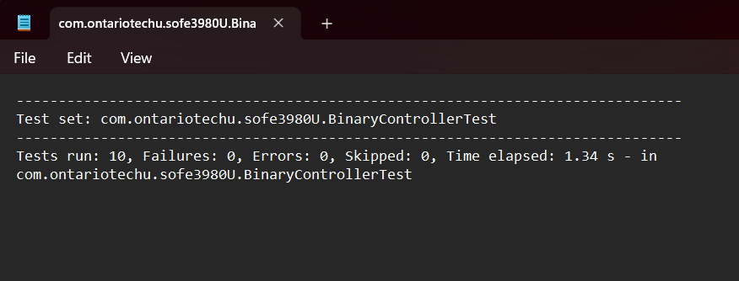

GITHUB: <https://github.com/tanish1409/SOFE3980-Lab2>

YOUTUBE: <https://youtu.be/DfIp8Di7xWo>