SOFE 3700: Data Management Systems



***Final Project Phase – II***

GROUP 3 Lab Sec: 003 CRN: 44213

**Group Member 1 Name:** Tanish Singla

**Student ID:** 100782583

**Group Member 2 Name:** Akshat Gupta

**Student ID**: 100813132

**Group Member 3 Name:** Avery Thurston

**Student ID**: 100845667

**Group Member 4 Name:** Hetvi Vaghela

**Student ID**: 100847993

**Date:** 5/11/2023

**PART A**

Relational Schema

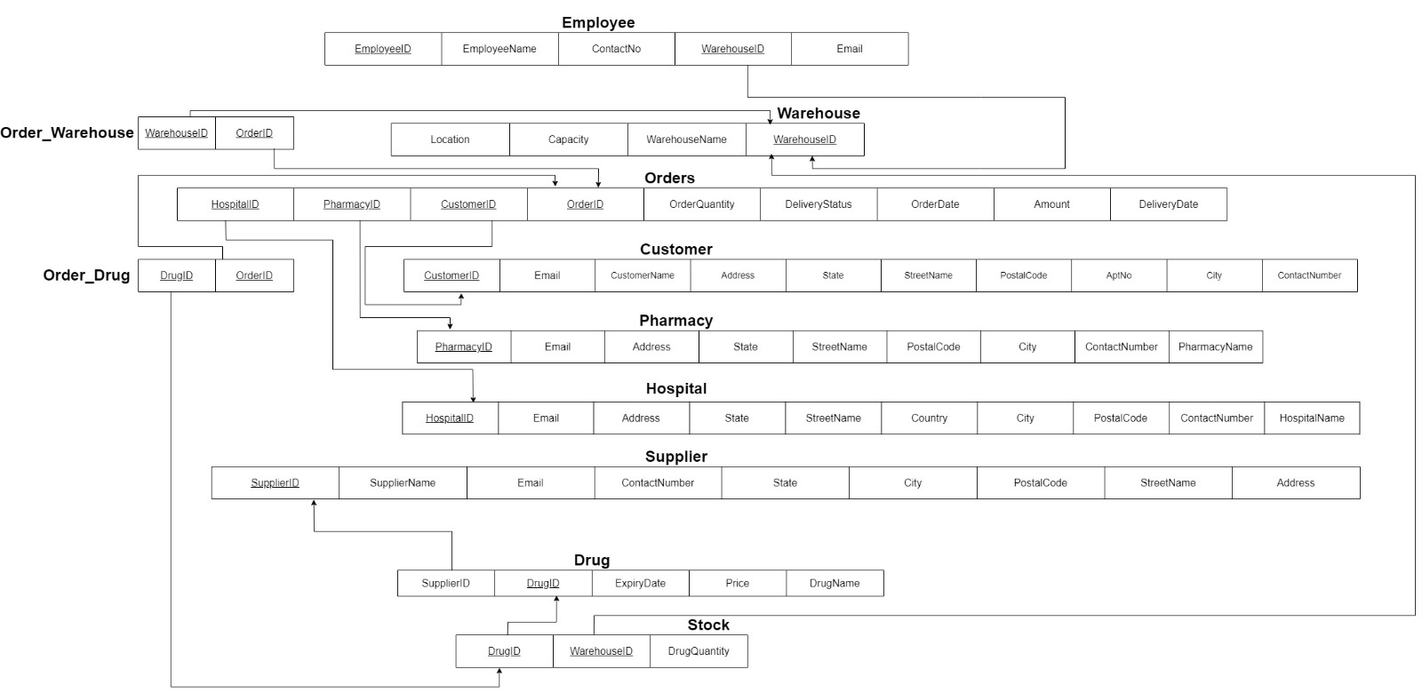

Screenshot of the created table  
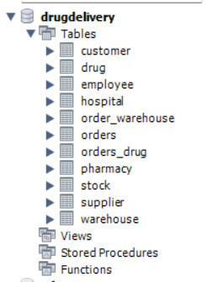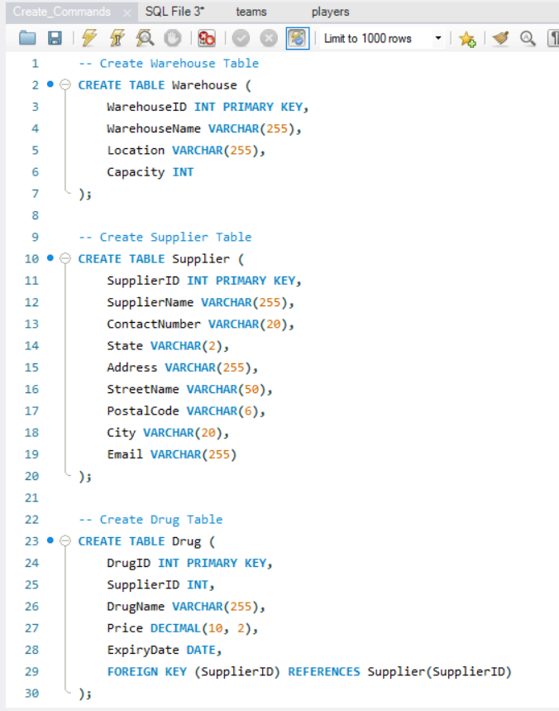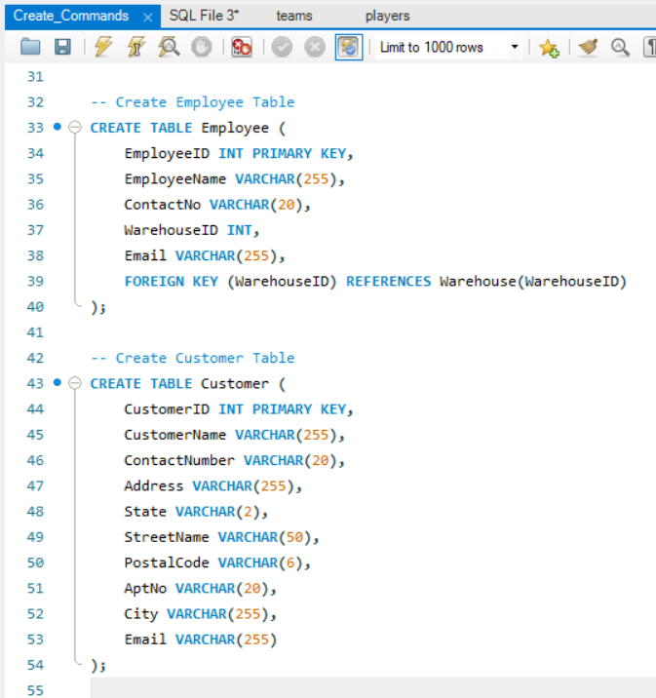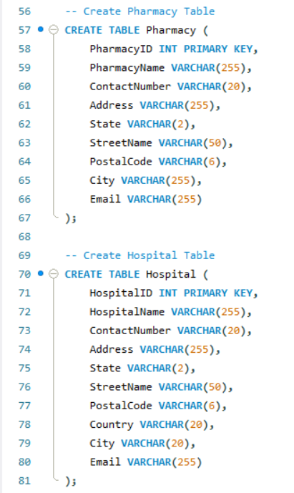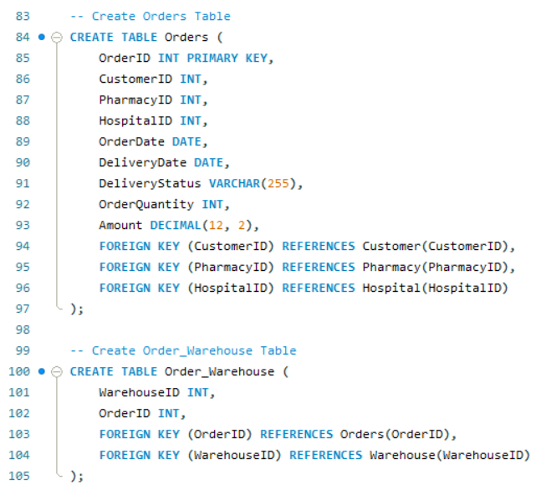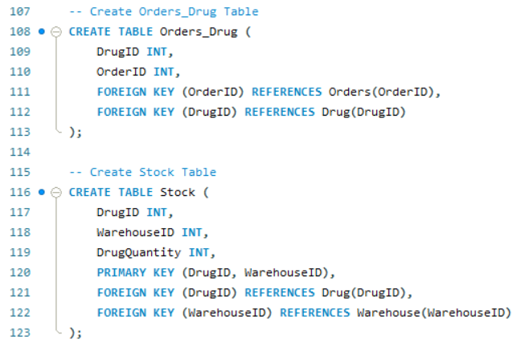

**PART B**

Customer

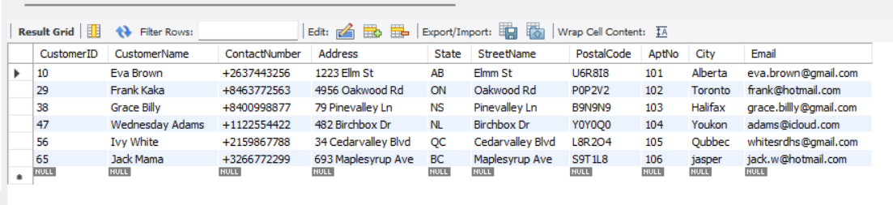

Warehouse

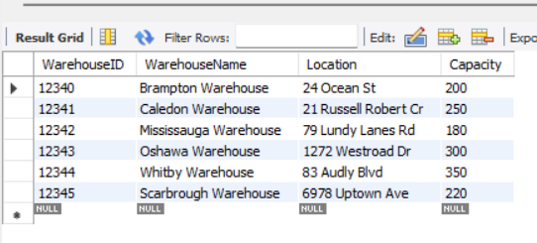

Supplier

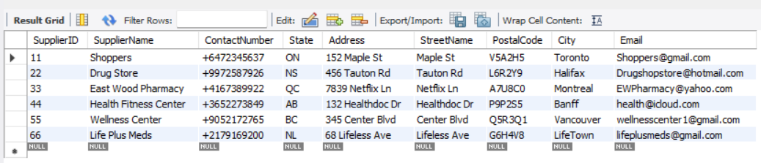

Employee

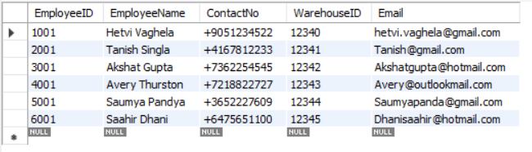

Drug

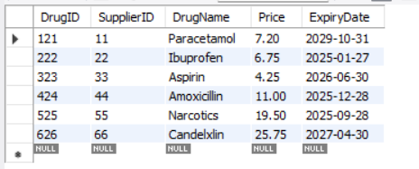

Stock

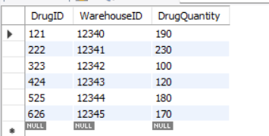

Pharmacy

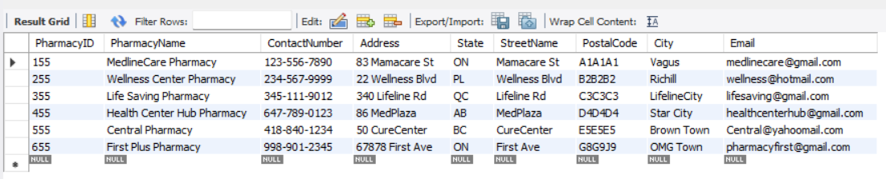

Hospital

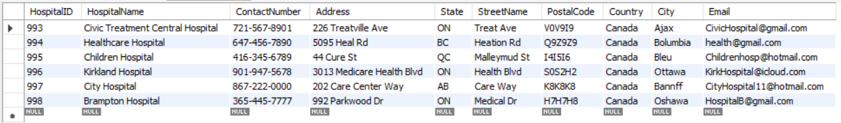

Order

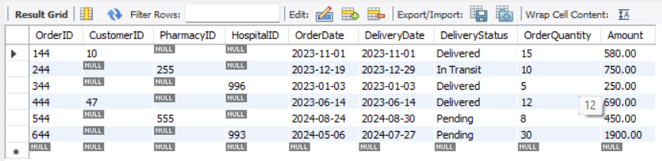

Order_Warehouse

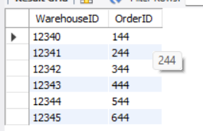

Order_Drug

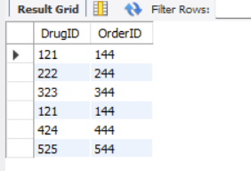

**PART C**

View 1

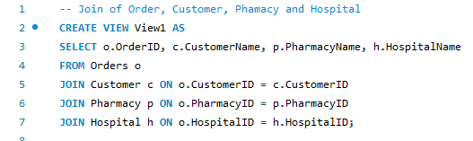

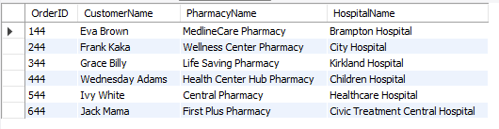

View 2

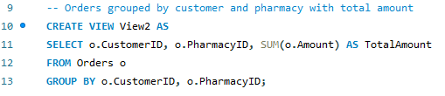

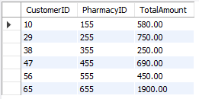

View 3

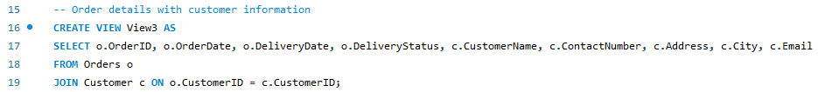

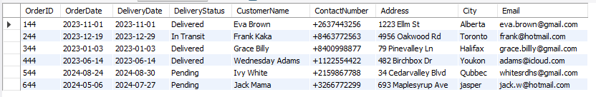

View 4

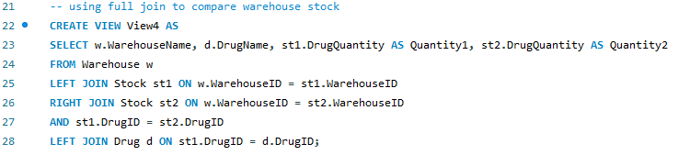

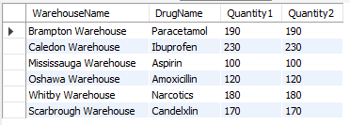

View 5

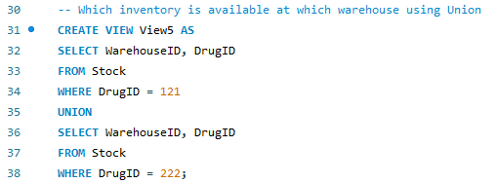

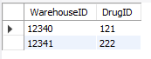

View 6

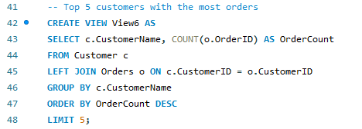

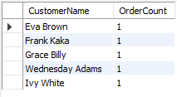

View 7

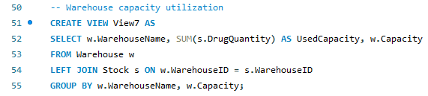

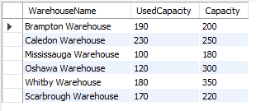

View 8

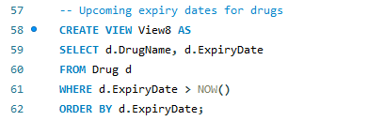

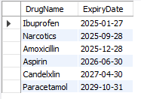

View 9

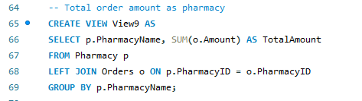

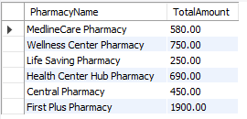

View 10

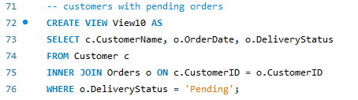

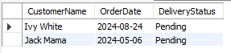

**PART D**

ER Schema

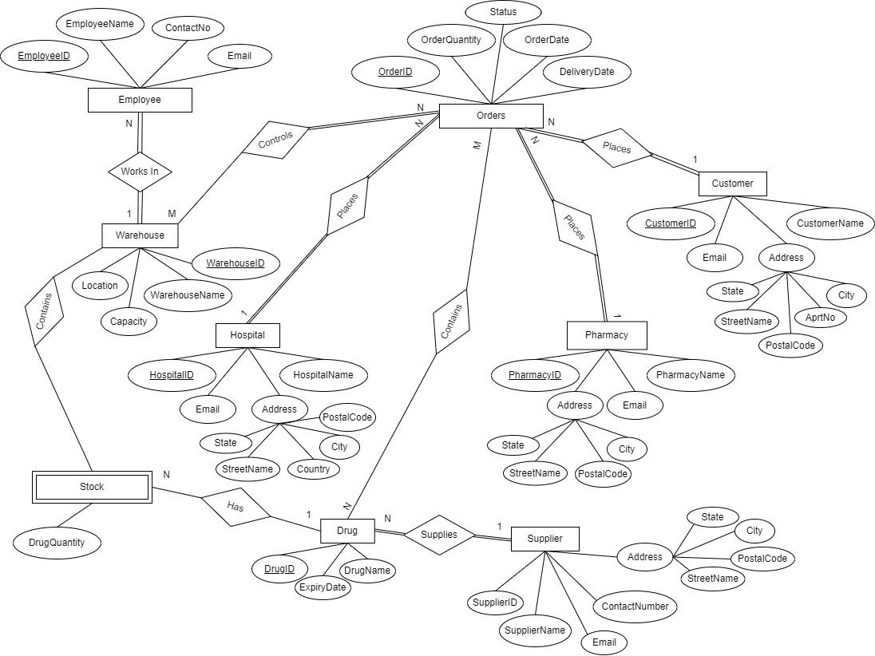

UML ER Schema

