EXPERIMENT 01

Explain Client–Server Architecture and Observation of HTTP Requests and Responses using Browser Developer Tools.
Client-Server Architecture is a computing model where the client (e.g., a user's web browser or application) requests resources or services from a centralized server, which processes the request and sends back the response, enabling efficient distribution of tasks and data management. This architecture separates concerns: the client handles user interface and input, while the server manages data storage, processing, and security.

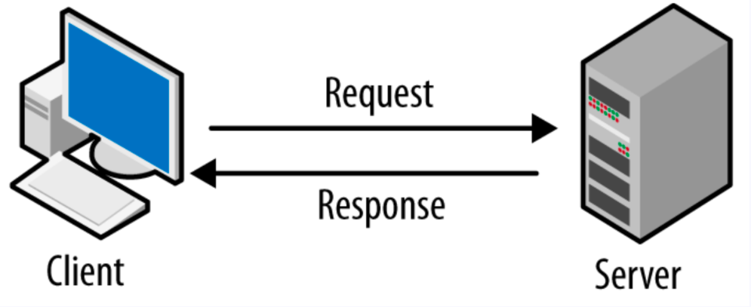
Figure 1 - Client Server Architecture

In the diagram, the client initiates communication by sending a request to the server, which then responds with the required data or action result.

What are HTTP Requests and Responses?

HTTP Request: This is a message sent by your browser to a web server when you go to a website (e.g., you are requesting an HTML page, CSS, JavaScript, images, APIs).

HTTP Response: The server's reply to the request (status code, headers, and the actual content).

How to See Them Using Developer Tools in Your Browser

Open Developer Tools (F12 or Ctrl+Shift+I ).

Open the Network tab and refresh the Page.

Click on the refresh/reload button or Ctrl+R.

Explore HTTP Requests -You should see a list of all resources (HTML, CSS, JS, images, fonts, API calls).

EXPERIMENT 02-04

02)Create a basic blog webpage that includes a header, paragraph text, and both ordered and unordered lists.
03) Insert an image and add hyperlinks, including both internal (within the same website) and external (to other websites) links.
04) Structure the blog content using semantic HTML tags such as <header>, <main>, and <footer> for better readability and SEO.

For this task, we created a simple blog webpage using basic HTML tags.

Header Section - We began the webpage by using the <header> tag, which defines the top section of the blog. Inside the header, we placed an <h1> element to display the blog’s main title. The header helps readers immediately understand what the page is about, and it also improves SEO.

Main Content Section - The main content of the blog is wrapped inside the <main> tag. This tag tells browsers and search engines that the content inside represents the core part of the webpage.

Paragraph and Lists - Inside the article, we wrote a paragraph using the <p> tag to introduce the blog. We also included two types of lists. An ordered list (<ol>) was used to show steps in a proper sequence, such as the steps to start blogging. An unordered list (<ul>) was used for general items, like resources. Each item in both lists was defined using the <li> tag.

Hyperlinks - We added hyperlinks using the <a> tag. One hyperlink was an internal link that connected to another page of the same website (for example- ). Another hyperlink was an external link that directed users to an outside website (Wikipedia). Internal links improve site navigation, while external links connect readers to additional information.

Image Insertion - To make the blog visually appealing, we used the <img> tag to insert an image. The src attribute specifies the image file path, while the alt attribute provides alternative text for accessibility. We also used the width attribute to control the image size on the page.

Conclusion - By combining these elements, we created a simple but structured blog webpage. The use of HTML tags such as <header>, <main>, and <article> improves readability, accessibility, and SEO. At the same time, basic tags like <p>, <ol>, <ul>, <li>, <footer> and <img> add meaningful content, interactivity, and visuals to the page.

<!DOCTYPE html>
<html>
<head>
<title>My Blog</title>
</head>
<body>

<header>
<h1>My Blog</h1>
<hr>
</header>

<main>
<article>
<p>
Welcome to my simple blog. This is a sample paragraph introducing the content.
It is created using only basic HTML elements.
</p>

<h2>Steps to Start Blogging</h2>
<ol>
<li>Choose a topic</li>
<li>Write content</li>
<li>Publish your blog</li>
</ol>
<hr>

<h2>Useful Resources</h2>
<ul>
<li><a href="about.html">About Page (Internal Link)</a></li>
<li><a href="https://www.wikipedia.org" target="_blank">Wikipedia (External Link)</a></li>
</ul>
<hr>

<h2>Sample Image</h2>
<p>Below is an example image for the blog:</p>
<img src="https://firstsiteguide.com/wp-content/uploads/2021/04/AdventurousKate.jpg" alt="Sample blog image" width="1000">
</article>
</main>

<hr>
<footer>
<p>&copy; 2025 My Blog. Thanks for visiting.</p>
</footer>

</body>
</html>
Figure 2 - Code Snippet

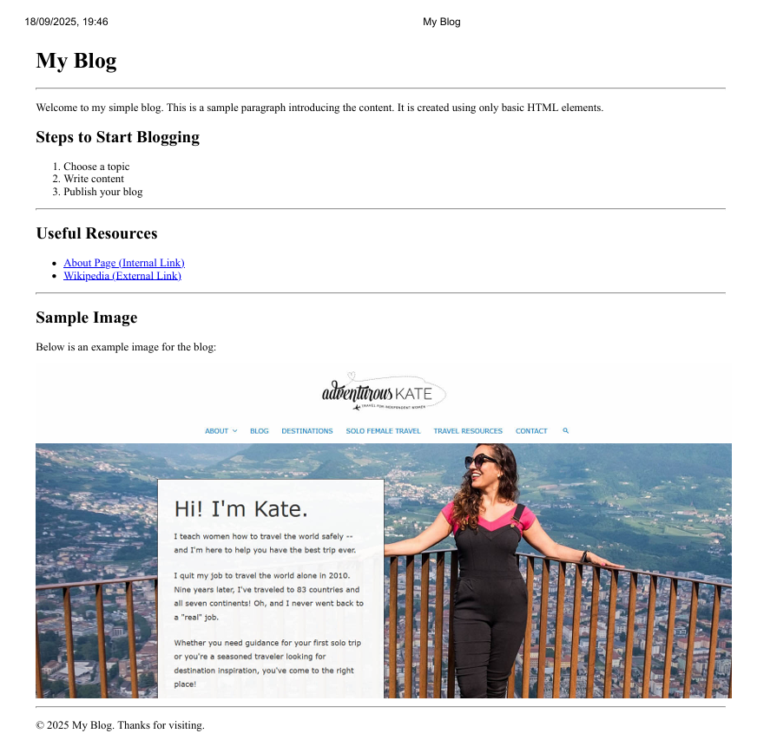
Figure 3 - Final Web Page Layout

