Q1.) SELECT * FROM EMP;

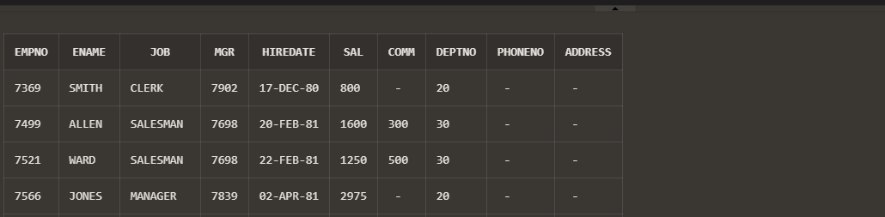

Q2.) SELECT deptno,dname FROM dept;

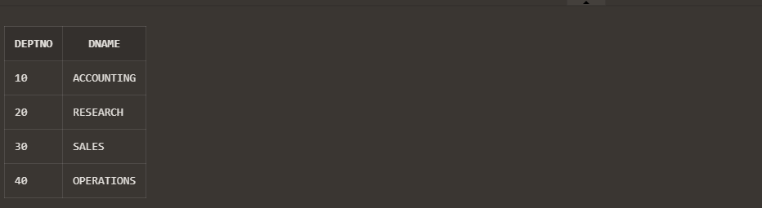

Q3.) SELECT EMPNO,ENAME,DEPTNO FROM EMP WHERE DEPTNO=20;

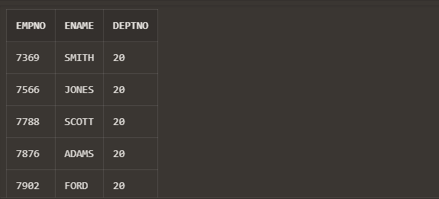

Q4.) SELECT * FROM EMP ORDER BY DEPTNO desc;

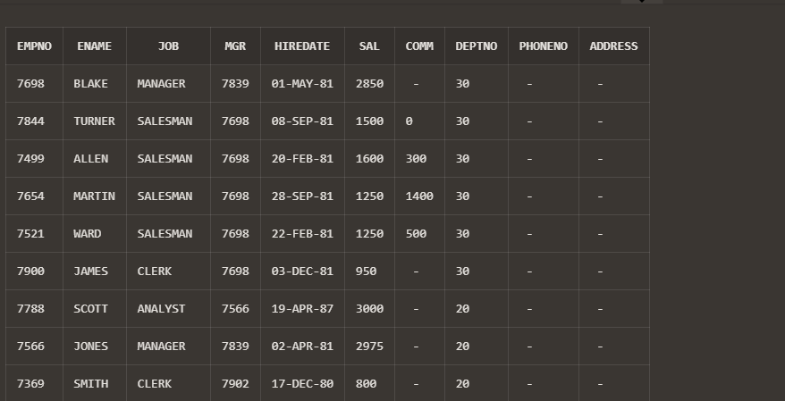

Q5.) SELECT JOB FROM EMP;



Q6.) SELECT ENAME,SAL,DEPTNO FROM EMP WHERE DEPTNO=20 AND JOB='CLERK';

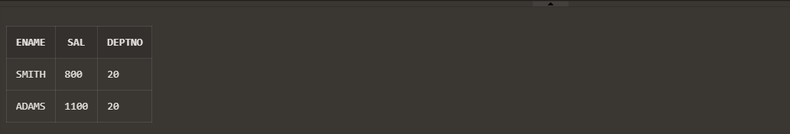

Q7.) SELECT ENAME,HIREDATE FROM EMP WHERE ENAME LIKE 'S%' OR ENAME LIKE '_C%';

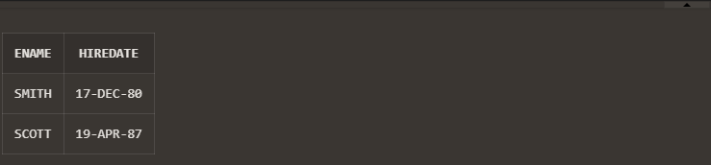

Q8.) SELECT ENAME,HIREDATE,SAL FROM EMP WHERE NOT JOB='MANAGER';

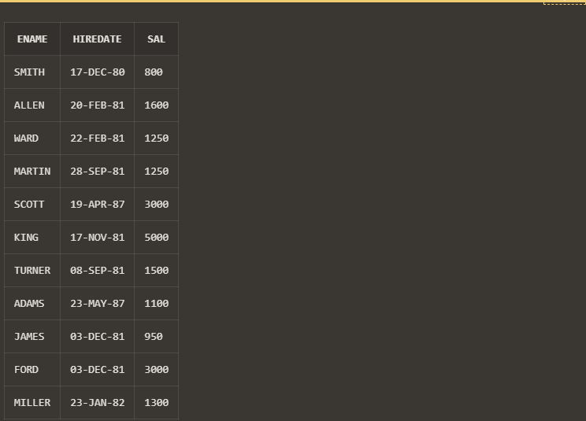

Q9.) SELECT ENAME,INITCAP(ENAME) AS capital_name,LENGTH(ENAME) as length FROM EMP;



Q10.) SELECT ENAME,SAL FROM EMP WHERE SAL>4000 AND SAL<6000;

