Q1.) Display the Name, manager Id, and hire date of all employees who are either clerk or works in dept 20. the date should be in the following format:

SELECT "ENAME", mgr, TO_CHAR(HIREDATE, 'DDSPTH MONTH,YYYY') AS "DATE_HIRED"

FROM emp

WHERE job = 'CLERK' OR deptno = 20

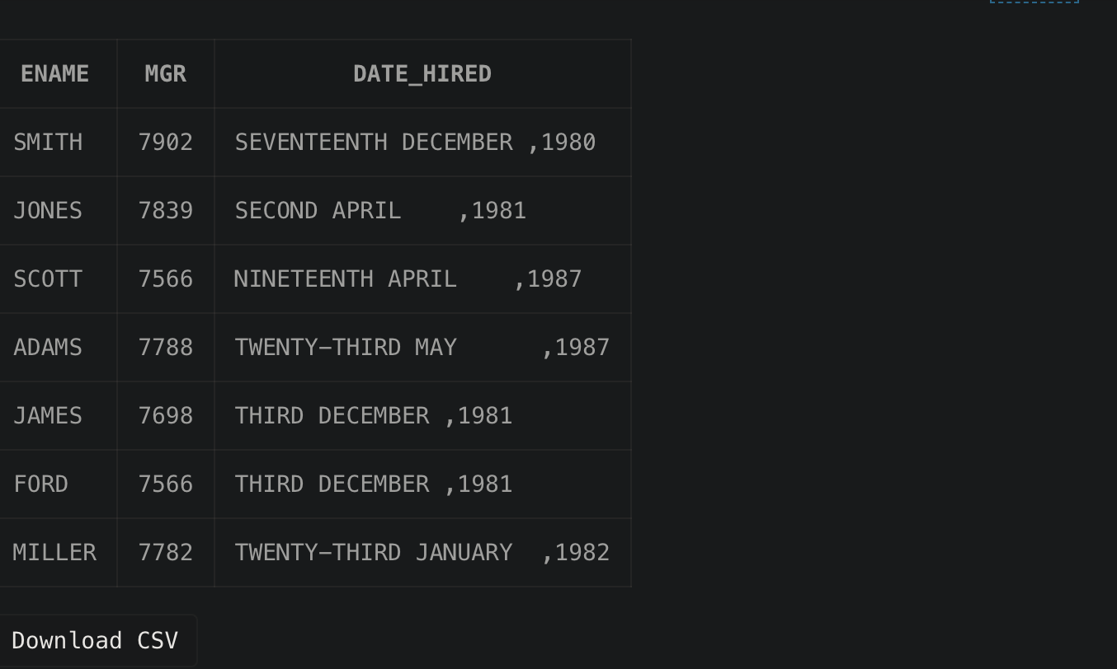

Q2.) List the employee name and old salary and new increased salary by 25% and expressed as a whole number.

SELECT "ENAME", SAL AS "OLD SALARY", ROUND(1.25*SAL) AS "NEW SALARY"

FROM emp

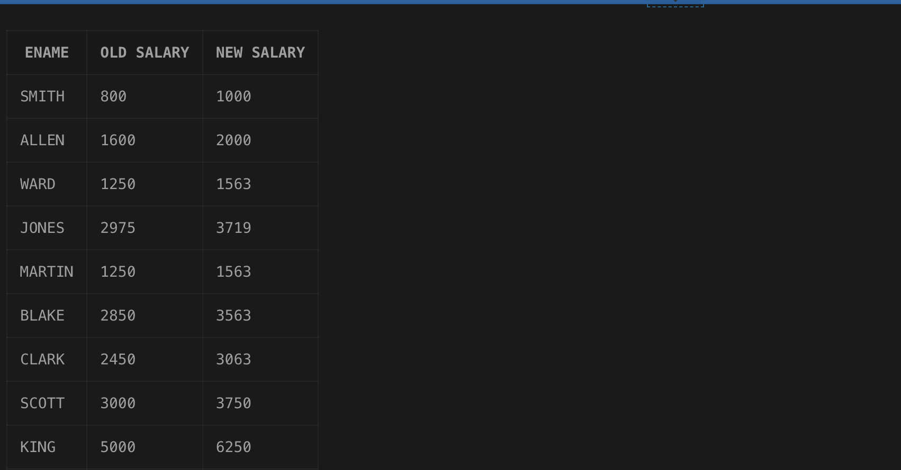

Q3.) List the employee name and salary where name is displayed as left justified and salary with right justified.

SELECT LPAD(ename, LENGTH(ename)) AS "Employee Name", LPAD(TO_CHAR(sal), 10) AS "Salary"

FROM emp;

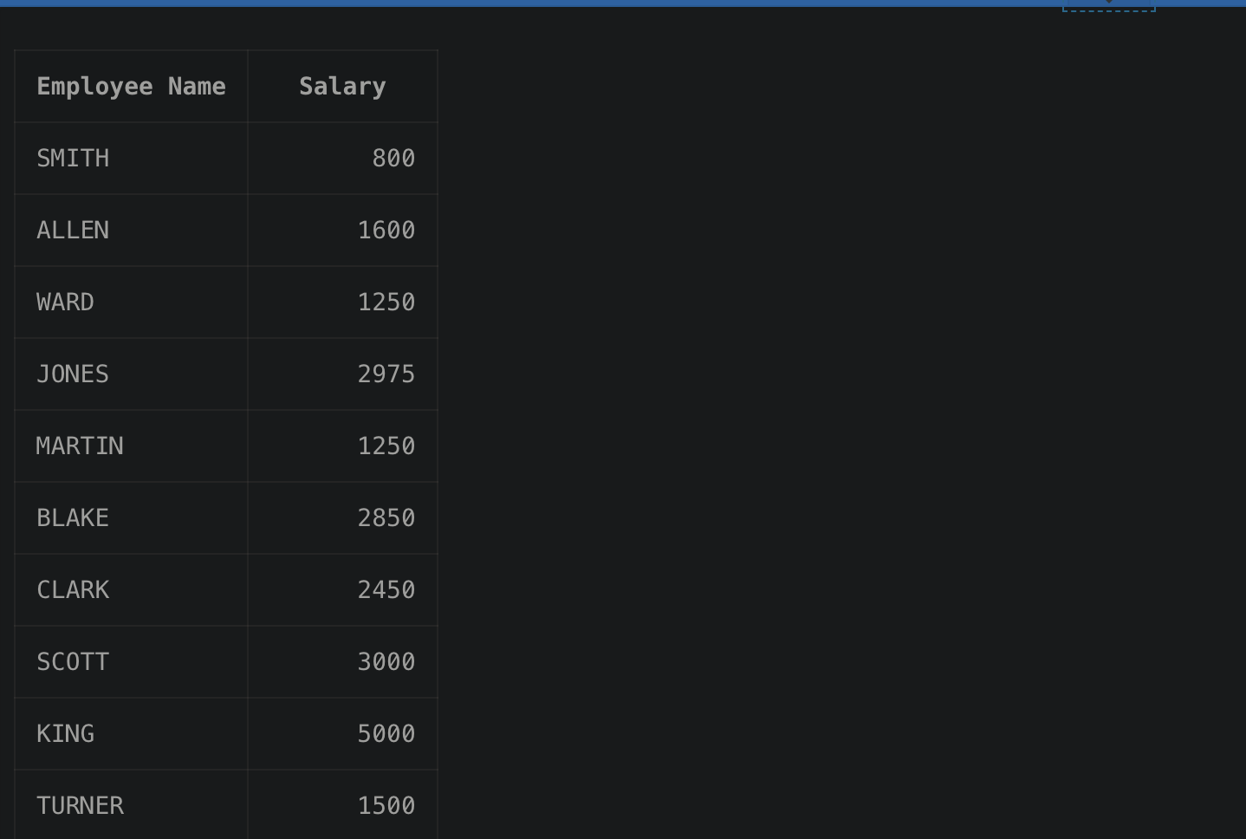

Q4.) Produce the output as follows(for all employees)

ROLE OF THE EMPLOYEE

Name1 (<Job of Name 1>)

Name2 (<Job of Name 2>)

SELECT CONCAT(CONCAT(INITCAP(ename), ' ('), CONCAT(INITCAP(job), ')')) AS "ROLE OF EMPLOYEE"

FROM emp;

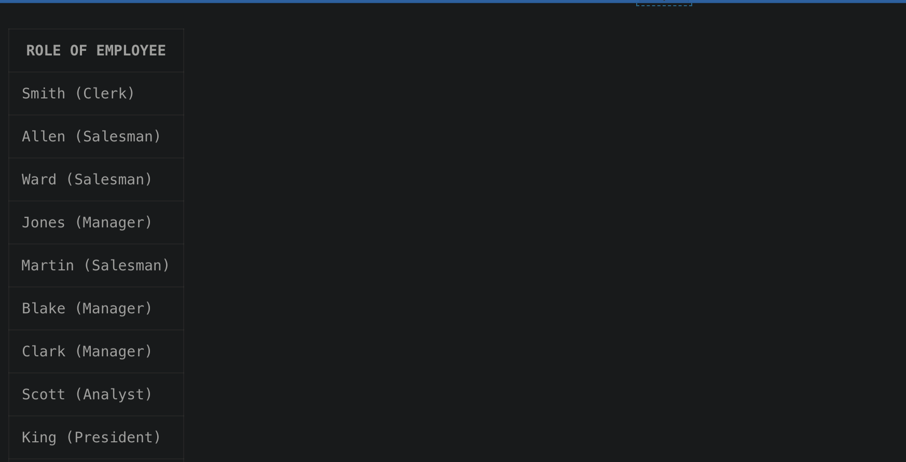

Q5.) Give the details of an employees with job is clerk (enter the job value clerk as input).

DECLARE

job_title VARCHAR2(50);

BEGIN

job_title := '&job_title';

FOR emp IN (

SELECT *

FROM emp

WHERE job = job_title

) LOOP

-- Output the employee details

DBMS_OUTPUT.PUT_LINE('ID: ' || emp.empno || ', Name: ' || emp.ename || ', Job: ' || emp.job);

END LOOP;

END;

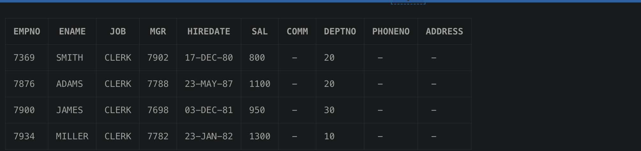

Q6.) Display each employee name with hiredate and salary review date. Assume that date is one year after hiredate. Order the output in ascending review date order.

SELECT ENAME,HIREDATE,ADD_MONTHS(HIREDATE,12) AS REVIEWDATE

FROM EMP

ORDER BY REVIEWDATE

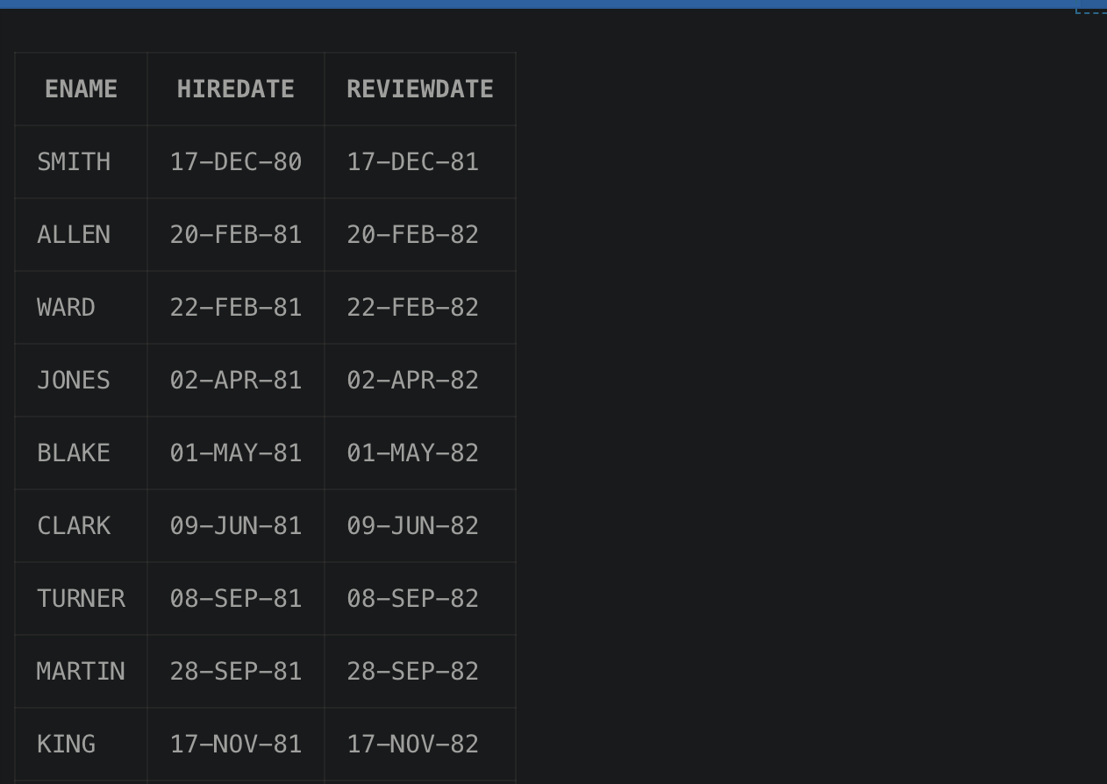

Q7.) Find the employees(s) who earn the highest salary in each job type sort in descending salary order(Use IN operator and subqueries)

SELECT *

FROM EMP

WHERE SAL IN (

SELECT MAX(SAL)

FROM EMP

GROUP BY JOB

)

ORDER BY SAL DESC;

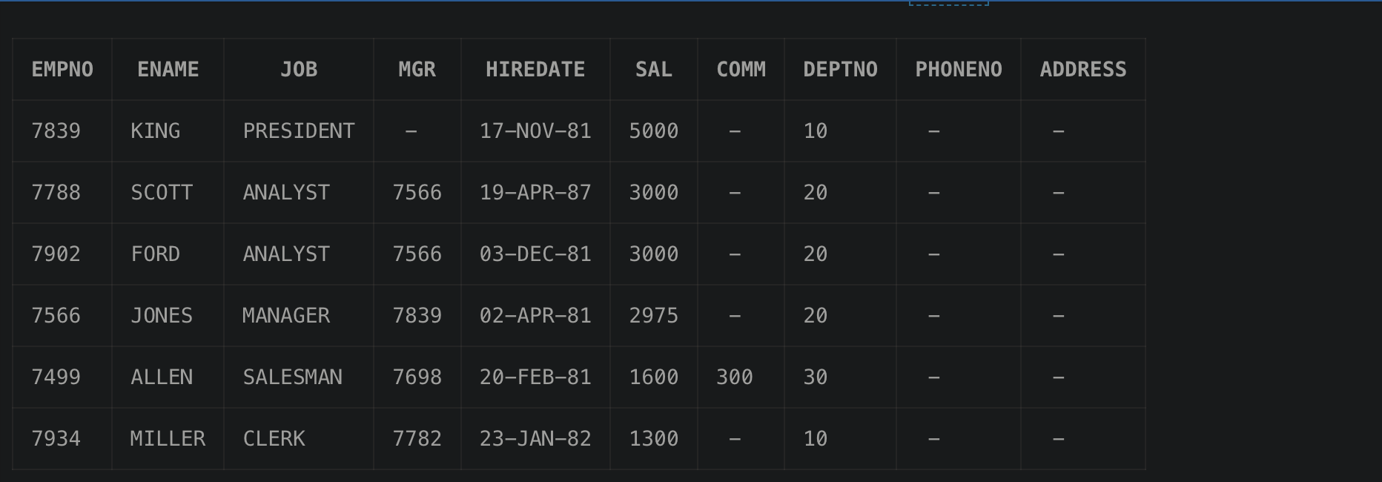

Q8.) Find the most recently hired employee in each department (give number only).

SELECT EMPNO

FROM EMP e

WHERE HIREDATE = (

SELECT MAX(HIREDATE)

FROM EMP

WHERE DEPTNO = e.DEPTNO

);



Q9.) Show the name of the department and no of employees who works in that department. Sort in department number.

SELECT d.deptno, d.DNAME, COUNT(e.EMPNO) AS NUM_OF_EMPLOYEES

FROM dept d

LEFT JOIN EMP e ON d.deptno = e.DEPTNO

GROUP BY d.deptno, d.DNAME

ORDER BY d.deptno;

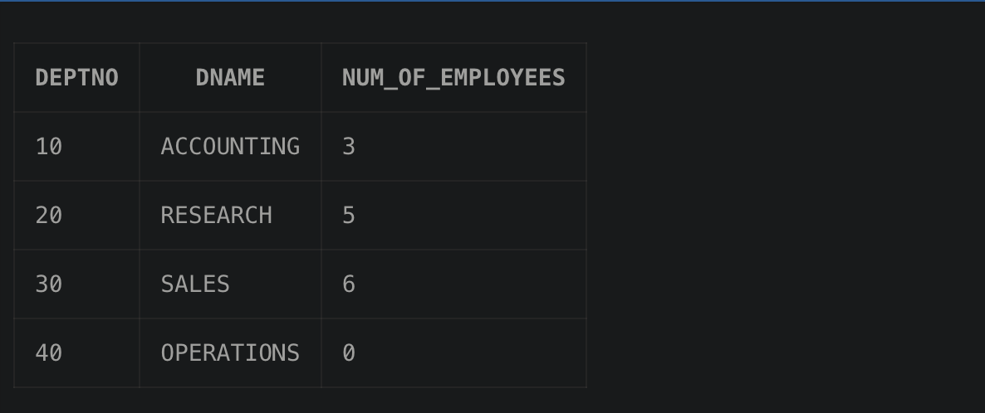

Q10.) Display the Id, name, salary and the salary grade for any employee who earns the

maximum salary for their department. Sort in department number.

SELECT e.DEPTNO, e.EMPNO, e.ENAME, MAX(e.SAL) AS MAX_SALARY, sg.grade, sg.losal, sg.hisal

FROM EMP e

JOIN SALGRADE sg ON e.SAL BETWEEN sg.losal AND sg.hisal

GROUP BY e.DEPTNO, e.EMPNO, e.ENAME, sg.grade, sg.losal, sg.hisal

ORDER BY e.DEPTNO;

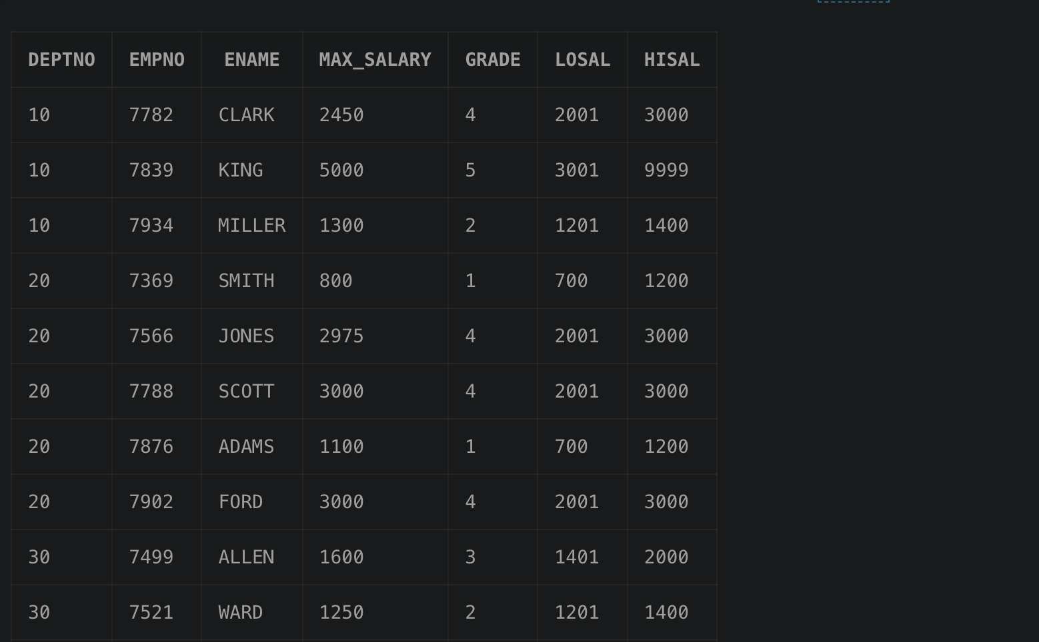

Q11.) In which year did most people join the company? Display the year and number of

employees.

SELECT EXTRACT(YEAR FROM HIREDATE) AS HIRE_YEAR, COUNT(*) AS num_employees

FROM EMP

GROUP BY EXTRACT(YEAR FROM HIREDATE)

ORDER BY num_employees DESC

FETCH FIRST 1 ROW ONLY;



Q12.) Show the every alternate row in employee table.

SELECT *

FROM (

SELECT EMP.*, ROW_NUMBER() OVER (ORDER BY EMPNO) AS rn

FROM EMP

)

WHERE MOD(rn, 2) = 1;

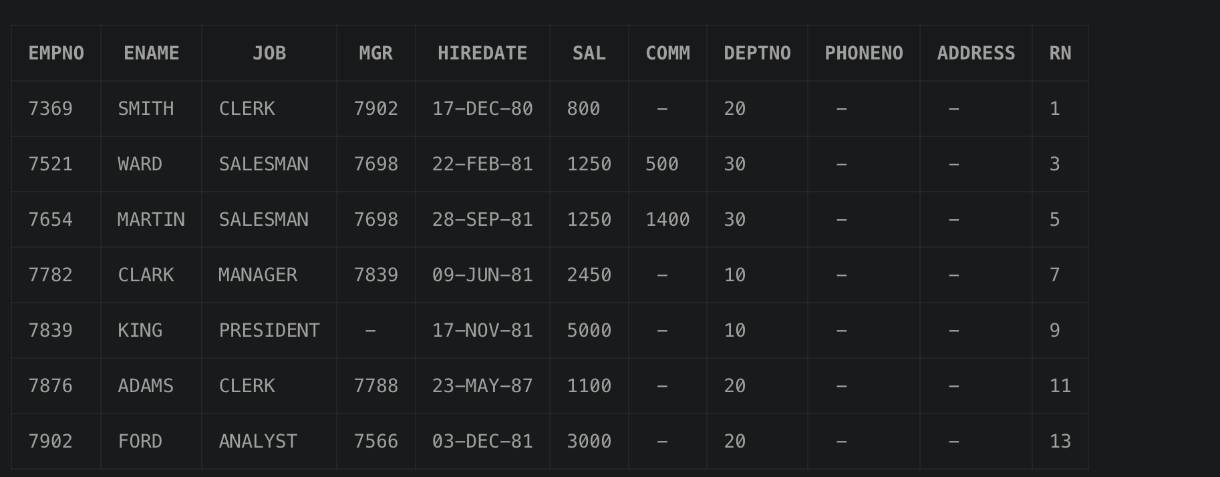

Q13.) Display the total salary of all employees. Total salary = salary + commission.

SELECT EMPNO, ENAME, JOB, (SAL + NVL(COMM, 0)) AS TOTAL_SALARY

FROM EMP;

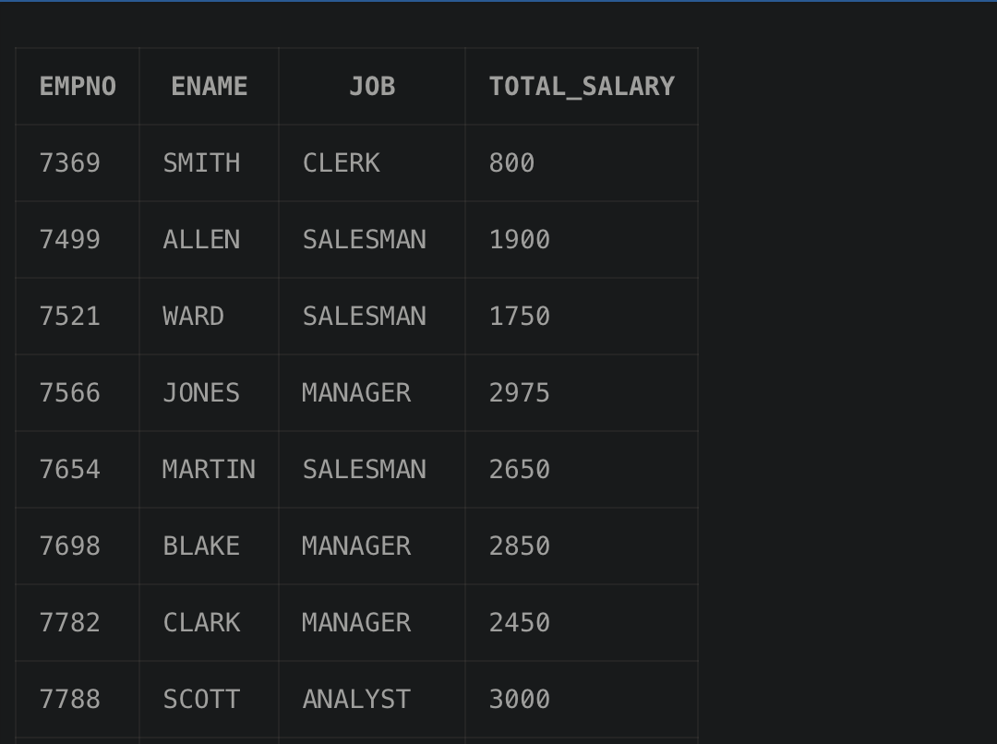

Q14.) Display the department name and available jobs in that department.

SELECT DISTINCT(JOB) AS AVAILABLE_JOBS,DNAME

FROM EMP,DEPT

WHERE DEPT.deptno=EMP.deptno

ORDER BY DNAME

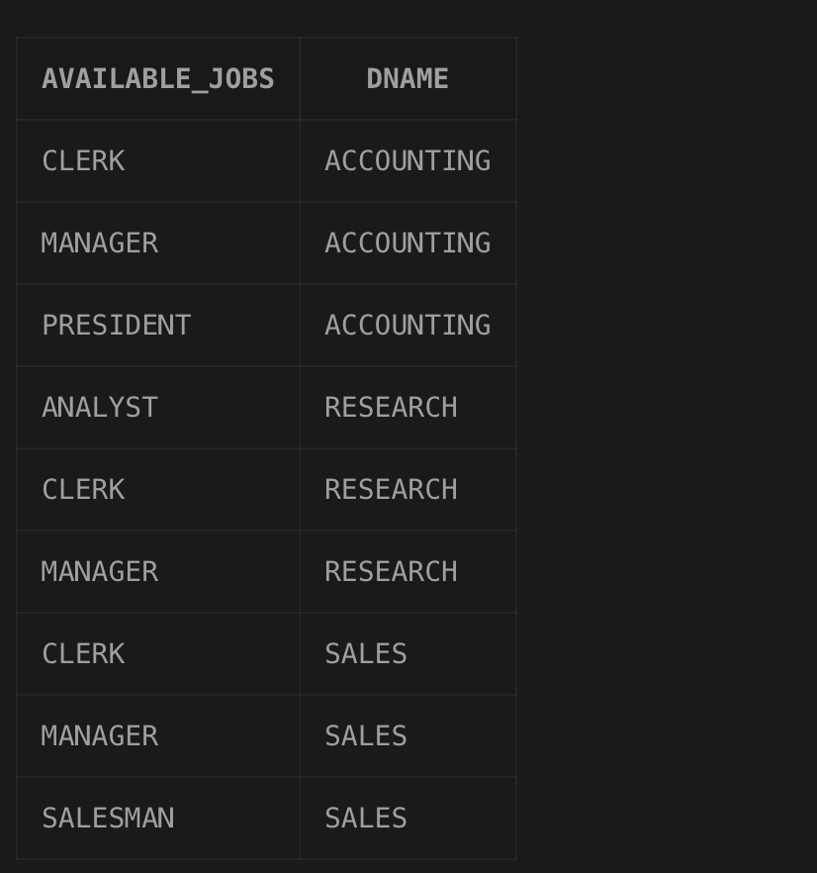

Q15.) Display all the available departments and the employee(s) works under it.

SELECT DNAME,ENAME

FROM EMP,DEPT

WHERE DEPT.deptno=EMP.deptno

ORDER BY DNAME

