DBMS LAB

ASSIGNMENT – 4

NAME : Tanish Majumdar

ROLL NO. : 002311001077

DATE : 27/9/24

**Consider a BANK database. Each bank can have multiple branches, and each branch can have multiple accounts and loans. Assumptions also can be made. Design an ER diagram and database schema for the system. Specify the primary key, foreign key and other constraints for all required**

**tables. Draw the ER diagram in MS Word.**

**Database Schema**

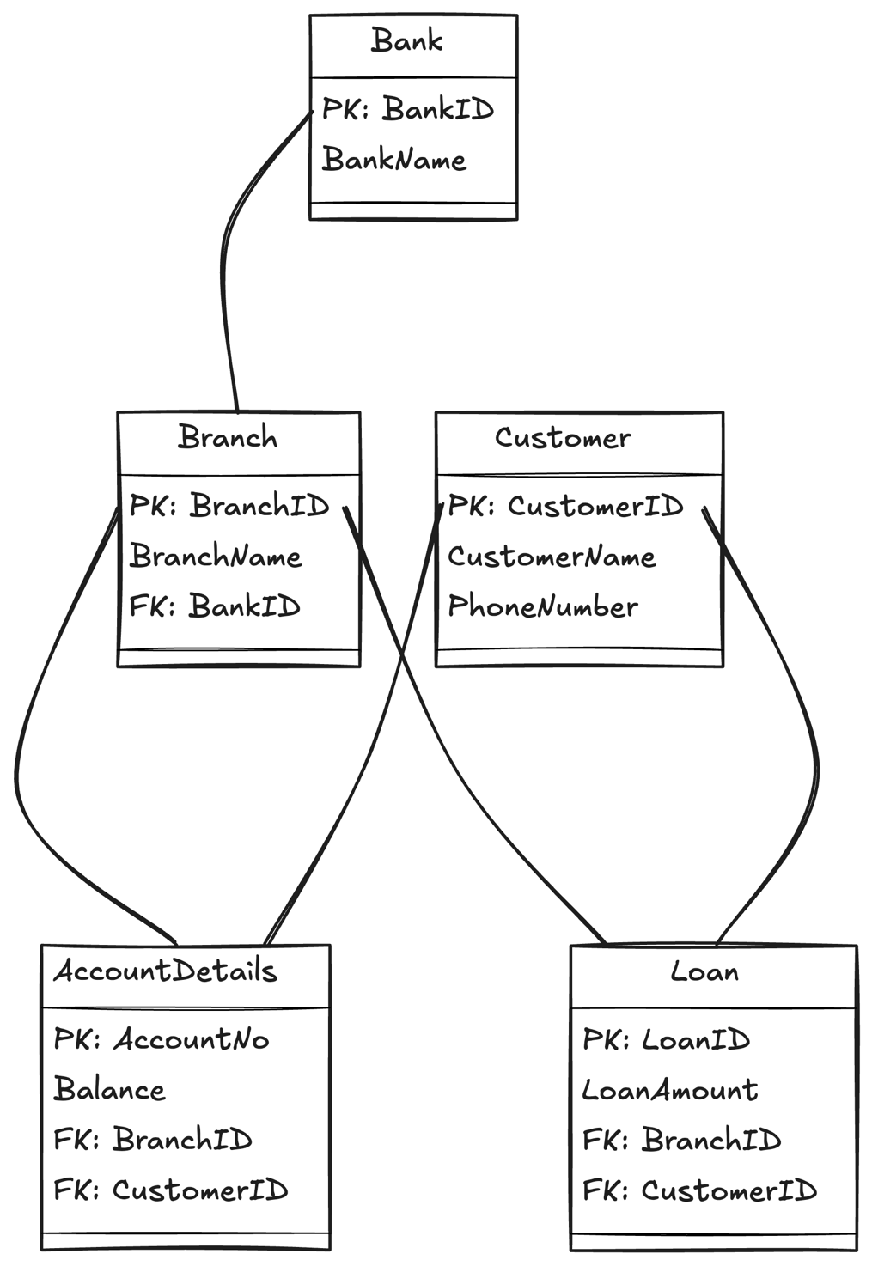

**ER DIAGRAM**

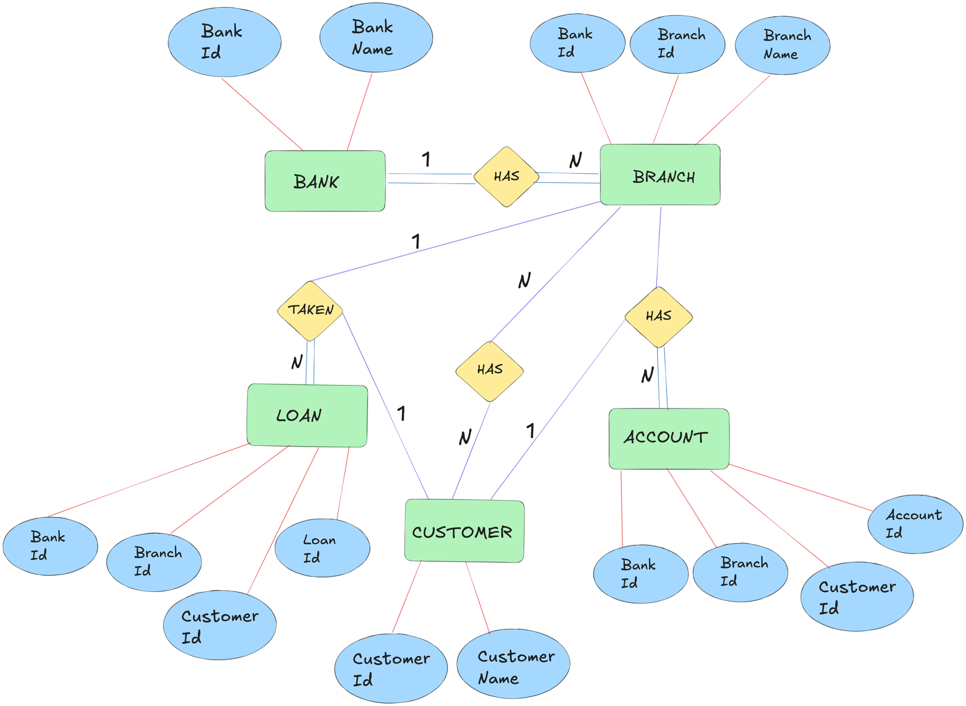

**Question and Answers**

Q1.) Insert at least five tuples in each table.

**CREATE** **TABLE** Bank (  
 BankID INT PRIMARY **KEY**,  
 BankName VARCHAR(100)  
);  
**CREATE** **TABLE** Branch (  
 BranchID INT PRIMARY **KEY**,  
 BranchName VARCHAR(100),  
 BankID INT,  
 **FOREIGN** **KEY** (BankID) **REFERENCES** Bank(BankID)  
);  
**CREATE** **TABLE** Customer (  
 CustomerID INT PRIMARY **KEY**,  
 CustomerName VARCHAR(100),  
 PhoneNumber VARCHAR(15)  
);  
**CREATE** **TABLE** AccountDetails (  
 AccountNo INT PRIMARY **KEY**,  
 Balance INT,  
 BranchID INT,  
 CustomerID INT,  
 **FOREIGN** **KEY** (BranchID) **REFERENCES** Branch(BranchID),  
 **FOREIGN** **KEY** (CustomerID) **REFERENCES** Customer(CustomerID)  
);  
**CREATE** **TABLE** Loan (  
 LoanID INT PRIMARY **KEY**,  
 LoanAmount INT,  
 CustomerID INT,  
 BranchID INT,  
 **FOREIGN** **KEY** (CustomerID) **REFERENCES** Customer(CustomerID),  
 **FOREIGN** **KEY** (BranchID) **REFERENCES** Branch(BranchID)  
);  
  
**INSERT** **INTO** Bank (BankID, BankName) **VALUES** (1, 'SBI');  
**INSERT** **INTO** Bank (BankID, BankName) **VALUES** (2, 'PNB');  
**INSERT** **INTO** Bank (BankID, BankName) **VALUES** (3, 'HDFC');  
**INSERT** **INTO** Bank (BankID, BankName) **VALUES** (4, 'ICICI');  
**INSERT** **INTO** Bank (BankID, BankName) **VALUES** (5, 'Axis');  
  
**INSERT** **INTO** Branch (BranchID, BranchName, BankID) **VALUES** (1, 'Salt Lake', 1);  
**INSERT** **INTO** Branch (BranchID, BranchName, BankID) **VALUES** (2, 'Sealdah', 2);  
**INSERT** **INTO** Branch (BranchID, BranchName, BankID) **VALUES** (3, 'Park Street', 3);  
**INSERT** **INTO** Branch (BranchID, BranchName, BankID) **VALUES** (4, 'Connaught Place', 4);  
**INSERT** **INTO** Branch (BranchID, BranchName, BankID) **VALUES** (5, 'MG Road', 5);  
  
**INSERT** **INTO** Customer (CustomerID, CustomerName, PhoneNumber) **VALUES** (101, 'Taylor Swift', '9876543210');  
**INSERT** **INTO** Customer (CustomerID, CustomerName, PhoneNumber) **VALUES** (102, 'Lana Del Rey', '9876543211');  
**INSERT** **INTO** Customer (CustomerID, CustomerName, PhoneNumber) **VALUES** (103, 'Tate McRae', '9876543212');  
**INSERT** **INTO** Customer (CustomerID, CustomerName, PhoneNumber) **VALUES** (104, 'Charlie XCX', '9876543213');  
**INSERT** **INTO** Customer (CustomerID, CustomerName, PhoneNumber) **VALUES** (105, 'Dua Lipa', '9876543214');  
**INSERT** **INTO** Customer **VALUES** (106, 'Ariana Grande', '9876543215');  
  
  
  
  
**INSERT** **INTO** AccountDetails (AccountNo, Balance, BranchID, CustomerID) **VALUES** (54321987654, 10000, 1, 101);  
**INSERT** **INTO** AccountDetails (AccountNo, Balance, BranchID, CustomerID) **VALUES** (54321987655, 20000, 2, 102);  
**INSERT** **INTO** AccountDetails (AccountNo, Balance, BranchID, CustomerID) **VALUES** (54321987656, 15000, 3, 103);  
**INSERT** **INTO** AccountDetails (AccountNo, Balance, BranchID, CustomerID) **VALUES** (54321987657, 12000, 4, 104);  
**INSERT** **INTO** AccountDetails (AccountNo, Balance, BranchID, CustomerID) **VALUES** (54321987658, 18000, 5, 105);  
**INSERT** **INTO** AccountDetails (AccountNo, Balance, BranchID, CustomerID) **VALUES** (54321987659, 22000, 1, 101);  
**INSERT** **INTO** AccountDetails (AccountNo, Balance, BranchID, CustomerID) **VALUES** (54321987660, 25000, 1, 101);  
**INSERT** **INTO** AccountDetails **VALUES** (54321987661, 30000, 1, 106);  
  
**INSERT** **INTO** Loan (LoanID, LoanAmount, CustomerID, BranchID) **VALUES** (1, 5000, 101, 1);  
**INSERT** **INTO** Loan (LoanID, LoanAmount, CustomerID, BranchID) **VALUES** (2, 8000, 102, 2);  
**INSERT** **INTO** Loan (LoanID, LoanAmount, CustomerID, BranchID) **VALUES** (3, 6000, 103, 3);  
**INSERT** **INTO** Loan (LoanID, LoanAmount, CustomerID, BranchID) **VALUES** (4, 7000, 104, 4);  
**INSERT** **INTO** Loan (LoanID, LoanAmount, CustomerID, BranchID) **VALUES** (5, 9000, 105, 5);

Q2.) At the time of creation if we forget to create a field enrollment date (ENROLL_DATE) in ENROLL table so add the field.

**ALTER** **TABLE** ENROLL **ADD** (enroll_date DATE);

Q3.) Give all the account details of a person who has accounts in SBI.

**SELECT** *   
**FROM** AccountDetails A, Branch B, Bank K  
**WHERE** A.BranchID = B.BranchID  
**AND** B.BankID = K.BankID  
**AND** K.BankName = 'SBI';

Q4.) Find the account holder name who has more than 2 accounts.

**SELECT** CustomerName  
**FROM** Customer  
**WHERE** CustomerID **IN** (  
 **SELECT** CustomerID  
 **FROM** AccountDetails  
 **GROUP** **BY** CustomerID  
 **HAVING** **COUNT**(AccountNo) > 2  
);

Q5.) Rename the accounts table as account details.

**ALTER** **TABLE** Accounts  
**RENAME** **TO** AccountDetails;

Q6.) Find the loan amount and loan taken from which bank for each account holder.

**SELECT** C.CustomerName, L.LoanAmount, K.BankName  
**FROM** Loan L, Branch B, Bank K, Customer C  
**WHERE** L.BranchID = B.BranchID  
 **AND** B.BankID = K.BankID  
 **AND** L.CustomerID = C.CustomerID;

Q7.) Find the account no. and account holder name who has not taken any loan.

**SELECT** A.AccountNo, C.CustomerName  
**FROM** AccountDetails A, Customer C  
**WHERE** A.CustomerID = C.CustomerID  
 **AND** C.CustomerID **NOT** **IN** (  
 **SELECT** CustomerID **FROM** Loan  
 );

Q8.) Delete the account of all the persons who had accounts in PNB, Sealdah branch.

**DELETE** **FROM** AccountDetails   
**WHERE** BranchID **IN** (  
 **SELECT** BranchID   
 **FROM** Branch   
 **WHERE** BranchName = 'Sealdah' **AND**   
 BankID = (  
 **SELECT** BankID   
 **FROM** Bank   
 **WHERE** BankName = 'PNB')  
);

Q9.) Update the branch to SBI, Salt Lake branch for all the persons who had a SBI account in Sealdah branch..

**UPDATE** AccountDetails  
**SET** BranchID = (  
 **SELECT** BranchID   
 **FROM** Branch   
 **WHERE** BranchName = 'Salt Lake' **AND**   
 BankID = (  
 **SELECT** BankID   
 **FROM** Bank   
 **WHERE** BankName = 'SBI')  
)  
**WHERE** BranchID = (  
 **SELECT** BranchID   
 **FROM** Branch   
 **WHERE** BranchName = 'Sealdah' **AND**   
 BankID = (  
 **SELECT** BankID   
 **FROM** Bank   
 **WHERE** BankName = 'SBI')  
);

Q10.) Find the maximum account balance of a person with account no 54321987654 among all of his accounts.

**SELECT** **MAX**(Balance)  
**FROM** AccountDetails  
**WHERE** CustomerID = (  
 **SELECT** CustomerID   
 **FROM** AccountDetails   
 **WHERE** AccountNo = 54321987654);