

School of Computer Science Engineering and Information Systems

Fall Semester 2025-2026

**Department of Information Technology**

BITE 487J Project – I

Review -1

Date: 10.9.2025

**PhilanthroBot: A Trust-Centric Conversational Agent for NGO Discovery and Recommendation using Stateful RAG Architecture**

**22BIT0013 – Tanish Maheshwari**

**22BIT0100 – Manya Dsouza**

**Under the Guidance of**

**Chiranji Lal Chowdhary**

**Professor Grade 1**

**SCORE**



**Guide Signature with date**

Chiranji Lal Chowdhary

**ABSTRACT:**

The non-profit sector faces a significant "trust deficit," where potential donors struggle to identify, vet, and connect with organizations that align with their values due to information asymmetry and a lack of transparency. Traditional web platforms often fail to provide a guided and personalized discovery experience. This project proposes the design and implementation of PhilanthroBot, a novel conversational agent aimed at bridging this gap. PhilanthroBot leverages a Retrieval-Augmented Generation (RAG) architecture, grounded in a curated knowledge base of NGO profiles, to provide users with factual and contextually relevant information. The system is orchestrated using LangGraph to manage a stateful, multi-turn dialogue, enabling the capture of user preferences and the delivery of personalized NGO recommendations. Powered by the gemini-2.0-flash large language model, the agent is designed for rapid, accurate, and natural interactions. This report details the complete architectural blueprint, from data structuring and RAG pipeline construction to the implementation of the stateful conversational agent and its optional deployment via the WhatsApp platform, presenting a robust framework for building trust-centric AI in the philanthropic domain.

**Keywords:**

Conversational AI, Retrieval-Augmented Generation (RAG), LangGraph, NGO, Philanthropy, Trust, Chatbot

1. **INTRODUCTION:**

The act of charitable giving is a cornerstone of civil society, yet the ecosystem connecting donors to non-governmental organizations (NGOs) is fraught with friction and inefficiency. This friction stems not from a lack of generosity but from a fundamental breakdown in the channels of information and trust. Potential donors, armed with the desire to contribute, often find themselves navigating a complex and opaque landscape, unable to confidently direct their resources to causes they care about. This project posits that the application of modern conversational artificial intelligence (AI) presents a powerful new paradigm for addressing this challenge, transforming the process of philanthropic discovery from a frustrating search into a guided, trust-building dialogue.

1.1. The Philanthropic Trust Deficit

The primary obstacle hindering the flow of donations to NGOs is a pervasive "trust deficit". This deficit is a multifaceted problem rooted in several interconnected challenges that both donors and organizations face. Donors are often hesitant to contribute unless they are provided with concrete guarantees of accountability and transparency regarding how their funds will be utilized. This concern is validated by research from the Give.org Donor Trust Report, which found that while 67% of donors consider it "highly important" to trust a charity before giving, only 22% of people actually report having "highly trust" in charitable organizations This sentiment has worsened over time, with studies indicating a general decline in public trust toward the non-profit sector.

The specific anxieties that fuel this mistrust are well-documented. A significant portion of donors (34%) report being most discouraged from giving when they are uncertain about what a charity will actually do with their donation. Another major deterrent is the perception that a high percentage of funds is spent on fundraising and administrative overhead rather than on direct program activities. NGOs, in turn, struggle to counter these perceptions. They face immense competition for a limited pool of donor funding, making it difficult to stand out.Furthermore, demonstrating tangible impact, especially for long-term development projects, is a significant operational challenge. This creates a detrimental cycle: NGOs require funding to build robust systems for impact reporting and transparency, but they struggle to secure that funding precisely because they lack the means to demonstrate their trustworthiness effectively. The core issue, therefore, is not an absence of goodwill but a critical failure of the mechanisms designed to foster confidence and connection between givers and doers.

1.2. The Failure of Traditional Discovery Mechanisms

The digital platforms that have emerged to facilitate philanthropy—from individual NGO websites to large donation portals—have largely failed to resolve this trust deficit. In many cases, they exacerbate the problem by employing outdated and ineffective discovery models. The typical online fundraising funnel is notoriously "leaky," losing a substantial number of potential donors at various stages. A user might be driven to a website but abandon the process if the organization's mission is not communicated convincingly, if the user interface is confusing, or if the donation page itself is difficult to navigate.

Moreover, the shift to online transactions introduces a new set of risks that further erodes donor confidence. Security concerns are paramount, as donors are rightly cautious about sharing financial information on platforms susceptible to cybersecurity threats. Many platforms charge transaction fees, which can discourage donors who want to ensure the maximum portion of their gift reaches the intended beneficiaries. The anonymity and scale of the internet also create fertile ground for fraud, with malicious actors creating "look-alike" websites or fraudulent campaigns that prey on donor generosity. Faced with this environment, donors are often inundated with solicitations and find it nearly impossible to differentiate between the multitude of organizations vying for their attention, leading to decision paralysis and donor fatigue.

These platforms fundamentally misunderstand the nature of philanthropic decision-making. They treat the process as a simple keyword search or a database filtering task, assuming the user already knows what they are looking for. This approach fails to address the donor's more profound need: not merely to *find* an NGO, but to *understand* its mission, *vet* its operations, and ultimately, *trust* its ability to create meaningful change.

1.3. The Conversational AI Imperative

A new technological paradigm is required to bridge the trust gap, one that moves beyond static web pages and search bars. Conversational AI offers a compelling and necessary evolution in how donors discover and engage with NGOs. Unlike traditional interfaces that demand users learn specific navigation paths or query syntax, conversational AI allows for interaction in natural, plain language, thereby eliminating the learning curve and creating a frictionless experience from the outset.

The true power of this approach lies in its adaptability. A conversational agent can engage in a dynamic dialogue, gathering nuanced details about a user's interests, values, and preferences. It can ask clarifying questions, process contextual clues, and, in doing so, provide highly personalized and relevant recommendations, much like a trusted human advisor or an expert in-store salesperson. This transforms the discovery journey from a solitary, often frustrating, task into a collaborative and guided exploration.

By facilitating this kind of dialogue, a conversational agent can directly address the root causes of the trust deficit. It can answer specific, detailed questions about an NGO's financial transparency, governance, and impact metrics. It can proactively present the very information that donors need to build confidence, grounding the conversation in verifiable facts rather than marketing claims. This project, therefore, is founded on the imperative that a well-designed conversational agent can fundamentally reshape the philanthropic landscape, creating a more transparent, personalized, and trustworthy bridge between donors and the causes they seek to support.

1. **PROBLEM STATEMENT:**

The core problem is the significant **"trust deficit"** in the non-profit sector, which hinders the flow of donations from potential donors to non-governmental organizations (NGOs). This deficit is driven by several interconnected issues:

* **Lack of Transparency and Information Asymmetry:** Donors struggle to find, vet, and connect with NGOs that align with their values. They are often uncertain about what a charity will actually do with their donation and are concerned that a high percentage of funds is spent on administrative overhead rather than direct program activities.
* **Ineffective Discovery Mechanisms:** Traditional websites and donation portals are often confusing, fail to communicate an organization's mission convincingly, and treat the search for an NGO as a simple filtering task. This approach fails to address the donor's need to understand, vet, and ultimately trust the organization, leading to decision paralysis and donor fatigue.
* **Failure to Build Confidence:** The existing digital platforms are not designed to facilitate a guided, trust-building dialogue. This creates a detrimental cycle where NGOs struggle to secure funding because they lack the means to effectively demonstrate their impact and trustworthiness to a wide audience.

1. **OBJECTIVES:**

The primary objective of this project is to **design and implement PhilanthroBot**, a novel conversational agent to bridge the philanthropic trust gap. The specific goals are:

* To create a guided, personalized, and trust-building discovery experience for potential donors.
* To provide users with **factual, verifiable, and contextually relevant information** about NGOs by leveraging a Retrieval-Augmented Generation (RAG) architecture grounded in a curated knowledge base.
* To develop a **stateful, multi-turn conversational agent** using LangGraph that can capture and remember a user's preferences (e.g., causes, geographic focus) within a conversation.
* To deliver **personalized NGO recommendations** that align with a user's explicitly stated values and interests, much like a trusted human advisor.
* To build a system that directly addresses the root causes of donor mistrust by being able to answer specific questions about an NGO's financial transparency, governance, and impact metrics

1. **SCOPE OF THE PROJECT:**

The scope of this project encompasses the end-to-end development of the PhilanthroBot prototype. This includes:

* **Knowledge Base Construction:** Creating a curated knowledge base consisting of 5-10 detailed, dummy NGO profiles. Each profile will be a structured text document adhering to a specific schema designed to build trust.
* **RAG Pipeline Implementation:** Building a complete RAG pipeline that can load the NGO documents, split them into semantically coherent chunks, create vector embeddings, and store them in a local vector database (like Chroma or FAISS) for efficient retrieval.
* **Stateful Agent Development:** Using LangGraph to build a stateful conversational agent that can manage dialogue history, update and maintain a profile of the user's preferences for the duration of a session, and route the conversation intelligently based on the user's intent.

**Out of Scope:** The project will focus on session-level memory. **Long-term memory** that persists across different conversations over days or weeks, **proactive agent engagement**, and **multimodal capabilities** (processing or displaying images/videos) are identified as potential future enhancements, not part of the core implementation.

1. **PROPOSED SYSTEM:**

The proposed system, PhilanthroBot, is a sophisticated conversational agent built on a modern, trust-centric AI architecture.

* **Core Architecture:** The system is founded on a **Retrieval-Augmented Generation (RAG)** paradigm. This is a strategic choice to ensure that all generated responses are grounded in the factual, authoritative information from the NGO knowledge base, thereby mitigating the risk of LLM "hallucinations" and building user trust.
* **Orchestration Engine:** The agent's logic and conversational flow will be orchestrated using **LangGraph**, an extension of the LangChain framework. Unlike simple linear chains, LangGraph allows for the creation of complex, stateful workflows. A central AgentState object will be used to maintain the conversation history and the user's learned preferences, enabling true personalization.
* **Knowledge Base Engineering:** The RAG system's effectiveness will be ensured by a meticulously engineered knowledge base. Each NGO will be represented by a semi-structured document with standardized fields that directly address common donor concerns.
* **Core Intelligence:** The agent will be powered by the **gemini-2.0-flash** large language model. This model was selected for its combination of speed, which is critical for a natural chat experience, and its large context window, which offers flexibility in the RAG pipeline.

1. **LITERATURE SURVEY: (minimum 15 papers)**

|  |  |  |  |
| --- | --- | --- | --- |
| **S.No** | **Title, APA Citation, and Link** | **Merits** | **Demerits** |
| 1 | [How donors choose charities: The role of personal taste and experiences in giving decisions Breeze, B. (2013). Voluntary Sector Review. Link](https://www.researchgate.net/publication/272147122_How_Donors_Choose_Charities_The_Role_of_Personal_Taste_and_Experiences_in_Giving_Decisions) | Supports the project's core goal of personalization by demonstrating that donor decisions are heavily influenced by personal tastes, values, and experiences. | The paper identifies the factors that drive personalized giving but does not propose or evaluate a technological solution, such as a conversational agent, to facilitate this personalization at scale. |
| 2 | [Trust and relationship commitment in the United kingdom voluntary sector: The impact on donor behavior Sargeant, A., & Lee, S. (2004). Nonprofit and Voluntary Sector Quarterly. Link](https://www.researchgate.net/publication/237450920_Donor_Trust_and_Relationship_Commitment_in_the_UK_Charity_Sector_The_Impact_on_Behavior) | Provides a foundational academic link between donor trust and positive giving behavior, validating the project's central focus on trust-building as the primary mechanism to achieve its goals. | The study is from 2004 and focuses on traditional donor-charity relationships. It does not address the challenges and opportunities of building trust through modern digital interfaces like AI chatbots. |
| 3 | [Trust, accreditation, and philanthropy in the Netherlands Bekkers, R. (2003). Nonprofit and Voluntary Sector Quarterly. Link](https://renebekkers.wordpress.com/wp-content/uploads/2011/08/bekkers_nvsq_03.pdf) | Highlights the importance of third-party accreditation as a key trust signal for donors. This directly justifies the inclusion of the vetting_and_accreditation field in the NGO knowledge base schema. | Focuses on static trust signals (like a certification seal) and does not explore dynamic, interactive methods for communicating trustworthiness and answering specific donor questions, which is the agent's primary role. |
| 4 | [Trust in AI-assisted Decision Making: Perspectives from Those Behind the System and Those for Whom the Decision is Made Vereschak, O., Bailly, G., & Pelachaud, C. (2021). Link](https://www.researchgate.net/publication/380525571_Trust_in_AI-assisted_Decision_Making_Perspectives_from_Those_Behind_the_System_and_Those_for_Whom_the_Decision_is_Made) | Provides a current perspective on trust in AI-assisted decision-making, which is the core function of the project's recommendation agent. | The paper is general and does not focus specifically on the unique challenges of conversational agents or the philanthropic domain, where trust factors like financial transparency are key. |
| 5 | [Human trust in artificial intelligence: The role of emotion and expertise Glikson, E., & Woolley, A. W. (2020). Academy of Management Discoveries. Link](https://www.researchgate.net/publication/340605601_Human_trust_in_artificial_intelligence_Review_of_empirical_research_Academy_of_Management_Annals_in_press) | Provides a modern theoretical framework for understanding how humans form trust in AI, considering factors like perceived expertise and emotional connection, which are relevant to the agent's conversational design. | Discusses trust in AI in a general sense, without offering a specific architectural blueprint (like RAG + LangGraph) for designing a system that actively operationalizes these trust-building principles. |
| 6 | [Trust in automation: Designing for appropriate reliance Lee, J. D., & See, K. A. (2004). Human Factors. Link](https://journals.sagepub.com/doi/10.1518/hfes.46.1.50_30392) | A classic paper that establishes core principles for designing trustworthy automated systems, such as ensuring reliability and transparency, which are central tenets of the PhilanthroBot architecture. | Predates modern LLMs and does not address the unique trust challenges of generative AI, such as the need to mitigate factual "hallucinations," which is a primary motivation for using RAG. |
| 7 | [A survey on conversational recommender systems Jannach, D., et al. (2021). ACM Computing Surveys. Link](https://doi.org/10.1145/3453154) | Provides a comprehensive overview of the field, validating that conversational recommenders are a significant and active area of research. It helps position PhilanthroBot within the broader academic landscape. | As a survey, it describes various approaches but does not offer a prescriptive guide for building a system for a niche, trust-sensitive domain like philanthropy, which requires more than just preference matching. |
| 8 | [Advances in conversational recommender systems Gao, C., et al. (2021). AI Open. Link](https://doi.org/10.1016/j.aiopen.2021.07.001) | Reviews recent advancements in the field, confirming that the project is leveraging a cutting-edge technological paradigm for providing personalized, interactive recommendations. | The focus of many systems reviewed is on optimizing for commercial metrics like engagement or conversion, not on optimizing for a qualitative and more complex metric like "user trust." |
| 9 | [Towards conversational recommender systems Christakopoulou, K., et al. (2016). KDD. Link](https://doi.org/10.1145/2939672.2939742) | A foundational paper that articulates the vision for moving from static recommenders to interactive, dialogue-based systems, which aligns perfectly with the project's core concept of a guided conversation. | Being an early paper, it outlines the conceptual goals but does not have the benefit of modern LLMs or frameworks like LangGraph to propose a concrete, state-of-the-art implementation. |
| 10 | [Retrieval-augmented generation for knowledge-intensive NLP tasks Lewis, P., et al. (2020). NeurIPS. Link](https://proceedings.neurips.cc/paper/2020/hash/6b493230205f780e1bc26945df7481e5-Abstract.html) | This is the seminal paper that introduced the RAG architecture. It provides the foundational academic justification for the project's core technical choice to ensure factual grounding and prevent hallucinations. | The paper proves the concept of RAG and measures its performance on NLP benchmarks. It does not explore its application in building user-facing, stateful conversational agents or its role in fostering user trust. |
| 11 | [Retrieval augmented language model pre-training Guu, K., et al. (2020). ICML. Link](http://proceedings.mlr.press/v119/guu20a.html) | Introduces REALM, another foundational approach to retrieval augmentation, further cementing the validity and importance of this architectural pattern in modern, knowledge-intensive AI systems. | The focus of the paper is on the pre-training stage of the language model itself, not on the application-level development of an interactive, state-managing agent using a framework like LangGraph. |
| 12 | [Few-shot learning with retrieval augmented language models Izacard, G., et al. (2022). arXiv. Link](https://doi.org/10.48550/arXiv.2208.03299) | Shows the continued relevance and evolution of RAG, demonstrating its power and flexibility even in data-scarce scenarios, which is highly relevant for a system built on a small, curated knowledge base of NGO profiles. | The research is highly technical and aimed at advancing state-of-the-art model performance, not on the user experience, conversational design, or practical application architecture for a specific domain. |
| 13 | [RAGAS: Automated evaluation of retrieval augmented generation Es, S., et al. (2023). arXiv. Link](https://arxiv.org/abs/2309.15217) | Directly provides the methodology for a key part of the project's evaluation phase. It offers a concrete, programmatic framework for measuring the factual accuracy and groundedness of the agent's responses. | The RAGAS framework focuses on the technical quality of the RAG output. It does not provide metrics for evaluating the equally important qualitative aspects, such as recommendation relevance or overall conversational quality. |
| 14 | [A user-centered approach to developing a conversational agent for personalized health communication Kvale, K., et al. (2022). Journal of Communication in Healthcare. Link](https://pmc.ncbi.nlm.nih.gov/articles/PMC7442948/) | Provides a case study for a user-centered design process for a personalized conversational agent, offering a strong methodological parallel for PhilanthroBot's development and evaluation phases. | The application domain is health communication. While it focuses on personalization, the specific trust factors and user needs are different from those in philanthropic decision-making. |
| 15 | [Introduction to recommender systems handbook Ricci, F., et al. (2011). Springer. Link](https://doi.org/10.1007/978-0-387-85820-3_1) | Serves as a foundational text for the core principles of recommender systems, including personalization techniques, user modeling, and evaluation methods, which are all central to the project's goals. | As a comprehensive handbook from 2011, it does not cover the recent paradigm shift in the field towards using large language models and conversational, RAG-based approaches for recommendation. |

**[6.1] FINDINGS IN LITERATURE SURVEY:**

The literature survey validates the core assumptions of the PhilanthroBot project and confirms the choice of its technological architecture.

**Confirmed Problems and Validated Technologies**

* **Pervasive Donor Mistrust**: Research confirms a significant and worsening "trust deficit" between donors and non-profit organizations. A primary reason donors hesitate to give is uncertainty about how a charity will actually use their donation. While a high percentage of donors consider trust "highly important," very few report having "high trust" in charitable organizations.
* **Failure of Current Platforms**: Existing digital platforms like NGO websites and donation portals are often ineffective at building trust. They frequently fail to provide a guided and personalized discovery experience, treating philanthropy as a simple search task rather than a trust-building dialogue.
* **RAG as a Trust-Building Architecture**: The literature strongly supports Retrieval-Augmented Generation (RAG) as a crucial architecture for building trustworthy AI. RAG is specifically designed to mitigate the risk of LLM "hallucinations" by compelling the model to base its answers on an authoritative, external knowledge base, ensuring responses are grounded in verifiable facts.
* **Stateful Agents for Personalization**: To provide a truly personalized experience, a conversational agent must be **stateful**—that is, it must remember the context and user preferences across multiple turns. The review identifies **LangGraph** as the key technology for this, as it is designed to build complex, stateful, and potentially cyclic agentic workflows that are not possible with simpler, stateless chains.

**Identified Gaps in the Literature**

The review also reveals critical gaps that the PhilanthroBot project is specifically designed to address.

* **Lack of Domain-Specific Application**: While the technical literature thoroughly explains the "how" of RAG and stateful agents, it does so in a general context. There is a lack of research applying these advanced conversational AI architectures specifically to the philanthropic domain to solve the trust deficit.
* **Disconnect Between Problem and Solution**: The sources that diagnose the trust deficit problem do so from a sociological or marketing perspective and do not propose or evaluate advanced technological interventions like stateful AI agents. Conversely, the technical papers describing the AI frameworks do not apply them to the problem of donor trust.
* **Focus on Simple Conversational Memory**: Many resources on building chatbots focus on simple, stateless Q&A or basic conversational memory (i.e., remembering the last few messages). They do not provide a clear roadmap for implementing a more sophisticated agent that maintains a **structured memory of user preferences** (e.g., causes, locations) to drive a personalized recommendation engine.

In conclusion, the literature validates the problem and the chosen technologies but reveals a clear gap in integrating these components into a unified, trust-centric solution for the philanthropic sector. **PhilanthroBot aims to fill this gap.**

**[7. ] METHEDOLOGY:**

The methodology for creating PhilanthroBot follows a structured, phased approach, moving from data preparation to agent development, integration, and finally, rigorous evaluation.

**Phase 1: Knowledge Base Construction**

The project begins by building the foundational knowledge base that the RAG (Retrieval-Augmented Generation) system relies on.

1. **Data Creation**: The first step is to create 5 to 10 detailed profiles for dummy NGOs. Each profile will be a separate text or Markdown file that strictly follows a predefined schema designed to build donor trust.
2. **Document Loading and Chunking**: The created NGO profile files are loaded into the system using LangChain's DirectoryLoader. A RecursiveCharacterTextSplitter is then used to break down the documents into smaller, semantically coherent chunks based on their structure (e.g., Markdown headings), a technique known as contextual chunking.
3. **Embedding and Indexing**: These text chunks are converted into numerical vector representations using the GoogleGenerativeAlEmbeddings model. The resulting vectors are then stored and indexed in a local vector store, such as Chroma, to allow for efficient similarity searching.

**Phase 2: Stateful Agent Development**

With the knowledge base in place, the next phase is to build the agent's "brain" using the LangGraph framework.

1. **Define Agent State**: A core AgentState object is defined to act as the agent's memory. This structure holds the conversation history as well as the user's learned preferences (causes, locations), which is the key to providing a personalized experience.
2. **Define Graph Nodes**: The agent's skills are implemented as a series of nodes, which are individual processing steps in the graph. Key nodes include an classify_intent, a update_preferences, retrieve_documents, and generate_response.
3. **Define Conditional Edges**: LangGraph's ability to create conditional edges is used to connect the nodes and define the logic of the conversation. This allows the agent to dynamically route the dialogue based on the user's intent, creating an intelligent flow that is not possible with simple, linear chains.

**Phase 3: System Evaluation**

The final phase involves a multi-faceted strategy to rigorously evaluate the implemented system, combining both automated metrics and human judgment.

1. **Recommendation Relevance**: Human evaluators will assess the quality of the NGO recommendations. They will interact with the chatbot using predefined user personas and rate the relevance of the recommendations.
2. **Conversational Quality**: A small group of test users will be recruited for user testing. They will be given open-ended tasks, and their qualitative feedback will be collected on aspects like the agent's ability to remember context and the naturalness of the dialogue.

**[8.] SOFTWARE REQUIREMENTS: Functional and Non Functional Requirements**

**Functional Requirements (FR)**

These are the specific functions the system must perform to meet its objectives. They define *what* the system does.

* **FR-1: Conversational Interaction** The system must provide a conversational interface that allows users to interact using natural, plain language. This interaction should be stateful, meaning the system must remember the context of the current conversation across multiple turns.
* **FR-2: User Preference Management** The chatbot must capture and store a user's philanthropic preferences within the conversation session. This includes their preferred causes (e.g., "Environment," "Education") and geographic locations of interest.
* **FR-3: Information Retrieval and Grounding** When a user asks a question, the system must retrieve factual information from a curated knowledge base of NGO profiles. All answers generated by the system must be strictly grounded in this retrieved information to ensure factual accuracy.
* **FR-4: Personalized Recommendation** The system must be able to generate and present personalized NGO recommendations to the user. These recommendations must be based on the preferences the user has previously stated in the conversation.
* **FR-5: Intent Classification** The system must be ableto analyze a user's message to determine its intent (e.g., asking a question, updating a preference, requesting a recommendation) in order to route the dialogue flow correctly.
* **FR-6: Source Attribution** To build trust, the system must provide source attribution for the information it presents, allowing the user to verify the facts themselves.
* **FR-7: (Optional) WhatsApp Integration** The system must be capable of being integrated with the WhatsApp platform via the Meta Cloud API, using a webhook to receive and send messages.

**Non-Functional Requirements (NFR)**

These are the quality attributes and constraints of the system. They define *how well* the system performs its functions.

* **NFR-1: Performance** The system must have

**low latency**, providing "near-instantaneous responses" to maintain a fluid and engaging user experience. The architecture must also support multiple concurrent users, with each conversation managed as a separate, persistent thread.

* **NFR-2: Reliability & Factual Accuracy** The system's highest priority is

**reliability**, defined as its ability to avoid generating factually incorrect information or "hallucinations". Every piece of information provided to the user must be accurate and directly traceable to the source knowledge base.

* **NFR-3: Transparency** The system's design must be **transparent**. This is achieved through the RAG architecture, which makes the agent's responses verifiable against the source NGO documents. The knowledge base schema itself is structured to provide transparent data on key donor concerns like financial health and governance.
* **NFR-4: Usability** The system must be highly

**usable**, offering a frictionless experience that does not require users to learn special commands or query syntax. The conversational nature is key to its ease of use.

* **NFR-5: Extensibility** The architecture must be **extensible**. The use of LangGraph with modular nodes and a separate state object is intended to allow for new capabilities to be added in the future without needing to refactor the entire application.

**[9.] SYSTEM ARCHITECTURE:**

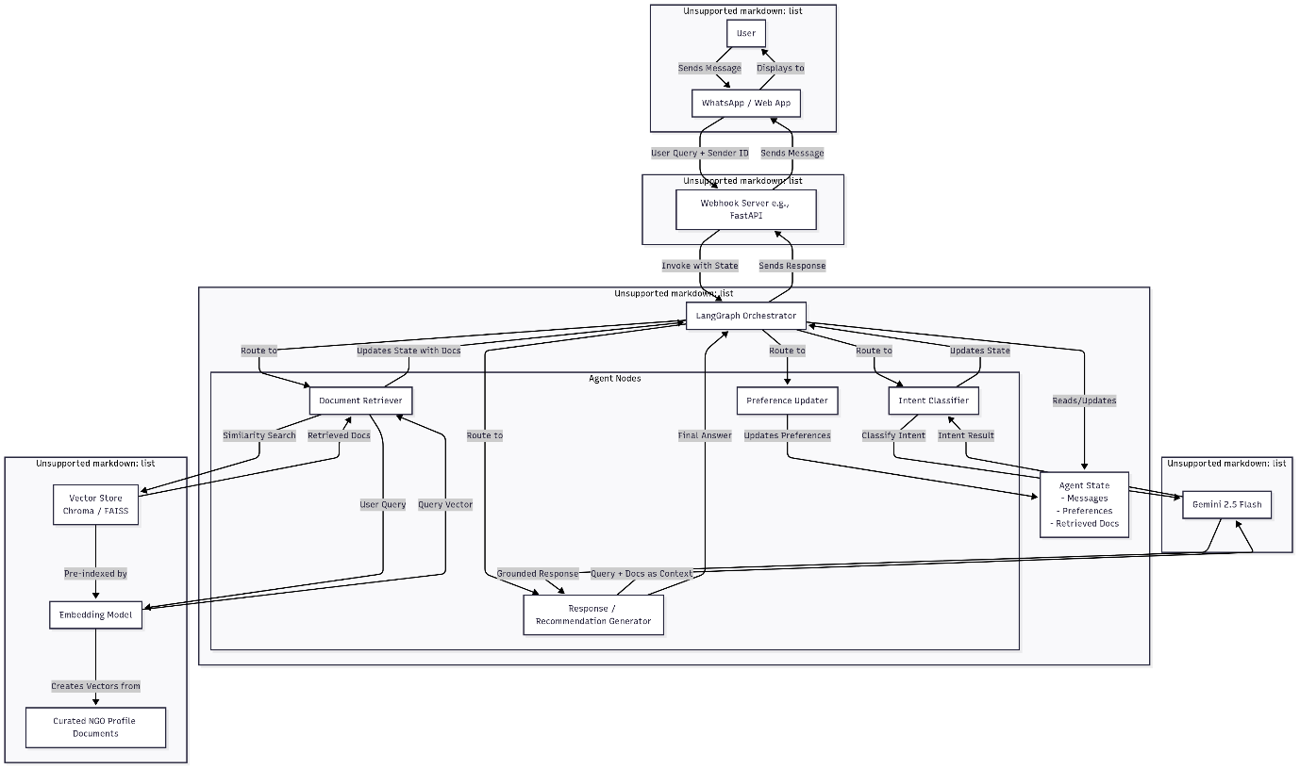

**Fig. 9.1** System Architecture

**[10]. UML DIAGRAMS:**

**Use Case Diagram**

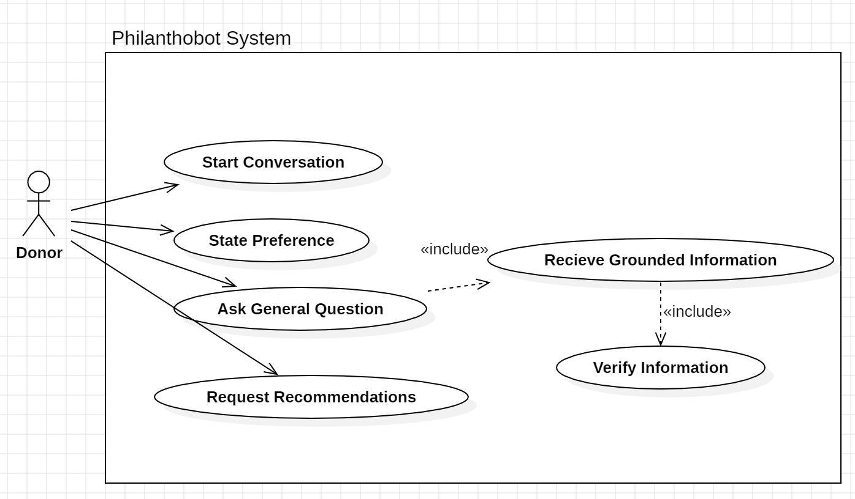

**Class Diagram**

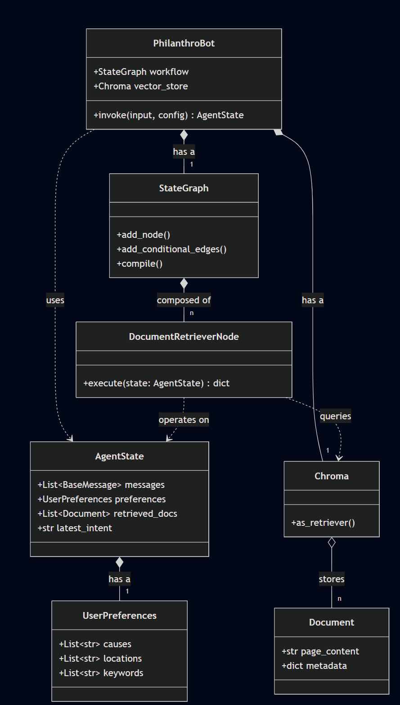

**[11]SUMMARY:**

The project is motivated by the fact that potential donors often struggle to find and trust non-governmental organizations (NGOs) due to a lack of transparency and the failure of traditional websites to provide a guided discovery experience. PhilanthroBot is proposed as a solution to bridge this gap.

The system's architecture is built on a **Retrieval-Augmented Generation (RAG)** paradigm to ensure all information provided to the user is grounded in a curated, factual knowledge base of NGO profiles. This approach is a strategic decision to mitigate the risk of Large Language Model (LLM) "hallucinations," which would be catastrophic to building donor trust.

To enable a truly personalized and guided experience, the agent is orchestrated using

**LangGraph**. This framework allows for the creation of a **stateful** conversational agent that can remember a user's preferences across multiple turns in a dialogue. This elevates the system beyond a simple question-answering bot into a sophisticated recommendation engine that can simulate the role of a trusted human advisor. The entire system is powered by the **gemini-2.0-flash** LLM, chosen for its speed and large context window, ensuring a fluid and responsive user interaction.

The implementation follows a clear, phased methodology:

* **Phase 1**: Constructing the RAG knowledge base by creating, chunking, and indexing structured NGO profiles.
* **Phase 2**: Developing the stateful agent with LangGraph by defining its memory, skills (nodes), and conversational logic (edges).
* **Phase 4**: A rigorous evaluation framework to assess the system's factual accuracy, recommendation relevance, and conversational quality.

Ultimately, PhilanthroBot serves as a blueprint for a new class of trust-centric applications in the social impact space. By creating a more transparent, intelligent, and personalized bridge between donors and the causes they wish to support, the project demonstrates a powerful and responsible application of AI to foster greater confidence and connection in the world of philanthropy.

**REFERENCES: (minimum 15 papers)**

1. Breeze, B. (2013). How donors choose charities: The role of personal taste and experiences in giving decisions. *Voluntary Sector Review*, *4*(1), 69–88. <https://www.researchgate.net/publication/272147122_How_Donors_Choose_Charities_The_Role_of_Personal_Taste_and_Experiences_in_Giving_Decisions>
2. Sargeant, A., & Lee, S. (2004). Trust and relationship commitment in the United kingdom voluntary sector: The impact on donor behavior. *Nonprofit and Voluntary Sector Quarterly*, *33*(2), 175–194.

[https://www.researchgate.net/publication/237450920_Donor_Trust_and_Relationship_Commitment_in_the_UK_Charity_Sector_The_Impact_on_Behavior](https://www.researchgate.net/publication/237450920_Donor_Trust_and_Relationship_Commitment_in_the_UK_Charity_Sector_The_Impact_on_Behavior%20)

1. Bekkers, R. (2003). Trust, accreditation, and philanthropy in the Netherlands. *Nonprofit and Voluntary Sector Quarterly*, *32*(4), 596–615

<https://renebekkers.wordpress.com/wp-content/uploads/2011/08/bekkers_nvsq_03.pdf>

1. Vereschak, O., Bailly, G., & Pelachaud, C. (2021). Trust in AI-assisted Decision Making: Perspectives from Those Behind the System and Those for Whom the Decision is Made <https://www.researchgate.net/publication/380525571_Trust_in_AI-assisted_Decision_Making_Perspectives_from_Those_Behind_the_System_and_Those_for_Whom_the_Decision_is_Made>
2. Glikson, E., & Woolley, A. W. (2020). Human trust in artificial intelligence: The role of emotion and expertise. *Academy of Management Discoveries*, *6*(4), 586–610. <https://www.researchgate.net/publication/340605601_Human_trust_in_artificial_intelligence_Review_of_empirical_research_Academy_of_Management_Annals_in_press>
3. Lee, J. D., & See, K. A. (2004). Trust in automation: Designing for appropriate reliance. *Human Factors*, *46*(1), 50–80. <https://journals.sagepub.com/doi/10.1518/hfes.46.1.50_30392>
4. Jannach, D., Manzoor, A., Cai, W., & Li, G. (2021). A survey on conversational recommender systems. *ACM Computing Surveys*, *54*(5), 1–36. <https://doi.org/10.1145/3453154>
5. Gao, C., Lei, W., He, X., de Rijke, M., & Chua, T. S. (2021). Advances in conversational recommender systems. *AI Open*, *2*, 97-117. <https://doi.org/10.1016/j.aiopen.2021.07.001>
6. Christakopoulou, K., Radlinski, F., & Hofmann, K. (2016). Towards conversational recommender systems. In *Proceedings of the 22nd ACM SIGKDD International Conference on Knowledge Discovery and Data Mining*. [https://doi.org/10.1145/2939672.2939742](https://www.google.com/search?q=https://doi.org/10.1145/2939672.2939742)
7. Lewis, P., Perez, E., Piktus, A., Petroni, F., Karpukhin, V., Goyal, N., Küttler, H., Lewis, M., Yih, W., Rocktäschel, T., Riedel, S., & Kiela, D. (2020). Retrieval-augmented generation for knowledge-intensive NLP tasks. In *Advances in Neural Information Processing Systems 33 (NeurIPS 2020)*. <https://proceedings.neurips.cc/paper/2020/hash/6b493230205f780e1bc26945df7481e5-Abstract.html>
8. Guu, K., Lee, K., Tung, Z., Pasupat, P., & Chang, M. W. (2020). Retrieval augmented language model pre-training. In *Proceedings of the 37th International Conference on Machine Learning (ICML)*. <http://proceedings.mlr.press/v119/guu20a.html>
9. Izacard, G., Lewis, M., Grave, E., Joulin, A., Riedel, S., & Rocktäschel, T. (2022). *Few-shot learning with retrieval augmented language models*. arXiv preprint arXiv:2208.03299. <https://doi.org/10.48550/arXiv.2208.03299>
10. Es, S., Yap, J., Jarrin, R. S., & de la Torre, J. (2023). *RAGAS: Automated evaluation of retrieval augmented generation*. arXiv preprint arXiv:2309.15217. <https://arxiv.org/abs/2309.15217>
11. Kvale, K., Bente, A., & Starks, K. (2022). A user-centered approach to developing a conversational agent for personalized health communication. *Journal of Communication in Healthcare*, *15*(3), 205-214. <https://pmc.ncbi.nlm.nih.gov/articles/PMC7442948/>
12. Ricci, F., Rokach, L., & Shapira, B. (2011). *Introduction to recommender systems handbook*. Springer US. <https://doi.org/10.1007/978-0-387-85820-3_1>