**Video Streaming Application**

**(React)**

**Architecture Design:-**

**Project Member: Tanisha Modi**

**Introduction: -**

Our educational video streaming application is designed with a robust architectural framework using React and Redux. The architecture focuses on delivering a seamless learning experience while addressing the constraint of performance. Components for authentication, personalized recommendations, and progress tracking are incorporated, and a comprehensive content management system ensures efficient organization and delivery of educational videos and courses. By leveraging React and Redux, our architectural design offers a scalable, secure, and interactive platform that caters specifically to the educational needs of users.

Semantic models that help the designer to understand the overall properties of the system.

* **Scope:-**

The architectural design for our educational video streaming application built with React and Redux encompasses a structured framework that focuses on delivering a seamless learning experience. It includes components for user authentication, personalized content recommendations, and progress tracking. The design also incorporates features like a comprehensive content management system, interactive elements for engagement, and analytics for performance evaluation. By leveraging React and Redux, our architectural design ensures a scalable and interactive platform that caters specifically to the educational needs of users.

* Constrains

The primary constraint for our educational video streaming application is performance. It must provide smooth and uninterrupted video playback, ensuring minimal buffering and latency, even with large video files and a high number of concurrent users. The application should be optimized to deliver a fast and responsive streaming experience, providing users with a seamless learning environment without delays or disruptions.

**Problem Statement:**

Despite the growing demand for video streaming platforms, users often face challenges that hinder their viewing experience. Current streaming apps struggle with frequent buffering, limited content selection, and lack of personalization. Additionally, the need to switch between multiple apps to access desired content creates inconvenience and confusion. These issues call for an innovative solution that provides seamless streaming, an extensive library of diverse content, and a personalized viewing experience, all in one user-friendly app.

**Approach:**

Our approach focuses on addressing the challenges faced by users through a combination of advanced technologies and user-centric features. Firstly, we employ robust content delivery networks and adaptive streaming algorithms to ensure smooth playback and eliminate buffering issues. Secondly, our app employs machine learning algorithms to curate personalized recommendations based on users' viewing history and preferences. Thirdly, we collaborate with leading content providers to offer an extensive and diverse library of movies, TV shows, and original content. Fourthly, we provide a user-friendly interface that allows seamless navigation and easy access to desired content. Finally, we prioritize cross-platform compatibility, enabling users to enjoy uninterrupted streaming across various devices.

**Tools Used:**

React js, redux-query, refux-toolkit, nodejs, npm

**Architecture :-**

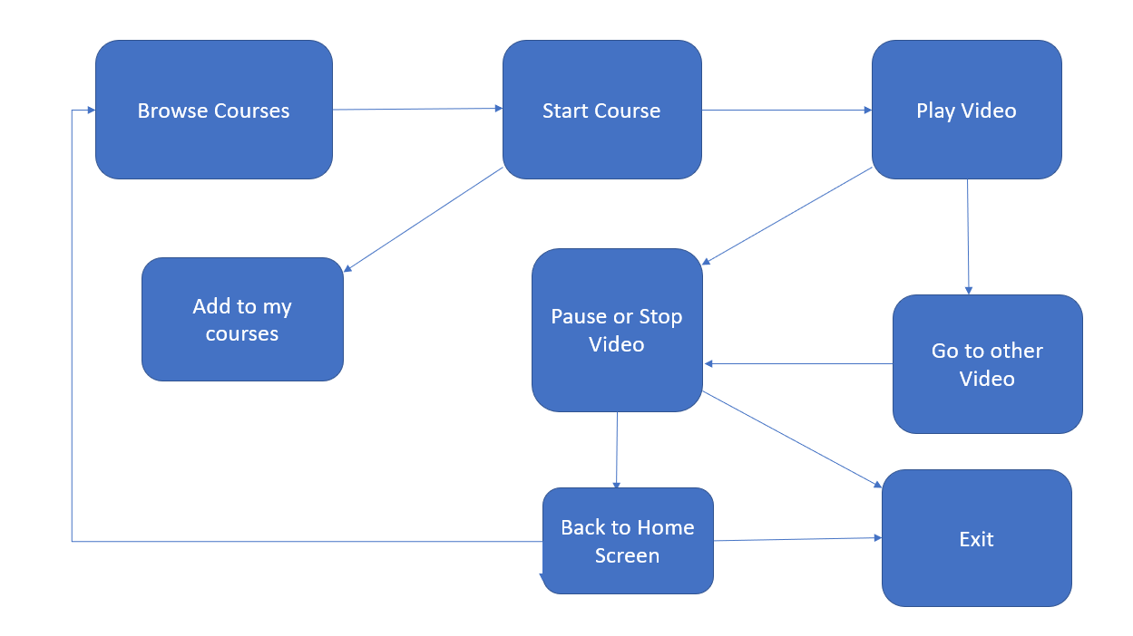

* **User input / Output flow:-**

**Conclusion :**

Our video streaming app aims to revolutionize the way users consume entertainment. By addressing the common challenges faced by viewers, such as buffering, limited content, and lack of personalization, we provide a comprehensive solution that enhances the streaming experience. With advanced technologies, personalized recommendations, a vast content library, user-friendly interface, and cross-platform compatibility, our app offers a seamless and immersive entertainment journey. Embrace the future of video streaming and embark on a limitless cinematic adventure with our app. Download now and enjoy the ultimate entertainment experience at your fingertips.