**Video Streaming**

**(React application)**

**High Level Design**

**Project Member: Tanisha Modi**

**Introduction :**

Introducing our revolutionary video streaming app, designed to deliver seamless entertainment straight to your fingertips. With a vast library of high-quality movies, TV shows, and original content, our app offers a personalized streaming experience tailored to your unique preferences. Discover new releases, binge-watch your favorite series, and enjoy uninterrupted streaming on any device, anytime, anywhere. Get ready to immerse yourself in the world of unlimited entertainment with our cutting-edge video streaming app. Download now and embark on a journey of endless cinematic delight.

**Problem Statement:**

Despite the growing demand for video streaming platforms, users often face challenges that hinder their viewing experience. Current streaming apps struggle with frequent buffering, limited content selection, and lack of personalization. Additionally, the need to switch between multiple apps to access desired content creates inconvenience and confusion. These issues call for an innovative solution that provides seamless streaming, an extensive library of diverse content, and a personalized viewing experience, all in one user-friendly app.

**Approach:**

Our approach focuses on addressing the challenges faced by users through a combination of advanced technologies and user-centric features. Firstly, we employ robust content delivery networks and adaptive streaming algorithms to ensure smooth playback and eliminate buffering issues. Secondly, our app employs machine learning algorithms to curate personalized recommendations based on users' viewing history and preferences. Thirdly, we collaborate with leading content providers to offer an extensive and diverse library of movies, TV shows, and original content. Fourthly, we provide a user-friendly interface that allows seamless navigation and easy access to desired content. Finally, we prioritize cross-platform compatibility, enabling users to enjoy uninterrupted streaming across various devices.

**Tools Used:**

React js, redux-query, refux-toolkit, nodejs, npm

**Design Flow:-**

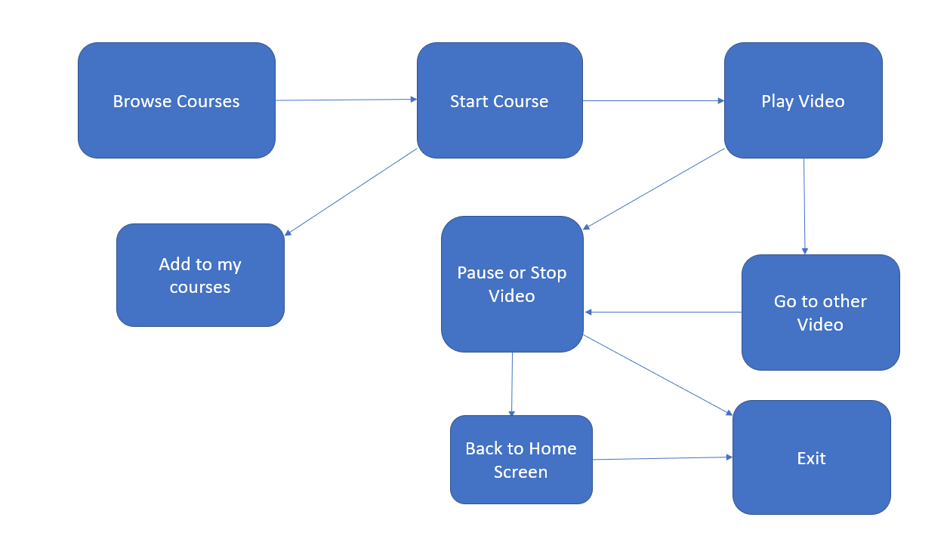

**Conclusion :**

Our video streaming app aims to revolutionize the way users consume entertainment. By addressing the common challenges faced by viewers, such as buffering, limited content, and lack of personalization, we provide a comprehensive solution that enhances the streaming experience. With advanced technologies, personalized recommendations, a vast content library, user-friendly interface, and cross-platform compatibility, our app offers a seamless and immersive entertainment journey. Embrace the future of video streaming and embark on a limitless cinematic adventure with our app. Download now and enjoy the ultimate entertainment experience at your fingertips.