**Video Streaming Application**

**(React)**

**Low** **Level Design**

**Project Member: Tanisha Modi**

**Introduction:-**

**What is low-level design document???**

The goal of LLD (low-level design document) is to give internal logical Design of the actual program code for Video streaming app.

The low-level design of our video streaming app focuses on the implementation details and specific components that make up the system. It covers the fine-grained aspects such as database schema, API endpoints, data flow, and module interactions. By diving deeper into the technical intricacies, our low-level design ensures a solid foundation for the development and deployment of a robust and scalable video streaming platform.

**Scope:-**

The scope of our low-level design encompasses the detailed design and implementation of the various modules and components within our video streaming app. It includes defining the database schema, specifying API endpoints, designing the user interface, outlining the data flow between modules, and ensuring proper integration with external services. By clearly defining the scope of our low-level design, we ensure a comprehensive and well-structured implementation of our video streaming platform.

**Architecture:-**

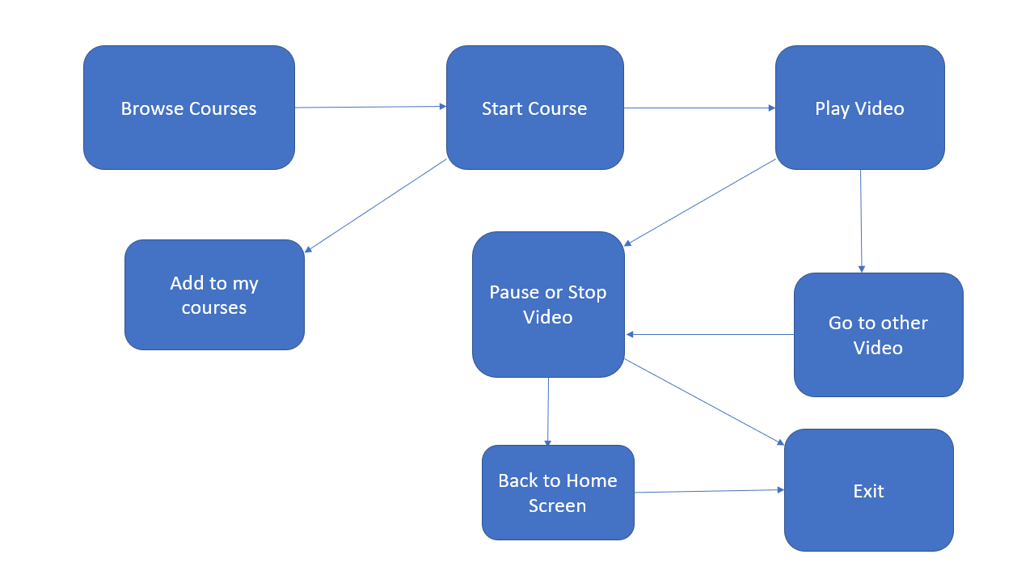

* **Architecture Description:-**

The video streaming app is built using the React and Redux frameworks, which provide a robust and efficient architecture for building interactive and scalable user interfaces. The architecture follows a component-based approach, where the app is divided into reusable and independent components, each responsible for its own rendering and state management. React's virtual DOM allows for efficient updates and rendering, while Redux manages the application state and ensures predictable data flow. The architecture also includes the integration of APIs for fetching and storing video content, as well as incorporating routing for seamless navigation between different sections of the app. Overall, the React and Redux architecture offers a solid foundation for developing a responsive, data-driven, and feature-rich video streaming app.

**Conclusion :**

Our video streaming app aims to revolutionize the way users consume entertainment. By addressing the common challenges faced by viewers, such as buffering, limited content, and lack of personalization, we provide a comprehensive solution that enhances the streaming experience. With advanced technologies, personalized recommendations, a vast content library, user-friendly interface, and cross-platform compatibility, our app offers a seamless and immersive entertainment journey. Embrace the future of video streaming and embark on a limitless cinematic adventure with our app. Download now and enjoy the ultimate entertainment experience at your fingertips.