**Video Streaming application**

**(React)**

**Wire-Frame**

**Project Member: Tanisha Modi**

This is the home page of the project.

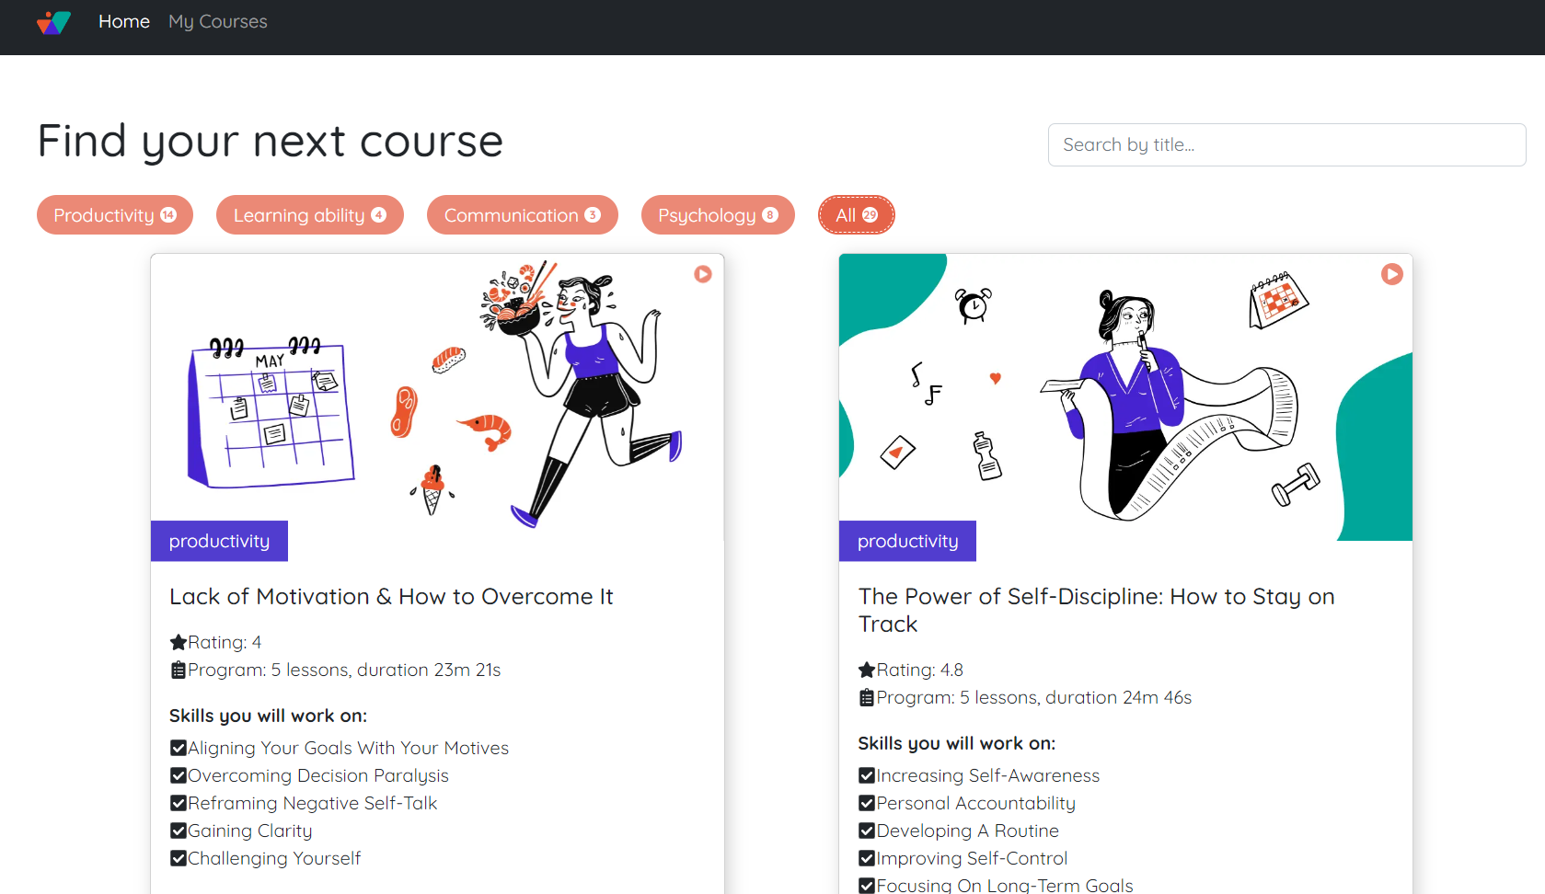

**Page 2: streaming page**

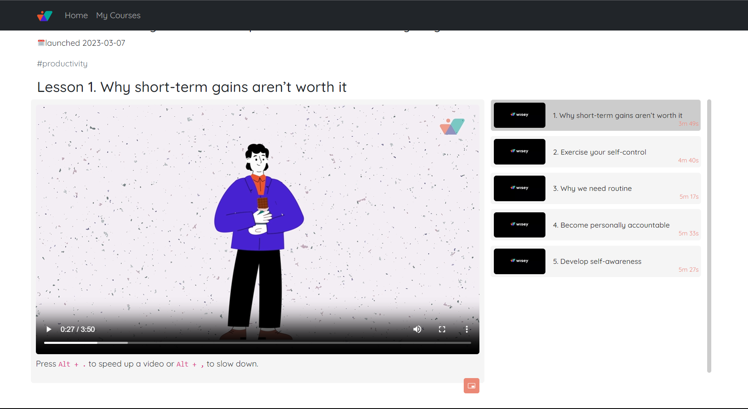

Page 3: My courses page

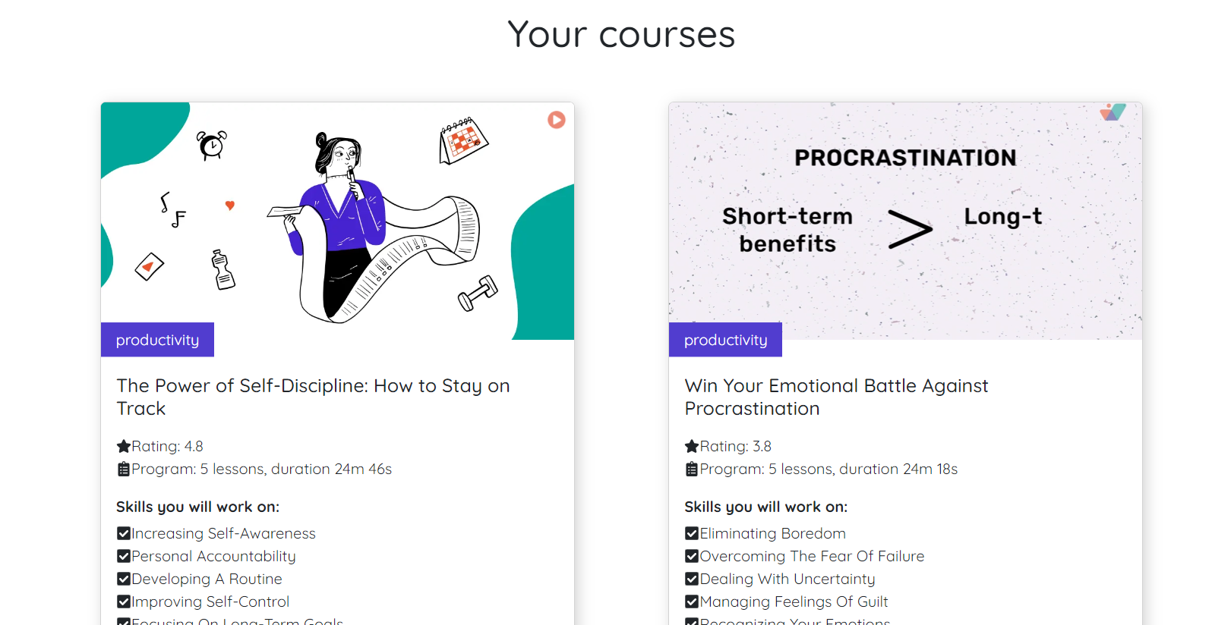

This is the End of Wireframe. Thank you.