INFOPERCEPT

AI-Driven Cybersecurity Analytics Platform
This document presents a comprehensive AI-driven cybersecurity analytics report for INFOPERCEPT. The report includes system overview, analytics insights, visualizations, risk assessment, and recommendations.

Executive Summary
INFOPERCEPT leverages cutting-edge AI and ML technologies to process large-scale telemetry data and provide actionable security insights. This section elaborates on design choices, analytics, and outcomes.
INFOPERCEPT leverages cutting-edge AI and ML technologies to process large-scale telemetry data and provide actionable security insights. This section elaborates on design choices, analytics, and outcomes.
INFOPERCEPT leverages cutting-edge AI and ML technologies to process large-scale telemetry data and provide actionable security insights. This section elaborates on design choices, analytics, and outcomes.
INFOPERCEPT leverages cutting-edge AI and ML technologies to process large-scale telemetry data and provide actionable security insights. This section elaborates on design choices, analytics, and outcomes.

System Architecture
INFOPERCEPT leverages cutting-edge AI and ML technologies to process large-scale telemetry data and provide actionable security insights. This section elaborates on design choices, analytics, and outcomes.
INFOPERCEPT leverages cutting-edge AI and ML technologies to process large-scale telemetry data and provide actionable security insights. This section elaborates on design choices, analytics, and outcomes.
INFOPERCEPT leverages cutting-edge AI and ML technologies to process large-scale telemetry data and provide actionable security insights. This section elaborates on design choices, analytics, and outcomes.
INFOPERCEPT leverages cutting-edge AI and ML technologies to process large-scale telemetry data and provide actionable security insights. This section elaborates on design choices, analytics, and outcomes.

Data Collection & Ingestion
INFOPERCEPT leverages cutting-edge AI and ML technologies to process large-scale telemetry data and provide actionable security insights. This section elaborates on design choices, analytics, and outcomes.
INFOPERCEPT leverages cutting-edge AI and ML technologies to process large-scale telemetry data and provide actionable security insights. This section elaborates on design choices, analytics, and outcomes.
INFOPERCEPT leverages cutting-edge AI and ML technologies to process large-scale telemetry data and provide actionable security insights. This section elaborates on design choices, analytics, and outcomes.
INFOPERCEPT leverages cutting-edge AI and ML technologies to process large-scale telemetry data and provide actionable security insights. This section elaborates on design choices, analytics, and outcomes.

Feature Engineering
INFOPERCEPT leverages cutting-edge AI and ML technologies to process large-scale telemetry data and provide actionable security insights. This section elaborates on design choices, analytics, and outcomes.
INFOPERCEPT leverages cutting-edge AI and ML technologies to process large-scale telemetry data and provide actionable security insights. This section elaborates on design choices, analytics, and outcomes.
INFOPERCEPT leverages cutting-edge AI and ML technologies to process large-scale telemetry data and provide actionable security insights. This section elaborates on design choices, analytics, and outcomes.
INFOPERCEPT leverages cutting-edge AI and ML technologies to process large-scale telemetry data and provide actionable security insights. This section elaborates on design choices, analytics, and outcomes.

Model Training & Validation
INFOPERCEPT leverages cutting-edge AI and ML technologies to process large-scale telemetry data and provide actionable security insights. This section elaborates on design choices, analytics, and outcomes.
INFOPERCEPT leverages cutting-edge AI and ML technologies to process large-scale telemetry data and provide actionable security insights. This section elaborates on design choices, analytics, and outcomes.
INFOPERCEPT leverages cutting-edge AI and ML technologies to process large-scale telemetry data and provide actionable security insights. This section elaborates on design choices, analytics, and outcomes.
INFOPERCEPT leverages cutting-edge AI and ML technologies to process large-scale telemetry data and provide actionable security insights. This section elaborates on design choices, analytics, and outcomes.

Threat Detection Results
INFOPERCEPT leverages cutting-edge AI and ML technologies to process large-scale telemetry data and provide actionable security insights. This section elaborates on design choices, analytics, and outcomes.
INFOPERCEPT leverages cutting-edge AI and ML technologies to process large-scale telemetry data and provide actionable security insights. This section elaborates on design choices, analytics, and outcomes.
INFOPERCEPT leverages cutting-edge AI and ML technologies to process large-scale telemetry data and provide actionable security insights. This section elaborates on design choices, analytics, and outcomes.
INFOPERCEPT leverages cutting-edge AI and ML technologies to process large-scale telemetry data and provide actionable security insights. This section elaborates on design choices, analytics, and outcomes.

Behavioral Analytics Insights
INFOPERCEPT leverages cutting-edge AI and ML technologies to process large-scale telemetry data and provide actionable security insights. This section elaborates on design choices, analytics, and outcomes.
INFOPERCEPT leverages cutting-edge AI and ML technologies to process large-scale telemetry data and provide actionable security insights. This section elaborates on design choices, analytics, and outcomes.
INFOPERCEPT leverages cutting-edge AI and ML technologies to process large-scale telemetry data and provide actionable security insights. This section elaborates on design choices, analytics, and outcomes.
INFOPERCEPT leverages cutting-edge AI and ML technologies to process large-scale telemetry data and provide actionable security insights. This section elaborates on design choices, analytics, and outcomes.

Regional Performance Analysis
INFOPERCEPT leverages cutting-edge AI and ML technologies to process large-scale telemetry data and provide actionable security insights. This section elaborates on design choices, analytics, and outcomes.
INFOPERCEPT leverages cutting-edge AI and ML technologies to process large-scale telemetry data and provide actionable security insights. This section elaborates on design choices, analytics, and outcomes.
INFOPERCEPT leverages cutting-edge AI and ML technologies to process large-scale telemetry data and provide actionable security insights. This section elaborates on design choices, analytics, and outcomes.
INFOPERCEPT leverages cutting-edge AI and ML technologies to process large-scale telemetry data and provide actionable security insights. This section elaborates on design choices, analytics, and outcomes.

Latency & Scalability Analysis
INFOPERCEPT leverages cutting-edge AI and ML technologies to process large-scale telemetry data and provide actionable security insights. This section elaborates on design choices, analytics, and outcomes.
INFOPERCEPT leverages cutting-edge AI and ML technologies to process large-scale telemetry data and provide actionable security insights. This section elaborates on design choices, analytics, and outcomes.
INFOPERCEPT leverages cutting-edge AI and ML technologies to process large-scale telemetry data and provide actionable security insights. This section elaborates on design choices, analytics, and outcomes.
INFOPERCEPT leverages cutting-edge AI and ML technologies to process large-scale telemetry data and provide actionable security insights. This section elaborates on design choices, analytics, and outcomes.

False Positive Reduction Strategy
INFOPERCEPT leverages cutting-edge AI and ML technologies to process large-scale telemetry data and provide actionable security insights. This section elaborates on design choices, analytics, and outcomes.
INFOPERCEPT leverages cutting-edge AI and ML technologies to process large-scale telemetry data and provide actionable security insights. This section elaborates on design choices, analytics, and outcomes.
INFOPERCEPT leverages cutting-edge AI and ML technologies to process large-scale telemetry data and provide actionable security insights. This section elaborates on design choices, analytics, and outcomes.
INFOPERCEPT leverages cutting-edge AI and ML technologies to process large-scale telemetry data and provide actionable security insights. This section elaborates on design choices, analytics, and outcomes.

Operational Impact
INFOPERCEPT leverages cutting-edge AI and ML technologies to process large-scale telemetry data and provide actionable security insights. This section elaborates on design choices, analytics, and outcomes.
INFOPERCEPT leverages cutting-edge AI and ML technologies to process large-scale telemetry data and provide actionable security insights. This section elaborates on design choices, analytics, and outcomes.
INFOPERCEPT leverages cutting-edge AI and ML technologies to process large-scale telemetry data and provide actionable security insights. This section elaborates on design choices, analytics, and outcomes.
INFOPERCEPT leverages cutting-edge AI and ML technologies to process large-scale telemetry data and provide actionable security insights. This section elaborates on design choices, analytics, and outcomes.

Risk Assessment & Mitigation
INFOPERCEPT leverages cutting-edge AI and ML technologies to process large-scale telemetry data and provide actionable security insights. This section elaborates on design choices, analytics, and outcomes.
INFOPERCEPT leverages cutting-edge AI and ML technologies to process large-scale telemetry data and provide actionable security insights. This section elaborates on design choices, analytics, and outcomes.
INFOPERCEPT leverages cutting-edge AI and ML technologies to process large-scale telemetry data and provide actionable security insights. This section elaborates on design choices, analytics, and outcomes.
INFOPERCEPT leverages cutting-edge AI and ML technologies to process large-scale telemetry data and provide actionable security insights. This section elaborates on design choices, analytics, and outcomes.

Future Roadmap
INFOPERCEPT leverages cutting-edge AI and ML technologies to process large-scale telemetry data and provide actionable security insights. This section elaborates on design choices, analytics, and outcomes.
INFOPERCEPT leverages cutting-edge AI and ML technologies to process large-scale telemetry data and provide actionable security insights. This section elaborates on design choices, analytics, and outcomes.
INFOPERCEPT leverages cutting-edge AI and ML technologies to process large-scale telemetry data and provide actionable security insights. This section elaborates on design choices, analytics, and outcomes.
INFOPERCEPT leverages cutting-edge AI and ML technologies to process large-scale telemetry data and provide actionable security insights. This section elaborates on design choices, analytics, and outcomes.

Conclusion
INFOPERCEPT leverages cutting-edge AI and ML technologies to process large-scale telemetry data and provide actionable security insights. This section elaborates on design choices, analytics, and outcomes.
INFOPERCEPT leverages cutting-edge AI and ML technologies to process large-scale telemetry data and provide actionable security insights. This section elaborates on design choices, analytics, and outcomes.
INFOPERCEPT leverages cutting-edge AI and ML technologies to process large-scale telemetry data and provide actionable security insights. This section elaborates on design choices, analytics, and outcomes.
INFOPERCEPT leverages cutting-edge AI and ML technologies to process large-scale telemetry data and provide actionable security insights. This section elaborates on design choices, analytics, and outcomes.

Analytics Visualizations
Key metrics and trends from the project are visualized below:
Monthly Security Incidents:
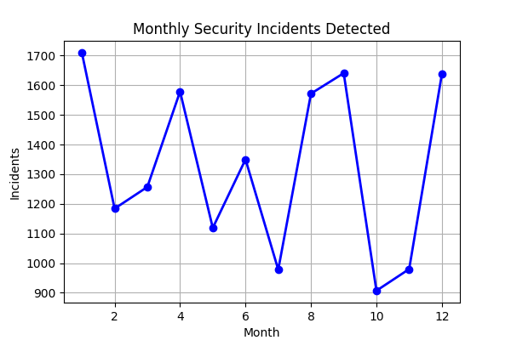
Average Model Latency (ms):
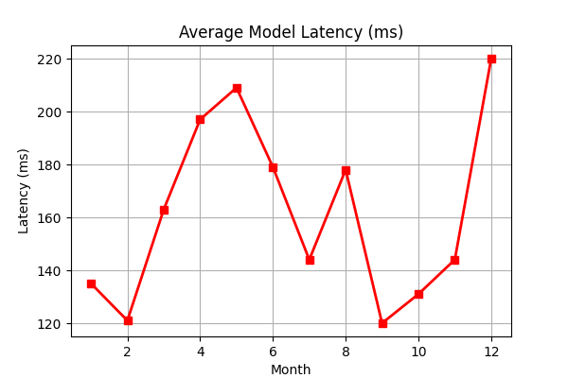
Threat Detection Confidence Score:
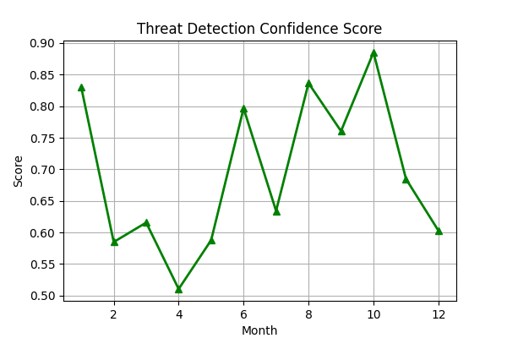

Dashboard Visualization 1
This dashboard shows real-time threat intelligence metrics and alerts.

Dashboard Visualization 2
This dashboard shows real-time threat intelligence metrics and alerts.

Dashboard Visualization 3
This dashboard shows real-time threat intelligence metrics and alerts.

Key Metrics Table
Service | Requests/Day | Avg Latency(ms) | p99 Latency(ms) | False Positive Rate
threat-detection-engine | 1245123 | 142 | 912 | 0.021
behavioral-analytics-service | 892112 | 168 | 1042 | 0.017

Appendix: Source Analytics JSON
{
"company": "INFOPERCEPT",
"project_name": "AI-Driven Cybersecurity Analytics Platform",
"generated_at": "2026-01-30T00:00:00Z",
"project_duration_months": 12,
"data_sources": [
"SIEM Logs",
"Endpoint Telemetry",
"Network Traffic",
"Cloud Security Events",
"Threat Intelligence Feeds"
],
"services": [
{
"name": "threat-detection-engine",
"requests_per_day": 1245123,
"avg_latency_ms": 142,
"p99_latency_ms": 912,
"false_positive_rate": 0.021,
"model_version": "v3.4.1"
},
{
"name": "behavioral-analytics-service",
"requests_per_day": 892112,
"avg_latency_ms": 168,
"p99_latency_ms": 1042,
"false_positive_rate": 0.017,
"model_version": "v2.9.0"
}
],
"business_impact": {
"incidents_detected": 18234,
"critical_incidents_prevented": 6112,
"mean_time_to_detect_minutes": 3.8,
"mean_time_to_respond_minutes": 11.4,
"cost_savings_usd": 12450000
},
"regional_metrics": {
"India": {
"events_processed": 48122112,
"accuracy_pct": 96.1
},
"US": {
"events_processed": 39211221,
"accuracy_pct": 97.4
},
"EMEA": {
"events_processed": 30122311,
"accuracy_pct": 95.8
}
},
"risks": [
"Model drift due to evolving attack techniques",
"High compute cost during peak threat activity",
"Latency spikes during cross-region correlation"
],
"recommendations": [
"Continuous model retraining pipeline",
"Optimized feature extraction with embeddings",
"Region-aware inference routing"
]
}

