figure 1: MYOPATHIC PATIENT DATA SET VALUES PLOT
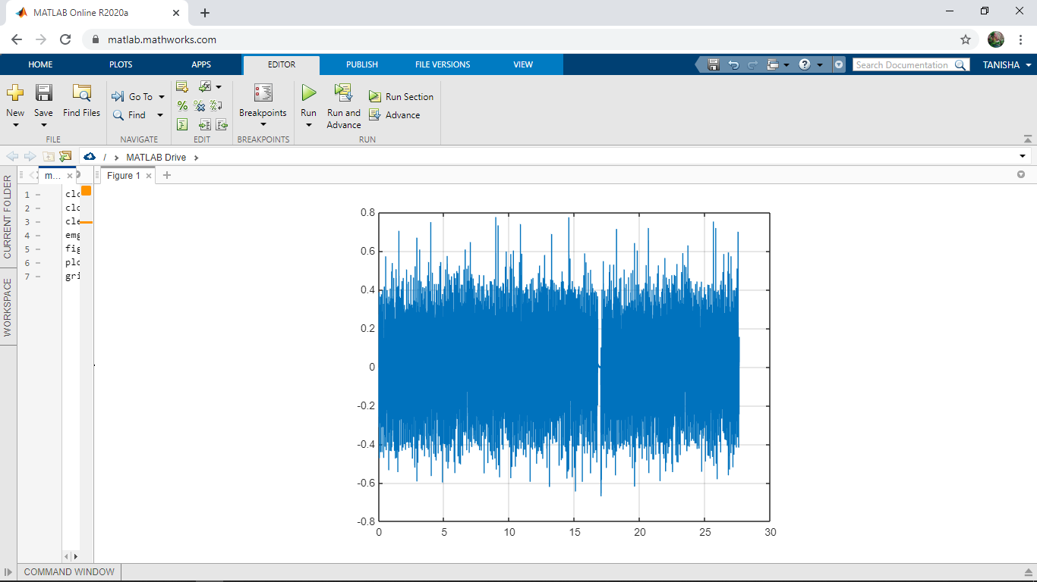

figure 2: POWER SPECTRUM PLOT
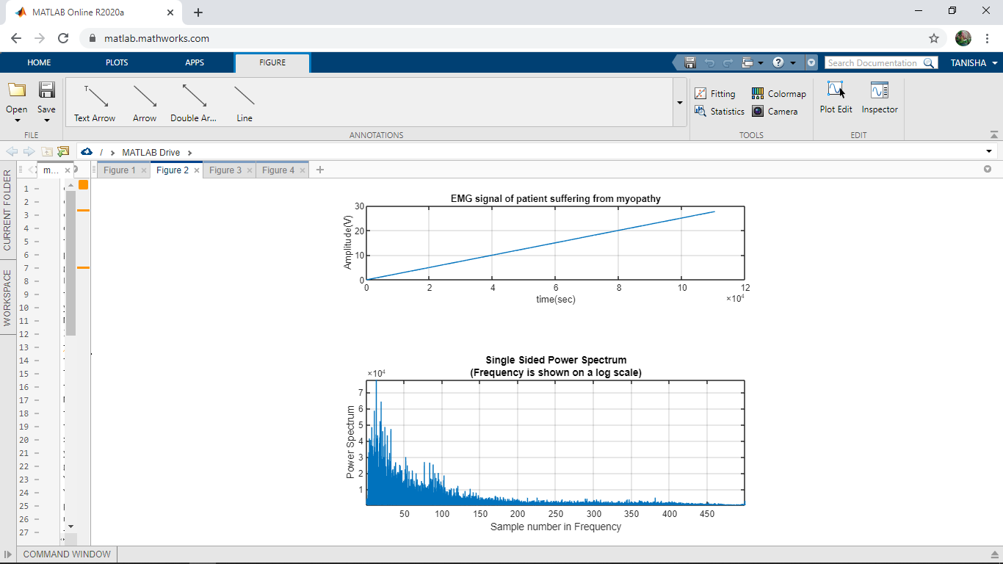

figure 3: RECTIFIED AMPLITUDE
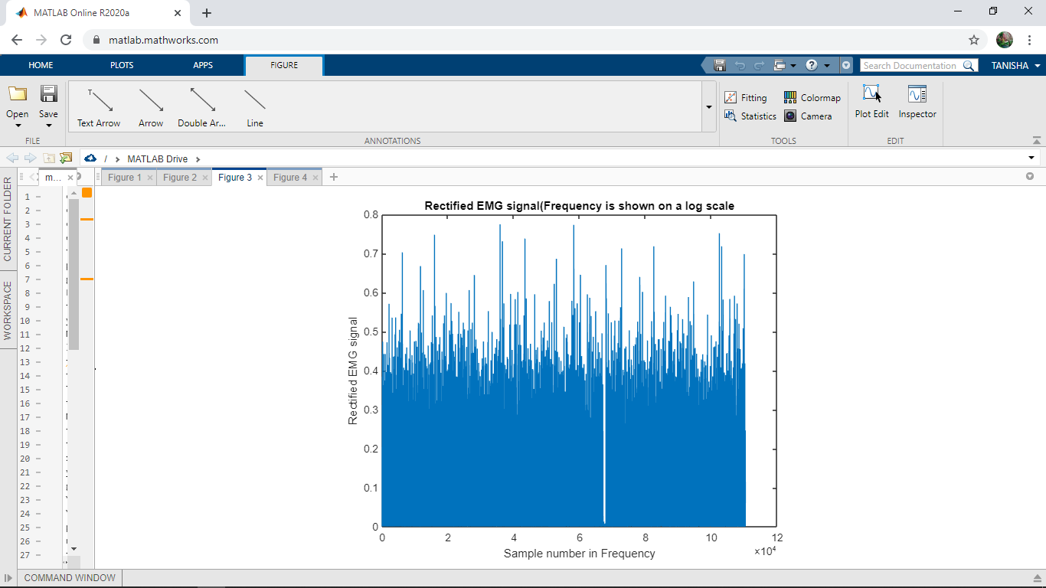

figure 4:
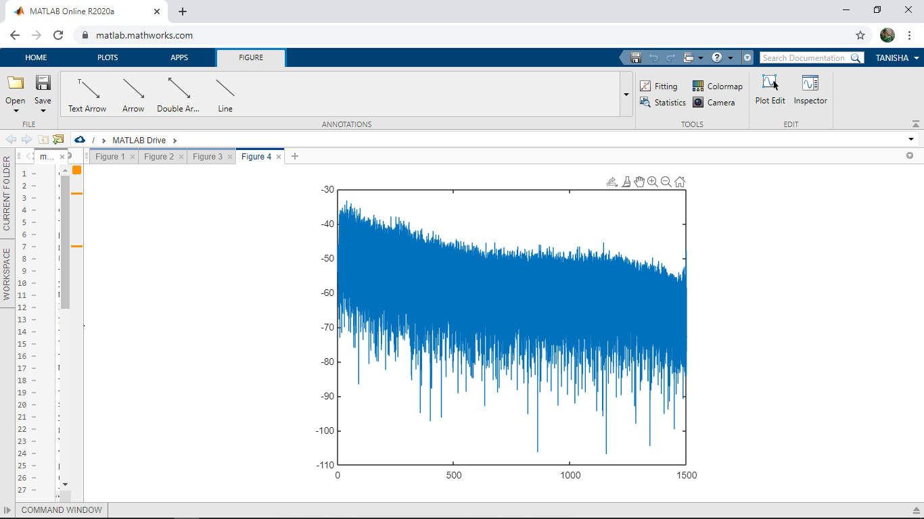

message box 1: RMS OF SIGNAL
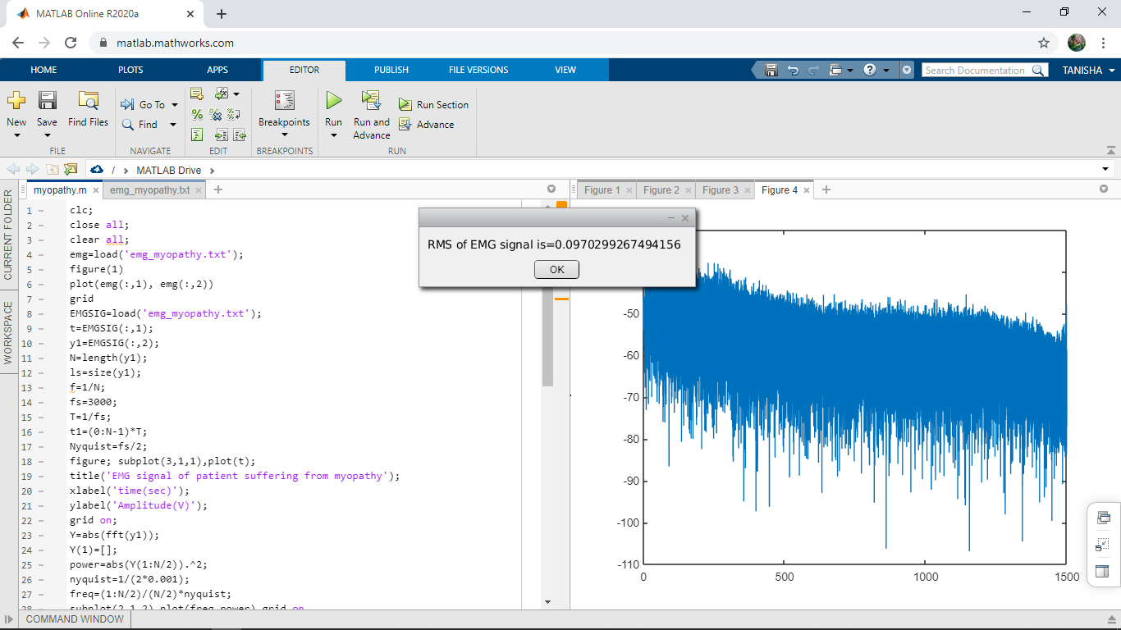
message box 2: ARV OF THE SIGNAL
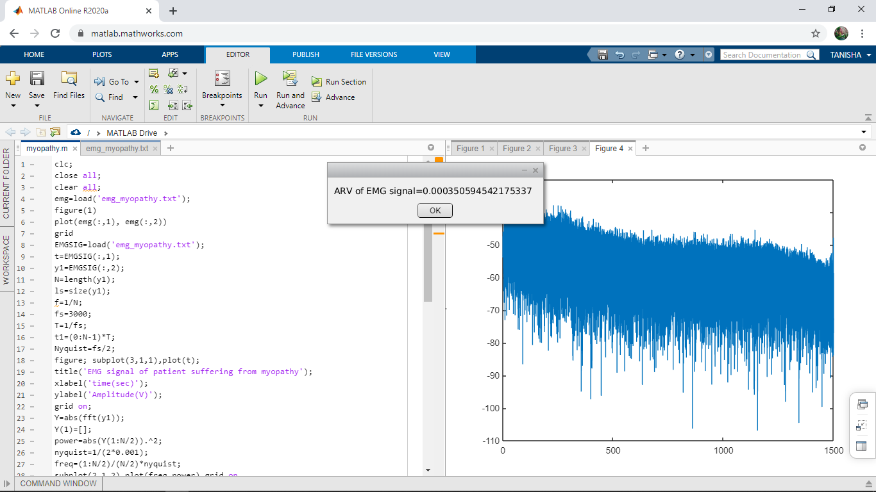

HEALTHY PATIENT: RMS AMPLITUDE AND ARV OF THE SIGNAL
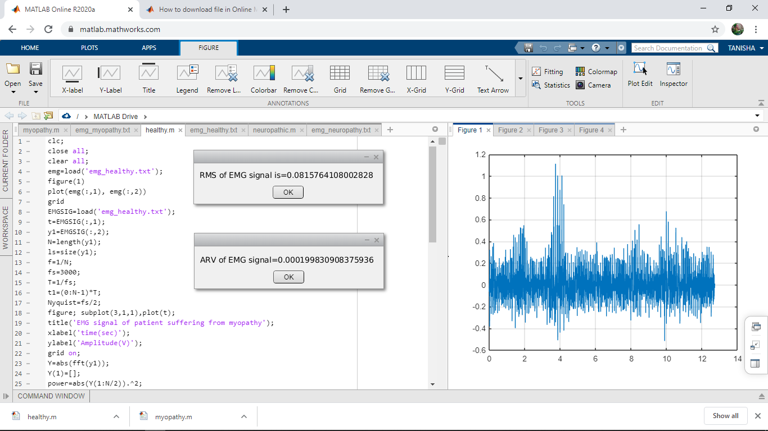

DATASET VALUES PLOT OF THE HEALTHY PERSON
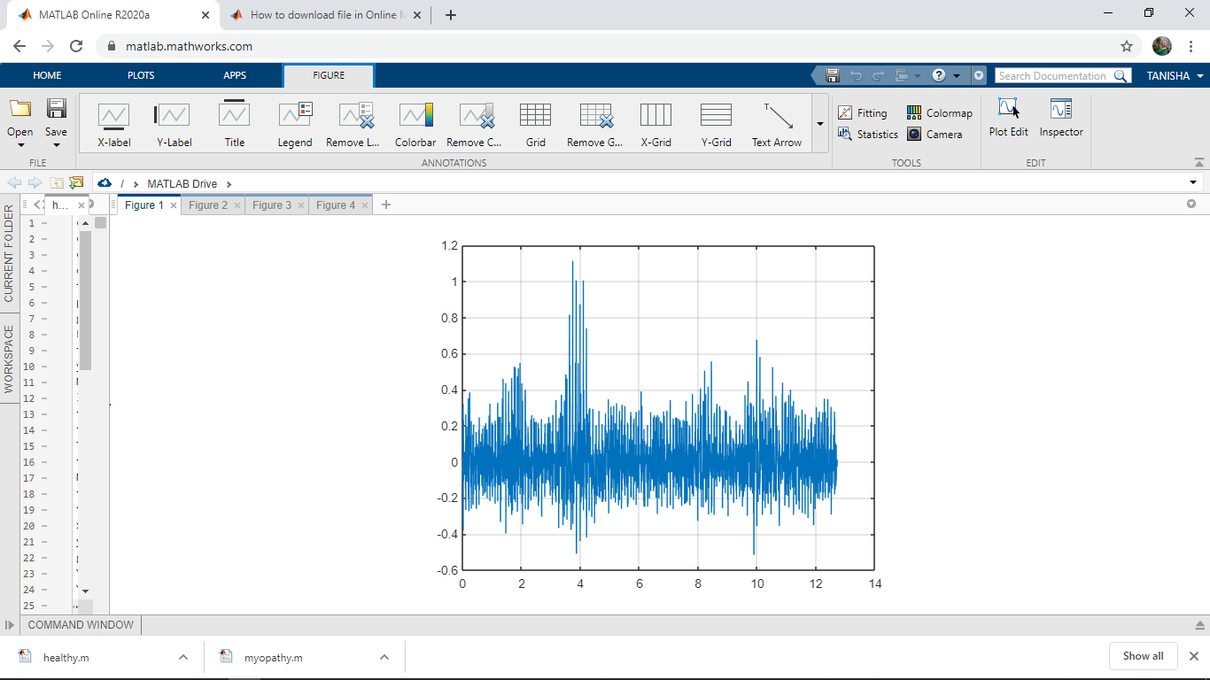

POWER SPECTRUM OF THE HEALTHY EMG SIGNAL
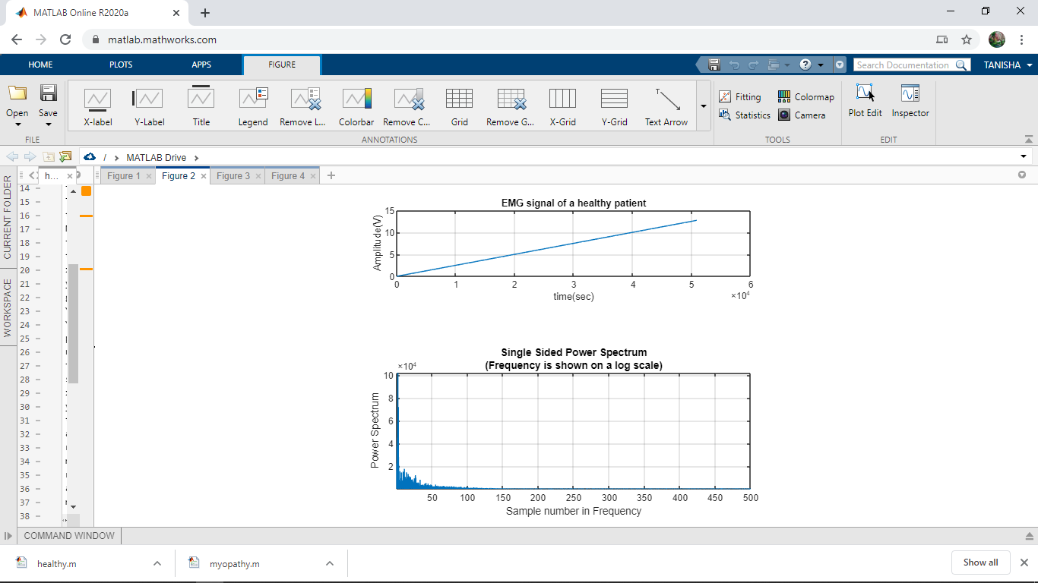

RECTIFIED EMG SIGNAL
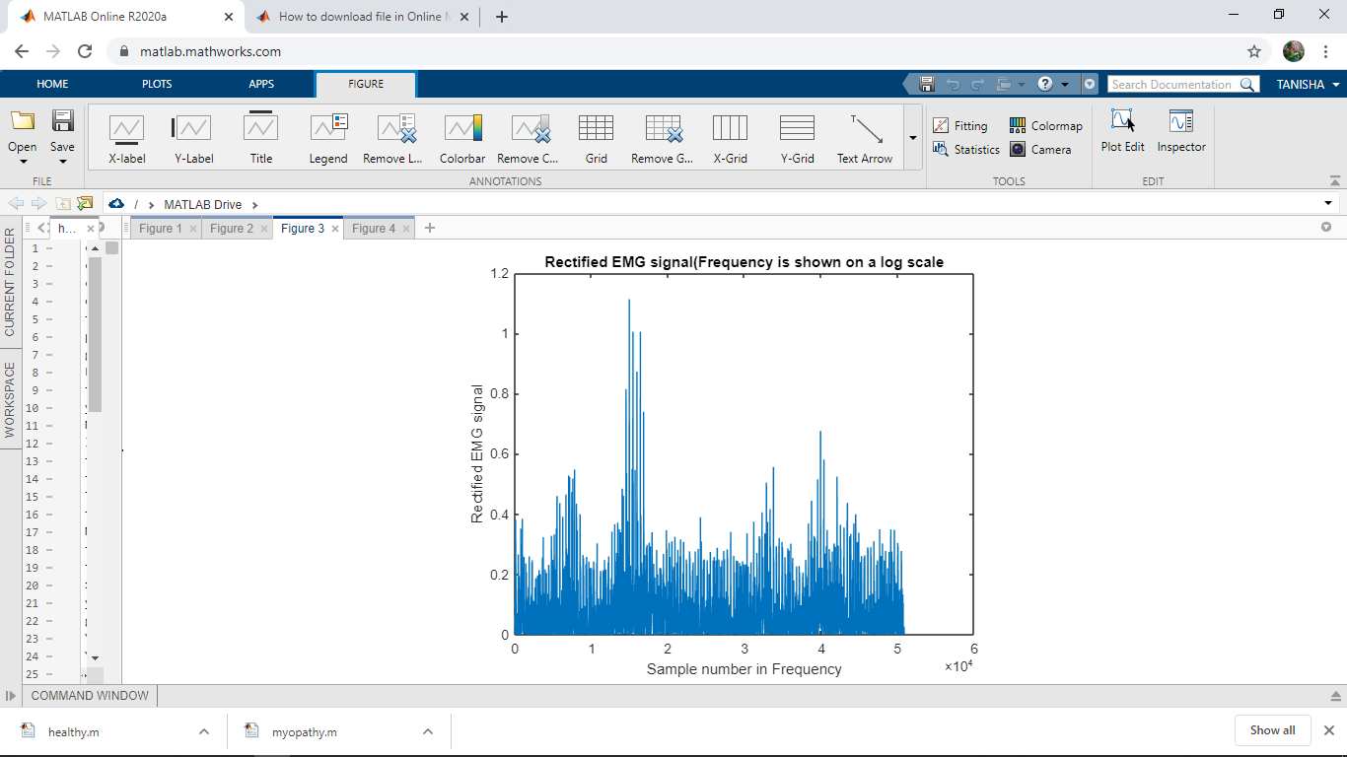
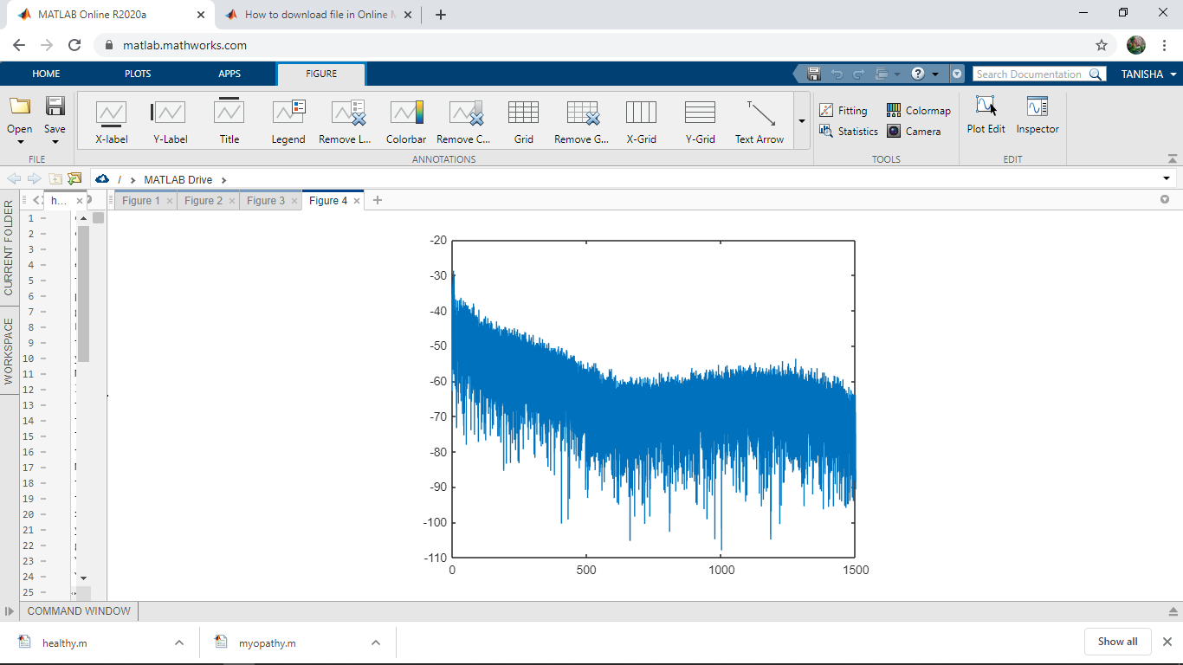

NEUROPATHIC PATIENT:

DATA SET PLOT OF NEUROPATHIC PATIENT

POWER SPECTRUM:

RECTIFIED AMPLITUDE OF EMG SIGNAL

