**PCB LAYOUT OF THE CIRCUIT**

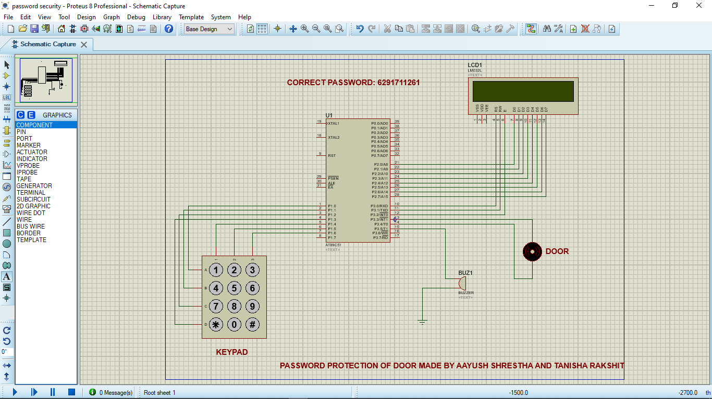

**SIMULATION**

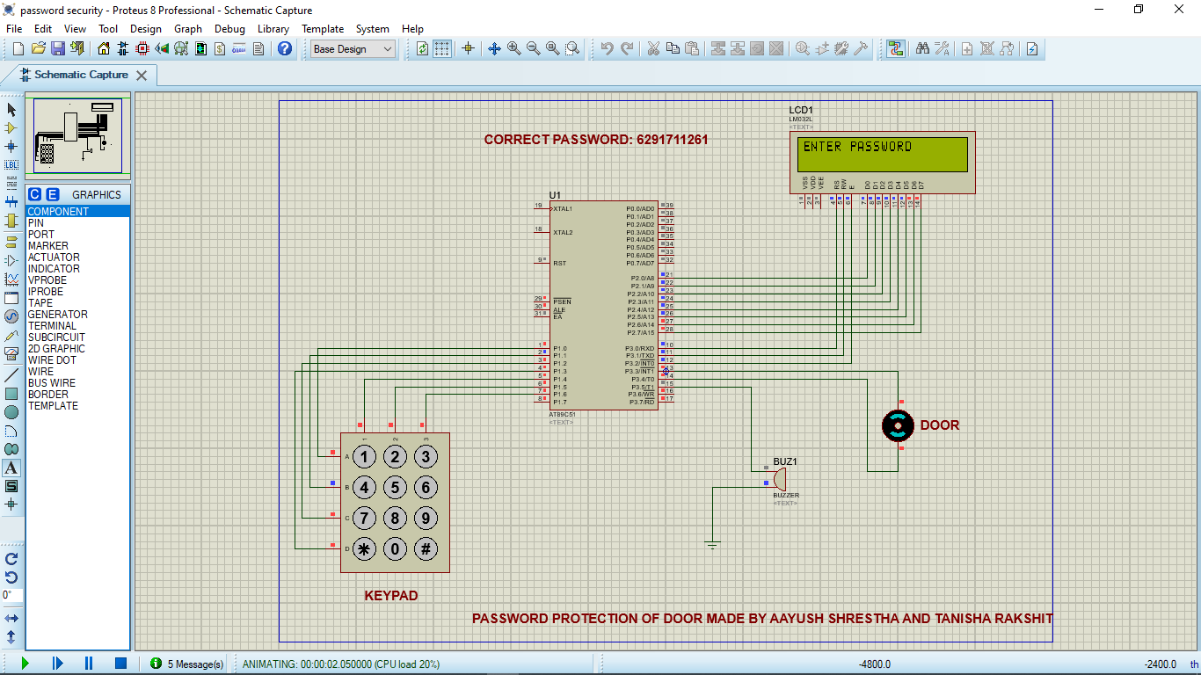

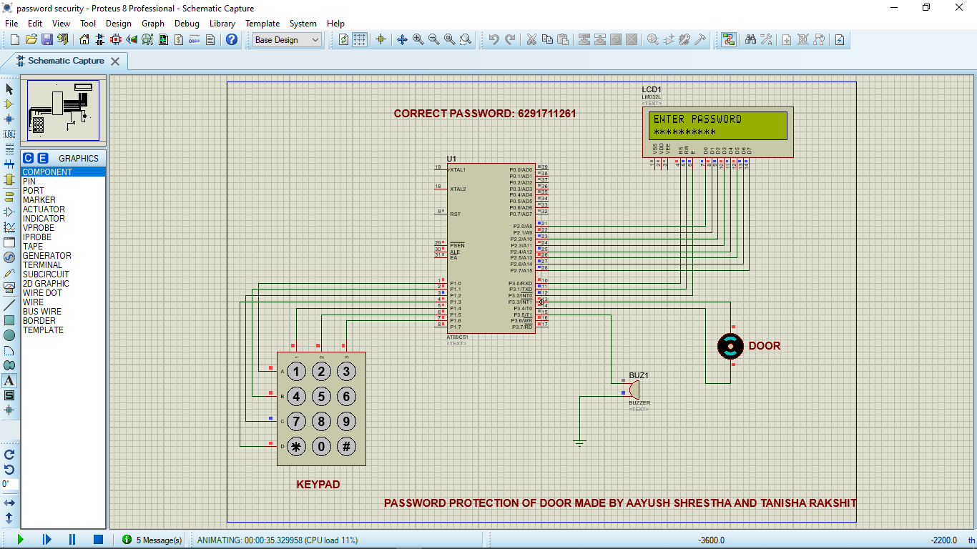

**PASSWORD MATCHED THEN DOOR STARTS MOVING AND BUZZER VALUE IS LOW 1.748mV**

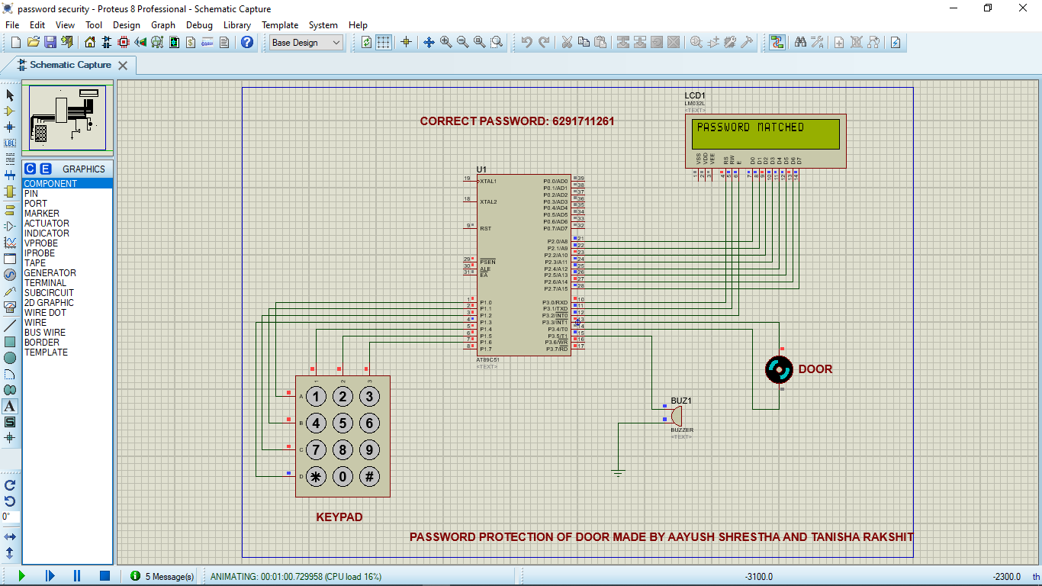

**PASSWORD WRONG THEN THE DOOR DOES NOT OPEN**

**AND BUZZER VALUE IS VERY HIGH 1.8V**

