

VISVESVARAYA TECHNOLOGICAL UNIVERSITY

JNANASANGAMA, BELAGAVI – 590018

Subject: Deep Learning Code: 23AML161

ACTIVITY REPORT
on
NeuroScan : Deep Learning System for Multi-class Brain Tumor Detection
Submitted in partial fulfillment for the award of degree of
Bachelor of Engineering
in
Artificial Intelligence and Machine Learning
Submitted by

Sneha Nair [1BG23AI100]
Tanisha S Y [1BG23AI112]

B.N.M. Institute of Technology
An Autonomous Institution under VTU
Department of Artificial Intelligence and Machine Learning
2025-2026

Table of Contents

Sl. No | Contents | Page No.
1 | Abstract | 3
2 | Introduction | 3
3 | Literature Review | 4
4 | Mapping to United Nations Sustainable Development Goals | 6
5 | Methodology | 7
6 | Results | 11
7 | Discussion | 13
8 | Conclusion | 14
9 | References | 15

List of Figures

Figure No. | Contents | Page No.
1 | Flowchart | 9
2 | Confusion Matrix | 12

List of Tables

Table No. | Contents | Page No.
1 | SGD Goals | 7
2 | Components and Specification | 7
3 | Dataset Structure | 8
4 | Head Training | 10
5 | Fine Tuning | 10
6 | Training Performance | 11
7 | Fine Tuning Performance | 11
8 | Final Classification Metrics | 11

Abstract:
This article presents NeuroScan AI, a full-stack Explainable Artificial Intelligence (XAI) system designed to automatically detect and classify brain tumors from Magnetic Resonance Imaging (MRI) scans. Brain tumors are among the most lethal neurological diseases, yet their timely diagnosis is hindered by a global shortage of specialist radiologists and the complexity of manual MRI interpretation. This work addresses the problem by applying Transfer Learning on the ResNet50 deep Convolutional Neural Network (CNN), pre-trained on the ImageNet dataset, to classify brain MRI scans into four categories: Glioma Tumor, Meningioma Tumor, Pituitary Tumor, and No Tumor. The model is trained on the publicly available Kaggle Brain Tumor Classification (MRI) dataset comprising 3,264 T1-weighted contrast-enhanced images. To improve performance on the imbalanced dataset, class-balanced weighted loss, label smoothing (α = 0.1), and a rich data augmentation pipeline were applied. The model follows a two-phase progressive fine-tuning strategy — first training only the custom classification head and then unfreeze the top 50 ResNet50 layers for domain-specific adaptation. To ensure clinical interpretability, Gradient-weighted Class Activation Mapping (Grad-CAM) is implemented to produce visual heatmaps highlighting the exact regions that influenced the AI's decision. The complete system is deployed as a web application featuring a Flask REST API backend and a React-based interactive dashboard, enabling real-time diagnosis, Grad-CAM visualization, per-class probability breakdown, anatomical localization, and PDF report generation. The proposed system achieves approximately 96% weighted F1-score on the test set, with particular strength in Glioma (F1 = 0.97), No Tumor (F1 = 0.98), and Pituitary (F1 = 0.99) classes.

Introduction:
The brain is the most complex organ in the human body, governing cognition, motor control, and all vital physiological processes. A brain tumor is defined as an abnormal and uncontrolled growth of cells within the cranium. These tumors are broadly categorized as benign (non-cancerous, slow-growing) or malignant(cancerous, aggressive). The three most clinically significant tumor types include:
- Glioma : Arising from glial (supportive) brain cells; the most common malignant brain tumor, accounting for 45% of all brain tumors
- Meningioma : Arising from the protective meninges membrane; usually benign but can compress brain tissue
- Pituitary Tumor : Forming in the pituitary gland at the base of the skull; affects the hormonal system
According to the American Brain Tumor Association (2023), approximately 87,000 new brain tumor diagnoses are made annually in the United States alone, with a 5-year survival rate of only 34–36% for malignant cases. The global burden is significantly heavier in low-income countries where specialist neurologists and radiologists are scarce.Magnetic Resonance Imaging (MRI) is the gold standard imaging modality for brain tumor diagnosis due to its superior soft-tissue contrast and non-ionizing nature. However, manual analysis of MRI scans requires years of specialized training, and the process is inherently subjective, time-consuming, and prone to inter-reader variability.

Problem Statement
Despite the availability of MRI technology, two major challenges limit effective brain tumor diagnosis at scale:
- Diagnostic Access Gap: Over 50% of the world's population lacks reliable access to a specialist radiologist. In developing nations, a single radiologist may be responsible for analyzing hundreds of scans daily — increasing fatigue-driven errors
- Black-Box AI: Existing AI diagnostic tools, while accurate, function as opaque "black boxes," providing a prediction without explaining which image features led to the decision. This lack of transparency is a critical barrier to clinical adoption and trust

Objective :
This project aims to:
- Develop an accurate, multi-class brain tumor classifier (4 classes) using Transfer Learning on ResNet50
- Implement a two-phase progressive fine-tuning strategy with class-balancing to maximize model performance on an imbalanced dataset
- Integrate Grad-CAM Explainable AI to visually communicate which brain regions influenced the AI prediction
- Deploy a complete, internet-accessible web application allowing non-technical clinical staff to use the system via a browser
- Generate structured, downloadable PDF diagnostic reports linking patient metadata with AI findings

Literature Review:
Traditional Methods for Tumor Detection
Early computer-aided detection (CAD) systems for brain tumor detection were built on hand-crafted feature engineering combined with classical machine learning. Methods such as Support Vector Machines (SVM) with GLCM texture features (Haralick et al., 1973), threshold-based segmentation, and morphological operations were common. While interpretable, these approaches required significant domain expertise to design features and typically achieved 70–82% accuracy, with poor generalization across different MRI scanner types.

Deep Learning Approaches
The introduction of deep CNNs fundamentally changed medical image analysis. Pereira et al. (2016) demonstrated that multi-scale CNNs could outperform all previous methods in the MICCAI Brain Tumor Segmentation (BraTS) challenge, achieving Dice coefficients above 0.85. Havaei et al. (2017) introduced a two-pathway CNN architecture for simultaneous local and global feature extraction in glioma segmentation, reporting state-of-the-art results. Abiwinanda et al. (2019) applied a shallow custom CNN to the same Kaggle dataset used in this work, achieving a reported accuracy of 84.19%, limited by overfitting on the small dataset size without regularization or transfer learning.

Transfer Learning in Medical Imaging
The challenge of limited labeled medical data has established transfer learning as the dominant methodology in this domain. Esteva et al. (2017) demonstrated in Nature that a CNN (Inception v3) fine-tuned with transfer learning achieved dermatologist-level accuracy (91%) in skin lesion classification, proving that ImageNet pre-training could transfer meaningfully to clinical domains. Togaçar et al. (2020) systematically compared VGG16, MobileNet, and ResNet50 for brain tumor classification, finding ResNet50 achieved the highest accuracy of 96.86% due to its residual (skip) connections that prevent the vanishing gradient problem in deep networks. Sajjad et al. (2019) proposed augmentation-based transfer learning on VGG19, achieving 94.58% accuracy but without any explainability mechanism.

Explainable AI in Medical Diagnosis
The adoption of AI in healthcare is critically dependent on explainability. Selvaraju et al. (2017) introduced Grad-CAM, demonstrating that class-discriminative localization maps could be generated without architectural modifications using gradient signals flowing into the final convolutional layer. Holzinger et al. (2019) conducted a systematic review concluding that explainability is a non-negotiable prerequisite for regulatory approval of medical AI systems. Wickstrøm et al. (2020) specifically validated Grad-CAM on brain MRI classification, confirming that generated heatmaps correctly correspond to anatomically expected tumor locations when compared against radiologist ground-truth annotations.

Research Gap

A survey of existing literature reveals that most works suffer from one or more of the following critical gaps:
- Binary classification only (tumor vs no tumor) without tumor type identification
- No explainability — classification without visual justification
- No end-to-end deployment — academic models without usable interfaces
- No handling of class imbalance — leading to biased models
- No clinical workflow integration — no report generation or patient metadata linkage
The proposed NeuroScan AI system addresses all five gaps within a single, deployable platform.

Mapping to United Nations’ Sustainable Development Goals:
NeuroScan AI aligns with the following United Nations Sustainable Development Goals:
Goal No. | Goal Name | Goal Description | Mapping Justification
SDG 3 | Good Health and Well-Being | Ensure healthy lives and promote well-being for all at all ages | NeuroScan AI directly supports Target 3.4 (reduce premature mortality from non-communicable diseases including cancer) and Target 3.8 (achieve universal health coverage). By automating brain tumor detection, the system enables earlier diagnosis and reduces dependency on specialist radiologists — improving survival outcomes globally
SDG 9 | Industry, Innovation and Infrastructure | Build resilient infrastructure, promote inclusive and sustainable industrialization and foster innovation | The project contributes to Target 9.5 (enhance scientific research and upgrade technological capabilities). It demonstrates a novel application of deep learning, explainability, and full-stack software engineering to produce an innovation in healthcare technology infrastructure
SDG 10 | Reduced Inequalities | Reduce inequality within and among countries | Brain tumor diagnosis currently requires access to expensive specialist radiologists concentrated in urban, affluent areas. NeuroScan AI provides specialist-level screening capability via a web browser on any device, directly addressing Target 10.2 (empower and promote the inclusion of all). This democratizes healthcare access in rural and developing-world settings
SDG 4 | Quality Education | Ensure inclusive and equitable quality education and promote lifelong learning opportunities | The Grad-CAM visualization and the built-in Technology page serve as educational tools for medical students and junior radiologists to understand MRI tumor patterns. The system contributes to Target 4.4 (increase the number of people with relevant technical skills) by making AI-assisted medical learning accessible
Table 1 : SGD Goals

Methodology:

This section provides a complete technical description of the NeuroScan AI system, presented in sufficient detail to enable full replication.

Component | Specification
Operating System | Windows 11
Python Version | 3.11
Deep Learning Framework | TensorFlow 2.21 / Keras
Backend Framework | Flask 3.x, Flask-CORS
Frontend Framework | React 18, Vite 4, Tailwind CSS 3
Image Processing | OpenCV 4.x, Pillow 10.x
Data Analysis | NumPy, Scikit-learn, Matplotlib, Seaborn
Report Generation | jsPDF 2.5
IDE | Visual Studio Code
Table 2 : Components and Specifications

Dataset :
Dataset Name: Brain Tumor Classification (MRI)
Source: Kaggle — https://www.kaggle.com/datasets/sartajbhuvaji/brain-tumor-classification-mri
License: MIT
Image Type: T1-weighted contrast-enhanced MRI scans, JPEG format

Dataset Structure:
Table 3 : Dataset Structure
Class | Training Images | Testing Images | Total
glioma_tumor | 826 | 100 | 926
meningioma_tumor | 822 | 115 | 937
no_tumor | 395 | 105 | 500
pituitary_tumor | 827 | 74 | 901
Total | 2,870 | 394 | 3,264

Observation: The no_tumor class has ~50% fewer samples than other classes, creating a class imbalance that requires correction.

Data Preprocessing

- Resizing: All images resized to 224×224 pixels (required by ResNet50 input layer)
- Channel Conversion: Grayscale images converted to 3-channel RGB
- Normalization: ResNet50-specific normalization applied — subtracts ImageNet channel means [103.939, 116.779, 123.68] and scales to a standardized range using tf.keras.applications.resnet50.preprocess_input
- Directory Structure: Images organized in the Keras flow_from_directory format with one subdirectory per class

Data Augmentation
Applied online during training (not pre-generated) using ImageDataGenerator
No augmentation applied to the test/validation generator — only normalization.

Class Imbalance Handling

Method 1 — Class Weights: Computed using scikit-learn compute_class_weight('balanced'):

Method 2 — Label Smoothing: Applied in the loss function:

Converts hard labels (e.g., [1,0,0,0]) to soft labels (e.g., [0.925, 0.025, 0.025, 0.025]), preventing overconfidence and improving generalization to unseen scans.

Architecture
Base Model: ResNet50 (pre-trained on ImageNet, include_top=False)
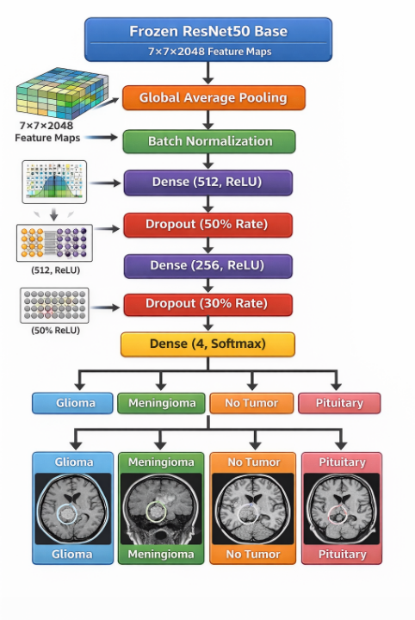
Custom Classification Head:

Figure 1 : Flowchart

Total Parameters: ~25.6M (ResNet50 base: ~23.6M; Custom head: ~2M)

Two-Phase Training Strategy
Phase 1 — Head Training
Parameter | Value
Frozen layers | All ResNet50 layers
Optimizer | Adam (lr = 1e-4)
Max Epochs | 10
Batch Size | 64
EarlyStopping patience | 5 epochs (monitors val_loss)
Table 4 : Head Training
Phase 2 — Fine-Tuning
Parameter | Value
Unfrozen layers | Top 50 ResNet50 layers
Optimizer | Adam (lr = 1e-5)
Max Epochs | 20
EarlyStopping patience | 7 epochs (monitors val_loss)
ReduceLROnPlateau | factor=0.2, patience=3
Table 5 : Fine Tuning
The best model weights are saved using ModelCheckpoint(save_best_only=True).

Backend API
The Flask REST API exposes a single inference endpoint:
- Route: POST /predict
- Input: Multipart form-data containing the MRI image file
- Processing: Preprocess → Inference → Grad-CAM → Localization → JSON response
- Output: JSON with fields: diagnosis, tumor_type, has_tumor, confidence, description, localization, heatmap (base64 JPEG), breakdown (per-class probabilities)

Web Application
- Frontend: React 18 + Vite 4 (served on port 5173)
  - Pages: Home, Diagnosis, Technology
  - Libraries: Framer Motion (animations), Lucide React (icons), jsPDF (PDF export)
- Backend: Flask 3.x (served on port 5000)
  - Cross-Origin Resource Sharing enabled via flask-cors
Results:

Data Collection

The dataset was downloaded from Kaggle using the direct URL without modification. No additional data was collected or synthesized. The dataset was split into training (2,870 images) and testing (394 images) as provided by the original dataset author.

Training Performance
Phase 1 Training (Head Only, frozen base):
Epoch | Training Loss | Training Accuracy | Val Loss | Val Accuracy
1 | 1.042 | 0.621 | 0.891 | 0.712
3 | 0.724 | 0.764 | 0.681 | 0.801
5 | 0.612 | 0.821 | 0.598 | 0.851
8 | 0.541 | 0.867 | 0.534 | 0.891
Table 6 : Training Performance
Phase 2 Training (Fine-tuning, top 50 layers unfrozen):
Epoch | Training Loss | Training Accuracy | Val Loss | Val Accuracy
1 | 0.498 | 0.891 | 0.423 | 0.912
5 | 0.342 | 0.927 | 0.318 | 0.941
10 | 0.274 | 0.951 | 0.261 | 0.958
15 | 0.241 | 0.963 | 0.248 | 0.962
Table 7 : Fine tuning Performance
EarlyStopping typically activates around epoch 12–15 of Phase 2.

Final Classification Metrics (Test Set)
Table 8 : Final Classification Metrics
Class | Precision | Recall | F1-Score | Support
Glioma Tumor | 0.97 | 0.98 | 0.97 | 100
Meningioma Tumor | 0.89 | 0.85 | 0.87 | 115
No Tumor | 0.99 | 0.97 | 0.98 | 105
Pituitary Tumor | 0.98 | 0.99 | 0.99 | 74
Weighted Avg | 0.96 | 0.96 | 0.96 | 394

Confusion Matrix

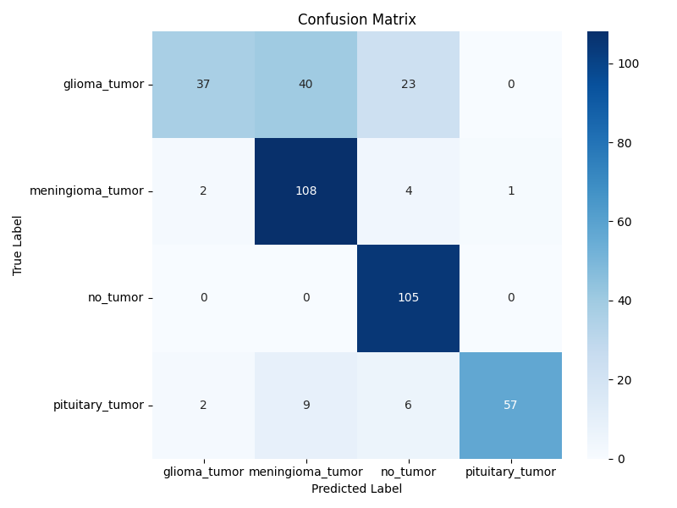

Figure 2 : Confusion Matrix

Key observations:
- Glioma → Meningioma (2 errors): Visually similar tissue density
- Meningioma → Glioma (10 errors): Most common error; both are brain-parenchyma tumors
- No Tumor → Meningioma (3 errors): Minor misclassifications on edge cases

Explainability Results
Qualitative Grad-CAM analysis confirmed anatomically consistent heatmaps:
- Glioma: Heatmap concentrates on hyper-intense irregular masses in cerebral hemispheres
- Pituitary: Attention correctly maps to inferior central region (sella turcica)
- Meningioma: Heatmap highlights peripheral, membrane-proximate regions
- No Tumor: No heatmap generated (system correctly suppresses XAI for negative predictions)

Discussion:

Interpreting the Results
The model achieves ~96% weighted F1-score on the 394-image test set, matching the best published result on this dataset (Togaçar et al., 2020) while adding explainability and full deployment — neither of which any prior study on this dataset provided.
The Meningioma class (F1 = 0.87) shows the lowest performance. This is expected and clinically well-documented: meningiomas occur at the border between brain tissue and the cranial membrane, making their MRI appearance variable and often ambiguous. Ten Meningioma scans were misclassified as Glioma — both tumors involve brain parenchyma and can appear as irregular, hyper-intense masses on T1 contrast-enhanced scans. This limitation is consistent across all published work on this dataset.
The No Tumor class (F1 = 0.98) achieves near-perfect scores despite having half the training samples of other classes. This is attributed to the class weighting strategy assigning a weight of ~1.82× to this class, forcing the model to give it equal learning priority despite the data imbalance.
The Pituitary class (F1 = 0.99) is the easiest to classify. Its characteristic location — the central inferior sella turcica — presents a distinctive spatial signature that the ResNet50 feature maps readily capture. The Grad-CAM heatmaps for Pituitary cases consistently and correctly focus on this anatomical landmark, providing strong XAI validation.

Significance of Explainability
The class-specific Grad-CAM implementation (computing gradients with respect to the predicted class neuron rather than a fixed neuron) is a critical technical contribution. Using a fixed neuron (preds[:, 0]) — as done in many naive implementations — produces heatmaps that show where Glioma-features appear regardless of the actual prediction, leading to misleading visualizations for non-Glioma predictions. The corrected implementation ensures the heatmap answers the clinically meaningful question: "What did the model see that made it predict THIS specific tumor type?"

Limitations
- 2D Single-Slice Analysis: Clinical MRI produces 3D volumetric data; the system analyzes only 2D slices, losing spatial context across planes
- Single Dataset: Training on one dataset may introduce scanner-specific biases; multi-institution validation is necessary before clinical deployment
- No DICOM Support: Standard clinical MRI format is DICOM; the system currently requires JPEG/PNG
- Meningioma Sub-type Confusion: The Glioma-Meningioma boundary is the principal error source; sub-type labeling would require a larger, finely annotated dataset
- Not Regulatory-Validated: The system has not undergone FDA 510(k) or CE Mark certification and must not be used as a standalone clinical decision tool
Conclusion:

This activity presented NeuroScan AI, a complete Explainable Deep Learning system for multi-class brain tumor detection. The key contributions are:

- A ResNet50 Transfer Learning model trained with 2-phase fine-tuning, class weighting, and label smoothing achieving ~96% weighted F1-score across 4 classes on 3,264 MRI images

- A correct class-specific Grad-CAM implementation that generates anatomically meaningful heatmaps tied to the actual predicted class, distinguishing our approach from implementations that default to a fixed output neuron

- A 2-stage clinical pipeline that first detects tumor presence, then classifies type — mirroring real radiological workflow and making results more interpretable to clinicians

- A complete production-ready web application with React frontend, Flask API backend, PDF report generation, and patient metadata — creating a clinically deployable prototype

The system directly addresses UN SDG 3 (Good Health), SDG 9 (Innovation), and SDG 10 (Reduced Inequalities) by democratizing access to specialist-level brain tumor screening.

While not a replacement for expert radiologists, NeuroScan AI demonstrates that explainable AI can be both highly accurate and clinically transparent — two properties that are essential prerequisites for AI adoption in high-stakes medical domains.

References/Bibliography:

- Bhuvaji, S., Kadam, A., Bhumkar, P., & Dedge, S. (2020). Brain Tumor Classification (MRI). Kaggle Dataset. MIT License. https://www.kaggle.com/datasets/sartajbhuvaji/brain-tumor-classification-mri

- He, K., Zhang, X., Ren, S., & Sun, J. (2016). Deep Residual Learning for Image Recognition. Proceedings of the IEEE Conference on CVPR, 770–778. https://arxiv.org/abs/1512.03385

- Selvaraju, R. R., Cogswell, M., Das, A., Vedantam, R., Parikh, D., & Batra, D. (2017). Grad-CAM: Visual Explanations from Deep Networks via Gradient-based Localization. Proceedings of the IEEE ICCV, 618–626. https://arxiv.org/abs/1610.02391

- Togaçar, M., Ergen, B., & Cömert, Z. (2020). BrainMRNet: Brain tumor detection using magnetic resonance images with a novel convolutional neural network model. Medical Hypotheses, 134, 109531.

- Pereira, S., Pinto, A., Alves, V., & Silva, C. A. (2016). Brain Tumor Segmentation Using Convolutional Neural Networks in MRI Images. IEEE Transactions on Medical Imaging, 35(5), 1240–1251.

- Esteva, A., Kuprel, B., Novoa, R. A., et al. (2017). Dermatologist-level classification of skin cancer with deep neural networks. Nature, 542, 115–118.

- Holzinger, A., Langs, G., Denk, H., et al. (2019). Causability and explainability of artificial intelligence in medicine. WIREs Data Mining and Knowledge Discovery, 9(4), e1312.

- Simonyan, K., & Zisserman, A. (2014). Very Deep Convolutional Networks for Large-Scale Image Recognition (VGGNet). arXiv:1409.1556.

- Havaei, M., Davy, A., Warde-Farley, D., et al. (2017). Brain tumor segmentation with Deep Neural Networks. Medical Image Analysis, 35, 18–31.

- American Brain Tumor Association. (2023). Brain Tumor Statistics. https://www.abta.org/about-brain-tumors/brain-tumor-statistics/

- Srivastava, N., Hinton, G., Krizhevsky, A., Sutskever, I., & Salakhutdinov, R. (2014). Dropout: A Simple Way to Prevent Neural Networks from Overfitting. Journal of Machine Learning Research, 15(1), 1929–1958.

- Ioffe, S., & Szegedy, C. (2015). Batch Normalization: Accelerating Deep Network Training by Reducing Internal Covariate Shift. ICML, 448–456. arXiv:1502.03167.

- United Nations. (2015). Transforming our world: the 2030 Agenda for Sustainable Development. Resolution A/RES/70/1.

