Database Management System

*Library Management System*

Maitreya Darokar – PC4

Krishna Patil – PC59

Mohit Garg – PC37

Kartikeya Pande – PC13

Jenil Jain – PC46

Karan Shah – PC31

Jay Patil – PC20

Problem Statement

LIBRARY MANAGEMENT SYSTEM

Objective

* The Library Management System allows the Librarian to login using a username and a password to access the system.
* The Librarian can perform many functions after logging into the system, such as, adding a new book, adding a new student, issuing a book, returning (accepting) a book, and view transactions (statistics about issuing and returning of books).
* In the System, every book has an ISBN no., Name, Author, and a Price.
* Every student has a student ID, Name, Course, Branch, and Year.
* While issuing a book the Librarian must enter the ISBN number of the book, the ID of the student, and the issue date.
* When the book is returned, student ID is entered by the Librarian to get details of the book issued, further the return date is mentioned and the book’s status is changed to returned/available.

Data Requirements

ENTITIES:

* Book
* Admin
* Student
* Record

ATTRIBUTES:

* BOOK:
* ISBN
* Title
* Author
* Quantity
* Price

* ADMIN:
* User_id
* Password

* STUDENT:
* Name
* Course
* Branch
* Student_id
* State
* RECORD:
* Return_Date
* ISBN
* Student_id
* Issue_Date

Relationships – Cardinality

* ADMIN adds BOOK (1-M)
* ADMIN adds STUDENT (1-M)
* ADMIN updates RECORD (1-M)

Entity-Relationship Diagram

Entity Relationship Diagram is used to model database software engineering to illustrate logical structure of the database. It is a relational schema database modelling approach. This approach commonly used in database design. The diagram created using this method is called E-R Diagram.

The E-R Diagram depicts the various relationships among entities, considering each object as entity. Entities are represented with a rectangle shape and relationships are represented with a diamond shape. It depicts the relationship between data objects. The ER Diagram is the notation that is used to conduct the data modelling activity.

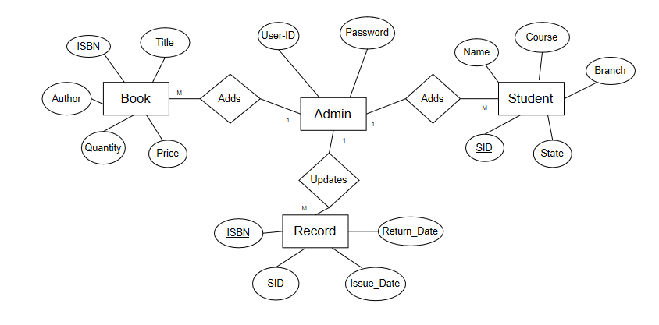

Schema Diagram

A schema is the structure behind data organization. It is a visual representation of how different table relationships enable the schema’s underlying mission business rules for which the database is created. Database schema defines its entities and the relationship among them.

It contains a descriptive detail of the database, which can be depicted by means of schema diagrams. It's the database designers who design the schema to help programmers understand the database and make it useful.

Schema diagrams have an important function because they force database developers to transpose ideas to paper. This provides an overview of the entire database, while facilitating future database administrator work.

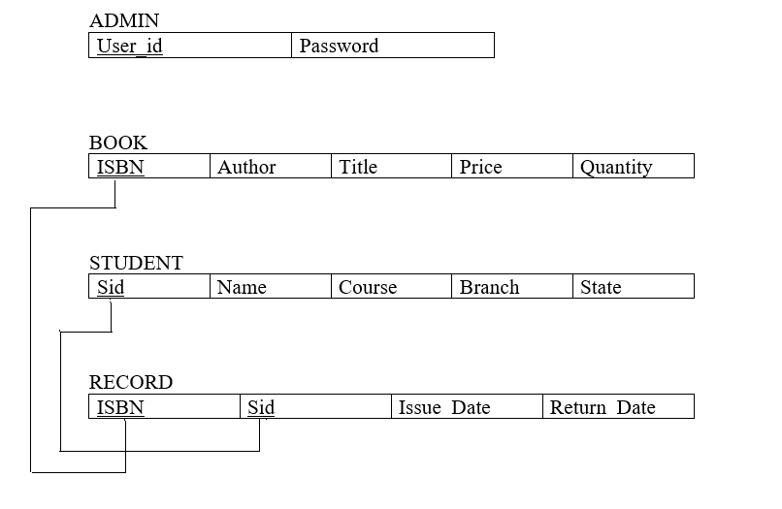

GUI Design

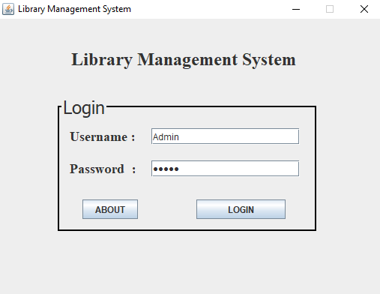

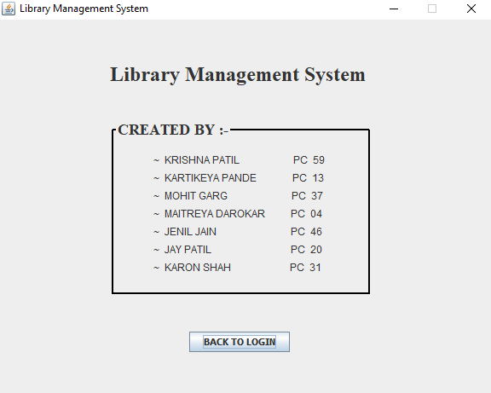

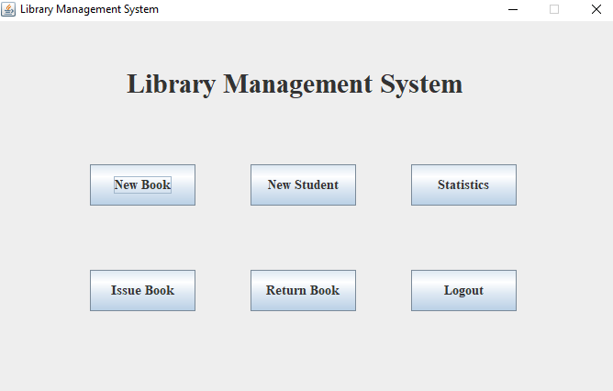

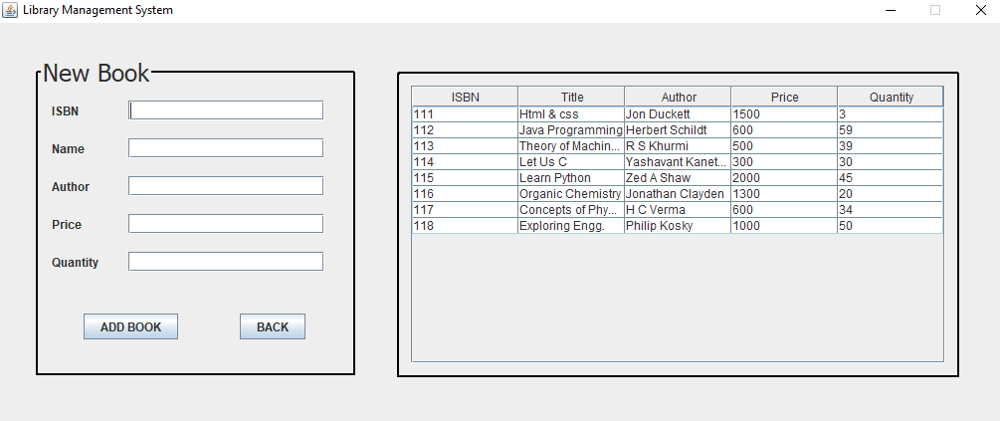

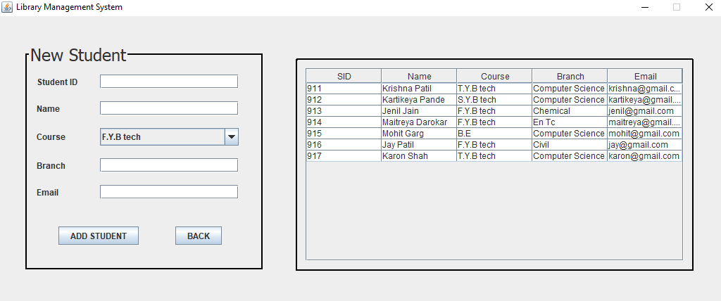

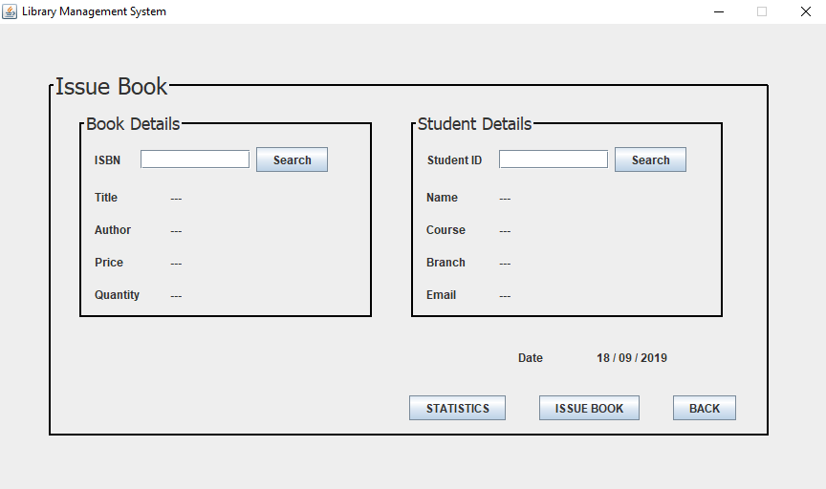

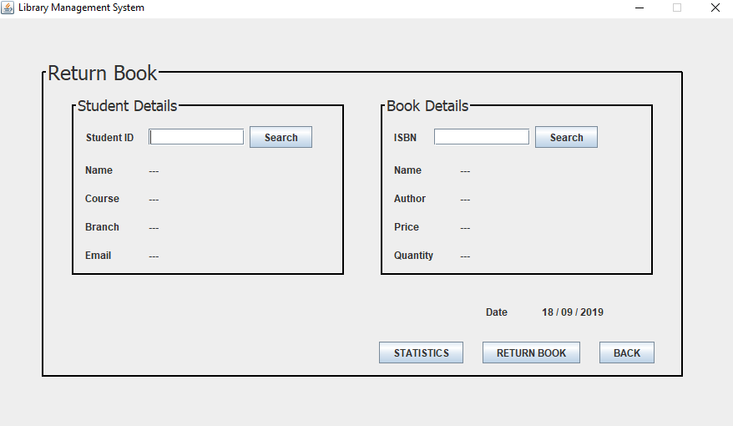

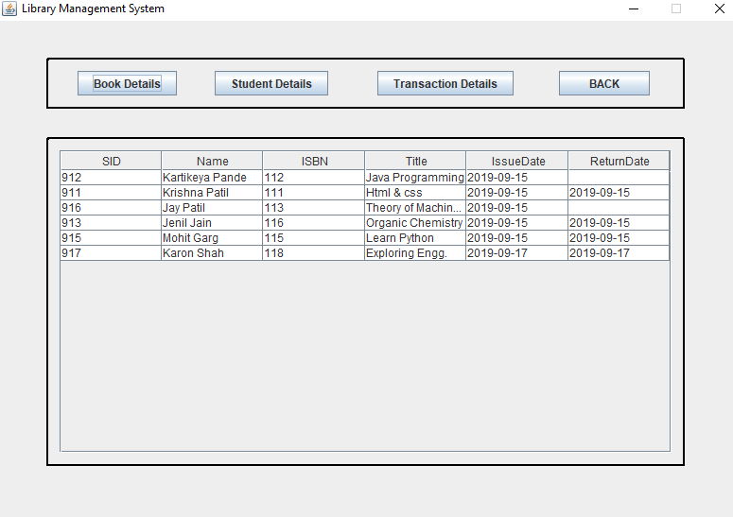

Conclusion

• SQL database management application which is very well used in the

modern world in organizing and manipulating a database.

• Though SQL doesn’t have the GUI interface like Microsoft access is

having and they all manage the database comfortable.

• Depending on the user or users, if an organization has multiple users

then they should go for SQL server based application.

• This project shows how to create tables in SQL and how to creates

simple data manipulation language and data definition language with

how to execute them.

• It also shows how relationships are established with the concepts of

primary and foreign key within a table.

• Lastly, the project shows how queries are created in SQL server,

Queries like the create command, view, update, alter etc.