TURBINE-X
Research Project Execution Blueprint
Joint Conventional Machine Learning for Gas-Turbine Emission and Energy-Yield Estimation
with Uncertainty-Aware Historical Operating-Point Analysis
Dataset: UCI Gas Turbine CO and NOx Emission Data Set
Five uploaded annual CSV files • 36,733 observations • 2011–2015
Prepared for: B.Tech Computer Science Engineering
Development: Windows 11 • VS Code • Jupyter Notebook
Hardware: Ryzen 9 8940HX • RTX 5060 8 GB • 16 GB RAM
Version 1.0 | 4 November 2026

Document Control
Field | Value
Project | TURBINE-X
Document | Research Project Execution Blueprint and Dataset Audit
Version | 1.0 — dataset-driven plan
Dataset status | All five user-uploaded CSV files physically inspected
Implementation status | Not started; starter scaffold only
Primary ML constraint | Conventional ML only; deep learning prohibited
Research status | Provisional; novelty requires further systematic literature search
Prepared date | 4 November 2026

Important status distinction: the uploaded CSV audit is complete for the five files supplied in this conversation. The starter package contains notebook templates, a progress tracker, configuration and diagrams; it does not contain trained models or a finished application.

Table of Contents
- 1. Executive Summary
- 2. Project Identity and Research Scope
- 3. Dataset Inventory and File-Level Audit
- 4. Data Quality, Correlation and Leakage Assessment
- 5. Valid ML Problem and Target Formulations
- 6. Literature Review and Research Gap
- 7. Frozen Research Questions and Hypotheses
- 8. Frozen Experimental Protocol
- 9. Conventional ML Algorithm Selection
- 10. Feature Engineering and Preprocessing
- 11. Complete ML Pipeline
- 12. Project Folder Structure
- 13. Jupyter Notebook Execution Roadmap
- 14. Centralized Automatic Progress Tracker
- 15. Experiment and Output Management
- 16. Architecture Diagrams
- 17. Week-by-Week Implementation Schedule
- 18. Evaluation and Statistical Analysis
- 19. Testing and Quality Assurance
- 20. Application Design
- 21. Hardware, Software and Environment
- 22. Risk Register and Mitigations
- 23. Expected Deliverables and Acceptance Criteria
- 24. Final Supervisor Verdict
- 25. References
In Microsoft Word, update the automatic Table of Contents field if a dynamic TOC is preferred. This document also includes the section list above for immediate navigation.

1. Executive Summary
TURBINE-X is a conventional-machine-learning research project built around five original annual CSV files from the UCI Gas Turbine CO and NOx Emission Data Set. All five uploaded files were read directly. They contain 36,733 observations in total and share the same 11 numerical columns. The proposed project studies the estimation of two pollutant concentrations (CO and NOX) and turbine energy yield (TEY) from eight contemporaneous ambient and turbine measurements.
The central research comparison is between independent target models and genuinely joint multi-output models. Experiment A reproduces the familiar two-emission prediction formulation using TEY among the predictors. Experiment B is the main investigation: eight measured inputs predict CO, NOX and TEY jointly. This separation avoids the logical error of using TEY as an input while simultaneously claiming to predict or optimize TEY.
The data are annual and ordered chronologically, but the uploaded rows do not contain timestamps. The project must not infer exact time intervals, construct hourly lags, or claim a verified forecast horizon. The dataset is observational and from one plant; no causal or safe-control claims are supported. A historical operating-point trade-off explorer may be demonstrated, but unconstrained operational optimization is not justified by the available variables.
A 2026 paper already studies the same dataset with chronological development/calibration/test partitions, pollutant-specific models, temporal shift and high-emission tail risk. Consequently, TURBINE-X must not claim novelty from those elements alone. Its provisional research direction is the controlled comparison of independent versus joint multi-output conventional ML for CO, NOX and TEY, together with multi-output uncertainty assessment and support-aware descriptive trade-off analysis. The novelty claim remains provisional until a systematic literature review confirms that the combination has not already been addressed.

2. Project Identity and Research Scope
Item | Definition
Title | TURBINE-X: Joint Conventional ML for Gas-Turbine Emission and Energy-Yield Estimation
Domain | Industrial energy systems and environmental monitoring
Problem | Estimate contemporaneous CO, NOX and TEY from measured ambient and turbine operating variables
Primary task | Multi-output regression, compared with independent regression
Users | Researchers, plant analytics teams and academic evaluators; not turbine controllers
Aim | Assess whether joint output learning improves predictive usefulness and uncertainty characterization across annual operating domains
Scope | Offline analysis, reproducible model experiments, explanatory analysis and a demonstration dashboard
Out of scope | Causal inference, control recommendations, safety certification, regulatory compliance, real-time streaming and hourly-ahead forecasting

2.1 Objectives
- Audit and document the five annual CSV files, including file hashes, schemas, row counts and quality checks.
- Quantify annual target distributions, feature drift, correlations and predictor redundancy.
- Establish two non-confounded prediction formulations with explicit feature/target separation.
- Compare statistical baselines, tree ensembles, boosting and joint multi-output estimators.
- Evaluate AutoML and hyperparameter optimization under fixed chronological validation and compute budgets.
- Assess uncertainty intervals, calibration, residual behavior and generalization to the final year.
- Explain model behavior using permutation importance, SHAP and dependence analysis, with correlation caveats.
- Build a support-aware historical operating-point comparison interface and document limitations.

3. Dataset Inventory and File-Level Audit
Source: UCI Machine Learning Repository, Gas Turbine CO and NOx Emission Data Set, DOI 10.24432/C5WC95, CC BY 4.0. The five user-supplied files were read with pandas read_csv. File sizes below are exact byte counts measured in the uploaded files.
File | Rows | Columns | Bytes | Missing | Exact duplicate rows
gt_2011.csv | 7411 | 11 | 562921 | 0 | 0
gt_2012.csv | 7628 | 11 | 577617 | 0 | 0
gt_2013.csv | 7152 | 11 | 540334 | 0 | 0
gt_2014.csv | 7158 | 11 | 541009 | 0 | 7
gt_2015.csv | 7384 | 11 | 556928 | 0 | 0
TOTAL | 36733 | 11 | 2,778,809 | 0 | 7

All five files have identical headers and column order: AT, AP, AH, AFDP, GTEP, TIT, TAT, TEY, CDP, CO, NOX. Every column was parsed as float64. There are no categorical columns, explicit date/time columns, row identifiers or ID-like columns. The annual identity is encoded by the filename and must be attached as metadata for ordering and partitioning only.

3.1 Column dictionary
Column | Meaning | Unit | Experiment A | Experiment B
AT | Ambient temperature | °C | Input | Input
AP | Ambient pressure | mbar | Input | Input
AH | Ambient humidity | % | Input | Input
AFDP | Air filter differential pressure | mbar | Input | Input
GTEP | Gas turbine exhaust pressure | mbar | Input | Input
TIT | Turbine inlet temperature | °C | Input | Input
TAT | Turbine after temperature | °C | Input | Input
TEY | Turbine energy yield | MWh | Input | Target
CDP | Compressor discharge pressure | mbar | Input | Input
CO | Carbon monoxide | mg/m³ | Target | Target
NOX | Nitrogen oxides | mg/m³ | Target | Target

3.2 Actual sample record
The first record in gt_2011.csv is: AT=4.5878, AP=1018.7, AH=83.675, AFDP=3.5758, GTEP=23.979, TIT=1086.2, TAT=549.83, TEY=134.67, CDP=11.898, CO=0.32663, NOX=81.952. This row is reproduced from the uploaded original file.

4. Data Quality, Correlation and Leakage Assessment
Check | Measured result | Interpretation
Missing values | 0 across all 11 columns | No imputation required for current snapshot; retain assertion tests
Non-finite values | 0 | No NaN or ±infinity observed
Exact duplicates | 7 duplicate occurrences in 2014; 2 repeated-value groups | Retain primary data; run duplicate-excluded sensitivity analysis
Cross-year duplicates | 0 identical physical rows across years | No exact physical-row overlap across annual files
Constant columns | None | All 11 columns vary
Data types | 11 float64 per file | All columns numeric
Categorical/date/ID columns | None | Year comes from filename; no row timestamp
Single-site coverage | One gas turbine in northwestern Turkey per UCI description | External plant generalization cannot be established

4.1 Observed ranges
Variable | Minimum | Maximum
AT | -6.2348 | 37.103
AP | 985.85 | 1036.6
AH | 24.085 | 100.2
AFDP | 2.0874 | 7.6106
GTEP | 17.698 | 40.716
TIT | 1000.8 | 1100.9
TAT | 511.04 | 550.61
TEY | 100.02 | 179.5
CDP | 9.8518 | 15.159
CO | 0.00038751 | 44.103
NOX | 25.905 | 119.91

4.2 Correlation diagnostics
Feature pair | Pearson r | Risk
TEY–CDP | 0.989 | Very high redundancy
GTEP–CDP | 0.978 | Very high redundancy
GTEP–TEY | 0.964 | Very high redundancy
TIT–TEY | 0.910 | High redundancy
TIT–CDP | 0.908 | High redundancy
TIT–GTEP | 0.874 | High redundancy
AFDP–TIT | 0.691 | Moderate/high association

These correlations are descriptive, not causal. Correlated predictors can destabilize linear coefficients and split or permutation importance. Report grouped ablations and compare importance methods. Do not drop a variable solely because its pairwise correlation is high.

4.3 Leakage and validity controls
- Never use CO or NOX as predictors for the other emission target in the primary benchmark.
- Experiment B excludes TEY from inputs because TEY is a target there.
- Do not use filename-derived year as a predictive feature in the primary models; use it for split metadata only.
- Do not construct lag, rolling or lead variables because exact row timestamps and interval continuity are not available.
- Fit scaling, imputation (if later needed), feature selection and tuning only within development folds.
- Keep 2015 untouched until final evaluation; do not use it for model or threshold selection.
- Do not infer causality or safe operating setpoints from observational associations.

5. Valid ML Problem and Target Formulations

5.1 Experiment A — emission benchmark
Inputs: AT, AP, AH, AFDP, GTEP, TIT, TAT, TEY, CDP (nine features). Targets: CO and NOX. This formulation matches the common predictive-emission-monitoring use case and allows comparison with prior work. It is a benchmark, not the primary novelty claim.

5.2 Experiment B — primary joint-output investigation
Inputs: AT, AP, AH, AFDP, GTEP, TIT, TAT, CDP (eight features). Targets: CO, NOX and TEY. Compare independent per-target models with true multi-output estimators. This formulation avoids providing TEY to the model when TEY itself is being predicted.

5.3 Decision-support boundary
A dashboard may show predicted CO, NOX and TEY with intervals and compare observed or support-near historical operating points. Candidate search must remain within the observed feature domain (e.g., nearest-neighbour support checks). Do not optimize arbitrary synthetic feature combinations or present the output as causal, safe or regulator-approved operating advice. The dataset does not contain control interventions, constraints, permit thresholds or equipment safety envelopes.

6. Literature Review and Research Gap
Reference | What it establishes | Implication for TURBINE-X
Kochueva & Nikolskii (2021), Data Analysis and Symbolic Regression Models for Predicting CO and NOx Emissions from Gas Turbines, Computation 9(12), 139. DOI: 10.3390/computation9120139 | Symbolic regression and interpretable emission modelling have already been studied. | Do not claim symbolic equations or explainability alone as novel.
Long-term atmospheric pollutant emissions from a combined cycle gas turbine: Trend monitoring and prediction applying machine learning (Fuel, 2023), DOI: 10.1016/j.fuel.2023.127722 | Multi-year emissions modelling and time-shift adjustment have been investigated. | Temporal emission prediction is established.
Reliability-Oriented Predictive Emission Monitoring of Gas Turbines Under Multiyear Distribution Shift and High-Emission Tail Risk (Engineering, 2026), DOI: 10.3390/eng7100538 | Uses this same 36,733-row dataset; 2011–13 development, 2014 selection/calibration, 2015 locked test; studies tail risk and distribution shift. | Do not claim that temporal split, tail weighting or reliability monitoring alone is novel.
Aboalhol & Abdusamad (2026), Gas turbine emissions modeling: from empirical correlations to hybrid physics-machine learning frameworks, DOI: 10.1016/j.nexres.2026.101332 | Review of 56 gas-turbine emission modelling studies. | Situate conventional tabular ML against physics-based and hybrid modelling; acknowledge no physics model is available in this dataset.

6.1 Provisional gap
The defensible investigation is whether shared multi-output conventional learners can jointly estimate emissions and turbine energy yield from eight non-target measurements, and whether their per-target and simultaneous uncertainty behavior differs from independently optimized estimators under the same chronological partitions. The associated historical trade-off explorer is descriptive, not a causal optimizer. This gap is a hypothesis, not a verified claim of first-ever work. Search IEEE Xplore, Scopus, Web of Science, Crossref and Google Scholar for combinations of gas turbine, multi-task regression, multi-output regression, TEY, CO, NOx, conformal prediction and Pareto analysis before writing a novelty statement.

7. Frozen Research Questions and Hypotheses
ID | Research question / hypothesis | Test
RQ1 | Does joint multi-output learning improve predictive quality versus independently fitted models? | Compare independent Ridge/ExtraTrees/CatBoost with CatBoost MultiRMSE and multi-output tree estimators.
RQ2 | Are gains consistent across CO, NOX and TEY and across years? | Per-target metrics and year-specific error analysis.
RQ3 | Can marginal and simultaneous intervals be calibrated on the 2014 partition? | Conformal interval coverage and width on 2015.
RQ4 | Does support-aware historical trade-off analysis change candidate rankings versus mean-only ranking? | Observed/support-near candidate comparison and sensitivity analysis.
H1 | Joint models may improve at least one output without unacceptable degradation in others. | Predefined multi-target score plus target-specific guardrails.
H2 | Benefits of joint learning, if any, will differ by target and annual domain. | Annual metrics and paired block comparisons.
H3 | Simultaneous three-output coverage will be lower than marginal coverage unless explicitly calibrated jointly. | Marginal versus joint conformal calibration.
H4 | Support-restricted candidate analysis is more conservative than unconstrained feature-space optimization. | Compare candidate support distances and Pareto sets.

8. Frozen Experimental Protocol
Partition | Year(s) | Rows | Use
Development | 2011–2013 | 22,191 | Model development and expanding-window validation
Calibration/configuration | 2014 | 7,158 | Conformal calibration and prespecified configuration decisions
Locked test | 2015 | 7,384 | One-time final generalization evaluation

Development folds: Fold 1 trains on 2011 and validates on 2012. Fold 2 trains on 2011–2012 and validates on 2013. Hyperparameter search and AutoML use only these development folds. The selected model is refitted on the development period; 2014 is reserved for calibration/configuration as prespecified; 2015 remains locked.
This is a strict future-year evaluation. UCI recommends the first three years for training/cross-validation and the last two for testing. The 2014 calibration/selection and 2015 locked test partition also matches the published 2026 same-dataset protocol. The project’s distinct question must therefore be the joint-output comparison, not a claim to have invented this split.

8.1 Leakage prevention
- Partition by annual source file before any model fitting.
- Never shuffle across years for the primary result.
- Keep the year metadata outside feature matrices.
- Do not fit preprocessing on calibration or test rows.
- Do not select hyperparameters using 2014 or 2015 labels beyond the explicitly pre-registered calibration/configuration role.
- Use 2014 labels only for the specified calibration/configuration procedure; never refit the predictive model on 2014 if the protocol treats it as calibration-only.
- Use 2015 exactly once for the final report.

9. Conventional ML Algorithm Selection
Model / method | Role | Reason / constraint
DummyRegressor | Baseline | Reference error floor; run separately per target.
Ridge / ElasticNet | Linear baselines | Fast and interpretable; scaling in fold-fitted pipeline; coefficients sensitive to collinearity.
RandomForestRegressor | Nonlinear baseline | Robust tabular ensemble; can support multi-output targets in sklearn.
ExtraTreesRegressor | Nonlinear baseline | Randomized tree ensemble; useful benchmark and relatively efficient.
CatBoostRegressor | Independent boosted model | Strong tabular learner; target-specific runs.
XGBoost | Boosting comparator | Well-established nonlinear tabular baseline; tune under fixed budget.
CatBoost MultiRMSE | Joint-output candidate | Native multi-target objective; directly tests shared-output learning.
FLAML | AutoML comparator | Bounded automated model selection per target; same temporal folds and metric.
Optuna TPE | HPO | Fixed trial budget and deterministic seeds; not itself AutoML.
Conformal prediction | Uncertainty layer | Calibrate intervals on held-out 2014; test empirical coverage in 2015.
SHAP / permutation / PDP-ALE | Explainability | Complementary explanations; correlated features require cautious interpretation.

Do not add Gaussian Processes to the main pipeline: exact GP scaling is unattractive for 36,733 rows. Do not use neural networks, deep forest, neural AutoML, or any deep-learning-based estimator. Do not include a large ensemble unless out-of-fold validation proves stable improvement.

10. Feature Engineering and Preprocessing
- Start with the 8/9 measured raw predictors; preserve original physical units for tree models.
- Standardize only for scale-sensitive linear/SVR baselines, fitting scaler within each fold.
- Do not impute current missing values; retain schema assertions. If future missingness is introduced in robustness tests, simulate it on copies and fit imputers only on training folds.
- Do not automatically clip emission tails; high values are important targets. Investigate physically implausible values separately.
- Create only justified ratios/interactions after domain review; document formula and physical interpretation before evaluation.
- Do not add time-lag or rolling features because row timestamps are unavailable.
- Use correlation/VIF diagnostics and grouped ablation rather than blind correlation-threshold deletion.
- Feature selection must be performed inside development folds only.

11. Complete ML Pipeline
- Initialize repository, environment, seed policy and config.
- Verify original file hashes and preserve immutable raw data.
- Run schema, row-count, type, missingness, non-finite, duplicate and range checks.
- Attach year from filename as metadata; preserve within-file row order.
- Generate EDA, annual summaries, target distributions and correlation diagnostics.
- Approve Experiment A and Experiment B feature/target manifests.
- Create chronological development, calibration and locked-test manifests.
- Train dummy and linear baselines.
- Train Random Forest, Extra Trees, CatBoost, XGBoost and true multi-output models.
- Run bounded Optuna and FLAML experiments on development folds only.
- Compare independent models, joint models and only justified ensembles.
- Freeze the selected model configuration.
- Calibrate uncertainty on the 2014 partition.
- Evaluate once on 2015, including per-target, tail, calibration and robustness metrics.
- Perform residual, duplicate-sensitivity, feature-ablation and support analyses.
- Create explainability artifacts and application-facing metadata.
- Serialize final pipeline, schema and provenance.
- Build Streamlit application, automated tests and documentation.

12. Project Folder Structure
TURBINE-X/
├── data/
│ ├── raw/ # Immutable five original CSVs
│ ├── interim/ # Validated concatenated data
│ ├── processed/ # Split manifests and feature matrices
│ └── external/ # No extra primary data; reference files only if licensed
├── notebooks/ # Ordered 00–17 Jupyter notebooks
├── src/
│ ├── data/ # Ingestion, schema and audit
│ ├── features/ # Feature manifests and transforms
│ ├── models/ # Baselines and conventional estimators
│ ├── evaluation/ # Metrics, calibration and tests
│ ├── visualization/ # Reusable plotting
│ └── utils/ # Config, logging, seeds, progress tracker
├── configs/ # project.yaml, logging.yaml, tasks.json
├── experiments/ # Trial records and persistent progress state
├── outputs/
│ ├── figures/ # EDA, diagnostics, SHAP, progress chart
│ ├── tables/ # Metric and audit tables
│ └── reports/ # JSON/Markdown audit and final reports
├── models/ # Serialized approved pipeline and metadata
├── logs/ # Runtime logs
├── tests/ # Unit, integration, leakage and app tests
├── app/ # Streamlit application
├── docs/
│ ├── diagrams/ # Editable Mermaid/DOT and SVG diagrams
│ └── PROJECT_BLUEPRINT.md
├── scripts/ # CLI entry points and progress report
├── artifacts/ # Release manifests and packaged deliverables
├── requirements.txt
├── README.md
└── .gitignore

13. Jupyter Notebook Execution Roadmap
Notebook | Objective | Main sections
00_environment_setup.ipynb | Environment, package versions, seed and path checks | Python/platform information; Dependency import checks; Create output directories …
01_dataset_inventory_and_audit.ipynb | Audit all five original annual CSV files | Read raw files without mutation; Inventory file sizes, hashes, shape and schema; Validate headers and dtypes …
02_data_understanding.ipynb | Confirm data dictionary, chronology and task formulation | Load inventory; Attach year from filename only; Validate annual row counts and order …
03_exploratory_data_analysis.ipynb | Understand distributions, correlations and year effects | Univariate summaries; Target distributions; Annual target and feature drift …
04_data_quality_and_cleaning.ipynb | Create a documented cleaned master table | Preserve raw inputs; Validate numeric ranges; Retain duplicates in primary data …
05_feature_engineering.ipynb | Build the two pre-registered feature/target formulations | Experiment A: nine inputs to CO/NOX; Experiment B: eight inputs to CO/NOX/TEY; No inferred timestamp/lag features …
06_feature_selection.ipynb | Assess redundancy and feature stability | Correlation/VIF diagnostics; Permutation importance on development folds; Grouped ablation for correlated pressure/temperature variables …
07_train_validation_test_split.ipynb | Create immutable chronological split manifest | Development 2011-2013; Expanding folds 2011→2012 and 2011-2012→2013; 2014 calibration/selection …
08_baseline_models.ipynb | Train dummy and regularized linear baselines | DummyRegressor; Ridge and ElasticNet pipelines; Fold-wise validation metrics …
09_advanced_ml_models.ipynb | Compare justified conventional tree models | RandomForest and ExtraTrees; CatBoost and XGBoost; CatBoost MultiRMSE for joint output …
10_hyperparameter_optimization.ipynb | Tune selected models with Optuna under a fixed budget | Define fold-aware objective; Fix seed and trial budget; Record all trials …
11_automl_experiments.ipynb | Run FLAML per target as a bounded AutoML comparator | Fixed time budget; Same chronological folds; Record search space and selected pipeline …
12_ensemble_learning.ipynb | Evaluate a small validation-selected stacking ensemble | Use out-of-fold development predictions; No test stacking; Compare ensemble against best single model …
13_model_explainability.ipynb | Explain final candidate predictions | Permutation importance; SHAP global and local explanations; PDP/ALE for selected variables …
14_model_evaluation.ipynb | Evaluate final regression and uncertainty metrics | MAE/RMSE/R2/MedianAE per target; Calibrate conformal intervals on 2014; Evaluate 2015 once …
15_error_and_robustness_analysis.ipynb | Stress-test temporal and data-quality sensitivity | Residual and tail analysis; Duplicate sensitivity; Noise/missingness simulation on copies only …
16_final_model_training_and_saving.ipynb | Freeze and serialize the selected model pipeline | Freeze model choices before test; Fit approved final model on development data; Persist model and metadata …
17_final_results_and_reproducibility.ipynb | Create locked evaluation report and reproduction manifest | Load saved artifacts; Reproduce 2015 metrics; Create final figures and tables …

Execution order is strictly 00 through 17. Each notebook is a reproducible stage, not a standalone source of hidden state. Promote reusable logic into src/ after a notebook experiment is validated. Save outputs to the paths declared in configs/tasks.json. Restart the kernel and run all cells before marking a notebook stage complete.

14. Centralized Automatic Progress Tracker
The starter package includes src/utils/tracker.py and configs/tasks.json. The registry stores task ID, phase, title, status, timestamps, dependencies, notebook, expected outputs, actual outputs, validation status, blockers and notes. Persistent state is written to experiments/progress_state.json.
- Allowed states: NOT_STARTED, IN_PROGRESS, BLOCKED, COMPLETED, FAILED.
- Completion requires validation_passed=True and every expected output to exist and be non-empty.
- Status changes are timestamped and persisted atomically through a temporary file replacement.
- Progress report includes overall completion, phase-wise completion, task counts, current phase, next dependency-ready task and a chart.
- Opening a notebook does not change task status. A validated output is required.
- Expected output paths must be updated if the implementation chooses different names.
python -m src.utils.tracker report
python -m src.utils.tracker update D01 IN_PROGRESS --notes "Started schema audit"
python -m src.utils.tracker update D01 COMPLETED --validated --notes "Inventory and schema reports checked"
In a notebook, import update_task from src.utils.tracker and call it only after programmatic validation. The tracker is a scaffold; test its behavior before relying on it for project governance.

15. Experiment and Output Management
Artifact | Naming convention | Required metadata
Experiment record | EXP_<YYYYMMDD>_<model>_<target>_<seed>.json | Model, target, params, seed, fold, dataset hash, package versions, runtime, metric, paths
Trial table | optuna_trials_<target>.csv | Trial ID, params, objective, fold metrics, duration, state
Model artifact | models/<experiment_id>.joblib | Pipeline, feature schema, target names, training years, code version
Figure | fig_<phase>_<topic>.png | Title, units, data subset, source, seed where relevant
Table | tbl_<phase>_<topic>.csv | Metric definition, split, target, sample count
Report | <topic>_report.md/json | Generation time, input hashes, validation state

Never overwrite a prior experiment. Use unique experiment IDs and save metadata beside artifacts. Record SHA256 hashes for the original five CSVs and the final model. Do not save 2015 labels or metrics into tuning artifacts before final model freeze.

16. Architecture Diagrams
Fifteen editable diagrams are included in docs/diagrams as Mermaid (.mmd), Graphviz (.gv) and SVG files. They cover the system architecture, workflow, ingestion, preprocessing, EDA, feature engineering, split/leakage control, model training, AutoML, optional ensemble, evaluation, XAI, application, progress tracking and roadmap.

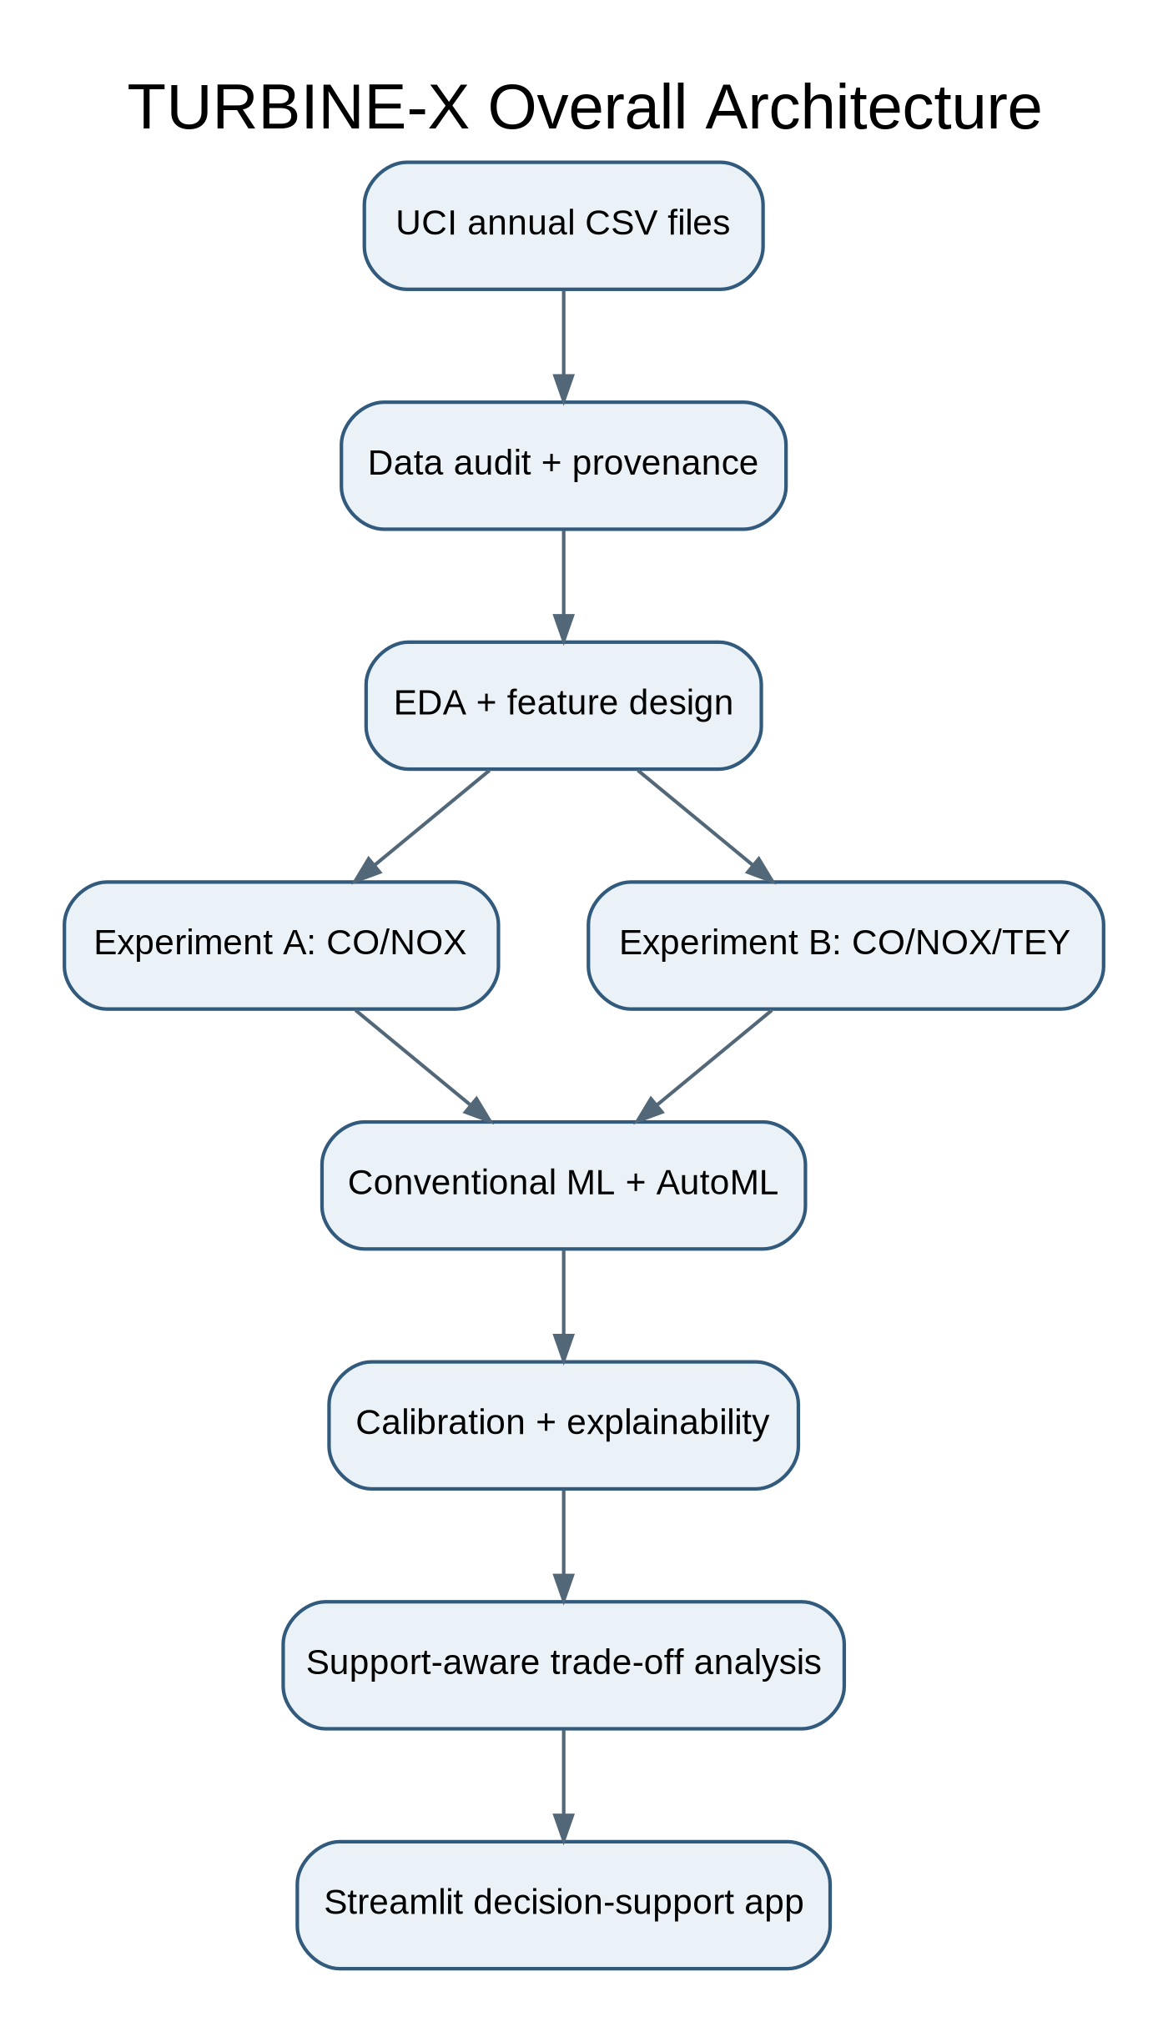
Figure 1. TURBINE-X Overall Architecture
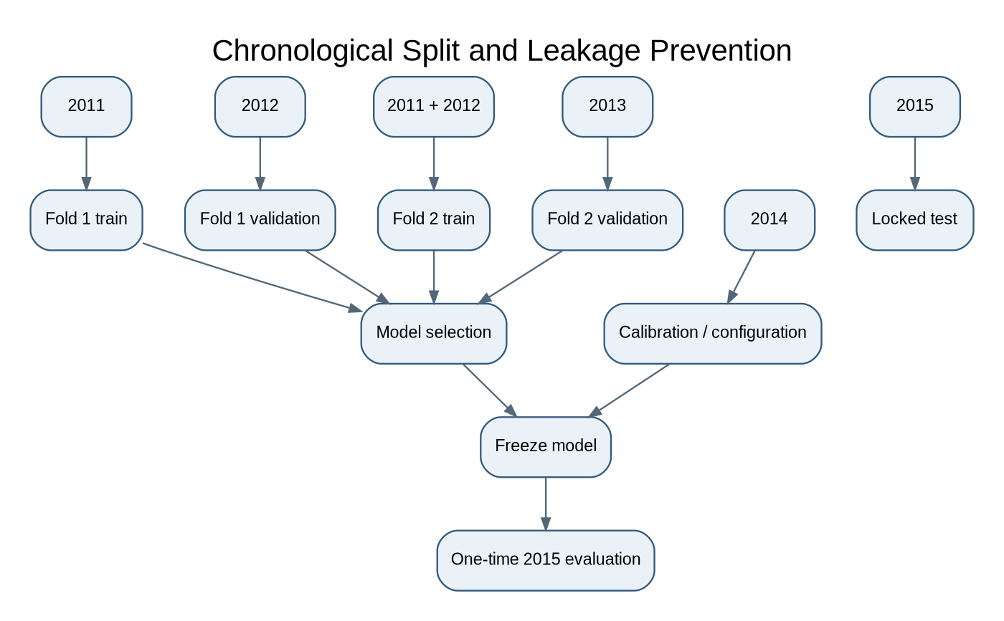
Figure 7. Chronological Split and Leakage Prevention
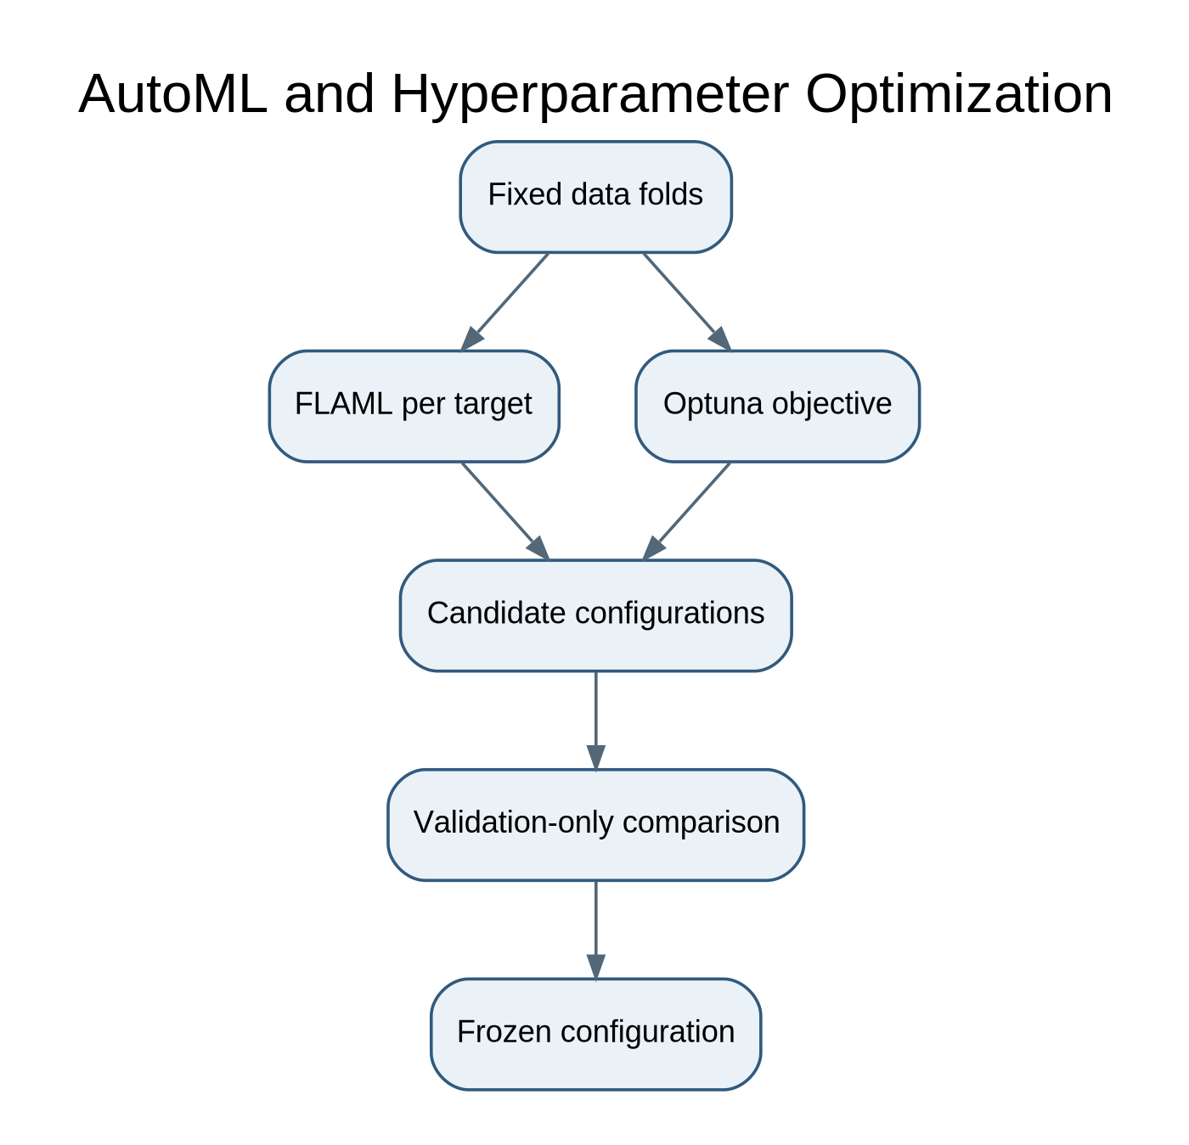
Figure 9. AutoML and Hyperparameter Optimization
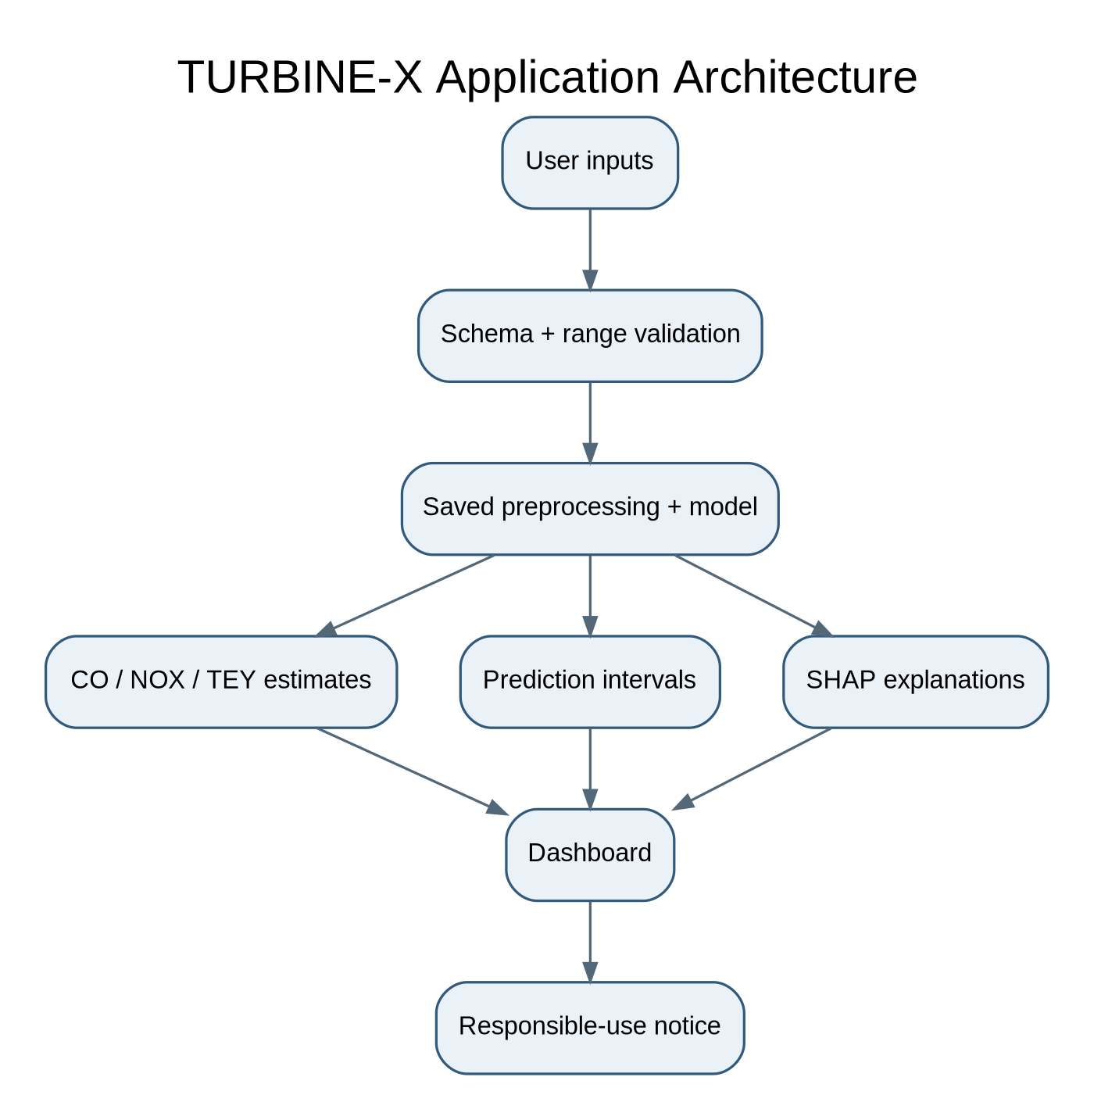
Figure 13. TURBINE-X Application Architecture
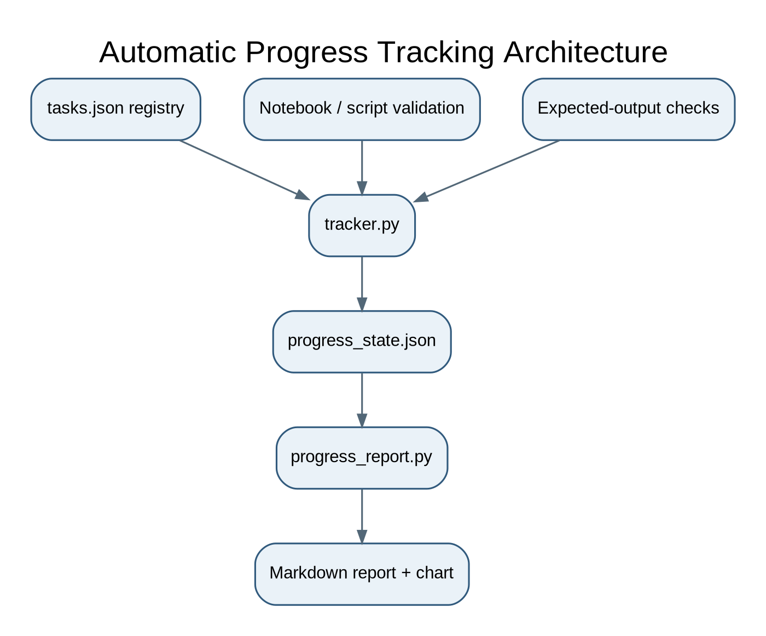
Figure 14. Automatic Progress Tracking Architecture

17. Week-by-Week Implementation Schedule
Week | Objective | Notebook | Expected outputs | Validation / completion | Common mistake
1 | Dataset audit | 01_dataset_inventory_and_audit.ipynb | Inventory, schema, quality JSON, hashes | Reconcile all five row counts/headers; zero missing/nonfinite; duplicates documented | Do not concatenate before schema agreement
2 | EDA and problem freeze | 02_data_understanding.ipynb; 03_exploratory_data_analysis.ipynb | Data dictionary, EDA figures, problem definition | Annual totals and feature/target summaries match raw files | No fabricated timestamps or lag features
3 | Cleaning and features | 04_data_quality_and_cleaning.ipynb; 05_feature_engineering.ipynb | Clean master, duplicate sensitivity copy, feature manifest | Assert exact columns, target isolation and row preservation | Do not silently drop duplicate records
4 | Feature diagnostics and splits | 06_feature_selection.ipynb; 07_train_validation_test_split.ipynb | Feature diagnostics, immutable split manifest | No year overlap; train folds strictly precede validation | Never random-split primary result
5 | Baselines | 08_baseline_models.ipynb | Dummy/Ridge/ElasticNet metrics | Fold metrics and reproducible pipeline | Scaling fit inside fold
6 | Advanced models | 09_advanced_ml_models.ipynb | RF/ExtraTrees/CatBoost/XGBoost and joint model metrics | Independent vs joint models compared on identical folds | Do not select on test
7 | HPO and AutoML | 10_hyperparameter_optimization.ipynb; 11_automl_experiments.ipynb | Optuna trials, FLAML summary | Fixed budget, objective and folds logged | Avoid runaway parallel jobs on 16 GB RAM
8 | Ensemble and XAI | 12_ensemble_learning.ipynb; 13_model_explainability.ipynb | Ensemble comparison, SHAP and PDP/ALE figures | Keep ensemble only if stable validation improvement | Correlated-feature explanations are not causal
9 | Uncertainty and final evaluation | 14_model_evaluation.ipynb | 2014 calibration and 2015 locked metrics | Coverage, width and all target metrics reported | Do not recalibrate on 2015
10 | Robustness | 15_error_and_robustness_analysis.ipynb | Residual/tail/duplicate/support reports | Sensitivity results and limitations documented | Synthetic missingness only on copies
11 | Final model and app | 16_final_model_training_and_saving.ipynb; app/app.py | Model artifact, metadata, dashboard | Input schema and prediction smoke tests pass | Do not claim control or safe setpoints
12 | QA and reporting | 17_final_results_and_reproducibility.ipynb | Final report, tests, DOCX/PDF research report | Re-run from clean environment; test report saved | All claims traceable to artifacts

18. Evaluation and Statistical Analysis

18.1 Regression metrics
- MAE and RMSE for CO, NOX and TEY separately.
- R² per target; do not aggregate R² across targets.
- Median absolute error for robustness to extreme residuals.
- Normalized RMSE only with a clearly stated normalization denominator derived from development data.
- Report annual/test sample count and target range alongside every metric.

18.2 Uncertainty metrics
- Marginal 90% and 95% interval coverage and mean interval width per target.
- Simultaneous coverage: proportion of rows for which all three outputs are covered.
- Conformal calibration quantiles estimated from 2014 only.
- Report empirical 2015 coverage; do not imply distribution-free guarantees under arbitrary temporal shift.

18.3 Statistical analysis
- Paired moving-block bootstrap for differences between model errors; report block length sensitivity.
- Use identical test observations for paired model comparisons.
- Correct for multiple comparisons if many models/targets are tested.
- Use ablations for joint versus independent outputs, feature groups and duplicate handling.
- Do not treat every adjacent row as independent or interpret block length in hours without timestamps.

19. Testing and Quality Assurance
Test category | Test examples | Automation
Dataset integrity | File exists, SHA256, expected row counts, header order | pytest
Schema | 11 expected float columns, no unexpected fields | pytest
Missing/finite | No NA/NaN/inf in original snapshot | pytest
Duplicates | Expected per-file counts and cross-year overlap | pytest
Feature validity | Experiment A/B columns exact; target never in X | pytest
Leakage | Year partitions disjoint; train year < validation year | pytest
Preprocessing | Fit only on fold training indices | Pipeline tests
Metrics | Known arrays produce expected MAE/RMSE/R² | pytest
Model I/O | Serialized model loads and predicts expected output shape | pytest
Application | Invalid input rejected; valid input returns all target outputs | Streamlit smoke test
Tracker | Unique IDs, dependency readiness, output existence gate | pytest
Reproducibility | Seed, package versions and data hashes captured | CI/manual release check

19.1 Suggested tests directory
tests/\n├── test_schema.py\n├── test_integrity.py\n├── test_duplicates.py\n├── test_feature_manifest.py\n├── test_split_leakage.py\n├── test_preprocessing.py\n├── test_metrics.py\n├── test_model_serialization.py\n├── test_tracker.py\n└── test_app_smoke.py

20. Application Design
Build a Streamlit demonstration only after the final pipeline is frozen. Pages: (1) Overview and model scope; (2) Input validation; (3) CO/NOX/TEY estimates; (4) marginal and simultaneous prediction intervals; (5) SHAP explanation for supported model types; (6) observed/support-near historical operating-point comparison; (7) model limitations and data provenance.
- Validate numeric inputs, allowed schema and broad observed support ranges.
- Warn when input is far from the development data distribution.
- Show units and clearly label predictions versus measured historical records.
- Do not present model output as a safe setpoint, causal intervention or compliance result.
- Store model version, feature order, target order and training partition metadata.

21. Hardware, Software and Environment
Resource | Plan
CPU | AMD Ryzen 9 8940HX; CPU-first training
GPU | RTX 5060 8 GB; optional, not required
RAM | 16 GB; cap parallel jobs and avoid large nested CV
Storage | 1 TB SSD; raw data under 3 MB total, model artifacts and outputs modest
OS / IDE | Windows 11, VS Code, Jupyter
Python | Python 3.11 recommended; create isolated .venv
Core packages | pandas, NumPy, SciPy, scikit-learn, CatBoost, XGBoost, FLAML, Optuna, SHAP, MAPIE, Streamlit, matplotlib, Plotly, pytest, PyYAML

22. Risk Register and Mitigations
Risk | Severity | Mitigation
Existing 2026 paper uses same dataset and temporal split | High | Novelty must focus on joint CO/NOX/TEY outputs; conduct systematic literature search before claiming novelty.
Single plant limits external validity | High | State single-site limitation; no cross-plant generalization claim.
No timestamps | High | No lags, rolling features or lead-time forecasting; year-level temporal evaluation only.
Correlated operating features | Medium | Grouped ablation, stability analysis, cautious SHAP interpretation.
TEY leakage in joint task | High | TEY excluded from Experiment B predictors; assert feature/target disjointness.
Temporal target shift | High | Chronological holdout, per-year errors, uncertainty coverage reporting.
Observational Pareto results mistaken for causal control | High | Restrict to observed/support-near points; explicit non-causal disclaimer.
Overfitting AutoML search | Medium | Fixed trial/time budget and development-only validation.
16 GB RAM exhaustion | Medium | Limit n_jobs, avoid excessive parallel trials, use compact outputs.
Tracker false completion | Medium | Require validation flag and non-empty expected output files.

23. Expected Deliverables and Acceptance Criteria
Deliverable | Acceptance criterion | Status
Dataset audit report | Five original files audited with actual hashes, rows, schema, missingness and duplicates | Completed in this session; machine-readable report in starter package
Research methodology | Two clear formulations; no leakage; chronological protocol; limitations | Provisional freeze included
Project starter package | Folder structure, config, notebook templates, tracker, tests, diagrams, raw CSVs | Created
Progress tracker | Persists state; output gate; report and chart generation | Code included; requires local test run
Diagrams | 15 editable Mermaid/DOT and SVG diagrams | Created; inspect/adjust to final implementation
DOCX blueprint | Professional sections, audit tables, roadmap and diagrams | Generated
PDF blueprint | Readable exported copy | Generated and checked for existence
Trained ML models | Reproducible metrics and saved model | Not started
Working Streamlit app | Validated model input/output and tests | Not started
Research paper | Novelty and results supported by actual experiments | Not started

24. Final Supervisor Verdict
The uploaded files are suitable for a serious conventional-ML regression study. They are not suitable for causal optimization, safe turbine control or exact time-series forecasting because the data are observational, single-site and lack row-level timestamps and engineering constraints. The most defensible project is a controlled study of independent versus joint multi-output learning for CO, NOX and TEY, with uncertainty and historical trade-off analysis as supporting components.
The project should proceed only after the student confirms the two formulations and accepts the limitations. The starter package is scaffolding; model code and application implementation remain future work.

25. References
- UCI Machine Learning Repository. Gas Turbine CO and NOx Emission Data Set (2019). DOI: https://doi.org/10.24432/C5WC95. https://archive.ics.uci.edu/dataset/551/gas+turbine+co
- Kochueva, O., & Nikolskii, K. (2021). Data Analysis and Symbolic Regression Models for Predicting CO and NOx Emissions from Gas Turbines. Computation, 9(12), 139. https://doi.org/10.3390/computation9120139
- Long-term atmospheric pollutant emissions from a combined cycle gas turbine: Trend monitoring and prediction applying machine learning. Fuel (2023), Article 127722. https://doi.org/10.1016/j.fuel.2023.127722
- Rodríguez-Abreo, O., et al. (2026). Reliability-Oriented Predictive Emission Monitoring of Gas Turbines Under Multiyear Distribution Shift and High-Emission Tail Risk. Engineering, 7(10), 538. https://doi.org/10.3390/eng7100538
- Aboalhol, T. R., & Abdusamad, K. A. (2026). Gas turbine emissions modeling: from empirical correlations to hybrid physics-machine learning frameworks. DOI: https://doi.org/10.1016/j.nexres.2026.101332
- Vovk, V., Gammerman, A., & Shafer, G. (2005). Algorithmic Learning in a Random World. Springer.
- Ke, G., et al. (2017). LightGBM: A Highly Efficient Gradient Boosting Decision Tree. NeurIPS.
- Prokhorenkova, L., et al. (2018). CatBoost: unbiased boosting with categorical features. NeurIPS.
- Lundberg, S. M., & Lee, S.-I. (2017). A Unified Approach to Interpreting Model Predictions. NeurIPS.

