**CLASS: F.Y.MCA SEM: 1**

**COURSE CODE: MC504**

**SUBJECT NAME: WEB TECHNOLOGY LAB**

**ROLL NO. : 2022510018 BATCH : B**

**NAME : AVISHKAR GHORPADE**

**EXPERIMENT NO: 03**

**EXPERIMENT TITLE:**  Create a responsive website using HTML,CSS and Javascript.

**Objective :**

1. To create a responsive website.
2. Use client side and server side programming and database.

**Project Structure :**

├── application

│ ├── graphs.py

│ ├── models.py

│ └── views.py

├── app.py

├── instance

│ └── Student_DB.db

├── README.md

├── requirements

├── static

│ ├── css

│ │ ├── animate.min.css

│ │ ├── bootstrap.css

│ │ ├── bootstrap.css.map

│ │ ├── bootstrap-grid.css

│ │ ├── bootstrap-grid.css.map

│ │ ├── bootstrap-grid.min.css

│ │ ├── bootstrap-grid.min.css.map

│ │ ├── bootstrap.min.css

│ │ ├── bootstrap.min.css.map

│ │ ├── bootstrap-reboot.css

│ │ ├── bootstrap-reboot.css.map

│ │ ├── bootstrap-reboot.min.css

│ │ ├── bootstrap-reboot.min.css.map

│ │ ├── default-skin.css

│ │ ├── font-awesome.min.css

│ │ ├── icomoon.css

│ │ ├── jquery.fancybox.min.css

│ │ ├── jquery.mCustomScrollbar.min.css

│ │ ├── jquery-ui.css

│ │ ├── meanmenu.css

│ │ ├── nice-select.css

│ │ ├── normalize.css

│ │ ├── owl.carousel.min.css

│ │ ├── profile.css

│ │ ├── report.css

│ │ ├── responsive.css

│ │ ├── slick.css

│ │ └── style.css

│ ├── images

│ │ ├── banner-bg.png

│ │ ├── call-icon1.png

│ │ ├── call-icon.png

│ │ ├── Chemistry BG.jpg

│ │ ├── client-img.png

│ │ ├── fb-icon.png

│ │ ├── footer-logo.png

│ │ ├── img-1.png

│ │ ├── img-2.png

│ │ ├── img-3.png

│ │ ├── img-4.png

│ │ ├── img-5.png

│ │ ├── img-6.png

│ │ ├── img-7.png

│ │ ├── img-8.png

│ │ ├── instagram-icon.png

│ │ ├── linkedin-icon.png

│ │ ├── login.png

│ │ ├── logo.png

│ │ ├── mail-icon1.png

│ │ ├── mail-icon.png

│ │ ├── map-img.png

│ │ ├── Maths BG.jpg

│ │ ├── Physics BG.jpg

│ │ ├── search-icon.png

│ │ ├── stu profile pic.jpg

│ │ └── twitter-icon.png

│ └── js

│ ├── bootstrap.bundle.js

│ ├── bootstrap.bundle.js.map

│ ├── bootstrap.bundle.min.js

│ ├── bootstrap.bundle.min.js.map

│ ├── bootstrap.js

│ ├── bootstrap.js.map

│ ├── bootstrap.min.js

│ ├── bootstrap.min.js.map

│ ├── custom.js

│ ├── jquery-3.0.0.min.js

│ ├── jquery.mCustomScrollbar.concat.min.js

│ ├── jquery.min.js

│ ├── jquery.validate.js

│ ├── modernizer.js

│ ├── plugin.js

│ ├── popper.min.js

│ └── slider-setting.js

└── templates

├── about.html

├── blog.html

├── contact.html

├── index.html

├── login.html

├── profile.html

├── report_card.html

└── services.html

**Code(Some of Important):**

**(views.py)**

from flask import Flask, request

from flask import render_template, url_for, redirect, flash,session

from flask import current_app as app

from application.models import Login

from application.models import Student

@app.route('/',methods=["GET","POST"])

def index():

return render_template('index.html')

@app.route('/login',methods=["GET","POST"])

def login():

if request.method == "POST":

username = request.form['uname']

password = request.form['pass']

result = Login.query.filter(Login.Student_id == int(username), Login.Password== password).first()

if result != None:

stud_info = Student.query.filter(Student.Student_id == result.Student_id)

name = stud_info.first()

session["name"] = name.Student_name

return redirect(url_for('profile',name=name.Student_name,id=name.Student_id))

else:

return render_template('login.html',error="Wrong Username or Password")

return render_template('login.html')

@app.route('/profile/<name>/<id>',methods=["GET","POST"])

def profile(name,id):

return render_template('profile.html',name=name,id=id)

@app.route('/report')

def generate_report():

nam1 = session.get("name")

stud_info = Student.query.filter(Student.Student_name == nam1)

return render_template('report_card.html',name=nam1,sf=stud_info)

@app.route('/about')

def about():

return render_template('about.html')

@app.route('/contact')

def contact():

return render_template('contact.html')

**(models.py)**

from flask_sqlalchemy import SQLAlchemy

db = SQLAlchemy()

class Student(db.Model):

Student_id = db.Column(db.Integer,primary_key=True)

Student_name = db.Column(db.String(100))

Physics = db.Column(db.Integer)

Maths = db.Column(db.Integer)

Chemistry = db.Column(db.Integer)

English = db.Column(db.Integer)

class Login(db.Model):

Student_id = db.Column(db.Integer,primary_key=True)

Password = db.Column(db.Integer, nullable=False)

**(graphs.py)**

from application.models import Student

import matplotlib.pyplot as plt

def Draw_eng():

l1,l2 = [],[]

name = Student.query.all()

for i in name:

l1.append(i.Student_name)

l2.append(i.English)

plt.figure(figsize=(20, 11))

plt.bar(l1,l2)

plt.savefig('static/English.png')

def Draw_phy():

l1,l2 = [],[]

name = Student.query.all()

for i in name:

l1.append(i.Student_name)

l2.append(i.Physics)

plt.figure(figsize=(20, 11))

plt.bar(l1,l2)

plt.savefig('static/Physics.png')

def Draw_maths():

l1,l2 = [],[]

name = Student.query.all()

for i in name:

l1.append(i.Student_name)

l2.append(i.Maths)

plt.figure(figsize=(20, 11))

plt.bar(l1,l2)

plt.savefig('static/Maths.png')

def Draw_chem():

l1,l2 = [],[]

name = Student.query.all()

for i in name:

l1.append(i.Student_name)

l2.append(i.Chemistry)

plt.figure(figsize=(20, 11))

plt.bar(l1,l2)

plt.savefig('static/Chemistry.png')

**(app.py)**

from flask import Flask,session

from flask_session import Session

from application.models import db

from os import urandom

from application.graphs import Draw_eng,Draw_chem,Draw_maths,Draw_phy

#---------------------------- Imports -----------------

app = None

def create_app():

app = Flask(__name__,template_folder="templates")

app.config['SQLALCHEMY_DATABASE_URI'] = 'sqlite:///Student_DB.db'

app.config["SESSION_PERMANENT"] = False

app.config["SESSION_TYPE"] = "filesystem"

Session(app)

db.init_app(app)

app.app_context().push()

Draw_phy()

Draw_maths()

Draw_chem()

Draw_eng()

return app

app = create_app()

from application.views import *

if __name__ == '__main__':

app.debug = True

app.secret_key = urandom(24)

app.run()

**(SOME TEMPLATES/HTML FILES)**

**(login.html)**

<!DOCTYPE html>

<html lang="en">

<head>

<meta charset="UTF-8">

<meta http-equiv="X-UA-Compatible" content="IE=edge">

<meta name="viewport" content="width=device-width, initial-scale=1.0">

<title>Student Login </title>

<meta charset="utf-8">

<meta http-equiv="X-UA-Compatible" content="IE=edge">

<meta name="viewport" content="width=device-width, initial-scale=1">

<!-- mobile metas -->

<meta name="viewport" content="width=device-width, initial-scale=1">

<meta name="viewport" content="initial-scale=1, maximum-scale=1">

<!-- site metas -->

<title>Contact</title>

<meta name="keywords" content="">

<meta name="description" content="">

<meta name="author" content="">

<!-- owl carousel style -->

<link rel="stylesheet" type="text/css" href="https://cdnjs.cloudflare.com/ajax/libs/OwlCarousel2/2.0.0-beta.2.4/assets/owl.carousel.min.css" />

<!-- bootstrap css -->

<link rel="stylesheet" type="text/css" href="static/css/bootstrap.min.css">

<!-- style css -->

<link rel="stylesheet" type="text/css" href="static/css/style.css">

<!-- Responsive-->

<link rel="stylesheet" href="static/css/responsive.css">

<!-- fevicon -->

<link rel="icon" href="static/images/fevicon.png" type="image/gif" />

<!-- Scrollbar Custom CSS -->

<link rel="stylesheet" href="static/css/jquery.mCustomScrollbar.min.css">

<!-- Tweaks for older IEs-->

<link rel="stylesheet" href="https://netdna.bootstrapcdn.com/font-awesome/4.0.3/css/font-awesome.css">

<!-- fonts -->

<link href="https://fonts.googleapis.com/css?family=Open+Sans:400,700|Poppins:400,700&display=swap" rel="stylesheet">

<!-- owl stylesheets -->

<link rel="stylesheet" href="static/css/owl.carousel.min.css">

<link rel="stylesheet" href="static/css/owl.theme.default.min.css">

<link rel="stylesheet" href="https://cdnjs.cloudflare.com/ajax/libs/fancybox/2.1.5/jquery.fancybox.min.css" media="screen">

<style>

body{

margin: 0;

padding: 0;

background-image: url(images/page1.jpg);

background-size: cover;

background-position: center;

font-family: sans-serif;

}

#sername,#password{

color: black;

}

.loginbox {

width: 320px;

height: 420px;

background: whitesmoke;

;

color: rgb(1, 5, 7);

top: 50%;

left: 50%;

position: absolute;

transform: translate(-50%, -50%);

box-sizing: border-box;

padding: 70px 30px;

}

.login {

width: 100px;

height: 100px;

border-radius: 50%;

position: absolute;

top: -50px;

left: calc(50% - 50px);

}

h1 {

margin: 0;

padding: 0 0 20px;

text-align: center;

font-size: 22px;

}

.loginbox p {

margin: 0;

padding: 0;

font-weight: bold;

}

.loginbox input {

width: 100%;

margin-bottom: 20px;

}

.loginbox input[type="text"],

input[type="password"] {

border: none;

border-bottom: 1px solid #fff;

background: transparent;

outline: none;

height: 40px;

color: #fff;

font-size: 16px;

}

.loginbox input[type="submit"] {

border: none;

outline: none;

height: 40px;

background: #fb2525;

color: #fff;

font-size: 18px;

border-radius: 20px;

}

.loginbox input[type="submit"]:hover {

cursor: pointer;

background: black;

color: rgb(255, 255, 255);

}

.loginbox a {

text-decoration: none;

font-size: 12px;

line-height: 20px;

color: rgb(242, 218, 218);

}

.loginbox a:hover {

color: black;

}

</style>

</head>

<body>

<!--navbar-->

<div class="header_section">

<div class="header_bg">

<div class="container">

<nav class="navbar navbar-expand-lg navbar-light bg-light">

<a class="logo" href="index.html"><img src="static/images/logo.png"></a>

<button class="navbar-toggler" type="button" data-toggle="collapse" data-target="#navbarSupportedContent" aria-controls="navbarSupportedContent" aria-expanded="false" aria-label="Toggle navigation">

<span class="navbar-toggler-icon"></span>

</button>

<div class="collapse navbar-collapse" id="navbarSupportedContent">

<ul class="navbar-nav mr-auto">

<li class="nav-item active">

<a class="nav-link" href="/">Home</a>

</li>

<li class="nav-item">

<a class="nav-link" href="/about">About</a>

</li>

<li class="nav-item">

<a class="nav-link" href="/login">Login</a>

</li>

<li class="nav-item">

<a class="nav-link" href="/contact">Contact Us</a>

</li>

</ul>

<div class="call_section">

<ul>

<li><a href="#"><img src="static/images/fb-icon.png"></a></li>

<li><a href="#"><img src="static/images/twitter-icon.png"></a></li>

<li><a href="#"><img src="static/images/linkedin-icon.png"></a></li>

<li><a href="#"><img src="static/images/instagram-icon.png"></a></li>

<div class="donate_bt"><a href="#"><img src="static/images/search-icon.png"></a></div>

</ul>

</div>

</div>

</nav>

</div>

</div>

<div class="loginbox">

<img src="static/images/login.png" class="login">

<h1>Student Login</h1>

<form action="{{ url_for('login') }}" method="post">

<p>Username</p>

<input type="text" id="sername" name="uname" placeholder="Enter Username">

<p>Password</p>

<input type="password" id="password" name="pass" placeholder="Enter Password">

<input type="submit" name="" value="Login"><br>

<!-- <a href="#">Lost your Password</a><br>

<a href="#">Don't have an account?</a> -->

<p style="color: red;">{{ error }}</p>

</form>

</div>

</body>

</html>

**(profile.html)**

<!DOCTYPE html>

<html lang="en">

<head>

<meta charset="utf-8">

<meta http-equiv="X-UA-Compatible" content="IE=edge">

<meta name="viewport" content="width=device-width, initial-scale=1">

<!-- mobile metas -->

<meta name="viewport" content="width=device-width, initial-scale=1">

<meta name="viewport" content="initial-scale=1, maximum-scale=1">

<!-- site metas -->

<title>Casinal</title>

<meta name="keywords" content="">

<meta name="description" content="">

<meta name="author" content="">

<!-- owl carousel style -->

<link rel="stylesheet" type="text/css"

href="https://cdnjs.cloudflare.com/ajax/libs/OwlCarousel2/2.0.0-beta.2.4/assets/owl.carousel.min.css" />

<!-- bootstrap css -->

<link rel="stylesheet" type="text/css" href="/static/css/bootstrap.min.css">

<!-- style css -->

<link rel="stylesheet" type="text/css" href="/static/css/style.css">

<!-- Responsive-->

<link rel="stylesheet" href="/static/css/responsive.css">

<!-- fevicon -->

<link rel="icon" href="/static/images/fevicon.png" type="image/gif" />

<!-- Scrollbar Custom CSS -->

<link rel="stylesheet" href="/static/css/jquery.mCustomScrollbar.min.css">

<!-- Tweaks for older IEs-->

<link rel="stylesheet" href="https://netdna.bootstrapcdn.com/font-awesome/4.0.3/css/font-awesome.css">

<!-- fonts -->

<link href="https://fonts.googleapis.com/css?family=Open+Sans:400,700|Poppins:400,700&display=swap"

rel="stylesheet">

<!-- owl stylesheets -->

<link rel="stylesheet" href="/static/css/owl.carousel.min.css">

<link rel="stylesheet" href="/static/css/owl.theme.default.min.css">

<link rel="stylesheet" href="https://cdnjs.cloudflare.com/ajax/libs/fancybox/2.1.5/jquery.fancybox.min.css"

media="screen">

<script>

function changeImage(element){

var image = document.getElementById('imageReplace');

image.src = element;

}

</script>

</head>

<body>

<!--header section start -->

<div class="header_section">

<div class="header_bg">

<div class="container">

<nav class="navbar navbar-expand-lg navbar-light bg-light">

<a class="logo" href="/login"><img src="/static/images/logo.png"></a>

<button class="navbar-toggler" type="button" data-toggle="collapse"

data-target="#navbarSupportedContent" aria-controls="navbarSupportedContent"

aria-expanded="false" aria-label="Toggle navigation">

<span class="navbar-toggler-icon"></span>

</button>

<div class="collapse navbar-collapse" id="navbarSupportedContent">

<div class="nav">

<ul class="navbar-nav mr-auto">

<li class="nav-item active">

<a class="nav-link" href="/report">Report</a>

</li>

<li class="nav-item">

<a class="nav-link" href="#" onclick="changeImage('/static/Chemistry.png')">Chemistry</a>

</li>

<li class="nav-item">

<a class="nav-link" href="#" onclick="changeImage('/static/English.png')">English</a>

</li>

<li class="nav-item">

<a class="nav-link" href="#" onclick="changeImage('/static/Maths.png')">Maths</a>

</li>

<li class="nav-item">

<a class="nav-link" href="#" onclick="changeImage('/static/Physics.png')">Physics</a>

</li>

</ul>

</div>

</div>

</nav>

<!-- Student Profile -->

<div class="student-profile py-4">

<div class="container">

<div class="row">

<div class="col-lg-4">

<div class="card shadow-sm">

<div class="card-header bg-transparent text-center">

<img class="profile_img" src="/static/images/stu profile pic.jpg" alt="">

<h3> {{ name }} </h3>

</div>

<div class="card-body">

<p class="mb-0"><strong class="pr-1">Student ID:</strong>{{ id }}</p>

<p class="mb-0"><strong class="pr-1">Class:</strong>4</p>

<p class="mb-0"><strong class="pr-1">Section:</strong>A</p>

</div>

</div>

</div>

<div class="col-lg-8">

<div class="banner">

<img id="imageReplace"src="">

</div>

</div>

</div>

</div>

</div>

</div>

</div>

</div>

</body>

</html>

**(report_card.html)**

<!DOCTYPE html>

<html>

<head>

<title>MARKS SHEET USING HTML TABLES</title>

<meta charset="UTF-8">

<meta name="viewport" content="width=device-width, initial-scale=1">

<meta name="Keywords" content="html, css, html tables, table">

<meta name="Description" content="html table">

<!-- add icon -->

<link rel="icon" href="/favicon.ico" type="image/x-icon">

<link href='http://fonts.googleapis.com/css?family=Lato:400,700' rel='stylesheet' type='text/css'>

</head>

<style>

body{

background-color: #c5cae9;

padding: 25px;

}

.container{

width: 700px;

height: 600px;

margin: 0 auto;

padding-left: 32px;

padding-right: 32px;

padding-top: 40px;

border-radius: 12px;

font-family: Lato;

background-color: aquamarine;

}

.container h2{

text-align: center;

}

table{

margin: 0 auto;

}

td, th {

padding: 12px;

border: 2px dotted;

}

</style>

<body>

<div class="container">

{% for i in sf %}

<h2>Report Card</h2>

<h3> Name :- {{ i['Student_name'] }}</h3>

<h3> Roll No :- {{ i['Student_id'] }}</h3>

<table>

<thead>

<tr>

<th>Chemistry</th>

<th>English</th>

<th>Maths</th>

<th>Physics</th>

<tr>

</thead>

<tbody>

<tr>

<td>{{ i['Chemistry'] }}</td>

<td>{{ i['English'] }}</td>

<td>{{ i['Maths'] }}</td>

<td>{{ i['Physics'] }}</td>

</tr>

</tbody>

</table>

{% endfor %}

</div>

</body>

</html>

**OUTPUT:**

**(index)**



**(login)**

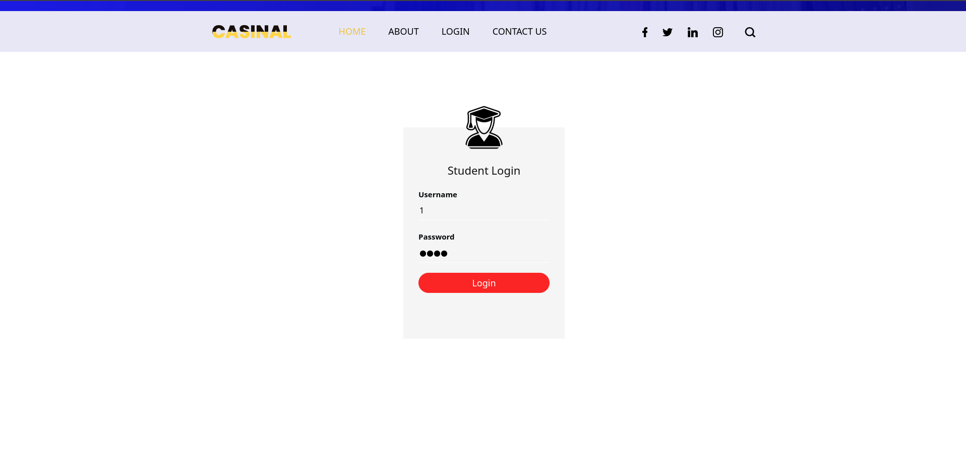

**(profile)**

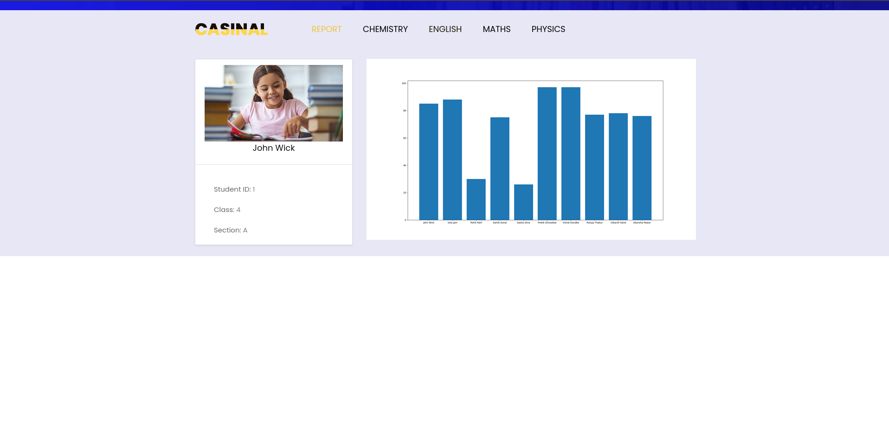

**(report_card)**

