|  |  |
| --- | --- |
| **Stericycle Hotsheet Pilot Ver1.1** |  |

|  |
| --- |
| **Purpose:** Unknown |
| **Author:** Unknown |

**Stericycle**

**20626-XXXXX**

**BB, Fortinet**

* **Installation Document**
* **Appendix A – Letter of Access from Stericycle**

**Scope of Document**

This Installation Hot Sheet is not intended to be all inclusive. It is to be used to identify installation related items that are specific to the customer. Installation related issues are not covered in this document. If you discover any errors within this document, please contact Joe Lance at Joe.Lance@SageNet.com. When reporting any errors please be specific and include page number, section, and the error in question.

**Notice of Proprietary Information**

This document and its contents are proprietary to SageNet and are intended solely for the contractual use of the issuer’s customers. This publication and its contents may not be reproduced or distributed without the written permission of SageNet.

**Contact Information**

|  |  |  |
| --- | --- | --- |
| **SageNet Management Contacts** | **PHONE NUMBER** | **EMAIL** |
| Kelly Dean – Implementation Manager | 918-878-9271 | Kelly.dean@SageNet.com |
| Joe Lance– Program Manager | 770.514.3470 | joe.lance@SageNet.com |
|  |  |  |
| **SageNet Help Desk** | **PHONE NUMBER** | **EMAIL** |
| Test and Turn-Up Team (TTUP)  TEXT | 703-848-1135 (Live answer)  920-543-5130 (Text) | ttup@sagenet.com |
| **SageNet Inventory** | **PHONE NUMBER** | **EMAIL** |
| Anthony Ward | 703-245-6553 | Anthony.Ward@SageNet.com |
| **Quality Assurance Technicians** | **PHONE NUMBER** | **EMAIL** |
| Joe Lajoie-Denver, CO | 720-810-5097 | Joe.Lajoie@SageNet.com |
| Bruce Michaud-Eastern PA | 570-262-8527 | Bruce.Michaud@SageNet.com |
| Neil Miles-Houston, TX | 713-382-2651 | Neil.Miles@SageNet.com |
| Dale Niehans-Dallas, TX | 817-271-4139 | Dale.Niehand@SageNet.com |
| Phil Schmeltzer- Tampa, FL | 571-213-5998 | George.Schmeltzer@SageNet.com |
| Larry Woodall- Western PA | 703-629-1816 | Larry.Woodall@SageNet.com |
| Thomas Zoggas- San Francisco, CA | 925-348-6592 | Thomas.Zoggas@SageNet.com |
| **SageNet Engineering** | **PHONE NUMBER** | **EMAIL** |
| Donny Braxton | 703-848-1426 | Donny.braxton@sagenet.com |

**Customer Contact Information**

|  |  |  |
| --- | --- | --- |
| **Contact** | **PHONE NUMBER** | **Email** |
|  |  |  |
|  |  |  |
|  |  |  |

**CUSTOMER:**

Stericycle is a compliance company that specializes in collecting and disposing regulated substances, such as medical waste and sharps, pharmaceuticals, hazardous waste, and providing services for recalled and expired goods. It also provides related education and training services, and patient communication services. The company was founded in 1989 and is headquartered in Lake Forest, Illinois, with many more bases of operation around the world, including toxic waste incinerators in Utah and North Carolina.

**SCOPE:**

The purpose of this visit is to install the Fortinet device, connect it to the broadband modem and to the customer’s equipment.

**HOURS APPROVED FOR INSTALLATION:**

Start time will be noted in the Installation Work Order.

**INSTALLER REQUIREMENTS:**

* Cellular Connection (hot spot)
* 7 foot Ethernet patch cable
* Bulk Ethernet Cable for extending Telco Dmark (100 Feet)
* DB9 to RJ45 console cable to access Fortinet router for configuration. (Included in box with each router)
* Cisco Console Cable DB9 to RJ45
* Laptop computer with DB9 serial port or USB-to-serial adapter.
* Laptop computer with minimum system requirements noted below: − PC Operating System Versions Windows 7 or Better
  + Wi-Fi Capability
* Digital Camera or Cell phone with camera

− **NOTE WINDOWS XP IS NOT ACCEPTABLE**

* FortiExplorer downloaded to your laptop (http://www.fortinet.com/resource_center/fortiexplorer_product_download.html)
* Team Viewer
* Java must be updated to the current version
* Putty or some kind of console application
* Screwdriver
* Dry Wall Screws for equipment mounting
* Scotch Tape

**BOM/EQUIPMENT**

One of the following devices will be installed:

|  |  |  |  |  |
| --- | --- | --- | --- | --- |
|  | | | |  |
| **UNIT** | **SKU** | **Description** | | |
| **FortiGate-60D** | FG-60D-BDL-900-36 | Hardware plus 3 yr. 8x5 FortiCare and FortiGuard UTM Bundle | | |
| **FortiGate-80D** | FG-80D-BDL-900-36 | Hardware plus 3 yr. 8x5 FortiCare and FortiGuard UTM Bundle | | |
| **FortiGate-100D** | FG-100D-BDL-900-36 | Hardware plus 3 yr. 8x5 FortiCare and FortiGuard UTM Bundle | | |
| **FortiGate-200D** | FG-200D-BDL-900-36 | Hardware plus 3 yr. 8x5 FortiCare and FortiGuard UTM Bundle | | |
| **NETWORK DIAGRAMS** | | | |  |
|  | | | |  |
|  | | | |  |

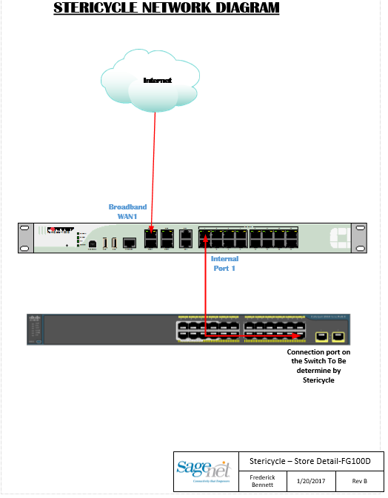

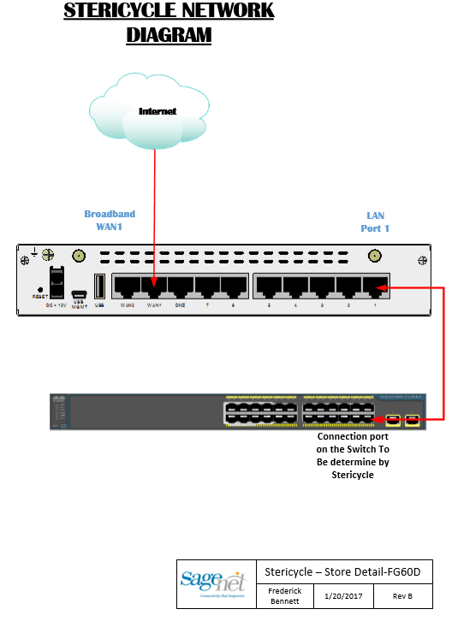

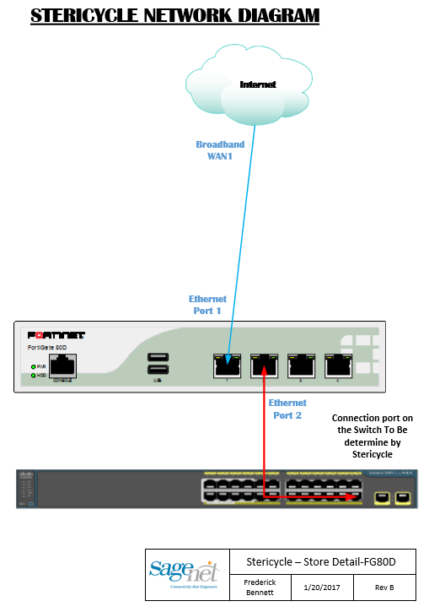

|  |  |
| --- | --- |
| **ARRIVAL NOTE:**   * MUST arrive no later than 15 minutes before the Installation Time noted in the Installation Work Order * If cancelation is necessary, you MUST contact your Installation Manager immediately. * **“If the Site Manager makes any requests outside the scope or direction of this hot sheet (for example: Placing the Router in a different location), The Stericycle Infrastructure Operations Department must be consulted and give approval”.** |  |

**INSTALLATION PROCEDURES:**

* Upon arrival call into the Conference Bridge (attended by Stericycle Infrastructure Operations, SageNet Installation Engineer and CIM) provided via email prior to the install.
* Check to see which broadband modem is installed.
* Confirm the broadband connection
  + Set your laptop to DHCP
  + Connect your laptop to the broadband modem with a cat 5 cable
  + Confirm that Broadband has been installed by surfing the internet using your laptop.
  + Go to Speedtest.net and run a speed test and confirm you are getting the speed documented in the email you received prior to this install
  + Run an extended ping test (ping –n 50 www.google.com) and verify there is little (2% or less) to no packet loss seen
* ***IMPORTANT NOTE:*** *If there are any issues with the Broadband service notify the SageNet personnel on the bridge and they will contact the SageNet NOC to troubleshoot.*

* Logon to the installed Broadband Modem and ensure it us configured as detailed in the Work Order for this location. SageNet TTUP team can assist with this.
  + Document the make/model of broadband modem
  + Ensure that the Wi-Fi and remote access on the Broadband Modem is disabled.
  + Ensure the Broadband Modem is in Bridge Mode
  + Change the Administrator password of the Broadband Modem as detailed in the Installation Work Order.
  + Verify the Static IP Address configured on the modem is the same as documented in the email you received prior to this install
* Reboot modem from the modem's web interface. When modem is rebooting, disconnect Ethernet cable from laptop. (Laptop should NOT be connected to any device at this point).
* After the modem has completed its reboot and has normal indications, configure your laptop LAN interface with the broadband static IP and reconnect laptop to the broadband modem to ensure browsing is possible before proceeding.

**INSTALL FORTINET ROUTER**

* Unpack and Install Fortinet Router. Fortinet will be shipped PRE-CONFIGURED, except for possibly the static IP on the WAN interface.
* Install the Fortinet in the network equipment rack.
* Power up the FortiGate Router (takes about 4mins)
* Connect Broadband Modem to WAN 1 of the Fortinet Router.
* Place a small piece of Scotch Tape over the Reset Button of the Modem
* The SageNet support person will perform a few steps in the background. Please wait for instruction before progressing.

**CONNECT TO STERICYCLE NETWORK**

* Verify with the Stericycle/SageNet Teams on the bridge that the Site is ready for connection
* Unplug the Juniper firewall from power (if it isn’t already at this point)
* Connect the LAN 1 port on the FortiGate Router to the switch port designated by the Stericycle person on the bridge.
* The Stericycle team on the bridge will verify all business systems are still online.
* The SageNet Team will verify that the router is visible in the SageNet monitoring tools and functioning properly.
* When both the Stericycle and SageNet teams confirm that all systems are operational, you will be excused from the bridge to begin the documentation tasks listed below.

**CLEAN UP / DOCUMENTATION TASKS**

* Ensure all cables are neatly arranged and tied down in the equipment rack before leaving the site.

**NOTE:** If you see any glaring issues with the way anything is racked (or not racked), any safety concerns or poor cable management, report it to the Stericycle team on the conference bridge.

* Complete the following checklist:

|  |  |  |  |
| --- | --- | --- | --- |
| SageNet Remote Site Install - Testing Checklist | | | |
| **Description** | | **Complete** | **Notes** |
| Ping Internet | |  |  |
| Traceroute to Internet | |  |  |
| Ping Steriworks | |  |  |
| Traceroute to Steriworks | |  |  |
| DHCP IP Received | |  |  |
| Run Iperf Test - Without MPLS Route | |  |  |
| Run Iperf Test - Using MPLS Route | |  |  |
| Tunnels to both Northbrook and Lakeside are up | |  |  |
| Ping Core Switch | |  |  |
| Verify Broadband Router - WIFI is Off |  |  |  |
| Data Collection | | | |
| Broadband Provider | |  | |
| Broadband Provided Public IP/Mask | |  | |
| Broadband Router/Modem Make/Model | |  | |
| Broadband Router Serial Number | |  | |
| Firewall Make/Model | |  | |
| Firewall Serial Number | |  | |
| Firewall LAN Interface | |  | |
| Firewall LAN IP/Mask | |  | |

**PICTURE REQUIREMENTS**

* The below pictures are required, and must be uploaded to the Picture Portal in order to receive payment for services performed. Included in each photo should also be a small erasable white board with the following information:
  + Functional Location
  + Notification Number
  + Customer Name, i.e. Stericycle
  + City and State
  + Installation company name and/or Work Center
  + Date

|  |
| --- |
| ***REQUIRED PHOTOS*** |
| * Photo of Communications rack (Where Equipment is Located) |
| * Photo of broadband Modem placement (Placed by Service Provider) |
| * Photo of broadband modem with connections |
| * Photo of Fortinet with all Connections |
| * Photo/screen shot of the Quality Test Results |
| * Photo/screen shot of Speed Test |
| * Photo of the existing switch with all connections clearly shown |

Release Notes

|  |  |  |  |
| --- | --- | --- | --- |
| **Version** | **Date** | **Modified By** | **Changes Made** |
| 1.0 | Unknown | Unknown | Initial Issue |
| 1.1 | 07/14/25 | Tanisha Batta | Added to the template and adjusted formatting. |