|  |  |
| --- | --- |
| **Stericycle Ops Handover** |  |

|  |
| --- |
| **Purpose:** Unknown |
| **Author:** Unknown |

**SageNet, LLC.**

**Stericycle Handover Document**

**February 20, 2017**

SageNet, LLC.

10740 Parkridge Blvd

Reston, VA 20191

Table of Contents

1. Overview & History 3

2. Network Description/Info 4

3. Production site examples & IPs 5-7

4. Network Diagram, Tier Diagrams & Equipment Connection 8-14

5. Network Monitoring (Solarwinds, Fortimanager, Forti Analyzer) 15-25

6. Helpdesk/TTUP 26-27

# Overview

* Stericycle is a global business-to-business services company providing an array of highly specialized solutions serving healthcare organizations and commercial businesses of every size. Since its founding over 25 years ago, Stericycle has grown from a small start-up in medical waste management into a leader across a range of increasingly complex and highly regulated arenas, including compliance and sustainability waste services, brand protection solutions, and customer contact solutions.

SageNet is providing a Cable First Complete-Connect proactive managed solution for Stericycle. The customer will purchase Fortigate security devices (60D, 80D or 100D) and terminate the VPN tunnels in their two data centers in Northbrook IL and Lakeside IL using Fortigate 200D Security devices in HA mode. The initial plan has Stericycle installing ~75% of their locations and SageNet is installing the remaining ~25%.

The current network size is 150 sites with potential growth. They also have an overseas operation but that is currently not part of this.

* SageNet will provide service to Stericycle branches configured for one of the below tiers of service.
* Tier II MPLS/VPN with Layer 2 switch
* Tier II MPLS/VPN with Layer 3 switch
* Tier IV VPN (No failover)

**Brief History:**

This network started on paper with a Fortinet plan but the customer requested a change to Meraki. The engineering pilot was initially designed with and activated on Meraki but due to limitations with Meraki (Lack of BGP) and their unwillingness to extend the process; a dual pilot was initiated with Fortinet. Fortinet won the pilot competition; due to timeline and pace of rollout we have been building the network as we go. This customer makes changes along the way in some cases just prior to or during installs.

# Network Description/Info:

* The Stericycle Network is based on 3 platforms using either a Fortigates (60D, 80D or 100D)

Tier II MPLS/VPN with Layer 2 switch

Tier II MPLS/VPN with Layer 3 switch

Tier IV VPN (No failover)

* Their Tier-II locations are using the existing primary MPLS connection, and SageNet is provisioning a new Cable First circuit as backup. Branches are using their existing equipment (switch) to connect to the primary MPLS. All branch traffic will traverse the VPN tunnel to the data center. Stericycle is responsible for their MPLS network.
* Customer managed switch is providing the failover from MPLS to broadband and running OSPF to the Cisco and Fortigate.
* Stericycle is providing a new DMZ at the data centers core firewall and implement OSPF to the Fortigate (60D, 80D or 100D) for route announcements.
* The service will support internal and external access all of which will flow through their primary connection or the Fortigate as back in most cases to one of two Data Centers. The internal components are work stations, printers and phones.
* SageNet will provide Proactive Network Management on the Fortigate devices using Solarwinds and auto open a ticket when the broadband and or Fortigate fails. SageNet will call the Customer tier-1 help desk to initiate troubleshooting.
* Some Stericycle sites require VRRP (I have requested a list of these sites)
* All broadband circuits are static connections.
* We plan to use Forti-deploy for all installations however we are testing this week.
* The Demarc for all sites will be the Fortigate.

# Production locations and network information:

* The below examples represent branch locations using a Fortinet (60D, 80D or 100D) connected to a MPLS Primary (Customer provided) and broadband backup. Customer will provide the L3 branch switch that will perform OSPF and failover between the MPLS Cisco and the Fortigate. For the pilot the two data centers will be configured using Fortigate 200D’s in HA mode. The distribution of equipment is as follows: (2) Fortigate 200Ds located within each Stericycle Data Center with branches be serviced by a Fortigate 60D, 80D or 100D.
* The Data Centers locations: Fortigate 200D

1. 4010 Commercial Avenue,

Northbrook, IL 60062

1. 6026 Lakeside Blvd

|  |
| --- |
| Indianapolis, IN 46278 |

The following locations were installed and are examples of each Fortigate model and configuration:

* Northbrook-DC Fortigate 200D
* Lakeside-DC Fortigate 200D
* 20626-NCREENV Fortigate 80D
* 20626-NCCAENV Fortigate 60D
* 20626-ALBRENV Fortigate 60D
* 20626-OKTUENV Fortigate 80D
* 20626-MGIR Fortigate 60D
* 20626- MNBLENV Fortigate 100D

# Existing Network Configurations (Data Centers & Branch examples)

|  |  |
| --- | --- |
| **Data Center Equip.** | Fortigate 200D |
| **Northbrook Wan** | **192.81.100.254** |
| **Northbrook Lan IP Address/Subnet mask** | **172.31.0.150 - 255.255.255.192** |
| **Lakeside Wan** | **192.81.101.99** |
| **Lakeside Lan IP Address/Subnet mask** | **172.30.111.50 - 255.255.255.248** |

|  |  |
| --- | --- |
| Branch Name | 1. 20626-MIGR 2. 20626-NCCAENV 3. 20626-NCREENV 4. 20626-ALBRENV 5. 20626-OKTUENV 6. 20626-MNBLENV |
| **Branch Unit # (Fortinet)** | 1. 20626-MIGR – 60D 2. 20626-NCCAENV – 60D 3. 20626-NCREENV- 80D 4. 20626-ALBRENV - 60D 5. 20626-OKTUENV – 80D 6. 20626- MNBLENV- 100D |
| **ISP Name** | Varying providers |
| **ISP Support Phone #** | 1. SageNet NMC & Broadband Team |
| **Public IP Address** | 1. 96.66.14.229 2. 162.231.78.49 3. 66.57.246.50 4. 99.8.144.233 5. 68.15.201.207 6. 50.249.126.65 |
| **Subnet Mask** | 1. 255.255.255.x (224/252/248) |
| **Default Gateway** | 1. 96.66.14.230 2. 162.231.78.54 3. 66.57.246.49 4. 99.8.144.238 5. 68.15.201.193 6. 50.249.126.66 |
| **DNS 1** | 8.8.8.8 |
| **DNS 2** | 8.8.4.4 |
| **LAN IP** | 1. 10.134.25.2 2. 10.111.51.2 3. 10.111.50.2 4. 10.111.122.2 5. 10.111.189.2 6. 10.111.201.2 |
| **Subnet Mask** | All: 255.255.255.0 |
| **Lan Default Gateway** | 1. 10.134.25.254 2. 10.111.51.254 3. 10.111.50.254 4. 10.111.122.254 5. 10.111.189.254 |
| **VRRP (Vip Address)** | If a VRRP site the Lan IPis the same GW IP |
|  |  |

# Network Diagram, Tier Diagrams & Equipment Physical Connections:

**Network Diagram for Stericycle**

.

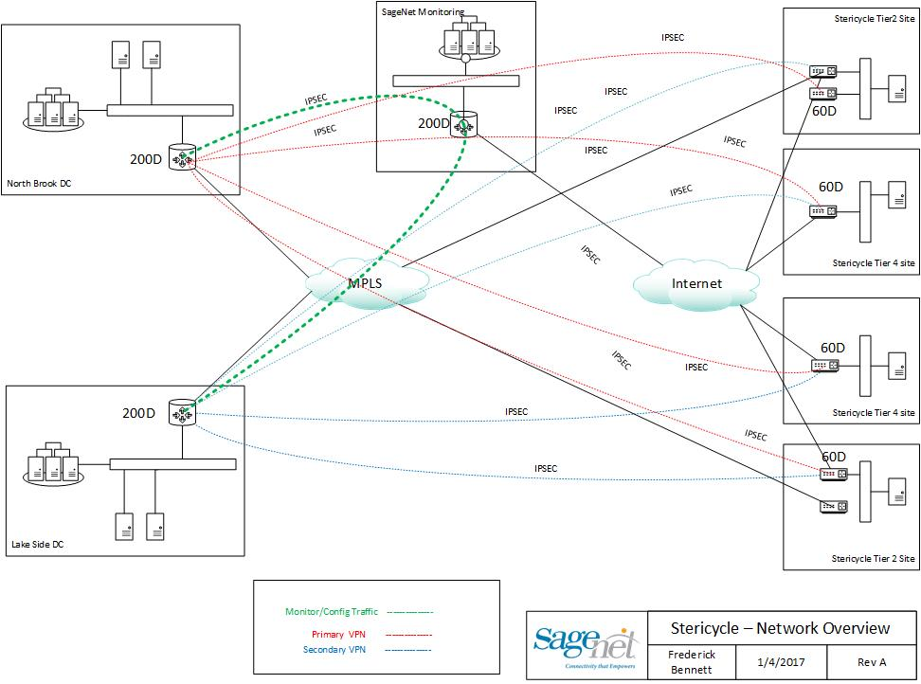

**StericycleTier-II Layer 3 switch Diagram  
  
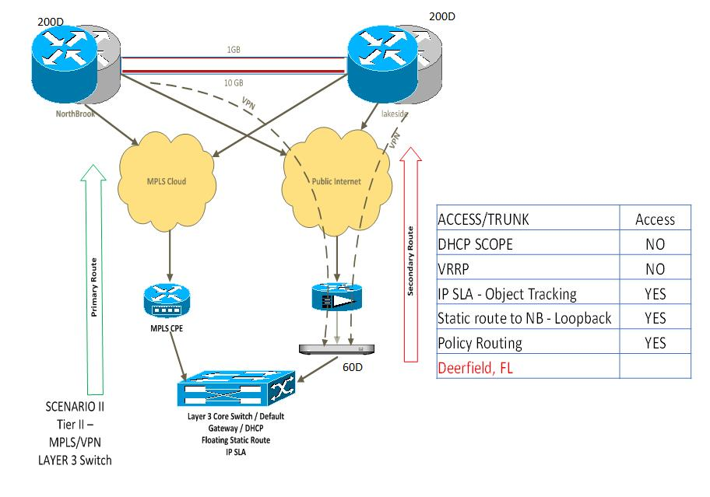**

**Stericycle Tier-II layer 2 switch Diagram**

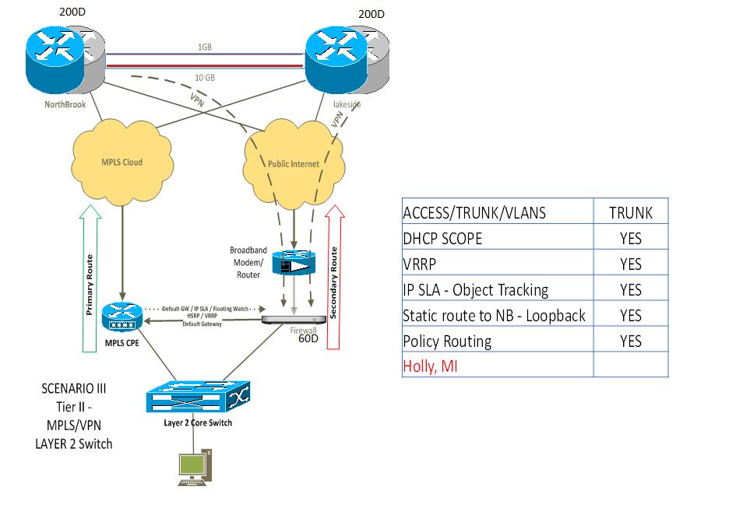

**Stericycle Tier-IV Site Diagram**

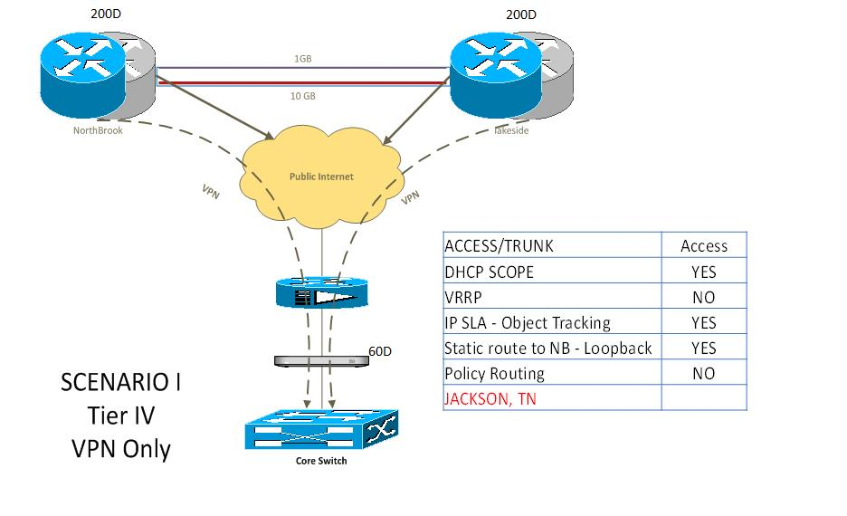

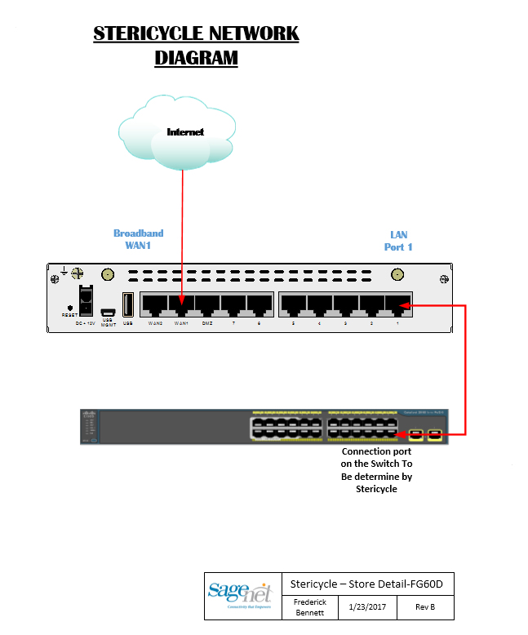



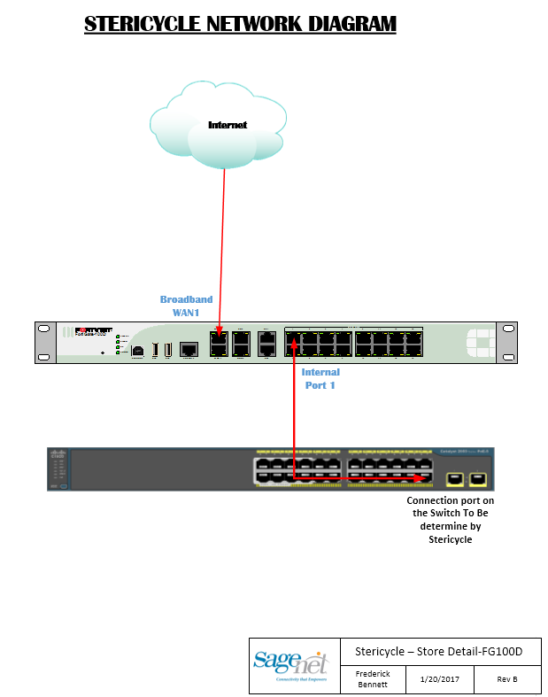

**5. Network and Branch Monitoring**

1. **Stericycle Solarwinds**

• We are using SNMP V3 option.

• The naming convention for this network is 20626

• We are currently monitoring the Fortigates using Solarwinds and Web-ticketing.

|  |  |  |
| --- | --- | --- |
|  | 1. **Standard Operating Procedure** |  |
|  |  |  |

**PROCEDURE FOR ADDDING STERICYCLE FORTIGATE 60D**

**TO SOLARWINDS**

1. **SolarWinds** 
   1. **Login to SolarWinds at**[**http://172.16.70.50:8080/Orion/Login.aspx**](http://cp.mcafee.com/d/5fHCNESyMOOyUehud79KVJ6UUQsL9TphvdET76zBVeXbBPqdNNEVujKOyUrhKYDtdBZBwS8JQDa7bhrBeoaFF7MrOVKCAv1LbCS7TTbefLZvAkn7HIftuVtdBZ7AQNMVBxXBHFShhlKyVOEuvkzaT0QSCrpdTV5MQsFIT7e6zBcTsS03h79YyVMW_fTiuKZv0N6loo5qApgU7xV85_dKc0D4YUuCWrEHdoLYoRzg52p2EvTCvz2I_VsSUqehMUScj_iFEwwq81wDFnPh0nd409-APh1I43h02mUMd40jmd40mzmTQEroKr6vPGOSHCeLEy)
   2. **Under the Down Nodes applet, click the "Manage Nodes" button**

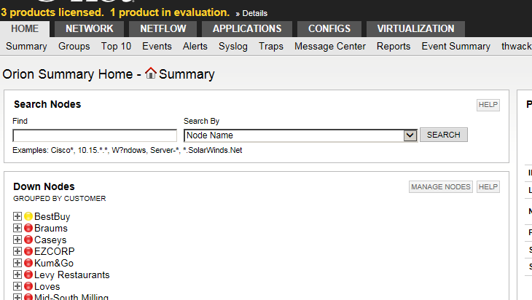

**Click the "Add Node" button**

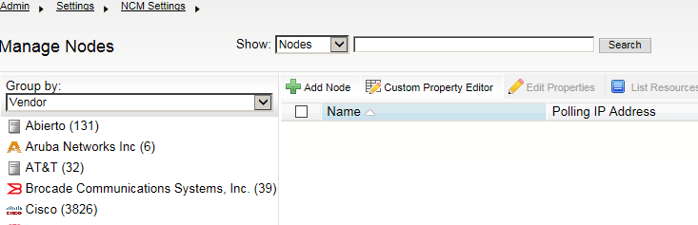

* 1. **Type the Loopback IP address of the Fortigate into the "Polling Hostname or IP Address" field found in Stericyele_IP_List under “Loopback 999 IP” column:**
  2. **Under the SNMP settings, change the "Community String" from public to SNMPv3**
     1. **SNMP Version : SNMPv3**
     2. **SNMPv3 credentials : SNMPv3 Username: sagecycle**
     3. **SNMPv3 Authentication : Method: SHA  
         Password: $@gCyc1E!2016  
        D. SNMPv3 Privacy / Encryption : Method :** AES **Password:** ST3r1cyCI3

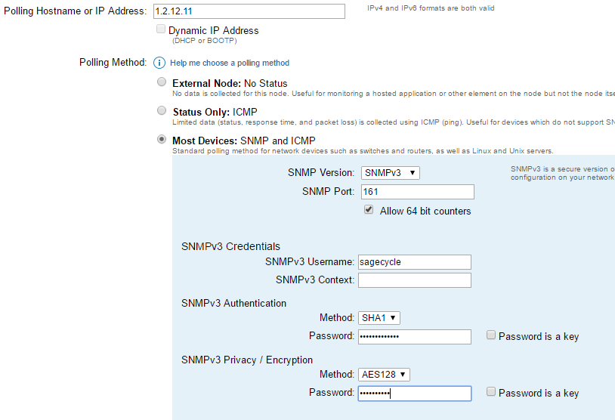

**A**

**D**

**C**

**B**

**From Step 4**

* 1. **Change the "Polling Engine" to SOLARWINDSNPM03 and click next**

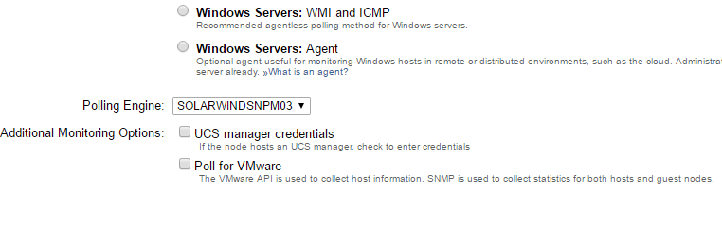

* 1. **On the "Choose Resources to Monitor" page, click "None" and then select the following interfaces and click next:** 
     1. **Routing**
     2. **Status and Response Time**
     3. **wan1**
     4. **Loopback 1**
  2. **Click Next on the "Add Application Monitors" page**
  3. On the "Add Pollers" page, expand the Default Group and select the following:
     1. fgSysCpuUsage
     2. fgSysMemUsage
  4. On the "Change Properties" page, change the following fields:
     1. Address: (from spreadsheet)
     2. City: (from spreadsheet)
     3. State: (from spreadsheet)
     4. Customer: STERICYCLE
     5. Customer Network Number: 20626
     6. Location ID: (Store Number. Ex 20626-MIHO)
  5. Click "OK, Add Node"

**Adding Stericycle Sites to FortiAnalyzer**

1. FortiAnalyzer

* <https://148.73.100.225/p/login>
* At disclaimer page select “**Accept**”
* Login to Fortimanager using your credentials

1. Select Device Manager

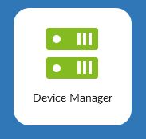

1. Top right corner - Find the unregistered devices (Click)



1. Select the device(s)

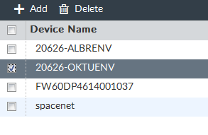

Add the device(s) (should be checked)

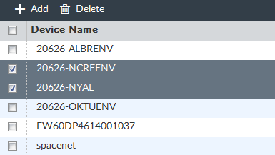

1. Device to “Root” ADOM (Click Ok)

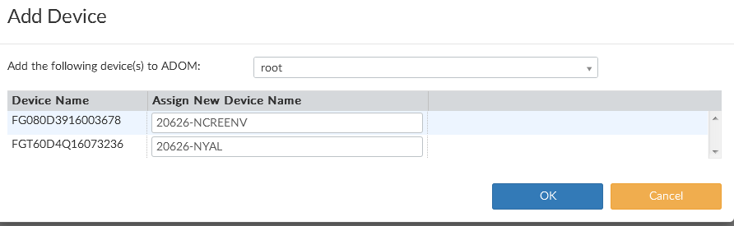

1. Click Close to finish

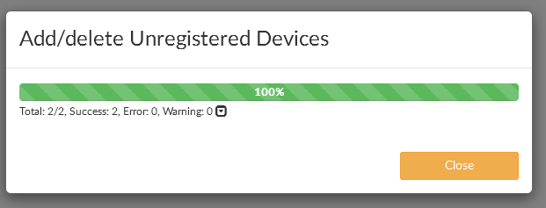

STERICYCLE Fortimanager (Site Adding)

1. FortiManager
   1. Browse to <https://148.73.100.224/login.htm>
   2. At disclaimer page select Accept
   3. Login to FortiManager using your credentials
   4. Select the Stericycle Adom

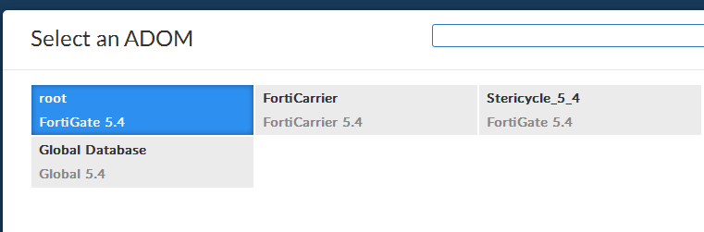

* 1. Select Device Manager

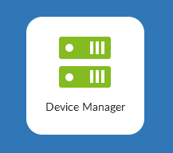

* 1. 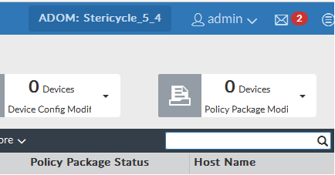

Double click on the Red Notification of new devices and Double Click on the unregistered devices

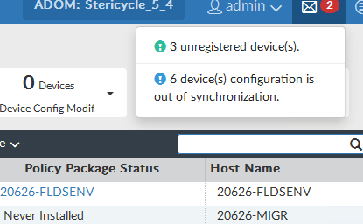

* 1. Right click the select add to add the new device

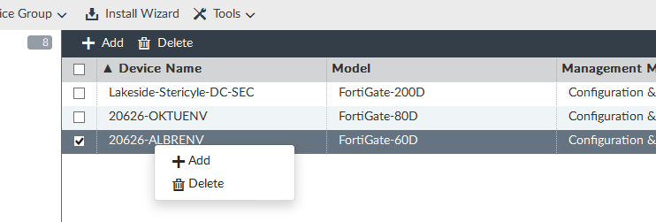

* 1. Enter the password as indicated and select OK
* 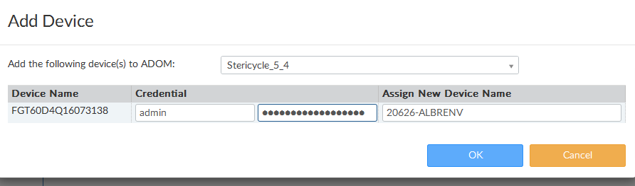 Click

@Stericycle$2016!!

* **Close**

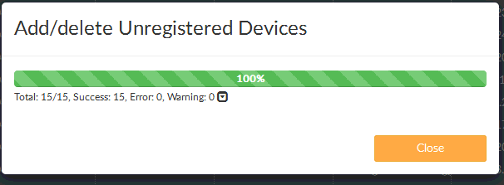

Points of Contact

SageNet

SE: Roger Deery

703 848 1406

Roger.Deery@sagenet.com

PM: Joe Lance

770 514 3470

[Joe.Lance@sagenet.com](mailto:Joe.Lance@sagenet.com)

NE: Donny Braxton

703 848 1426

[Donny.Braxton@Sagenet.com](mailto:Donny.Braxton@Sagenet.com)

SE: Frederick Bennett

703 848 1483

[Frederick.bennett@sagenet.com](mailto:Frederick.bennett@sagenet.com)

Stericycle:

Senior Network Consultant: Ayaz Merchant

847 964 2288

[Ayaz.Merchant@STERICYCLE.com](mailto:Ayaz.Merchant@STERICYCLE.com)

Stericycle Tier1 Support:

Phone: TBD

Email: [ISNetcom-US@STERICYCLE.com](mailto:ISNetcom-US@STERICYCLE.com)

**Help Desk:**

Tier 1 & 2 Support / Proactive Management / Test and Turn Up

Proactive Management

* 24/7 support.
* SageNet will provide Tier 1 and 2 support for broadband connection and Fortinet
* PAM generated tickets will be created after 30 minutes and will be triggered on Broadband failures
  + (Will need to find out hours of operation for sites. If not 24/7, may need to alter PAM hours)
  + Solar Winds will monitor primary connection
* Customer’s contact email address (Located in the Points of contact list pg 25)

**Test and Turn up**

Test and Turn up will assist technician in verification of Broadband and installation of Fortinet.

Responsibilities include:

* Work with Technician, Provider, & Engineering during customer’s installation
  + Client to provide location of router and connection point into Customer Network

Release Notes

|  |  |  |  |
| --- | --- | --- | --- |
| **Version** | **Date** | **Modified By** | **Changes Made** |
| 1.0 | Unknown | Unknown | Initial Issue |
| 1.1 | 07/14/25 | Tanisha Batta | Added to the template and adjusted formatting. |