**Stericycle Installation Guide for Test and Turn-up**

Overview – This document will provide installation steps when installing SageNet/Fortinet equipment for Stericycle partner locations. The pre-configuration shall be completed by Tulsa Config-Line, and in case of any issues during install, escalate to SageNet Engineering.

**Location of Equipment and Basic Connectivity**

1. Initially the Fortinet was shipped preconfigured however Forti-deploy will be online for all installs when the remaining sites are rolled out.

2. Unpack and Install Fortinet Router (60D, 80D or 100D) in the customers network equipment rack. Do not connect the Fortinet to the Broadband connection or the customer’s switch until instructed, this will prevent a network outage.

•“If the Site Manager makes any requests outside the scope or direction of the hot sheet (for example: Placing the Router in a different location). The Stericycle Engineers on the call must be consulted and give approval”.

3. All Stericycle BB connections are statically assigned and must have the WiFi option disabled. Ensure the connection is up and the tech is able to surf using the correct static IP. To do this, have the technician connect a laptop to the modem, to see what IP is being supplied and attempt to surf. If getting the correct static IP, configure his laptop with the IP, login to the modem and disable WIFI capability. TTUP should now be able to ping the static (public IP) of the Broadband using a command prompt and the tech is able to surf. Once connectivity is confirmed, have the tech run a speed test and capture a screen shot of the results (To be emailed to Stericyle with the install pictures). Now the tech can disconnect the laptop from the Broadband Modem and power cycle it.

NOTE: The static IPs for each site should be in SAP. It is the responsibility of TTUP to verify the modem is configured properly. There are some instructions available in our knowledge base for certain modems: <https://kb.sagenet.com/index.php/Main_Page>

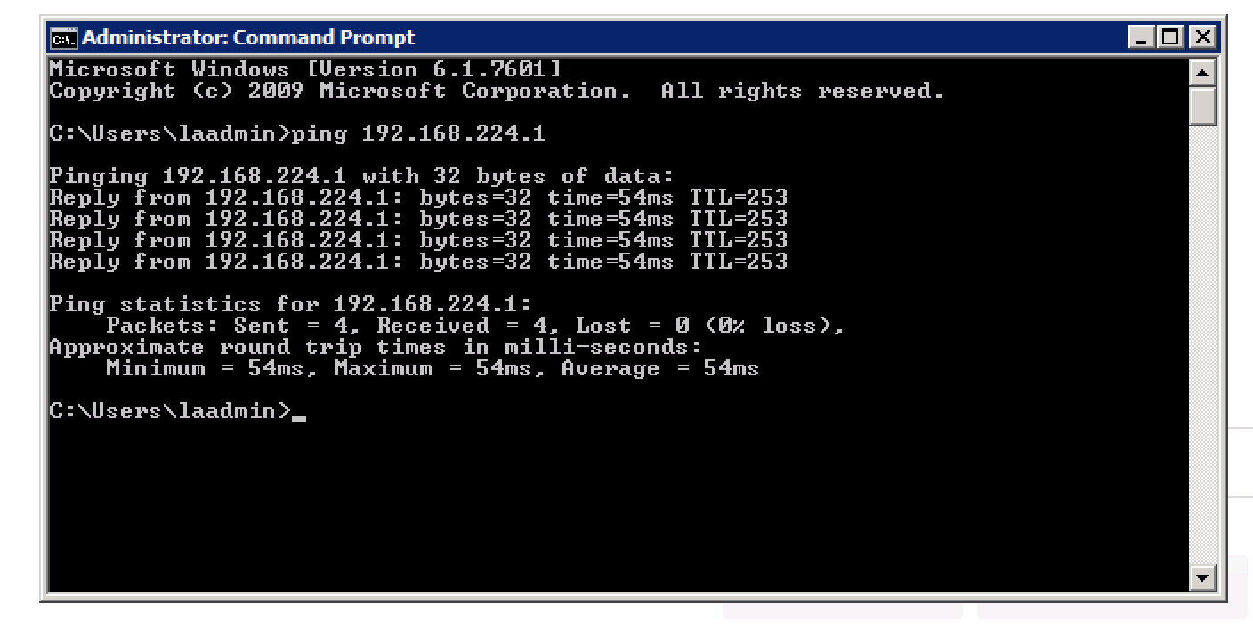

4. Power up the FortiGate Router (Takes about 4 minutes) “Do not connect it to the Broadband or Customer equipment until instructed”

5. Once the BB connection and the Fortigate are ready. The tech will be instructed by Stericycle to connect a laptop by (console cable) to the Customer core switch. The Stericycle engineer on the call will need visibility & control through a laptop to configure their network for the Fortigate (WebEx connection or TeamViewer). During this time they may ask for the tech’s assistance in verifying connectivity to a workstation. Please await further instructions from Stericycle before proceeding.

6. When instructed by Stericyle to connect the Fortigate to the Broadband Modem, the tech will connect WAN1 of the 60D, 100D Fortigate or if installing a Fortinet 80D (Port1) to the Broadband Modem. Connection diagrams are on pages 3-5.

7. The Stericyle engineer will instruct the tech which port on their core switch to attach the LAN connection from the Fortigate to the switch. If installing a 60D or 100D the LAN connection will be Port1 of the Fortigate, if installing an 80D the LAN connection will be Port2. All Stericycle FortiGate devices LAN IP will end in .2 (example 10.111.205.2). See the below diagrams depicting the equipment WAN/LAN connection ports. (Pages 3-5)

8. When the Fortigate pings and during the time Stericycle is performing their switch/network configurations; we can move forward with adding the site to Solarwinds and Fortimanager. Proceed to pages 6 -13 for instructions on adding Stericycle sites to Solarwinds and Fortimanager. **NOTE:** The Forti-deploy should add the site to Fortimanager but I have attached a procedure for this in the event something happens

9. Network and site Tier diagrams are pages 14-17.

10. These are the onsite technician sign off requirements for Stericyle. are on pages 18-20. The tech should have IPerf downloaded to his PC along with the Stericycle checklist (spreadsheet) prior to arriving onsite. If not obtained prior to arrival, TTUP will have to get it to the tech by email or by file transfer. Before leaving site the technician is required to run all IPERF testing (on pages 18-20) and take pictures of the below items. All (spreadsheet & pictures) to be sent to Kelly Dean who will in turn send them to Stericycle. *However lately Stericycle has been performing the IPERF portion themselves from a client PC but we should remain ready in the event that changes (again).*

• Photo of Communications rack (Where Equipment is Located)

• Photo of broadband Modem placement (Placed by Service Provider)

• Photo of broadband modem with connections

• Photo of Fortinet with all Connections

• Photo/screen shot of the Quality Test Results

• Photo/screen shot of Speed Test

• Photo of the existing switch with all connections clearly shown

• Remove the additional Century-link modem and ship back to the warehouse. (Per Stericycle)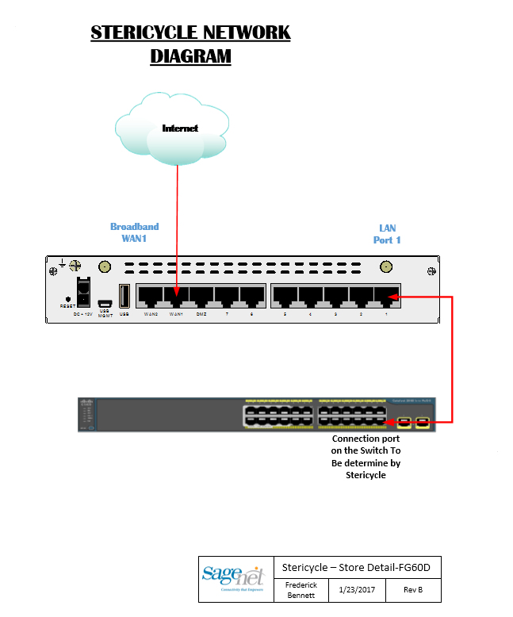



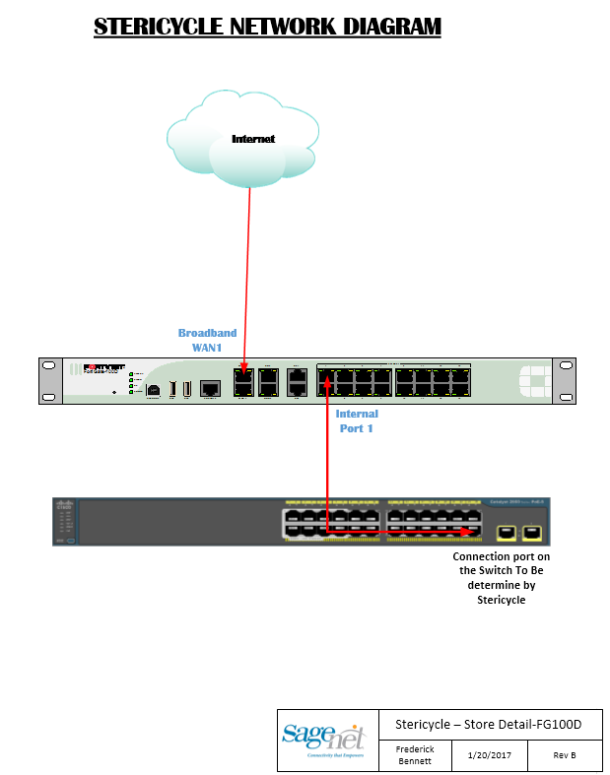

|  |  |  |
| --- | --- | --- |
|  | Standard Operating Procedure |  |
|  |  |  |

**PROCEDURE FOR ADDDING STERICYCLE FORTIGATE 60D**

**TO SOLARWINDS**

1. **SolarWinds** 
   1. **Login to SolarWinds at**[**http://172.16.70.50:8080/Orion/Login.aspx**](http://cp.mcafee.com/d/5fHCNESyMOOyUehud79KVJ6UUQsL9TphvdET76zBVeXbBPqdNNEVujKOyUrhKYDtdBZBwS8JQDa7bhrBeoaFF7MrOVKCAv1LbCS7TTbefLZvAkn7HIftuVtdBZ7AQNMVBxXBHFShhlKyVOEuvkzaT0QSCrpdTV5MQsFIT7e6zBcTsS03h79YyVMW_fTiuKZv0N6loo5qApgU7xV85_dKc0D4YUuCWrEHdoLYoRzg52p2EvTCvz2I_VsSUqehMUScj_iFEwwq81wDFnPh0nd409-APh1I43h02mUMd40jmd40mzmTQEroKr6vPGOSHCeLEy)
   2. **Under the Down Nodes applet, click the "Manage Nodes" button**

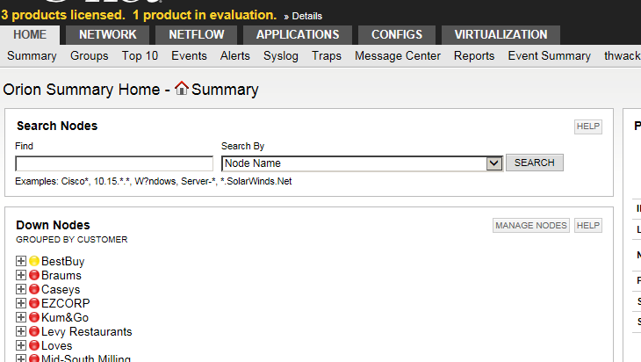

* 1. **Click the "Add Node" button**

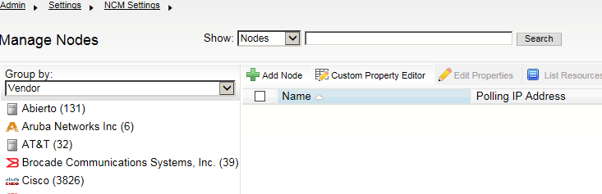

* 1. **Type the Loopback IP address of the Fortigate into the "Polling Hostname or IP Address" field found in Stericyele_IP_List under “Loopback 999 IP” column:**
  2. **Under the SNMP settings, change the "Community String" from public to SNMPv3**
     1. **SNMP Version : SNMPv3**
     2. **SNMPv3 credentials : SNMPv3 Username: sagecycle**
     3. **SNMPv3 Authentication : Method: SHA  
         Password: $@gCyc1E!2016  
        D. SNMPv3 Privacy / Encryption : Method :** AES **Password:** ST3r1cyCI3

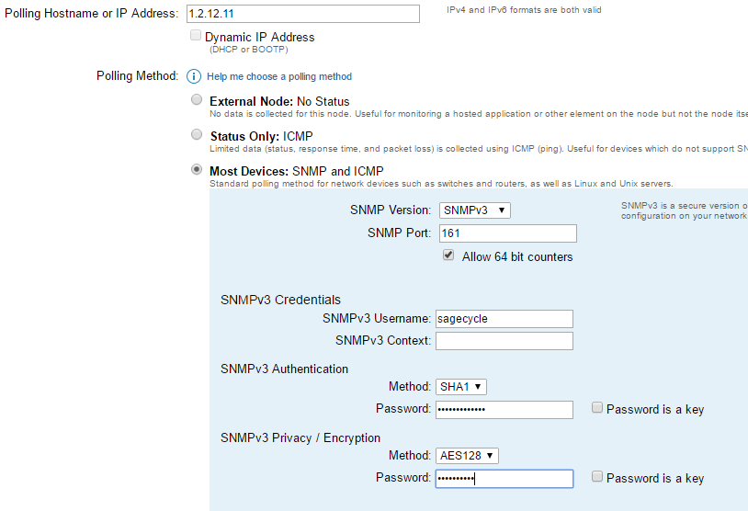

**A**

**D**

**C**

**B**

**From Step 4**

* 1. **Change the "Polling Engine" to SOLARWINDSNPM03 and click next**

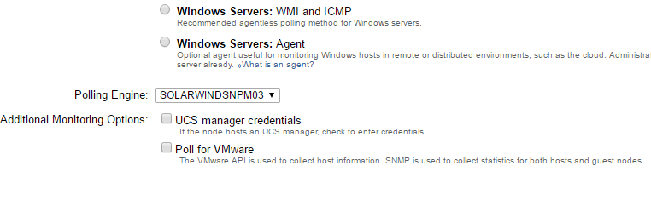

* 1. **On the "Choose Resources to Monitor" page, click "None" and then select the following interfaces and click next:** 
     1. **Routing**
     2. **Status and Response Time**
     3. **wan1**
     4. **Loopback 1**
  2. **Click Next on the "Add Application Monitors" page**
  3. **On the "Add Pollers" page, expand the Default Group and select the following:** 
     1. **fgSysCpuUsage**
     2. **fgSysMemUsage**
  4. **On the "Change Properties" page, change the following fields:** 
     1. **Address: (from spreadsheet)**
     2. **City: (from spreadsheet)**
     3. **State: (from spreadsheet)**
     4. **Customer: STERICYCLE**
     5. **Customer Network Number: 20626**
     6. **Location ID: (Store Number. Ex 20626-MIHO)**
  5. **Click "OK, Add Node"**

**Adding Stericycle Sites to FortiAnalyzer**

1. FortiAnalyzer

* <https://148.73.100.225/p/login>
* At disclaimer page select “**Accept**”
* Login to Fortimanager using your credentials

1. Select Device Manager

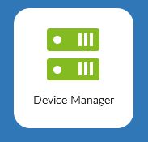

1. Top right corner - Find the unregistered devices (Click)



1. Select the device(s)

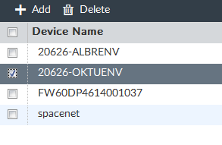

Add the device(s) (should be checked)

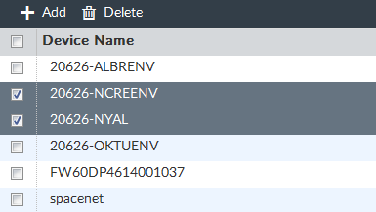

1. Device to “Root” ADOM (Click Ok)

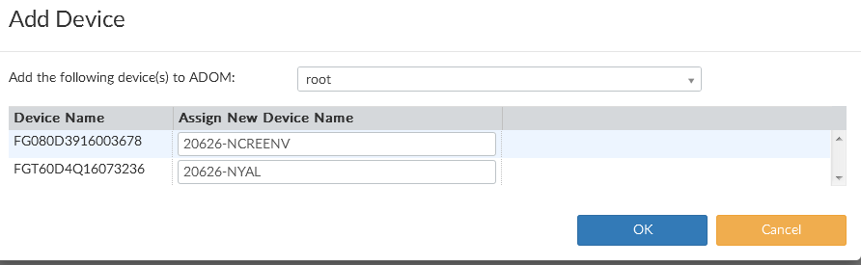

1. Click Close to finish

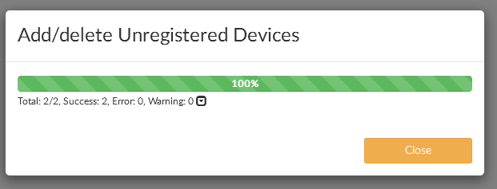

STERICYCLE Equipment: Adding to Fortimanager

1. FortiManager
   1. Browse to <https://148.73.100.224/login.htm>
   2. At disclaimer page select Accept
   3. Login to FortiManager using you credentials

* 1. Select the Stericycle Adom

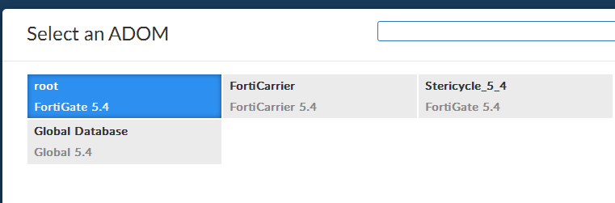

* 1. Select Device Manager

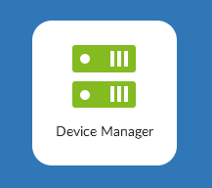

* 1. 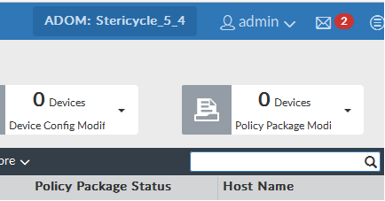

Double click on the Red Notification of new devices and Double Click on the unregistered devices

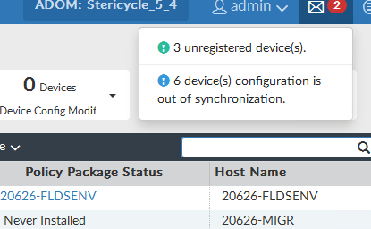

* 1. Right click the select add to add the new device

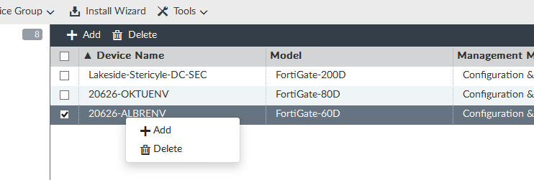

Enter the password as indicated and select OK

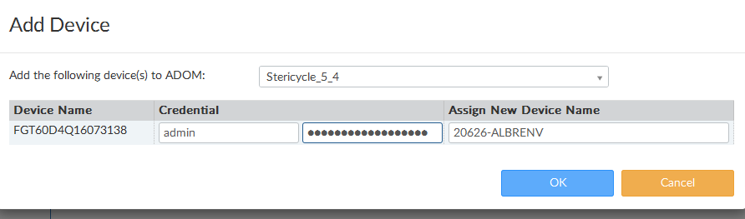 Click “Ok” then close

@Stericycle$2016!!

**Stericycle Network Diagrams DC and site level**

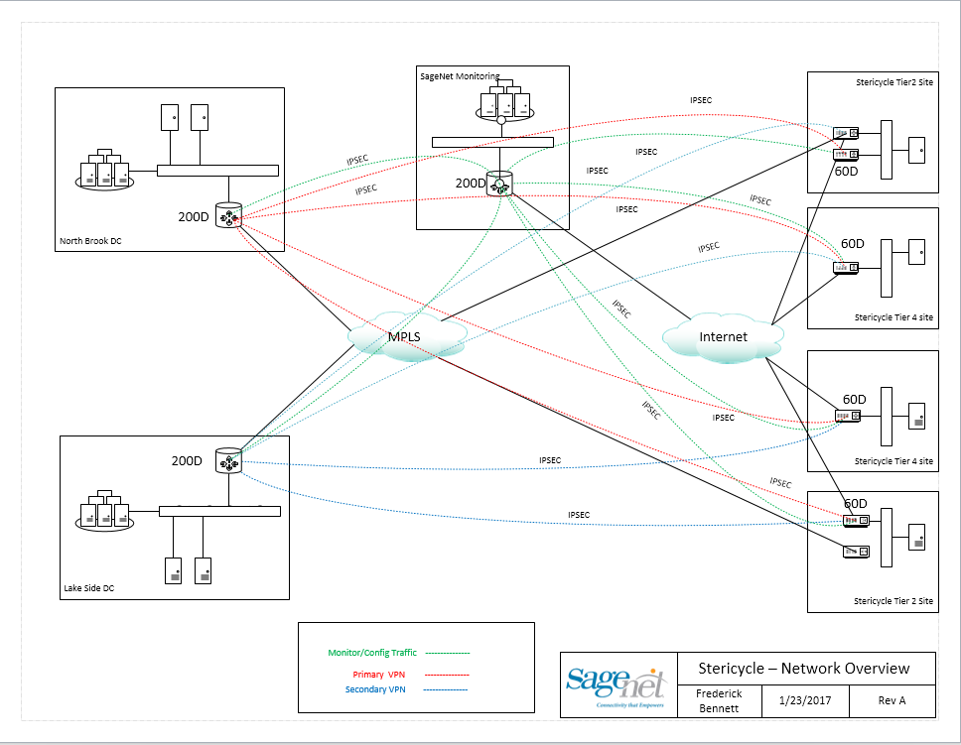

Northbrook Wan 192.81.100.254

Northbrook Lan IP Address/Subnet mask 172.31.0.150 - 255.255.255.192

Lakeside Wan 192.81.101.99

Lakeside Lan IP Address/Subnet mask 172.30.111.50 - 255.255.255.248

**\*The Headend 200D’s will use Netcool and Cacti for Hub monitoring.**

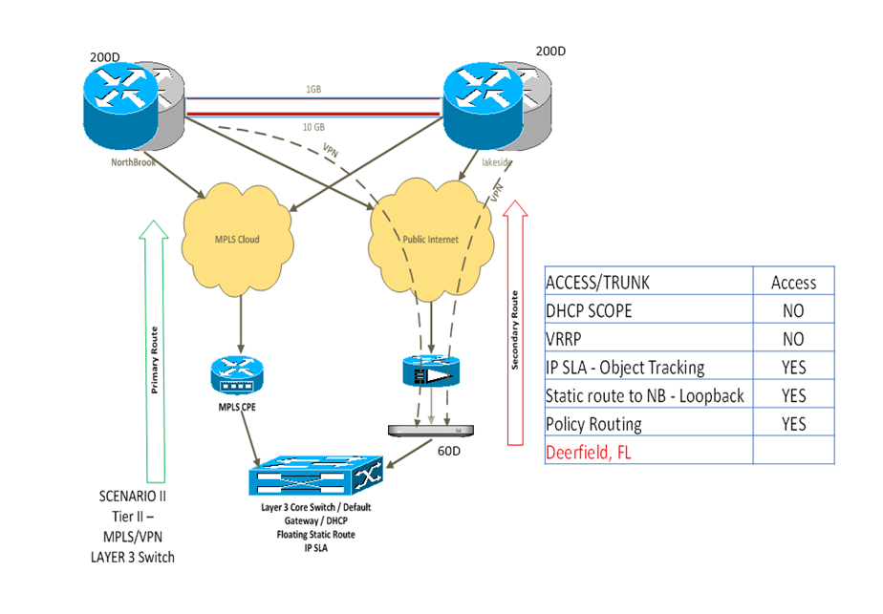

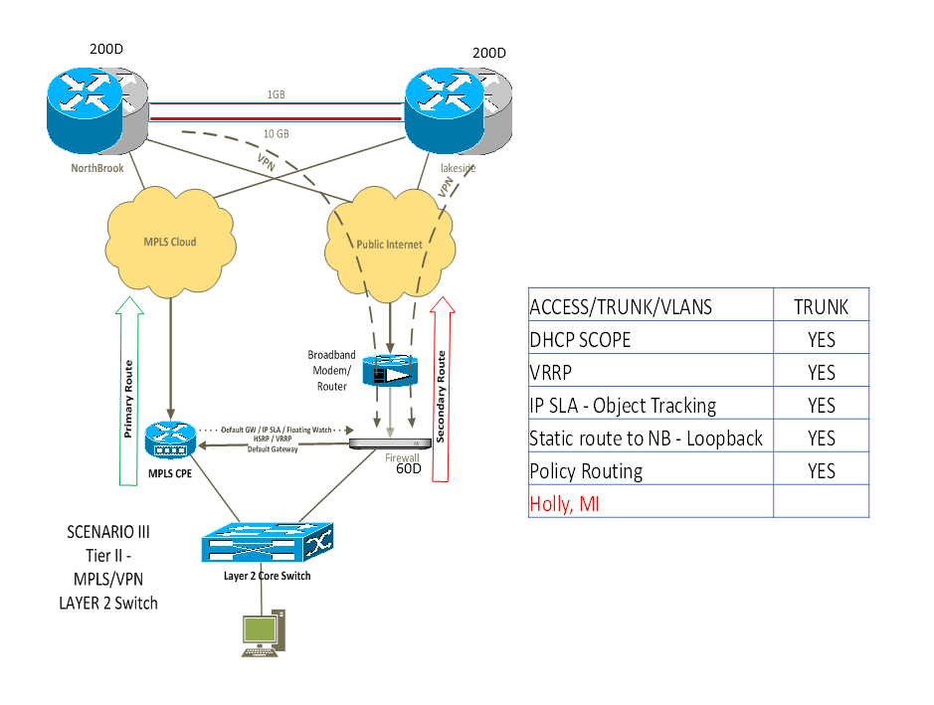

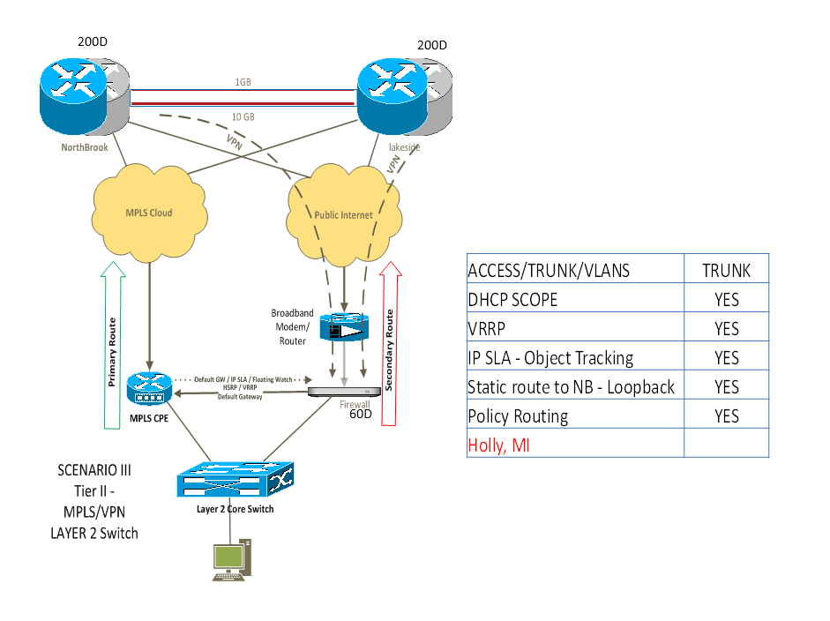

|  |  |  |  |  |  |  |  |  |  |  |  |  |  |  |  |  |  |
| --- | --- | --- | --- | --- | --- | --- | --- | --- | --- | --- | --- | --- | --- | --- | --- | --- | --- |
|  |  |  |  |  |  |  |  |  |  |  |  |  |  |  |  |  |  |
| |  | | --- | |  | |  |  |  |  |  |  |  |  |  |  |  |  |  |  |  |  |  |
|  |  |  |  |  |  |  |  |  |  |  |  |  |  |  |  |  |  |
|  |  |  |  |  |  |  |  |  |  |  |  |  |  |  |  |  |  |
|  |  |  |  |  |  |  |  |  |  |  |  |  |  |  |  |  |  |
|  |  |  |  |  |  |  |  |  |  |  |  |  |  |  |  |  |  |
|  |  |  |  |  |  |  |  |  |  |  |  |  |  |  |  |  |  |
| Site Name | | | | | | | | | | Site Code | | | | | | | |
| **Stericycle** | | | | | | | | | | **20626-MIGR** | | | | | | | |
| Turn-up & Testing Date | | | | | | | | | | Site Contact | | | | | | | |
| 10/26/2016 | | | | | | | | | | Harold Cornelisse | | | | | | | |
| SageNet Engineer | | | | | | | | | | Site Contact Phone | | | | | | | |
| Brian Gibson | | | | | | | | | | 616-791-2276 | | | | | | | |
| SageNet Engineer Phone | | | | | | | | | | Site Manager | | | | | | | |
| 810-250-8924 | | | | | | | | | | Harold Cornelisse | | | | | | | |
|  |  |  |  |  |  |  |  |  |  |  |  |  |  |  |  |  |  |
| SageNet Remote Site Install - Testing Checklist | | | | | | | | | | | | | | | | | |
| **Description** | | | | | | | | | | **Complete** | | | | **Notes** | | | |
| Ping Internet | | | | | | | | | |  | | | |  | | | |
| Traceroute to Internet | | | | | | | | | |  | | | |  | | | |
| Ping Steriworks | | | | | | | | | |  | | | |  | | | |
| Traceroute to Steriworks | | | | | | | | | |  | | | |  | | | |
| DHCP IP Received | | | | | | | | | |  | | | |  | | | |
| Run Iperf Test - Across VPN | | | | | | | | | |  | | | |  | | | |
| Run Iperf Test - Across MPLS | | | | | | | | | |  | | | |  | | | |
| Tunnels to both Northbrook and Lakeside are up | | | | | | | | | |  | | | |  | | | |
| Ping Core Switch | | | | | | | | | |  | | | | 10.134.25.5 | | | |
| Verify Broadband Router - WIFI is Off | | | | | | | | |  |  | | | |  | | | |
| Data Collection | | | | | | | | | | | | | | | | | |
| Broadband Provider | | | | | | | | | | Comcast | | | | | | | |
| Broadband Provided Public IP/Mask | | | | | | | | | | 99.66.4.229 | | | | | | | |
| Broadband Router/Modem Make/Model | | | | | | | | | | smcd3g | | | | | | | |
| Broadband Router Serial Number | | | | | | | | | | h2130434b700 | | | | | | | |
| Firewall Make/Model | | | | | | | | | | mx64-hw | | | | | | | |
| Firewall Serial Number | | | | | | | | | | q2kn-5zuy-7c9k | | | | | | | |
| Firewall LAN Interface | | | | | | | | | | lan 1 | | | | | | | |
| Firewall LAN IP/Mask | | | | | | | | | | 10.134.25.2/24 | | | | | | | |

|  |  |  |  |  |  |  |  |  |  |
| --- | --- | --- | --- | --- | --- | --- | --- | --- | --- |
| **2 - Traceroute --> Internet Results:** |  |  |  |  | **4 - Traceroute --> Steriworks:** |  |  |  |  |
| C:\Windows\System32>tracert -d 4.2.2.2  Tracing route to 4.2.2.2 over a maximum of 30 hops   1 <1 ms <1 ms <1 ms 10.111.205.254  2 1 ms 11 ms 11 ms 96.120.41.97  3 14 ms 20 ms 11 ms 68.85.84.141  4 16 ms 18 ms 16 ms 68.87.188.133  5 19 ms 17 ms 33 ms 4.68.71.37  6 * * * Request timed out.  7 33 ms 33 ms 31 ms 4.2.2.2  Trace complete. | | | |  | C:\Windows\System32>tracert -d steriworks  Tracing route to steriworks.stericorp.com [10.134.1.183] over a maximum of 30 hops:   1 <1 ms <1 ms <1 ms 10.111.205.254  2 32 ms 31 ms 32 ms 172.31.0.193  3 27 ms 28 ms 25 ms 172.31.0.45  4 25 ms 30 ms 25 ms 10.134.1.183  Trace complete.  C:\Windows\System32> | | | | |
|  |
|  |
|  |
|  |
|  |
|  |
|  |
|  |
|  |
|  |
|  |
|  |
|  |
|  |

|  |  |  |
| --- | --- | --- |
| **5 - DHCP IP --> Ipconfig/all:** |  | **6 - IPERF Results: --> Across VPN** |
| C:\Windows\System32>ipconfig  Windows IP Configuration   Ethernet adapter Local Area Connection:   Connection-specific DNS Suffix . : stericorp.com  IPv4 Address. . . . . . . . . . . : 10.111.205.1  Subnet Mask . . . . . . . . . . . : 255.255.255.0  Default Gateway . . . . . . . . . : 10.111.205.254 |  | C:\>iperf3 -c 10.133.0.48 -p 5001 -f Mbits -t 10 Connecting to host 10.133.0.48, port 5001 [ 4] local (Lan IP) port 52725 connected to 10.133.0.48 port 5001 [ ID] Interval Transfer Bandwidth [ 4] 0.00-1.01 sec 2.62 MBytes 2.59 MBytes/sec [ 4] 1.01-2.01 sec 2.62 MBytes 2.63 MBytes/sec [ 4] 2.01-3.01 sec 2.75 MBytes 2.75 MBytes/sec [ 4] 3.01-4.01 sec 2.75 MBytes 2.75 MBytes/sec [ 4] 4.01-5.01 sec 2.75 MBytes 2.75 MBytes/sec [ 4] 5.01-6.01 sec 2.62 MBytes 2.63 MBytes/sec [ 4] 6.01-7.00 sec 2.62 MBytes 2.63 MBytes/sec [ 4] 7.00-8.00 sec 2.62 MBytes 2.63 MBytes/sec [ 4] 8.00-9.00 sec 2.75 MBytes 2.75 MBytes/sec [ 4] 9.00-10.02 sec 2.62 MBytes 2.59 MBytes/sec - - - - - - - - - - - - - - - - - - - - - - - - - |
|  |
|  |
|  |
|  |
|  |
|  |
|  |
|  |
|  |

|  |
| --- |
| **7 - IPERF Results: --> Across MPLS** |
| C:\>iperf3 -c 10.133.0.48 -p 5001 -f Mbits -t 10 Connecting to host 10.133.0.48, port 5001 [ 4] local 10.134.25.146 port 53997 connected to 10.133.0.48 port 5001 [ ID] Interval Transfer Bandwidth [ 4] 0.00-1.01 sec 640 KBytes 0.62 MBytes/sec [ 4] 1.01-2.01 sec 512 KBytes 0.50 MBytes/sec [ 4] 2.01-3.01 sec 640 KBytes 0.63 MBytes/sec [ 4] 3.01-4.01 sec 512 KBytes 0.50 MBytes/sec [ 4] 4.01-5.01 sec 512 KBytes 0.50 MBytes/sec [ 4] 5.01-6.01 sec 512 KBytes 0.50 MBytes/sec [ 4] 6.01-7.00 sec 512 KBytes 0.50 MBytes/sec [ 4] 7.00-8.00 sec 512 KBytes 0.50 MBytes/sec [ 4] 8.00-9.00 sec 512 KBytes 0.50 MBytes/sec [ 4] 9.00-10.02 sec 512 KBytes 0.49 MBytes/sec - - - - - - - - - - - - - - - - - - - - - - - - - |
|
|
|
|
|
|
|
|
|

Basic Troubleshooting: