# This Statement of Work (“SOW”) by and between SageNet LLC (“SageNet”) and Stericycle Inc. (“Customer” and collectively the “Parties”), shall be effective as of the later date of signature of the Parties below (the “SOW Effective Date”), and is incorporated into the Master Services Agreement between the Parties dated 10/11/2016 (the “MSA”) and the CompleteConnect™ Services Addendum dated October 11, 2016 (the “Addendum” and collectively, the “Agreement”). Capitalized terms not otherwise defined herein shall have the meanings set forth in the Agreement. In the event of a conflict between this SOW, the MSA or the Addendum, this SOW will control, followed by the Addendum.

# **Overview**

## This SOW describes the circuits and network services that Customer wishes to purchase from SageNet and that SageNet shall provide to Customer pursuant to the Agreement (the “Services”) and provides additional details regarding the scope of work and the Parties’ responsibilities.

# **Term of Service and Pricing**

## The Term of Service for each location shall be for thirty-six (36) months, and in further accordance with the terms of the Addendum, specifically Section 2. The Parties hereby agree that the *Pricing Attachment* of this SOW, Exhibit A, shall replace in its entirety that certain *Pricing Attachment* to the Addendum, Exhibit B. Further, broadband provider pricing is specified in detail in Table 2 to Exhibit A of this SOW, and may be modified over time as SageNet secures additional third-party broadband provider Services. Additional requests for Service shall be on a case-by-case basis, and subject to the prior approval of Customer.

## The pricing provided on Exhibit A is not guaranteed with respect to Services ordered for locations ordered more than twenty-four (24) months after the SOW Effective Date. Pricing for Services at such locations shall be quoted on an individualized basis.

# **Solution Overview**

## SageNet is providing a CompleteConnect™ service offering. The service includes a rollout plan, pre-qualification, order management, installation support, single consolidated billing services, project management, proactive management of the broadband circuit and the FortiGate security device, statistical performance reporting, 7x24x365 Tier 2 Helpdesk, NOC support and Customer online ePortal. The network design includes a cost effective primary circuit based on Cable first if available then DSL, U-verse or FiOS. If these broadband technologies are not available, T1 or other technologies will be quoted on an individual case basis.

## Customer branch locations consist of four types. See Table 1 below. MPLS circuits are provided by Customer and SageNet will provide the broadband circuits.

Table 1

|  |  |
| --- | --- |
| Branch Type | Connection Type |
| Tier I | MPLS Primary/MPLS Backup |
| Tier II | MPLS Primary/Broadband Backup |
| Tier III | Not Defined |
| Tier IV | Broadband Primary/No Backup |

## The roll out will be scheduled in multiple phases. Schedules will be mutually agreed upon between SageNet and Customer. SageNet managed Services are detailed in Table 1 on Exhibit A, with provider pricing per speed listed in Table 2.

## SageNet will provide a managed FortiGate security device with premise based Unified Threat Management (UTM) security features and 8x5 FortiCare support at each remote location. The initial design will incorporate IPS/IDS. All traffic will be routed over the IPSEC tunnel to the Customer data center. Additional premise based UTM functionality may be incorporated into the design as Customer applications require Internet access directly from the branch location. If selected, SageNet will provide a change order for the network changes and integration required.

## The FortiGate model being deployed will be determined by the provisioned circuit speed. The following Table 2 will be used to properly size the FortiGate security device based on the provisioned broadband service speed.

Table 2

|  |  |
| --- | --- |
| Broadband Circuit Speed | FortiGate Security Device |
| Up to 25Mbps | FortiGate 60D |
| Up to 80Mbps | FortiGate 80D |
| Up to 100Mbps | FortiGate 100D |
| Up to 200Mbps | FortiGate 200D |

## Customer is responsible for all switch(s) and connected devices that are connected to the SageNet provided FortiGate security device.

## SageNet will provide VPN termination head-end services and dedicated redundant head-end routers that are located in Customer data centers in Lakeside IN and Northbrook IL. The Customers data centers are configured in active – active mode. SageNet will install and manage two (2) FortiGate 200D head-end aggregation devices at each Customer data center.

The Customer network diagram is defined below.

Network Diagram



The Customer branch locations will have three configurations define below, Scenario 1, Scenario 2 and Scenario 3.

Scenario 1

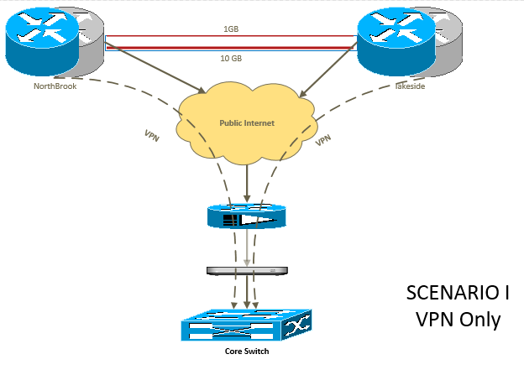

Scenario 2

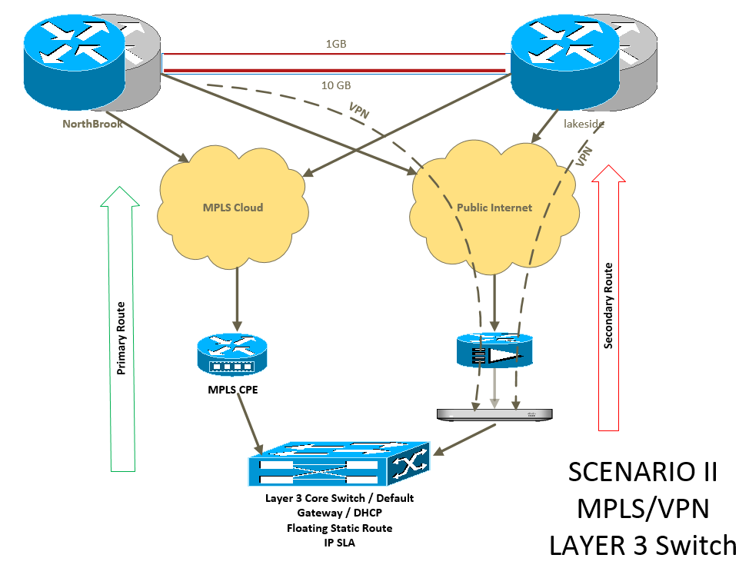

Scenario 3

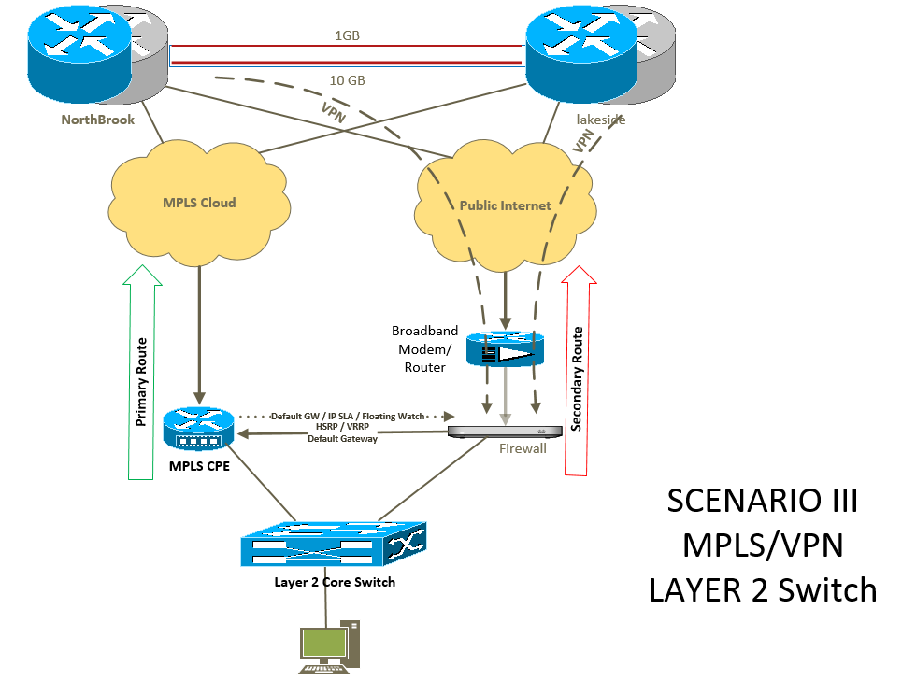

## **Connect Series Service Offering**

### SageNet will order broadband circuits for Customer’s locations.

### SageNet will work with third party service providers to deliver a broadband service to Customer locations.

### SageNet shall determine circuit availability for each Customer location.

### Customer preference for Circuit Type is: Cable First - Fiber, FiOS, ADSL, T1

### SageNet shall use reasonable efforts to provide the upload and download speeds as defined in Exhibit A, Table 2.

### Using information provided by the Customer, SageNet will provide a preliminary solution design, prequalification and pricing analysis.

### Customer acknowledges that distance and pricing information provided by SageNet is based on information provided to SageNet by third party service providers and that SageNet does not guarantee or warrant the accuracy of such information.

### Shared loop pricing assumes SageNet can deliver ADSL services on an End User provided POTS line.

### SageNet will obtain written permission from the Customer before exceeding estimate for out of scope charges.

## **Complete Connect**

### SageNet will request the Provider to install Provider modem at the Customer’s desired location and with the desired configuration but does not warrant the Provider is able or willing to do this.

### SageNet Installer will relocate and reconfigure Provider modem as needed to support Service.

### SageNet shall provide helpdesk services 24 x 7 x 365 to resolve network related issues.

### SageNet will proactively monitor the SageNet managed FortiGate security device and respond to broadband communications or Equipment failures.

### SageNet NOC will create a trouble ticket in the SageNet Ticketing System and initiate troubleshooting and problem resolution procedures.

### SageNet NOC will attempt to contact the affected Customer Location(s) via telephone to notify them of the failure and obtain the information necessary to continue troubleshooting procedures remotely.

### If the SageNet NOC is unable to gain assistance from the affected Customer Location(s) to perform remote troubleshooting during location operating hours, then SageNet will reach out to the Customer’s Tier 1 call center for further assistance.

### If SageNet determines the problem resides with the circuit, SageNet will open a ticket and coordinate with the appropriate third party service provider to diagnose and resolve the problem. During this process, SageNet will provide Customer with updates via the ePortal. Prior to closing the ticket, SageNet will attempt to contact Customer’s POC to confirm that the circuit is operational.

### The Customer can view the network status at any time via the SageNet ePortal bound by the combined limitations of Customer Equipment and SageNet monitoring system.

### If the circuit and SageNet Equipment are operational but Customer’s network remains down, Customer must dispatch its own technician to diagnose the problem; however, upon request and subject to availability, SageNet may supply a technician to assist Customer for an additional fee represented as Out of Scope in the Agreement.

### SageNet will procure one (1) FortiGate security device for each Customer location.

### SageNet will procure 8x5 FortiCare maintenance package for Equipment for 3 years. If Customer has a verifiable failure, and adequate spares are in stock, SageNet will ship a pre-configured Fortinet router to Customer site and dispatch a technician at Time & Materials rates.

### SageNet will work with the Customer to set up a standard router configuration that fits the Customer’s requirements.

### SageNet will configure the router to set broadband as the primary WAN for Tier 4 branches and broadband as the backup WAN for Tier 2 branches.

### SageNet will set up the Whitelist as requested by the Customer using Access Control Lists (“ACLs”). SageNet will allow up to a maximum of 20 URLs in the whitelist. Any other Web traffic will be blocked. The Service does not include blacklisting of networks and domains.

### SageNet allows the Customer to request changes to the Equipment configuration whether it be due to Customer policy changes or normal evolution of Service. Such requests need to be submitted as a ticket in the SageNet ePortal.

### SageNet will record and maintain an audit trail of changes made to the Equipment. Any change request that originates through the SageNet Ticketing System (within SageNet ePortal) will create an audit trail. These change requests are retained for one (1) year.

### SageNet will provide the VPN aggregation hardware at two (2) Customer data centers, located in Lakeside IN and Northbrook IL to terminate VPN tunnels from each Equipment, subject to the Service terms. The VPN aggregation hardware is being purchased by Customer.

### VPN Configuration Management. SageNet will provide the initial configuration and the ongoing configuration management support for the Equipment at each remote Customer location as part of the Managed VPN Service. SageNet allows for the establishment of up to 4 tunnel end-points originating from a single Equipment. SageNet will keep logs for all configuration changes and remote access to the Equipment, pursuant to the Service terms.

### Customer is responsible for providing Tier 1 support for its end user(s) at the remote Customer Location(s).

### Network Design

Supplier will provide and manage the network design using the defined functionality but not limited to the list below.

* VLANs/Sub-Interfaces – provided by Customer and managed buy SageNet
* IP Addresses - provided by Customer and managed buy SageNet
* Routing – provided by SageNet and approved by Customer
* NAT/VIP - provided by SageNet and approved by Customer
* Firewall Policy Elements - provided by SageNet and approved by Customer
* Address Objects/Groups - provided by SageNet and approved by Customer
* Services Objects/Groups - provided by SageNet and approved by Customer

### Supplier will provide FortiGuard CPE based UTM IPS/IDS functionality at each branch location. Customer will select up to two (2) network wide IPS specific configurations (including actions such as detect, block, etc.) during network design and setup. Customer shall be permitted to make IPS configuration changes for the duration of the Term of the Agreement.  Change requests will be made using Supplier Trouble Ticket System and will be responded to within twenty-four (24) hours.  Customer is given an allowance of two (2) IPS changes per month. IPS changes beyond the contracted monthly allowance will be charged at $100 per change. Emergency requests during normal business hours will be responded to within two (2) hours.  SageNet provides its IPS service on a commercially reasonable efforts basis but SageNet makes no guarantees with respect to the detection or blocking of malware or any other types of attacks, and is not responsible for any such malicious data that may be transmitted over the SageNet provided network.

* The IPS service supports
  + A signature database of thousands of known threats to stop attacks that may evade conventional firewall defenses
  + Anomaly-based detection to recognize threats for which no signature has yet been developed

## **Provider Wireless Service (*Optional*)**

### SageNet will install Provider Wireless WAN primary service utilizing the Accelerated Concepts modem. All locations will share a 10 GB pooled plan where each location contributes 10 GB per month to the Customer aggregate plan. Plan Overages are invoiced at rate included in the *Pricing Attachment*, Exhibit A.

### SageNet will procure one (1) Accelerated Concepts modem for each Customer location with Accelerated View TM and extended maintenance support package for three (3) years.

### SageNet will attempt to install the Accelerated Concepts modem next to the FortiGate security device.

### If the signal level is unacceptable (typically RSSI below -75 dbm), the installer will identify a location within the store where the signal is acceptable using a CAT 5 cable up to 100 feet from the FortiGate security device.

### If Installer determines store cannot be serviced by the wireless carrier of first preference, Installer shall swap out the modem for one with an alternate wireless carrier service.

### If attempt is still unsuccessful, installation will be aborted (abort fees apply as specified in Out of Scope).

### Customer can choose to have SageNet install an external antenna with booster that will be installed as part of a separate dispatch (additional fees apply).

### SageNet will monitor the status of the Accelerated Concepts modem and open Ticket if the connection fails.

### SageNet will provision the Accelerated Concepts modem via the hardware vendor’s Cloud Management system on the Customer’s behalf and provide read-only access to Customer.

## **SageNet Professional Installation Service**

### Unless otherwise dictated by Customer, SageNet will presume it is performing Professional Installation for the Customer devices. At time of order placement, Customer must submit installation preference, broadband speed and router model type. SageNet offers a nation-wide field service team of technicians who can perform many onsite services.

### A site SOW (referred to as “Hot Sheet”) is required prior to professional installation services being performed.

### All Equipment required will be shipped to site POC

### Installer will retrieve the Equipment from site POC

### If Equipment cannot be retrieved installation is aborted and Customer may be charged an abort fee.

### SageNet will professionally install one (1) FortiGate security device at a mutually agreed upon remote site location between SageNet and Customer. Supplier will connect the MNA to the Broadband modem, and connect the MNA to the designated port on the existing customer provided LAN switch as outlined in Supplier provided installation hot sheet.

### SageNet will work with Customer to define mounting procedure(s) for the SageNet supplied FortiGate security device.

### SageNet will provide Test and Turn up service and network sign-off acceptance as define in the installation hot sheet.

## **SageNet Professional De-Installation Service**

The purpose of this separate site visit is to de-install a CenturyLink modem/router and power supply, deliver the device to a shipping center and pack and ship the device to CenturyLink.

### Customer will define and provide a site list of locations.

### Customer will provide a pre-printed shipping label.

### SageNet will take pictures of the following:

* Photo of the cabinet with modem/router in place (Before)
* Photo of the cabinet with the modem/router de-installed (After)
* Photo of the serial number from the modem/router
* Photo of the receipt or paperwork from the shipper when the modem/router is shipped

### SageNet technician will remove the modem/router, power supply and any cables attached to the modem/router (Phone lines and patch cables).

### SageNet technician will take the de-installed equipment to the shipping location and have them pack the equipment.

### Pricing for this service is defined in Exhibit A.

* 1. **FortiGate Depot Maintenance –** SageNet will provide “depot maintenance” for FortiGate routers that are purchased under this SOW. In the event of a failure of a router at a Customer location, that cannot be repaired remotely, SageNet will send a replacement router configured for SageNet to the site via overnight delivery services. Customer will open a ticket with SageNet requesting a replacement router configured to the Customer’s specifications. Customer site personnel will be responsible for disconnecting the failed router and reconnecting the new router. SageNet will re-commission the router remotely and Customer will return the impaired router back to SageNet via overnight delivery systems. If a problem continues to exist at a site, SageNet will dispatch a technician to the Customer site, subject to time & materials rates as Out of Scope. The foregoing is reliant on Customer maintaining sufficient spares at all times, otherwise Depot Maintenance is subject to delay without fault to SageNet. Other maintenance options are available for an additional cost.

## **Program Management**

### SageNet will assign a Program Manager (“PM”) to manage services purchased by Customer from the initial ramp-up to deployment and operations. The PM is the single point of contact for Customer and will work with Customer and leverage key resources at SageNet to quickly resolve technical, business, and operational issues.

### The PM will setup Customer in all necessary systems. For each unique Customer profile (Corporate, Franchise, etc.) a 5-digit Network ID will be created. This number precedes Customer location identifiers. The two IDs combined are referred to as the “Functional Location” which is imperative for any and all service correspondence between the Customer and SageNet.

### During the network deployment, the role of the Program Manager (“PM”) is to:

#### Maintain the deployment schedule

#### Manage orders to help ensure target completion dates are met

#### Generate weekly reports

#### Organize weekly deployment status calls

### After the network is deployed, the PM will conduct regular reviews to assess network status and will address any pending issues and any changes to Customer’s needs.

### The PM shall serve as the interface between Customer and all SageNet Services.

## **Tier 2 Helpdesk**

### SageNet shall provide Tier 2 helpdesk services 24 x 7 x 365 to resolve network related issues.

#### If a Service issue is discovered by Customer, then their call center should contact the service location to determine root cause. In the event the Customer diagnoses the outage is related to the SageNet managed Service, the Customer should open a trouble ticket through the SageNet Ticketing System providing as much detail as possible from the Tier 1 troubleshooting efforts including light status after power cycle and cabling.

#### SageNet will begin working internally or with third party service provider toward resolution.

#### If necessary, SageNet will attempt to contact Customer’s POC for additional troubleshooting.

#### SageNet will close the ticket when the issue is resolved or if determination is made it is not related to the SageNet managed service.

#### In certain situations, the third party service provider may need to dispatch to the service location to resolve the issue.

#### If the third party service provider finds that the issue is site related they will invoice SageNet who in turn will invoice the Customer.

#### If the circuit is operational but Customer’s network remains down, Customer must dispatch its own technician to diagnose the problem. Alternatively, SageNet may supply a technician to assist Customer for an additional fee represented as Out of Scope.

## **ePortal**

### SageNet shall provide Customer with access to SageNet’s ePortal a secure, customizable web interface that enables Customer to view service information 24 x 7 x 365.

### With SageNet’s ePortal, Customer can place orders, view order details, open maintenance/trouble tickets, view deployment status, and cancel, move, change or disconnect Services.

# **Key Assumptions**

## **General**

### All locations to which SageNet is providing Services are located within the Continental United States.

### Site installation can take place anytime between 8am to 5pm local time Monday through Friday (excluding holidays).

### On-site maintenance is not included. If Customer requests that a SageNet technician be dispatched to a Customer location. Customer will be charged for dispatch as per Out of Scope.

### SageNet shall not de-install or disconnect any existing Customer equipment.

### SageNet is not responsible for management or access to Customer Equipment including but not limited to: Firmware version, configuration or network path.

### PCI compliance services are available to Customer at an additional charge, and are not included in the scope of this SOW.

## **Complete Connect**

### SageNet shall work with Customer to build a deployment schedule which SageNet shall manage and control.

### SageNet shall utilize existing Customer cabling unless specifically stated otherwise.

### SageNet will leverage a single truck-roll to perform DMARC extension, inside wiring and installation of other devices as defined in an agreed upon Statement of Work. Depending on the particular scope of work involved, additional charges may apply. DMARC extension work may include: (i) Cable routing through dropped ceiling, wall fish or existing conduit to a location as close to the Customer’s requested location as possible; and, (ii) Reconnection of the CPE to the extended DMARC, and verify that it is communicating with the broadband service.

# **Customer Responsibilities**

## **General**

### Assign a project manager who will be SageNet’s primary point of contact during deployment.

### Assign an engineer who will provide SageNet engineering group all Customer specific technical information needed during the network design and initial service setup phases.

### Provide SageNet with user information (name, email, phone number and time zone) of authorized personnel that need access to the management systems.

### Provide SageNet with email address where service alerts will be sent.

### Provide SageNet with email address where standard scheduled reports will be sent.

### Customer shall establish and maintain a lab which mirrors the production environment where all proposed solutions can be validated during the integration and testing phase of any new solution.

### Customer shall test and accept configurations and setup prior to rolling out to production sites.

### Customer is responsible for timely communicating to SageNet all issues with respect to the Services.

### Customer will identify and provide physical location for SageNet’s remote site Equipment.

### Customer shall provide the IP schema used for edge site and network device.

### Customer will provide SageNet with key information (name, email, phone number and time zone) of authorized personnel that need access to the management systems.

### Customer will provide a Letter of Authorization/Right of Entry at PM request.

### Customer is responsible for all store support issues.

### All service issues must be submitted either by opening a ticket on the ePortal or by calling the SageNet Tier 2 helpdesk. Customer is responsible for detailing the Tier 1 steps taken (including the light status of all hardware after power cycle) when opening a ticket on the ePortal or during Customer’s initial call to SageNet’s Tier 2 helpdesk. Failure to provide this information will delay ticket acceptance and issue resolution.

### Customer shall provide SageNet with a POC for each Customer location and the contact information of Customer personnel authorized to approve OOS activities requiring Customer approval.

### Customer shall ensure that the installation technician has access to the location at the scheduled installation time. Customer shall be charged an abort fee if the installation technician is unable to perform the installation at a Customer location at the scheduled time as a result of any Customer related issues, including the technician’s inability to physically access the installation location.

### Customer is responsible for providing and maintaining the adequate power, ventilation and space necessary for services to operate as intended and in accordance with any environmental specifications or regulations.

### Customer is solely responsible for Customer Equipment-related support issues. If Customer requests that a SageNet technician be dispatched for an issue that SageNet determines to be Customer Equipment related, Customer will be charged for such dispatch.

### Customer is responsible for timely communicating to SageNet all issues with respect to the Services.

### Customer is responsible for all Tier 1 helpdesk support.

### Customer will provide SageNet with an accurate site list that includes address, phone number and point of contact for each Customer location.

### If Customer requests that a SageNet technician be dispatched for an issue that SageNet determines to be Customer hardware related, Customer will be charged for such dispatch.

## **Connect Services**

### SageNet cannot guarantee, and is not responsible, for circuit speed. The foregoing is dictated by the individual providers

### For Broadband DSL service expect a 5% variance from prequalification results.

### Cable requires a site survey; expect a prequalification failure rate of +35%. All circuits are installed and supported within the provider’s scope of service. The Customer and SageNet cannot modify or amend the provider’s scope.

### Provider statement of work for construction must be approved by Customer. Customer is responsible for all coordination with applicable facility/building management. For an additional per site fee of Out of Scope, SageNet can assist with the coordination.

### Provider special construction charges must be paid before provider will start construction. SageNet will invoice Customer for provider special construction. Customer agrees to pay construction invoice and administrative fee upon receipt.

### Customer is solely responsible for all hardware related support issues.

### Customer is responsible for providing and maintaining adequate power, ventilation and space necessary for hardware to operate as intended and in accordance with any environmental specifications or regulations.

### Customer will identify and provide preferred physical location for equipment.

## **Complete Connect**

### Customer shall ensure that the installation technician has access to the location at the scheduled installation time. Customer shall be charged an abort fee if the installation technician is unable to perform the installation at a Customer location at the scheduled time as a result of any Customer related issues, including the technician’s inability to physically access the installation location.

### Customer shall provide the IP schema used for edge site network devices/setup.

### Customer shall provide detailed description of LAN configuration (such as VLANs, firewall rules etc.).

### Customer will work with SageNet to finalize the LAN configurations on Equipment.

### Customer shall verify in their lab that the configuration provided by SageNet meets Customer requirements before service is installed at production sites.

### Customer shall designate up to 10 sites as pre-production locations SageNet and Customer will use these sites to finalize the on-site installation process/activities (hot sheet).

### Customer shall approve the hot sheet after the pre-production location are installed and before the rollout starts.

# **Entire Agreement**

## This SOW shall prevail in the event of any conflict with the underlying Agreement. Otherwise, unless amended herein, the terms and conditions of the Agreement shall remain in full force and effect. The Parties hereto agree that execution of this SOW and delivery by facsimile transmission or electronic transmission shall be acceptable and treated as if such reproductions were executed originals and shall be binding upon the Parties.

**STERICYCLE, INC. SAGENET LLC**

By: By:

Name: Brad Wise

Title: President

Date: Date:

**Exhibit A**

**Pricing Attachment**

This Pricing Attachment, Exhibit A to the SOW, shall replace, in its entirety, that certain Pricing Attachment, Exhibit B, to the Addendum as between the Parties dated October 11, 2016. Any terms and conditions contained in Exhibit B shall hereinafter be null and of no further force and effect, and this Exhibit A shall prevail in all respects.

Services Term: Thirty-Six (36) months per Location, commencing on Services Activation Date.

Purchase Commitment: $600,000 in MRC (Line Items 1-2 below) over 36 months commencing on the Purchase Commitment Commencement Date (defined in Section II.A of the Addendum).

Churn Limit: Up to ten (10) Locations with no penalty on 30 days’ prior notice to SageNet; unless Location’s Service Activation Date has had Service for less than 12 months, Customer will be liable for a one-time fee of $400.

Early Termination: Customer termination for convenience after 24-month anniversary of Services Activation Date, with no penalty on 30 days’ prior notice to SageNet.

Table 1 – Managed Services

|  |  |  |  |  |
| --- | --- | --- | --- | --- |
| LINE ITEM | SAGENET MANAGED SERVICES | EXPECTED QUANTITY | NON-RECURRING CHARGES (NRC) | MONTHLY RECURRING CHARGES (MRC) |
| 1* | **Broadband Service (cable first)**  Cable first, with one (1) static IP address. Provider speed and pricing identified in Table 2 below. NRC includes broadband modem, circuit professional install/provisioning. Additional install costs may be required if special construction required. Pricing may vary if speed requirements change, provider no longer offers speed, or another provider is selected. | 150 |  | See Table 2 |
| 2* | **SageNet CompleteConnect™**  Includes: Managed Broadband Circuit (Ordering/Provisioning), Single Consolidated Invoice, Professional Network Rollout, Tier 2 Support, Network Lifecycle Management, Online Portal, Network Monitoring and Statistical Reporting, Managed Router Services, Proactive Broadband management | 150 |  | $32.00 per Location |
| LINE ITEM | **SAGENET MANAGED SERVICES** | **EXPECTED QUANTITY** | **NON-RECURRING CHARGES (NRC)** | **MONTHLY RECURRING CHARGES (MRC)** |
| *Optional Services\*\** | | | | |
| 3 | **Professional Installation** – includes termination to one (1) device, Meraki or Fortinet. |  | $325.00 |  |
| 4 | **Self-Installation Support** – pre-configure FortiGate router, ship to site and after normal business hours NOC help desk installation and test support |  | $150.00 |  |
| 5 | **Fortinet FortiGate 60D –** w/three (3) year term, UTM and FortiCare 8x5 Warranty. Applies only to Locations up to 25M. |  | $972.00 |  |
| 6 | **Fortinet FortiGate 80D** – w/three (3) year term, UTM and FortiCare 8x5 Warranty. Applies only to Locations up to 80M. |  | $1,390.00 |  |
| 7 | **Fortinet FortiGate 100D** – w/three (3) year term, UTM and FortiCare 8x5 Warranty. Applies only to Locations up to 100M. |  | $2,784.00 |  |
| 8 | **Fortinet FortiGate 200D** – w/three (3) year term, UTM and FortiCare 8x5 Warranty. Applies only to Locations up to 200M. |  | $4,178.00 |  |
| 9 | **Management Infrastructure – Fortinet**  VM FortiManager and FortiAnalyzer – per device |  |  | $3.00 |
| 10 | **Head-End Infrastructure – Fortinet FortiGate 200Dx4 for Lakeside and Northbrook**  18 x GE RJ45 (including 16 x LAN ports, 2 x WAN ports), 2x GE SFP DMZ Ports, FortiASIC NP4Lite and CP8 Hardware accelerated, 64 GB onboard SD storage. Installation, integration and monitoring. |  | $22,713.00 | $100.00 per Location |
| 11 | **Wireless Quick Start Service**  Includes 10GB Plan with USB Modem and Service. Accelerated brand router, model 6300 CX w/integrated modem (Flash) and 3-year warranty with View Cloud Management. Installation not included. |  | $550.00 | $99.00 per Location |
| 12 | **De-installation of Router**  Removal of Customer’s existing CenturyLink router and power supply. |  | $285.00 |  |

* + Customer responsible for ongoing maintenance of sufficient Fortigate 60D spares. Failure to maintain adequate stock may impact SageNet maintenance obligations.

Table 2 – Provider Pricing Tiers

Pricing presumes a three (3) year term per circuit. Providers not included below will be quoted individually on a per site basis. Installations will occur only upon approval from Customer via email or purchase order confirmation.

|  |  |
| --- | --- |
| PROVIDER & SPEED | MRC |
| Cablevision 15/2 | $85 |
| Cablevision 50/20 | $112 |
| Cablevision 101/15 | $150 |
| Charter / Time Warner Cable 60/5 | $119 |
| Charter / Time Warner Cable 100/10 | $180 |
| Comcast 16/3 | $105 |
| Comcast 25/10 | $130 |
| Comcast 50/10 | $150 |
| Comcast 75/15 | $190 |
| Comcast 100/20 | $230 |
| Comcast 150/20 | $325 |
| Cox 15/3 | $100 |
| Cox 28/4 | $150 |
| Cox 50/5 | $220 |
| Cox 100/20 | $280 |
| MediaCom10MB/1MB | $112 |
| MediaCom 20MB/2MB | $192 |
| MediaCom 50MB/5MB | $230 |
| MediaCom 105MB/10MB | $419 |
| Suddenlink 10/2 | $257 |
| Suddenlink 12/2 | $270 |
| Suddenlink 20/5 | $417 |
| Suddenlink 50/5 | $485 |
| DSL OPTION | |
| AT&T 24M Uverse | $130 |
| AT&T Up to 1.5mb/384k | $73 |
| AT&T Up to 12mb/1mb | $92 |
| AT&T Up to 18mb/1.5mb | $115 |
| AT&T Up to 24mb/3mb | $130 |
| AT&T Up to 3mb/768k | $76 |
| AT&T Up to 6mb/768k | $82 |
| AT&T18M Uverse | $113 |
| CenturyLink 1500/896 | $89 |
| CenturyLink 7000/896 | $116 |
| CenturyLink | $125 |
| Covad 20mb/2mb | $212 |
| Windstream1.5M/384K | $96 |
| Windstream 3M/768K | $96 |
| Windstream 6M/768K | $104 |
| Windstream 10M/2M | $148 |
| Windstream 12M/1M | $148 |
| Windstream 12M/768K | $148 |
| Windstream 24M/2M | $200 |
| Windstream24M/4M | $200 |
| Windstream 40M/4M | $235 |
| Frontier 15MB/1MB | $108 |
| Frontier 15MB/2MB | $129 |
| Frontier 20MB/1MB | $151 |
| Frontier 20MB/3MB | $172 |
| Frontier 30MB/1MB | $194 |
| Frontier 40MB/10MB | $215 |

Pricing Notes:

* Prices as shown do not include shipping, freight, applicable US state, federal, or international taxes.
* NRC includes CPE, activation and installation.
* Wireless Quick Start Service includes monthly 10GB plan, with overage rate of $0.12 / MB. Licensed software will not automatically renew and must be coordinated by Customer with SageNet in advance of the applicable expiration date.
* Customer may place orders for Locations by PO and in accordance with the pricing and terms contained herein.
* SageNet is typically able to install 90-95% of locations for broadband. SageNet will assist in provisioning alternatives for remaining sites. Pricing may vary.
* Providers not included in price schedule will be quoted individually on a per site basis. Installations will occur only upon approval from Customer via email or purchase order confirmation.

**Agreed to and Accepted by**: **Stericycle, Inc.**

**By:**

**Name:**

**Title:**

**Date:**