SAP CONNECTIVITY DESIGN DOCUMENT

Project Title : AI-Powered Workforce Analytics and Talent Intelligence Dashboard

Module :Research and Configure Secure Connectivity with SAP HR Systems (API/Authentication Study)

Prepared By:
Name: Kavya konkala

Introduction

SAP HR is a system used to store employee information such as employee details, departments, attendance, leave, payroll, and performance. The AI-Powered Workforce Analytics Dashboard needs this data to create reports and workforce insights.
Instead of entering employee data manually, the dashboard connects to SAP HR and gets the information securely. This helps save time, reduce errors, and keep the data up to date.

Objective:
- Connect the dashboard with SAP HR.
- Transfer employee data securely.
- Use REST APIs for communication.
- Use OAuth 2.0 for authentication.
- Protect employee information.

2.SAP Connectivity Design

Purpose:
Design a secure connection between SAP HR and the Workforce Analytics Dashboard.

Explanation:-
The dashboard sends a request for employee data. Before the request reaches SAP HR, the application verifies its identity using OAuth 2.0 authentication. After successful verification, SAP sends the required employee data through REST APIs using HTTPS.

Workflow:
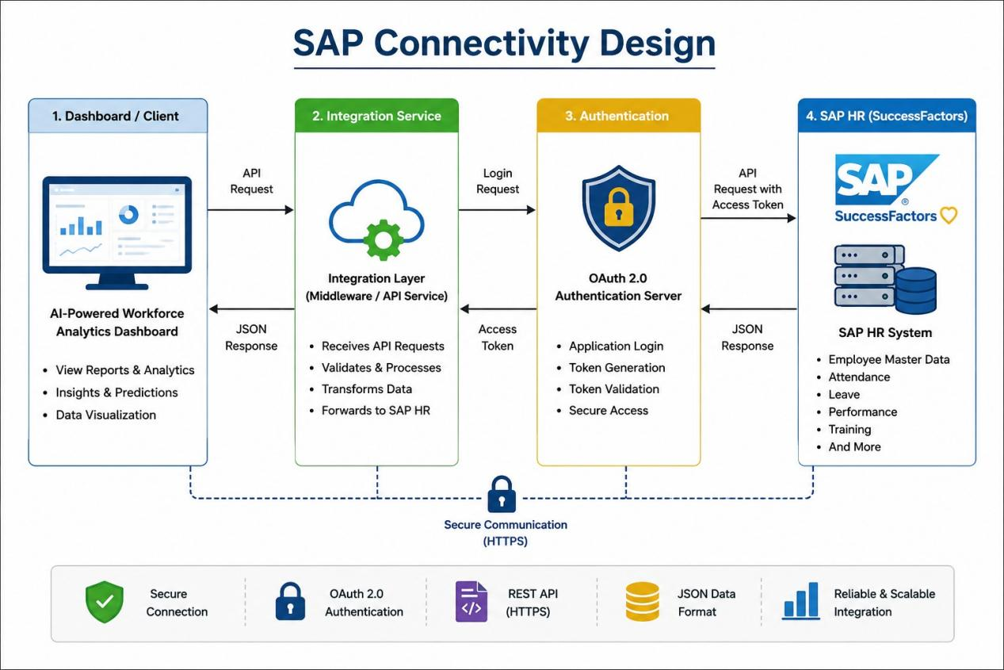

Benefits:-
- Secure communication
- Real-time employee data
- Easy integration
- Less manual work

3.SAP Connectivity Workflow

How It Works:-
- User opens the dashboard.
- Dashboard requests employee information.
- Integration Service authenticates with SAP.
- SAP verifies the request.
- SAP sends employee data.
- Dashboard displays reports and analytics.

Simple Data Flow:
User
│
▼
Dashboard
│
▼
Integration Service
│
▼
OAuth Server
│
▼
SAP API
│
▼
Employee Database
│
▼
Dashboard Reports

Advantages:-
- Fast data transfer
- Accurate information
- Secure access
- Easy to manage
4.System Architecture
The system architecture shows how different components work together to securely transfer employee data from SAP HR to the AI Workforce Analytics Dashboard. Each component has a specific role in the system.

Architecture Diagram:-
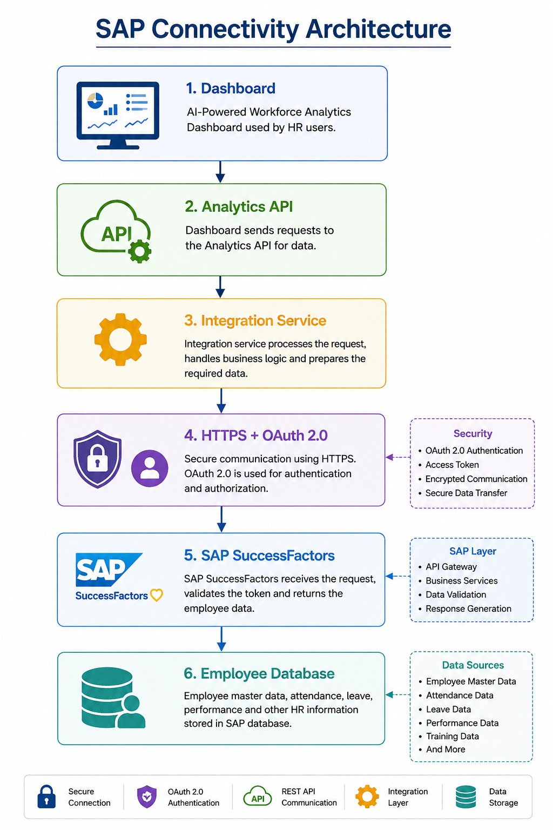

User Interface (Dashboard):
The User Interface is the front-end of the application where users can view workforce reports, employee details, and analytics. It sends requests to the backend whenever data is needed.
Purpose:
- Displays reports and dashboards.
- Allows users to access workforce information.
- Sends requests for employee data.

Workforce Analytics API:
The Workforce Analytics API receives requests from the dashboard and processes them. It acts as the communication layer between the dashboard and the Integration Service.
Purpose:
- Receives requests from the dashboard.
- Processes employee data requests.
- Sends responses back to the dashboard.

Integration Service:
The Integration Service acts as the bridge between the application and SAP HR. It handles authentication, sends API requests, receives employee data, and converts the response into JSON format.
Purpose:
- Connects the dashboard with SAP HR.
- Sends and receives API requests.
- Converts data into JSON format.
- Handles errors and validates access tokens.

OAuth 2.0 Authentication:
OAuth 2.0 verifies the identity of the application before it can access SAP HR. After successful authentication, SAP provides an Access Token that is used for secure communication.
Purpose:
- Authenticates the application.
- Generates Access Tokens.
- Prevents unauthorized access.

SAP SuccessFactors REST API:
The SAP SuccessFactors REST API provides secure access to employee information stored in SAP HR. It receives authenticated requests and returns the required employee data.
Purpose:
- Provides secure access to SAP HR data.
- Processes API requests.
- Returns employee information.

SAP HR Employee Database:
The SAP HR Employee Database is the main storage system for employee information. It contains data such as employee profiles, departments, attendance, leave, payroll, and performance records.
Purpose:
- Stores employee information.
- Acts as the primary data source.
- Provides data for reports and analytics.

5. Security Design:
Security is an important part of SAP connectivity because employee information is private and should only be accessed by authorized users. The proposed design uses different security methods to protect data while it is being transferred between the AI Workforce Analytics Dashboard and SAP HR.
- Security Features

1. OAuth 2.0 Authentication
Before the dashboard can access employee data, it must first prove its identity using OAuth 2.0. After successful verification, SAP provides an Access Token. This token is used for all API requests instead of a username and password, making the connection more secure.

2. HTTPS Encryption
All communication between the dashboard and SAP HR takes place over HTTPS. HTTPS encrypts the data during transmission, which helps protect sensitive employee information from unauthorized access or interception.

3. Access Tokens
Instead of sending login credentials with every request, the application uses a temporary Access Token. The token is valid only for a limited time and must be renewed after it expires. This reduces the risk of unauthorized access.

4. Role-Based Access Control (RBAC)
Different users have different responsibilities. RBAC ensures that users can only access the information they are authorized to view. For example, an HR manager may access employee records, while other users may only view reports.

5. Secure Credential Storage
Important credentials such as the Client ID and Client Secret are stored securely using environment variables or a secure storage service. They are not hardcoded into the application, which helps protect them from unauthorized users.

6. Logging and Monitoring
Every API request is recorded in a log file. These logs help developers monitor system activity, identify errors, and investigate security issues if they occur.

API & Authentication Configuration Plan

1. Introduction
This document explains how the AI-Powered Workforce Analytics Dashboard connects securely with SAP HR using APIs and authentication.
The main purpose is to transfer employee information safely between SAP HR and the dashboard.
The communication uses REST APIs and OAuth 2.0 authentication.

2. API Configuration Plan

Purpose
Configure the application so it can communicate with SAP HR.

Explanation
The application sends API requests to SAP HR to get employee information.
The communication is done through REST APIs.
The data is transferred in JSON format using HTTPS.

Configuration Details
Parameter | Value
API Type | REST API
Protocol | HTTPS
Data Format | JSON
Authentication | OAuth 2.0
Authorization | Bearer Token

3. Authentication Plan

Purpose
Ensure that only authorized applications can access SAP HR data.

Explanation
Before requesting employee information, the application must authenticate itself.
SAP verifies the application and provides an Access Token.
The Access Token is used for all API requests. 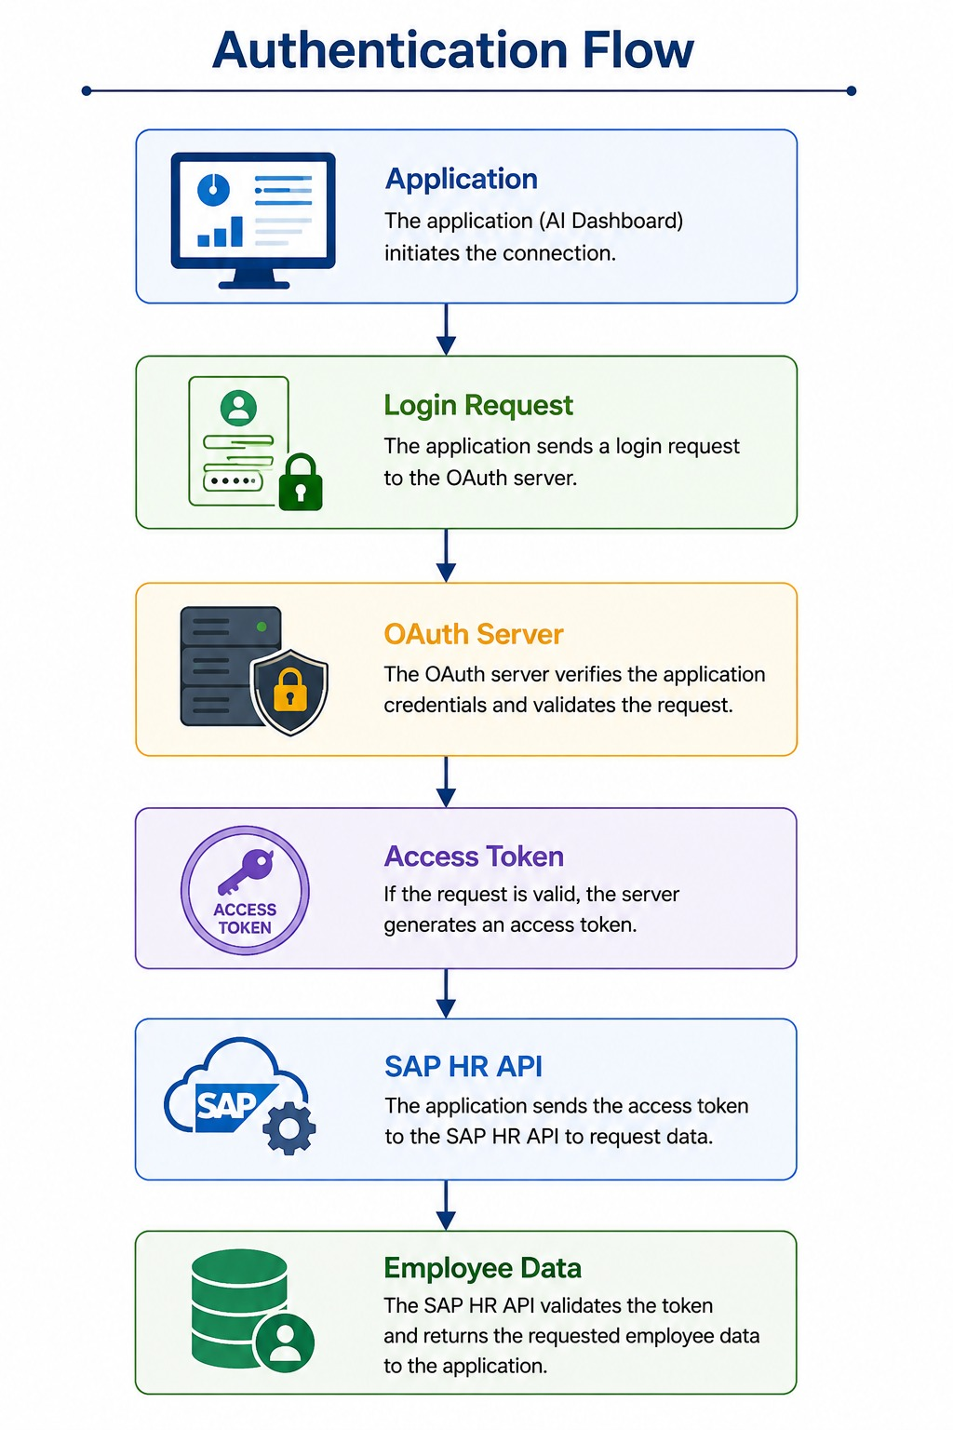

4. API Workflow

Purpose
Shows how employee data is transferred.

Workflow
- User opens the dashboard.
- Dashboard requests employee data.
- Application authenticates with SAP.
- SAP verifies the request.
- SAP returns an Access Token.
- Application requests employee information.
- SAP returns employee data.
- Dashboard displays analytics.
Workflow Diagram
Dashboard

↓

Authentication

↓

REST API

↓

SAP HR

↓

Employee Data

↓

Dashboard

5. API Endpoints

Purpose
List the APIs used for communication.
API | Method | Purpose
/login | POST | User Authentication
/employees | GET | Retrieve Employee Details
/departments | GET | Retrieve Department Details
/attendance | GET | Retrieve Attendance Records
/training | GET | Retrieve Training Information

Sample Request
GET /employees HTTP/1.1

Authorization: Bearer ACCESS_TOKEN

Content-Type: application/json

Sample Response
{
"employeeId":"1001",
"employeeName":"Rahul",
"department":"IT",
"designation":"Software Engineer"
}

6. Security Best Practices
The following security methods are used:
- Use HTTPS for secure communication.
- Use OAuth 2.0 authentication.
- Store Client ID and Client Secret securely.
- Use Access Tokens instead of passwords.
- Validate every API request.
- Log API activities for monitoring.

