AI ANALYSIS WORKFLOW DESIGN
Creation of Workforce Insights Dashboard for Employee Skill & Analytics
Prepared by - Tanisha Gehlot

OVERVIEW
1. Executive Summary
This document defines the Milestone 2 AI analysis workflow for the AI-Powered Workforce Analytics & Talent Intelligence Dashboard. It establishes a controlled flow from validated workforce data through preprocessing, feature engineering, machine-learning analysis, validation, insight generation, automation and dashboard-ready outputs.
The current implementation uses the IBM HR Analytics Employee Attrition dataset and a Random Forest classifier. The workflow acts as an orchestration layer that controls how approved inputs are processed and how validated outputs are released to reporting and dashboard components.
1.1 Objectives
- Define the complete flow from approved workforce data to AI-generated insights.
- Specify data-quality checks, transformation steps, model inputs, validation metrics and publication controls.
- Define configurable triggers for refresh, risk alerts, retraining and exception handling.
- Establish a consistent output contract for risk, trends, alerts, model metrics and recommendations.
- Maintain clear data boundaries so unsupported analysis is not presented as completed prediction.
1.2 Scope
Area | Definition
Input | Approved workforce records from enterprise HR sources or the current Excel/CSV implementation dataset.
AI Analysis | Workforce trend monitoring, attrition prediction, workforce health/engagement analysis and skill-gap integration.
Controls | Data-quality gate, model-validation gate, automation triggers and audit logging.
Outputs | Validated risk scores, trend metrics, alerts, model metrics and business-readable insights.

WORKFLOW ARCHITECTURE
2. End-to-End AI Workflow
The primary workflow below is intentionally presented in the same visual style as the presentation: sequential stages, clear gates, and a controlled output path
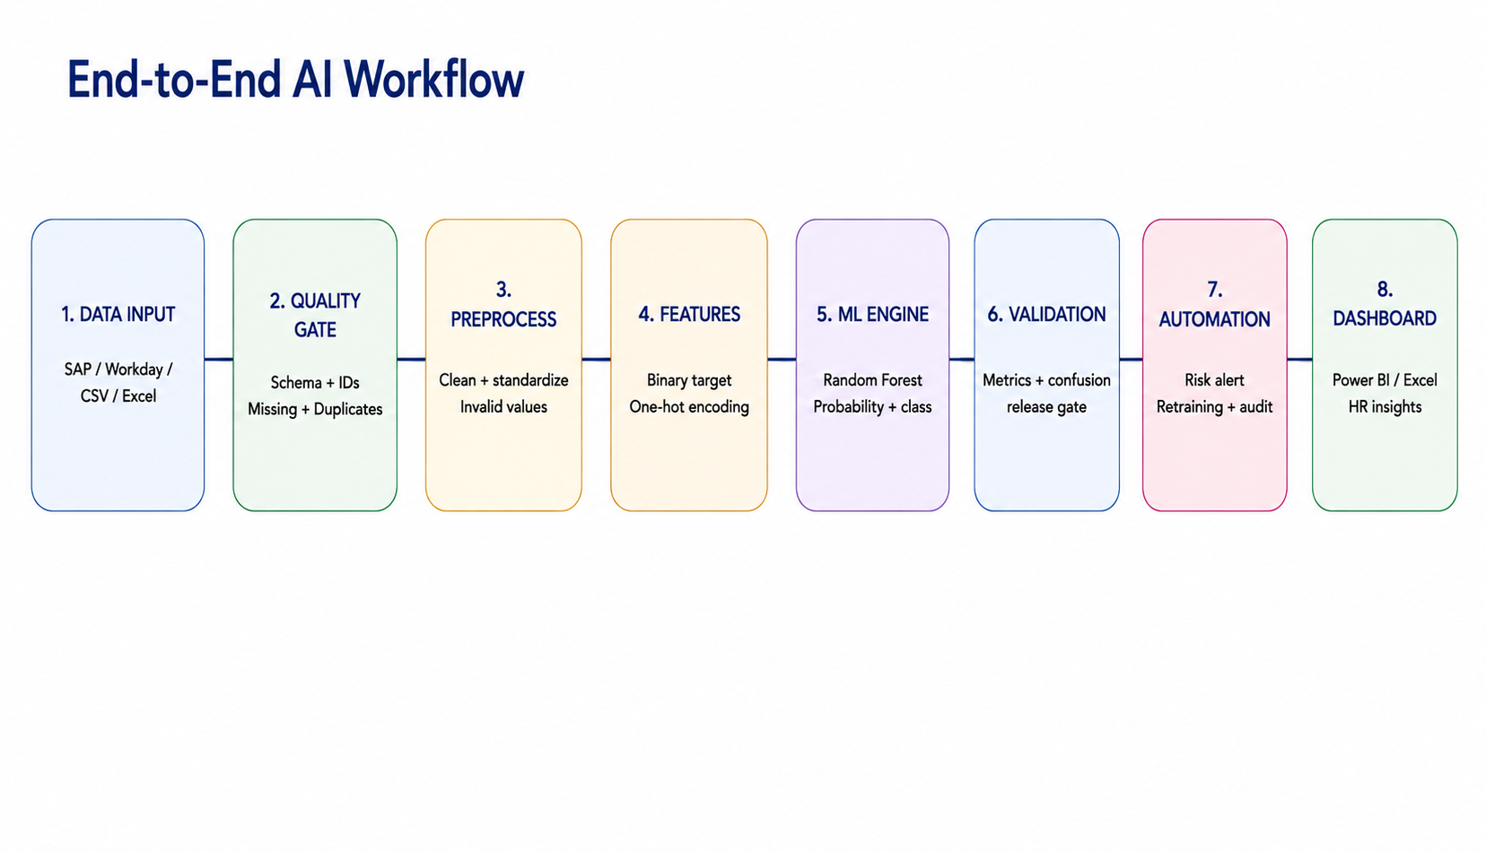
Key principle
No prediction is published until the required data-quality and model-validation gates pass.

PROCESSING LOGIC
3. Data Flow & Processing Steps
Each stage produces a defined output for the next stage. The two-column layout is used only for readability; the numbered sequence remains the source of execution order.
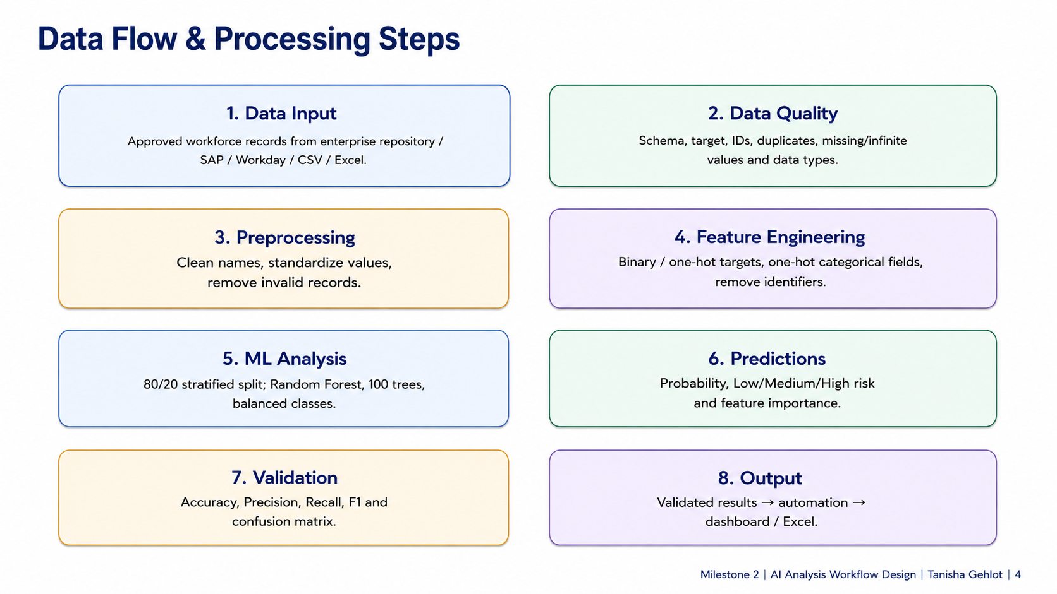
3.1 Processing Controls
Control | Definition
Data Quality | Schema, target, identifiers, duplicates, missing/infinite values and data types are checked before downstream processing.
Preprocessing | Column names and values are standardized and invalid records are removed.
Feature Engineering | Binary Attrition target, one-hot categorical fields and identifier exclusion prepare the ML-ready matrix.
Prediction & Validation | Probability, risk category and validation metrics are generated before release.

AI MODEL
4. Machine-Learning Engine & Validation
The current workflow uses a Random Forest classifier for attrition analysis.
Model Item | Current Configuration
Algorithm | Random Forest Classifier
Trees | 100
Class Handling | class_weight = balanced
Training Split | 80% training / 20% testing, stratified
Random State | 42
Model Output | Predicted class, attrition probability and Low/Medium/High risk category
Validation | Accuracy, precision, recall, F1-score and confusion matrix
4.1 Current Validation Results
Accuracy | Precision | Recall | F1 Score
83.67% | 44.44% | 8.51% | 14.29%
Validation interpretation
Accuracy alone is not sufficient for attrition detection. The reported recall and F1-score indicate that further tuning and validation are required before autonomous production HR decisions.
4.2 Key Model Drivers
- Monthly Income
- Age
- Daily Rate
- Total Working Years
- Distance From Home
- Monthly Rate
- Years With Current Manager
- OverTime

AI ANALYSIS BRANCHES
5. AI Analysis Branch Architecture
Validated ML-ready features are routed into complementary workforce intelligence branches and then consolidated into validated insights.
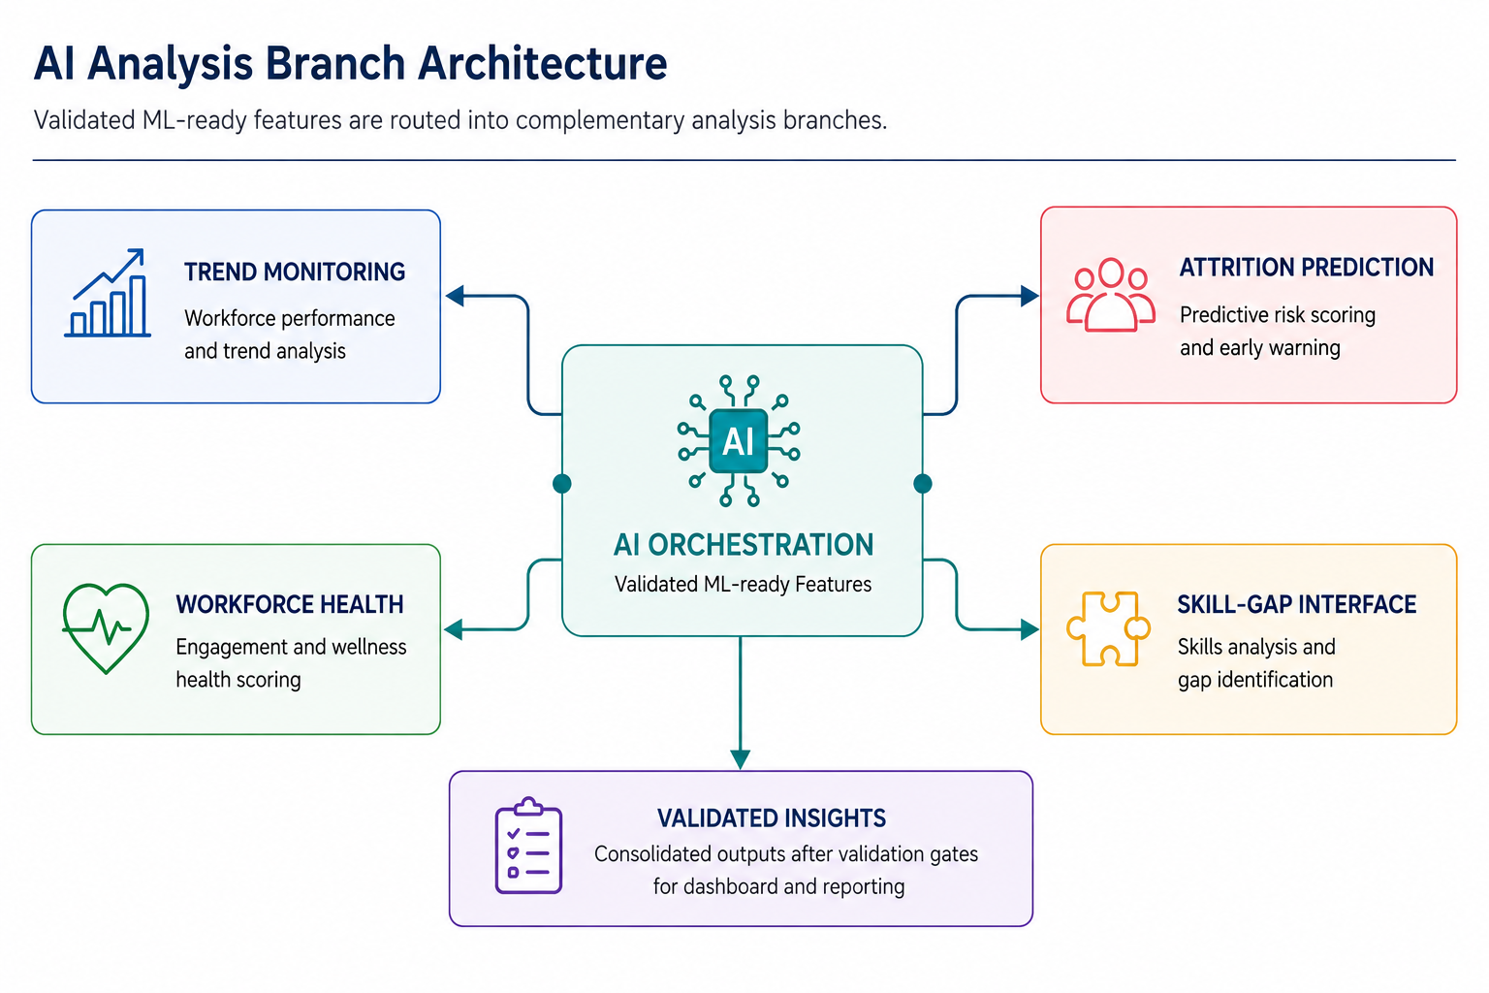

AUTOMATION & CONTROL
6. Automation & Exception Handling
Automation keeps the workflow current while preserving controlled publication and traceability.
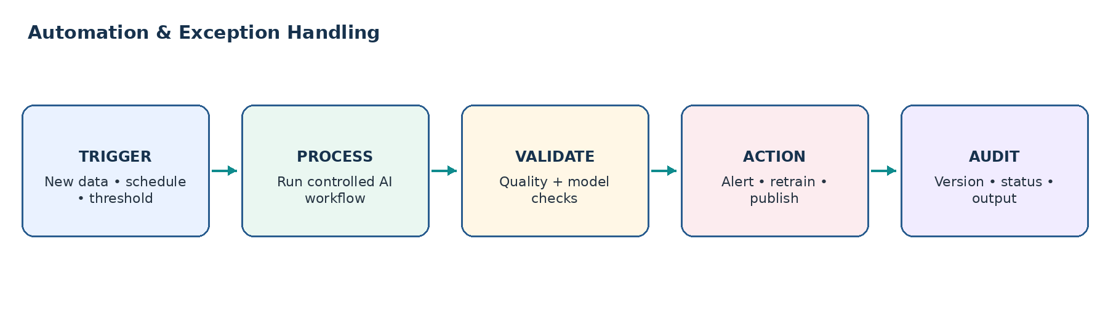
Trigger | Automated Action
New / Updated Dataset | Run ingestion and the full AI workflow when an approved dataset arrives.
Scheduled Refresh | Run routine workforce monitoring and dashboard refresh.
Risk Threshold | Create an alert when a configured attrition-probability threshold is crossed.
Retraining | Run retraining after a configured record-count or cadence trigger.
Data-Quality Failure | STOP downstream processing → LOG → NOTIFY → retain the last validated output.
Model-Validation Failure | HOLD prediction publication → LOG → retain the last validated output.

OUTPUT & GOVERNANCE
7. Dashboard-Ready Output Contract
Output | Fields / Contents
Employee Risk | Probability, risk category, prediction timestamp and top model drivers.
Model Metrics | Accuracy, precision, recall, F1, confusion matrix and release status.
Trend Metrics | Attrition rate, risk distribution and approved workforce dimensions.
Alerts | High-risk count, threshold, severity and HR review status.
Recommendations | Validated business actions derived from approved upstream outputs.
7.1 Employee Search Use Case
When HR searches an employee, the workflow can return available employee attributes together with validated attrition risk and top model drivers. Historical risk trends require stored prediction snapshots across multiple periods.
7.2 Data Availability & Governance
- The current IBM HR Attrition dataset does not directly provide an attendance/leave-history system.
- The current dataset does not contain an employee skills inventory or role-skill taxonomy.
- Promotion prediction requires direct promotion outcome/history data; the current dataset alone is insufficient for supervised promotion prediction.
- Historical risk trends require stored prediction snapshots across multiple periods.
- Unsupported outputs must not be presented as completed predictions.
- Model-driven HR actions should use validated outputs and appropriate human review.

