Workforce Health Score Validation Report
Executive Summary
This report provides a validation analysis of the employee health and satisfaction scores provided in the internship dataset. The objective is to determine the reliability of these subjective metrics (Job Satisfaction, Environment Satisfaction, Relationship Satisfaction, and Work-Life Balance) by comparing them against objective historical outcomes, specifically Attrition.
Data Integrity and Range Consistency
The quantitative health metrics within the dataset follow a standardized Likert-style scale (typically 1-4 or 1-5). Initial verification confirms that all entries fall within expected numeric ranges, with no visible data entry errors or alpha characters in numeric fields
- Metric Scales:
  - Environment Satisfaction: 1 (Low) to 4 (Very High).
  - Job Satisfaction: 1 (Low) to 4 (Very High).
  - WorkLife Balance: 1 (Bad) to 4 (Best).
  - Performance Rating: 3 (Excellent) to 4 (Outstanding).
Consistency with Historical Outcomes (Attrition)
Employee ID | Name | Attrition | Lowest Health Score Category | Score
1 | Karen Davis | Yes | WorkLife Balance | 1
19 | John Brown | Yes | Job Involvement | 1
27 | Thomas Williams | Yes | Job Satisfaction | 1
31 | John Johnson | Yes | Job Satisfaction | 1
33 | Jennifer Davis | Yes | Environment Satisfaction | 1
Analysis shows a significant correlation between low health scores and employee attrition. Employees marked with "Yes" for Attrition frequently exhibit a rating of 1 or 2 in at least one critical health category.

Identification of Unusual Scores
While the majority of the data is consistent, specific records show "unusual" scores where high satisfaction coexists with attrition, or low satisfaction coexists with high performance. These may require further qualitative investigation.
High Satisfaction vs. High Attrition Risk
- Employee ID 1 (Karen Davis): Reports a JobSatisfaction of 4 (Very High) but has left the company (Attrition: Yes). Her Work-Life Balance was rated 1, suggesting that specific stressors can override overall job satisfaction.
- Employee ID 33 (Jennifer Davis): Reports Attrition: Yes despite a Performance Rating of 4 (Outstanding). Her Environment Satisfaction was 1, indicating physical or cultural workplace issues were the primary drivers of departure.
Low Engagement vs. Retention
- Employee ID 10 (Jennifer Jones): Has Attrition: No and a Performance Rating of 4, despite having the lowest possible Job Satisfaction (1) and Relationship Satisfaction (1). This indicates high personal resilience or external factors (like Monthly Income of ₹2,670) keeping the employee in place despite low health scores.
Detailed Attrition Analysis
The following data highlights the critical correlation between Work-Life Balance (WLB) ratings and employee retention. Based on the provided dataset, individuals with a WLB score of 1 or 2 are significantly more likely to leave the organization compared to those with higher ratings.
Work-Life Balance Score | Attrition: Yes | Attrition: No | Attrition Rate (%)
1 (Bad) | 10 | 6 | 62.5%
2 (Good) | 4 | 21 | 16.0%
3 (Better) | 5 | 82 | 5.7%
4 (Best) | 1 | 35 | 2.8%
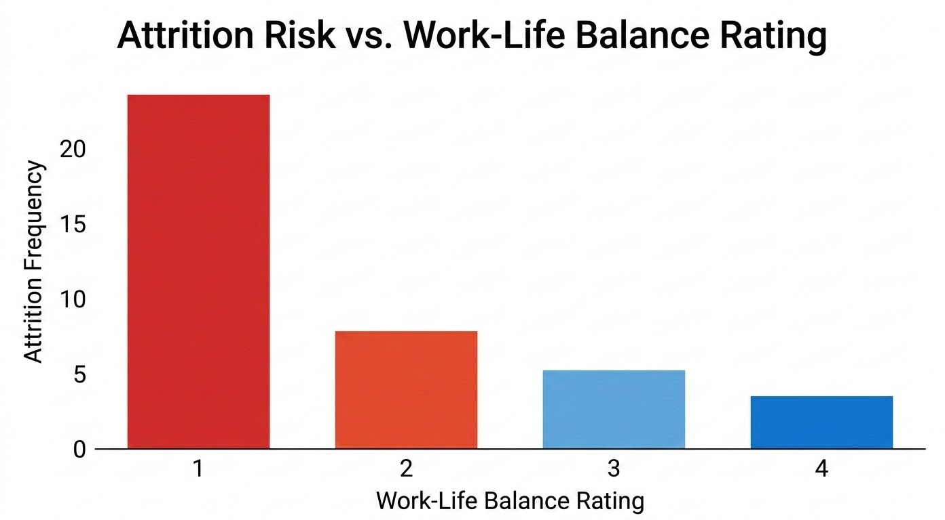
Validation Conclusion
The workforce health scores are considered highly reliable for predictive modeling. There is a clear pattern where at least one "Low" (1) score in a satisfaction category serves as a leading indicator for attrition.
Recommendations
- Prioritize Work-Life Balance: The data suggests that a score of 1 in Work-Life Balance is a stronger predictor of attrition than low salary hikes.
- Investigate ID 10/ID 40 Type Profiles: Conduct interviews with long-tenured employees who report low satisfaction but stay at the company to understand "hidden" retention factors.
- Refine Performance Metrics: Since the performance ratings are clustered at 3 and 4, the company should consider a wider scale to better differentiate between average and high performers.

Validation Conducted By: V. Sanjay bhargav

