AI Recruitment Chatbot

By Team:- Fire starters

BY:-Tanisha goyal(Team leader)

Tanishk aggarwal

|  |  |
| --- | --- |
|  |  |
|  |  |

**OVERVIEW OF PROJECT**

**Chat bot** is merely a computer program that fundamentally simulates human conversations. It allows a form of interaction between a human and a machine the communication, which happens via messages or voice command. A **chat bot** is programmed to work independently from a human operator.

### Our project is a kind of software bot i,e CHATBOT which is totally based on AI +ML .we have used IBM cloud's Watson assistant service.This chatbot will filter applicants on the basis of their qualification and their knowledge.

### As we can see that more and more applicants apply for job (may be in LAKHS) and to answer everyone's question is really a difficult task, not only this to choose among those by taking individual interview of every applicant is really a tough task, it takes a lot of time and resources . To solve this problem me and my team have decided to create a virtual assistant who gives information related to the job and also clear their doubts regarding the company or job. This virtual assistant also appoint an interview for them if and only if they clear their question-answer round .Their is a condition also that applicant must score more than 75% to qualify for the interview.

Moreover, our chat bot is providing the platform for the students whom to sit in the placement during this Covid-19 pandemic time. Through chat bot a student can virtually give their test and qualify for the final round in placement .

Although this also decrease the pressure on the student because through virtually they are unable to see how many students participant’s in it as a result they can easily give their best performance in it .

**PURPOSE**

One of the most important purpose of this chat bot it decrease the pressure among the students and increase their quality based performance even in this time when the Social Distancing is the main criteria. It may help in that also even that it not only select the **B.Tech**  candidate on basis of their coding skills but also some students have management based quality also, as a result most of the students get placed on the basis of their skills without getting any peer pressure on them .

Moreover, chat bot is one of most important factor for any company/institution for helping their customers/students for their help in 24X7 for their suitable time table.

It will be a time saving process for company to select candidate as they get only the relevant and suitable candidate for the interview.

Link to use our UI

<https://node-red-zrzva.eu-gb.mybluemix.net/ui/#!/0?socketid=Z14KQlcdxE2G6k7aAAA0>

Preview link of our chatbot

<https://web-chat.global.assistant.watson.cloud.ibm.com/preview.html?region=eu-gb&integrationID=d241aba5-ca36-4990-85a1-37adb0ba0349&serviceInstanceID=9c1ab459-6a21-41c8-8301-20694cc7dc30>

Existing problem

As we all are aware of the fact that, as the time is passing more and more students apply for a job. sometimes more than lakhs apply for a single post. The problem is that to handle such a big group of students and to choose best one out of them is a very big and tough task. We can't take interview of each and every student and also to conduct test for them is also a big task. Sometimes those who don't have required qualification and skills also apply for job and thus conducting a test and to take interview of them is waste of time and resourses.

some other problems are:-

Maintaining a scorecard:-While taking interview interviewer also has to maintain a scorecard where he writes score for each and every student and thus it will be very complex to evaluate the result.

Interviewer can be bias:-This is especially true in an interview situation – you’ll naturally gravitate to people you like without making a qualitative assessment of whether they can do the job or not.

Solution

The solution can be a Virtual assistant who can reduce the human efforts and is available 24x7. A bot can be a better solution sice it can take assist number of sudents or user simulataneously. It will filter out the best candidates on the basis of their knowledge and skills.

some points to solve the above writen problems:-

Chatbot is not biases:- A machine can't think like human so it will give us unbiased result.

need not to maintain scorecard:- A computer itself can evaluate the result and no and another resourse is required to maintain scores.

Time saving:- Interviewer only has to take interview of relevant and deserving candidates.

Information available:- A databse will be maintained which will store the information of every candidate.

Always available:- anyone from any part of the world can use it anytime.

Steps to setup project in your system:

Setting up node red

Step 1:- Open Node red folder which is downloaded through github.

Step2:- login to IBM cloud and create Node red service.

Step3:-import the node red file in your node red flow.

Step4:-if audio node is not recognized in your flow, click on the manage palllete and install node -red-contrib-play-audio.

Step5:-add userid and password in dashDB(both registration and login) and user_details node

Step6:-create a table in db2 with the fields given in login form

Setting to import chatbot

Step:-7 create Watson assistant service in ibm cloud.

Step8:-import Bot json file from Bot folder

Step9:-create preview link of this skills.

Stpe10:-add this preview link to “link of bot node” in place of already written link.

Block diagram

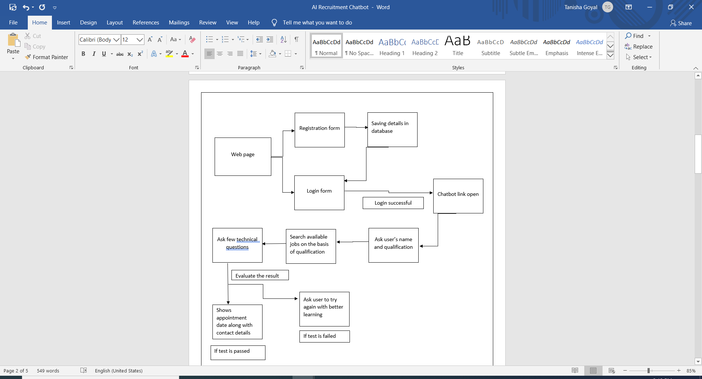

FLOWCHART

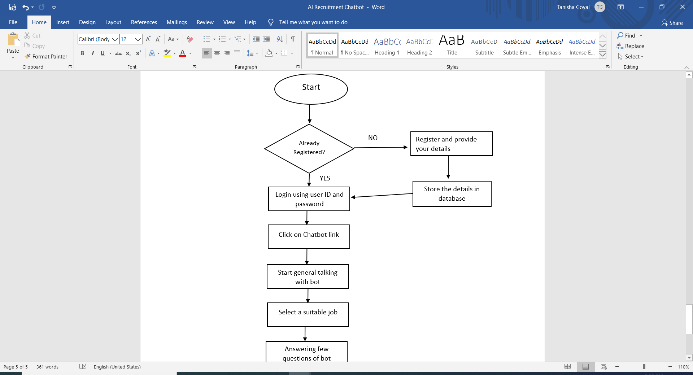

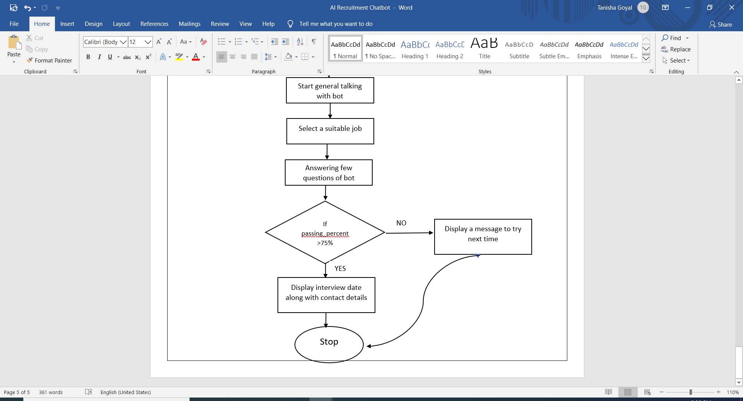

**ADVANTAGES**

Chat bot in itself have it’s own great advantages because humans can serve only limited number of clients at a time but that restriction doesn’t exist for the chat bots and they can manage all necessary queries at a time .

1. **Reduce Cost:-** Chat bots eliminate the need for labour during online interaction with customers. This is obviously a great advantage for companies that receive multiple queries at once. In addition to saving costs with them, companies can align the chat bot with their objectives, and use them as a means to enhance customer conversion.
2. **24/7 Availability:-** Unlike humans, once we install a chat bot, it can handle queries at any time of day. Thus, the customer does not have to wait for a commercial of the company to help him. This also allows companies to monitor customer « traffic » during non-working hours and contact them later. Even in our chat bot student can give their placement test any time as suitable their timings no restriction is apply on them. This is one of the major factor of our chat bot or any chat bot.
3. **Learning and Updating :-**  AI-based chat bots are able to learn from interactions and update independently. This is one of the main advantages. Whenyou hire a new employee, you have to train them continuously. However, chat bots « form » themselves. Mostly chat bot’s are made of these but in our chat bot we trained it by implying entities in it , setting particular messages in it and trained according to the students so that they can’t face problem regarding in the future of our chat bot .
4. **Management of multiple clients :-**  Humans can serve a limited number of customers at the same time. This restriction does not exist for chat bots, and they can manage all the necessary queries simultaneously. This is one of the main advantages of using chat bot, as no customer is left unattended and you are solving different problems at the same time. There are chat bots companies already working on developing voice chat bot services.

**DISADVANTAGES**

**Complex Interface :-**  It is often considered that chat bots are complicated and need a lot of time to understand what you want in customer. Sometimes, it can also annoy the client about their slowness, or their difficulty in filtering responses.

**They don’t get you right :-** Fixed chat bots can get stuck easily. If a query doesn’t relate to something you’ve previously « taught » it, you won’t understand it. This can lead to a frustrated a student and have a negative impact on company prestige. Other times they do understand you, but they need double (or triple) as many messages as one person, which spoils the user experience.

**Time-Consuming:-** Chat bots are installed with the aim of speeding up responses and improving customer/student interaction. However, due to the limited availability of data and the time needed for self-updating, this process can be slow and costly. Therefore, there are times when instead of serving several customers/students at once, chat bots may become confused and not serve the customer or not properly handle the students queries as well.

* **Installation cost :-**  Chat bots can attack the nerves of more than one because they are not able to make decisions.

This can lead to problems. For example: Microsoft launched a chat bot for Twitter. In less than 24 hours, the content it received from users turned it into a racist and misogynistic account.

It is very important that your chat bot is well optimized, so that it does not end up being a disaster like this.

**Bad Memory :-** The chat bots are not able to memorize a conversation already had, which forces the user to write the same thing over and over again. This can be cumbersome for the client and annoying for the effort required. Therefore, it is important to be careful when designing chat bots and make sure that the program is able to understand users’ queries and respond accordingly.

**APPLICATIONS**

Chat bot is a platform which is agnostic manner. Whether they are on website, Facebook Messenger, email or some other platform, chat bot are essentially conversational interfaces.

Chat bot is format which is used in every field as already mentioned in the above statement but one of the main point is that company can get the right candidate according their demands as result they easily know about that how much a person is a techno savvy or not because for CSE student it is quite easy to clear all the rounds virtually i.e., a person also learn about the company norms and provision that what kind of platform company required or in which field they want to work as a result in future it may have great scope for the students.

**CONCLUSION**

Chat bot is one of the main criteria for any company in this **COVID-19** pandemic time because through virtually company get the right candidate for their job role although it may also decrease the peer pressure among students as result they can easily give their best performance in their test in our chat bot we fulfill all the candidate‘s requirement because not everyone is good in coding some students are good in other fields also like – content writing, marketing, SEO jobs UI/UX designing, etc. This shows that our chat bot providing the right platform to every student whether they are belong to any community it doesn’t matter because it provide the jobs all the students on their skills not particularly on the coding based .

Moreover our chat bot include also include certain question’s for those students also who are interested in the coding also as a result chat bot is platform where every particular branch can take the part in it and may have bright future for increasing their skills regarding in it .

**FUTURE SCOPE**

**Removing barriers to entry** :- Currently the chat bot are increasing day-by-day as result at a rate of 24% annually the industry is projected about $1.2 million dollar market by 2025 as a result it may lead to tremendous change in a IT sector as a result most of the works are done through only chat bots especially the placement which involve lot of candidates so through virtually we can get a creamy students for a company on the basis of their skills.

**Linguistic and conversational ability must improve** :-

Chat bots are terrible conversation. The anticipated benefits of chat bot often fall short due to their notoriously robotic language, inflexibility and difficulty in understanding intent and nuance of the language. User experience demands a consistent, clear and focused personality so that humans can easily interact with machine without facing any difficulty.

|  |  |  |  |
| --- | --- | --- | --- |
|  |  |  |  |
|  |  |  |  |
|  |  |  |  |
|  | Biblography | | |

Took help from Google

Took help from Cognitive course

https://www.edx.org/course/AI-chatbots-without-programming

https://www.edx.org/course/smarter-chatbots-with-node-red-and-watson-ai

<https://nodered.org/docs/user-guide/>

|  |  |  |  |
| --- | --- | --- | --- |
|  |  |  |  |
|  |  |  |  |
|  |  |  |  |
|  |  | | |

|  |  |  |  |
| --- | --- | --- | --- |
|  |  |  |  |
|  |  |  |  |
|  |  |  |  |
|  |  | | |

|  |  |  |  |
| --- | --- | --- | --- |
|  |  |  |  |
|  |  |  |  |
|  |  |  |  |
|  |  | | |

|  |  |  |  |
| --- | --- | --- | --- |
|  |  |  |  |
|  |  |  |  |
|  |  |  |  |
|  |  | | |

|  |  |  |  |
| --- | --- | --- | --- |
|  |  |  |  |
|  |  |  |  |
|  |  |  |  |
|  |  | | |

Block Diagram

|  |  |  |  |
| --- | --- | --- | --- |
|  |  |  |  |
|  |  |  |  |
|  |  |  |  |
|  |  | | |

|  |  |  |  |
| --- | --- | --- | --- |
|  |  |  |  |
|  |  |  |  |
|  |  |  |  |
|  |  | | |

Block Diagram

|  |  |  |  |
| --- | --- | --- | --- |
|  |  |  |  |
|  |  |  |  |
|  |  |  |  |
|  |  | | |

Flowchart



    
    
    
    