Internship at Tech Fortune Technologies, Bangalore
INTERNSHIP REPORT SUBMITTED
TO
THE DEPARTMENT OF COMPUTER SCIENCE

IN PARTIAL FULFILLMENT OF THE REQUIREMENTS FOR THE AWARD OF
BACHELOR OF SCIENCE
In
Computer Science and Mathematics
BY
Tanisha Jain
2440156
DEPARTMENT OF COMPUTER SCIENCE
CHRIST (DEEMED TO BE UNIVERSITY)
BANGALORE-560029
INDIA

JULY 2025
DECLARATION

I hereby declare that the content of this internship report entitled "INTERNSHIP AT TECH FORTUNE TECHNOLOGIES, BANAGLORE" is the result of work carried out by me at Tech Fortune Technologies, Bangalore under the supervision of Ms. Srusti S Deshmukh. This work is part of my academic requirements in the Department of Computer Science at CHRIST (Deemed to be University). No part of this work has been presented for any other degree or diploma.

Bangalore Tanisha Jain
July 2025 2440156

ACKNOWLEDGEMENTS

I am profoundly grateful to Fr. (Dr.) Joseph C C, Vice Chancellor, CHRIST (Deemed to be University), Bengaluru, for providing an excellent academic environment and facilities.
My sincere thanks to Dr. T V Joseph, Dean of School of Sciences, for his constant support and encouragement.
I would like to express my deep gratitude to Dr. Ashok Immanuel V, Head, Department of Computer Science, CHRIST (Deemed to be University), for his guidance and support throughout this project.
I am also thankful to my external guide, Ms.Srusti S Deshmukh, Tech Fortune Technologies, Bangalore, for his valuable insights and assistance during my internship.
I extend my heartfelt thanks to my internal guide and UG Coordinator, Dr. Manjunatha Hiremath, for his continuous support and mentorship.
Finally, I would like to thank my family and friends for their unwavering support and encouragement throughout my academic endeavours.

ABSTRACT

Title: Front-End Web Development Internship at Tech Fortune Technologies, Bangalore.
During the summer of 2025, I completed a one-month internship (26/04/2025 to 27/05/2025) at Tech Fortune Technologies, a web development company in Bangalore, Karnataka. My primary responsibility was to independently design and build a visually engaging and interactive e-commerce-like product website. The internship focused on front-end development, and I created dynamic interfaces for product listings, product detail pages, and a working cart system entirely using HTML5, CSS3, Bootstrap 5, JavaScript, along with backend integration using PHP and MySQL.
Key features of the project included the implementation of client-side storage using localStorage for maintaining product selections and cart data, as well as dynamic event-driven functions to support cart updates, quantity adjustments, and price calculations. I also developed logic for image switching on thumbnail clicks, responsive layout design using Bootstrap’s grid system, and form handling for user interaction. In addition to the front-end features, I connected the website to a MySQL database through PHP for handling product details, storing user information, and performing basic CRUD operations, which provided a more realistic e-commerce workflow.
Throughout this experience I gained practical exposure to JSON parsing, UI design patterns, database connectivity, and client-server interaction. Working with tools like Visual Studio Code, MySQL Workbench, and browser developer tools helped me debug issues efficiently and deliver a fully responsive, user-friendly web application. The internship significantly improved my problem-solving skills, logical reasoning, and independent project handling — reinforcing my interest and capabilities in front-end as well as backend web development.
Keywords: HTML5, CSS3, JavaScript, Bootstrap, localStorage, DOM Manipulation, Web Design, Visual Studio Code, Responsive UI, PHP, MySQL

CONTENTS
Chapter 1 – Introduction to the Organization
1.1 Profile of the organization
1.2 Vision, Mission, Goals of the organization
Chapter 2 – Project/Task Description:
2.1 Background of the internship
2.2 Objectives and goals of the internship
2.3 Scope and limitations
2.4 Detailed description of the project or tasks assigned during the internship
2.5 Technologies used
2.6 Challenges faced and how they were addressed
Chapter 3 – Methodology, Results and achievements
3.1 Approach/methods used to accomplish the assigned tasks
3.2 Development process (if applicable), Tools and techniques utilized
3.3 Accomplishments during the internship, Key outcomes of the project/task.
3.4 Detailed technical aspects of the project.
3.5 SWOC analysis of the organization (Based on observations by the student, backed by facts and examples, must include strengths, strategies and success factors, weaknesses, opportunities and challenges)
Chapter 4 – Internship Experience
4.1 Skills acquired during the internship
4.2 Lessons learned
4.3 Challenges encountered during the internship.
Chapter 5 – Conclusion: Summary of the internship experience

Chapter 1 – Introduction to the Organization

1.1. Profile –
Tech Fortune Technologies is an emerging technology and business solutions enterprise headquartered in Vijayapur, Karnataka, with operational branches in Bangalore, Belagavi, and Hubballi. Founded in 2013, the company began its journey in the Engineering, Procurement, and Construction (EPC) domain, focusing on infrastructure and real estate sectors. Over the past decade, it has successfully transformed into a multi-disciplinary IT services firm, delivering innovation-led and scalable solutions tailored to meet the evolving demands of modern enterprises.
Today, Tech Fortune Technologies operates as a full-spectrum IT and consulting firm, offering services across software development, mobile application development, IT infrastructure, cloud services, cybersecurity, BPO, strategic consulting, and digital transformation. With a deep commitment to innovation, the organization has invested significantly in cutting-edge domains such as Artificial Intelligence (AI), Machine Learning (ML), Blockchain, Cybersecurity, and Enterprise Resource Planning (ERP).
Despite being relatively young, Tech Fortune has earned a reputation for its client-first approach, agile project delivery, and cost-effective, quality-driven solutions. It is supported by a strong team of over 20 skilled professionals, including software engineers, domain experts, UI/UX designers, and project managers. The company serves a diverse clientele spanning sectors like e-commerce, education, banking, healthcare, government, and logistics.

Key Service Offerings –
1. Software Development & Custom Solutions
- Full-stack development of web, mobile, and desktop applications
- ERP and CRM systems tailored for SMEs and educational institutions
- API integration, payment gateways, and marketplace platforms
2. Mobile App Development
- Native and cross-platform applications (Android, iOS, Windows)
- RESTful API integration and cloud backend support
- Emphasis on UX, data security, and performance
3. IT Infrastructure & Cloud Services
- Cloud deployment and management (AWS, Azure)
- Virtualization, server monitoring, and network configuration
- End-to-end IT support services
4. Cybersecurity & Compliance
- Vulnerability Assessment and Penetration Testing (VAPT)
- Firewall configuration, endpoint security, and audits
- Assistance in ISO 27001 and GDPR compliance
5. Digital Transformation & Smart Services
- E-governance and citizen services
- Workflow automation, digital identity systems
- AI-powered analytics dashboards and smart city solutions
6. IT Consulting & Advisory
- Technology strategy, Agile and DevOps implementation
- Resource augmentation and IT talent deployment
- Business process improvement and digital roadmap planning
7. Business Process Outsourcing (BPO)
- Data entry, digitization, and documentation services
- RPO, payroll processing, and loan servicing
- Specialized services like legal analytics and medical transcription
These services are reinforced by dedicated teams in Quality Assurance, Project Management, Technical Support, and Regulatory Compliance, ensuring timely and efficient project execution.

Leadership and Team
Tech Fortune Technologies is led by an experienced and forward-looking leadership team:
- Mallari Kulkarni – Founder and Director
A seasoned entrepreneur with expertise in operations and strategic planning. He brings strong leadership in transforming ideas into scalable business models.
- Manjushree Mashal – Head of Business Strategy
A strategist focused on innovation and market alignment. She leads initiatives to integrate emerging technologies into the service portfolio.
- Sagar Awati – Head of Operations
Responsible for delivery excellence and customer satisfaction. He oversees project execution, process mapping, and employee development programs.
The leadership is further supported by industry and academic advisors specializing in cloud, data analytics, enterprise architecture, and machine learning. The broader team includes software architects, developers, QA analysts, DevOps engineers, and UI/UX specialists, working collaboratively to deliver high-performance solutions.

Growth and Recognition
In recent years, Tech Fortune Technologies has experienced significant growth and industry recognition. Notable achievements include:
- Strategic partnerships with major IT vendors and solution providers
- Long-term MoUs with engineering institutions for student training and internships
- Recognition by local industry bodies for enabling MSMEs through tech solutions
- Successful implementation of proprietary platforms like student management systems and logistics tracking tools
- Active CSR programs such as tech boot camps, skill workshops, and job fairs in Tier 2 and Tier 3 cities
These initiatives reflect the company’s adaptability, innovation, and commitment to community development.

Work Culture and Human Capital
Tech Fortune Technologies believes that people are its greatest asset. The company fosters a transparent, inclusive, and performance-driven work environment. It emphasizes continuous learning, innovation, and employee engagement.
Key HR and Work Culture Highlights –
- Diverse and merit-based recruitment
- Employee development through certifications and mentorship
- Performance-linked appraisals and growth opportunities
- Internal forums for idea exchange and innovation
- Encouragement of work-life balance and social responsibility
The company’s HR practices aim to build a strong, motivated, and future-ready workforce aligned with its strategic goals.

1.2. Vision, Mission, Goals –

Vision –
To emerge as a recognized leader in IT services and digital transformation, delivering innovation-led, customer-first solutions that simplify complex business challenges. Tech Fortune aspires to make a lasting impact by enabling operational excellence and sustainable growth through technology.

Mission –
To deliver high-quality, timely, and cost-effective technology solutions that foster trust, innovation, and collaboration. The organization seeks to bridge the demand-supply gap in technology services by understanding client needs and nurturing long-term partnerships. It aims to build a collaborative digital ecosystem that supports sustainable progress and inclusive development.

Strategic Goals –
1. Client-Centric Excellence
Deliver customized, responsive, and innovative solutions that exceed client expectations.
2. Process Optimization and Quality Assurance
Streamline internal workflows and enforce quality standards for compliance and risk mitigation.
3. Technological Advancement
Invest in upskilling and adopting emerging technologies such as AI, ML, Cloud, and Cybersecurity.
4. Human Capital Development
Foster an inclusive and growth-driven environment that promotes innovation, leadership, and employee engagement.
5. Strategic Collaborations
Forge partnerships with academic institutions, industry leaders, and technology firms to co-create knowledge and solutions.
6. Sustainable and Ethical Operations
Uphold ethical business conduct, promote social responsibility, and support environmental sustainability through all initiatives.

Chapter 2 – Project Description

2.1. Background of the Internship
As part of my one-month internship at Tech Fortune Technologies, I was assigned to the Web Development and UI Design Department, where I gained practical exposure to front-end development within a structured and industry-oriented setting. The internship was strategically divided into two major phases — a learning and mini-task execution phase during the first three weeks, and a project implementation phase during the final two weeks.
During the initial phase, I was mentored in core web development technologies, including HTML5, CSS3, JavaScript,Php and Bootstrap 5. I undertook a series of mini-projects and exercises such as designing login forms, creating responsive employee data tables, and working with layout structures using Bootstrap.
In the final phase, I was assigned a capstone project — to design and develop a mini e-commerce food ordering website. Inspired by real-world platforms like Swiggy and Amazon, the goal was to create a responsive and interactive single-page web application allowing users to view food items, view details, and add them to a shopping cart. Key features included a carousel, navbar, product details page, cart summary, and user authentication pages like Login and Sign-Up. The application emphasized modular code design, intuitive navigation, clean UI, and real-time interactivity using JavaScript.

2.2. Objectives and Goals of the Internship
The internship aimed to bridge the gap between academic knowledge and real-world application by immersing interns in actual development workflows. The specific objectives were:
• To gain practical exposure to front-end web development using HTML, CSS, JavaScript, and Bootstrap, along with backend integration through PHP and MySQL.
• To understand the structure and modularity of a web application, including multi-page layout planning and database connectivity.
• To implement interactive UI components and enhance user experience through dynamic JavaScript functionality and responsive design.
• To build an independently managed web application that demonstrates both front-end and backend skills in a practical context.
• To improve problem-solving and debugging techniques using browser tools, MySQL Workbench, and structured testing.
• To understand how to modify and extend Bootstrap components according to project needs and connect them effectively with server-side logic.
Overall, the internship enabled me to develop a strong foundation in full-stack web development, improve my confidence in real-time coding, and prepare for industry-level projects by combining client-side and server-side technologies.

2.3. Scope and Limitations
The scope of my project extended to both front-end and backend development of an e-commerce food ordering platform. It involved designing multiple functional pages and dynamic components using HTML, CSS, Bootstrap, JavaScript, and integrating backend functionality with PHP and MySQL. Core pages and features included:
• Home Page: Showcased a responsive carousel with promotional banners and product listings.
• Product Details Page: Provided additional information about selected food items retrieved dynamically.
• Shopping Cart: Allowed users to add/remove items with real-time total calculation and updated records.
• Login and Sign-Up Pages: Structured forms for user input connected with PHP for basic authentication and data handling.
• Checkout Page: Displayed a summary of selected items, final amount, and stored order-related information in the database.
• About Page: Gave an overview of the platform and its purpose.
• Navbar & Footer: Persistent layout elements across all pages for consistent design.
Limitations:
• Authentication and user sessions were implemented at a basic level, without advanced encryption or security features.
• Payment and real-time order placement were not integrated; checkout only simulated the process.
• Product data and cart interactions were partly managed with localStorage, with only essential product details stored in the MySQL database.
• The backend logic was functional but limited to basic CRUD operations without advanced scalability.
Despite these limitations, the project was highly successful in achieving front-end interactivity, database connectivity, modular design, and a near-complete e-commerce workflow.

2.4. Detailed Description of the Project or Tasks Assigned

Phase 1 – Learning and Mini Tasks (Weeks 1 to 3)
Under the guidance of a senior developer, I completed a structured curriculum to understand web technologies in a layered manner:
- HTML Practice:
  - Created forms for login, registration, and data input.
  - Designed semantic pages with proper headings, lists, and tables.
- CSS Styling:
  - Applied internal and external stylesheets.
  - Learned positioning (relative, absolute, fixed), box model, and transitions.
- JavaScript Basics:
  - Practiced event handling (onclick, onsubmit), DOM selection, and manipulation.
  - Implemented basic scripts for form validation and dynamic content update.
- Bootstrap 5:
  - Created responsive navbars, cards, modals, buttons, and forms.
  - Used Bootstrap grid system and utility classes for layout management.
  - Integrated a carousel component for dynamic banner rotation.
Each task was carefully reviewed, and feedback was incorporated to improve code readability, accessibility, and mobile responsiveness.

Phase 2 – Final Project: E-Commerce Food Ordering Website (Weeks 4 to 5)
The final deliverable was a responsive and interactive mini e-commerce web application structured as a multi-page site with dynamic cart functionality and basic backend integration.
Main Features Developed:
• Home Page with Carousel:
Used Bootstrap’s Carousel component to display sliding food banners, adding aesthetic value and promotional appeal.
• Product Display Section:
Rendered using a JavaScript array containing product objects (name, image, price, description). Each product card included an “Add to Cart” button, with additional product details managed via a MySQL database connected through PHP.
• Cart Functionality:
o Dynamic updates on adding/removing items.
o Real-time total price and item count updates.
o DOM manipulation using JavaScript to reflect cart state.
o Cart data partially stored in MySQL through PHP for persistence.
• User Authentication Pages:
o Login and Sign-Up forms with fields (email, password, confirm password).
o Input validation using JavaScript.
o Backend integration with PHP and MySQL for storing and verifying user credentials (basic authentication).
• Checkout Page:
Summarized selected items with quantity, subtotal, and final amount. Order details were stored in the MySQL database through PHP, while a mock confirmation alert simulated the payment step.
• About Page:
Provided information about the platform’s objective and developer intent.
• Navbar Customization:
Initially implemented using Bootstrap’s default navbar. However, due to design limitations, I later customized the navbar by modifying the HTML structure and styling it with custom CSS to better match the theme and user flow.
Layout and Navigation:
• Persistent navbar and footer across all pages.
• Clean and mobile-friendly UI using Bootstrap’s grid and utility classes.
• Modular structure maintained by separating HTML, CSS, JavaScript, and PHP files, with database management handled in MySQL.

2.5. Technologies Used
The project made use of the following tools and technologies:
Technology | Purpose
HTML5 | Structuring all pages and forms
CSS3 | Styling layout, colors, typography, and hover effects
JavaScript | DOM manipulation, event handling, cart logic
Bootstrap 5 | Responsive layout, carousel, navbar, forms, and UI components
PHP | Server-side scripting for handling user data, authentication, and CRUD operations
MySQL | Database management for storing products, user credentials, and order details
VS Code | Primary code editor
These technologies were integrated cohesively to create a dynamic, responsive, and user-friendly full-stack web application.

2.6. Challenges Faced and How They Were Addressed
Challenge | Resolution
Navbar Customization | Initially used Bootstrap’s default navbar, which didn’t fit the design. I redesigned it with custom HTML/CSS while keeping it responsive and functional.
Carousel Integration | Understanding Bootstrap’s carousel structure and data attributes took time. I followed Bootstrap documentation and online examples to integrate it successfully.
Responsive Layout Issues | Product cards sometimes overlapped on smaller screens. I fixed this using Bootstrap’s grid system and media queries.
DOM Manipulation in JavaScript | Managing dynamic cart updates was complex. I learned to use querySelector, addEventListener, and innerHTML effectively.
Code Reusability and Modularity | My early code was repetitive. I refactored using arrays, functions, and loops for better maintainability.
CSS Conflicts with Bootstrap | Custom styles sometimes overrode Bootstrap classes. I scoped styles carefully and used Bootstrap utility classes wherever possible.
Database Connectivity (PHP–MySQL) | Initially faced errors while connecting PHP scripts to MySQL database. I resolved this by configuring mysqli_connect, checking server credentials, and debugging queries using MySQL Workbench.
Authentication Logic | Implementing login/sign-up with PHP and MySQL was challenging. I addressed it by creating a simple user table, validating form inputs, and storing credentials securely with basic hashing.
Time Management | Balancing learning with implementation was difficult. I planned daily tasks with realistic milestones to stay on track.
These challenges helped me become more confident and capable in writing clean, structured, and scalable code, while also strengthening my understanding of both front-end and backend development workflows.
Chapter 3: Methodology, Results, and Achievements

3.1. Methods Used to Accomplish the Assigned Tasks
My internship followed an Agile-based learning and development methodology, which emphasized hands-on experience, gradual complexity in tasks, and continuous mentor feedback. I began the internship with limited practical exposure, and no prior experience in a professional environment. However, through this structured, iterative process, I was able to evolve from building basic webpages to developing a full-fledged, interactive e-commerce project frontend.

Agile Learning Pathway
The structure of my internship was based on Agile principles—working in small sprints, learning new skills as needed, and improving through rapid feedback cycles. Rather than receiving formal classroom-style training, I was trained via practical assignments. Each task built upon the last, allowing me to consolidate my skills gradually.

3.2. Training Phase: Step-by-Step Skill Development
Week 1 – HTML Fundamentals
My training began with learning the structure of web pages through HTML. I was taught how to:
• Use semantic HTML tags like <div>, <section>, <article>, <header>, <footer>.
• Create lists, tables, forms, and hyperlink navigation.
• Design static pages with multiple sections and navigation links.
I was assigned a task to create a basic static webpage. This helped me become comfortable with the syntax and flow of structuring a complete webpage.
Week 2 – Styling with CSS
In the second week, I progressed to styling these pages using CSS. My key learnings included:
• Styling elements with classes and IDs.
• Creating layout designs with flexbox and grid.
• Adding hover effects, transitions, and font styling.
To apply this, I was assigned to create an employee webpage with hover animations and a visually engaging layout. This made the page dynamic and visually appealing, improving my understanding of responsive design.
Week 3 – JavaScript for Interactivity
The third week focused on making webpages interactive with JavaScript. Here, I learned to:
• Use JavaScript to respond to user input.
• Validate forms and display alert/confirmation messages.
• Dynamically show/hide elements or change content based on actions.
Assignments included validating form inputs (like email, password strength, etc.) and simple DOM manipulation. These formed the foundation for my work on the main project.
Week 4 – PHP for Server-Side Development
In the fourth week, I was introduced to PHP for backend development. I learned how to:
• Write PHP scripts to process form data and connect with a database.
• Use $_POST and $_GET methods to handle user input securely.
• Manage sessions and authentication logic for login and signup pages.
• Work with server-side validation alongside front-end validation.
I practiced these concepts by extending my forms to store user details in a database and validating them through PHP scripts.
Week 5 – MySQL and Database Integration
In the fifth week, I worked on integrating MySQL with PHP to make the application more realistic. I was taught to:
• Create and manage databases, tables, and relationships.
• Perform basic CRUD (Create, Read, Update, Delete) operations through SQL queries.
• Connect PHP scripts with MySQL using mysqli_connect and mysqli_query.
• Debug database issues using MySQL Workbench.
By the end of this week, I successfully connected my web application to a database, enabling dynamic storage of products, user information, and orders. This step marked the transition from a purely front-end project to a mini full-stack e-commerce application.

3.3. Task-Based Agile Progression
After the initial training, I began working on progressively complex tasks. My mentor provided small, manageable assignments that aligned with Agile principles—build small, testable features and improve them iteratively.

Simple Tasks:
- Designing static landing and product pages.
- Applying layout structures using CSS.
- Writing JavaScript to show/hide content and toggle form inputs.

Intermediate Tasks:
- Creating dropdowns and modals.
- Making alert and confirmation messages via JavaScript.
- Form handling and validation logic.

Advanced Tasks – E-Commerce Project:
The core of my internship centered around developing a fully functional front-end e-commerce system. I was tasked with building a UI that allows users to browse, select, and manage products in a shopping cart.
Key features I developed:

Homepage Carousel:
- Integrated Bootstrap's Carousel to showcase promotional banners.
- Automated slide transitions for dynamic visuals.

Product Navigation:
- Each product image or name was clickable.
- Used JavaScript to redirect users to a product detail page, displaying details like price, description, and image.

Cart System:
- Added an "Add to Cart" button for each product.
- When clicked, the product was stored in a JavaScript array representing the cart.
- Cart page dynamically listed selected items, quantity, and price.

Checkout Page:
- Implemented quantity increment/decrement buttons for each item.
- Dynamically updated the total amount as quantities changed.
- Displayed alerts like "Item added", "Removed from cart", or "Checkout completed".
This project was developed incrementally, reviewed frequently, and improved based on feedback from my mentor. Each new feature was treated as a sprint, focusing on completing and testing that single module.

3.4. Development Tools and Techniques Used
Tool/Technology | Purpose
HTML | Webpage content structure
CSS | Styling layout, fonts, colors
JavaScript | Dynamic functionality and logic
Bootstrap | Responsive layout, carousel, buttons
Visual Studio Code | Code editor and development environment
Chrome DevTools | Debugging, layout inspection, responsiveness

3.5. Technical Aspects & Code Samples

1. Adding the automatic carosel in the home page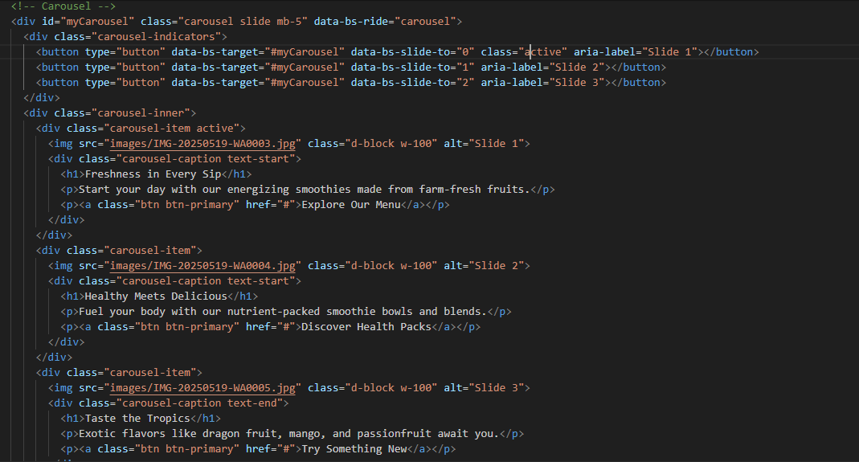

2. Updating the Cart Count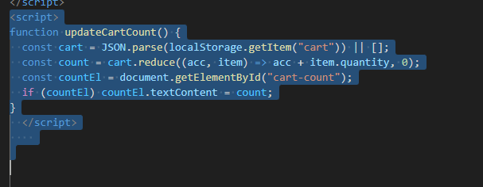

3. Add to Cart Functionality

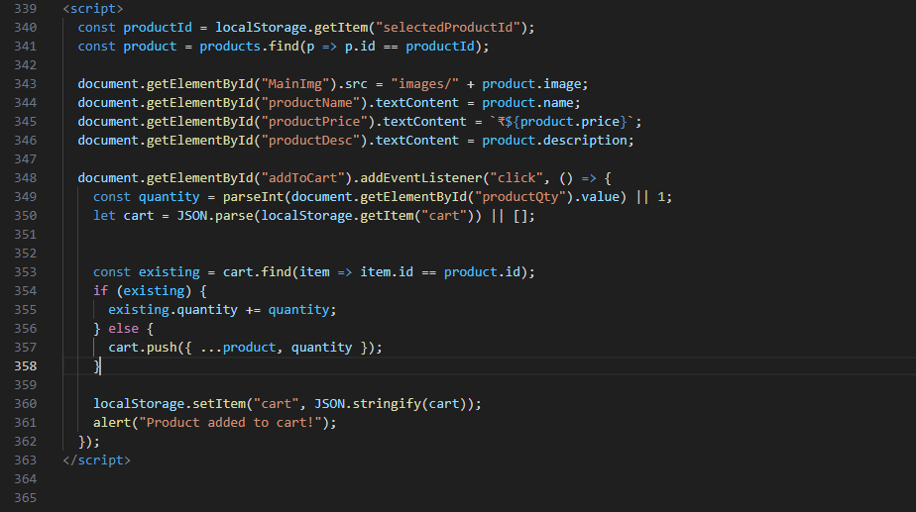

4. JavaScript Object Array for Dynamic Product Listing and Detail Retrieval
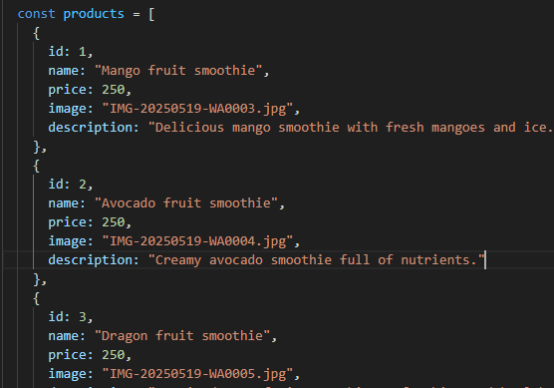

5.JavaScript Code for Cart Management and Quantity Update Using Local Storage
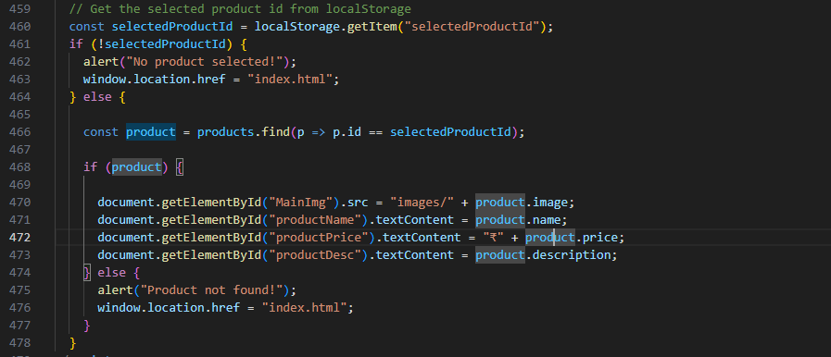

6. Cart Item Removal, Quantity Update, and Dynamic Cart Count Using JavaScript"
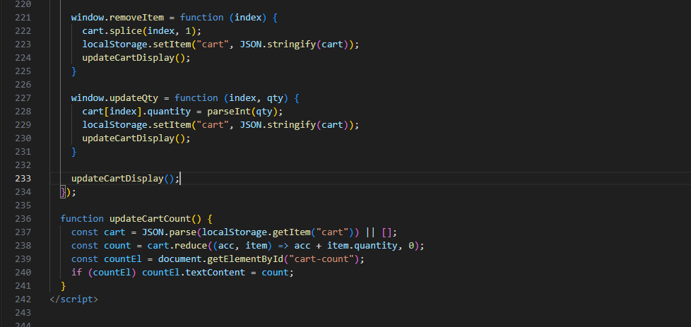

3.6. Key Achievements
• Designed and built a complete e-commerce web application with a responsive front-end interface.
• Integrated Bootstrap carousel on the homepage to enhance visual appeal and user engagement.
• Implemented click-based navigation between product list and product detail pages.
• Developed Add to Cart, Checkout, and Dynamic Total Calculation features using JavaScript and DOM manipulation.
• Connected the website to a MySQL database through PHP for storing user credentials, product details, and order records.
• Implemented basic login and signup functionality with PHP and MySQL, including input validation and backend verification.
• Applied form validation and alert messaging with JavaScript to improve user experience.
• Practiced real-world Agile methodology by delivering incremental updates and responding to feedback throughout the internship.

3.7. Project Outcomes
• Functional and Modular E-Commerce UI: Built with HTML, CSS, JavaScript, and Bootstrap, with PHP–MySQL integration for dynamic data handling, making it easily extendable and scalable.
• Responsive Design: Works seamlessly on both desktop and mobile screens using Bootstrap’s grid system and custom CSS.
• Engaging User Experience: Fast, interactive, and visually clear interface with dynamic cart, real-time price updates, and product detail navigation.
• Agile-Compatible Codebase: Features were built incrementally with regular testing, debugging, and feedback integration.
• Basic Backend Functionality: User authentication, product storage, and order management were implemented through PHP and MySQL, simulating real-world e-commerce workflows.

3.8. Information Technology: Role in Project Success
Information technology was the foundation of my project. Using only front-end tools, I could build a system that mimicked real e-commerce behaviour:
- Automation: Reduced the need for manual data entry with JavaScript logic.
- Responsiveness: Ensured UI scaled well across devices using Bootstrap.
- Efficiency: Bootstrap and JavaScript simplified UI design and logic.
- Usability: The app was intuitive and easy to use.

3.9. SWOC Analysis of UMT
Strengths | Weaknesses
Supportive mentorship and feedback cycle | Limited exposure to advanced backend technologies (beyond PHP & MySQL)
Hands-on learning from day one | Restricted mostly to foundational web technologies

Opportunities | Challenges
Can expand backend/API integration training with advanced frameworks | Needs to stay up to date with rapid tech advancements
Can introduce React, Angular, or Node.js stack | Competing with full-stack training companies
Personal Observation: UMT’s method of training interns through practical tasks and real-time guidance is highly effective. It allowed me to grow at my own pace and focus deeply on both front-end development and beginner-level backend integration with PHP and MySQL. With expanded training into modern frameworks and advanced backend concepts, the program can become even more robust and industry-aligned.

3.10. Conclusion
This internship helped me bridge the gap between academic learning and real-world web development. I began with simple HTML tasks and, through constant practice and support, developed a complete e-commerce front-end with shopping cart logic, UI enhancements, and dynamic behaviours—all without any prior professional experience. I now understand the importance of incremental development, user experience design, and efficient code structuring in web-based applications. This hands-on journey has significantly boosted my confidence, and I look forward to applying these skills in future projects or advanced learning tracks.

Chapter 4 – Internship Experience

4.1 Skills Acquired
During my internship, I gained hands-on experience in both front-end and backend web development through the creation of a smoothie-based e-commerce interface. The internship involved building interactive product listings, detail pages, and cart functionality using HTML, CSS, JavaScript, and Bootstrap, while also integrating PHP and MySQL for database connectivity and user authentication. I implemented persistent storage using localStorage to maintain user data and cart sessions, and extended this by connecting PHP scripts to a MySQL database for handling product details, user credentials, and orders.
Key Skills Acquired:
- Front-End Development (HTML, CSS, Bootstrap)
I used HTML5 to build the structure of web pages and CSS3 to style components. Bootstrap ensured responsiveness and a modern layout across devices, simplifying development with its grid system and ready-to-use classes.
- JavaScript for Dynamic Behavior
JavaScript was extensively used to add interactivity, including image switching, dynamic cart updates, and DOM manipulation. I implemented logic for adding items to the cart, adjusting quantities, calculating totals, and triggering event-driven updates.
- Data Persistence with localStorage
I used localStorage to store selected product IDs and cart contents, ensuring continuity of the user’s shopping experience even after page reloads. This gave me practice with JSON stringifying/parsing and browser-side storage.
- Dynamic Cart System
Implemented full cart functionality, including:
o Adding/removing products
o Increasing/decreasing quantities
o Calculating subtotal and total prices
o Displaying all items dynamically in a table layout
- Image Interaction and UI Enhancements
Enabled functionality such as:
o Switching main images by clicking on thumbnails
o Using hover effects and buttons for better UX
o Adding carousel features for better presentation
- Backend Development with PHP
I created PHP scripts to handle form submissions, process login/signup data, and connect with a database. This introduced me to $_POST, session handling, and server-side validation.
- Database Management with MySQL
I designed tables to store products, users, and order details. I learned how to write queries for CRUD operations and debug errors using MySQL Workbench.
- Debugging and Problem Solving
I resolved issues such as event handler bugs, database connectivity errors, and UI responsiveness problems. Debugging tools like console.log, browser DevTools, and SQL query testing taught me to work independently and analytically.
- Development Environment (VS Code & MySQL Workbench)
I used VS Code with extensions like Live Server and Prettier for clean, real-time testing. MySQL Workbench helped me design and query databases efficiently.

4.2 Lessons Learned, Personal and Professional Development
My internship was a transformative experience that bridged academic learning with real-world application. It helped me understand what it’s like to work as a developer, taught me the importance of clear logic, responsive design, and introduced me to backend integration.
Key Lessons Learned:
- Creating Responsive and Accessible Interfaces – Designing for all screen sizes taught me the importance of visual consistency, accessibility, and mobile-first development.
- Modular Code and DRY Principles – I practiced writing reusable functions in JavaScript and modularized PHP scripts to reduce repetition and improve maintainability.
- Workflow Planning and Structured Development – Planning page layouts, database schemas, and directory structures kept the project organized. Separating HTML, CSS, JS, PHP, and SQL scripts minimized errors.
- Handling Real-Time Interactions – From listening to button clicks to updating product details dynamically, I understood how interactivity improves UX.
- Persistence and Logical Debugging – Debugging both front-end issues and backend database errors helped me develop patience and problem-solving skills.
- Prioritization and Time Management – Balancing UI styling, backend integration, and testing within limited timeframes trained me to deliver in phases.
- Communication and Self-Guidance – Documenting progress, clarifying doubts, and exploring official documentation (Bootstrap, PHP, MySQL) strengthened my self-learning ability.

4.3 Challenges Encountered & Strategies Adopted
Throughout the internship, I faced both front-end and backend challenges, which strengthened my coding ability and boosted my confidence as a developer.
Challenge | Description | Strategy/Solution
Product info not loading properly | On the detail page, product data didn’t show after click | Stored product ID in localStorage on click and retrieved it using getItem() on next page
Duplicates in Cart | Same product added multiple times created repeated entries | Checked for existing product in cart before pushing new one; updated quantity instead
Quantity adjustment didn’t reflect totals | Changing quantity in the input box didn’t recalc total price | Added onchange listeners to quantity inputs, recalculated totals inside updateCartDisplay()
Images not updating on thumbnail click | Clicking a thumbnail didn’t change the main image | Wrote a function to update the src of the main image using onclick on each thumbnail
Inconsistent UI across devices | Layouts broke on small screens | Used Bootstrap’s grid system and responsive classes (col-sm-, col-md-)
Cart reset on refresh | Cart data disappeared after reload | Used localStorage instead of global variables for persistence
Confusing event flow | Some event listeners triggered prematurely | Refactored code structure so DOM elements loaded before attaching event listeners
Database Connectivity Errors | PHP scripts initially failed to connect with MySQL database | Fixed by configuring mysqli_connect, checking credentials, and testing queries
Authentication Validation | Login/signup didn’t verify properly | Implemented PHP form handling with SQL queries to check credentials against database
These challenges not only tested my technical skills but also encouraged persistence, analysis, and self-learning — qualities that I now consider as important as coding itself.

Chapter 5 – Conclusion: Summary of the Internship Experience
In conclusion, my internship experience was a rewarding and transformative journey. Over the course of the internship, I built a strong foundation in front-end web development by working on a practical and functional e-commerce project. I moved from basic webpage creation to implementing dynamic functionality like shopping cart logic, product selection, and data persistence using localStorage.
The internship helped me bridge the gap between academic knowledge and industry practices. It gave me real exposure to how a web application works from a user's interaction to data handling and user experience design. More importantly, it helped me build confidence in my coding ability and improved my problem-solving mindset.
Through this experience, I gained:
- Hands-on experience with real-world HTML, CSS, JavaScript, and Bootstrap development
- An understanding of UI/UX principles like responsive design and interactive behavior
- Practical debugging and testing skills
- A better appreciation of how front-end logic integrates with storage and user actions
Overall, the internship has greatly enriched my technical and personal development. I now feel more confident and better prepared for future opportunities in web development and software engineering.

