**DSA ASSIGNMENT-1**

**TANISHA KARMAKAR**

**21051950**

**CSE 37**

**Q1. WAP to create a dynamic array and perform linear search function.**

**Ans.**

#include <stdio.h>

#include <stdlib.h>

int search(int a[], int n, int key) {

int i;

for ( i = 0; i < n; ++i){

if (a[i] == key){

return i;

}

}

return -1;

}

int main() {

int n, i, x;

int *arr;

printf("Enter the number of elements: ");

scanf("%d", &n);

arr=(int*) malloc (sizeof(int)*n);

printf("enter the elements of the array: \n");

for(i=0;i<n;i++){

scanf("%d", &arr[i]);

}

printf("Enter term you want to search for: ");

scanf("%d", x);

int pos = search(arr, n, x);

if (pos != 1)

printf("Key Found! ");

else

printf("Key not found \n");

return 0;

}

**Output:**

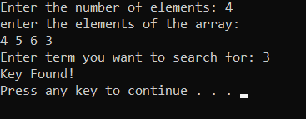

**Q2. WAP to static array and write a sort function for bubble sort.**

**Ans.**

#include <stdlib.h>

#include<stdio.h>

void swap(int* x, int* y)

{

int temp = *x;

*x = *y;

*y = temp;

}

void sort(int a[],int n){

int i, j;

for (i = 0; i < n - 1; i++)

for (j = 0; j < n - i - 1; j++)

if (a[j] > a[j + 1])

swap(&a[j], &a[j + 1]);

}

int main()

{

int n;

printf("Enter elements of array: ");

scanf("%d", &n);

int arr[n];

for (int i = 0; i < n; ++i) {

printf("Enter the element %d - ",i+1);

scanf("%d",&arr[i]);

}

printf("\n");

sort(arr,n);

printf("Sorted Array - \n");

for (int i = 0; i < n; i++)

printf(" %d ",arr[i]);

return 0;

}

**Output:**

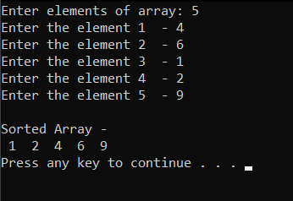

**Q3. WAP to merge two sorted array into one sorted array.**

**Ans.**

#include <stdio.h>

int main(){

int arr1[100],arr2[100],m,n;

printf("Enter the size of the 1st array: ");

scanf("%d",&m);

printf("Enter the size of the 2nd array: ");

scanf("%d",&n);

printf("Enter the elements in the 1st array: ");

for (int i = 0; i < m; i++)

{

scanf("%d",&arr1[i]);

}

printf("Enter the elements in the 2nd array: ");

for (int i = 0; i < n; i++)

{

scanf("%d",&arr2[i]);

}

sort(arr1,m);

sort(arr2,n);

merge(arr1,arr2,m,n);

return 0;

}

void merge(int arr1[] , int arr2[],int m,int n){

int arr3[100];

for (int i = 0; i < m; i++)

{

arr3[i]=arr1[i];

}

for (int i = 0; i < n; i++)

{

arr3[m+i]=arr2[i];

}

sort(arr3,(m+n));

printf("Merged Array: \n");

for (int i = 0; i < m+n; i++)

{

printf("%d ",arr3[i]);

}

}

void sort(int arr[],int n){

for (int i = 0; i < n; i++)

{

for (int j = i+1; j < n; j++)

{

if(arr[i]>arr[j])

{

int temp = arr[i];

arr[i]=arr[j];

arr[j]=temp;

}

}

}

}

**Output:**

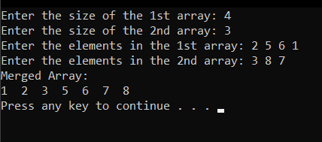

**Q4.  WAP to take an array and reverse the array.**

**Ans.**

#include <stdio.h>

int main ()

{

int arr[100];

int i, n, temp=0;

printf("Enter the size of array: ");

scanf("%d", &n);

printf("Input elements in the array :\n");

for (i = 0; i < n; i++) {

scanf("%d", &arr[i]);

}

for ( i = 0; i <= n/2; i++)

{

for (int j = n-1-i; j>=0; j--)

{

temp=arr[i];

arr[i]=arr[j];

arr[j]=temp;

break;

}

}

printf("After Reversing:\n ");

for ( i = 0; i < n; i++)

{

printf("%d ",arr[i]);

}

return 0;

}

**Output:**

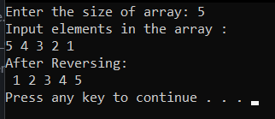

**Q5.**  **WAP to find the largest element and count the occurrence of the largest element.**

**Ans.**

#include <stdio.h>

int main ()

{

int arr[10];

int i, n, max,count=0;

printf("Enter the size of array: ");

scanf("%d", &n);

printf("Input %d elements in the array :\n", n);

for (i = 0; i < n; i++) {

scanf("%d", &arr[i]);

}

max=arr[0];

for (int i = 0; i < n; i++)

{

if(arr[i]>max)

max=arr[i];

}

for (int i = 0; i < n; i++)

{

if(max==arr[i])

count++;

}

printf("The Largest Element: %d",max);

printf("\nThe Number of times it occured: %d",count);

return 0;

}

**Output:**

