A PROJECT REPORT

on
“Plan-AI: Smart Travel Companion using LLM planning”
Submitted to KIIT Deemed to be University



By:
Tanisha Karmakar 21051950
Shubhangi 21051939
Adarsh Tiwari 21052554
Debadrita Mandal 21051808

UNDER THE GUIDANCE OF

Dr. Murari Mandal

SCHOOL OF COMPUTER ENGINEERING KALINGA INSTITUTE OF INDUSTRIAL TECHNOLOGY BHUBANESWAR,
ODISHA-751024

KIIT Deemed to be University
School of Computer Engineering
Bhubaneswar, ODISHA 751024

CERTIFICATE
This is to certify that the project entitled
“Plan-AI: Smart Travel Companion using LLM planning” submitted by-
TANISHA KARMAKAR 21051950
SHUBHANGI 21051939
ADARSH TIWARI 21052554
DEBADRITA MANDAL 21051808

is a record of bona-fide work carried out by them, in the partial fulfilment of the requirement for the award of Degree of Bachelor of Engineering Computer Science & Engineering at KIIT Deemed to be university, Bhubaneswar. This work is done during the year 2023-2024, under our guidance.

Date: 12 /11 /2024

Dr. Murari Mandal (Project Head)

Acknowledgment

I am profoundly grateful to Dr. Murari Mandal of Kalinga Institute of Industrial Technology for her expert guidance
and continuous encouragement throughout to see that this project meets its target since its commencement to its completion.

TANISHA KARMAKAR SHUBHANGI
ADARSH TIWARI DEBADRITA MANDAL

ABSTRACT

The Plan-AI project provides an AI-driven solution for planning affordable and efficient trips across India. It helps users create personalized travel itineraries based on inputs like budget, duration, group size, and chosen destinations. By leveraging natural language processing (NLP) and large language models (LLMs), Plan-AI generates detailed trip plans, covering tourist spots, transportation, accommodation, and local tips within budget constraints. The system uses Groq- powered LLMs to optimize travel recommendations, offering popular destinations, transport options, and hotel suggestions. Plan-AI also simulates real-world trip planning by handling dynamic variables such as financial and logistical preferences. It allows users to book hotels, flights, and services, comparing prices to stay within their budget. Additionally, the AI provides cost-saving recommendations and adjusts budgets to fit the trip. Overall, Plan-AI showcases the potential of AI to enhance travel planning with convenience, personalization, and efficiency, offering users a seamless way to explore India’s heritage. Index Terms- AI-driven trip planning, LLM planning, personalized travel itineraries, smart travel planning .
Index : AI-driven trip planning, LLM planning, personalized travel itineraries, smart travel planning

CONTENTS

1 | INTRODUCTION
2 | TECHNOLOGY STACKS
3 | PROPOSED MODEL
4 | REQUIREMENT SPECIFICATION
 | Functional Requirements
 | Non-Functional Requirements
5 | REQUIREMENT ANALYSIS AND SYSTEM WORKFLOW
 | User-Constraints
 | Feasibility and Constraints Evaluation
 | Planning Phase
 | Local Knowledge Integration
 | Final Output
6 | IMPLEMENTATION
7 | FUTURE SCOPE AND CONCLUSION
8 | REFERENCES

- INTRODUCTION
In the rapidly evolving landscape of the 21st century, technology plays a pivotal role in reshaping various industries, with travel and tourism being no exception. The increasing complexity of travel planning, driven by diverse user needs and budgetary constraints, necessitates innovative solutions to enhance the overall experience.

The Plan-AI project addresses this need by integrating advanced artificial intelligence(AI) capabilities to create tailored, efficient travel itineraries across India. By leveraging natural language processing (NLP) and large language models (LLMs), the project aims to streamline the planning process, making it more accessible and user-friendly. In particular, research in travel planning highlights the challenges faced by traditional methods, which often struggle to accommodate dynamic variables such as user preferences and environmental constraints [1], [2]. By employing LLMs, Plan-AI can synthesize complex data into comprehensive travel plans, simulating real-world scenarios and addressing the practical needs of modern travellers

The primary goal of the Plan-AI project is to simplify the travel planning process by offering an intelligent, AI-driven tool that generates personalized itineraries. Users provide specific inputs, such as budget, duration, and preferred destinations, enabling the system to recommend suitable tourist attractions, transportation options, and accommodation while adhering to the specified constraints.

This aim aligns with findings in the literature, which emphasize the importance of user-centric design in travel planning applications [3], [4]. By focusing on individual user needs, Plan-AI not only enhances the efficiency of the planning process but also elevates the overall travel experience, allowing users to explore India’s rich cultural and historical heritage.
In a world where travel options are vast yet complicated, there is a critical need for intelligent tools that can help users navigate their choices effectively.

Traditional travel planning methods often fail to account for multiple variables and can result in missed opportunities or overspending.

The Plan-AI project addresses these challenges by automating the trip planning process, taking into consideration budget constraints and user preferences. Research shows that existing language models, although powerful, often fall short when it comes to generating effective travel plans under complex conditions [1], [3].

The integration of LLMs in Plan-AI allows for a nuanced understanding of user requirements, ultimately leading to more relevant and personalized travel itineraries.
By fostering a user-friendly interface, Plan-AI can enhance accessibility to travel planning, promoting tourism across India [2], [4].

The societal impact of such a project is significant, as it democratizes access to information and resources, enabling a wider audience to embark on journeys that enrich their lives and broaden their perspectives. Furthermore, as AI-driven solutions gain traction, the potential for transforming the travel industry into a more efficient, cost-effective, and an enjoyable experience becomes increasingly tangible, ultimately benefiting society as a whole.

- TECHNOLOGY STACKS

The Plan-AI project integrates several advanced technologies to deliver a robust and intelligent travel planning platform. These technologies work together to automate the travel itinerary generation process, responding to user inputs and providing tailored travel recommendations.

Key components include Groq API calls for high- performance AI computations, large language models (LLMs) for processing natural language queries, natural language processing (NLP) for semantic understanding, a frontend built using React for dynamic user interface (UI/UX), and a backend using Flask and MySQL for secure data handling and processing.

This combination of cutting-edge technologies aims to create a seamless and user-friendly experience for travellers Groq API is central to Plan-AI’s computational efficiency, enabling the fast processing of complex AI models.
Groq is designed for handling AI workloads with low latency and high throughput, making it an ideal choice for applications that involve real-time decision-making, such as travel planning.

The API facilitates quick responses to user queries by leveraging AI models deployed on specialized hardware, thus ensuring that the generated travel itineraries are produced rapidly without compromising accuracy.

This use of Groq ensures scalability, allowing the platform to handle a large number of users simultaneously. LLMs or Large Language Models are at the heart of Plan-AI's functionality, enabling the system to process and generate human-like text based on user input.

PROPOSED MODEL
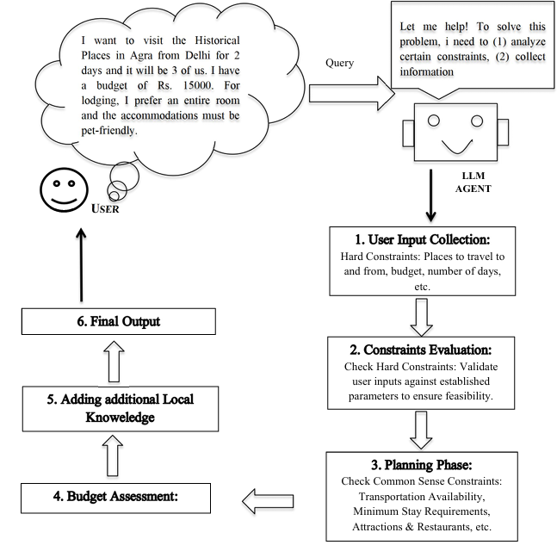

The above User Case Diagram gives a thorough idea of the model and its workings.

REQUIREMENTS SPECIFICATION

4.1 Functional Requirements:

User Inputs: Budget, travel duration, destination, accommodation preferences, and more.

Dynamic Budgeting: Real-time cost analysis and budget adherence suggestions. Recommendation Engine: Suggestions for transport, accommodation, and attractions.

Real-Time Travel Options and Bookings through API integrations: Plan-AI can display real- time availability and booking options, enhancing planning with booking assistance.

Alternative Options: Offers alternative accommodations or activities if selected options are unavailable.

4.2 Non-Functional Requirements:

Scalability: Ability to support multiple users and process various requests simultaneously. User Experience: Interface designed with React for intuitive navigation.

Responsive Design: Compatible across devices, adjusting automatically for desktops, tablets, and smartphones.

Interactive Elements: Real-time feedback on input changes, with visual updates for budget adjustments and activity suggestions.

5. REQUIREMENT ANALYSIS AND SYSTEM WORKFLOW

5.1 User-Specific Constraints:
Collect essential user inputs, such as:
- Travel Origin and Destination
- Budget constraints
- Duration of the trip (number of days)
- Number of People travelling
- Preferred Transportation (e.g., flight, train, car)
- Accommodation Type (e.g., hotel, hostel, Airbnb)
and specific requirements (e.g., non-smoking, pet-friendly)
- Preferred Cuisines and dietary preferences

5.2 System Capabilities:
- The system needs robust NLP and LLM capabilities to interpret and process natural language inputs from users, facilitating an intuitive query-response system.

- Integrate APIs for real-time data on transportation, accommodation, and local attractions, enabling updated and accurate itinerary planning within budget constraints.

5.3 Feasibility and Constraints Evaluation:
- Hard Constraints: Ensures the feasibility of travel based on the user-provided budget, preferred transportation, and accommodation.

- Common-sense Constraints: Verifies practical details, such as transportation availability, minimum stay requirements, and attraction diversity, to enhance travel quality and enjoyment.

- Budget Adherence: Regular checks to ensure all elements of the plan (e.g., transport, lodging, dining) align with the user’s financial constraints, recommending adjustment is necessary.

Checks the hard constraints against these factors:

- Validation: The LLM checks if the user inputs are valid and reasonable. For example, it validates that the mode of transportation aligns with available options, the budget is realistic, and the number of days fits the accommodations selected.

- Conflict Detection: The LLM ensures there are no conflicts, such as budget constraints being exceeded or incompatible transportation methods.

API Calls : This step is handled internally by the LLM through common-sense reasoning and its internal database of general knowledge about constraints (e.g., typical transportation methods between cities).

5.4 Planning Phase

Common-sense Reasoning Before calling external APIs, the LLM applies common sense reasoning to ensure no internal contradictions in the user’s request. For example, if a user has requested air travel but the distance between cities is only a short car ride, the LLM suggests alternative transportation methods. Similarly, it ensures that the selected accommodation meets the minimum stay duration and the overall trip fits within the specified budget.

API Calls:
Transportation API: The LLM calls an API to fetch real-time transportation options.

Accommodation API: The LLM calls an API to fetch available rooms based on the duration of stay, room type, and room rules.

A• ttractions API: The LLM fetches local attractions and dining options via an API to provide a varied experience.

5.5 Local Knowledge Integration

Integrating Local Knowledge The LLM enhances the plan by integrating essential local knowledge:

- Best Time to Visit: Suggests the ideal season for visiting the destination.

- City’s Culture: Provides cultural insights, including etiquette and local customs.

- Famous Garments/Shopping Items: Highlights items or products unique to the city.

- Famous Food: Recommends must-try local dishes.

- Languages Spoken: Informs the user about the primary languages used.

Role of LLM: The LLM applies its pre-trained knowledge to provide cultural insights and local tips without the need for API calls. This information is derived from general knowledge and region-specific data built into the model.

5.6 Final Output: Presenting the Final Travel Plan

Confirmed transportation options based on availability. 

Suggested accommodations that fit user preferences. 

Dining and attraction options at the destination. 

Localtips including culture, famous food, shopping, and language.

Presentation: The LLM structures the final output in an easy-to-understand format, detailing all aspects of the trip and highlighting any areas where the user might save money or need additional funds.

API Calls Summary:
Transportation: Real-time availability and pricing for various modes of transport.

Accommodation: Availability of rooms that match user preferences.

Attractions and Dining: Information on diverse dining options and activities based on the user's constraints.

The external APIs are called only after the LLM completes its initial reasoning phase. This ensures that unnecessary API calls are avoided, optimizing system efficiency. The timing of the API call occurs after the common sense reasoning and preliminary constraint checks are performed by the LLM.

6. IMPLEMENTATION

The Plan-AI project is designed to be a user-friendly travel companion that generates personalized, budget- friendly itineraries using AI.

6.1 Front-end Implementation

Technology Stack: The front-end is built using React for its modular architecture, which facilitates the development of dynamic and responsive interfaces. React’s component-based structure enables flexibility in creating user input forms, itinerary displays, and real-time interaction features.

User Interface Design: The user interface prioritizes accessibility, with clear forms for inputting travel details (e.g., budget, origin, destination, duration). Real-time feedback mechanisms are incorporated to inform users if certain options, like accommodations or transportation, are not feasible within the given constraints.

Components:

Input Form: Allows users to specify travel preferences such as dates, destination, accommodation type, budget, etc. Each input is a React component that validates entries in real time. Itinerary Display: Shows the proposed itinerary, including accommodation, travel, and local attractions, organized day-by-day.

Interactive Elements: Search bars, filtering options, and recommendation pop-ups are included to make adjustments or refine selections within the generated itinerary.

Communication with Back-end: React components communicate with the back-end using AJAX calls (via Fetch API or Axios), sending user inputs and receiving itinerary details. React updates are efficiently handled through state management, ensuring that users experience minimal delay when interacting with the app.

6.2 Backend Implementation

Technology Stack: The backend uses Flask as the primary web framework, facilitating rapid development and handling HTTP requests from the frontend. MySQL is utilized for database management, storing user data, itineraries, and travel- related information.

Database Structure:
User Data Table: Stores details like user ID, prefences, past itineraries, and login
Information

Itinerary Table: Holds generated itineraries linked to user profiles, including details on transportation, accommodation, and planned activities.

Travel Resource Table: Contains information on hotels, flights, tourist spots, and dining options, enabling rapid data retrieval.

APIs and Groq Integration:
LLM Integration with Groq: For processing complex queries and generating travel plans, the backend integrates with Groq API. This API supports the LLM used in Plan-AI to analyze input and provide contextually relevant itineraries.

xternal API Calls: The backend fetches real-time data from external sources like accommodation, transportation, and local attractions through RESTful API calls. API responses are structured to match the database schema for easy storage and retrieval.

Data Handling: User inputs are processed to assess constraints (budget, duration, accommodation preferences). Flask manages routing, validating requests, and sending responses. All responses are JSON- formatted for easy parsing by the frontend.

6.3 AI and LLM Integration for Itinerary Generation:
Natural Language Processing (NLP):
Parsing and Understanding User Input: User inputs are processed using NLP techniques such as entity recognition (identifying key terms like "budget" or "destination") and sentiment analysis (to prioritize user-
preferred options).

Common sense Constraints Evaluation: NLP- driven common sense reasoning is applied to ensure feasible plans. For example, if a destination lacks available transportation on specific dates, alternatives are suggested.
LLM-Driven Itinerary Creation:
Initial Planning: The LLM interprets the parsed input, generates an initial travel plan, and categorizes user requests into structured data.
Budget Assessment: An internal algorithm estimates the total cost, accounting for transportation, accommodations, and dining. If the plan exceeds the budget, the LLM proposes adjustments, such as cheaper transportation or shorter stay durations.

Local Knowledge Integration: Using pre-trained datasets, the LLM provides cultural insights, top local foods, and language tips to enrich the travel plan. This information enhances user engagement, offering a personalized experience beyond mere itinerary suggestions.

6.4 Real-Time Data Integration with APIs
API Calls for Dynamic Information: Transportation API: Fetches options for flights, trains, and local travel, updating availability and pricing based on the user’s travel dates and budget.

Accommodation API: Retrieves accommodation options, matching them with user-specified preferences and ensuring compatibility with the travel duration.

Attractions and Dining API: Gathers information on local tourist spots, restaurants, and events to provide diverse activity suggestions.

Data Synchronization: To ensure timely and accurate updates, the system only initiates API calls after the LLM completes the common sense reasoning phase, reducing unnecessary requests. Data is cached temporarily to prevent redundant calls, improving response times.

6.5 Output Generation and User Feedback
Final Itinerary Assembly:
Once all constraints and preferences are evaluated, the LLM finalizes the travel plan. The structured output includes detailed travel information, such as: Confirmed transportation and accommodation
Day-by-day schedule of attractions and activities Cost breakdown to ensure adherence to the budget

Presentation to User:
The itinerary is presented on the frontend in an easy- to-read format, with options for users to make final adjustments. Visual aids, such as maps and image galleries, enhance engagement, and provide a more immersive experience.

User Feedback Loop:
Users can rate and provide feedback on the travel plans, which helps refine the LLM’s recommendations in future iterations. This feedback is stored in MySQL and analyzed periodically to enhance system performance.

Testing and Performance Optimization System Testing: Comprehensive testing is performed, covering functional tests (correctness of itinerary generation), performance tests (API response times), and user interface tests (ease of navigation).

Optimization: Adjustments are made to minimize API latency, cache static data, and optimize database queries, ensuring the platform remains responsive under high user loads.
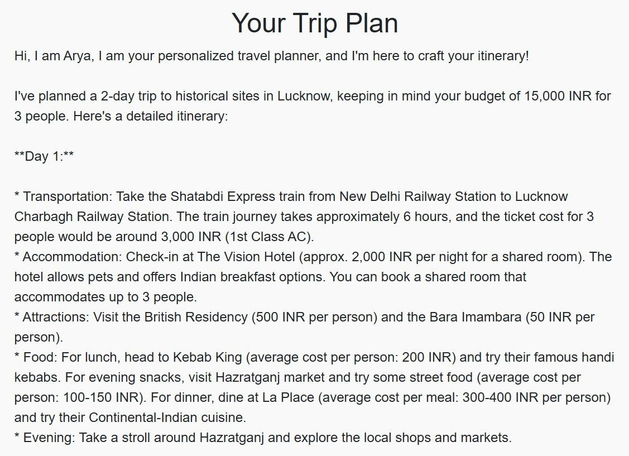
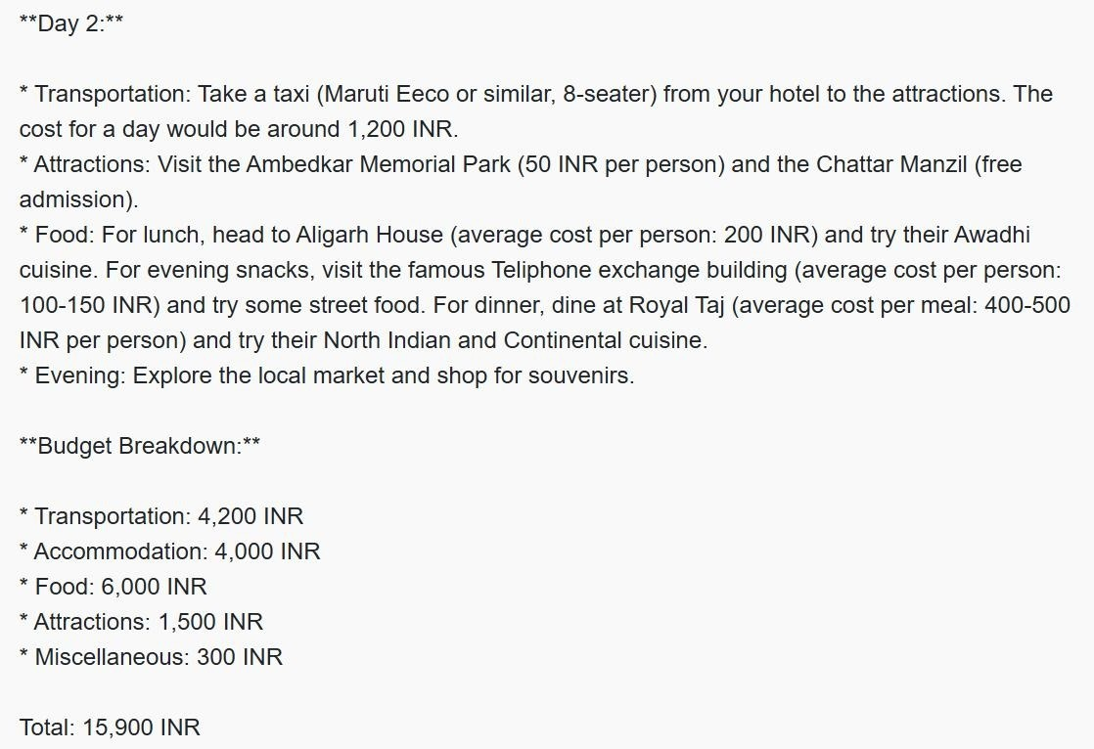

PROMPTS FOR TESTING:

FIGURE 2.1 PLAN AI’S OUTPUT (1/3)

FIGURE 2.2 PLAN AI’S OUTPUT (2/3)
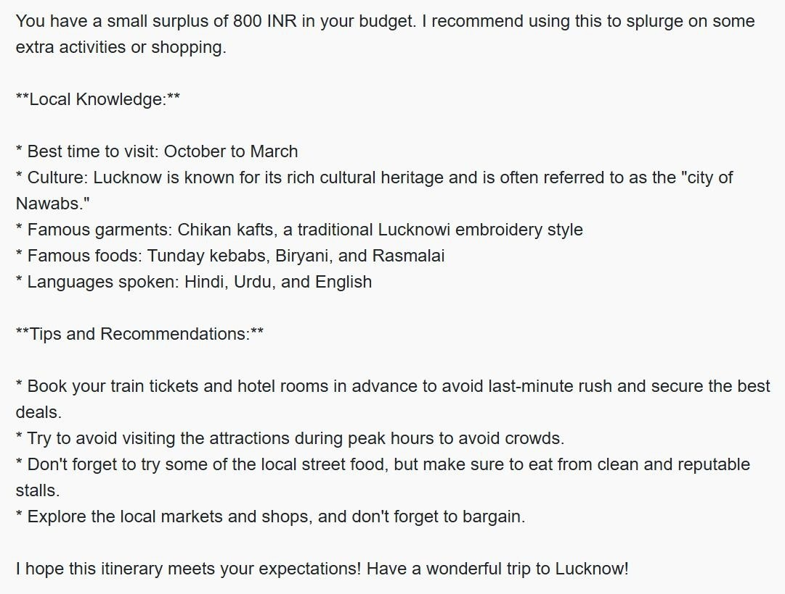

FIGURE 2.3 PLAN AI’S OUTPUT (3/3)

7. CONCLUSION AND FUTURE SCOPE
In this project, we designed and implemented Plan AI, an intelligent planning tool that leverages artificial intelligence to enhance decision-making processes. The goal was to create a system capable of analyzing complex datasets and generating optimized plans tailored to specific goals or constraints. Plan AI integrates machine learning algorithms and data- driven models to predict outcomes, allocate resources efficiently, and provide recommendations.

Key achievements of this project include:

Automated Planning and Optimization: The system successfully automates the planning process, significantly reducing the time required for decision-making.

Data-Driven Insights: With built-in predictive analytics, Plan AI provides users with insights that improve accuracy in planning and resource allocation.

User-Friendly Interface: The intuitive interface enables users across varying technical backgrounds to engage with the AI recommendations effectively.

By meeting these objectives, Plan AI demonstrates the potential of AI in transforming planning tasks into more efficient, accurate, and scalable processes, making it a valuable tool for industries where strategic planning is critical.

There are several promising avenues for the future development of Plan AI:
Incorporating Real-Time Data: Adding real-time data integration could allow Plan AI to make live adjustments, adapting to changes on the fly and enhancing its value in dynamic environments.

Enhanced Machine Learning Models: By exploring advanced machine learning algorithms, including deep learning and reinforcement learning, Plan AI could handle more complex scenarios and provide more refined recommendations.

Expanding Domain-Specific Capabilities: Adapting Plan AI for industry-specific applications, such as logistics, healthcare, and finance.

References

- Xie, J., Zhang, K., Chen, J., Zhu, T., Lou, R., Tian, Y., Xiao, Y., & Su, Y. (2024). TravelPlanner: ABenchmark for Real-World Planning with Language Agents. ArXiv. https://arxiv.org/abs/2402.01622

- Zheng, H. S., Mishra, S., Zhang, H., Chen, X., Chen, M., Nova, A., Hou, L., Cheng, H., Le, Q. V., Chi, E. H., & Zhou, D. (2024). NATURAL PLAN: Benchmarking LLMs on Natural Language Planning.
ArXiv. https://arxiv.org/abs/2406.04520

- Valmeekam, K., Marquez, M., Olmo, A., Sreedharan, S., & Kambhampati, S. (2022). PlanBench: AnExtensible Benchmark for Evaluating Large Language Models on Planning and Reasoning about Change. ArXiv. https://arxiv.org/abs/2206.10498

- Valmeekam, K., Marquez, M., Sreedharan, S., & Kambhampati, S. (2023). On the Planning Abilitiesof Large Language Models : A Critical Investigation. ArXiv. https://arxiv.org/abs/2305.15771

- Huang, W., Abbeel, P., Pathak, D., & Mordatch, I. (2022). Language Models as Zero-Shot Planners: Extracting Actionable Knowledge for Embodied Agents. ArXiv. https://arxiv.org/abs/2201.07207

- Zhou, D., Schärli, N., Hou, L., Wei, J., Scales, N., Wang, X., Schuurmans, D., Cui, C., Bousquet, O., Le, Q., & Chi, E. (2022). Least- to-Most Prompting Enables Complex Reasoning in Large Language Models. ArXiv. /abs/2205.10625

- Song, C. H., Wu, J., Washington, C., Sadler, B. M., Chao, W., & Su, Y. (2022). LLM-Planner: Few Shot Grounded Planning for Embodied Agents with Large Language Models. ArXiv. https://arxiv.org/abs/2212.04088

- Zhao, Z., Lee, W. S., & Hsu, D. (2023). Large Language Models as Commonsense Knowledge for Large-Scale Task Planning. ArXiv. https://arxiv.org/abs/2305.14078

- Zhou, Z., Song, J., Yao, K., Shu, Z., & Ma, L. (2023). ISR-LLM: Iterative Self-Refined Large Language Model for Long-Horizon Sequential Task Planning. 2024 IEEE International Conference onRobotics and Automation (ICRA), 2081-2088.

- Dagan, G., Keller, F., & Lascarides, A. (2023). Dynamic Planning with a LLM. ArXiv. https://arxiv.org/abs/2308.06391

